SOFTWARE ENGINEERING Project Part - 2

Project: Facial recognition

**Use cases:**

**1. Use Case:** Student login

**Primary Actor:** Student

**Goal:** To accurately classify students’ photographs

**Preconditions:**

* No hindrance in photo capturing

**Triggers:**

* Signal depending on model confidence

**Steps:**

1. The student enters his/her credentials to login into the website
2. The student uploads his/her photo
3. The administration checks whether the photo uploaded by the student is valid or not according to the institutes’ data

**Postconditions:**

* On approval, the image is sent for fine tuning purposes.

**2. Use Case:** Administration

**Primary Actor:** Administration

**Goal:** To accurately classify students’ photographs.

**Preconditions:**

* Administration credentials are valid

**Triggers:**

* The job seeker clicks on the "Approve" or “Reject” button on the platform.

**Steps:**

1. Administration reviews the image according to the data with them.
2. If correct, administration approves by clicking on the approve button.
3. If incorrect, it is rejected by the administration.

**Postconditions:**

* Photos are sent for fine tuning.

**3. Use Case:** Camera

**Primary Actor:** Student

**Goal:** To accurately classify students’ photographs

**Preconditions:**

* Model is trained.
* No hindrance in image capturing
* System is online

**Triggers:**

* Student stands in front of the camera for photograph

**Steps:**

1. Student poses for the photograph
2. Image is sent to the model and it returns a confidence score with respect to each class
3. If the topmost score is above the confidence threshold, then the model gives a label to the image, i.e., model labels the image as of person X.
4. A green signal is sent and data entry is made with the details of X and the current time (FOR IN/OUT).
5. If the model does not give a score above threshold confidence, red signal is sent and camera goes to capture mode again.

**Postconditions:**

* Data is entered into the administration’s system and the camera waits for next capture.

**Diagrams:**

1. **Use Case Diagram:**
   1. **Level 0**

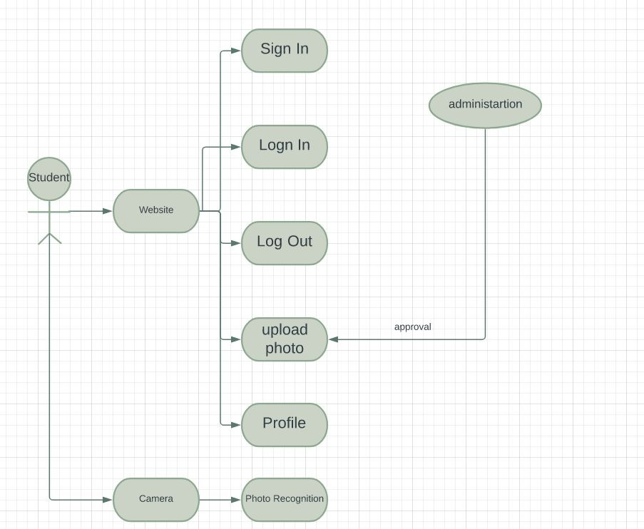

1. **Level 1**

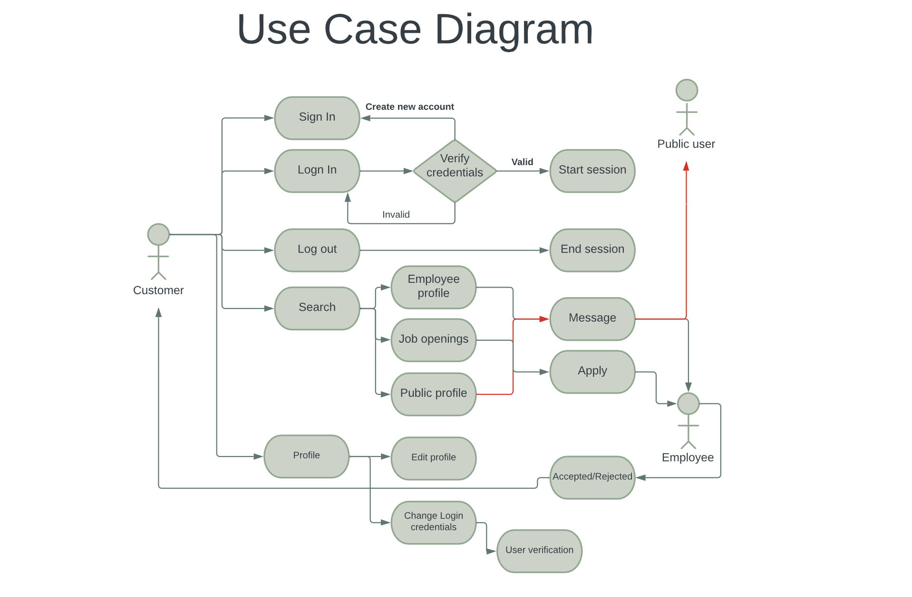

1. **Class Diagram:**

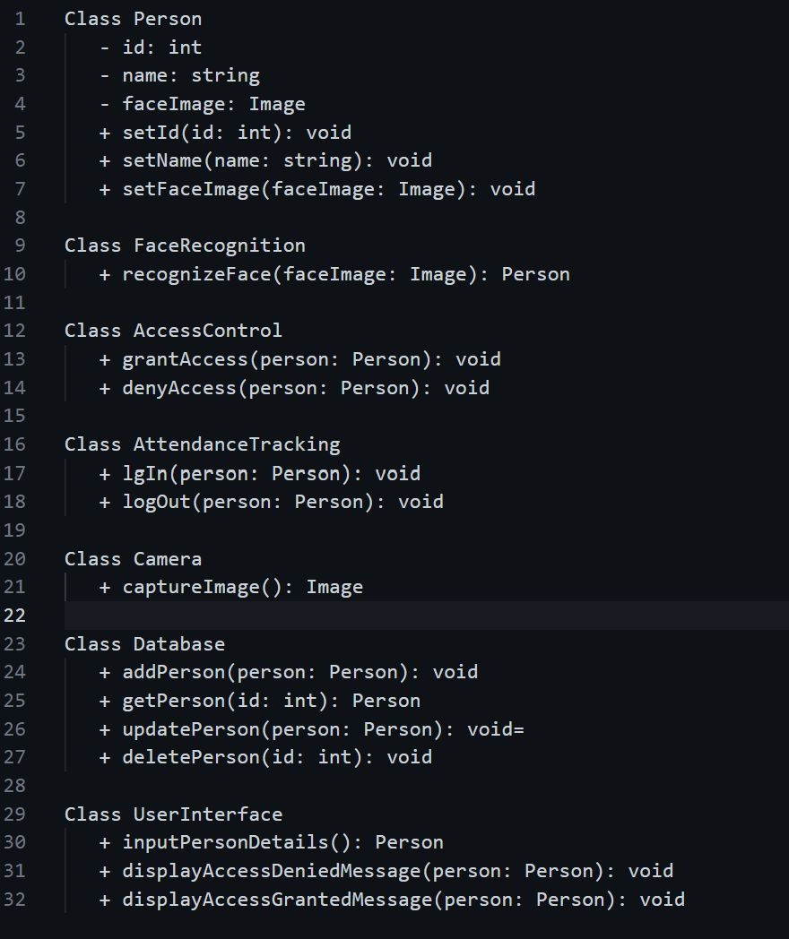

1. **Sequential Diagram:**

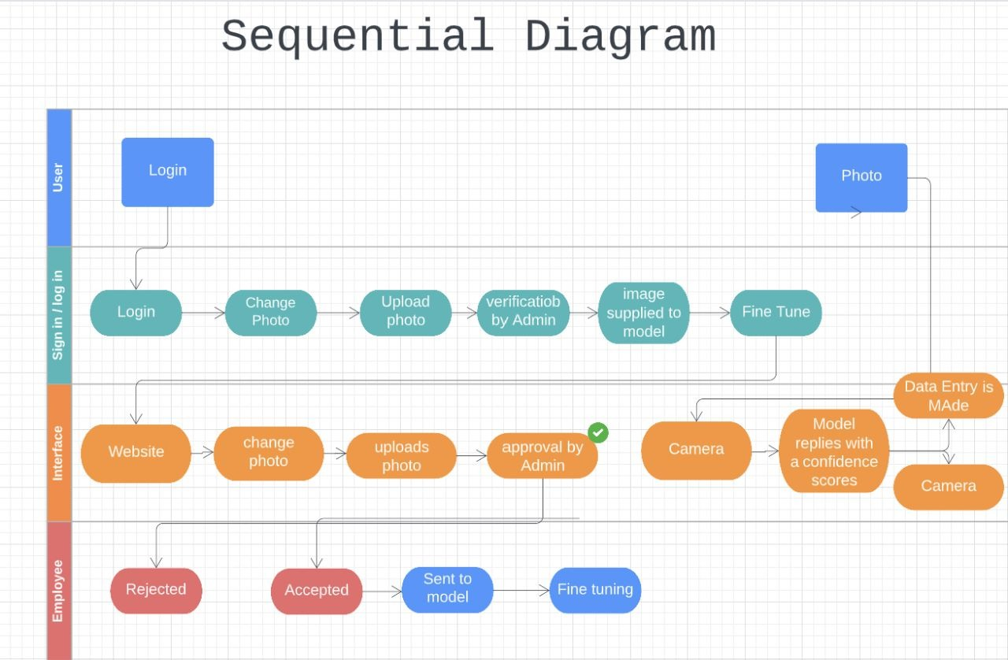

**Team Members:**

1. Varun Samaga BL 21BCS129
2. K. Mourya 21BCS049
3. Sakshi Kusale 21BCS098
4. Sanket Mishra 21BCS100
5. Vishwateja P. 21BCS135
6. Shashank Rajora 21BCS016