The Code-Mixing Penalty in Clinical Retrieval-Augmented Generation: A Measurement Study for Hinglish Clinical Decision Support
Anonymous Author(s)
¹Anonymised for review.
¹Anonymised for review.
Abstract
Patients in multilingual communities routinely describe symptoms in romanised, code-switched language, while the clinical literature that could answer them is written in formal English. We present a measurement study of retrieval-augmented generation (RAG) for Hinglish patient questions grounded in English clinical case reports, built on 3,015 query–case pairs that link the MMCQS question set to the MultiCaRe corpus through a label-leakage gate. Four pre-registered null hypotheses are tested. Code-mixing imposes a significant retrieval penalty under every system tested, roughly 4.4 times larger for lexical retrieval than for dense cross-lingual embedding: BM25 is the best system on English queries and the worst on Hinglish. A script-mismatch analysis shows that MuRIL, pretrained on Devanagari Hindi, retrieves at chance on romanised input. Grounding significantly improves factual support and absorbs the degradation code-mixing induces in the ungrounded arm, replicating across two generator families; but the apparent size of that benefit depends substantially on the scoring reference, and degenerate one-word baselines expose the limits of absolute concept-overlap scores. Evidence provenance significantly changes refusal behaviour (Cochran’s Q = 9.09, p = 0.028), but its effect on answer quality remains undetermined. All corrections, negative results, and evaluation hazards are reported in full.
Keywords: Hinglish, code-mixing, retrieval-augmented generation, clinical question answering, cross-lingual retrieval, evaluation methodology
1. Introduction
A patient types: “Doctor, meri beti ko skin pe rash hai aur bahut khujli ho rahi hai.” The case report that could inform an answer reads: “erythematous maculopapular rash with pruritus.” The clinical content is present in the evidence; the surface form of the question is not what the system expects. Romanised Hindi–English code-switching, known as Hinglish, is a register in which many patients actually describe their symptoms online, yet the clinical literature is written in formal English and most retrieval pipelines are built and evaluated on monolingual queries.
Retrieval-augmented generation (RAG) promises to bridge this gap: retrieve an English case that matches the patient’s situation, then generate a grounded answer in the patient’s own register. Whether that promise survives code-mixing is an empirical question with two separable parts: does the code-mixed surface form damage retrieval, and does grounding improve the factual quality of the generated answer? Existing evaluations rarely isolate either part: retrieval studies seldom compare code-mixed queries against gold human translations of the same questions, and grounding studies routinely score answers against the very evidence the grounded arm was conditioned on.
This paper is a measurement study, not a system-improvement study. We assemble a Hinglish clinical RAG pipeline from deliberately standard components (3,015 Hinglish patient questions from MMCQS [1] paired with case reports from MultiCaRe [2], LaBSE embeddings [3] over a FAISS index, and grounded prompting of an instruction-tuned generator), so that the measurements characterise the setting rather than a bespoke architecture. Four null hypotheses, fixed in advance in the project proposal, are tested: that grounding does not change factual consistency (H₀₁); that code-mixing intensity does not affect the grounded/ungrounded difference (H₀₂); that authoritative case evidence does not improve factual correctness over general biomedical text (H₀₃); and that retrieval quality does not differ between code-mixed queries and their English equivalents (H₀₄).
Several of the project’s original claims did not survive scrutiny, and we report those corrections as findings in their own right: a code-mixing index that misclassified common English words, an index configuration that silently truncated every case narrative, a published context-selection heuristic that never fires on this data, and an evaluation protocol whose circular reference inflates the apparent benefit of grounding. Throughout the paper, rejecting a null hypothesis is the positive outcome: it means the corresponding effect is real.
The study makes three contributions. First, it quantifies the retrieval-stage code-mixing penalty, measured against gold human translations of the same questions behind a label-leakage gate, together with the lexical/dense asymmetry and its script-mismatch mechanism (Sect. 5.1). Second, it provides pre-registered hypothesis tests for the grounding effect and for code-mixing robustness, replicated across two generator families (Sects. 5.3 and 5.4). Third, it demonstrates that evaluation design changes the reported benefit of grounding and supplies the degenerate baselines required to detect such artefacts (Sects. 5.2 and 5.3).
2. Related Work and Research Gap
Work on code-mixed clinical language has concentrated on the query side of the encounter. MedSumm [1] introduced the MMCQS corpus, pairing Hinglish patient questions with human-written English summaries and textual image descriptions, and proposed multimodal summarisation of those queries; HealthAlignSumm [4] extended this line with alignment-based training for multimodal summarisation of code-mixed healthcare dialogues. The present study uses the MMCQS questions and gold English summaries as matched query pairs and the image descriptions only as a scoring reference; no images are processed at any stage, and the task studied is retrieval and grounded generation rather than summarisation.
A second body of work develops retrieval-augmented generation for medicine. Xiong et al. [5] benchmark medical RAG across corpora, retrievers and generators; MMed-RAG [6] adds domain-aware retrieval and adaptive context selection for medical vision-language models; and factuality-targeted augmentation has been applied to radiology reporting [7] and to clinical pipelines such as AlzheimerRAG [8]. Vision-language assistants such as LLaVA-Med [9] generate without a retrieval stage. Across this line the query language is uniformly English, and reported grounding benefits are frequently computed against the retrieved evidence itself, a reference the grounded arm was conditioned on and the ungrounded arm never saw. Section 5.3 quantifies how much of the apparent benefit this circularity contributes in our setting, and Sect. 5.6 tests whether the adaptive context-selection heuristic of [6] transfers to it.
Code-switching has also become an evaluation axis in its own right outside medicine. CroCoSum [10] benchmarks cross-lingual code-switched summarisation, and HiFactMix [11] pairs a Hinglish benchmark with a graph-aware model for political claim verification; neither addresses the clinical domain or isolates the retrieval stage. On the retrieval side, lexical rankers such as BM25 [12] depend on surface-form overlap, which romanisation removes; dense cross-lingual encoders such as LaBSE [3] place translations near one another in a shared space, and reciprocal-rank fusion [13] combines the two signals; encoders pretrained on Indian languages, notably MuRIL [14], target Devanagari Hindi, raising the script-mismatch question that Sect. 5.1 answers empirically. One boundary is explicit: the present system is text-only. Earlier project documents mentioned multimodal components, but none was implemented or evaluated here and no multimodal claim is made.
To our knowledge, no prior study of code-mixed clinical question answering (i) isolates the retrieval-stage penalty of romanisation by comparing code-mixed queries against gold human translations of the same questions under a label-leakage gate, (ii) tests grounding and code-mixing robustness as pre-registered hypotheses across generator families, or (iii) measures how strongly the choice of scoring reference changes the reported grounding benefit. This paper does all three.
3. Materials and Methods
The pipeline is intentionally standard; every design choice that turned out to matter (chunking, sequence limits, the code-mixing index, the scoring reference) is reported with its measured consequence in Sect. 5. All symbols are defined at first use.
3.1 Problem Formulation
Each evaluation item is a pair (q, q_{E}): a Hinglish patient question q and its gold human-written English equivalent q_{E}. The evidence corpus contains 10,000 English MultiCaRe case narratives drawn from 18 condition groups and chunked into 41,746 passages. A retrieval system s maps a query to a ranked list of cases; Recall@1_{s}(·) is the fraction of queries whose top-ranked case belongs to the same condition group as the query. This condition-group criterion is deliberately coarse (Sect. 6.1), but it is identical across languages, which is what the penalty estimand requires. The per-system code-mixing penalty is
Δ_{s} = Recall@1_{s}(q_{E}) − Recall@1_{s}(q) | (1)
where a positive Δ_{s} means the deployed, code-mixed form retrieves worse than its English equivalent. For generation, an instruction-tuned generator g produces a zero-shot answer a₀ = g(q) and a grounded answer a_{r} = g(q, c) conditioned on a retrieved or oracle case c; both answers are in Hinglish. Answers are scored by overlap with a fixed 26-concept clinical lexicon against a designated reference text: factual support is concept precision (the share of asserted concepts present in the reference), concept recall is the share of reference concepts asserted, and F₁ combines the two. The estimands are the per-system penalty Δ_{s}, paired within-query differences between arms scored identically, the Spearman correlation between the Hindi proportion of q and each arm’s score, and contrasts across matched evidence corpora.
3.2 Architecture
The deployed path embeds the Hinglish query with LaBSE [3] and searches a FAISS index of the 41,746 passages; passage scores are aggregated to cases and the top case is returned. Lexical baselines (TF-IDF and BM25 [12]) rank the full documents, and a hybrid system fuses the dense and BM25 rankings by reciprocal-rank fusion [13]. The retrieved case is injected into a grounded prompt instructing the generator to answer the patient in Hinglish using only the supplied evidence; the zero-shot arm receives the identical instruction without evidence. An oracle-evidence condition supplies a case filtered to the query’s own condition group, upper-bounding what retrieval could deliver; the real-retrieval condition uses the deployed path unchanged. The evaluation harness extracts lexicon concepts from each answer and reference and computes factual support, recall, F₁, and refusal status, to which the statistical procedures of Sect. 4.2 are applied.
4. Experimental Design and Evaluation
The study tests four pre-registered null hypotheses, each fixed in the project proposal before the analyses were run. Rejecting a null is the positive outcome: it means the corresponding effect is real. Two-sided tests are used throughout, with Benjamini–Hochberg (BH) false-discovery-rate correction within each hypothesis family; cluster bootstraps handle the non-independence introduced by repeated reference texts (Sect. 6.1).
4.1 Datasets and Preprocessing
Queries are drawn from MMCQS [1], which provides Hinglish patient questions, each with a human-written English summary and a textual image description; only text fields are used in this study, and no images are processed. Evidence comes from MultiCaRe [2], which supplies open-access clinical case reports: 61,316 cases pass filtering, of which 10,000 are indexed, balanced across 18 condition groups; the median case is 554 words, and passage chunking yields 41,746 passages. Pairing produces 3,015 query–case evaluation pairs at 100% query coverage.
The choice of evidence corpus is itself a finding. An initial attempt to match MMCQS to Open-i radiology reports by TF-IDF similarity produced only 11 usable pairs: the corpora share almost no topical overlap. Switching the evidence base to MultiCaRe and matching with LaBSE similarity plus condition-aware filtering produced 3,015 pairs, a 274-fold increase. Pairing decisions of this kind can dominate everything downstream and deserve explicit reporting.
A leakage gate is required because MMCQS’s English summary embeds an image caption that names the query’s condition group in 96.2% of rows and reproduces the underscore-joined group label exactly in 33.6%; that is, the summary itself contains the relevance label. Any English-versus-Hinglish comparison that uses the full summary is therefore inflated by construction. All English-side queries use the caption-stripped summary, and an automated gate asserts that no label string survives.
4.2 Baselines and Evaluation Metrics
Four retrieval systems are compared on the passage-chunked index: TF-IDF, BM25 [12], dense LaBSE retrieval [3], and a hybrid fusing the BM25 and LaBSE rankings by reciprocal-rank fusion [13]. A supplementary single-vector index (one embedding per case) additionally hosts MuRIL [14] and multilingual-e5-base for the script-mismatch analysis. The metric is Recall@1 against condition-group relevance; its random floor, the Recall@1 of condition-blind retrieval, is 0.0626. Because the relevance criterion is coarse, absolute Recall@1 is a lower bound on true relevance (Sect. 6.1). The penalty Δ_{s} is tested per system with McNemar’s test on paired top-1 correctness: a penalty appearing under one configuration is a property of that configuration, whereas one holding across methods is a property of code-mixing itself.
For generation, each query is answered zero-shot and grounded (Sect. 3.2). Answers are scored with the 26-concept lexicon against two references: the retrieved evidence (circular, because the grounded arm was conditioned on it and the zero-shot arm never saw it) and the dataset’s image description, which neither arm saw (unbiased). Factual support equals concept precision, and the commonly reported “hallucination rate” is exactly 1 − precision (verified min = max = 1.0 across rows), so the two are one number and are never reported as two findings here. Because precision has no recall term, degenerate constant answers can outscore real systems (Sect. 5.2); F₁ is therefore reported wherever quality is at issue, degenerate baselines accompany the scored tables, and refusal and coverage (answers asserting at least one scoreable concept) are reported beside every factuality number.
The statistical toolkit comprises paired within-query deltas with Cohen’s d, McNemar’s test for paired binary outcomes, Spearman ρ with 95% confidence intervals for dose–response, BH correction within hypothesis families, cluster bootstraps over repeated references, and Cochran’s Q for refusal across matched evidence conditions.
4.3 Implementation Details
The pipeline uses LaBSE sentence embeddings with a FAISS index over the 41,746 passages; lexical baselines index full documents. Generators are llama-3.1-8b-instant, a hosted instruction-tuned model, and gpt-oss-120b, an open-weight model; both receive identical prompts. Midway through the study the hosting provider decommissioned llama-3.1-8b-instant, which now returns HTTP 404: its archived outputs remain re-scorable, but no new generations are possible (Sect. 6.1). An early index build imposed a 128-token sequence limit whose consequences are reported as a corrected result in Sect. 5.6; all dense results elsewhere use the corrected, passage-chunked index unless stated otherwise. Experiments ran under Python 3.12 with sentence-transformers 3.0.1, transformers 4.42.4, PyTorch 2.3.1, faiss-cpu 1.8.0, scikit-learn 1.8.0, NumPy 1.26.4, pandas 2.2.1, SciPy 1.12.0 and matplotlib 3.8.3, with rank_bm25 for the BM25 baseline; full pinned versions are listed in requirements.txt in the released repository. All stages ran on commodity CPU hardware (a four-core Intel Core i3-8130U, 12 GB memory); no GPU was used at any stage. Approximately 7,200 generation calls were issued in total: about 4,300 on llama-3.1-8b-instant and about 2,800 on the gpt-oss models. Random seeds are fixed at 42 throughout. Code and data availability are stated in the Declarations.
5. Results
Subsections follow the pre-specified order: the retrieval-stage hypothesis H04 first, a validity audit of the scoring instrument before any generation numbers, then H01, H02 and H03, and finally the negative and corrected results. H04, H01 and H02 are rejected; H03 is partially answered. Bold marks values highlighted in the text; all p-values are two-sided.
5.1 Code-Mixing Penalty at Retrieval (H₀₄)
Table 1 reports Recall@1 for each system on the deployed Hinglish queries and on their gold English equivalents over all 3,015 pairs, and Fig. 1 visualises it. Every system with a paired test retrieves significantly worse on Hinglish (McNemar, largest p = 0.018), and TF-IDF shows the same direction. Because the penalty holds across lexical, dense, and hybrid methods, it is a property of code-mixing rather than of any single configuration; this is the reason the test is run per system. H04 is rejected for every system tested.
Table 1 Recall@1 by retrieval system and query language (n = 3,015 pairs; higher is better). Penalty = English − Hinglish; McNemar’s test per system. Bold marks the best deployed-condition (Hinglish) system and the largest penalty. Penalty 95% CIs (bootstrap): LaBSE [+0.0040, +0.0375], BM25 [+0.0743, +0.1085], Hybrid [+0.0036, +0.0408].
System | Hinglish (deployed) | English | Penalty (En − Hi) | McNemar p
Hybrid (RRF) | 0.1751 | 0.1973 | +0.0222 | 0.018
LaBSE (passages) | 0.1280 | 0.1486 | +0.0206 | 0.017
BM25 | 0.0935 | 0.1847 | +0.0912 | 9.9 × 10⁻²⁶
TF-IDF | 0.0842 | 0.1529 | — | —
Random floor | 0.0626 | 0.0626 | — | —

The damage is sharply asymmetric. BM25 loses 0.0912 Recall@1 to code-mixing against 0.0206 for dense LaBSE, roughly 4.4 times more, producing a crossover: BM25 is the best system on English queries (0.1847) and the worst on Hinglish (0.0935). This crossover is the paper’s empirical argument for cross-lingual embedding at the retrieval layer: surface-form overlap is precisely what romanised code-switching removes.
On the single-vector index, MuRIL, an encoder pretrained on Indian languages with Hindi in Devanagari script, scores 0.0640 on Hinglish against the 0.0626 random floor: chance. On the same content in English it recovers to 0.1821. The failure is therefore one of script mismatch rather than language mismatch: MMCQS is romanised, and the encoder has no purchase on the romanised surface. For comparison, Hinglish Recall@1 on that index is 0.1343 for BM25, 0.1303 for multilingual-e5-base, 0.1167 for TF-IDF, and 0.1144 for LaBSE. Practitioners deploying Indian-language encoders on romanised user text should expect near-chance retrieval.
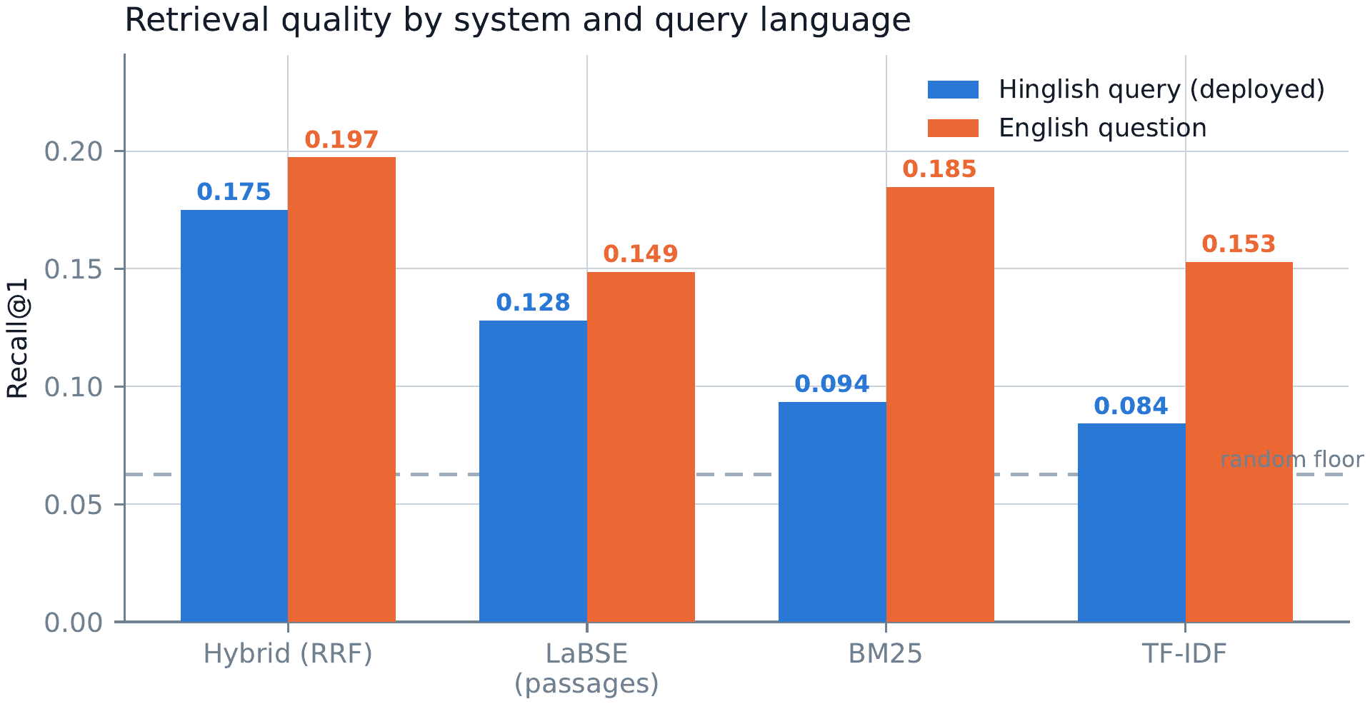
Fig. 1 Recall@1 by retrieval system and query language over 3,015 pairs (higher is better). The dashed line marks the random floor (0.0626). Values correspond to Table 1.
5.2 Validity of the Scoring Instrument
Before any generation result, Table 2 audits the concept-precision instrument against the unbiased reference (n = 1,876 for the constants) using degenerate baselines. A hard-coded one-word answer, the constant string “swelling”, scores 0.7132, beating the real grounded system (0.1528) by a factor of 4.7. The reason is structural: precision has no recall term, so its optimum is terseness. Absolute concept-precision levels therefore carry no information about answer quality; only paired deltas between arms scored identically are interpretable. Accordingly, F1 is reported wherever quality is at issue, and these baselines ship with the scored tables.
Table 2 Concept precision of degenerate baselines and of the two systems against the unbiased reference (n = 1,876 for the constants, 1,705 for the verbatim-copy ceiling, and 701 for the two systems; rows are dropped where an arm asserts no scoreable concept). Absolute levels are not quality measures: a one-word constant outscores the deployed system 4.7-fold.
Scored answer | Concept precision
Copy of the reference, verbatim | 1.0000
Constant “swelling” | 0.7132
Constant “swelling and erythema” | 0.6586
Constant “erythema” | 0.6039
Constant “rash swelling pain erythema infection lesion” | 0.2338
Grounded system | 0.1528
Zero-shot system | 0.1066
Constant “pain” | 0.0032

The same audit closes a double-counting hazard: the commonly reported hallucination rate is exactly 1 − precision (verified min = max = 1.0), so a factuality improvement and a hallucination reduction of matching size are one finding, not two, and every result below is reported once.
5.3 Grounding Effect (H₀₁) and Its Reference-Sensitivity
Under the evaluation protocol in common use, scoring both arms against the retrieved evidence, grounding improves factual support strongly and consistently (Table 3). The effect replicates across two generator families and survives the lexicon repair of Sect. 5.4, so H01 is rejected. Following Sect. 5.2, the arm means in Table 3 are components of the paired estimand Δ, not quality measures.
Table 3 Grounding effect on factual support, scored against the retrieved evidence. Δ = grounded − zero-shot within query; arm means are shown only as components of Δ (Sect. 5.2).
Generator / evidence | n | Zero-shot | Grounded | Δ | Cohen’s d | p
llama-3.1-8b, oracle (original lexicon) | 1,165 | 0.3190 | 0.5535 | +0.2345 | 0.576 | 3.1 × 10⁻⁶⁴
llama-3.1-8b, oracle (repaired lexicon) | 669 | 0.2796 | 0.5758 | +0.2962 | 0.720 | 2.8 × 10⁻⁴⁹
gpt-oss-120b, oracle | 223 | — | — | +0.2659 | 0.662 | 5.5 × 10⁻¹⁷
gpt-oss-120b, real retrieval | 237 | — | — | +0.2238 | 0.616 | 6.5 × 10⁻¹⁷

The magnitude, however, depends on what is scored against (Fig. 2). Re-scoring the same generations by concept F1, BH-corrected, against the circular reference (the retrieved evidence) versus the unbiased reference (the image description, which neither arm saw) changes the picture: llama-3.1-8b with oracle evidence falls from +0.203 to +0.062; gpt-oss-120b with oracle evidence falls from +0.093 to −0.021 (n.s.); and gpt-oss-120b under real retrieval reads −0.032 (n.s.) circular and −0.047 unbiased. This reference-sensitivity is a methodological caution attached to the finding, not a retraction of it: the grounding effect of Table 3 is real under its stated protocol, and the size a paper reports depends substantially on the evaluation design it chooses.
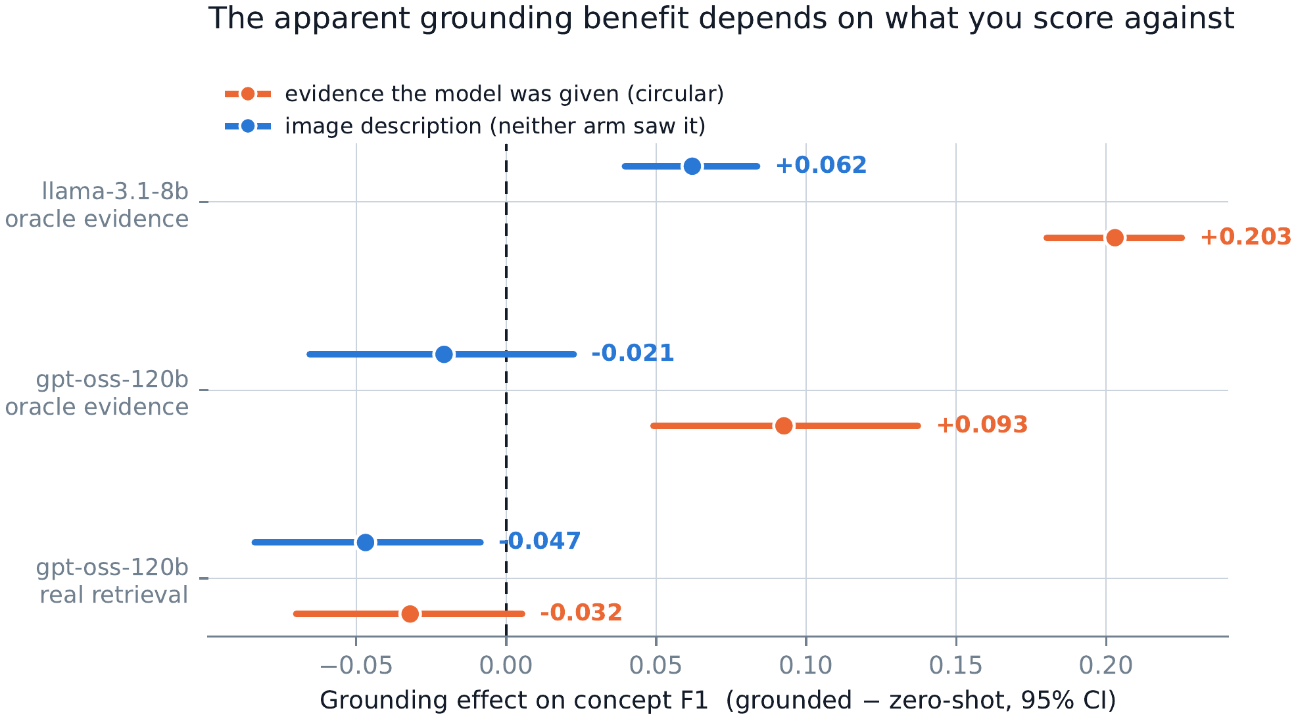
Fig. 2 Grounding effect on concept F1 (grounded − zero-shot, 95% CI) for the same generations scored against two references. Against the circular reference the benefit is large; against the unbiased reference it shrinks or reverses. Significance statements are BH-corrected.
Mechanistically, grounding trades recall for precision: it lowers concept recall by 0.138 (BH p = 0.00025), making the model more conservative, and whether that trade is profitable depends on the generator. Oracle evidence outperforms real retrieval by +0.0875 (p = 0.041): the condition filter buys a small but significant amount over honest retrieval.
Refusal behaviour is itself an outcome of grounding. For gpt-oss-120b (n = 467) the zero-shot arm almost never declines (0.2%), while the grounded arms decline on 29.8% (oracle) and 33.8% (real retrieval) of queries, typically stating that the evidence concerns a different patient; coverage, the share of answers asserting at least one scoreable concept, falls from 92.9% zero-shot to 49.3% and 52.0% respectively. Retrieval’s top-1 was condition-correct in only 10.7% of these rows. Refusals assert no scoreable concept and vanish from a naive mean, which would make the system look healthiest exactly where it fails; coverage is therefore reported beside every factuality number.
5.4 Code-Mixing Robustness of Generation (H₀₂)
H02 is tested per arm: the Spearman correlation between a query’s Hindi proportion and each arm’s score over n = 1,165 pairs, BH-corrected (Table 4; Fig. 3). Zero-shot factual support degrades significantly as code-mixing intensifies (ρ = −0.116, BH p = 0.0003), while the grounded arm is flat (ρ = −0.001, n.s.); neither arm shows a significant hallucination trend. Grounding absorbs the degradation that code-mixing induces in the ungrounded model, and H02 is rejected per arm. The per-arm design is deliberately stronger than testing the grounded-minus-zero-shot gain directly; that difference of two noisy arms is under-powered by construction and is non-significant.
Table 4 Spearman correlation between code-mixing intensity (Hindi proportion, repaired lexicon) and outcome, per arm (n = 1,165), BH-corrected.
Arm / outcome | ρ | 95% CI | BH p | Reading
Grounded factual support | −0.001 | [−0.058, +0.057] | 0.98 | flat
Zero-shot factual support | −0.116 | [−0.171, −0.059] | 0.0003 | degrades
Grounded hallucination | −0.022 | [−0.080, +0.036] | 0.59 | flat
Zero-shot hallucination | +0.042 | [−0.018, +0.101] | 0.30 | flat

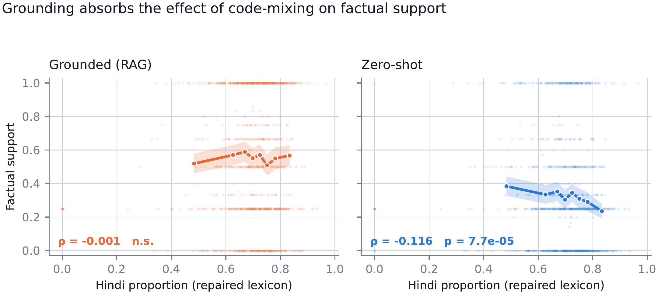
Fig. 3 Factual support against Hindi proportion under the repaired lexicon, with binned means and 95% bands. The grounded arm is flat; the zero-shot arm degrades. Panel annotations show uncorrected p-values; Table 4 reports BH-corrected values.
The code-mixing measure itself required repair. The original index counted the English words “doctor” and “please” as Hindi; they occur in 68.2% and 35.7% of the 1,165 evaluated queries respectively (71.0% and 38.0% across all 3,015 queries), systematically distorting measured intensity. Two hallucination effects reported under the original measure did not survive the repaired lexicon and are withdrawn. All correlations above use the repaired measure.
5.5 Evidence Provenance (H₀₃)
Does authoritative case evidence beat general biomedical text? The candidate corpora differ enormously in topical coverage of the 18 condition groups (MultiCaRe 67.9%, MMedBench-English 16.4%, PubMedQA 2.1%), so an unmatched comparison would measure corpus topicality, not evidence provenance. Four topically matched corpora of 1,872 documents each are therefore constructed: MultiCaRe case reports, PubMedQA abstracts, MMedBench English exam text, and a sentence-shuffled MultiCaRe control; gpt-oss-120b answers n = 160 queries under each condition.
Provenance significantly changes refusal behaviour (Cochran’s Q = 9.09, df = 3, p = 0.028; Table 5), and in the opposite of the expected direction: case reports, the “authoritative” source, provoke the most refusals (88.1%); exam text provokes the fewest (76.2%). Answer quality is undetermined: pairwise F1 differences are small and none is significant, and the four-way omnibus rests on only 13 of 160 queries for which all four conditions produced a scoreable answer; with refusal rates of 76–88%, that joint event has probability near 0.1%. This is absence of evidence, not evidence of absence, and H03 is only partially answered.
Table 5 Evidence-provenance conditions on four topically matched corpora of 1,872 documents each (gpt-oss-120b, n = 160 per condition).
Evidence corpus | Refusal | Mean F₁ | n scoreable
MultiCaRe (case reports) | 88.1% | 0.3265 | 63
Shuffled MultiCaRe control | 82.5% | 0.3186 | 61
PubMedQA (abstracts) | 79.4% | 0.3476 | 70
MMedBench (exam text) | 76.2% | 0.2659 | 66

5.6 Negative and Corrected Results
A published heuristic does not transfer to this setting. The similarity-gap heuristic for adaptive context selection proposed for multimodal medical RAG [6] fires when adjacent retrieval neighbours differ by at least 0.248 in similarity. On this data it fires on 0 of 3,015 queries: the largest gap occurring anywhere is 0.109. Swept across thresholds against fixed-k selection at matched evidence budget, it wins 0 of 6 settings; precision is flat (0.112–0.115) at every setting while recall falls monotonically. The similarity gap carries no relevance information here, and no claim is made that adaptive context selection works in this setting.
A configuration defect dominated the original retrieval comparison. The first dense index was built with a 128-token sequence limit, truncating 99.9% of case narratives (median 300 tokens) and 60.0% of queries, while the lexical baselines read full documents, giving BM25 roughly 2.4 times more information. Correcting the limit and adding passage chunking raised dense Recall@1 on Hinglish from 0.1144 to 0.1280 and reversed the dense-versus-BM25 ordering; raising the sequence limit alone reaches 0.1310, so passage chunking is adopted not because it maximises that figure but because it puts dense and lexical retrieval on matched content. The uncorrected comparison supported the opposite conclusion; it is reported because silent truncation defects are easy to ship and expensive to detect. The withdrawn hallucination effects are reported in Sect. 5.4.
6. Discussion
The retrieval findings are the study’s most decision-relevant. The code-mixing penalty is significant under every system tested and roughly 4.4 times larger for lexical than for dense retrieval, producing a best-on-English, worst-on-Hinglish crossover for BM25. For deployments whose users write romanised code-switched queries the architectural implication is direct: the retrieval layer should be cross-lingual and dense, or hybrid, because surface-form matching is exactly what romanisation destroys.
The MuRIL result sharpens the mechanism to script rather than language: an encoder pretrained on the right language in the wrong script retrieves at chance (0.0640 against a 0.0626 floor) and recovers to 0.1821 on identical content in English. Transliteration-aware pretraining or romanisation normalisation, rather than more Indian-language data alone, is the indicated remedy; this is a hypothesis the study motivates but does not test.
Grounding is better described as a robustness and behaviour mechanism than a guaranteed quality gain. It stabilises factual support against code-mixing intensity, shifts the generator toward precision over recall, and converts silent confabulation into explicit refusal when the evidence does not fit. Whether that trade profits depends on the generator (the two families disagree in sign under the unbiased reference), and the size of any reported gain depends on the scoring reference. None of this retracts the effect; it bounds how it may honestly be reported.
The evaluation findings generalise beyond this system. Factuality should be scored with F1 rather than precision alone; degenerate baselines should accompany scored tables, since a one-word constant outscoring a real system 4.7-fold is otherwise invisible; refusal and coverage belong beside every factuality number, because refusals vanish from naive means precisely where systems fail; factuality and hallucination should not be reported as two findings when one is the complement of the other; references neither arm saw are preferable; dose–response should be tested per arm rather than on the noisier arm difference; and corpora should be topically matched before effects are attributed to provenance.
Finally, hosted-model decommissioning is a concrete reproducibility hazard: the generator behind the largest analyses disappeared mid-study. Archiving raw outputs kept every number in this paper re-scorable; without that discipline, the corrections reported here would have been impossible.
6.1 Limitations and Threats to Validity
Seven limitations bound the claims; each is stated with its measured extent. First, the relevance labels are coarse: condition-group matching over 18 groups admits same-group but clinically irrelevant cases, so absolute Recall@1 is a lower bound on true relevance. Second, the concept lexicon covers 26 concepts and has not been clinician-validated. Third, the unbiased reference is narrow and repetitive: it averages 1.5 concepts, takes 412 distinct values over 2,988 rows, and a single value covers 22% of rows; cluster bootstraps handle the induced non-independence, but the construct captured is partial. Fourth, generation results are generator-dependent: two results differ in sign between generator families under the unbiased reference, both are reported, and neither is selected.
Fifth, provider instability is a concrete threat: llama-3.1-8b-instant, the generator behind the n = 1,165 analyses, was decommissioned mid-study and now returns HTTP 404, so its outputs remain archived and re-scorable but cannot be regenerated, a real hazard for research on hosted models. Sixth, the H₀₃ answer-quality comparison is under-powered, with only 13 of 160 queries scoreable under all four evidence conditions (Sect. 5.5). Seventh, no clinical deployment claim is made: absolute Recall@1 of 0.1751 on Hinglish, roughly two to three times the random floor, is far below what patient-facing use would require.
7. Conclusion and Future Work
This study set out to characterise, rather than improve, retrieval-augmented generation for Hinglish clinical questions over English case reports. Code-mixing significantly degrades clinical retrieval, about four times more for lexical than for dense methods; and while grounding measurably improves factual support and shields it from code-mixing intensity, the apparent size of that benefit depends substantially on the evaluation protocol.
The contributions are the retrieval-stage code-mixing penalty with its lexical/dense asymmetry and script-mismatch mechanism; pre-registered hypothesis tests replicated across two generator families; and a demonstration that evaluation design changes the reported benefit, with the degenerate baselines needed to detect it.
Future work should replace the coarse condition-group labels with graded clinical relevance, validate the 26-concept lexicon with clinicians, adopt richer unbiased references, test transliteration-aware encoders against the script-mismatch failure, and power the provenance comparison for answer quality. Each tightens a bound this study has measured.
Acknowledgements
Acknowledgements are withheld for anonymous review.
Declarations
Funding: The authors received no specific funding for this work.
Competing interests: The authors declare no competing interests.
Ethics approval and consent to participate: Not applicable; this study analyses publicly available, de-identified datasets and involved no human or animal participants.
Consent for publication: Not applicable.
Data availability: MMCQS [1] and MultiCaRe [2] are publicly available datasets. Scored result files and generator outputs are version-controlled in the code repository (see Code availability); derived pairing tables and FAISS indices are deposited in a public repository; the DOI is withheld for anonymous review.
Materials availability: Not applicable.
Code availability: Available at [repository URL withheld for anonymous review]. Archived outputs permit re-scoring of every reported number (Sect. 6.1).
Author contributions: Both authors contributed equally to the conceptualisation, methodology, software, data curation, formal analysis, validation, visualisation, and writing of this work.
References
[1] Ghosh, A., Acharya, A., Jha, P., et al.: MedSumm: a multimodal approach to summarizing code-mixed Hindi–English clinical queries. arXiv:2401.01596 (2024)
[2] Nievas Offidani, M., Roffet, F., González Galtier, M.C., et al.: An open-source clinical case dataset for medical image classification and multimodal AI applications. Data 10(8), 123 (2025). https://doi.org/10.3390/data10080123
[3] Feng, F., Yang, Y., Cer, D., Arivazhagan, N., Wang, W.: Language-agnostic BERT sentence embedding. In: Proceedings of the 60th Annual Meeting of the Association for Computational Linguistics (ACL), pp. 878–891 (2022)
[4] Ghosh, A., Acharya, A., Saha, S., et al.: HealthAlignSumm: utilizing alignment for multimodal summarization of code-mixed healthcare dialogues. In: Findings of the Association for Computational Linguistics: EMNLP 2024, pp. 11546–11560 (2024)
[5] Xiong, G., Jin, Q., Lu, Z., Zhang, A.: Benchmarking retrieval-augmented generation for medicine. In: Findings of the Association for Computational Linguistics: ACL 2024, pp. 6233–6251 (2024)
[6] Xia, P., Zhu, K., Li, H., et al.: MMed-RAG: versatile multimodal RAG system for medical vision language models. In: International Conference on Learning Representations (ICLR) (2025)
[7] Sun, L., Zhao, J., Han, M., Xiong, C.: Fact-aware multimodal retrieval augmentation for accurate medical radiology report generation. In: Proceedings of the 2025 Conference of the North American Chapter of the Association for Computational Linguistics (NAACL), pp. 643–655 (2025)
[8] Lahiri, A.K., Hu, Q.V.: AlzheimerRAG: multimodal retrieval-augmented generation for clinical use cases. Mach. Learn. Knowl. Extr. 7(3), 89 (2025). https://doi.org/10.3390/make7030089
[9] Li, C., Wong, C., Zhang, S., et al.: LLaVA-Med: training a large language-and-vision assistant for biomedicine in one day. In: Advances in Neural Information Processing Systems (NeurIPS), Datasets and Benchmarks Track (2023)
[10] Zhang, R., Eickhoff, C.: CroCoSum: a benchmark dataset for cross-lingual code-switched summarization. In: Proceedings of the 2024 Joint International Conference on Computational Linguistics, Language Resources and Evaluation (LREC-COLING 2024), pp. 4113–4126 (2024)
[11] Anonymous: HiFactMix: a code-mixed benchmark and graph-aware model for evidence-based political claim verification in Hinglish. Under review, ICLR 2026 (2026)
[12] Robertson, S., Zaragoza, H.: The probabilistic relevance framework: BM25 and beyond. Found. Trends Inf. Retr. 3(4), 333–389 (2009). https://doi.org/10.1561/1500000019
[13] Cormack, G.V., Clarke, C.L.A., Buettcher, S.: Reciprocal rank fusion outperforms Condorcet and individual rank learning methods. In: Proceedings of the 32nd International ACM SIGIR Conference on Research and Development in Information Retrieval, pp. 758–759 (2009). https://doi.org/10.1145/1571941.1572114
[14] Khanuja, S., Bansal, D., Mehtani, S., et al.: MuRIL: multilingual representations for Indian languages. arXiv:2103.10730 (2021)

