CineBook Movie Ticket Booking System
SQL Database Management System Project


Database: MySQL
Tools: MySQL Workbench, SQL, VS Code, Microsoft Excel
Academic Project Report
Submitted By
Rabin Das, Sanju Jana, Farhana Sultana

Table of Contents
1. Introduction
2. Objectives
3. Scope of the Project
4. Technologies Used
5. Database Design
5.1 Customers
5.2 Movies
5.3 Theatres
5.4 Screens
5.5 Shows
5.6 Bookings
5.7 Payments
5.8 Booking_Cancellations
5.9 Payment_Refunds
5.10 Database Relationships
5.11 ER Diagram
6. SQL Queries and Analysis
6.1 Basic Data Retrieval
6.2 Aggregate Functions
6.3 GROUP BY and HAVING
6.4 JOIN Queries
6.5 Business Analysis
6.6 Cancellation Analysis
6.7 Refund Analysis
6.8 Subqueries
6.9 Window Functions
6.10 Indexes
6.11 Database View
7. Project Results and Key Findings
8. Conclusion
Appendix A – Project Screenshots

1. Introduction
The CineBook Movie Ticket Booking System is a SQL-based database management project developed to manage and analyze movie ticket booking activities. The system stores information about customers, movies, theatres, screens, shows, bookings, payments, booking cancellations, and payment refunds.
The database follows a relational structure in which tables are connected through primary keys and foreign keys. The project covers movie booking and show data for January 2026 to June 2026.
SQL is used to retrieve, filter, group, join, and analyze the stored data. The project demonstrates practical concepts including aggregate functions, GROUP BY, HAVING, JOINs, subqueries, window functions, indexes, and views.

Project Dataset
Table | Records
Customers | 50
Movies | 20
Theatres | 8
Screens | 16
Shows | 100
Bookings | 250
Payments | 250
Booking_Cancellations | 60
Payment_Refunds | 60

2. Objectives
- To design a relational database for a movie ticket booking system.
- To store and manage customer and movie information.
- To manage theatres, screens, and movie shows.
- To record customer bookings and payment details.
- To maintain booking cancellation and refund information.
- To use SQL queries for data retrieval and analysis.
- To analyze booking revenue, movie performance, and customer spending.
- To demonstrate JOINs, aggregate functions, subqueries, and window functions.
- To improve query performance using indexes.
- To create a database view for simplified access to booking information.

3. Scope of the Project
The CineBook Movie Ticket Booking System focuses on the main activities involved in a movie ticket booking process.
- Customer Management – storing customer name, age, gender, phone, email, and city.
- Movie Management – maintaining title, genre, language, duration, and rating.
- Theatre and Screen Management – managing theatres, locations, screens, and capacities.
- Show Management – maintaining show dates, show times, screens, and ticket prices.
- Booking Management – recording customers, shows, booking dates, seats, amounts, and status.
- Payment Management – maintaining payment methods, statuses, and payment dates.
- Cancellation Management – recording cancelled bookings, dates, and reasons.
- Refund Management – maintaining refund amounts, dates, statuses, and methods.
- Data Analysis – analyzing bookings, revenue, customer spending, cancellations, and refunds.
- Database Optimization – demonstrating indexes and a database view.

4. Technologies Used
Technology / Tool | Purpose
MySQL | Relational database management system used to store and manage CineBook data.
SQL | Used to create tables, insert data, retrieve information, and perform analysis.
MySQL Workbench | Used to execute SQL queries, manage the database, and create the ER diagram.
VS Code | Used to write and manage SQL project files.
Microsoft Excel | Used to store and review the generated project dataset.

Database name: CineBook
The database contains 9 related tables: Customers, Movies, Theatres, Screens, Shows, Bookings, Payments, Booking_Cancellations, and Payment_Refunds.

5. Database Design
The CineBook database follows a relational database structure. Primary keys uniquely identify records, while foreign keys establish relationships between related tables.

5.1 Customers
Field | Description
Customer_ID | Primary key identifying each customer
Name | Customer name
Age | Customer age
Gender | Customer gender
Phone | Customer phone number
Email | Customer email address
City | Customer city

5.2 Movies
Field | Description
Movie_ID | Primary key identifying each movie
Title | Movie title
Genre | Movie genre
Language | Movie language
Duration_Min | Movie duration in minutes
Rating | Movie rating

5.3 Theatres
Field | Description
Theatre_ID | Primary key identifying each theatre
Theatre_Name | Name of the theatre
Location | Theatre location
Total_Screens | Total screens available

5.4 Screens
Field | Description
Screen_ID | Primary key identifying each screen
Theatre_ID | Foreign key referencing Theatres
Screen_Name | Name of the screen
Capacity | Seating capacity

5.5 Shows
Field | Description
Show_ID | Primary key identifying each show
Movie_ID | Foreign key referencing Movies
Screen_ID | Foreign key referencing Screens
Show_Date | Date of the show
Show_Time | Time of the show
Ticket_Price | Price of one ticket

5.6 Bookings
Field | Description
Booking_ID | Primary key identifying each booking
Customer_ID | Foreign key referencing Customers
Show_ID | Foreign key referencing Shows
Booking_Date | Date of booking
Seats_Booked | Number of seats booked
Total_Amount | Total booking amount
Booking_Status | Status of the booking

5.7 Payments
Field | Description
Payment_ID | Primary key identifying each payment
Booking_ID | Unique foreign key referencing Bookings
Payment_Method | Method used for payment
Payment_Status | Status of payment
Payment_Date | Date of payment

5.8 Booking_Cancellations
Field | Description
Cancellation_ID | Primary key identifying each cancellation
Booking_ID | Unique foreign key referencing Bookings
Cancellation_Date | Date of cancellation
Cancellation_Reason | Reason for cancellation

5.9 Payment_Refunds
Field | Description
Refund_ID | Primary key identifying each refund
Booking_ID | Unique foreign key referencing Bookings
Refund_Date | Date of refund
Refund_Amount | Amount refunded
Refund_Status | Status of refund
Refund_Method | Method used for refund

5.10 Database Relationships
Parent / Child | Relationship
Customers → Bookings | One-to-Many
Movies → Shows | One-to-Many
Theatres → Screens | One-to-Many
Screens → Shows | One-to-Many
Shows → Bookings | One-to-Many
Bookings → Payments | One-to-One
Bookings → Booking_Cancellations | One-to-Zero/One
Bookings → Payment_Refunds | One-to-Zero/One

5.11 ER Diagram
The ER diagram created in MySQL Workbench represents the 9 tables and their primary-key and foreign-key relationships.
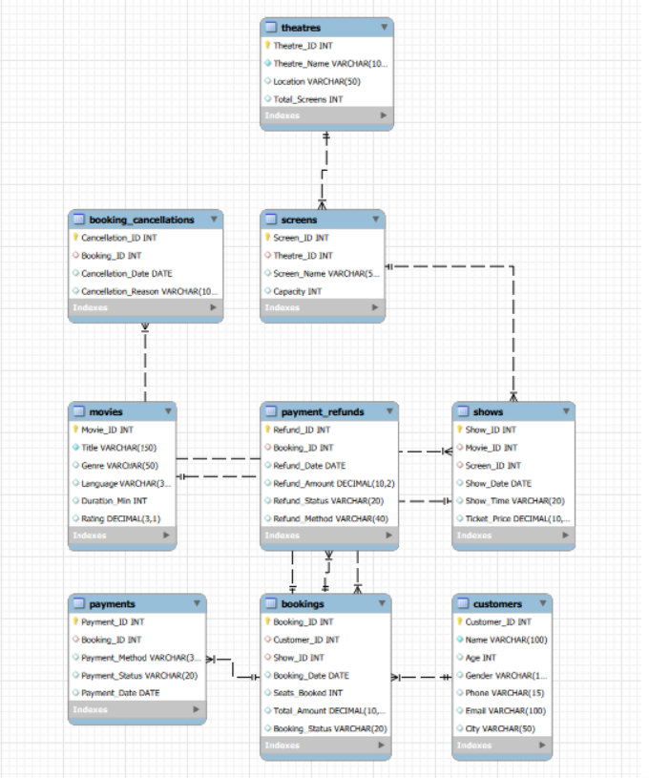
Figure 1: CineBook Entity-Relationship Diagram

6. SQL Queries and Analysis
SQL was used throughout the CineBook project to retrieve, filter, summarize, join, and analyze movie booking data. The following sections summarize the main query techniques implemented.

6.1 Basic Data Retrieval
Basic SELECT and WHERE queries were used to retrieve specific information from the database.
- Displaying all customers and movies.
- Finding movies with a rating greater than 8.
- Finding movies by genre or language.
- Finding customers from a particular city.
SELECT Title, Rating
FROM Movies
WHERE Rating > 8;
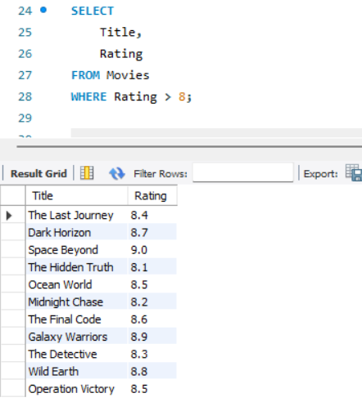
Figure 2: Basic movie-rating query and result

6.2 Aggregate Functions
Aggregate functions were used to calculate summary information.
- COUNT() – count records
- SUM() – calculate totals
- AVG() – calculate averages
- MAX() – find maximum values
- MIN() – find minimum values
Examples include total customers, total movies, total bookings, total booking revenue, average booking amount, highest and lowest booking amounts, and total refunds.
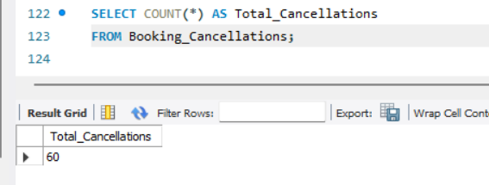
Figure 3: Aggregate Function query and result

6.3 GROUP BY and HAVING
GROUP BY was used to divide records into groups for analysis, while HAVING was used to filter grouped results.
SELECT
City,
COUNT(*) AS Customer_Count
FROM Customers
GROUP BY City;
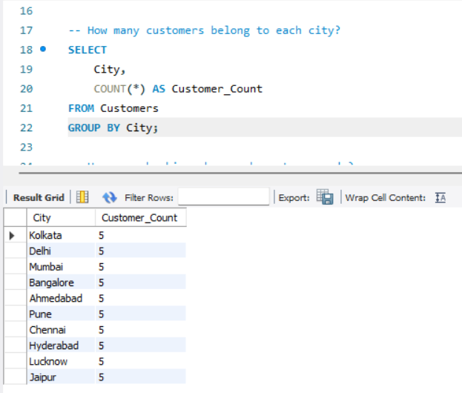
Figure 4: GROUP BY query and result

6.4 JOIN Queries
JOIN operations were used to combine information from multiple related tables, including customer, movie, theatre, show, screen, booking, and payment information.
SELECT
b.Booking_ID,
c.Name AS Customer_Name,
m.Title AS Movie_Name,
t.Theatre_Name,
b.Total_Amount
FROM Bookings b
JOIN Customers c
ON b.Customer_ID = c.Customer_ID
JOIN Shows s
ON b.Show_ID = s.Show_ID
JOIN Movies m
ON s.Movie_ID = m.Movie_ID
JOIN Screens sc
ON s.Screen_ID = sc.Screen_ID
JOIN Theatres t
ON sc.Theatre_ID = t.Theatre_ID;
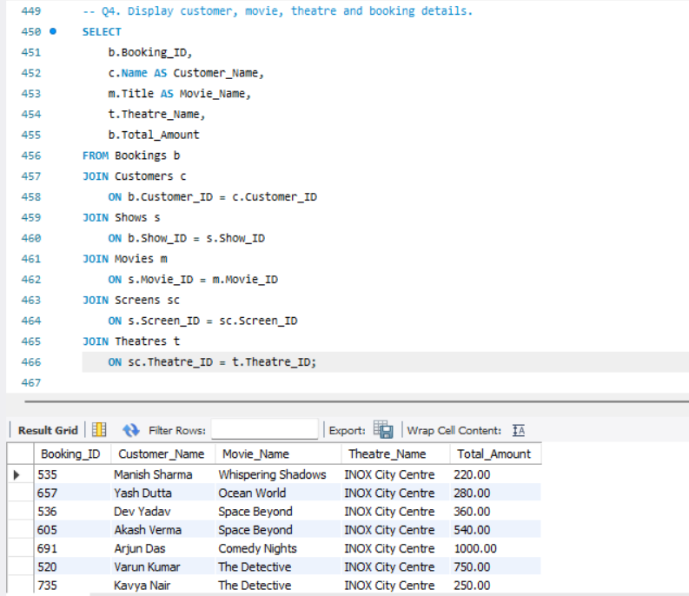
Figure 5: Multi-table JOIN query and result

6.5 Business Analysis
Business analysis queries were used to examine monthly bookings and revenue, revenue by movie and theatre, movie booking counts, customer spending, the highest-spending customer, and the highest-revenue movie.
SELECT
m.Title AS Movie_Name,
SUM(b.Total_Amount) AS Total_Revenue
FROM Bookings b
JOIN Shows s
ON b.Show_ID = s.Show_ID
JOIN Movies m
ON s.Movie_ID = m.Movie_ID
GROUP BY m.Movie_ID, m.Title
ORDER BY Total_Revenue DESC
LIMIT 1;
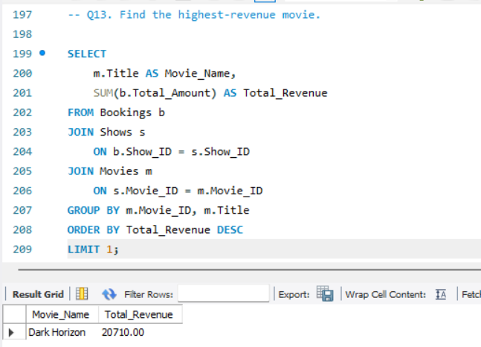
Figure 6: Highest-revenue movie analysis

6.6 Cancellation Analysis
Cancellation data was analyzed using the Booking_Cancellations table. The project calculates total cancellations, cancellation counts by reason, monthly cancellations, movie-wise cancellations, and theatre-wise cancellations.
SELECT
Cancellation_Reason,
COUNT(*) AS Cancellation_Count
FROM Booking_Cancellations
GROUP BY Cancellation_Reason
ORDER BY Cancellation_Count DESC;
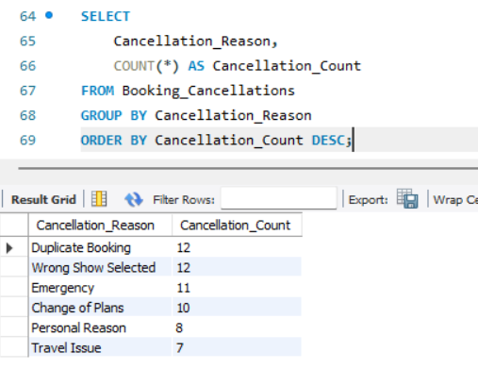
Figure 7: Cancellation analysis

6.7 Refund Analysis
The Payment_Refunds table was used to calculate total refund amounts, monthly refund amounts, refunds by movie, and refunds grouped by payment method.
SELECT
SUM(Refund_Amount) AS Total_Refund
FROM Payment_Refunds;
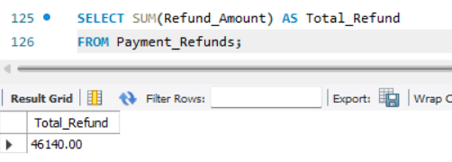
Figure 8: Cancellation analysis

6.8 Subqueries
Subqueries were used to compare records with calculated values, including movies with ratings above the average rating and customers whose spending was above the calculated average.
SELECT
Title,
Rating
FROM Movies
WHERE Rating > (
SELECT AVG(Rating)
FROM Movies
);
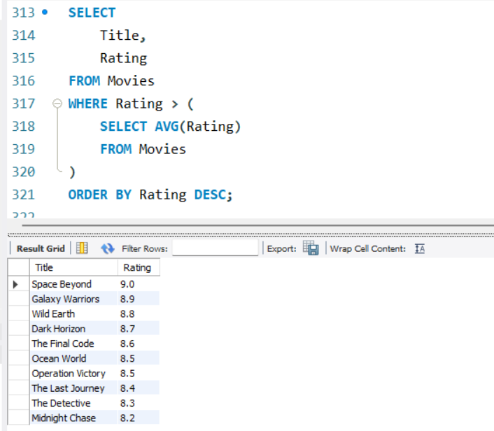
Figure 9: Subquery

6.9 Window Functions
A window function was used to rank movies according to revenue without collapsing the individual movie rows.
RANK() OVER (
ORDER BY Total_Revenue DESC
) AS Revenue_Rank
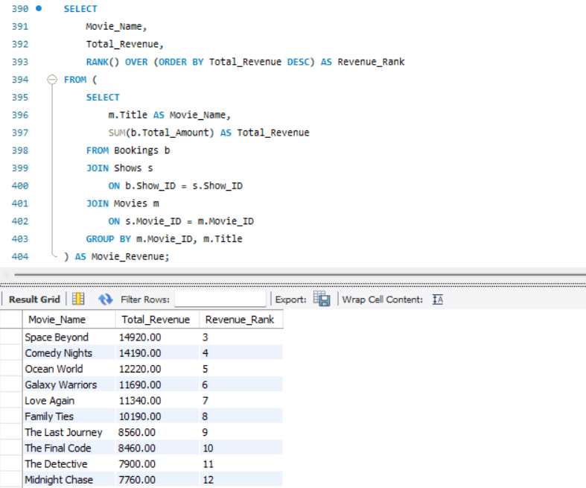
Figure 9: Window function

6.10 Indexes
Indexes were created on selected columns to demonstrate database optimization.
CREATE INDEX idx_movie_genre
ON Movies(Genre);
CREATE INDEX idx_booking_date
ON Bookings(Booking_Date);
CREATE INDEX idx_show_date
ON Shows(Show_Date);
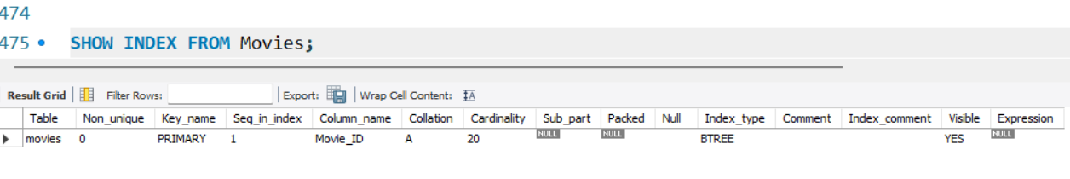
Figure 10: Movie index verification

6.11 Database View
A view named Booking_Details was created to provide a convenient combined representation of booking information.
- Booking ID
- Customer name
- Movie name
- Theatre
- Screen
- Show date and time
- Seats booked
- Total amount
- Booking status
SELECT *
FROM Booking_Details;
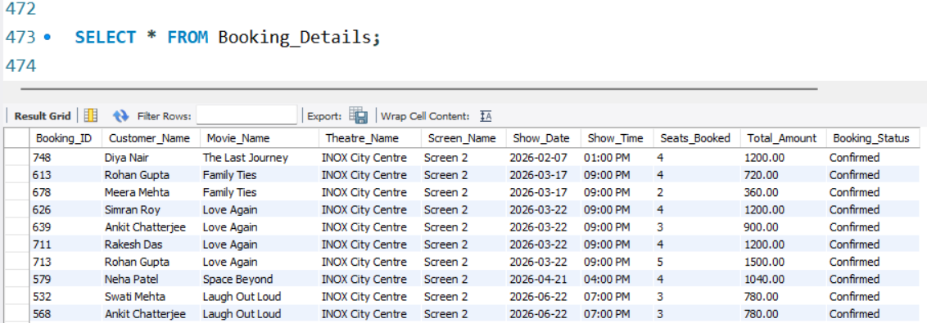
Figure 11: Booking_Details view result

7. Project Results and Key Findings
The CineBook database was successfully implemented using MySQL. The completed analysis demonstrates how the database can be used to examine booking activity, movie performance, customer spending, theatre activity, cancellations, refunds, and database optimization.

7.1 Dataset Results
Metric | Result
Customers | 50
Movies | 20
Theatres | 8
Screens | 16
Shows | 100
Bookings | 250
Payments | 250
Booking Cancellations | 60
Payment Refunds | 60
Data Period | January 2026 – June 2026

7.2 Sample Analytical Findings
- The highest-revenue movie identified by the completed analysis was Dark Horizon, with total booking revenue of 20,710.00.
- The system can calculate monthly booking and revenue trends for January through June 2026.
- The system can identify customer-level booking counts and total spending.
- The system can measure cancellation activity by month, movie, theatre, and cancellation reason.
- The system can measure refund amounts by month, movie, and payment method.
- The database includes indexes on movie genre, booking date, and show date to demonstrate query optimization.
- The Booking_Details view provides a convenient combined representation of booking information.

7.3 Screenshot Evidence
The project was verified through MySQL Workbench using query-result screenshots. The screenshots in Appendix A show the database tables, basic query, GROUP BY analysis, JOIN analysis, business analysis, ER diagram, view, and index verification.

8. Conclusion
The CineBook Movie Ticket Booking System successfully demonstrates the design and implementation of a relational database using MySQL. The project manages customers, movies, theatres, screens, shows, bookings, payments, cancellations, and refunds through related tables with primary-key and foreign-key relationships.
The project applies practical SQL concepts including SELECT statements, filtering, aggregate functions, GROUP BY, HAVING, JOINs, subqueries, window functions, indexes, and views. These techniques were used to perform booking, revenue, customer, cancellation, and refund analysis.
Overall, the project provides practical experience in relational database design, SQL programming, data analysis, and database management.

Appendix A – Project Screenshots

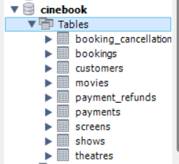
Figure A1: CineBook database tables

Figure A2: Basic SELECT and WHERE query

Figure A3: GROUP BY query

Figure A4: JOIN query

Figure A5: Business analysis

Figure A6: Final ER diagram

Figure A7: Booking_Details view

Figure A8: Index verification

