**AIM: Perform data integration using SQL Server Integration Services.**

THEORY:

Data integration:

**Data integration** involves combining data residing in different sources and providing users with a unified view of these data. Data integration appears with increasing frequency as the volume and the need to share existing data explodes.

Microsoft SQL Server Management Studio:

The SQL Server Management Studiol introduces you to the integrated environment for managing your SQL Server infrastructure. SQL Server Management Studio presents a graphical interface for configuring, monitoring, and administering instances of SQL Server. It also allows you to deploy, monitor, and upgrade the data-tier components used by your applications, such as databases. SQL Server Management Studio also provides Transact-SQL, MDX, DMX, and XML language editors for editing and debugging scripts.

1. Facts files are the text files which are to be integrated:

tab1.txt:

1,abc,2000,14/3/1996

3,xyz,1500,4/10/1995

5,pqr,2500,12/11/1994

7,efg,2000,30/1/1995

tab2.txt:

1,ABC,200,14/3/1996,2000

2,JKL,150,5/5/1996,3000

3,xyz,100,4/10/1995,1500

4,HGJ,200,6/7/1994,4000

6,UIO,120,24/8/1997,5000

Steps for performing data conversion:

2. Table which is used to store the contents of the fact files:

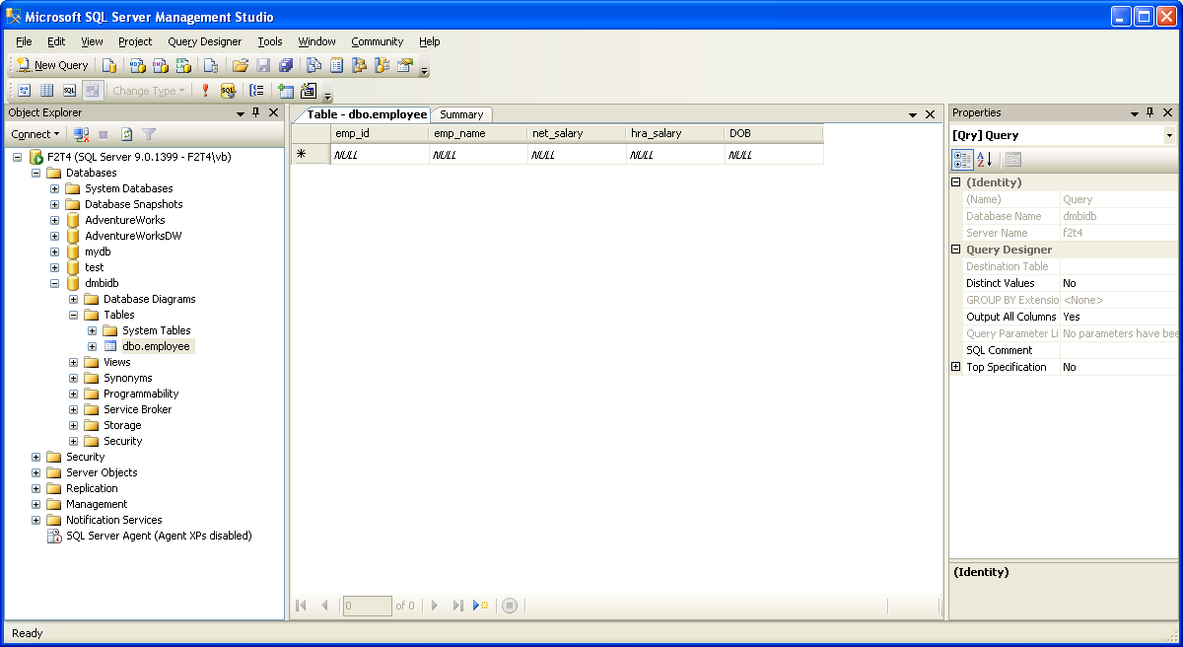

3. Add a **Data Flow** task to our control flow. The task lets us retrieve data from our data source, transform that data, and insert it into our destination. To add the task, drag it from the **Control Flow Items** window to the Control Flow tab of the **SSIS Designer** screen.

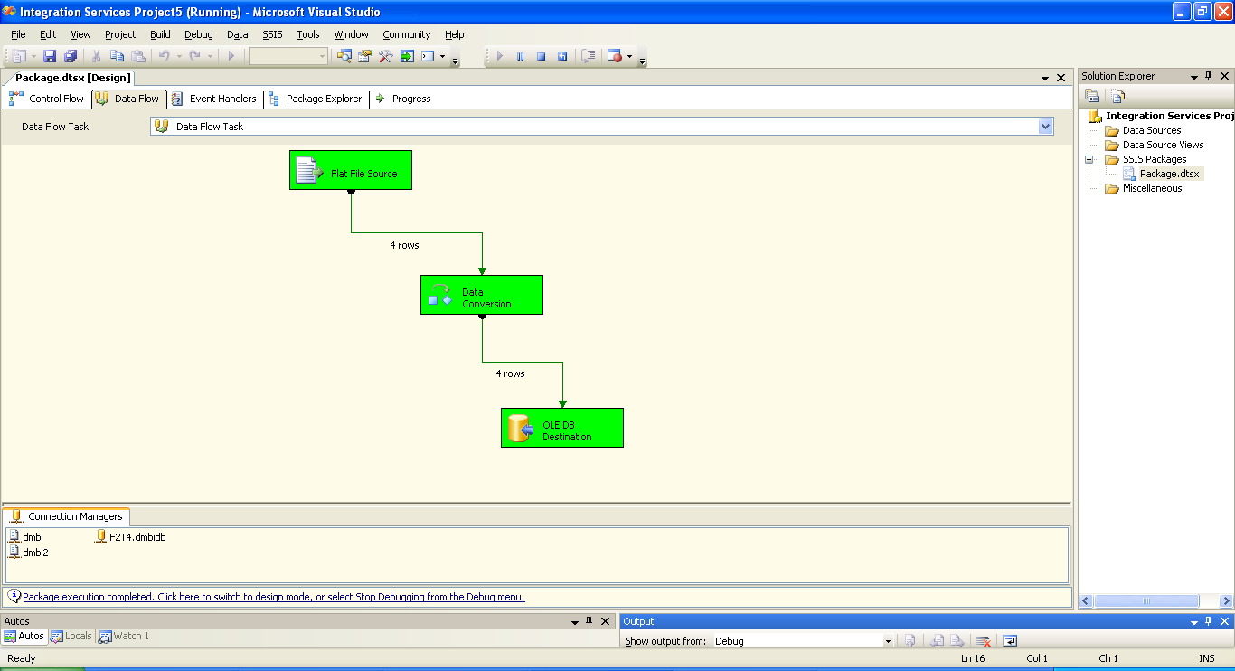

4. Use the **Data Conversion Transformation Editor** dialog box to select the columns to convert, select the data type to which the column is converted, and set conversion attributes.

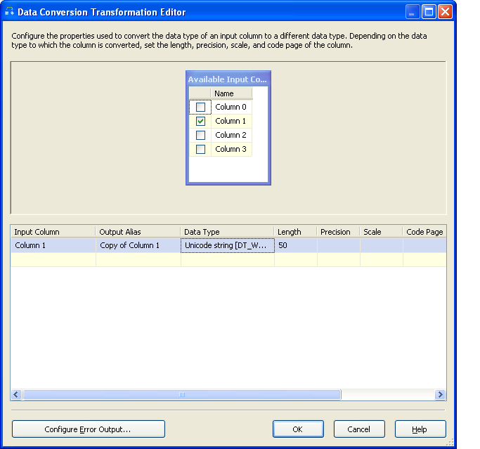

5. Resultant table obtained after applying data conversions.

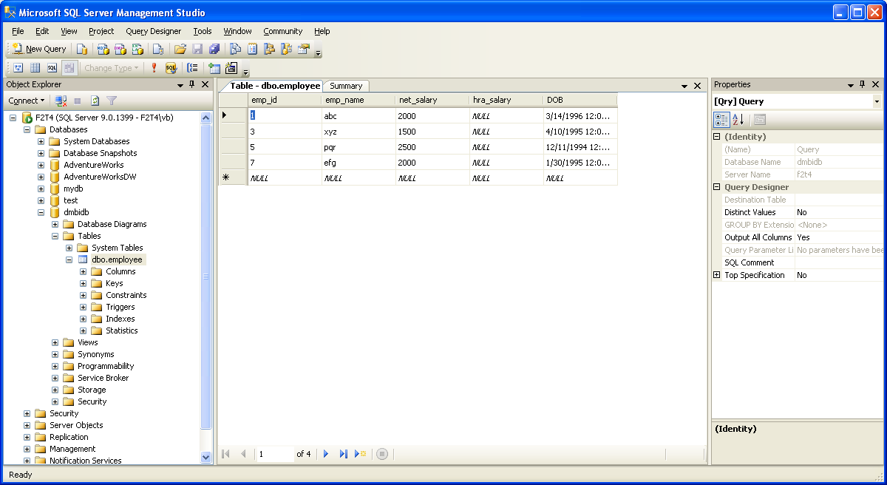

Steps for performing character making:

1. Data flow task containing character map is added depicting its completion.

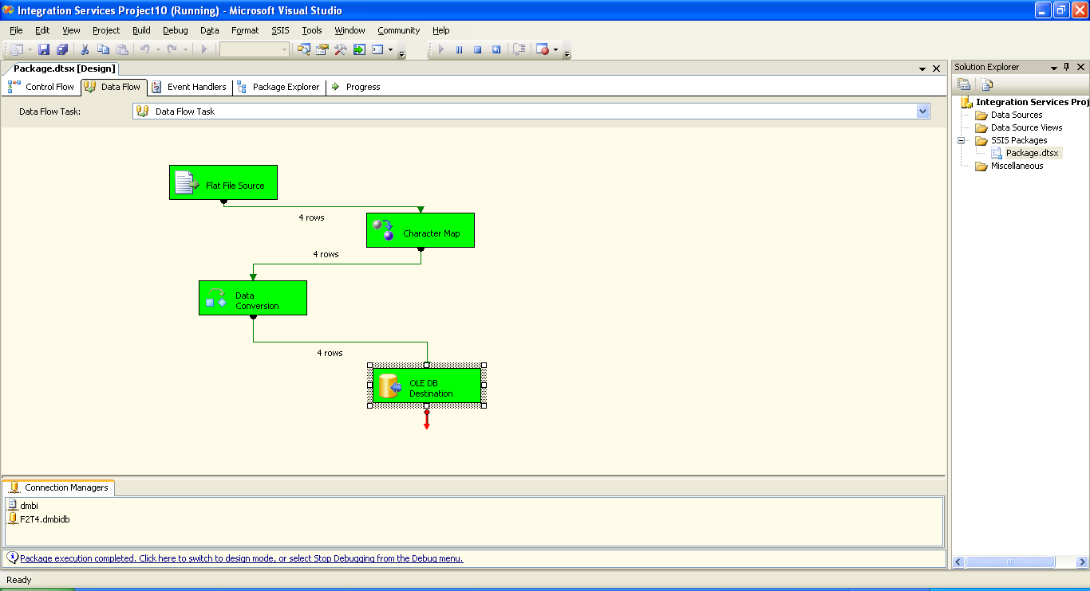

1.The result of character mapping using changing to upper case, we get the following table in the database where we are integrating it.

