**STEP 1:** Go to <https://sourceforge.net/projects/xampp/> and download XAMPP Installer

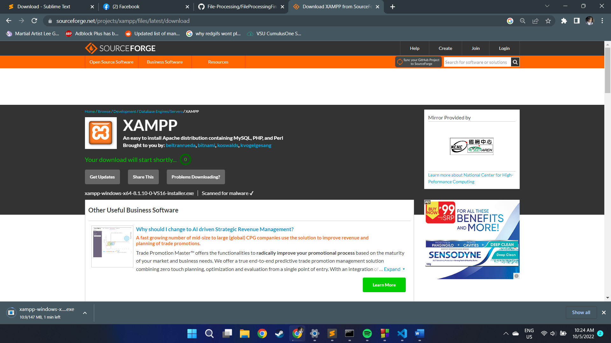

**STEP 2:** Open the file you downloaded and just follow the steps to install XAMPP

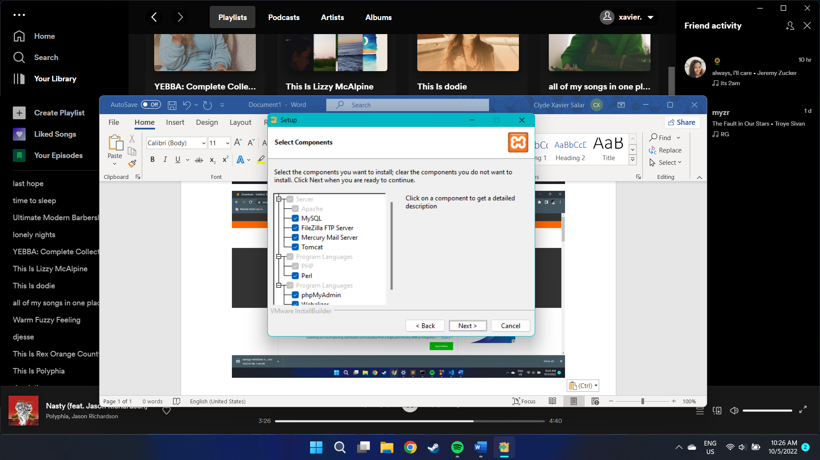

**STEP 3:** Put it in your directory. Much preferable if it is on C drive.

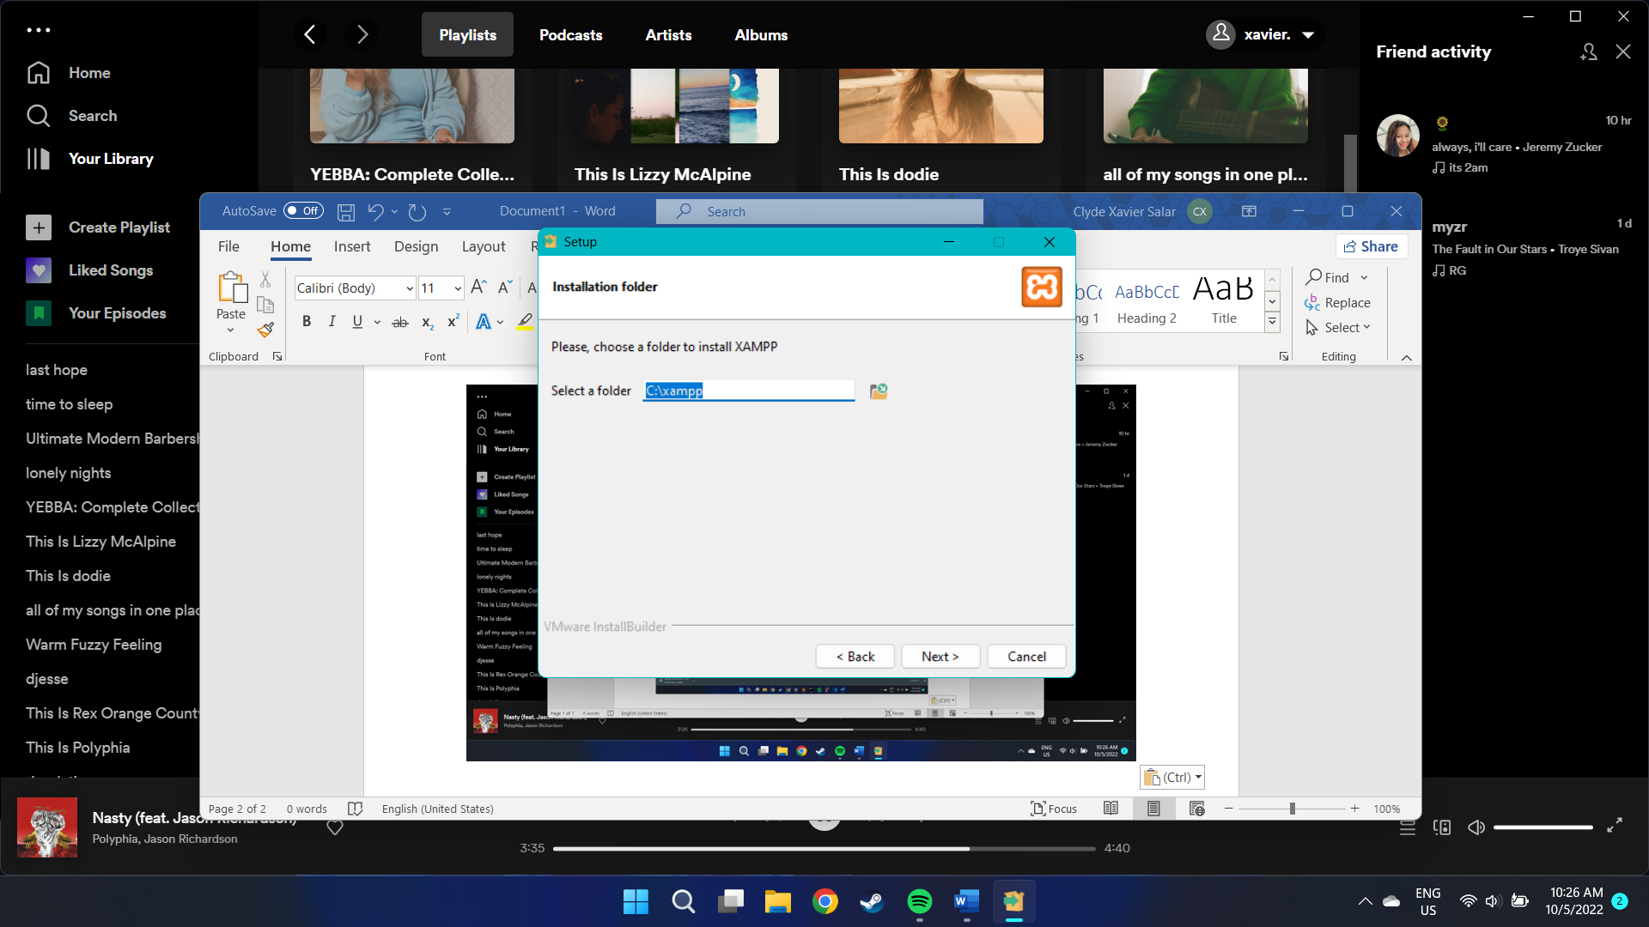

**STEP 4:** Unpack the files

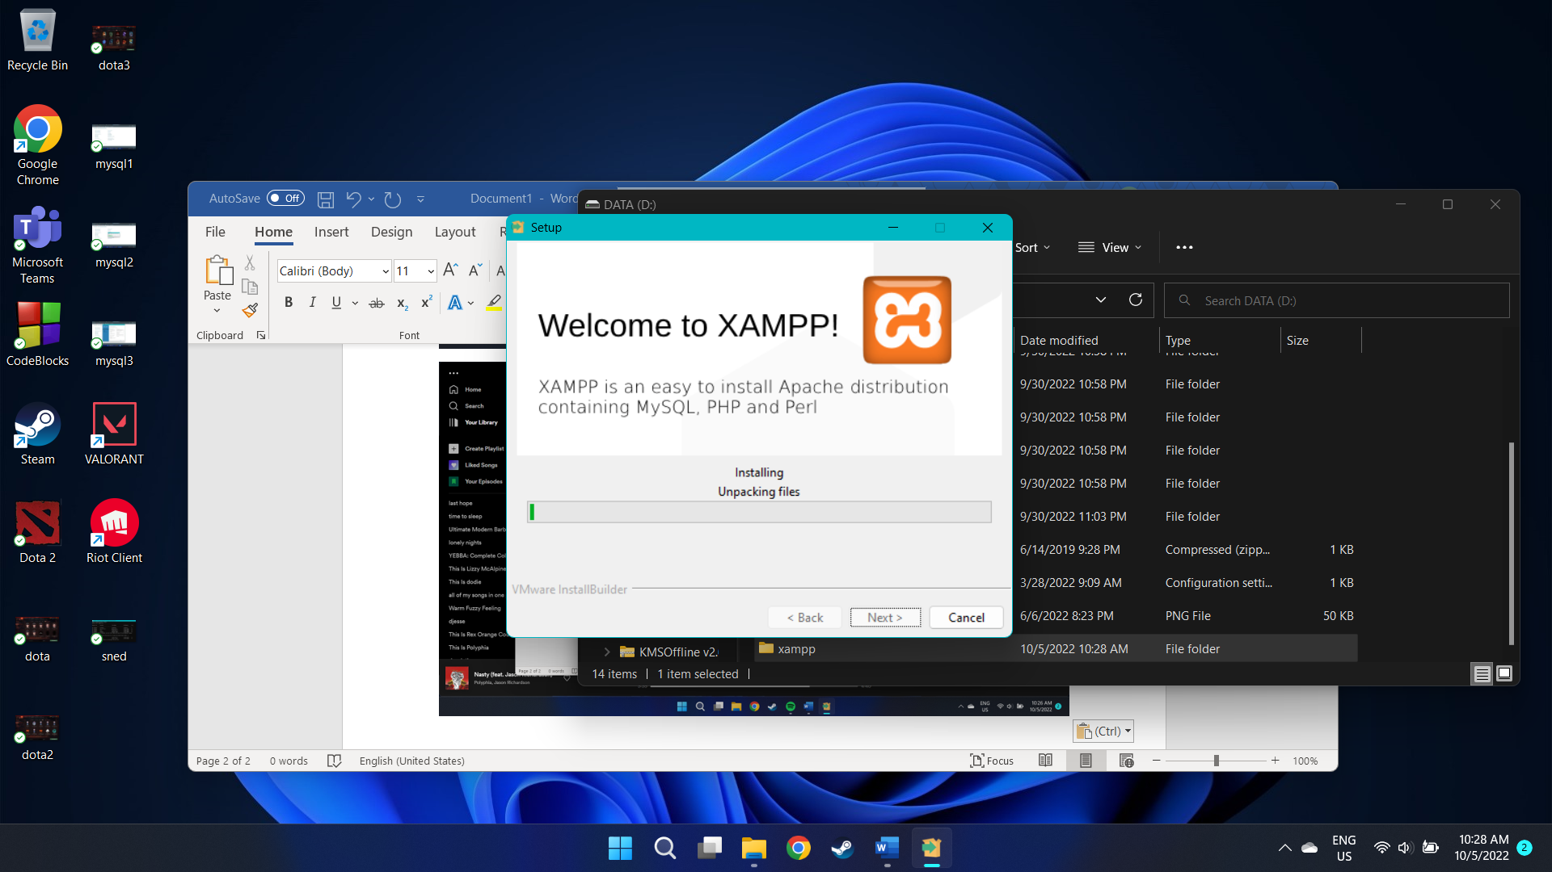

**STEP 5:** Click finish

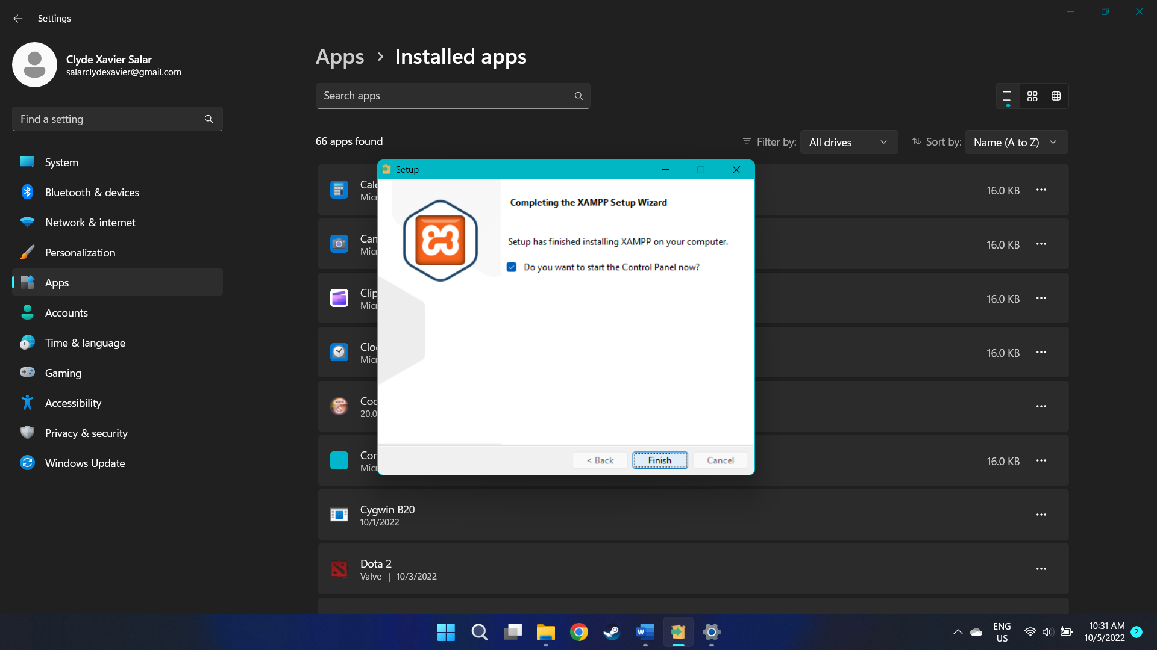

**STEP 6:** Open XAMPP Control Panel

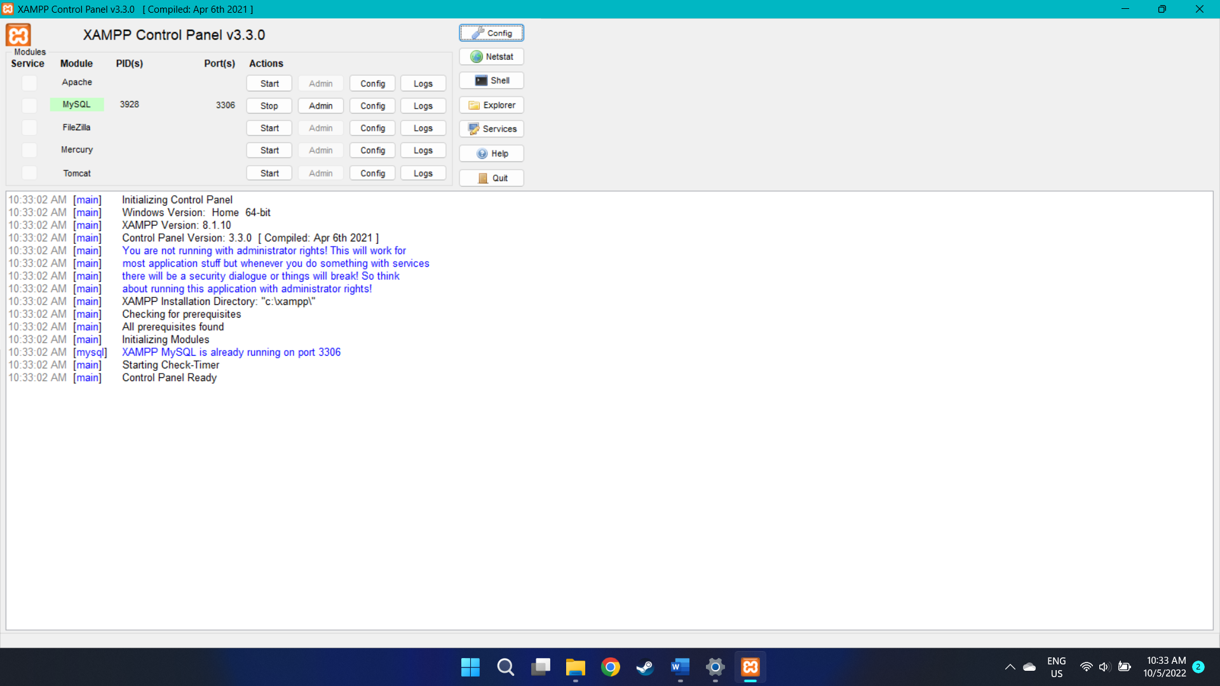

**STEP 7:** Start and Run Apache and MySQL

