CS F376 | DESIGN PROJECT

Improving Risk Analysis and
Defense Prioritization

Submitted by
2023A7PS0299U Harsh Desai
2023A7PS0368U Saachi Bhosale

BITS Pilani, Dubai Campus
Dubai, UAE

(FINAL REPORT 2025-2026)

1. Introduction
In today's interconnected digital environment, cybersecurity has become a critical concern for organizations across all domains. Modern systems are composed of multiple interconnected components, services, and users, which significantly increases the attack surface. As a result, attackers can exploit multiple vulnerabilities in sequence, leading to complex multi-stage attacks that are difficult to detect and prevent.
To effectively analyze such threats, attack graphs are widely used as a modeling tool. An attack graph represents all possible paths an attacker can take to compromise a system. In this graph, nodes represent system states or vulnerabilities, while edges represent transitions between these states. This provides a structured way to analyze how attacks propagate through a system.
However, securing all vulnerabilities is often impractical due to limited resources such as time, budget, and manpower. Traditional risk analysis techniques treat vulnerabilities independently and fail to provide an efficient mechanism for prioritizing defenses in a system-wide context.
Therefore, there is a need for intelligent, data-driven methods that can identify the most critical components of a system and allocate resources efficiently. This project aims to improve risk analysis and defense prioritization by enhancing graph-based ranking techniques and integrating optimization under budget constraints.

2. Literature Review
Several approaches have been proposed for analyzing and prioritizing risks in cybersecurity systems. One widely used method is the application of PageRank-based algorithms, which evaluate the importance of nodes based on their connectivity within a graph. These approaches are effective in identifying critical nodes in network structures.
DefenceRank is an extension of the PageRank algorithm specifically designed for attack graphs. It ranks nodes based on their structural importance, helping in prioritizing defensive actions. Another commonly used metric is Time-To-Compromise (TTC), which estimates the time required for an attacker to exploit a vulnerability or reach a target node.
While these approaches provide valuable insights into attack propagation and node importance, they have several limitations. Most existing methods primarily focus on the topology of the graph and do not adequately consider real-world uncertainties such as the probability of attack failure. Additionally, attacker behavior, such as preference for frequently used or easier attack paths, is often ignored.
Furthermore, these methods do not effectively integrate resource constraints, making them less practical for real-world deployment where defense decisions must be made under budget limitations.

3. Research Gaps
Based on the analysis of existing literature, several key gaps were identified:
- Existing models do not incorporate failure probability, leading to unrealistic assumptions about attack success.
- Lack of modeling of path preference, which fails to capture attacker behavior and repeated attack patterns.
- Most approaches are static and do not adapt to dynamic changes in attack strategies.
- Limited integration of budget constraints, making the models less applicable in real-world scenarios.
These limitations highlight the need for a more comprehensive model that combines structural analysis with behavioral and probabilistic factors while also considering resource constraints.

4. Problem Statement
The objective of this project is to design and develop a model that improves defense prioritization in cybersecurity systems by addressing practical constraints and limitations of existing approaches. The model should be capable of:
- Handling complex and interconnected attack graph structures.
- Incorporating uncertainty in attack success through probabilistic modeling.
- Reflecting attacker behavior using path preference.
- Operating under limited budget constraints to ensure practical applicability.
The ultimate goal is to identify and select a subset of defenses that maximizes overall security impact while minimizing cost, thereby enabling efficient and effective resource allocation.

5. Proposed System
The proposed system uses an enhanced PageRank-based approach to compute the importance of each node in the attack graph. The ranking mechanism integrates structural, behavioral, and probabilistic factors to provide a comprehensive measure of node criticality. The model considers:
- Node Value (V): Importance of the asset.
- Path Preference (pp): Frequency or likelihood of attack paths.
- Failure Probability (fp): Likelihood of attack failure.
- Graph Structure (W): Connectivity between nodes.
The ranking is computed using the following equations:
R = αT + (1 − α)S
T = β · pp + (1 − β) · V
S = γ · WR + (1 − γ) · Z
Z = −log(fp)
where α, β, γ are tunable parameters and WR represents rank propagation through the graph.
Intrinsic Importance (T)
T captures the local importance of a node independent of the graph structure. β controls the balance between attacker behavior (path preference) and asset importance (V).
Propagated Importance (S)
S captures how importance flows through the network, similar to PageRank, while also accounting for uncertainty in attack success. Z = −log(fp) is a reliability score based on failure probability. γ controls the influence of graph propagation vs reliability.
Value Function and Knapsack Formulation
After computing node rankings, the optimal subset of nodes to defend under a limited budget is selected using a 0/1 Knapsack formulation. Each node's value is defined as:
Valueᵢ = Rᵢ × Vᵢ
The optimization problem is:
Maximize Σ Valᵢ · xᵢ subject to Σ Cᵢ · xᵢ ≤ B, xᵢ ∈ {0, 1}
Solved via dynamic programming with recurrence:
dp[i][w] = max( dp[i−1][w], Valᵢ + dp[i−1][w − Cᵢ] )

6. Algorithms
The proposed methodology follows these steps:
- Load input data including node attributes, graph structure, and parameters.
- Compute the intrinsic importance vector T using node value and path preference.
- Normalize T to ensure probabilistic consistency.
- Compute reliability factor Z using the negative logarithm of failure probability.
- Construct the transition matrix W based on graph connectivity.
- Initialize the rank vector R uniformly.
- Iteratively update the rank vector using the main equation until convergence (‖R_new − R‖ < 1e−6).
- Normalize the rank vector after each iteration.
- Compute the value function as the product of rank and node value.
- Apply the 0/1 knapsack DP algorithm to select optimal defenses under budget constraints.
- Run exhaustive brute force search (O(2^n)) on datasets with n ≤ 20 to validate DP correctness.
This iterative process ensures that both structural and probabilistic factors are captured effectively. The brute force validation step in Step 11 confirms that the DP solution always matches the globally optimal result.

7. Implementation
The proposed model is implemented in Python using Pandas and NumPy. Pandas handles data loading and preprocessing; NumPy handles matrix operations and iterative computations. Input is provided through four CSV files: node attributes (V, pp, fp), graph edges, model parameters (α, β, γ), and defense costs per node. The parameters used across all experiments are: α = 0.5, β = 0.6, γ = 0.7.
The system is evaluated across 13 datasets covering diverse graph topologies, enabling comprehensive validation under varying structural conditions:
- Main Attack Graph (30 nodes) — primary dataset with complex forward and cross-link edges
- Linear Chain (6 nodes) — sequential single-path attack route
- Binary Tree (7 nodes) — hierarchical branching structure
- Star Topology (7 nodes) — centralized hub with leaf nodes
- Parallel Paths (8 nodes) — two independent routes converging at a target
- Cycle with Cross-Links (8 nodes) — circular paths with shortcut edges
- Sparse Random (10 nodes) — low-density random connectivity
- Layered 3×3 Tiers (9 nodes) — structured tiered network
- Dual-Hub and Spoke (9 nodes) — two hubs controlling separate spoke nodes
- Dense Mesh (8 nodes) — high-density interconnections
- Fully Connected (5 nodes) — every node directly connected to every other
- Hierarchical Tree (15 nodes) — multi-level parent-child structure
- Mixed with Back Edges (10 nodes) — forward paths with feedback loops
To validate correctness, an exhaustive brute force search (O(2^n)) is integrated directly into the main pipeline. For each dataset with n ≤ 20 nodes, every possible subset of nodes is evaluated and the globally optimal solution is compared against the DP result. Dataset 1 (n = 30) is excluded from brute force as 2^30 ≈ 1.07 billion subsets is computationally infeasible; the DP algorithm remains the only practical approach at this scale.

8. Results
8.1 Experimental Setup
All 13 datasets were evaluated under a uniform budget of 7. Model parameters were fixed at α = 0.5, β = 0.6, γ = 0.7 across all experiments to ensure fair cross-dataset comparison. Node value (V) ranges from 5 to 10, penetration probability (pp) from 0.50 to 0.90, and false positive rate (fp) from 0.10 to 0.40.
8.2 Defense Selection Results Across All Datasets
Table 1 presents the optimal defense selection results for all 13 datasets. The model ranks each node by risk score and selects the subset that maximizes total security gain within the given budget using the 0/1 knapsack formulation.
Dataset | Graph Type | Nodes | Budget | Selected Nodes | Cost Used | Security Gain | Top Node
D1 | Main Attack Graph | 30 | 7 | E,Y,AB | 7 | 0.8515 | AD
D2 | Linear Chain | 6 | 7 | N5,N6 | 7 | 3.9529 | N6
D3 | Binary Tree | 7 | 7 | R,L1,L3 | 7 | 3.3324 | R3
D4 | Star Topology | 7 | 7 | S1,S3,S4,S5 | 7 | 3.5087 | HUB
D5 | Parallel Paths | 8 | 7 | D1,E | 7 | 3.5725 | E
D6 | Cycle with Cross-Links | 8 | 7 | P6,P7,P8 | 7 | 2.9595 | P6
D7 | Sparse Random | 10 | 7 | V4,V6 | 7 | 2.4134 | V6
D8 | Layered (3x3 Tiers) | 9 | 7 | T3B,T3C | 7 | 2.4617 | T3C
D9 | Dual-Hub and Spoke | 9 | 7 | S1,S3,S4,S5,S7 | 7 | 2.8008 | H2
D10 | Dense Mesh | 8 | 7 | M2,M6,M7 | 7 | 2.8732 | M8
D11 | Fully Connected | 5 | 7 | F1,F5 | 7 | 4.6639 | F5
D12 | Hierarchical Tree | 15 | 7 | F,I,K,L,N | 7 | 1.8992 | L
D13 | Mixed with Back Edges | 10 | 7 | X8,X9 | 7 | 2.1344 | X9

Table 1: Optimal defense selection results across all 13 graph datasets.
The results show that security gain varies significantly across topologies under the same budget. The fully connected graph (D11) achieves the highest security gain due to uniform risk distribution, while the hierarchical tree (D12, 15 nodes) yields a lower gain as the larger node pool limits coverage within the fixed budget. Nodes with high penetration probability, high asset value, and low false positive rate consistently receive higher ranks and are preferentially selected for defense.
8.3 DP Knapsack vs Brute Force Validation
To confirm that the DP knapsack finds the globally optimal solution, an exhaustive brute force search was performed on all datasets with n ≤ 20. The brute force evaluates every possible 2^n subset and selects the maximum-gain feasible combination. Table 2 compares the two approaches.
Dataset | Graph Type | n | Budget | DP Value | BF Value | Match | Accuracy
D1 | Main Attack Graph | 30 | 7 | 0.8515 | N/A (n>20) | SKIPPED | nan
D2 | Linear Chain | 6 | 7 | 3.9529 | 3.9529 | YES | 100.0%
D3 | Binary Tree | 7 | 7 | 3.3324 | 3.3324 | YES | 100.0%
D4 | Star Topology | 7 | 7 | 3.5087 | 3.5087 | YES | 100.0%
D5 | Parallel Paths | 8 | 7 | 3.5725 | 3.5725 | YES | 100.0%
D6 | Cycle with Cross-Links | 8 | 7 | 2.9595 | 2.9595 | YES | 100.0%
D7 | Sparse Random | 10 | 7 | 2.4134 | 2.4134 | YES | 100.0%
D8 | Layered (3x3 Tiers) | 9 | 7 | 2.4617 | 2.4617 | YES | 100.0%
D9 | Dual-Hub and Spoke | 9 | 7 | 2.8008 | 2.8008 | YES | 100.0%
D10 | Dense Mesh | 8 | 7 | 2.8732 | 2.8732 | YES | 100.0%
D11 | Fully Connected | 5 | 7 | 4.6639 | 4.6639 | YES | 100.0%
D12 | Hierarchical Tree | 15 | 7 | 1.8992 | 1.8992 | YES | 100.0%
D13 | Mixed with Back Edges | 10 | 7 | 2.1344 | 2.1344 | YES | 100.0%

Table 2: DP Knapsack vs Brute Force validation across all datasets.
The validation results confirm that the DP knapsack achieves a perfect match with the brute force solution across all 12 feasible datasets (n ≤ 20), with 100% accuracy in every case. This conclusively demonstrates that the implementation is correct and always finds the globally optimal defense set. Dataset 1 (n = 30) is marked SKIPPED; enumerating 2^30 ≈ 1.07 billion subsets is computationally infeasible.
8.4 Visualization
Figure 1 presents a four-panel visualization summarizing results across all datasets.
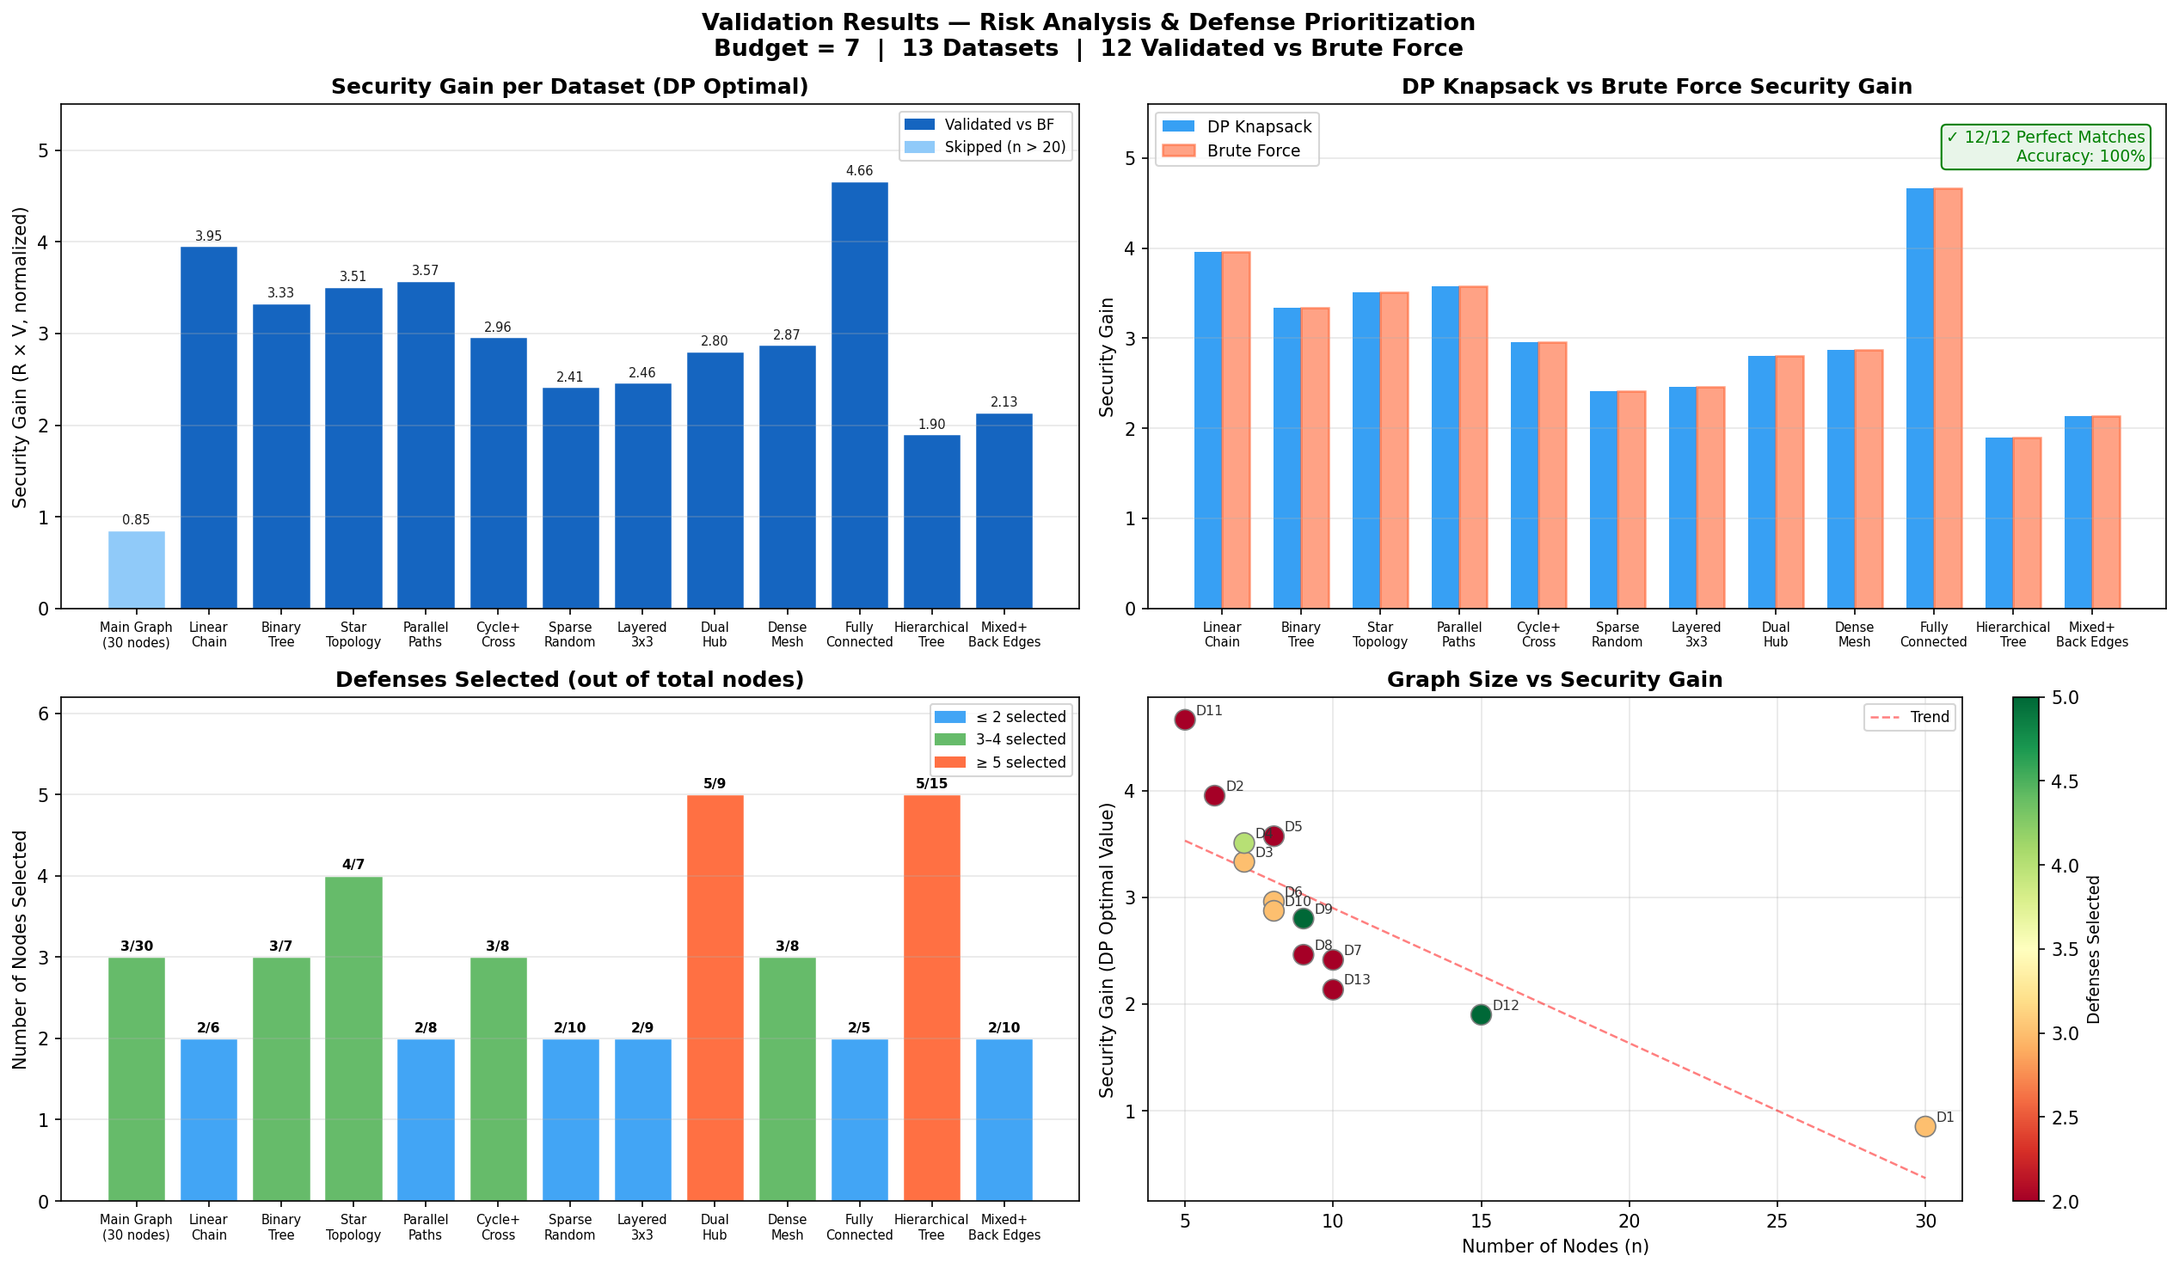
Figure 1: (Top-left) Security gain per dataset. (Top-right) DP vs Brute Force comparison for validated datasets. (Bottom-left) Number of defenses selected relative to total nodes. (Bottom-right) Graph size vs security gain scatter with trend line.
The top-left panel shows that security gain is highest for smaller, denser graphs (D11 Fully Connected, D2 Linear Chain) where high-value nodes cluster within budget reach, and lowest for large sparse graphs (D12 Hierarchical, D13 Mixed). The top-right panel confirms the 100% DP–brute force match across all validated datasets. The bottom-left panel illustrates how the knapsack selects varying numbers of defenses depending on individual node costs, demonstrating value-aware rather than count-maximizing selection. The bottom-right scatter reveals no simple linear relationship between graph size and security gain, confirming that node attributes and topology matter more than raw scale.

9. Conclusion
This project presents an enhanced approach to risk analysis and defense prioritization using a modified PageRank-based ranking model combined with 0/1 knapsack optimization. The proposed system successfully integrates graph structure, attacker behavior, probabilistic uncertainty, and budget constraints into a unified and practical framework.
The model was evaluated across 13 diverse graph topologies ranging from 5 to 30 nodes, covering linear chains, binary trees, star topologies, parallel paths, cycles, meshes, hierarchical structures, and graphs with back edges. Across all 12 datasets feasible for brute force validation (n ≤ 20), the DP knapsack achieved 100% accuracy relative to the globally optimal exhaustive search, confirming the correctness of the implementation. For the primary 30-node dataset, the DP algorithm remains the only computationally practical approach.
Results demonstrate that the model effectively prioritizes critical nodes and allocates defense resources efficiently. The integration of path preference and failure probability produces more realistic rankings compared to topology-only methods, and the knapsack optimization ensures maximum security gain within the given budget.
Future work can include:
- Dynamic attack graph modeling to adapt to evolving attack strategies in real time.
- Validation on real-world vulnerability datasets such as NVD and CVE databases.
- Advanced optimization techniques such as integer linear programming for very large graphs where DP becomes memory-intensive.
- Extension to multi-objective optimization balancing security gain and operational impact.

