**Bollywood Movies That Redefined Indian Cinema: A Look at Groundbreaking Storytelling and Cinematic Techniques**

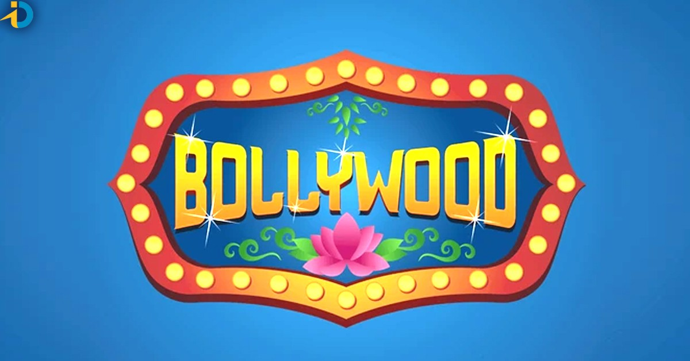

Bollywood, the largest film industry in India, has seen tremendous growth over the years, producing thousands of films that capture the rich culture and diverse stories of the nation. While many [bollywood movies](https://www.bwcinema.com/Blog/GetBlogs) have entertained audiences with their grandeur, there are a select few that have truly redefined the landscape of Indian cinema. These films have pushed the boundaries of storytelling, visual aesthetics, and cinematic techniques, making an indelible impact on both Indian and global cinema. Let's take a look at some of these groundbreaking films that have set new standards.

### ****1. Sholay (1975): A Game Changer in Storytelling and Action****

Released in 1975, Sholay is a cult classic that revolutionized the Indian film industry. Directed by Ramesh Sippy, this epic film combined the genres of action, drama, and adventure, breaking new ground with its gripping narrative and memorable characters. The film’s portrayal of friendship, revenge, and villainy became a template for future Bollywood films.

**Groundbreaking Aspects:**

* **Strong Characterization**: The characters of Jai, Veeru, and the iconic villain Gabbar Singh became immortalized in Indian cinema.
* **Action Sequences**: Sholay brought unprecedented action scenes to Indian audiences, with large-scale battle sequences and high tension moments.
* **Music and Dialogue**: The unforgettable dialogues and the music by R.D. Burman contributed to the film’s lasting influence.

### ****2. Mother India (1957): A Monumental Leap in Cinematic Expression****

Directed by Mehboob Khan, Mother India was not just a film but a monumental statement about Indian values, sacrifices, and the strength of a mother. This film marked a significant shift from the melodramatic style of earlier Indian cinema to a more socially conscious, realistic approach.

**Groundbreaking Aspects:**

* **Social Commentary**: The film explored themes of poverty, rural life, and the strength of women, all while addressing the post-independence struggles.
* **Epic Cinematic Scale**: With its grand sets and intense emotional scenes, Mother India was one of the first Bollywood films to be nominated for an Academy Award.
* **Influence on Bollywood**: It set the foundation for Bollywood films that combined melodrama with social and political messages.

### ****3. Dilwale Dulhania Le Jayenge (1995): Changing the Romance Genre Forever****

A true game-changer in terms of romantic storytelling, Dilwale Dulhania Le Jayenge (DDLJ) became a cultural phenomenon. Directed by Aditya Chopra, the film broke away from the traditional love stories and created a new benchmark in romantic filmmaking in India.

**Groundbreaking Aspects:**

* **Global Appeal**: The film was one of the first Bollywood films to reach international markets, especially in the UK and the US.
* **Realistic Romance**: DDLJ redefined romance in Bollywood by depicting a more relatable, realistic love story, focusing on cultural assimilation and family values.
* **Memorable Music and Iconic Scenes**: Songs like “Tujhe Dekha Toh” and the iconic “palat” scene became immortal in the hearts of fans.

### ****4. Lagaan (2001): A Blend of Indian History and Sport****

Directed by Ashutosh Gowariker, Lagaan took a bold leap by blending historical drama with the sport of cricket, set in British colonial India. This film not only redefined Bollywood’s approach to period cinema but also elevated Indian cinema on the global stage.

**Groundbreaking Aspects:**

* **Historical Narrative with a Modern Twist**: Lagaan presented a historic tale of resistance through an underdog sports story, which was both unique and powerful.
* **International Recognition**: Nominated for an Academy Award for Best Foreign Language Film, Lagaan introduced Indian cinema to international audiences.
* **Music and Dance**: The soundtrack by A.R. Rahman became one of Bollywood's finest, with songs that enhanced the film’s emotional impact.

### ****5. Rang De Basanti (2006): Revolutionizing Political Cinema****

Directed by Rakeysh Omprakash Mehra, Rang De Basanti redefined political filmmaking in Bollywood. It explored themes of youth, revolution, and patriotism, resonating strongly with the younger generation of India.

**Groundbreaking Aspects:**

* **Youth-Centric Narrative**: The film used the backdrop of contemporary India to connect with today’s youth, encouraging them to engage with national issues.
* **Blending of History and Modern-Day Events**: By juxtaposing the story of freedom fighters with modern-day students, the film effectively bridged the gap between past and present.
* **Influence on Society**: Rang De Basanti sparked a wave of political awareness among the youth and is often credited with inspiring the youth protests of the mid-2000s.

### ****6. Gully Boy (2019): The Rise of Hip-Hop and Urban India****

Gully Boy, directed by Zoya Akhtar, was a cultural milestone in Indian cinema, highlighting the underground rap scene in Mumbai. The film explored the struggles of a young man aspiring to make it as a rapper, breaking stereotypes about music and class.

**Groundbreaking Aspects:**

* **New Genre**: The movie brought hip-hop music to the forefront of Bollywood and showed how the genre can be used to express social issues and personal struggles.
* **Representation of Urban India**: Gully Boy gave a voice to the urban youth, depicting the struggles of the working class in a way that hadn’t been done before.
* **Music and Lyrics**: The film’s music, composed by Dub Sharma and Divine, became a massive hit and revolutionized the role of music in Bollywood films.

### ****7. Barfi! (2012): A Visual Feast with Minimal Dialogue****

Anurag Basu’s Barfi! was a visual and emotional masterpiece that told the story of love between a deaf-mute man and an autistic woman. The film’s use of minimal dialogue, along with brilliant cinematography, made it stand out in an industry often dominated by sound and melodrama.

**Groundbreaking Aspects:**

* **Unique Storytelling**: Barfi! used limited dialogue and relied heavily on visual storytelling, which was a bold choice in mainstream Bollywood cinema.
* **Focus on Differently Abled Characters**: The film sensitively portrayed characters with disabilities, breaking stereotypes and showcasing their humanity.
* **Cinematography and Music**: The film’s cinematography, led by Ravi Varman, captured the beauty of the landscapes, while Pritam’s music added to the emotional depth of the story.

### ****Conclusion: A Legacy of Innovation****

These films represent just a fraction of the cinematic milestones in Bollywood that have reshaped how stories are told, how characters are portrayed, and how films are crafted. From larger-than-life epics to intimate, character-driven narratives, Bollywood movies continue to evolve and innovate, captivating audiences around the world. As filmmakers continue to experiment with new storytelling techniques and explore fresh themes, we can only imagine what the future of Indian cinema holds. Bollywood’s journey of groundbreaking cinema is far from over, and its impact will undoubtedly resonate for years to come.

Explore more insightful articles on Bollywood cinema and stay updated with the latest trends at [BWCinema](https://www.bwcinema.com/Blog/GetBlogs).