**Exploring the Evolution of Hindi Movies Online: From Classics to Contemporary Hits**

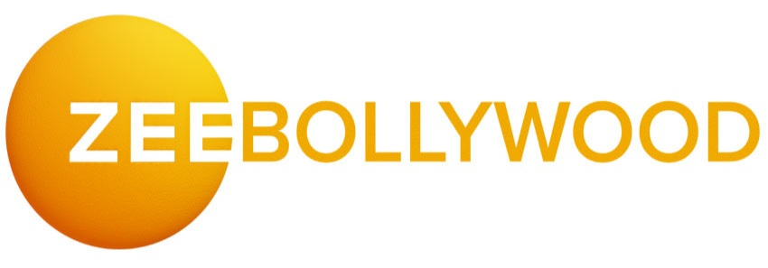

Hindi cinema, often referred to as Bollywood, has always been a significant part of India's cultural fabric. Over the decades, it has evolved dramatically, adapting to changes in technology, audience preferences, and global trends [hindi movies online](https://www.bwcinema.com/Movies/AllMovies). One of the most significant changes in recent years is the transition of Hindi movies from traditional cinema halls to online streaming platforms. In this article, we will explore the evolution of Hindi movies, focusing on the journey from classics to contemporary hits, and how the online medium has played a pivotal role in this transformation.

### ****The Golden Era of Hindi Cinema: A Glimpse into the Classics****

In the early years of Hindi cinema, the industry produced a series of classic films that are still regarded as masterpieces. The 1950s to the 1970s is often considered the Golden Era of Hindi movies. Films like Mughal-e-Azam (1960), Sholay (1975), and Mother India (1957) set the benchmark for storytelling, performances, and cinematic grandeur. These films were characterized by larger-than-life narratives, intense emotional drama, and iconic music.

During this time, the cinema was primarily consumed in movie theaters, and audiences eagerly awaited the release of their favorite stars' films. The connection between filmgoers and Hindi cinema was deeply rooted in the theater-going experience. While the internet was non-existent during this era, these films found a place in the hearts of generations, and their legacy continues to inspire filmmakers and actors today.

### ****The 80s and 90s: The Rise of Mass Appeal****

The 1980s and 1990s marked a shift in Hindi cinema, as it moved towards more commercially viable and mass-appealing films. The influence of action-packed storylines, romance, and family drama grew during this period. Iconic stars such as Amitabh Bachchan, Shah Rukh Khan, and Aamir Khan emerged, and their films became synonymous with Hindi cinema. Movies like DilwaleDulhania Le Jayenge (1995), Baazigar (1992), and Lagaan (2001) were not only massive hits but also introduced global audiences to Hindi cinema.

The 90s also witnessed the rise of melodious music and the prevalence of big-budget productions that brought spectacle to the screen. This era saw Hindi cinema reaching a broader audience, not only in India but also in the Indian diaspora abroad. As a result, it laid the foundation for the digital revolution that would follow in the 2000s.

### ****The Digital Revolution: The Impact of Online Platforms****

As technology advanced, so did the way audiences consumed movies. The 2000s and 2010s brought the digital revolution, changing the way films were made and distributed. The rise of online streaming platforms like Netflix, Amazon Prime Video, and Disney+ Hotstar has completely transformed the Hindi movie industry.

Today, online platforms provide Hindi movie lovers with easy access to a vast library of films, spanning all genres and decades. Movies that were once only available in theaters or on DVDs are now just a click away, enabling viewers to watch their favorite films from the comfort of their homes. This accessibility has opened up Hindi cinema to a global audience, breaking language barriers and allowing non-Hindi speakers to enjoy films with subtitles.

Moreover, streaming platforms have changed the way films are made. With the demand for content at an all-time high, producers are now able to reach a wider audience with a diverse range of movies. The success of online platforms has encouraged filmmakers to experiment with unconventional storylines, alternative genres, and lesser-known actors, creating a more inclusive and innovative landscape for Hindi cinema.

### ****Contemporary Hits: A New Era of Storytelling****

In recent years, Hindi cinema has witnessed a shift towards more realistic and socially relevant storytelling. Films like Gully Boy (2019), Andhadhun (2018), and Dangal (2016) reflect a growing trend towards more meaningful narratives that tackle complex issues such as identity, class struggle, and mental health. This evolution has been fueled by the increasing availability of online content, where filmmakers are no longer confined by traditional theatrical formulas.

Contemporary hits have also embraced the digital space, with films like Ludo (2020) and Article 15 (2019) being released directly on streaming platforms. This shift to digital-first releases has proven successful, as audiences are no longer limited by time and location constraints. Movies are now easily accessible on-demand, enabling viewers to watch a wide variety of films at their convenience.

In addition to the changing nature of the content, the visual appeal of modern-day Hindi films has evolved with advancements in technology. From the use of CGI to realistic action sequences and stunning cinematography, Hindi films today offer a visually immersive experience that rivals global cinema.

### ****The Future of Hindi Cinema Online****

Looking ahead, the future of Hindi cinema seems brighter than ever, thanks to the growing popularity of online streaming. With increased competition in the digital space, platforms are constantly looking to offer fresh, innovative content that attracts audiences. This has resulted in a surge of talent coming from diverse backgrounds, offering fresh perspectives and new ideas.

The increasing popularity of regional cinema and niche genres is also worth noting. While Bollywood has traditionally dominated the Hindi movie industry, films in various regional languages are now being showcased on streaming platforms, making them accessible to a global audience. This has paved the way for a more inclusive film industry, where stories from different parts of India and the world can be told in their original forms.

### ****Conclusion****

From the golden era of classics to the mass-appeal films of the 80s and 90s, and now the modern-day hits streaming online, Hindi cinema has undergone a remarkable transformation. The digital revolution has not only reshaped how films are consumed but has also influenced the types of films being made. With online platforms offering endless possibilities for both filmmakers and audiences, the future of Hindi cinema looks more exciting than ever.

For those who want to dive into this vast world of evolving Hindi cinema, there’s no better place to start than with streaming platforms like [BW Cinema](https://www.bwcinema.com/Movies/AllMovies), where you can explore a diverse range of films from all eras of Hindi cinema. Whether you're a fan of classics or contemporary hits, the world of Hindi movies is at your fingertips.