Software Design Specifications

[Project Title]

Version: [xx.xx]

Project Code | CarShowroomRental  Management
Supervisor | MISS MAHRUKH KHAN
Co Supervisor
Project Team
Submission Date

[Instructions]
- No section of template should be deleted. You can write ‘Not applicable’ if a section is not applicable to your project. But all sections must exist in the final document.
- All comments/examples mentioned in square brackets ([]) are in the template for explanation purposes and must be replaced / removed in final document.
- This’ Instruction’ section should also be removed in final document.
- MS-Word Reviewing feature must be used to get the document reviewed by PMs or supervisors.

Document History
[Revision history will be maintained to keep a track of changes done by anyone in the document.]
Version | Name of Person | Date | Description of change
 |  |  | [e.g. Document Created]
 |  |  | [Added Non-functional requirements]
 |  |  | [Added UseCase x.x.xx]

Distribution List
[Following table will contain list of people whom the document will be distributed after every sign-off]

Name | Role
Miss Mahrukh | Supervisor
 | Co Supervisor

Document Sign-Off
[Following table will contain sign-off details of document. Once the document is prepared and revised, this should be signed-off by the sign-off authority.
Any subsequent changes in the document after the first sign-off should again get a formal sign-off by the authorities.]

Version | Sign-off Authority | Project Role | Signature | Sign-off Date

Document Information

Category | Information
Customer | FAST-NU
Project | Car Showroom Retal Managment
Document | Software Design Specification
Document Version | 1.0
Status | Draft
Author(s) | <Names of all the authors of this document>
Approver(s)
Issue Date
Document Location
Distribution | Advisor  Project Coordinator’s Office (through Advisor)

Definition of Terms, Acronyms and Abbreviations
[This section should provide the definitions of all terms, acronyms, and abbreviations required to interpret the terms used in the document properly. ]

Term | Description
ASP | Active Server Pages
DD | Design Specification

Table of Contents
1 Introduction 8
1.1 Purpose of Document 8
1.2 Intended Audience 8
1.3 Document Convention 8
1.4 Project Overview 8
1.5 Scope 8
2 Design Considerations 9
2.1 Assumptions and Dependencies 9
2.2 Risks and Volatile Areas 9
3 System Architecture 10
3.1 System Level Architecture 10
3.2 Software Architecture 10
4 Design Strategy 11
5 Detailed System Design 12
5.1 Database Design 12
5.1.1 ER Diagram 12
5.1.2 Data Dictionary 12
5.1.2.1 Data 1 12
5.1.2.2 Data 2 12
5.1.2.3 Data n 12
5.2 Application Design 14
5.2.1 Sequence Diagram 14
5.2.1.1 <Sequence Diagram 1> 14
5.2.1.2 <Sequence Diagram 2> 14
5.2.1.3 <Sequence Diagram n> 14
5.2.2 State Diagram 14
5.2.2.1 <State Diagram 1> 14
5.2.2.2 <State Diagram 2> 14
5.2.2.3 <State Diagram n> 14
6 References 15
7 Appendices 16

Introduction

Purpose of Document
The Vehicle Listings and Inquiry Management System is a comprehensive solution designed to cater to the needs of a car, bike, and 3-wheeler showroom business. It aims to streamline the process of listing, managing, and promoting vehicles, while also providing a seamless experience for customers to interact with the showroom. The system allows users to search, filter, and inquire about vehicles, schedule test drives, and explore financing options for purchasing.
The primary goals of this system include:
Simplifying Vehicle Discovery: Users can easily browse and search for vehicles based on various parameters like type, brand, price, and features.
Streamlining Customer Interaction: The system facilitates direct customer engagement through features like test drive scheduling and inquiries for installment plans.
Efficient Vehicle Management: Admin users can manage vehicle listings, user inquiries, and test drive schedules efficiently, ensuring that the business operates smoothly.
User-Friendly Experience: By leveraging modern web technologies, the system provides a responsive, intuitive interface suitable for a wide range of users, including customers and showroom staff.

Intended Audience
This document is intended for the following audiences:
- Developers: They will use this document to understand the functional and non-functional requirements.
- Project Managers: They will use this for tracking the scope and deliverables.
- Testers: This document will guide the creation of test plans and test cases.
- End Users: Although they are not the primary audience, they should be aware of the intended functionalities described here.
Suggested reading order:
- Begin with the Introduction and Overall Description to understand the product's scope.
- Review External Interface Requirements to understand system interfaces.
Dive into the System Features for detailed requirements

Document Convention
This document uses the following conventions:
- Priority Levels:
  - High: Critical requirements for system functionality.
  - Medium: Important but non-critical features.
  - Low: Desirable but non-essential features.
- Terminology:
  - Vehicle Listings: Collection of available vehicles.
  - Admin User: A user with privileges to manage the system.
Notes: Any assumptions or constraints are highlighted for clarity, such as access to the internet and modern browsers

Project Overview
- The car showroom industry currently faces challenges with manual processes for managing vehicle listings, customer inquiries, and sales. These inefficiencies can lead to errors, delays, and difficulty in tracking inventory and sales performance.
- This project aims to address these issues by developing a digital platform that will automate and streamline operations for car showrooms. The system will enable customers to browse available vehicles, apply filters based on their preferences, inquire about vehicles, and schedule test drives.
By implementing this system, the showroom will be able to improve inventory management, customer interactions, and sales tracking, ultimately enhancing overall business efficiency and customer satisfaction

Scope
The Car showroom rental enables car showroom businesses to manage vehicle listings and customer inquiries. The system facilitates test drive scheduling, user profile management, vehicle favorites, and finance options. It targets car and bike dealerships. The system integrates with a backend using MySQL, ensuring secure and efficient management of data

Design Considerations

Assumptions and Dependencies
- The system will rely on a cloud-based infrastructure for hosting.
- The system assumes users will have access to modern browsers.
- The project depends on third-party payment gateways for installment options

Risks and Volatile Areas
- Changing Requirements: Stakeholders may request new features or modifications during development.
- Technology Updates: Frameworks like ReactJS or Flask may introduce breaking changes.
- Data Privacy Regulations: Legal rules (e.g., GDPR) may change, requiring compliance updates.
- Security Risks: Possible threats from unauthorized access or weak authentication.
- Performance Issues: System may face slowdowns under heavy user load.

Contingency: The system will be built with flexibility and modularity to accommodate such changes efficiently.

System Architecture
The Vehicle Listings and Inquiry Management System is structured using a three-tier architecture model: Presentation Layer, Application Layer (Back-End), and Data Layer. This modular structure ensures scalability, maintainability, and a clear separation of concerns.

System Level Architecture

System Decomposition:
- Front-End (Client): HTML, CSS, JavaScript (Bootstrap used for styling).
- Back-End (Server): Python Flask manages all the business logic and routes.
- Database: MySQL handled via phpMyAdmin.
Component Relationships:
- The client interacts with the Flask back-end via HTTP requests (GET/POST).
- Flask routes these requests to appropriate modules which then interact with the MySQL database for data storage and retrieval.
Interfaces to External Systems:
- May include future payment gateway or SMS/email notification APIs.
Design Considerations:
- Flask app is hosted on a web server.
- Secure authentication mechanisms are implemented.
- Error handling through Flask’s error management system.

Component Diagram:
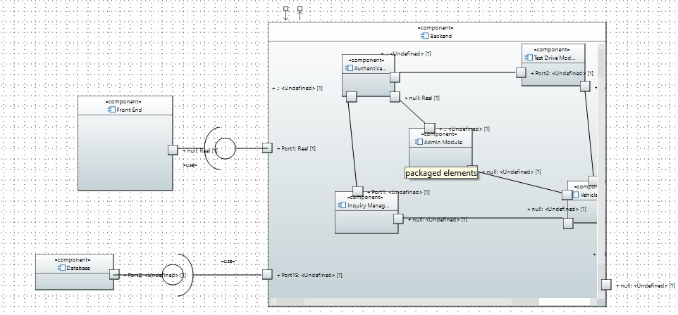

Software Architecture

The software architecture follows a three-tier layered model:
- User Interface Layer (Frontend)
  - Developed using HTML, CSS, Bootstrap, JavaScript.
  - Allows users to browse vehicles, apply filters, send inquiries, and book test drives.
- Middle Tier (Flask App - Business Logic Layer)
  - Handles request processing, form validation, session handling, and business rules.
  - Routes manage user interactions and interface with the database layer.
- Data Access Layer (MySQL)
  - Stores data related to vehicles, users, test drive bookings, and inquiries.
  - CRUD operations are performed via Flask’s MySQL connector.

Deployment Diagram:
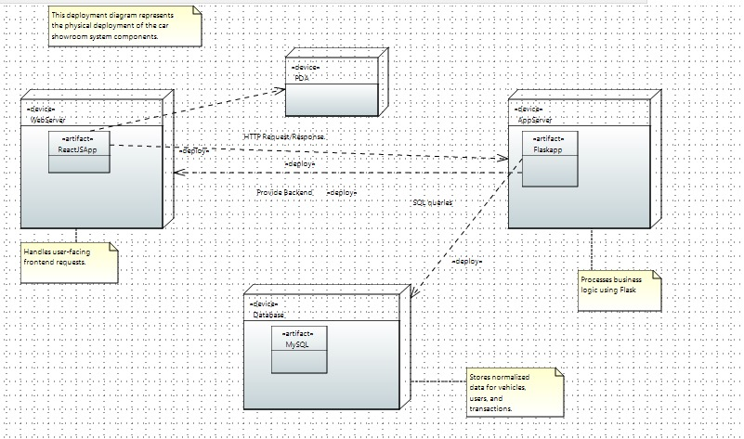

Design Strategy
The system is designed with modularity, scalability, and user-friendliness in mind. A three-tier architecture separates concerns across presentation, logic, and data layers. This not only simplifies development and maintenance but also ensures the system can evolve over time without significant structural changes.
Key Design Considerations:
- Future System Extension or Enhancement
The system uses a modular design with clear separation of front-end, back-end, and database logic. This allows easy integration of new features such as online payments, chat support, or recommendation engines without restructuring the core system.
- System Reuse
Reusable components like vehicle cards, inquiry forms, and admin dashboards are developed as independent modules in ReactJS. Backend utility functions (e.g., for authentication, filtering, and database access) are kept generic for reuse across different routes and services.
- User Interface Paradigm
The system follows a responsive web design approach using Bootstrap and ReactJS to provide a consistent experience across desktop and mobile platforms. Interfaces are kept intuitive and visually clean, catering to both customers and admin users.
- Data Management (Storage & Persistence)
MySQL is used for structured, relational data storage. Normalization up to BCNF ensures minimal redundancy and better data integrity. Data persistence is ensured with proper backup and restore mechanisms, and user data is encrypted where necessary.
- Concurrency and Synchronization
Flask handles concurrent requests through threaded request handling. Admin-level operations (e.g., editing vehicle listings) are synchronized using locks or transaction control where needed to prevent race conditions and ensure data consistency.
Trade-offs:
While ReactJS provides an interactive front-end, it increases the complexity of state management compared to simpler HTML/CSS. Flask is lightweight but may need to be replaced with a more robust framework (like Django) in future if traffic or complexity grows.

Detailed System Design

Database Design

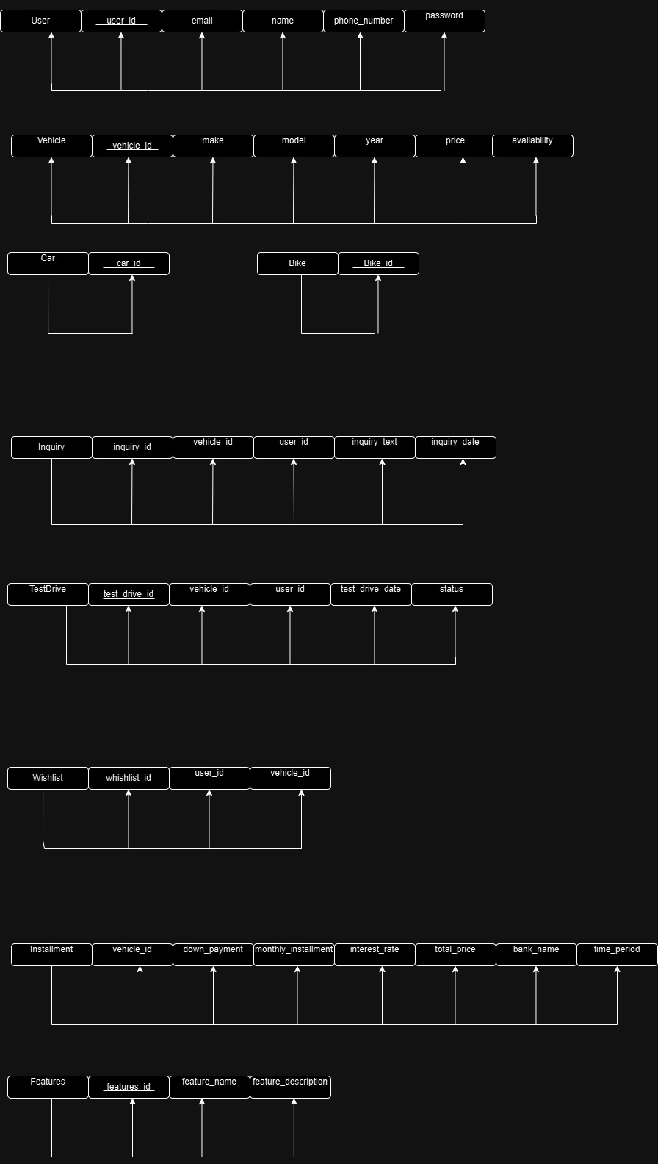

ER Diagram
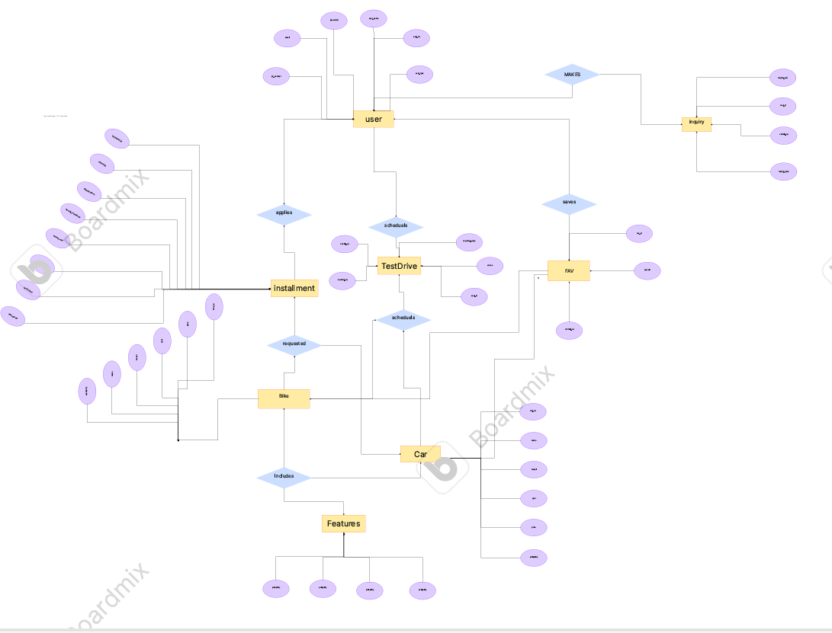

Data Dictionary

Data 1: Vehicle
Field Name | Description | Data Type | Constraints
vehicle_id | Unique identifier for the vehicle | INT | Primary Key, Auto Increment
make | Manufacturer of the vehicle | VARCHAR(50) | Not Null
model | Model of the vehicle | VARCHAR(50) | Not Null
year | Manufacturing year | INT | Must be ≥ 2000
price | Listed price | DECIMAL(10,2) | Not Null
fuel_type | Type of fuel used (e.g., petrol, diesel) | VARCHAR(20) | Not Null
transmission | Manual or Automatic | VARCHAR(20) | Not Null
mileage | Distance covered by the vehicle (in km) | INT | Optional
availability_status | Whether the vehicle is available or sold | VARCHAR(20) | Default = 'Available'

Data 2: User
Field Name | Description | Data Type | Constraints
user_id | Unique user identifier | INT | Primary Key, Auto Increment
name | Full name of the user | VARCHAR(100) | Not Null
email | User’s email address | VARCHAR(100) | Unique, Not Null
password_hash | Hashed password for secure login | VARCHAR(255) | Not Null
phone_number | Contact number | VARCHAR(15) | Optional
user_type | 'Admin' or 'Customer' | VARCHAR(20) | Not Null

Application Design

<Sequence Diagram 1>

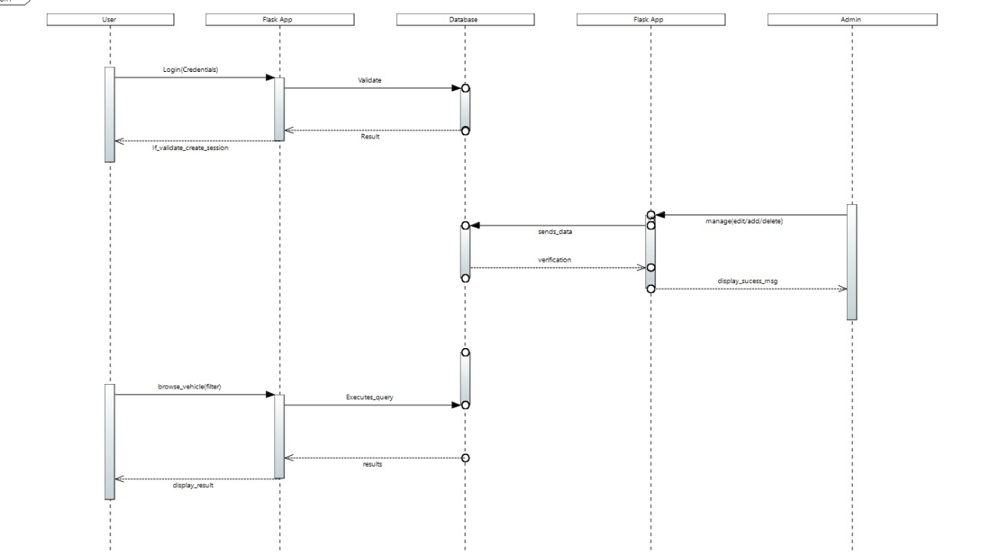<Sequence Diagram 2>
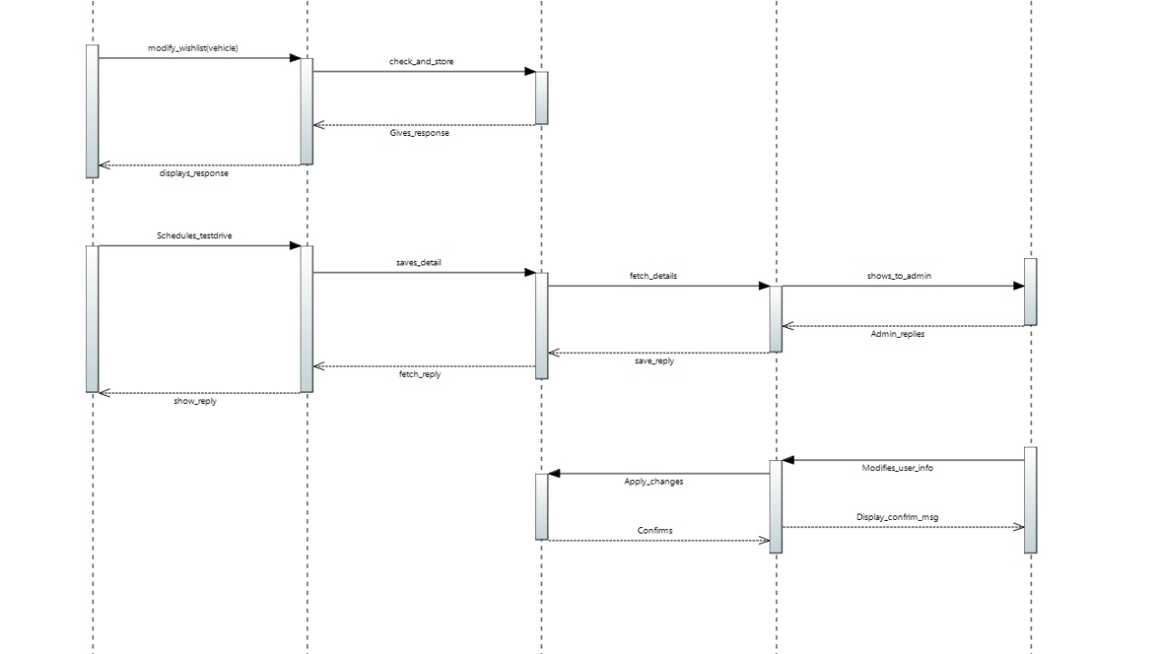.
.

<Sequence Diagram 3>
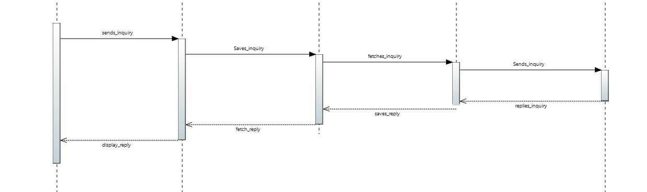

State Diagram

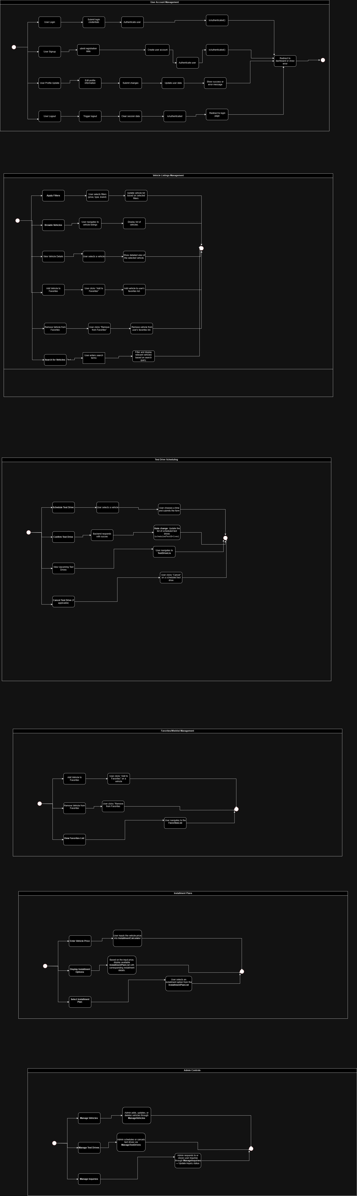

Activity Diagram:

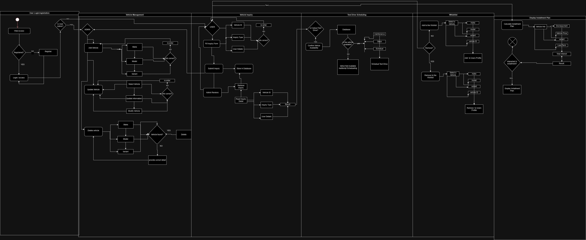

References
The following documents are referenced in the development of the Vehicle Listings and Inquiry Management System:
- Flask Documentation
  - Title: Flask Documentation
  - Date: Ongoing updates
  - Publisher: Pallets Projects
  - Source: https://flask.palletsprojects.com
- PHPMyAdmin Documentation
  - Title: PHPMyAdmin Documentation
  - Date: Ongoing updates
  - Publisher: PHPMyAdmin
  - Source: https://www.phpmyadmin.net/docs/
- Bootstrap Documentation
  - Title: Bootstrap Documentation
  - Date: Ongoing updates
  - Publisher: Bootstrap
  - Source: https://getbootstrap.com/docs/
- MDN Web Docs - HTML/CSS/JavaScript
  - Title: HTML, CSS, JavaScript MDN Docs
  - Date: Ongoing updates
  - Publisher: Mozilla
  - Source: https://developer.mozilla.org/
- General Data Protection Regulation (GDPR) Guidelines
  - Title: GDPR Compliance Guidelines
  - Date: May 2018
  - Publisher: European Commission
  - Source: https://gdpr.eu

6 Appendices
- Admin: A user with privileges to manage the system's data, including vehicle listings, user accounts, and financial details.
- Vehicle Listing: A collection of vehicles available for browsing and purchase on the showroom platform. This includes detailed information such as specifications, price, and availability.
- Test Drive: A scheduled event where a customer can experience a vehicle firsthand before deciding to purchase it.
- User: A registered or guest individual who interacts with the system to browse vehicles, schedule test drives, or inquire about installment options.
- Finance Inquiry: A request made by a user to learn about installment plans or financial details for purchasing a vehicle.
- Favorites/Wishlist: A feature that allows users to save vehicles they are interested in for easy access later.
- Installment Plan: A financial arrangement that enables users to pay for a vehicle in periodic payments rather than a single lump sum.
- Database Normalization: The process of organizing data to minimize redundancy and ensure data integrity, implemented up to Boyce-Codd Normal Form (BCNF) in this project.
- SQL: Structured Query Language, used for managing and querying the MySQL database.
- CRUD Operations: Basic database operations — Create, Read, Update, and Delete — used for managing data in the system.
- Responsive Design: A design approach ensuring the system is usable across different devices, including desktops, tablets, and smartphones.
- Encryption: A security measure that converts sensitive information into unreadable formats to prevent unauthorized access during data transmission.
- Features Management: The ability for admins to add, update, or delete vehicle-specific features displayed on listings.
User Profile Management: A feature allowing users to update personal information, view their activity, and track interactions with the system

