عند تحميل برامج على الاوبونتو يجب فتح terminal وكتابة الامر التالى بها

sudo apt install ثم نكتب اسم البرنامج

المحاضرة يوم الاثنين

التعامل مع الفيجول استيديو و terminal and github.com

putty يستخدم لتنفيذ برامج الويندوز على الاوبونتو

**ls** **تعرض** معلومات النظام و الملفات الموجودة به

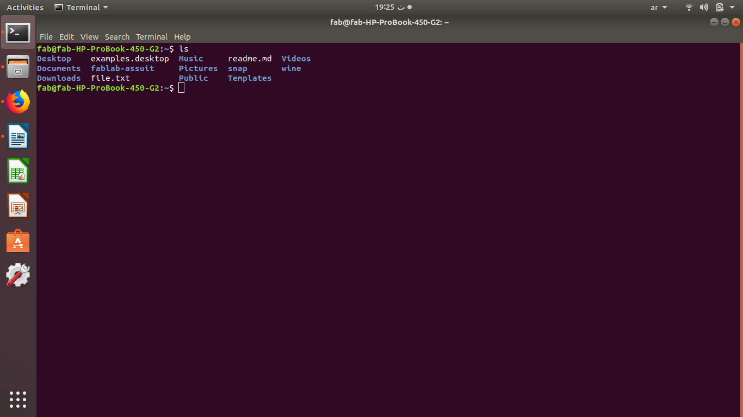

**clear** يستخدم **لحذف** كل الاوامر السابقة

**pwd** لمعرفى **مكان الصفحة المفتوحة** بامتدادها

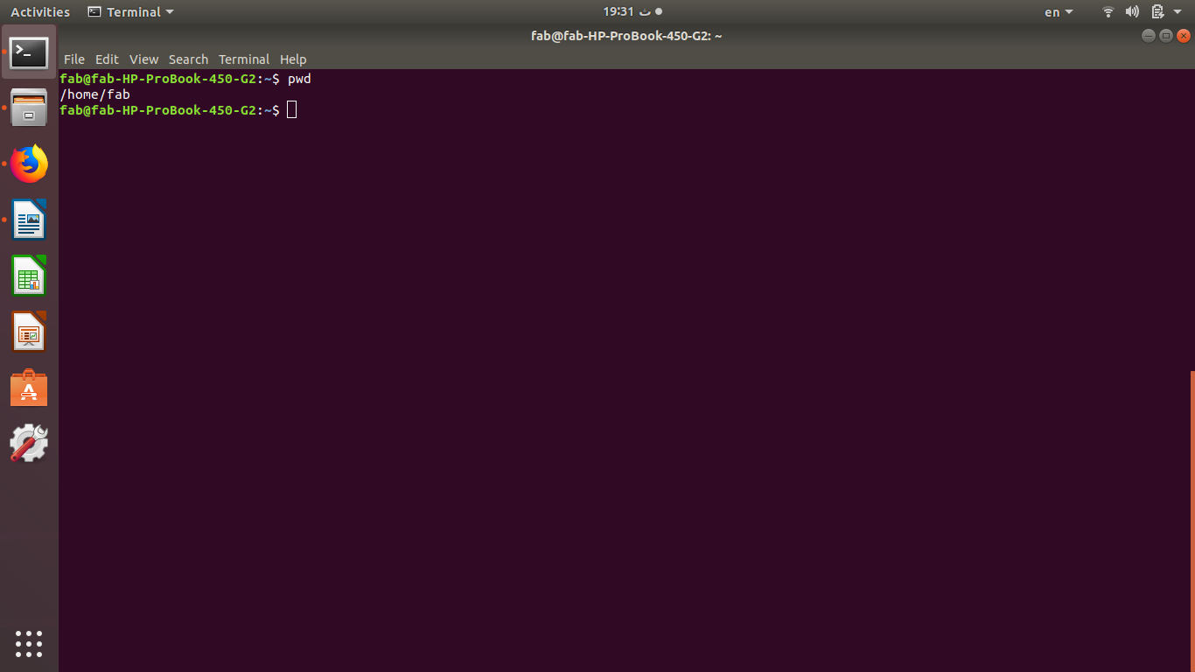

**ls -l** تستخدم **لعرض** الملفات الموجودة على النظام مع **حجم** المساحات بالبابت

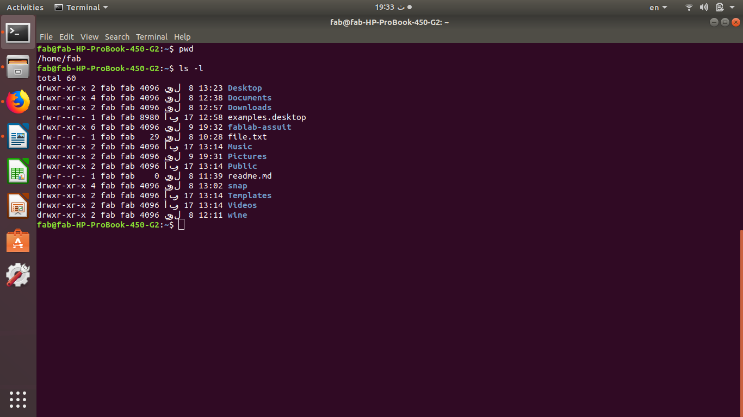

ls -lh**ls -l** تستخدم **لعرض** الملفات الموجودة على النظام مع **حجم** المساحات بالكيلوبايت

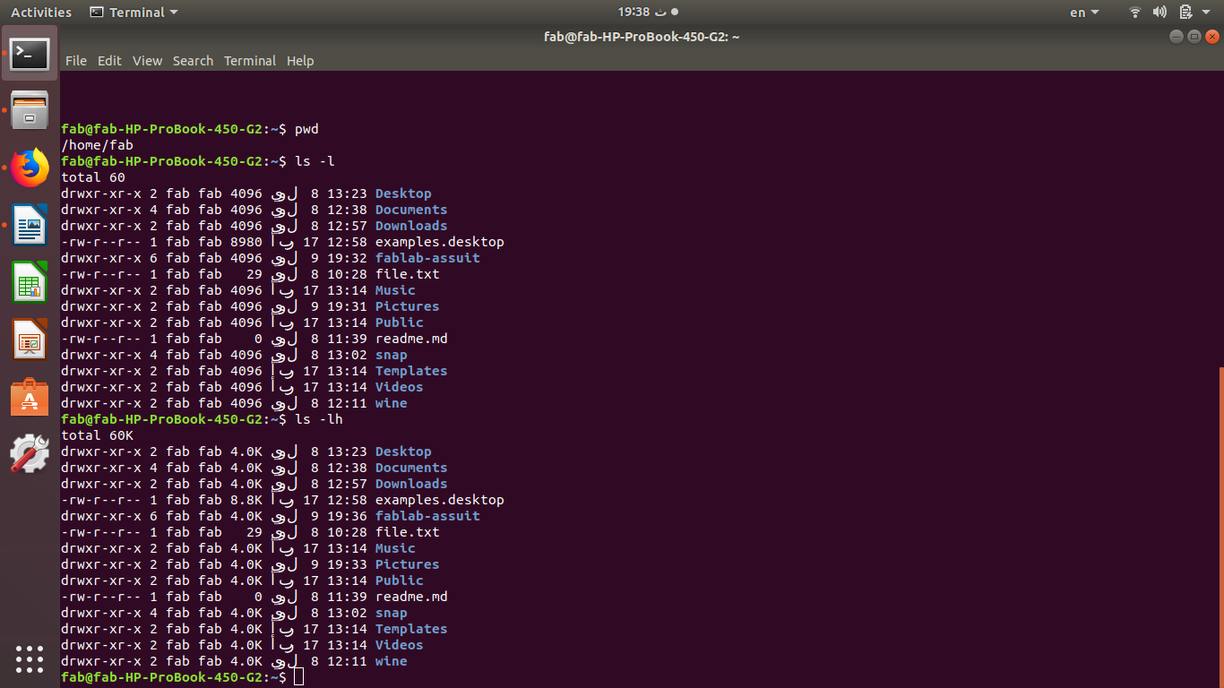

**mkdir اسم الملف الجديد**

تستخدم لعمل ملف جديد

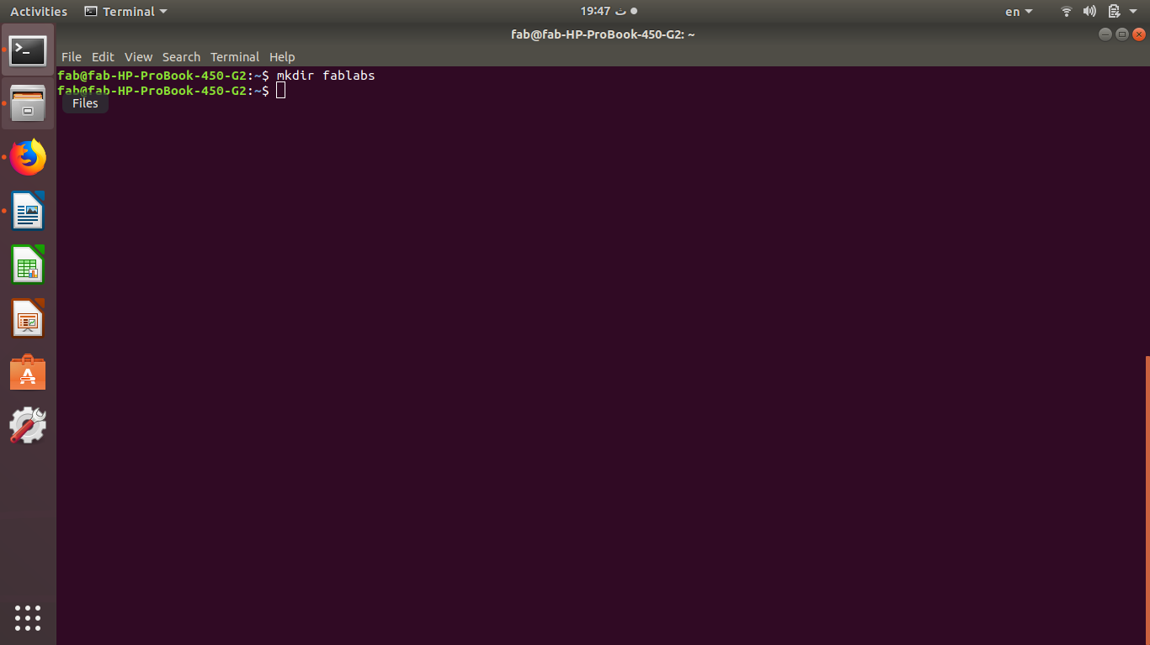

**cd اسم الملف السابق انشاؤه**

تستخدم لفتح الملف المطلوب

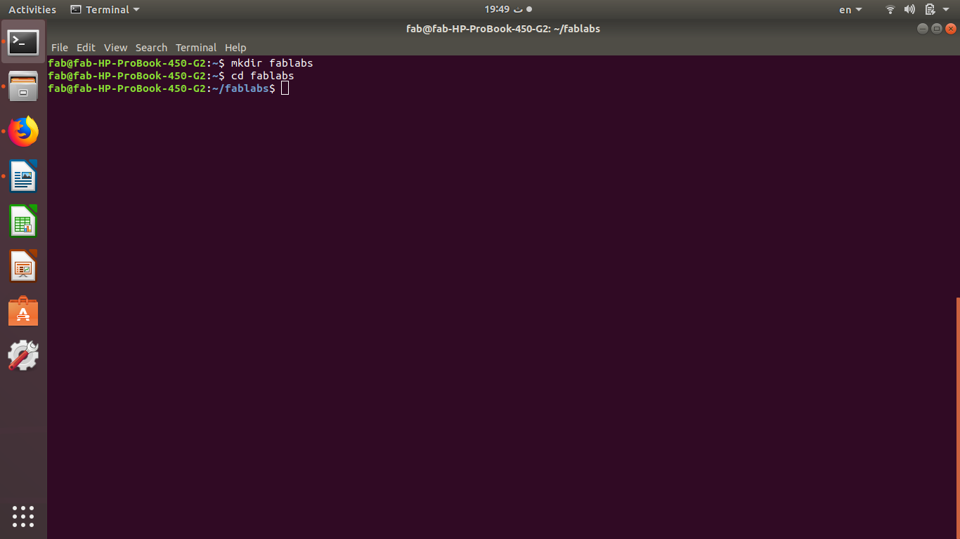

**cd ..**

تستخدم للعودة الى الملف السابق مباشرة

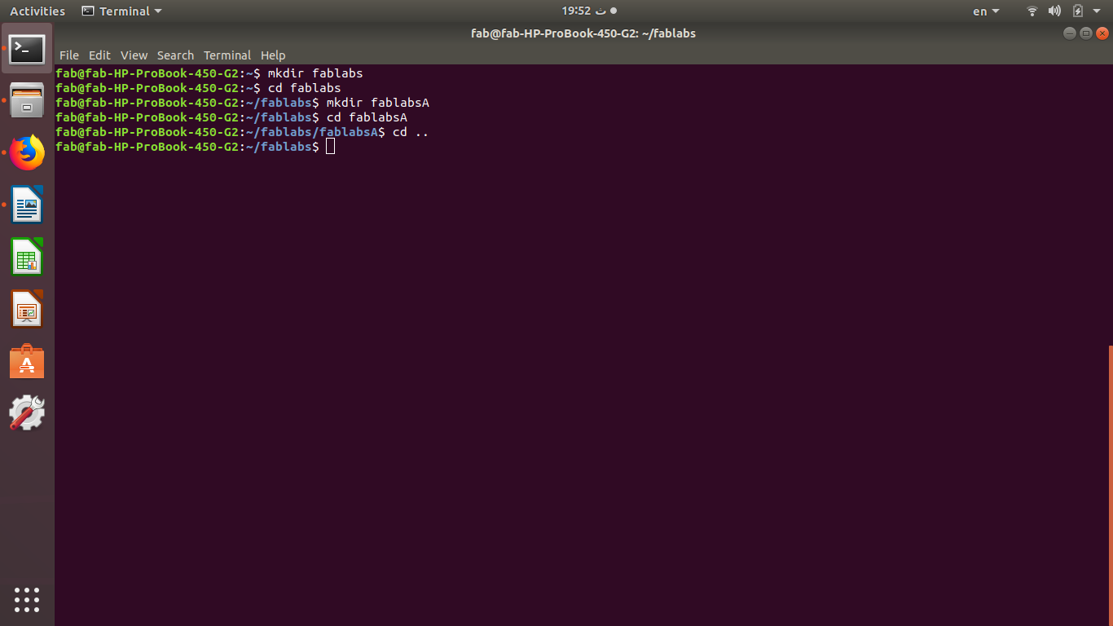

cd -

تستخدم للتقدم الى الملف التالى عكس الامر السابق

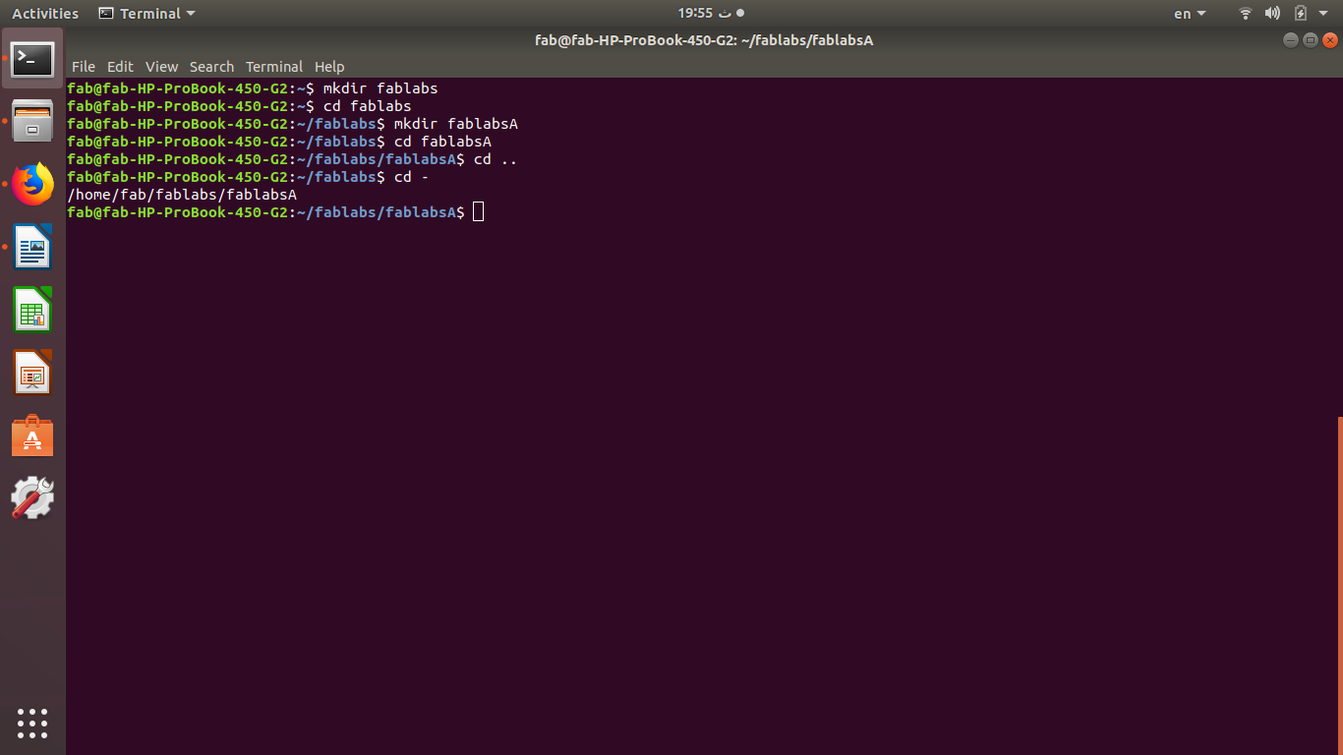

**touch اسم الملف وليكن مثلا (fablabs)**

تستخدم لعمل ملف انترنت

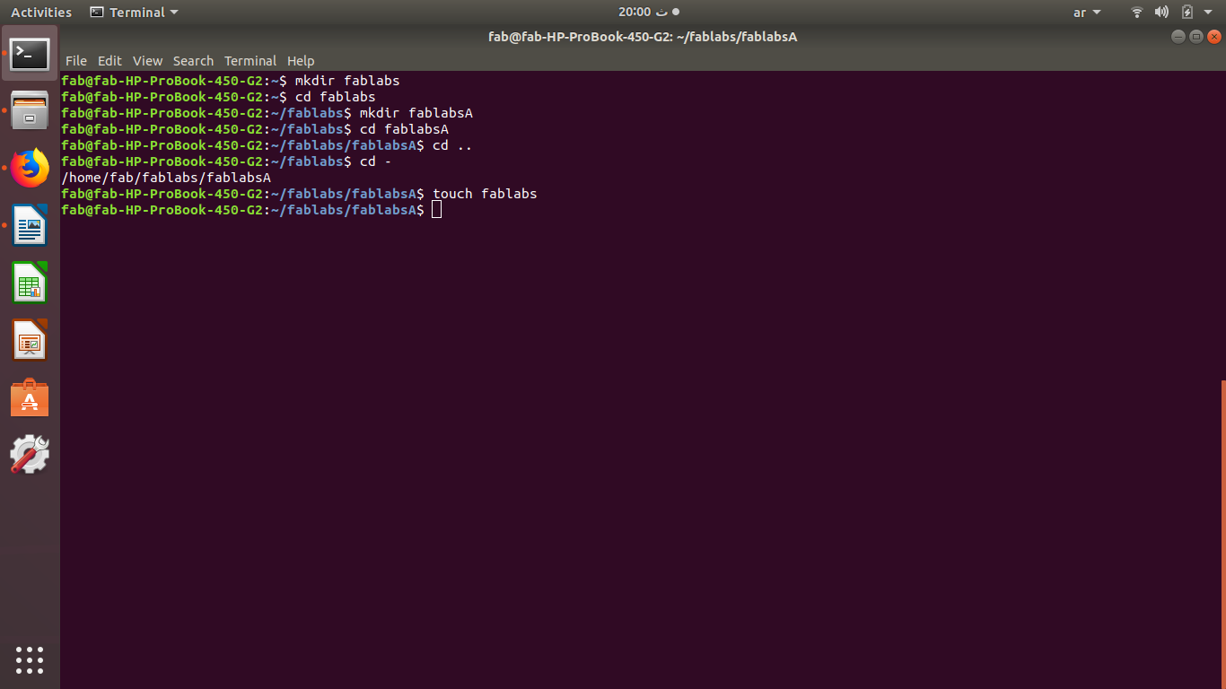

**echo رسالة معينة ولتكن hello**

**تستخدم لعرض رسالة داخل الملف**

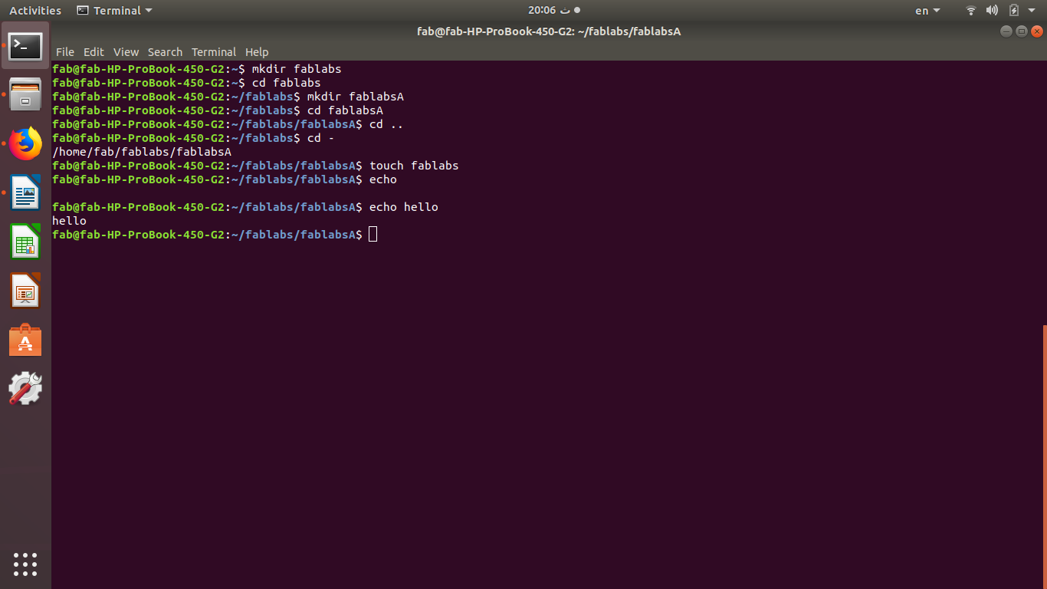

**echo الرسالة >**

**تستخدم لاظهار رسالة معينة داخل ملف معين يكتب اسم الملف بعد علامة >**

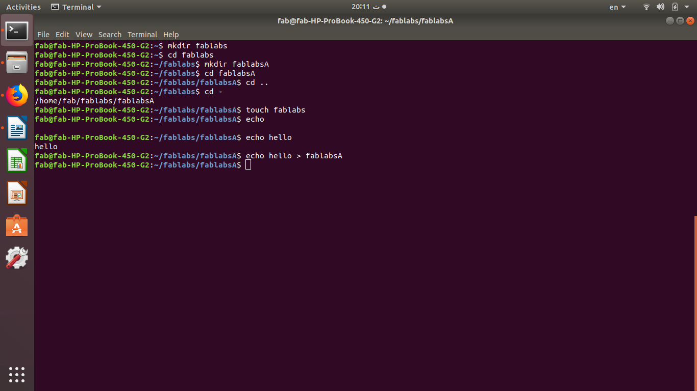

**man echo**

تستخدم للبحث عن الامر echo

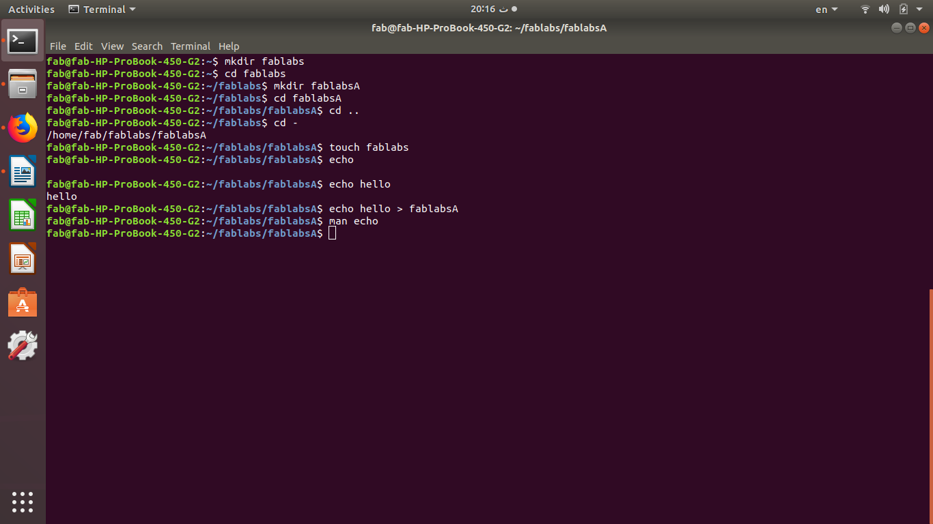

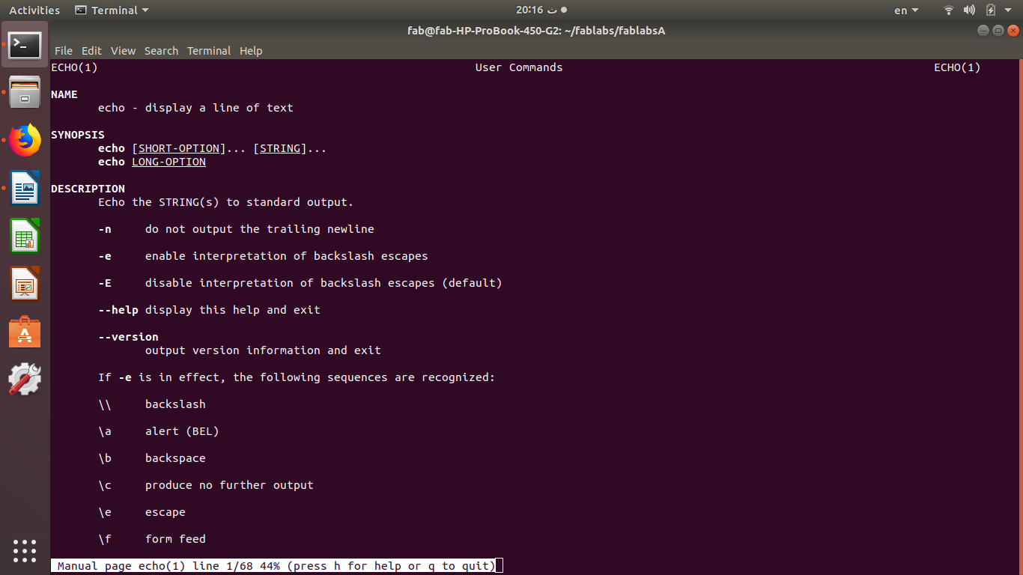

qبعد تنفيذ الامر السابق للعودة الى صفحة الاوامر نقوم بالضغط على زر

**echo -\n goodbye**

تستخدم لاظهار رسالة فى بداية سطر اوامر جديد

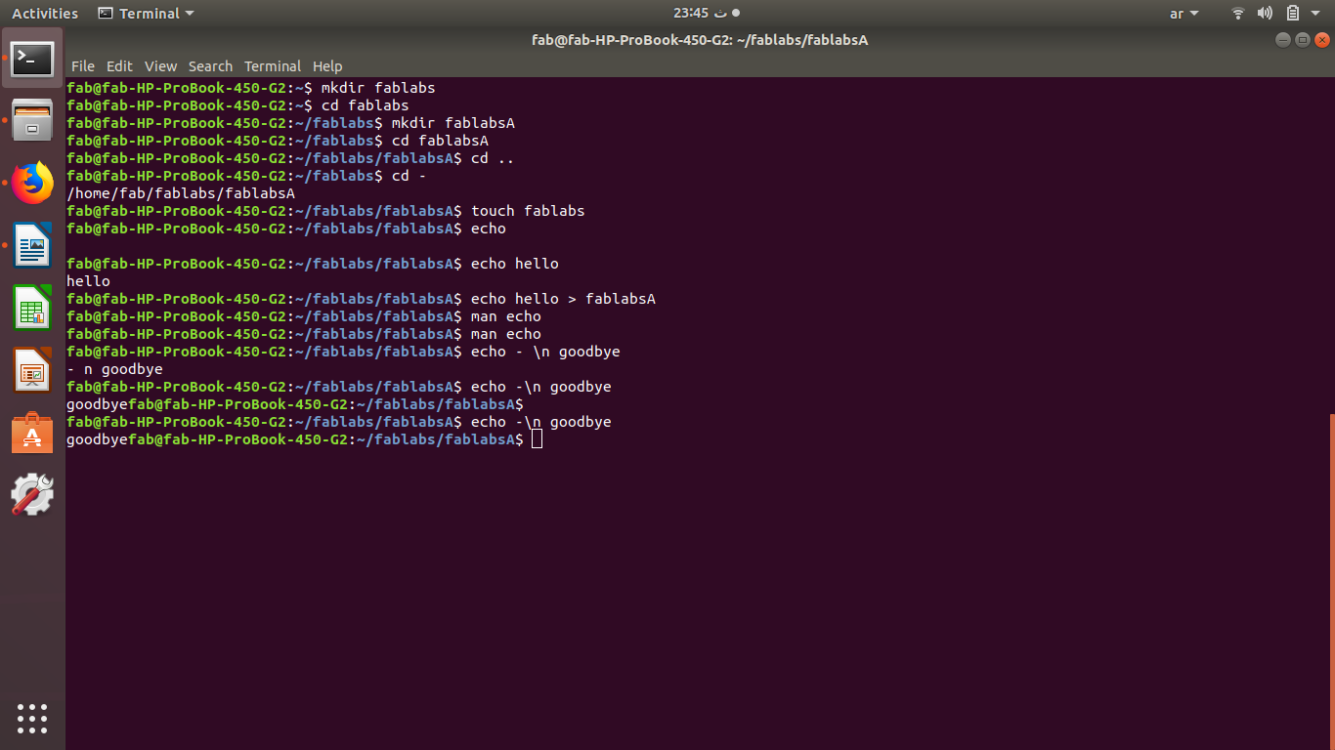

nano اسم الملف

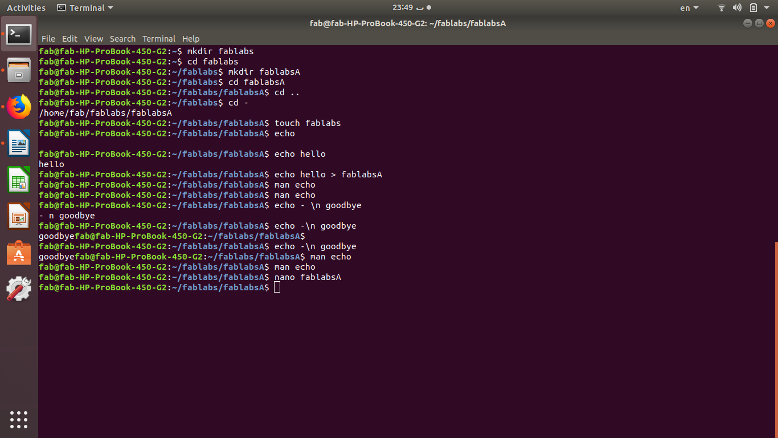يستخدم لفتح صفحة كتاب تشبه صفحة الوورد باد

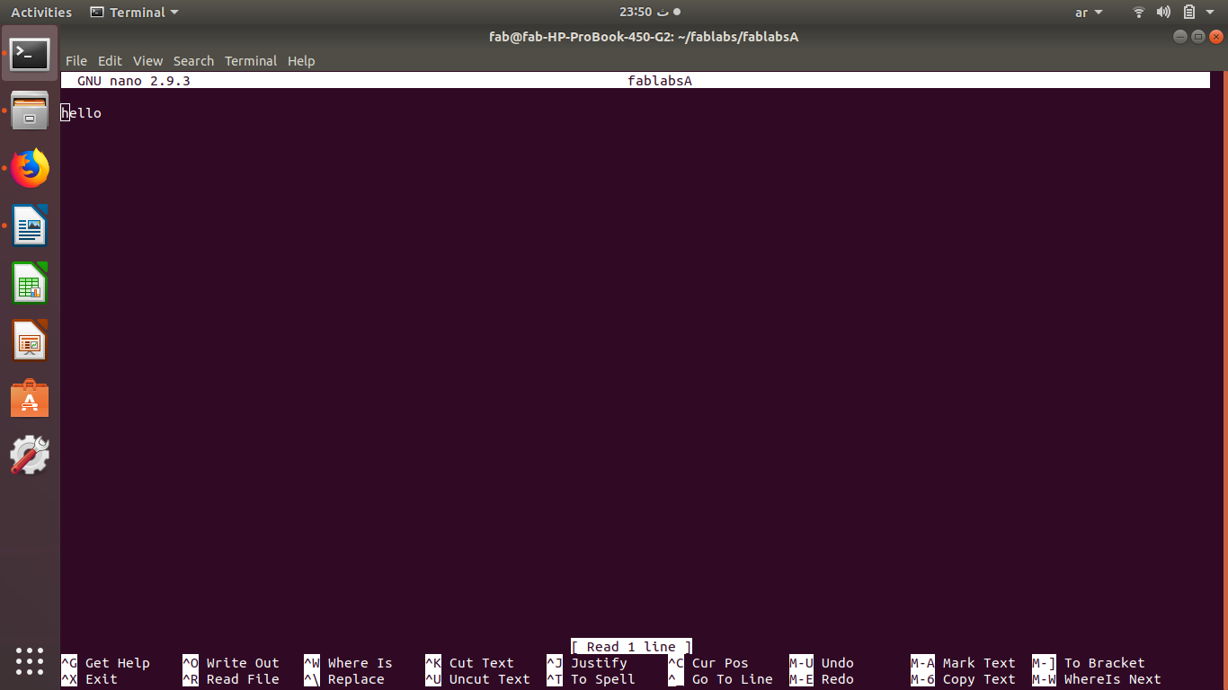

**passphase**

ssh-rsa  [saadmoha559@gmail.com](mailto:saadmoha559@gmail.com)

fab@fab-HP-ProBook-450-G2:~$ cd

fab@fab-HP-ProBook-450-G2:~$ ssh-keygen -t rsa -b 4096 -C "saadmoha559@gmail.com"

Generating public/private rsa key pair.

Enter file in which to save the key (/home/fab/.ssh/id_rsa):

Enter passphrase (empty for no passphrase):

Enter same passphrase again:

Your identification has been saved in /home/fab/.ssh/id_rsa.

Your public key has been saved in /home/fab/.ssh/id_rsa.pub.

The key fingerprint is:

SHA256:d3p6r7HRnpsVfvJ1eR4VR+T2KmISMmi9NgVbKZGNa9Y saadmoha559@gmail.com

The key's randomart image is:

+---[RSA 4096]----+

| .+ .o|

| o... o |

| ooo .+|

| o+=E .+|

| oo= S . . .o|

| . = o o ...+|

| + . + = ++*|

| . . o +.* B*|

| ..oo*.o|

+----[SHA256]-----+

fab@fab-HP-ProBook-450-G2:~$ ls .ssh/

id_rsa id_rsa.pub

fab@fab-HP-ProBook-450-G2:~$ cat id_rsa id_rsa.pub

cat: id_rsa: No such file or directory

cat: id_rsa.pub: No such file or directory

fab@fab-HP-ProBook-450-G2:~$ cat id_rsa id_rsa.pub

cat: id_rsa: No such file or directory

cat: id_rsa.pub: No such file or directory

fab@fab-HP-ProBook-450-G2:~$ cat .ssh/id_rsa.pub

ssh-rsa  saadmoha559@gmail.com

fab@fab-HP-ProBook-450-G2:~$ eval "$(ssh-agent -s)"

Agent pid 11586

fab@fab-HP-ProBook-450-G2:~$ > Agent pid 59566

Command 'pid' not found, but there are 23 similar ones.

fab@fab-HP-ProBook-450-G2:~$ eval "$(ssh-agent -s)"

Agent pid 11610

fab@fab-HP-ProBook-450-G2:~$ ssh-add ~/.ssh/id_rsa

Identity added: /home/fab/.ssh/id_rsa (/home/fab/.ssh/id_rsa)

fab@fab-HP-ProBook-450-G2:~$ sudo apt-get install xclip

[sudo] password for fab:

Sorry, try again.

[sudo] password for fab:

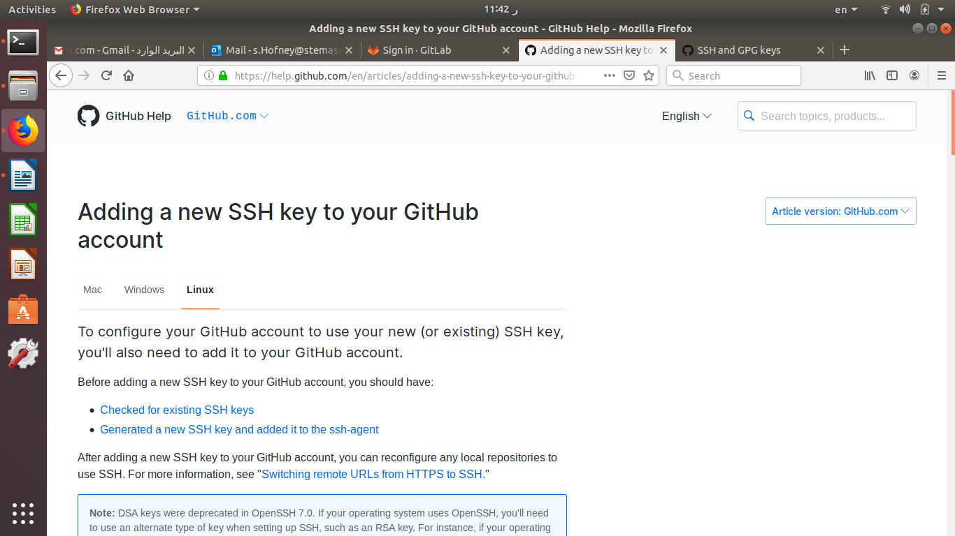

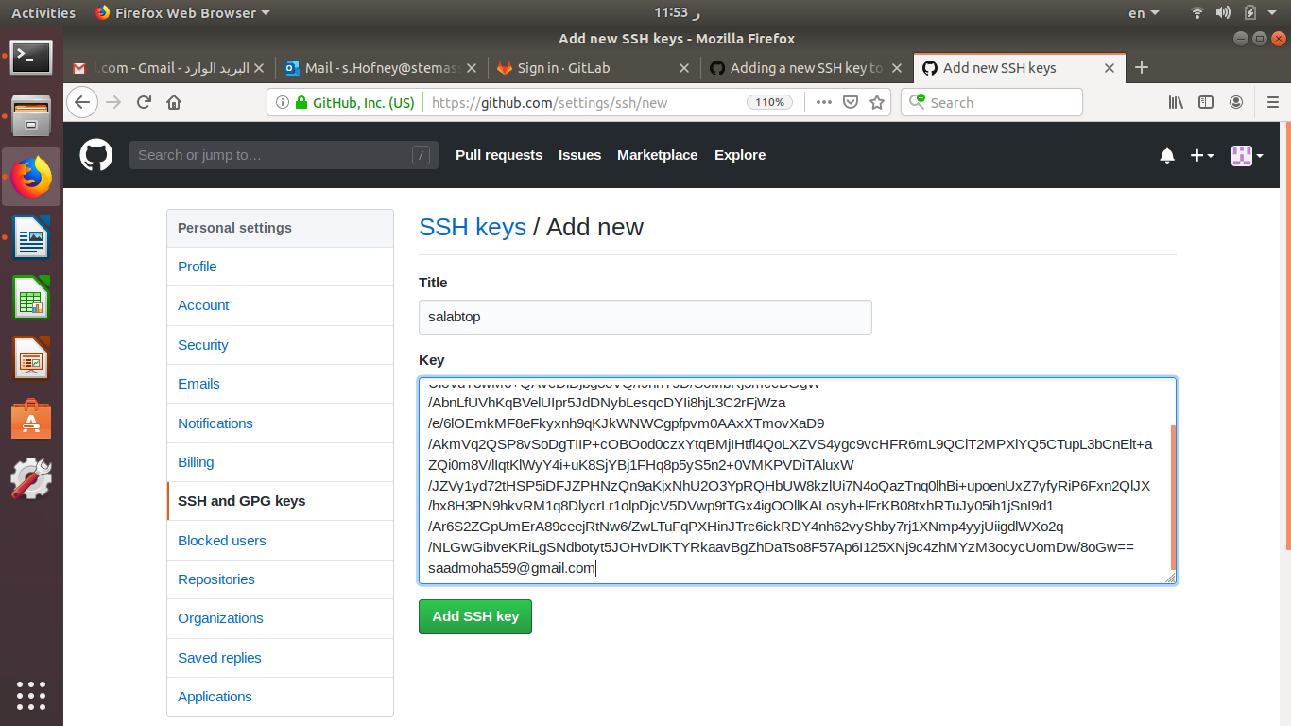

fab@fab-HP-ProBook-450-G2:~$ cd

fab@fab-HP-ProBook-450-G2:~$ ssh-keygen -t rsa -b 4096 -C "saadmoha559@gmail.com"

Generating public/private rsa key pair.

Enter file in which to save the key (/home/fab/.ssh/id_rsa):

Enter passphrase (empty for no passphrase):

Enter same passphrase again:

Your identification has been saved in /home/fab/.ssh/id_rsa.

Your public key has been saved in /home/fab/.ssh/id_rsa.pub.

The key fingerprint is:

SHA256:d3p6r7HRnpsVfvJ1eR4VR+T2KmISMmi9NgVbKZGNa9Y saadmoha559@gmail.com

The key's randomart image is:

+---[RSA 4096]----+

| .+ .o|

| o... o |

| ooo .+|

| o+=E .+|

| oo= S . . .o|

| . = o o ...+|

| + . + = ++*|

| . . o +.* B*|

| ..oo*.o|

+----[SHA256]-----+

fab@fab-HP-ProBook-450-G2:~$ ls .ssh/

id_rsa id_rsa.pub

fab@fab-HP-ProBook-450-G2:~$ cat id_rsa id_rsa.pub

cat: id_rsa: No such file or directory

cat: id_rsa.pub: No such file or directory

fab@fab-HP-ProBook-450-G2:~$ cat id_rsa id_rsa.pub

cat: id_rsa: No such file or directory

cat: id_rsa.pub: No such file or directory

fab@fab-HP-ProBook-450-G2:~$ cat .ssh/id_rsa.pub

ssh-rsa  saadmoha559@gmail.com

fab@fab-HP-ProBook-450-G2:~$ eval "$(ssh-agent -s)"

Agent pid 11586

fab@fab-HP-ProBook-450-G2:~$ > Agent pid 59566

Command 'pid' not found, but there are 23 similar ones.

fab@fab-HP-ProBook-450-G2:~$ eval "$(ssh-agent -s)"

Agent pid 11610

fab@fab-HP-ProBook-450-G2:~$ ssh-add ~/.ssh/id_rsa

Identity added: /home/fab/.ssh/id_rsa (/home/fab/.ssh/id_rsa)

fab@fab-HP-ProBook-450-G2:~$ sudo apt-get install xclip

[sudo] password for fab:

Sorry, try again.

[sudo] password for fab:

Sorry, try again.

[sudo] password for fab:

Reading package lists... Done

Building dependency tree

Reading state information... Done

The following packages were automatically installed and are no longer required:

libwine-development libwine-development:i386 wine32-development:i386

wine64-development

Use 'sudo apt autoremove' to remove them.

The following NEW packages will be installed:

xclip

0 upgraded, 1 newly installed, 0 to remove and 2 not upgraded.

Need to get 17.5 kB of archives.

After this operation, 52.2 kB of additional disk space will be used.

Get:1 http://eg.archive.ubuntu.com/ubuntu bionic/main amd64 xclip amd64 0.12+svn84-4build1 [17.5 kB]

Fetched 17.5 kB in 0s (48.2 kB/s)

Selecting previously unselected package xclip.

(Reading database ... 217348 files and directories currently installed.)

Preparing to unpack .../xclip_0.12+svn84-4build1_amd64.deb ...

Unpacking xclip (0.12+svn84-4build1) ...

Setting up xclip (0.12+svn84-4build1) ...

Processing triggers for man-db (2.8.3-2ubuntu0.1) ...

fab@fab-HP-ProBook-450-G2:~$ xclip -sel clip < ~/.ssh/id_rsa.pub

fab@fab-HP-ProBook-450-G2:~$ ssh -T git@github.com

The authenticity of host 'github.com (140.82.118.3)' can't be established.

RSA key fingerprint is SHA256:nThbg6kXUpJWGl7E1IGOCspRomTxdCARLviKw6E5SY8.

Are you sure you want to continue connecting (yes/no)? yes

Warning: Permanently added 'github.com,140.82.118.3' (RSA) to the list of known hosts.

Hi saad-assiut! You've successfully authenticated, but GitHub does not provide shell access.

fab@fab-HP-ProBook-450-G2:~$ git remote -v

fatal: not a git repository (or any of the parent directories): .git

fab@fab-HP-ProBook-450-G2:~$ ls

Agent fablab1 Public Templates

assuit fablab-assuit readme.md Videos

Desktop fablabs '‪saad moha‬‏'$'\r''saadmoha559@gmail.com' wine

Documents file.txt saso

Downloads Music snap

examples.desktop Pictures stem

fab@fab-HP-ProBook-450-G2:~$ cd fablab-assuit/

fab@fab-HP-ProBook-450-G2:~/fablab-assuit$ ls

assiut.jpeg 'Markdown Cheatsheet · adam-p_markdown-here Wiki_files'

ext.jpeg 'Markdown Cheatsheet · adam-p_markdown-here Wiki.html'

fabzero readme.md

hell.jpg training.odt

index1.jpeg 'Welcome | FabLabs_files'

index5.jpeg 'Welcome | FabLabs.html'

fab@fab-HP-ProBook-450-G2:~/fablab-assuit$ git remote -v

origin https://github.com/saad-assiut/fabzero.git (fetch)

origin https://github.com/saad-assiut/fabzero.git (push)

fab@fab-HP-ProBook-450-G2:~/fablab-assuit$ git remote

add prune rename set-head show

get-url remove set-branches set-url update

fab@fab-HP-ProBook-450-G2:~/fablab-assuit$ git remote set-url origin git@github.com:saad-assiut/fabzero.git

fab@fab-HP-ProBook-450-G2:~/fablab-assuit$ git remote -v

origin git@github.com:saad-assiut/fabzero.git (fetch)

origin git@github.com:saad-assiut/fabzero.git (push)

fab@fab-HP-ProBook-450-G2:~/fablab-assuit$ add .

Command 'add' not found, did you mean:

command 'dd' from deb coreutils

command 'dad' from deb debian-dad

command 'pdd' from deb pdd

command 'ddd' from deb ddd

command 'ldd' from deb libc-bin

command 'and' from deb and

command 'tdd' from deb devtodo

command 'adb' from deb adb

command 'adbd' from deb android-tools-adbd

command 'amd' from deb am-utils

command 'aid' from deb id-utils

command 'atd' from deb at

command 'ad' from deb netatalk

command 'axd' from deb afnix

Try: sudo apt install <deb name>

fab@fab-HP-ProBook-450-G2:~/fablab-assuit$ git add .

warning: adding embedded git repository: fabzero

hint: You've added another git repository inside your current repository.

hint: Clones of the outer repository will not contain the contents of

hint: the embedded repository and will not know how to obtain it.

hint: If you meant to add a submodule, use:

hint:

hint: git submodule add <url> fabzero

hint:

hint: If you added this path by mistake, you can remove it from the

hint: index with:

hint:

hint: git rm --cached fabzero

hint:

hint: See "git help submodule" for more information.

fab@fab-HP-ProBook-450-G2:~/fablab-assuit$ git add .

fab@fab-HP-ProBook-450-G2:~/fablab-assuit$ git commit -m "using ssh"

[master eb6308c] using ssh

6 files changed, 2 insertions(+)

create mode 100644 .~lock.training.odt#

create mode 100644 assiut.jpeg

create mode 100644 ext.jpeg

create mode 160000 fabzero

create mode 100644 index5.jpeg

rewrite training.odt (78%)

fab@fab-HP-ProBook-450-G2:~/fablab-assuit$ git commit -m"using ssh"

On branch master

Your branch is ahead of 'origin/master' by 2 commits.

(use "git push" to publish your local commits)

nothing to commit, working tree clean

fab@fab-HP-ProBook-450-G2:~/fablab-assuit$ push

Command 'push' not found, did you mean:

command 'pwsh' from snap powershell (6.2.1)

command 'ppsh' from deb ppsh

command 'pdsh' from deb pdsh

command 'rush' from deb rush

command 'posh' from deb posh

See 'snap info <snapname>' for additional versions.

fab@fab-HP-ProBook-450-G2:~/fablab-assuit$ git pus

git: 'pus' is not a git command. See 'git --help'.

The most similar commands are

push

pull

fab@fab-HP-ProBook-450-G2:~/fablab-assuit$ git push

Warning: Permanently added the RSA host key for IP address '140.82.118.4' to the list of known hosts.

Counting objects: 35, done.

Delta compression using up to 4 threads.

Compressing objects: 100% (34/34), done.

Writing objects: 100% (35/35), 2.57 MiB | 1015.00 KiB/s, done.

Total 35 (delta 3), reused 0 (delta 0)

remote: Resolving deltas: 100% (3/3), completed with 1 local object.

To github.com:saad-assiut/fabzero.git

670af22..eb6308c master -> master

fab@fab-HP-ProBook-450-G2:~/fablab-assuit$ git remote -v

origin git@github.com:saad-assiut/fabzero.git (fetch)

origin git@github.com:saad-assiut/fabzero.git (push)

fab@fab-HP-ProBook-450-G2:~/fablab-assuit$ ls

assiut.jpeg 'Markdown Cheatsheet · adam-p_markdown-here Wiki_files'

ext.jpeg 'Markdown Cheatsheet · adam-p_markdown-here Wiki.html'

fabzero readme.md

hell.jpg training.odt

index1.jpeg 'Welcome | FabLabs_files'

index5.jpeg 'Welcome | FabLabs.html'

fab@fab-HP-ProBook-450-G2:~/fablab-assuit$ git pull

Already up to date.

fab@fab-HP-ProBook-450-G2:~/fablab-assuit$ ls

assiut.jpeg 'Markdown Cheatsheet · adam-p_markdown-here Wiki_files'

ext.jpeg 'Markdown Cheatsheet · adam-p_markdown-here Wiki.html'

fabzero readme.md

hell.jpg training.odt

index1.jpeg 'Welcome | FabLabs_files'

index5.jpeg 'Welcome | FabLabs.html'

fab@fab-HP-ProBook-450-G2:~/fablab-assuit$ cd safablab

bash: cd: safablab: No such file or directory

fab@fab-HP-ProBook-450-G2:~/fablab-assuit$ cd ..

fab@fab-HP-ProBook-450-G2:~$ ls

Agent fablab1 Public Templates

assuit fablab-assuit readme.md Videos

Desktop fablabs '‪saad moha‬‏'$'\r''saadmoha559@gmail.com' wine

Documents file.txt saso

Downloads Music snap

examples.desktop Pictures stem

fab@fab-HP-ProBook-450-G2:~$ cd salabtop

bash: cd: salabtop: No such file or directory

fab@fab-HP-ProBook-450-G2:~$ git status

fatal: not a git repository (or any of the parent directories): .git

fab@fab-HP-ProBook-450-G2:~$ cd fablab

bash: cd: fablab: No such file or directory

fab@fab-HP-ProBook-450-G2:~$ cd fablab-assuit

fab@fab-HP-ProBook-450-G2:~/fablab-assuit$ touch yalla

fab@fab-HP-ProBook-450-G2:~/fablab-assuit$ echo yalla

yalla

fab@fab-HP-ProBook-450-G2:~/fablab-assuit$ nano yalla

fab@fab-HP-ProBook-450-G2:~/fablab-assuit$ sh yalla

start updating documantation

Already up to date.

git: 'connit' is not a git command. See 'git --help'.

The most similar commands are

commit

config

Everything up-to-date

i am done

fab@fab-HP-ProBook-450-G2:~/fablab-assuit$

