Re-Engineering of the Walmart.com E-Commerce Platform: From a Monolithic ATG Architecture to Cloud-Native Microservices

1. Original System
Walmart operates several technology programs, so this study examines the Walmart.com e-commerce platform and its successive re-engineering stages. Walmart Canada's rebuild is treated as a labelled sub-case because its outcome measurements are the most detailed in the public record. The analysis is document-based and draws on engineering publications from Walmart Global Tech and Walmart Labs, trade-press interviews with Walmart engineers, vendor case studies, conference presentations and secondary technical summaries.
Before its infrastructure and application overhaul, Walmart.com ran a legacy ATG e-commerce solution on scale-up production infrastructure that was mostly bare metal, with the Oracle database layer on bare metal as well [1]. The layering is documented in more detail for the Walmart Canada platform that preceded its rebuild: JSP presentation on ATG, Oracle as the data store and Endeca for search and merchandising [7]. Mobile functionality drew on a legacy Java back end [12].
In structural terms, presentation, commerce logic (catalog, pricing, cart, checkout and order capture) and shared code formed one deployable unit. That unit depended on a single shared relational database, and capacity grew by buying larger servers.
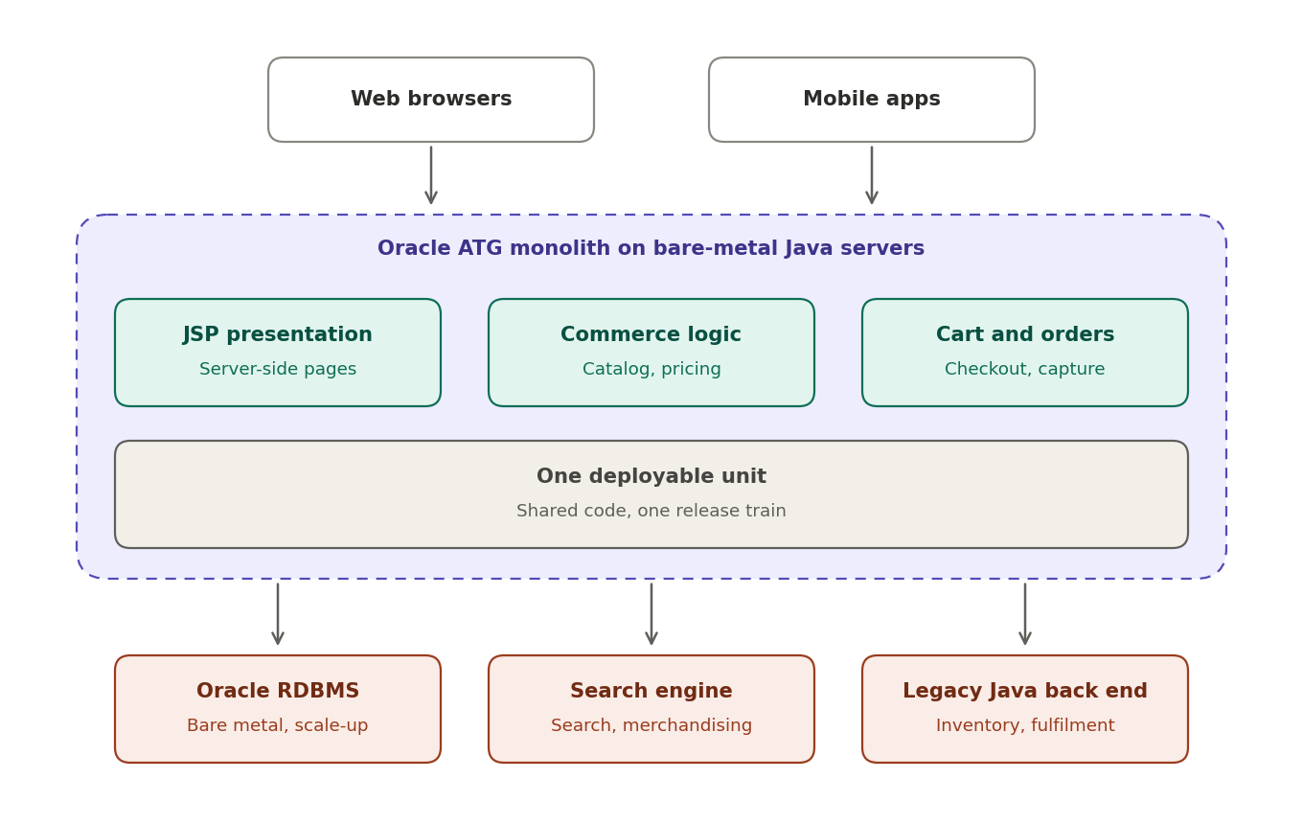
Figure 1. Original Walmart.com architecture (logical view)
The "Search engine" and "Legacy Java back end" labels are generic. Endeca is documented for Walmart Canada [7], and the legacy Java back end for the mobile tier [12].

2. Problems with the Existing System
Walmart engineers characterise the legacy commercial-off-the-shelf (COTS) monolith as extremely hard to scale beyond a point. It suffered delayed release cycles, heavy team coordination at deployment, slow development and long QA cycles [2]. These symptoms follow directly from how the system was built.
Problem | Architectural cause
Inability to scale for peak traffic | Every capability ran in one process on scaled-up servers, so extra capacity meant buying expensive hardware that sat idle off-peak. Walmart Canada's legacy Java infrastructure could serve only a limited number of simultaneous requests per application server and could not use commodity servers for burst capacity [5].
Delayed releases and long QA cycles | The whole site was one deployable unit, so any change required retesting and redeploying everything and coordinating many teams [2].
Database scalability issues | The application used a relational database with hundreds of tables, and Walmart reported scalability problems with it [2]. A single shared store made every feature compete for the same scale-up resource.
Limited experimentation | A COTS monolith constrains the technology stack, which restricts quick experiments and the adoption of new technologies [2].

Taken together, the problems trace back to three properties of the original architecture: one deployable unit, one shared relational store and vertical scaling. Each later re-engineering stage targeted at least one of them.

3. Why Was Re-Engineering Necessary?
Peak-event reliability was the most visible business pressure. A re-architecture lead at Walmart Canada said the legacy platform could not handle 6 million page views per minute and was down for most of the day during peak events, with Black Friday failures in two consecutive years [6]. Growth added urgency. The e-commerce business described in the 2020 platform paper earned about $5 billion annually and was growing 30–40% a year, and the team set a goal of 10 times the then-current throughput, measured in page views and orders per minute [2]. Cost mattered as well, since the existing application was expensive in development, support and hardware [2].
Several technical factors reinforced these pressures. Mobile traffic exposed the limits of the old stack: Walmart engineers argued that Node.js coped well with the strain of many high-latency, intermittently disconnected mobile connections, and the hapi framework came out of the Walmart Labs mobile team, led by Eran Hammer, to handle Black Friday traffic [11]. Availability targets also tightened, as the 2020 platform specified 99.99% uptime, citing the direct link between downtime and lost revenue [2]. Finally, Walmart ran several promotional events each year, so the platform needed to scale up for them and back down afterwards under a pay-per-use model [2].

4. Re-Engineering Approach
Re-engineering took the form of sequential changes across layers, not a single rewrite.
- The mobile service tier was rebuilt on Node.js and hapi. Node.js acted as an orchestration layer in front of legacy Java back-end services [12]. One example is Quimby, a service layer that combines several data sources into a compact set of API calls that mobile clients use to configure themselves [18].
- Applications were split into services. Walmart divided its applications into resource services and orchestration services, with infrastructure-as-a-service beneath them [1].
- The platform moved to a private OpenStack cloud. The entire e-commerce operation ran on OpenStack at more than 100,000 cores and several petabytes of storage. The deployment used the Havana components Nova, Swift, Cinder, Neutron, Horizon and Keystone, with multiple clouds federated through Keystone. The Oracle database layer initially stayed as it was, with Cassandra planned for wider use [1].
- Lifecycle automation was handled through OneOps. OneOps was founded in 2011 and acquired by Walmart in 2013. It manages walmart.com and Sam's Club and works with technologies such as Node.js, Docker and Elasticsearch [10].
- The web front end moved to React and Node.js (Electrode). Walmart.com completed this migration in under a year, and Electrode was open-sourced in 2016. Most of the site, including the home, login, cart, checkout, category and item views, ran on it [3].
- Event streaming was introduced for data flows. In a redesign beginning around 2014, item-setup changes were modelled as event streams recorded in Kafka before processing, and Kafka also backed a near-real-time search index in which changes reach the site within seconds [17]. A real-time inventory system later replaced batch-based inventory processes [14].
- A cloud-native microservice platform was built. The 2020 platform was created from scratch on public cloud. The monolith was decomposed along domain boundaries into services such as Catalog, Search, Cart, Checkout, Promotion, Payment, Inventory, Order and Return, packaged as Docker containers and orchestrated on Kubernetes with the Istio service mesh. Services are stateless, use NoSQL storage (Azure Cosmos DB), run active-active across two Azure regions and are each owned end to end by one team [2].

5. How Was the Re-Engineering Performed?
The documented order of change works from the edge inward. The mobile service tier came first [12], followed by infrastructure and service decomposition [1], lifecycle automation [10], the web front end [3], the event and data layer [17][14], and finally a full domain-based platform [2]. This sequence reduces risk at the edges first: the mobile tier was a bounded layer that could be rebuilt in front of existing back-end services, infrastructure and tooling were standardised before the web front end moved [4][3], and the most tightly coupled layers, data and the full commerce domain, came last [2].
The OpenStack migration was carried out while the site stayed live. Walmart's cloud operations lead likened it to heart surgery, brain surgery and several other operations at once while the site kept running. The migration, reported in March 2015 as having taken place the previous August, left the site up throughout the holiday period [1].
Tooling was provided before applications were forced across. Teams building Node.js applications on their own each had to solve CI/CD, deployment, monitoring and integration with existing infrastructure. Walmart responded with full-solution tooling and repeatable deployment. Since npm is not designed for building immutable releases, a new approach was developed, and that work became the basis of Electrode [4]. Shared infrastructure moved as well: Walmart's Kafka service was relocated from shared bare-metal machines to a self-serving deployment on OpenStack and OneOps [16].
The 2020 platform followed explicit principles: domain-oriented microservices with clear ownership and API contracts, containerised deployment, stateless services, autoscaling at every level, resilience patterns, trunk-based development with continuous integration and deployment, and declared service-level objectives for each service [2]. Single-team ownership of each service through development, deployment and production support paired the technical change with an organisational one, addressing the coordination and release problems of the original system.

6. Before vs. After Architecture
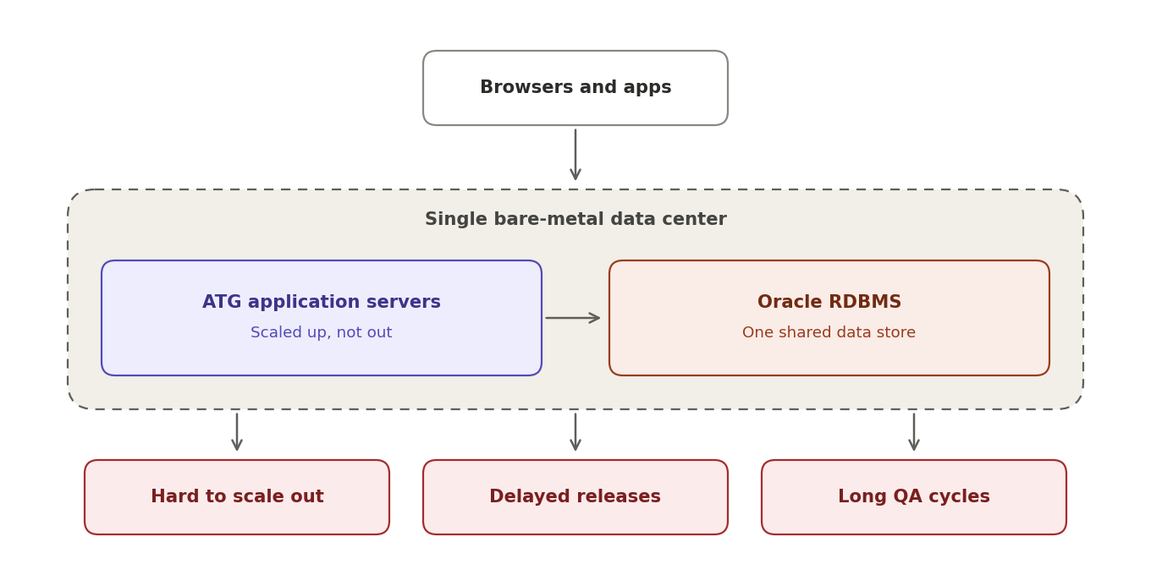
Figure 2. Before: runtime view of the legacy platform
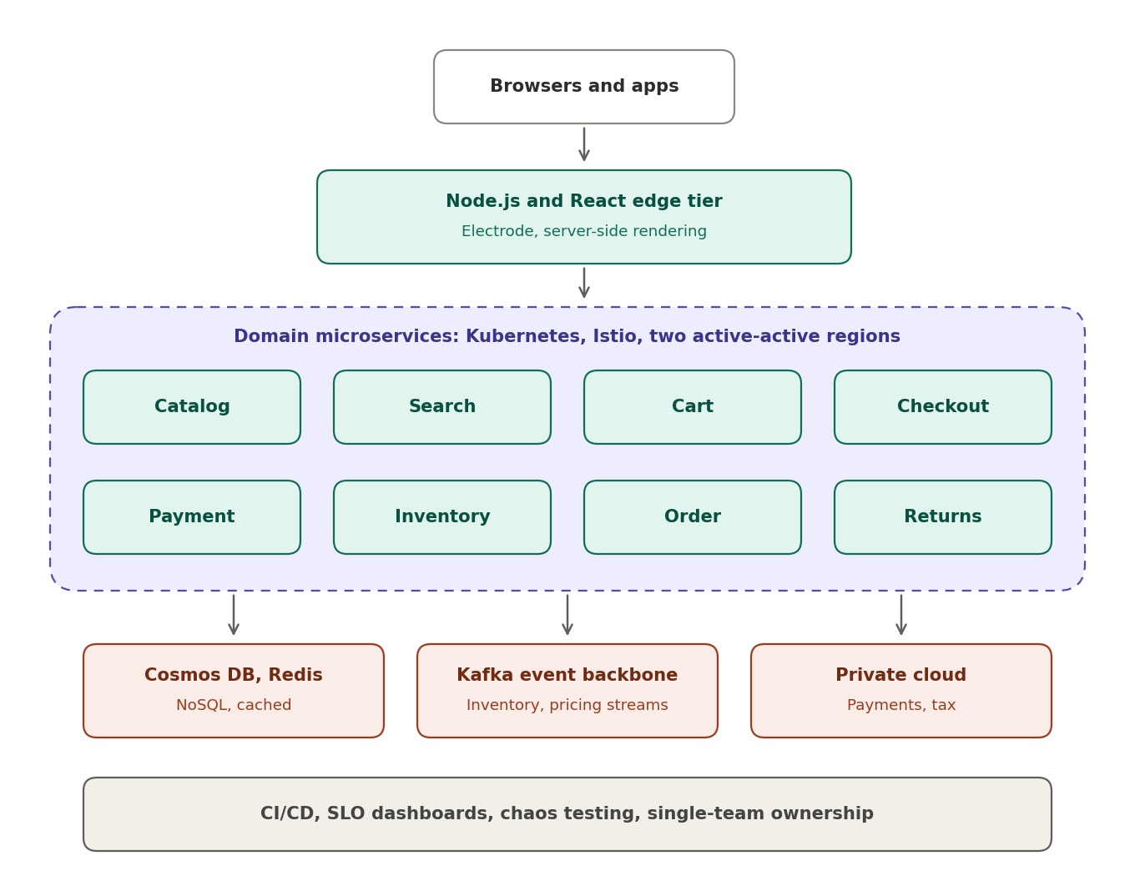
Figure 3. After: runtime view of the cloud-native platform
# | Dimension | Before | After
1 | Application structure | One ATG monolith, one deployable unit [1][7] | Domain microservices (Catalog, Cart, Checkout, Payment, Inventory, Order and others) [2]
2 | Presentation | Server-side JSPs [7] | Node.js/React edge tier with server-side rendering [3][18]
3 | Mobile/API layer | Legacy Java back end [12] | Node.js/hapi orchestration layer [12][18]
4 | Scaling model | Scale-up on bare metal [1] | Horizontal autoscaling of pods and nodes [2]
5 | Infrastructure | Mostly bare metal, then OpenStack private cloud [1] | Multi-cloud, mostly Azure PaaS on Kubernetes, with payments and tax on private cloud [2]
6 | Data | Shared Oracle RDBMS with hundreds of tables [1][2] | Per-service NoSQL (Cosmos DB), eventual consistency where possible, caching [2]
7 | Integration | Shared-code, tightly coupled processing [2] | Asynchronous non-blocking calls and Kafka event streams [2][17]
8 | Availability | Single estate, hardware-bound [1] | Active-active regions, circuit breakers, bulkheads, fault injection [2]
9 | Delivery | Whole-site releases, long QA cycles [2] | CI/CD, trunk-based development, frequent deployment [2]
10 | Ownership | Heavy cross-team coordination [2] | One team owns each service end to end [2]
11 | Observability | – | Declared SLOs and SLIs, Splunk, Prometheus, Grafana dashboards [2]

7. Measuring the Improvement
Each quantitative result below is graded by source type. Grade A covers material written by Walmart engineers or presented in Walmart's own materials, Grade B covers vendor or partner case studies, and Grade C covers secondary articles relaying interviews or talks. No figure is estimated or extrapolated, and results belong to individual stages instead of being combined into one overall figure.
Stage | Reported result | Grade
Mobile Node.js tier (Black Friday) | All mobile Black Friday traffic handled with about 10 CPU cores and 28 GB RAM, with extra servers mostly idle at about 0.75% load [11] | C
Walmart Canada rebuild | 20% rise in web conversions and 98% rise in mobile orders in the four weeks after launch [5] | B
Walmart Canada rebuild | About 40% of compute cycles moved to commodity x86 servers in a private cloud, saving 20–50% of web-related infrastructure cost over time [5] | B
Walmart Canada rebuild | No downtime on Black Friday or Boxing Day since replatforming [6] | C
OpenStack and OneOps | 280,000+ cores, 30+ cloud regions, 5,000+ users, 5,000+ applications and services, 65,000+ monthly deployments [9] | A
Real-time inventory (Kafka) | About 500 million events ingested per day and 1 million online transactions processed [14] | A
Real-time replenishment (Kafka) | Tens of billions of messages from close to 100 million SKUs processed in under three hours per day, at 85 GB of messages per minute [13] | A
Kafka platform | Trillions of messages per day at 99.99% availability, with 25,000+ consumers across private and public cloud [15] | C
Cloud-native platform (Cosmos DB) | Key lookups under 10 ms at the 99th percentile for the platform's access patterns [2] | A

The Walmart Canada conversion and order figures were measured after launch and coincided with a responsive redesign, so they reflect the platform and the new design together [5][7]. The 10 times throughput and 99.99% uptime values in the 2020 platform paper are design objectives, not measured outcomes [2]. Public sources offer no single before-and-after benchmark for the complete Walmart.com migration, and the Walmart Canada and Walmart US programs are separate, so findings from one do not transfer automatically to the other.

8. Challenges and Risks
- Migrating a live revenue system. The OpenStack migration took place while the site was running, with the holiday peak serving as the effective test of success [1].
- Immature infrastructure technology. OpenStack documentation was described as lacking, and the planned Havana-to-Juno upgrade proved destructive, forcing the cloud to be taken down and rebuilt. Walmart recruited heavily for OpenStack engineering and built deep in-house expertise [1].
- Uneven pace across layers. The Oracle database stayed on bare metal while applications moved, and its re-architecture was still being determined, with Cassandra planned for wider use [1].
- Tooling gaps across independent teams. Teams working alone on Node.js each had to solve CI/CD, deployment, monitoring and infrastructure integration, and a new immutable-release mechanism was needed because npm does not provide one [4].
- Platform-specific production issues. Node.js memory leaks emerged in production and were investigated with Joyent [20]. Server-side rendering of a single-page application on the Node.js tier later brought challenges unlike the earlier, mostly I/O-bound load [18].
- Skills and learning curve. At Walmart Canada the team was learning functional Scala, reactive programming, Play and Akka at the same time, and the lead developer recommended professional services where budget permits [8].
- Distributed-system complexity. The 2020 platform needed timeouts, retries, circuit breakers, bulkheads, throttling and fault-injection testing. Monitoring moved from Azure Application Insights to Splunk and Prometheus for performance reasons [2].
- Data modelling and consistency. Moving from relational tables to NoSQL demanded careful partition-key design, access-pattern design and session-consistency handling [2].
- Scale of the event layer. At very high message volumes, Kafka consumer rebalancing can cause disruption and latency in a near-real-time e-commerce setting. Walmart built a Messaging Proxy Service to decouple message consumption from Kafka's partition model [15][19].

[1] E. Knorr, "Walmart doubles down on OpenStack," InfoWorld, Mar. 2, 2015.
[2] S. Patnaik, "Building the Next-Generation E-Commerce Platform for 10X Growth," Walmart Global Tech Blog, Oct. 2020.
[3] WalmartLabs, "Introducing Electrode, an open source release from @WalmartLabs," Walmart Global Tech Blog, 2016.
[4] Walmart Global Tech, "Migrating Large Enterprise to NodeJS," Walmart Global Tech Blog.
[5] Akka (Lightbend), "Walmart Canada boosts conversions by 20% with Akka," customer story.
[6] F. Hámori, "How Enterprises Benefit From Microservices Architectures," RisingStack Engineering, 2016 (updated 2024).
[7] Nurun, "Big Retail Goes Reactive at Walmart," presentation slides.
[8] K. Webber, "Transitioning to Scala," kevinwebber.ca.
[9] Walmart Labs, "Clouds Ahead: Work with Walmart Labs's Hybrid, Multicloud Environment," conference presentation (OneOps).
[10] "Walmart Launches OneOps, An Open-Source Cloud And Application Lifecycle Management Platform," TechCrunch, Jan. 26, 2016.
[11] "Introduction to Hapi.js (Part 1)," The Resonant Web, Medium.
[12] K. Chisholm, "When did Walmart become so hip?" (summary of Node.js at Walmart).
[13] S. Pattnaik, "How Walmart Uses Apache Kafka for Real-Time Replenishment at Scale," Confluent Blog.
[14] Confluent, "Real-time inventory and Real-time replenishment use-cases at Walmart," webinar page.
[15] ByteByteGo, "The Trillion Message Kafka Setup at Walmart."
[16] Walmart Global Tech, "Kafka Ecosystem on Walmart's Cloud," Walmart Global Tech Blog.
[17] Walmart Global Tech, "Apache Kafka for Item Setup," Walmart Global Tech Blog.
[18] "Hapi Thanksgiving; It is about systems of nodes scaling, not node scaling," Medium.
[19] Walmart Global Tech, "Reliably Processing Trillions of Kafka Messages Per Day," Walmart Global Tech Blog.
[20] The Changelog, "Node Black Friday at Walmart (Eran Hammer)," episode 116, Jan. 2014 (links to Joyent's Walmart Node.js memory-leak articles).

