BS(CS) FINAL PROJECT
Agile Software Design Specification

AgriVision: AI-Powered Crop Health Monitoring



Product Owner

Dr. M. Umair

Presented by:
Group ID: S26CS007

Student Reg# | Student Name
L1S23BSCS0289 | Muhammad Saad Nazir
L1S23BSCS0285 | Muhammad Raafay
L1S23BSCS0098 | Areeba Najam

Faculty of Information Technology & Computer Science

University of Central Punjab

Agile Software Design Specification

SDS Phase II

Version 2.0

Product Owner

Dr. M. Umair

Scrum Master

Muhammad Raafay

Group S26CS007

Team
Member Name | Roles
Muhammad Raafay | Scrum Master / Data Preprocessing Lead
Muhammad Saad Nazir | Backend Developer / Deep Learning Lead
Areeba Najam | Integration & Cloud Lead / Visualizations Lead

Table of Contents
Table of Contents i
Revision History & Sprint Log ii
Previous Phases Feedback ii
Abstract iii
1 System Architecture 1
1.1 High-Level Architecture 1
1.2 Architecture Diagram 2
1.3 Component Overview 3
2 Mapping Design to User Stories 4
3 Detailed System Design 5
3.1 Module Decomposition 5
3.1.1 User and Role Management Module 5
3.1.2 AOI Management Module 5
3.1.3 Satellite Data Acquisition Module 5
3.1.4 Preprocessing and NDVI Module 5
3.1.5 Model Inference Module 5
3.1.6 Evaluation Module 5
3.1.7 Alert Module 6
3.1.8 Visualization and Reporting Module 6
3.2 Data Flow Description 6
4 UML Diagrams 7
5 Database Design (ERD) 9
5.1 ER Diagram 9
5.2 Schema Tables 9
6 API Design 10
1. UI/UX Design (Prototypes) 13
7 Sprint-wise Design Evolution 18
8 Test Design 18
9 Design Quality Attributes 20
9.1 Reliability 20
9.2 Performance 20
9.3 Usability 20
9.4 Security 21
9.5 Maintainability 21
9.6 Traceability 21
9.7 Scalability 21
10 Deployment Considerations 22
11 Future Enhancements 23
12 Revised Project Plan 23
13 References 24
Appendix A: Glossary 26
Appendix B: IV & V Report 28

Revision History & Sprint Log
Version | Sprint | Date | Changes | Owner
1.0 | Phase 1 | Jan 2026 | Initial SRS created. Project scope, objectives, user stories, and team roles defined. | S26CS007
2.0 | Phase 2 Design | June 2026 | Agile Software Design Specification prepared from Phase 1 SRS and confirmed Phase 2 scope decisions. | S26CS007

Previous Phases Feedback

Idea Defence Feedback (Screenshot)

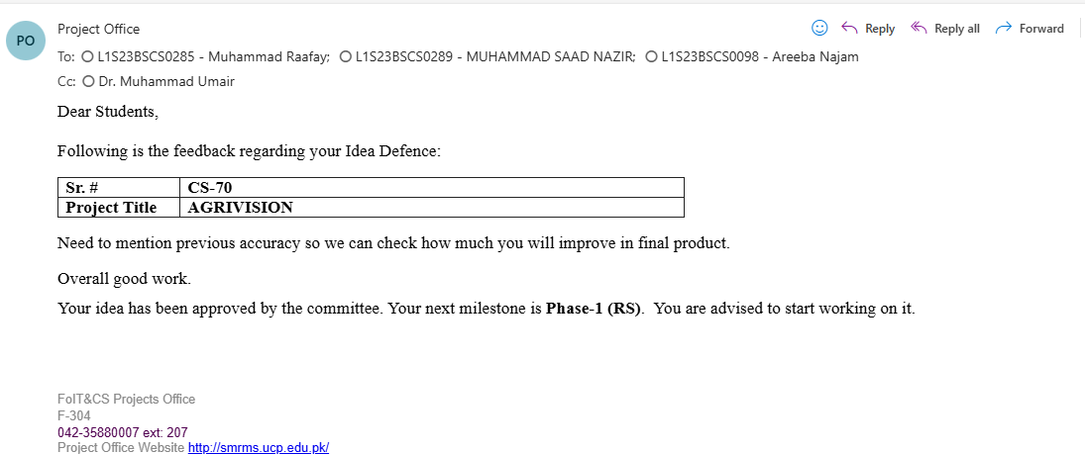

Abstract
Pakistan's agricultural sector contributes approximately 23% to national GDP and employs around 37% of the labor force, making timely crop health monitoring important for food security, resource planning, and agricultural decision-making. Current field-level monitoring practices are often manual, delayed, and limited in geographic coverage. Satellite-based vegetation monitoring provides a scalable alternative, but practical use is constrained by the spatial-temporal trade-off between available sensors. MODIS provides frequent observations but at coarse spatial resolution, while Sentinel-2 provides higher spatial detail but has lower temporal availability due to revisit cycles and cloud cover.
AgriVision addresses this gap through a deep learning-based spatiotemporal fusion approach that combines MODIS and Sentinel-2 NDVI data acquired through Google Earth Engine. The system aims to generate Sentinel-2-like high-resolution NDVI outputs for selected areas within Pakistan while maintaining a research-aware position that 10 m output is a target rather than a guaranteed production claim. Although the system is designed for Pakistan-wide applicability, operational processing is performed through selected AOIs or geospatial tiles to remain feasible within FYP compute, storage, and cloud-access constraints.
The system includes a MERN-based dashboard for farmers, government/planning users, and system administrators. Users can view reconstructed NDVI maps, inspect historical vegetation trends, receive generic NDVI-threshold-based crop stress alerts, and access reports. The model output is evaluated using RMSE, R-squared, SSIM, and PSNR. AgriVision does not diagnose specific causes of crop stress such as pests, disease, nutrient deficiency, or flooding; alerts are treated as generic NDVI anomaly indicators requiring field verification.

System Architecture

High-Level Architecture
AgriVision follows a layered architecture. This style separates the user interface, backend services, geospatial processing, machine learning inference, and persistent storage into distinct layers. The layered approach is appropriate because the system combines web application workflows with computationally intensive geospatial and machine learning tasks. It also supports maintainability by allowing the dashboard, backend API, preprocessing pipeline, and model inference service to evolve independently.
The main layers are:
Layer | Responsibility
Presentation Layer | Provides the React-based web dashboard for AOI selection, NDVI visualization, trend charts, alerts, reports, and role-based navigation.
Backend API Layer | Handles authentication, role-based authorization, request validation, dashboard APIs, metadata access, alert APIs, and report APIs using Node.js and Express.js.
Geospatial Processing Layer | Retrieves MODIS and Sentinel-2 imagery from Google Earth Engine, performs cloud masking, NDVI computation, spatial alignment, and preprocessing.
ML Inference Layer | Hosts the trained deep learning fusion model as a Python inference service. It accepts preprocessed NDVI inputs and returns Sentinel-2-like NDVI outputs.
Data Layer | Stores users, roles, AOIs, satellite request metadata, processed image metadata, NDVI result metadata, alerts, reports, model run logs, and evaluation metrics in MongoDB and associated file/object storage.
External Data Source Layer | Provides MODIS and Sentinel-2 imagery through Google Earth Engine.

Table 1:High Level Architecture

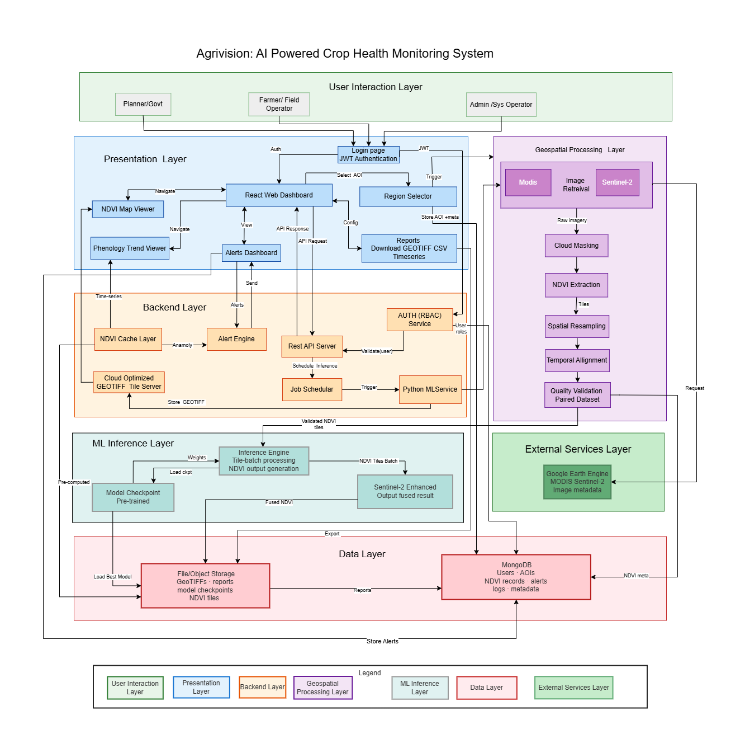
Architecture Diagram
Figure 1 : Architecture Diagram

Component Overview

Component | Description
React Dashboard | User-facing interface for maps, trends, alerts, reports, and role-specific navigation.
Authentication and RBAC Module | Provides JWT-based login and restricts features by Farmer, Planner/Government User, and Admin roles.
AOI Management Module | Allows users/admins to define or select geographic areas within Pakistan for monitoring.
Satellite Data Acquisition Module | Retrieves MODIS and Sentinel-2 imagery from Google Earth Engine for selected AOIs and date ranges.
Preprocessing Module | Applies cloud masking, NDVI computation, spatial alignment, range validation, and preparation of model-ready inputs.
Model Inference Service | Runs the trained deep learning fusion model and generates Sentinel-2-like NDVI outputs.
Alert Engine | Applies NDVI threshold/deviation rules to detect generic vegetation anomaly conditions.
Visualization Module | Renders reconstructed NDVI maps, legends, AOI boundaries, and trend charts.
Report Module | Provides summaries, exports, and evaluation-related outputs for admin and planning use.
MongoDB Database | Stores structured records for users, AOIs, satellite metadata, NDVI results, alerts, reports, and model runs.

Table 2: Components Overview

Mapping Design to User Stories
Story ID | Component | Description
US-01 | AOI Management, Satellite Data Acquisition | Admin defines AOI and date range; system retrieves MODIS and Sentinel-2 data through GEE.
US-02 | Preprocessing Module | System cloud-masks, aligns, and computes NDVI from retrieved satellite imagery.
US-03 | Model Inference Service | System generates Sentinel-2-like NDVI maps from preprocessed MODIS/Sentinel-2 inputs.
US-04 | Evaluation Module | Admin compares generated NDVI outputs with available Sentinel-2 reference imagery using evaluation metrics.
US-05 | Evaluation Module, Report Module | System computes RMSE, R-squared, SSIM, and PSNR for academic validation and reporting.
US-06 | Alert Engine, Dashboard | Farmer receives a generic NDVI anomaly alert when vegetation health drops below configured threshold rules.
US-07 | Visualization Module | Farmer or Planner views reconstructed NDVI map for selected AOI and date.
US-08 | Trend Module | Planner views historical NDVI trends for selected AOI and date range.
US-09 | Report Module | Admin or Planner exports maps, summaries, and reports in supported formats.
US-10 | Authentication and RBAC Module | Users log in and access only role-appropriate dashboard features.
Table 3:User Stories

Detailed System Design

Module Decomposition

User and Role Management Module
This module handles user registration, login, JWT generation, session validation, and role-based access. The confirmed roles are Farmer, Planner/Government User, and Admin. Farmers access NDVI maps, trends, and alerts for assigned AOIs. Planner/Government Users access broader trend summaries and reports. Admins manage AOIs, run metadata, model runs, evaluation outputs, and system-level operations.

AOI Management Module
This module stores geographic AOIs within Pakistan. Since the confirmed scope is whole Pakistan, the system must support AOI-based or tile-based processing rather than assuming that the entire country is processed as one job. AOIs may represent farms, administrative regions, or processing tiles.

Satellite Data Acquisition Module
This module communicates with Google Earth Engine to retrieve MODIS and Sentinel-2 imagery for selected AOIs and date ranges. It stores request metadata, source identifiers, acquisition dates, cloud-cover information where available, and retrieval status.

Preprocessing and NDVI Module
This module applies cloud masking, band selection, NDVI computation, spatial alignment, resampling, and range validation. NDVI values must remain within the valid range of [-1, 1]. Outputs from this module are used by the model inference service.

Model Inference Module
This module hosts the deep learning-based spatiotemporal fusion model. The final architecture is not yet selected and may be CNN-based, GAN-based, Transformer-based, or another literature-supported architecture. The Phase 2 design therefore treats the model as a replaceable inference service with defined inputs and outputs. The service accepts preprocessed NDVI inputs and returns Sentinel-2-like NDVI output for the selected target date and AOI.

Evaluation Module
This module computes RMSE, R-squared, SSIM, and PSNR where reference Sentinel-2 imagery is available. It is an internal academic/admin function, not a separate target-user workflow for researchers.

Alert Module
This module applies configurable NDVI threshold or deviation rules to detect generic vegetation anomalies. It does not diagnose pest attack, disease, nutrient deficiency, or flooding. Alerts include AOI, date, severity, NDVI value or deviation, confidence/quality notes where available, and a recommendation to verify conditions in the field.

Visualization and Reporting Module
This module displays NDVI maps, legends, AOI overlays, historical trend charts, alert history, and reports. It supports dashboard interpretation by non-specialist users.

Data Flow Description
1. A user logs in through the React dashboard.
2. The backend verifies the JWT and applies role-based access control.
3. The user or admin selects an AOI within Pakistan and a target date/date range.
4. The backend creates a satellite processing request and stores request metadata.
5. The data acquisition module retrieves MODIS and Sentinel-2 imagery from Google Earth Engine.
6. The preprocessing module applies cloud masking, computes NDVI, validates the NDVI range, and aligns sensor data.
7. The model inference service receives preprocessed input and generates a Sentinel-2-like high-resolution NDVI output.
8. The system stores NDVI result metadata, file references, model run information, and processing status.
9. The alert engine evaluates NDVI values against configured threshold/deviation rules and creates generic crop stress alerts if needed.
10. The dashboard displays NDVI maps, legends, trend charts, alerts, and reports to authorized users.

UML Diagrams

- Use Case Diagram:

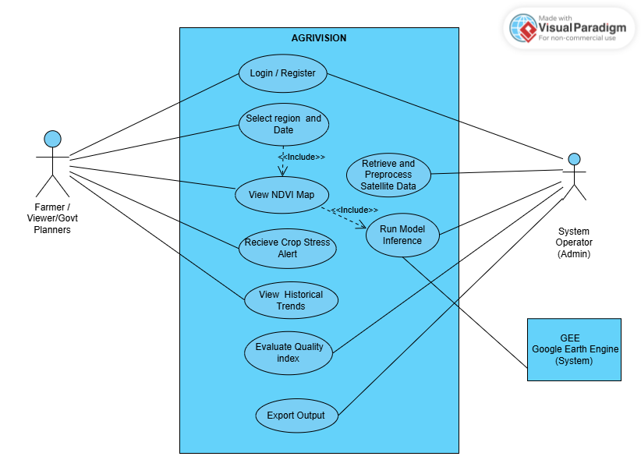
Figure 2: Use case diagram

- Class Diagram:

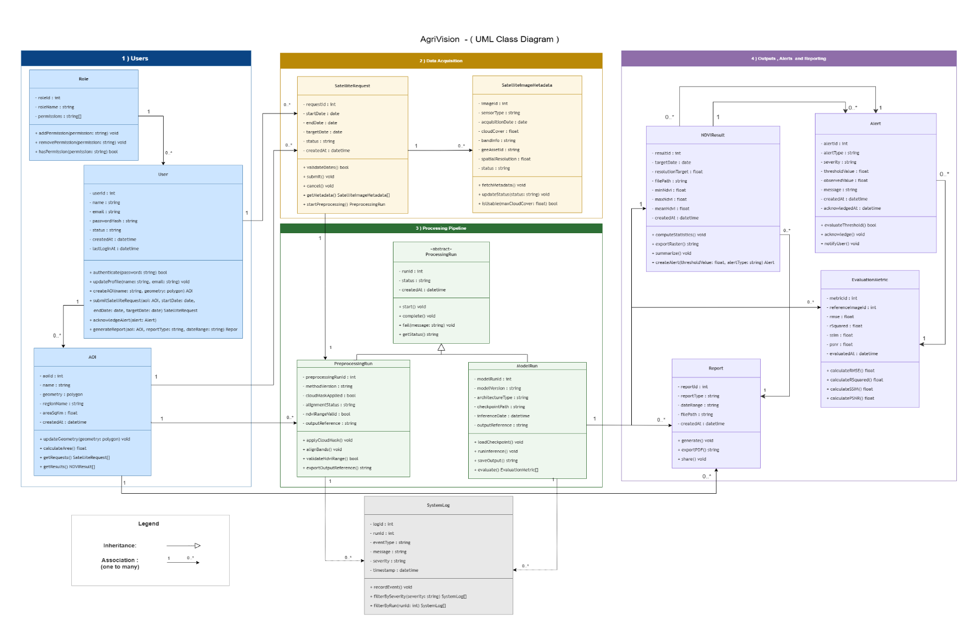

Figure 3:Class Diagram

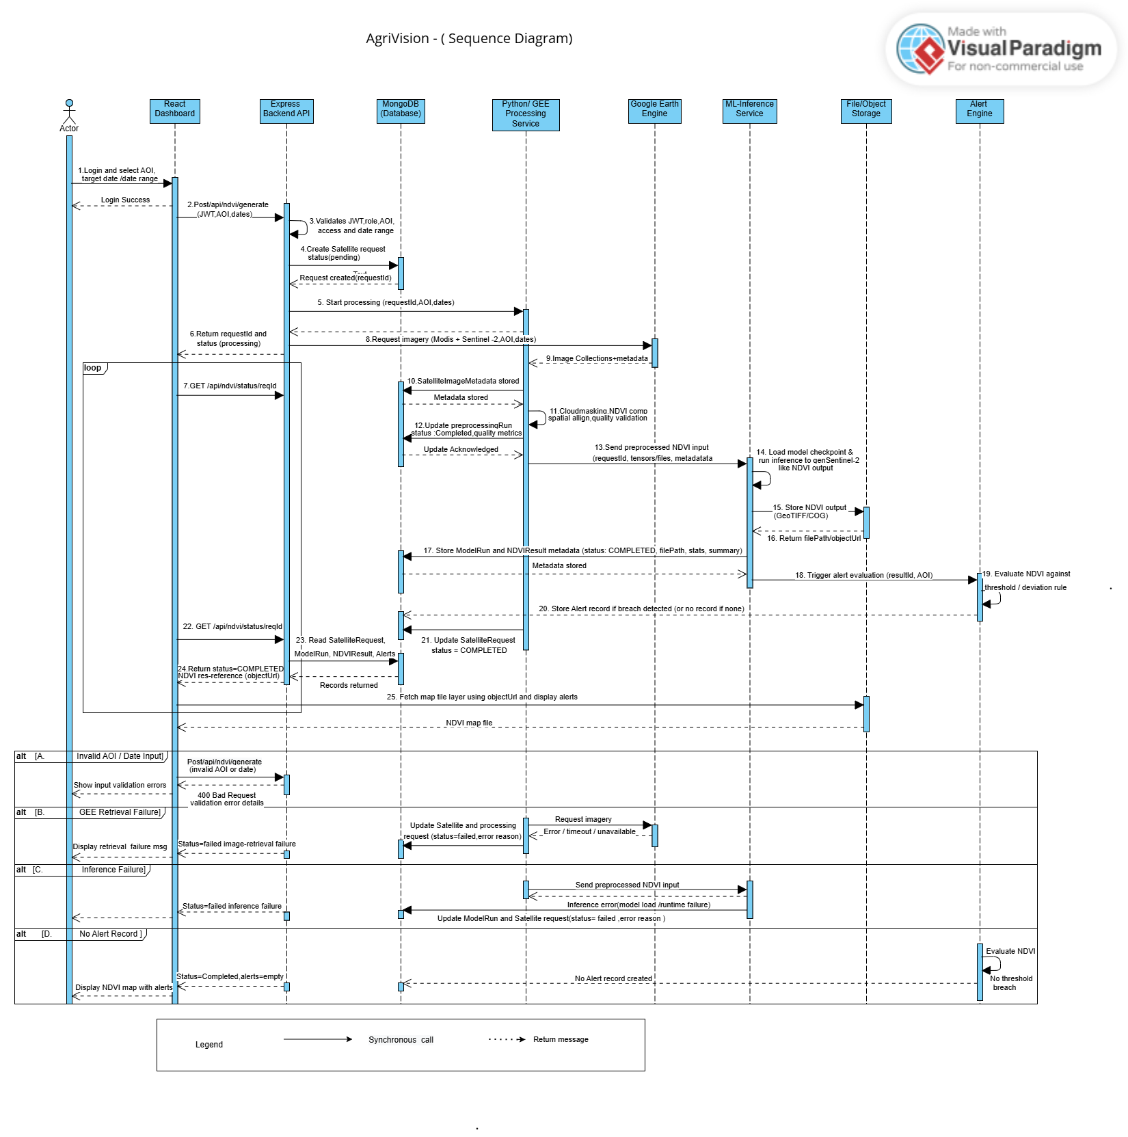
- Sequence Diagram:
Figure 4: Sequence Diagram

Database Design (ERD)

ER Diagram

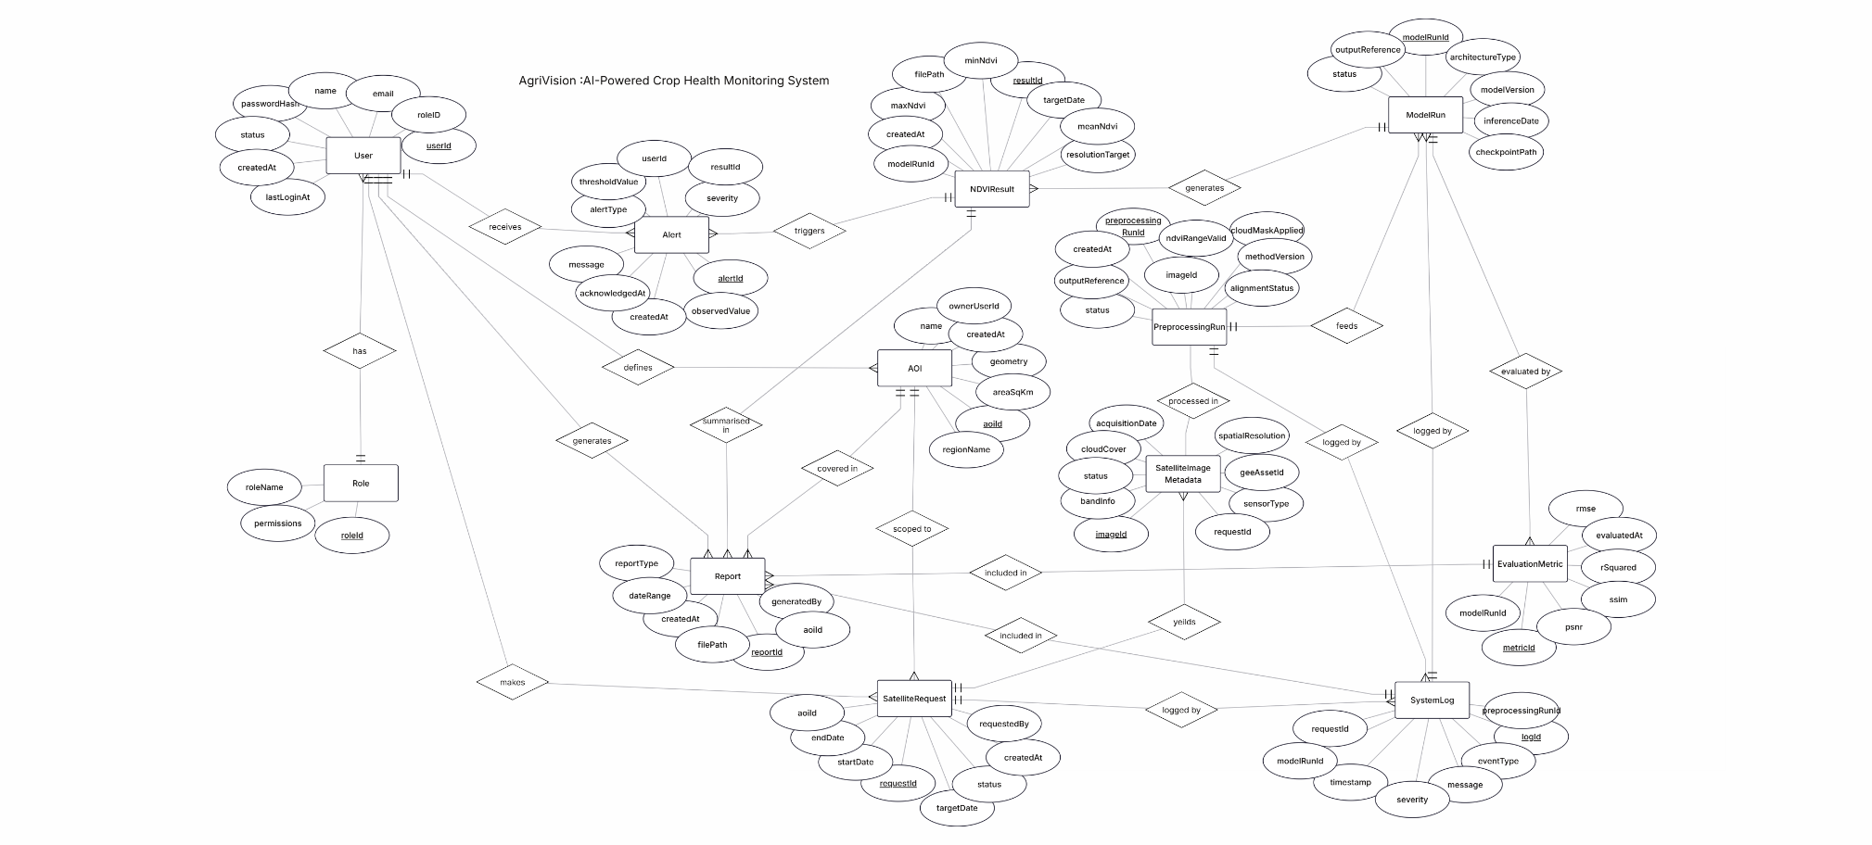
Figure 4:Entity Relationship Diagram

Schema Tables
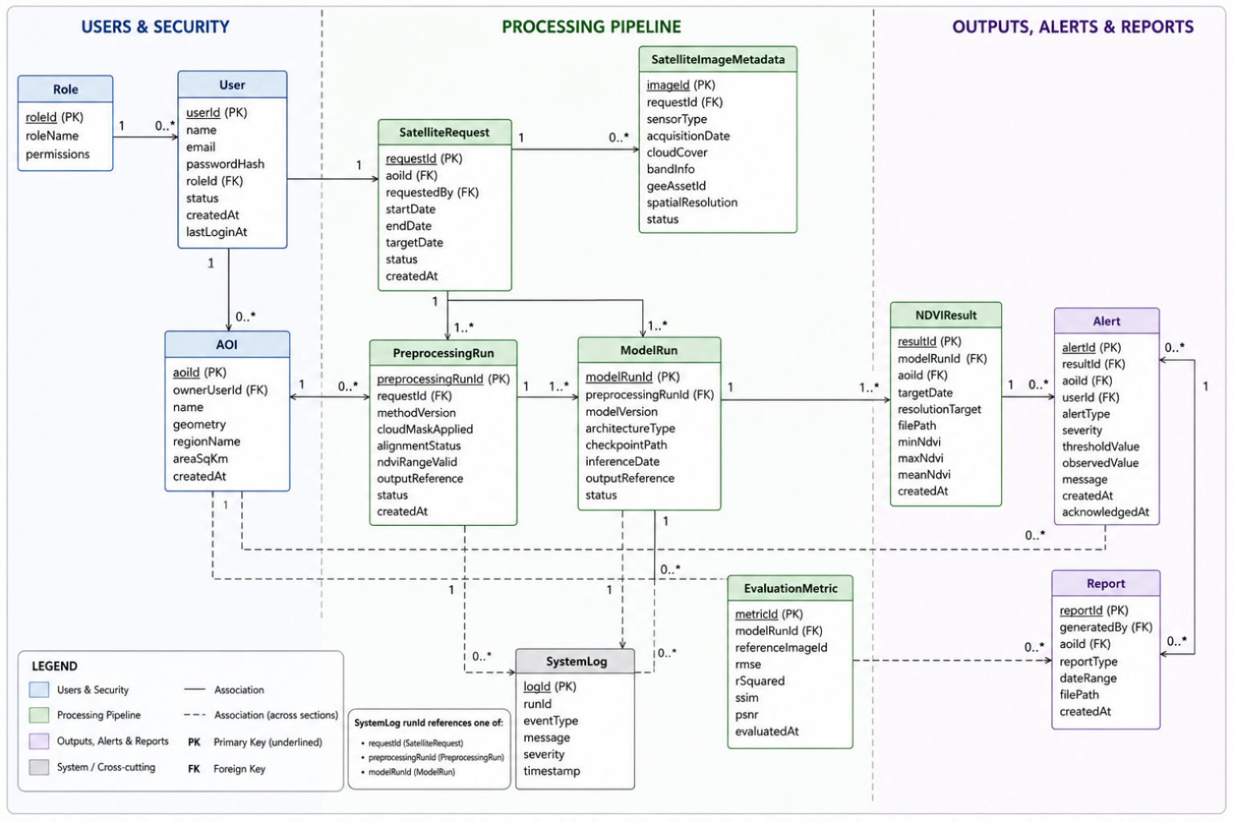

Figure 5: Schema Tables

API Design
API Group | Endpoint | Method | Input | Output
Authentication APIs | /api/auth/register | POST | name, email, password, requestedRole | user profile, pending/created status
Authentication APIs | /api/auth/login | POST | email, password | JWT token, user profile, role
Authentication APIs | /api/auth/me | GET | JWT token | current user profile
Authentication APIs | /api/auth/logout | POST | JWT token | logout status
User and Role APIs | /api/users | GET | filters: role, status | user list
User and Role APIs | /api/users/:userId | GET | userId | user details
User and Role APIs | /api/users/:userId/role | PATCH | roleId | updated user role
User and Role APIs | /api/users/:userId/status | PATCH | status | updated user status
User and Role APIs | /api/roles | GET | none | role list and permissions
AOI APIs | /api/aois | POST | name, geometry, regionName, assignedUsers | created AOI
AOI APIs | /api/aois | GET | filters: regionName, ownerUserId | AOI list
AOI APIs | /api/aois/:aoiId | GET | aoiId | AOI details
AOI APIs | /api/aois/:aoiId | PATCH | name, geometry, assignedUsers | updated AOI
AOI APIs | /api/aois/:aoiId | DELETE | aoiId | deletion/archive status
Satellite Request APIs | /api/satellite-requests | POST | aoiId, startDate, endDate, targetDate | requestId, status
Satellite Request APIs | /api/satellite-requests | GET | filters: status, aoiId, dateRange | request list
Satellite Request APIs | /api/satellite-requests/:requestId | GET | requestId | request details, image metadata summary
Satellite Request APIs | /api/satellite-requests/:requestId/status | GET | requestId | current processing status
Processing and Inference APIs | /api/processing/:requestId/preprocess | POST | requestId | preprocessingRunId, status
Processing and Inference APIs | /api/inference | POST | preprocessingRunId, optional modelVersion | modelRunId, status
Processing and Inference APIs | /api/model-runs | GET | filters: status, modelVersion, aoiId | model run list
Processing and Inference APIs | /api/model-runs/:modelRunId | GET | modelRunId | model run metadata
NDVI Result APIs | /api/ndvi-results | GET | filters: aoiId, dateRange | NDVI result metadata list
NDVI Result APIs | /api/ndvi-results/:resultId | GET | resultId | NDVI result metadata and file references
NDVI Result APIs | /api/ndvi-results/:resultId/map | GET | resultId | map tile, reference, or preview URL
NDVI Result APIs | /api/ndvi-results/:resultId/download | GET | format: PNG or GeoTIFF | downloadable NDVI file
Alert APIs | /api/alerts | GET | filters: aoiId, severity, acknowledged | alert list
Alert APIs | /api/alerts/:alertId | GET | alertId | alert details
Alert APIs | /api/alerts/:alertId/acknowledge | PATCH | optional acknowledgement note | updated alert
Alert APIs | /api/admin/alert-rules | GET | none | threshold rules
Alert APIs | /api/admin/alert-rules | PATCH | threshold values, severity rules | updated rules
Report APIs | /api/reports | POST | reportType, aoiId, dateRange, format | reportId, status
Report APIs | /api/reports | GET | filters: reportType, aoiId, dateRange | report list
Report APIs | /api/reports/:reportId | GET | reportId | report metadata
Report APIs | /api/reports/:reportId/download | GET | reportId | downloadable PDF, CSV, PNG, or GeoTIFF
Admin / Evaluation APIs | /api/evaluations | POST | modelRunId, referenceImageId | evaluationId, status
Admin / Evaluation APIs | /api/evaluations | GET | filters: modelRunId, aoiId, dateRange | evaluation metric list
Admin / Evaluation APIs | /api/evaluations/:evaluationId | GET | evaluationId | RMSE, R-squared, SSIM, PSNR
Log APIs | /api/logs | GET | filters: severity, runId, dateRange | system logs
Log APIs | /api/logs/:logId | GET | logId | log detail
Table 4:API Design

UI/UX Design (Prototypes)
- Wireframes:
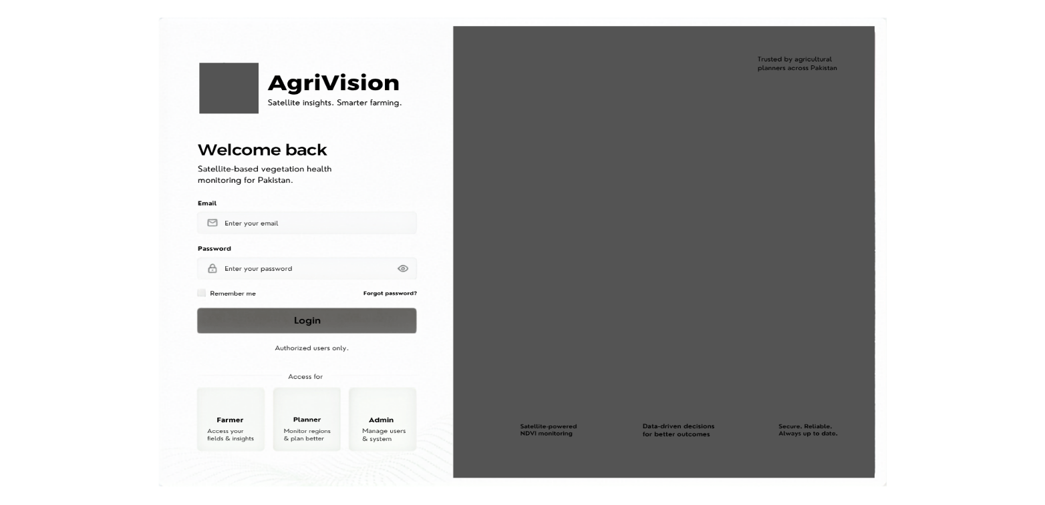
signup page:
Figure 6: Sign-up page wireframe
dashboard/Homepage:
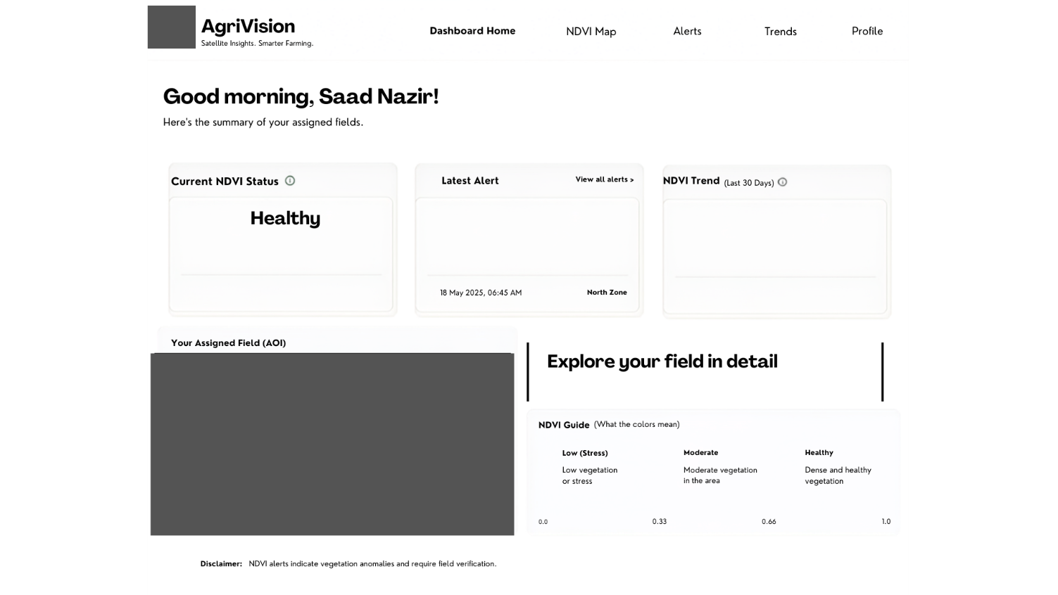
Figure 7:Dashboard wireframe
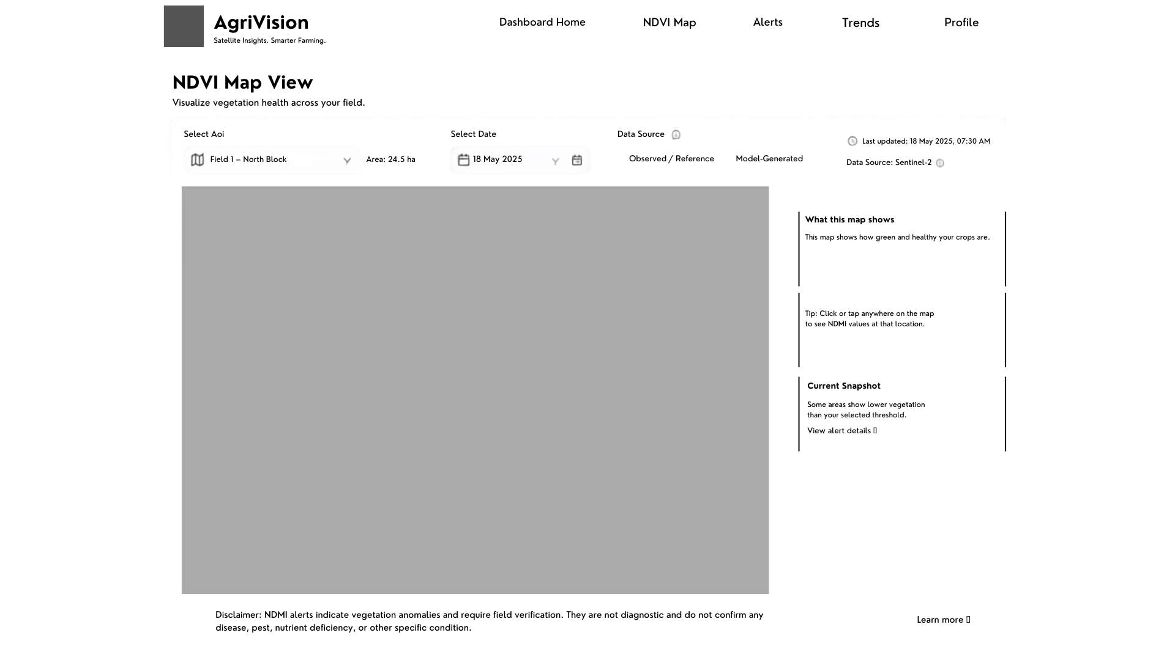
ndvi maps page:
Figure 8:NDVI Maps wireframe
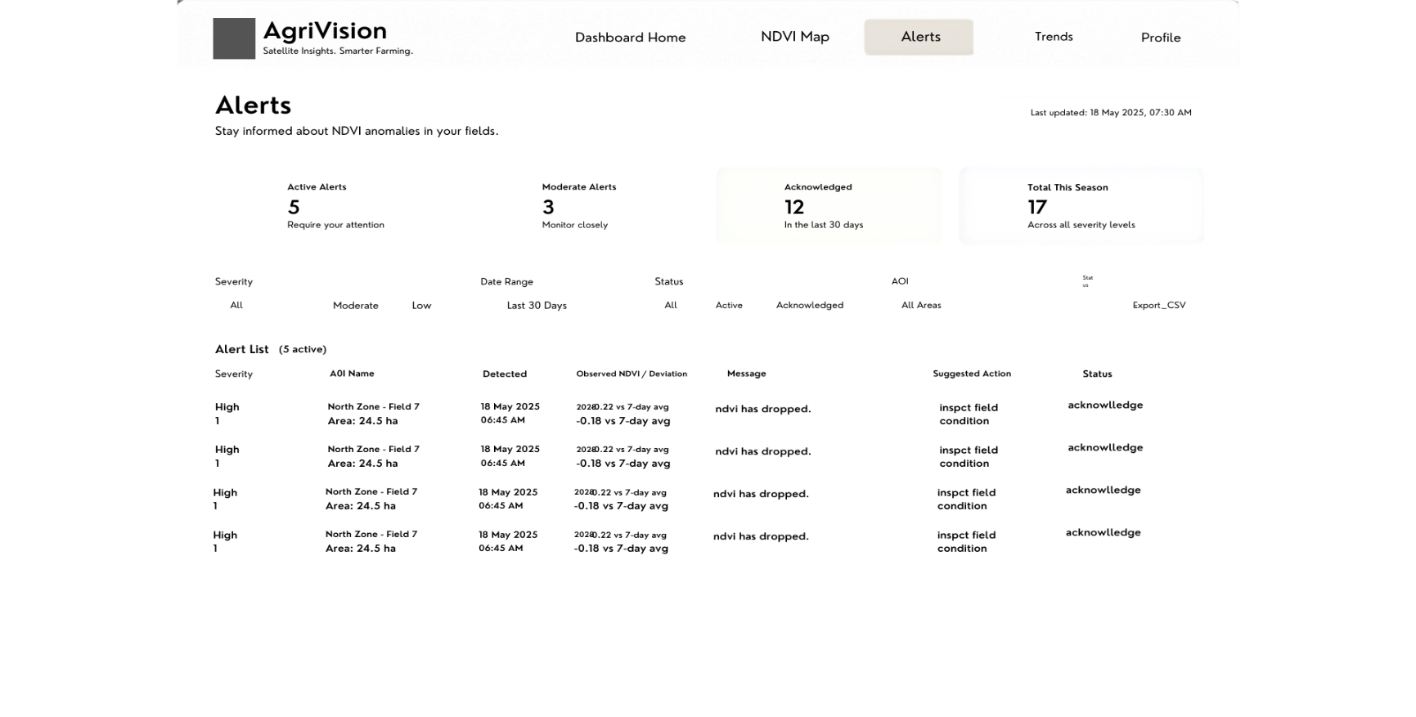
alerts page:
Figure 9:Alerts wireframe
Trends Page:
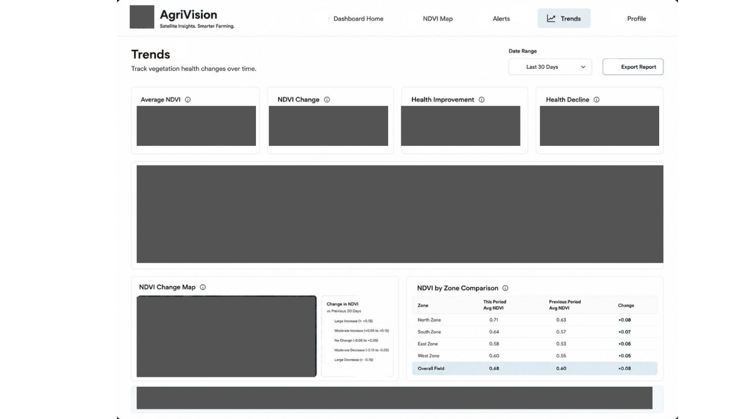
Figure 10:Trends wireframe
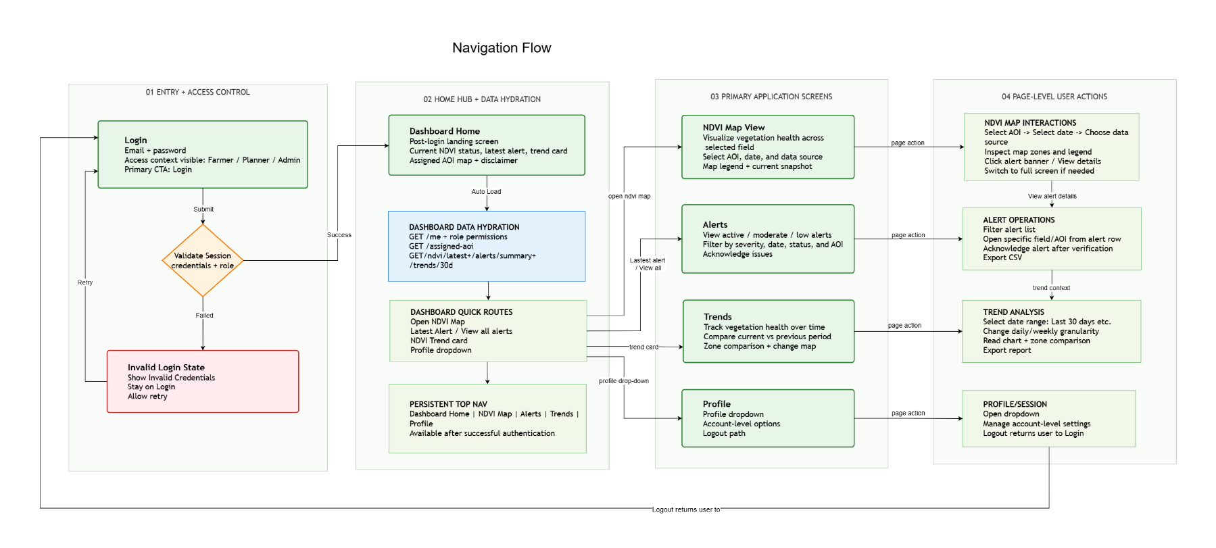
- Navigation Flow: A flowchart showing how a user gets from Screen A to Screen B.
Figure 11: Navigation Flow

- Screens:
Signup page:
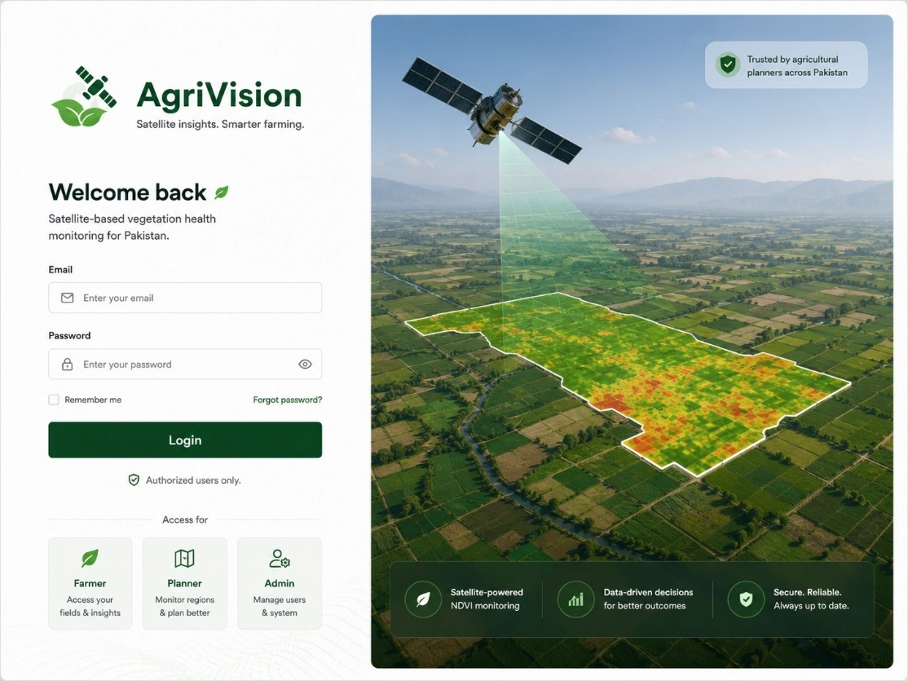
Figure 12:Signup

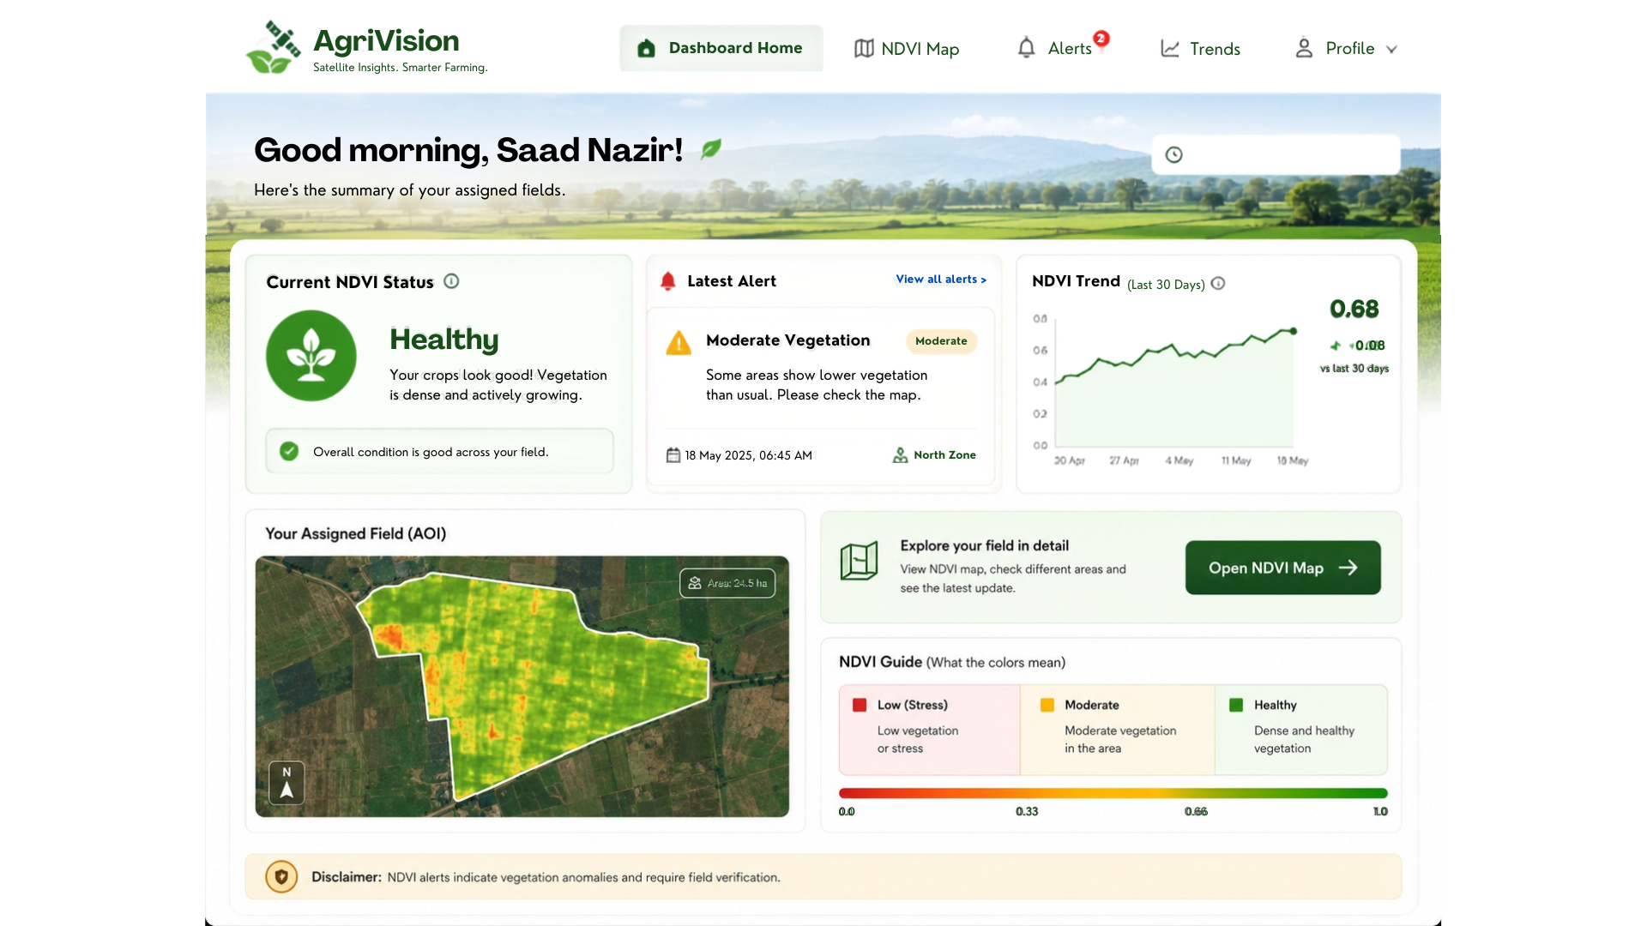
Dashboard/ Homepage:
Figure 13:Dashboard

NDVI maps page:

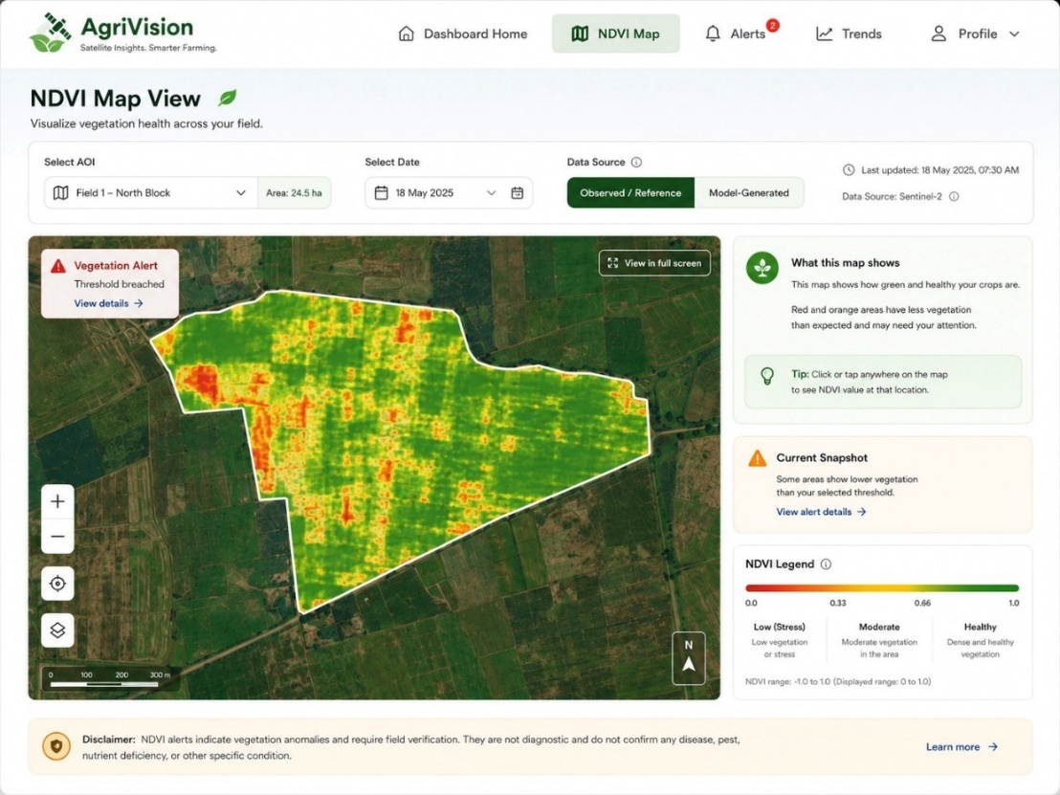

Figure 14:NDVI Maps

Alertspage:
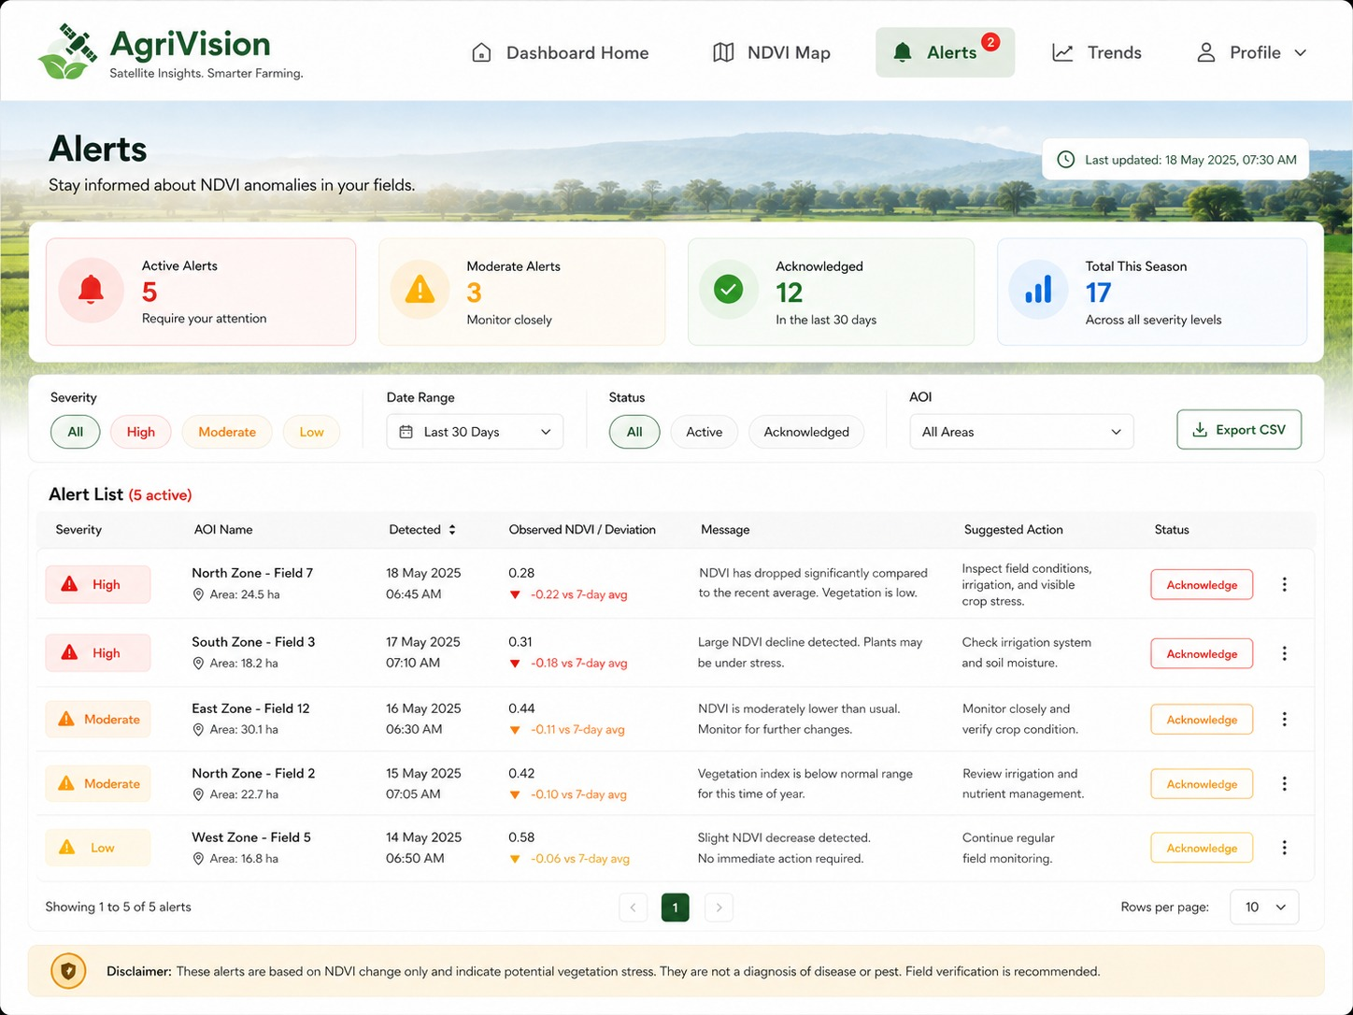
Figure 15:Alerts page

Trends Page:
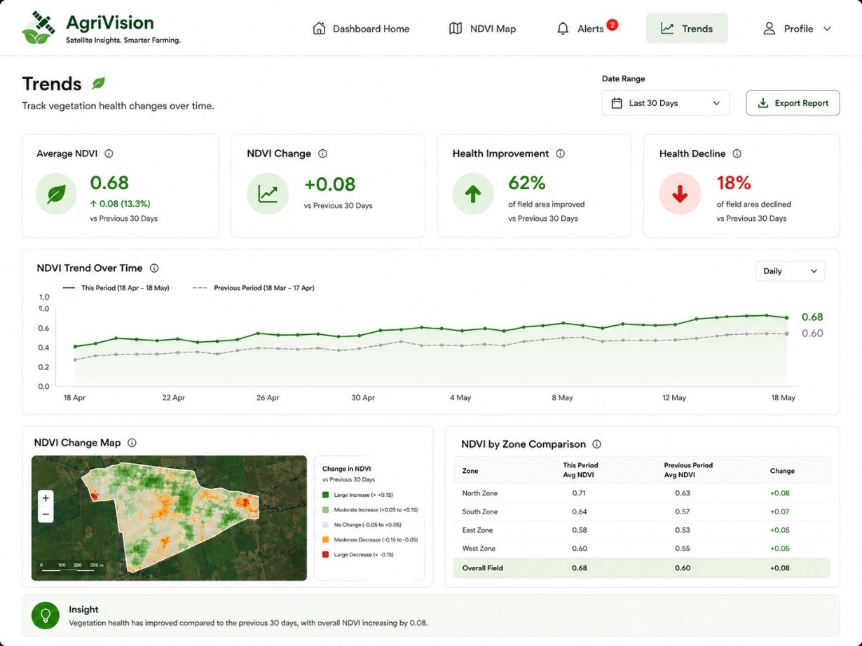
Figure 16:Trends

Sprint-wise Design Evolution
Sprint | Features Designed | Improvements / Design Evolution
Sprint 1 | Literature review and initial SRS structure | Project problem, stakeholder needs, and initial scope were documented.
Sprint 2 | System architecture, dataset, and tools | MODIS and Sentinel-2 through Google Earth Engine were selected as core data sources.
Sprint 3 | GEE access and retrieval pipeline | Satellite acquisition was separated from preprocessing for maintainability.
Sprint 4 | Preprocessing and NDVI generation | Cloud masking, NDVI computation, and alignment were defined as explicit modules.
Sprint 5 | Preprocessing validation | Quality checks were added for NDVI range, alignment, and cloud-contaminated inputs.
Sprint 6 | Training dataset preparation | Patch/tile-based processing was adopted to support Pakistan-wide scope realistically.
Sprint 7 | Deep learning architecture design | Model architecture kept candidate-based until literature review and experiments finalize it.
Table 5:Sprint-wise designs

Test Design

Test ID | Scenario | Expected Result | Related Module
TC-01 | Enter valid email/password and submit login form. | JWT token issued; user redirected to role-specific dashboard. | Authentication
TC-02 | Enter wrong password. | System rejects login and displays clear error message. | Authentication
TC-03 | Login as Farmer and attempt to access admin processing page. | Access denied; no admin data exposed. | RBAC
TC-04 | Admin selects valid AOI within Pakistan and valid date range. | System accepts AOI/date and creates satellite request. | AOI Management
TC-05 | Submit AOI outside Pakistan or malformed geometry. | System rejects request with validation error. | AOI Management
TC-06 | Trigger retrieval for valid AOI/date range. | MODIS and Sentinel-2 metadata returned and stored. | Satellite Data Acquisition
TC-07 | Simulate GEE API failure or quota issue. | Request marked failed; clear error logged and shown to admin. | Satellite Data Acquisition
TC-08 | Run preprocessing on image with cloud-contaminated pixels. | Cloudy pixels are masked or marked NoData according to preprocessing rule. | Preprocessing
TC-09 | Run NDVI computation on valid input bands. | NDVI values remain within [-1, 1]. Invalid values are flagged. | Preprocessing
TC-10 | Process MODIS and Sentinel-2 imagery for same AOI. | Outputs are aligned to the target grid within accepted tolerance. | Preprocessing
TC-11 | Submit valid preprocessed input to inference service. | ModelRun created; NDVI output reference returned; no runtime retraining triggered. | ML Inference
TC-12 | Submit missing or malformed preprocessing reference. | Inference request rejected with descriptive error. | ML Inference
TC-13 | Open NDVI result in dashboard. | Map preview/reference loads with legend and AOI boundary. | Visualization
TC-14 | Provide NDVI result below configured threshold. | Generic NDVI anomaly alert created and stored. | Alert Engine
TC-15 | Provide low-quality/cloud-contaminated input if quality threshold fails. | Alert is suppressed or marked low confidence according to rule. | Alert Engine
TC-16 | Farmer acknowledges alert. | Alert status updates and acknowledgement timestamp is stored. | Alerts
TC-17 | Select AOI and date range with available NDVI results. | Chart renders correct time axis and NDVI values. | Trend Visualization
TC-18 | Planner requests summary report for AOI/date range. | Report metadata created and downloadable file generated. | Reports
TC-19 | Admin evaluates model output against reference Sentinel-2 image. | RMSE, R-squared, SSIM, and PSNR are calculated and stored. | Evaluation
TC-20 | Inspect a completed NDVI result. | Result links to requestId, preprocessingRunId, modelRunId, source metadata, and output file. | Traceability

Table 6:Test Designs

Design Quality Attributes

Reliability
The system should log each processing request with status values such as pending, processing, completed, failed, or partially completed. If the inference service fails, the dashboard should show a meaningful error or the latest valid output instead of displaying misleading blank results. All generated NDVI outputs must be associated with their source data and model run metadata.

Performance
The system should avoid processing the entire country as a single job. Pakistan-wide support should be implemented through AOI-based or tile-based workflows. Dashboard map rendering should be optimized for selected AOIs, and large outputs should be loaded through stored raster references or map tiles rather than raw arrays in API responses.

Usability
The dashboard should be interpretable by non-specialist users. NDVI maps should use clear legends, color scales, labels, and explanations. Alerts should use simple language and must clearly state that they indicate generic NDVI anomalies rather than confirmed disease, pest, nutrient, or flood conditions.

Security
The system uses JWT authentication and role-based access control. Farmers, Planner/Government Users, and Admins must have different permissions. GEE credentials, database connection strings, JWT secrets, and model file paths must be stored in environment variables and excluded from source code.

Maintainability
The system is decomposed into independent modules for frontend, backend API, geospatial preprocessing, ML inference, alerts, reporting, and storage. The model inference service is treated as replaceable so that the final architecture can be updated after literature review without redesigning the entire dashboard.

Traceability
Each inference run should be linked to AOI, target date, source imagery metadata, preprocessing version, model version, output file path, and evaluation metrics where available.

Scalability
The architecture supports Pakistan-wide applicability by allowing AOI/tile-based processing. Future scaling can add batch queues, object storage, map tile services, and distributed processing.

Deployment Considerations
- Hosting: Frontend on Vercel or Netlify, Backend API on Render or Railway, Model on Hugging Face Inference Endpoint.
- Database: Mongodb
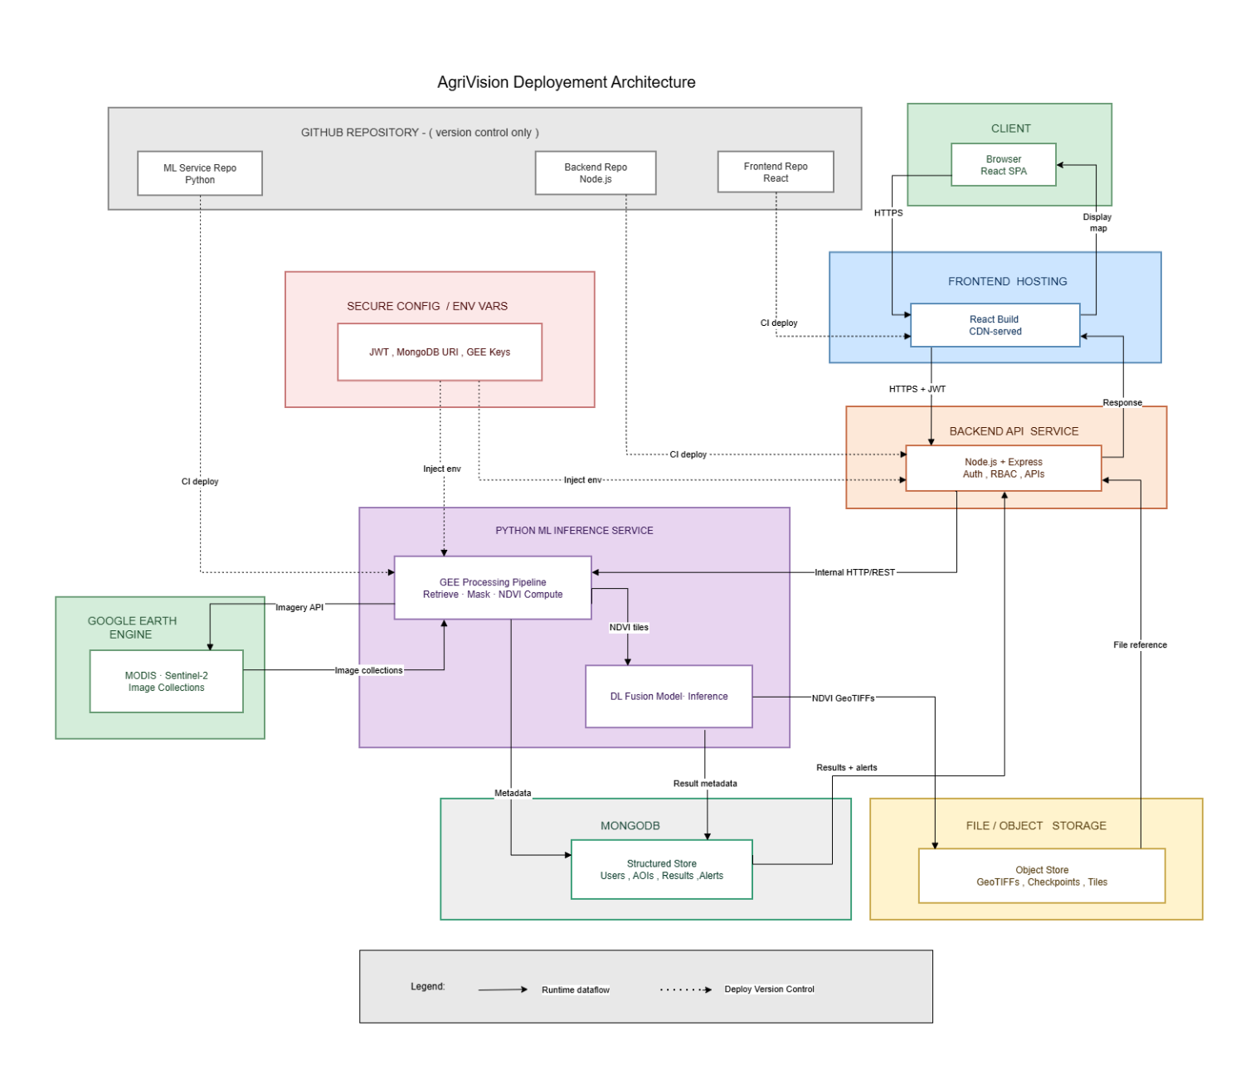
- Version Control: Github repository
Fig 17:Deployement Considerations

Future Enhancements
Although all the required modules are included, but if we were to enhance the app experience, the following two modules could have been added:
- AI chatbot support to guide users about NDVI results, alerts, and crop condition reports.
- Multi-lingual voice support module with which illiterate users could also interact with.

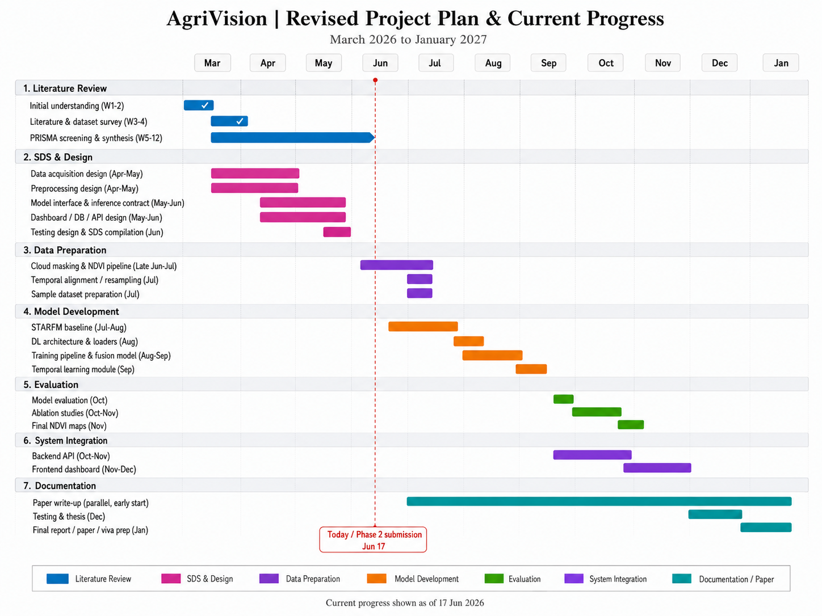
Revised Project Plan
Fig 18:Revised plan

References
[1] World Bank, "Pakistan: Country Overview," World Bank Group. [Online]. Available: https://www.worldbank.org/en/country/pakistan/overview
[2] M. Ali and S. Ahmad, "Agriculture sector performance and its role in Pakistan's economy," Asian J. Agric. Rural Dev., vol. 13, no. 2, pp. 85-97, 2023.
[3] J. W. Rouse, R. H. Haas, J. A. Schell, and D. W. Deering, "Monitoring vegetation systems in the Great Plains with ERTS," in Proc. Third ERTS Symp., NASA SP-351, vol. 1, 1973, pp. 309-317.
[4] F. Gao, J. Masek, M. Schwaller, and F. Hall, "On the blending of the Landsat and MODIS surface reflectance: predicting daily Landsat surface reflectance," IEEE Trans. Geosci. Remote Sens., vol. 44, no. 8, pp. 2207-2218, 2006. DOI: 10.1109/TGRS.2006.872081.
[5] B. Mishra and T. B. Shahi, "Deep learning-based framework for spatiotemporal data fusion: an instance of Landsat 8 and Sentinel-2 NDVI," J. Appl. Remote Sens., vol. 15, no. 3, p. 034520, 2021. DOI: 10.1117/1.JRS.15.034520.
[6] Z. Ao, Y. Sun, and Q. Xin, "Constructing 10-m NDVI time series from Landsat 8 and Sentinel-2 images using CNNs," IEEE Geosci. Remote Sens. Lett., vol. 18, no. 4, pp. 589-593, 2021. DOI: 10.1109/LGRS.2020.3003322.
[7] X. Zhu, E. H. Helmer, F. Gao, D. Liu, J. Chen, and M. A. Lefsky, "A flexible spatiotemporal method for fusing satellite images with different resolutions," Remote Sens. Environ., vol. 172, pp. 165-177, 2016. DOI: 10.1016/j.rse.2015.11.016.
[8] X. Zhu, J. Chen, F. Gao, X. Chen, and J. G. Masek, "An enhanced spatial and temporal adaptive reflectance fusion model for complex heterogeneous regions," Remote Sens. Environ., vol. 114, no. 11, pp. 2610-2623, 2010. DOI: 10.1016/j.rse.2010.05.032.
[9] Q. Wang and P. M. Atkinson, "Spatio-temporal fusion for daily Sentinel-2 images," Remote Sens. Environ., vol. 204, pp. 31-42, 2018. DOI: 10.1016/j.rse.2017.10.046.
[10] H. Song, Q. Liu, G. Wang, R. Hang, and B. Huang, "Spatiotemporal satellite image fusion using deep convolutional neural networks," IEEE J. Sel. Top. Appl. Earth Observ. Remote Sens., vol. 11, no. 3, pp. 821–829, 2018. DOI: 10.1109/JSTARS.2018.2797894.
[11] Z. Lian et al., "Recent advances in deep learning-based spatiotemporal fusion methods for remote sensing images," Sensors, vol. 25, no. 4, p. 1093, 2025. DOI: 10.3390/s25041093.
[12] Z. Gu et al., "Agri-Fuse: A novel spatiotemporal fusion method for agricultural scenarios with diverse phenological changes," Remote Sens. Environ., vol. 299, p. 113874, 2023. DOI: 10.1016/j.rse.2023.113874.
[13] Q. Cheng, R. Xie, J. Wu, and F. Ye, "Deep learning-based spatiotemporal fusion of Landsat 8 and Sentinel-2 data for 10 m series imagery," Remote Sensing, vol. 16, no. 6, p. 1033, 2024. DOI: 10.3390/rs16061033.
[14] Z. Lian et al., "Recent advances in deep learning-based STF methods for remote sensing images," Sensors, vol. 25, no. 4, p. 1093, 2025. DOI: 10.3390/s25041093.
[15] P. Mu and F. Tian, "Spatiotemporal fusion of multi-temporal MODIS and Landsat-8/9 imagery for enhanced daily 30 m NDVI reconstruction," Remote Sensing, vol. 17, no. 9, p. 1510, 2025. DOI: 10.3390/rs17091510.
[16] G. Rahman, S. Khalid, S. ArshaM. F. Ul Moazzam, and H.-H. Kwon, "Remote sensing-based spatiotemporal assessment of agricultural drought and its impact on crop yields in Punjab, Pakistan," Sci. Rep., 2025. DOI: 10.1038/s41598-025-06095-6
[17] M. Weiss, F. Jacob, and G. Duveiller, "Remote sensing for agricultural applications: A meta-review," Remote Sens. Environ., vol. 236, p. 111402, 2020. DOI: 10.1016/j.rse.2019.111402
[18] Y. Hu et al., “Comparative analysis and comprehensive trade-off of four spatiotemporal fusion models for NDVI generation,” Remote Sensing, vol. 14, no. 23, p. 5996, 2022.
[19] M. Z. et al., STARFM/STVIFM comparative NDVI fusion study, Remote Sensing of Environment / MDPI dataset evaluations, 2022.

Appendix A: Glossary
The following terms and acronyms are used throughout this document.
Term / Acronym | Definition
AOI | Area of Interest: the geographic polygon defining the agricultural region selected for satellite data retrieval, inference, and dashboard monitoring.
CNN | Convolutional Neural Network: the deep learning architecture used for spatiotemporal fusion. Trained once offline and deployed as a static inference service.
FSDAF | Flexible Spatiotemporal Data Fusion: a classical hybrid fusion method used as a comparison baseline [7].
Fit-FC | A spatiotemporal fusion method using regression model fitting, spatial filtering, and residual compensation; used as a comparison baseline [9].
Frozen Model | A trained neural network whose weights are fixed and not updated during deployment. Inference passes inputs through fixed weights only.
GEE | Google Earth Engine: cloud-based geospatial analysis platform used for satellite data retrieval and preprocessing.
JWT | JSON Web Token: compact, signed token used for secure REST API authentication.
MERN | MongoDB, Express, React, Node.js: the fullstack web framework used for the AgriVision dashboard.
MODIS | Moderate Resolution Imaging Spectroradiometer: a NASA sensor providing ~500 m daily global coverage.
NDVI | Normalised Difference Vegetation Index: vegetation health indicator from red and NIR satellite bands, ranging from -1 to +1.
PSNR | Peak Signal-to-Noise Ratio: image quality metric measuring reconstruction fidelity relative to noise (dB). Higher is better.
RBAC | Role-Based Access Control: access control mechanism restricting system features by assigned user role.
R² | Coefficient of Determination: statistical measure of how well predicted values explain variance in the reference data. Ranges from 0 to 1.
RMSE | Root Mean Square Error: square root of mean squared pixel-level differences between predicted and reference NDVI. Lower is better.
Sentinel-2 | ESA satellite providing 10-20 m multispectral imagery with a five-day revisit cycle under cloud-free conditions.
SSIM | Structural Similarity Index: image quality metric assessing luminance, contrast, and structural fidelity. Ranges from 0 to 1.
STARFM | Spatial and Temporal Adaptive Reflectance Fusion Model: foundational classical STF algorithm [4].
Static Model | See Frozen Model. Contrasted with a dynamic or online-learning system that retrains during deployment.
STF | Spatiotemporal Fusion: techniques combining multi-resolution satellite datasets to produce dense high-resolution time series.

Appendix B: IV & V Report
(Independent verification & validation)
IV & V Resource

Name Signature

S# | Defect Description | Origin Stage | Status | Fix Time
 |  |  |  | Hours | Minutes
1
2
3
…
Table 9: List of non-trivial defects

 |  |  | University of Central Punjab  (Incorporated by Ordinance No. XXIV of 2002 promulgated by Government of the Punjab)  Faculty of Information Technology and Computer Science
 |  | Semester wise SDP Meeting Report
 |  | Group ID |  | Student Roll Number |  |  |  |  | Student Name and Signatures |  | Advisor
 | Sr. | Date |  | Status (P/A/L) |  |  |  |  | Agenda Items | Notes
 |  |  |  | Student 1 | Student 2 |  | Student 3
 | 1
 | 2
 | 3
 | 4
 | 5
 | 6
 | 7
 | 8
 | 9
 | 10
 | 11
 | 12
 | 13
 |  | Date: |  |  | Advisor's Signatures: |  |  |  | ________________________________

