Meta Title: Professional Book Editing & Proofreading Services | The Pulp House Publishing
Meta Description: Get expert book editing and proofreading services trusted by indie authors in the US. We polish grammar, structure, clarity, and consistency. Contact us today!
Main Keywords LSI Keywords
Hero Section

You Know Your Story Is Good… So Why Doesn’t It Read Like It Yet?

Get Professional Book Editing & Proofreading Services for Indie Authors Here!

We connect you with expect book editors and proofreaders that provide human-first editing. Once your manuscript is polished, all you have to do is hit 'Publish my book'.
CTA: Start Editing Today

Problem and Solution Breakdown

You've Reread It 100 Times. That's Why You Can't See the Mistakes.

Many authors struggle with overlooked grammar mistakes, awkward phrasing, inconsistent tone, confusing sentences, and small errors that distract readers. This is because you are too close the manuscript.

We Provide the Second Perspective to You

Go beyond software. Work with our professional editorial team to eliminate blind spots, refine your voice, and guarantee your powerful story is flawless and ready for success.
CTA: Hire a Book Editor

Banner

Top Book Editing & Proofreading Service in the U.S. Trusted by Thousands of Indie Authors
At The Pulp House Publishing, you receive expert editors, consistent communication, and exceptional results. We transform your manuscript to a polished, professional, reader-ready book.
CTA: Edit my Book

Service Overview

What Our Book Editing Services Include
(Display these qualities in small boxes)
With our editor service for fiction and non-fiction books, you can have a manuscript that is ready for publication.

Line Editing
Fine-tuning sentences for clarity, tone, flow, and readability.

Copyediting
Correcting grammar, punctuation, spelling, syntax, and consistency.

Proofreading
Final layer of polish to eliminate typos, errors, and formatting issues.

Style & Voice Alignment
Ensuring your narrative voice stays consistent and engaging throughout.

Formatting Consistency
Fixing spacing, headings, chapter alignment, and manuscript formatting errors.

Final Quality Check
A complete manuscript review to ensure error-free and professional presentation.

Sub Section of Service Overview

Who Our Editing & Proofreading Service Is For

We proudly provide expert manuscript editing services for:
- Authors who are blind to typos after endless rereads
- Novelists who are done with their draft, needing clarity check.
- Authors ready to submit manuscripts to agents.
- Indie writers aiming for books polished like major publisher releases.
- Anyone who demands professional quality control.
- Debut authors who want to make the best first impression.
- Professional authors who are too busy to proofread.
CTA: Get a Professional Book Editing

How it Works

Our Complete Editing and Proofreading Process

Discovery & Manuscript Review
We understand your goals, genre, audience, and concerns.

Detailed Editing Pass
Our editors refine grammar, flow, voice, clarity, and line-level structure.

Proofreading Pass
A final sweep to eliminate typos, punctuation errors, and formatting issues.

Edited Manuscript Handoff
You receive a clean, error-free manuscript ready for publishing, printing, or pitching.

Sub Section of How It Works

Common Problems We Fix
(Use suitable icons/illustrations)
• Grammar mistakes
• Typos & punctuation errors
• Repetitive sentences
• Awkward phrasing
• Inconsistent tone
• Wrong word usage
• Formatting issues
• Spelling inconsistencies
• Misplaced commas & run-on sentences

Before & After Transformation

The Pulp House Publishing Guarantees Flawless Manuscripts
Here is how we elevate your manuscript from unpolished writing to a publication-ready book. Authors report improved clarity, stronger flow, and a more professional reading experience.
Before Professional Editing | After Professional Editing
Editing Sample:
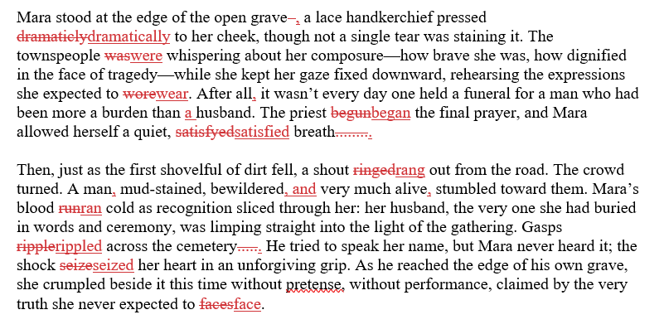

Developmental Editing Sample:
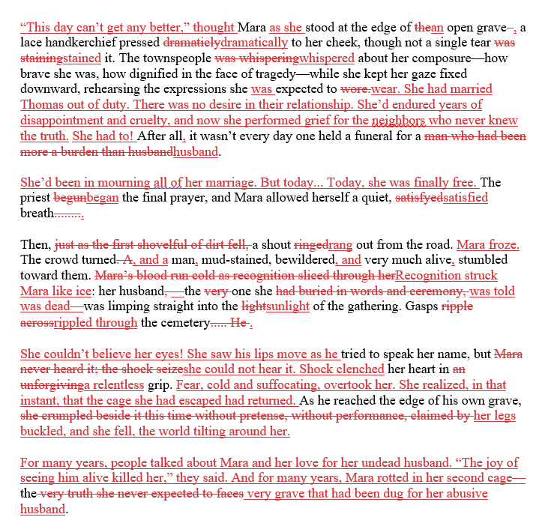

Why Choose Us

Why Authors Choose Our Book Editing & Proofreading Services
• Human-First Editors: Skilled editors with real publishing experience.
• Market-Aware Improvements: Edits that help you appeal to today’s readers.
• Voice-Preserving Approach: We improve your writing without altering your style.
• Complete Transparency: Clear editing reports, revisions, and tracking notes.
• Fast & Reliable Delivery: On-time every time every time. No delays, no hassle.
CTA: Get Your Free Quote for Book Editing

Banner

Editing That Gets Exactly What You Meant to Say
We don’t just fix grammar. Out team of editors shape every sentence to fit your voice, genre, and audience. Your book won’t just be error-free; it’ll sound how it is meant to be.
CTA: Transform my Draft

Us vs. Freelancers
(in a comparison table side by side)

Freelancers
- Skills vary widely
- May miss subtle errors
- No style consistency
- Limited communication
- Unpredictable timelines
- Informal agreements

The Pulp House Publishing
- Professional editors with genre expertise
- Detailed, multi-level editing
- Clear notes and tracked changes
- Consistent availability & support
- Guaranteed delivery timeline
- Transparent NDAs & work-for-hire protection

Us vs. AI Tools
(in a comparison table side by side)

AI Tools
- Algorithm-based corrections
- May distort tone or voice
- Cannot understand nuance
- Limited grammar detection
- Uses your work for database

The Pulp House Publishing
- Human editors with years of experience
- Natural, audience-aligned corrections
- Full understanding of tone & style
- Thorough grammar, clarity, and formatting checks
- Complete confidentiality & rights protection

Us vs. Agencies
(in a comparison table side by side)

Agencies
- Detached workflow
- Generic editing
- No personalized attention
- Complex contracts
- Rigid processes

The Pulp House Publishing
- Personalized, author-first approach
- Customized editing for every manuscript
- Detailed notes & revision guidance
- 100% Transparent processes
- Friendly communication throughout

Banner

No AI Editing Software! Get 100% Human Editing & Proofreading.
Every manuscript gets complete human attention to detail so your book stands out in a saturated market.
CTA: Call Us Today!

FAQs
Q1: What’s the difference between editing and proofreading?
Editing fixes mistakes and improves grammar, structure, and consistency. Proofreading fixes typos and punctuation errors after editing is complete.
Q2: Will you change my writing style?
No. Our editors refine your writing while preserving your authentic voice and tone.
Q3: How long does book editing take?
Depending on word count and complexity, editing typically takes 4–6 weeks, plus 1–2 weeks for proofreading.
Q4: Do you provide feedback notes?
Yes! You get marked-up edits, comments, suggestions, and a clean final version.

Client Testimonials
“Thanks to their editing team, my manuscript reads smoothly and professionally. They fixed errors I didn’t even realize were there. Worth every penny!” — Simone W.
“Their proofreading gave my book the polish it desperately needed. I was amazed at the accuracy and attention to detail.” — Jonathan Briggs
“I love how they refined my sentences without changing my voice. My book feels cleaner, more powerful, and completely error-free.” — Priya K.

