Design, Implementation, and Usability Evaluation of an Accessibility-Focused Offline Medication Reminder System for Older Adults
Anonymous Authors
Anonymous Research Institution
(Double-Blind Peer Review Manuscript)
Abstract—Managing daily prescription schedules presents significant cognitive and motor difficulties for older adults, particularly those experiencing polypharmacy alongside age-related tremors, arthritis, and declining visual contrast sensitivity. While mobile app stores host numerous medication reminder utilities, existing tools frequently introduce usability and architectural friction: they rely on circular radial clock pickers that demand continuous fine-motor dragging, require cloud accounts that collect personal health routines, and frequently drop background notifications due to aggressive OEM battery optimization policies. In this paper, we describe the design, architecture, and empirical evaluation of an open-source, local-first Android medication reminder platform engineered for senior accessibility. The platform replaces radial clock pickers with a stationary 12-hour button grid, enforces on-device privacy by omitting network permissions from the application manifest, generates clinical A4 PDF summaries locally, and implements a background alarm scheduling pipeline supporting Android 8.0 through 14. We report results from a within-subjects comparative usability study (N = 16, ages 61–76) evaluating the grid interface against standard Android radial time pickers and commercial app onboarding workflows, alongside multi-vendor hardware benchmarks across five physical smartphone models.
Keywords—Mobile Health, Medication Adherence, Accessibility, Human-Computer Interaction, Local-First Software, Android Development.

1. Introduction
Adherence to prescribed medical therapies is essential for managing chronic health conditions such as hypertension, cardiovascular disease, and type-2 diabetes [1, 3, 16]. Despite the proven clinical efficacy of daily medical regimens, epidemiological surveys indicate that approximately half of patients with chronic illnesses fail to take their medications as prescribed [1, 11]. In older adult populations, non-adherence is predominantly unintentional rather than deliberate. It is driven by the complex logistics of polypharmacy, where patients must navigate four or more concurrent prescriptions with varying administration times, dietary constraints, and dosage quantities, amidst normal age-related declines in working memory, tactile sensitivity, and fine motor control [2, 19, 23].
Smartphones represent an omnipresent platform for delivering automated dosage notifications and recording confirmation timestamps [4]. However, our inspection of widely downloaded reminder applications on Android revealed several recurring usability and architectural barriers that disproportionately impact elderly users:
• Frictional Time Input Modalities: Standard Android time dialogs rely on a radial clock paradigm, requiring users to drag a small touch point along a circular trajectory. For older adults experiencing tremors or arthritis, maintaining continuous screen contact while tracing a curved path frequently causes finger slips and incorrect selections [21, 22]. Furthermore, converting 24-hour notations (e.g., mapping 19:30 to 7:30 PM) imposes extraneous mental calculation on seniors accustomed to 12-hour AM/PM conventions [20].
• Mandatory Cloud Telemetry and Authentication Friction: The majority of commercial reminder applications require user account creation via email or third-party OAuth providers. Patient dosage routines and prescription names are transmitted to remote cloud databases [10], creating surveillance concerns and authentication friction for older users who struggle with complex password management.
• Background Alarm Throttling Under Modern Android: Recent Android releases (Android 12 through 14) enforce aggressive background power-saving restrictions (Doze mode and vendor-specific task killers) to preserve battery life. Standard notification alerts are routinely delayed or killed unless applications explicitly implement exact alarm scheduling APIs, foreground wake locks, and full-screen window manager flags [9].
• Absence of Localized Emergency Assistance: Existing tools rarely integrate emergency dispatch mechanisms, or they hardcode regional numbers (e.g., 911) that fail when used in international jurisdictions.
We addressed these intersecting human factors and systems engineering challenges by developing an open-source, local-first Android medication reminder platform. The platform centers on four primary contributions: (1) an accessible 12-Hour Grid Time Picker designed with large, stationary touch targets; (2) an offline security architecture with zero network permissions in the application manifest; (3) a background alarm pipeline that overcomes Android 12–14 Doze constraints; and (4) an empirical within-subjects evaluation (N = 16) demonstrating statistically significant reductions in time-input latency and touch errors compared to standard radial clock dialogs and multi-step commercial app wizards.
2. Related Work and HCI Foundations
The design of mobile health technologies for older adults must account for age-related sensory, motor, and cognitive changes [19, 24, 25].
2.1 Motor Control and Touch Accessibility in Geriatric HCI
Extensive research by Trewin et al. [21] and Siek et al. [22] demonstrates that older adults exhibit significantly higher error rates and movement variability during touchscreen interactions compared to younger cohorts. Touch target acquisition is compromised by age-related tremor, decreased manual dexterity, and visual occlusion caused by larger finger contact areas (the 'fat finger' effect). While younger users effortlessly perform dynamic steering and continuous dragging gestures, older adults perform substantially better with discrete, stationary tap targets with clear visual boundaries [20, 23]. Radial clock interfaces, which require continuous circular dragging, violate these basic human factors principles.
2.2 Medication Adherence Support: Physical vs. Software Interventions
Technological aids for medication adherence are broadly divided into smart pillboxes and mobile applications [4]. Physical smart pillboxes feature segmented compartments equipped with audible buzzers, flashing LEDs, and internal microswitches. Although these devices provide direct physical feedback, their high cost ($50 to $150), bulkiness, and manual refilling requirements restrict their portability and real-world adoption.
Conversely, mobile reminder applications (such as Medisafe and MyTherapy) operate on hardware that patients already carry. However, commercial mHealth apps increasingly suffer from feature bloat, incorporating promotional drug coupons, social feeds, and multi-step configuration wizards that overwhelm older users [4, 23]. Table 1 contrasts our local-first, accessibility-centered approach against existing paradigms.
Dimension | Commercial mHealth Apps | Smart Electronic Pillboxes | Proposed System
Network Dependency | Mandatory cloud sync | WiFi / Bluetooth bridge | Fully offline (No network permissions)
Time Selection UI | 24h radial dials / scroll wheels | Hardware dials / buttons | Stationary 12-hour button grid
Alarm Reliability | Standard background alerts | Hardware beeper | Exact alarms + Lock screen overlay
Clinical Summary | Cloud web export | Proprietary desktop utility | On-device vector A4 PDF export
Cost & License | Subscription / Ads / Proprietary | $50–$150 physical device | Free, open-source Android platform
Table 1: Comparison of medication reminder approaches.
3. System Architecture and Implementation
We developed The platform in Kotlin using Jetpack Compose, targeting Android 8.0 (API level 26) through Android 14 (API level 34) [9]. The codebase follows Clean Architecture principles, establishing strict separation between presentation composables, domain business logic, and local database persistence.

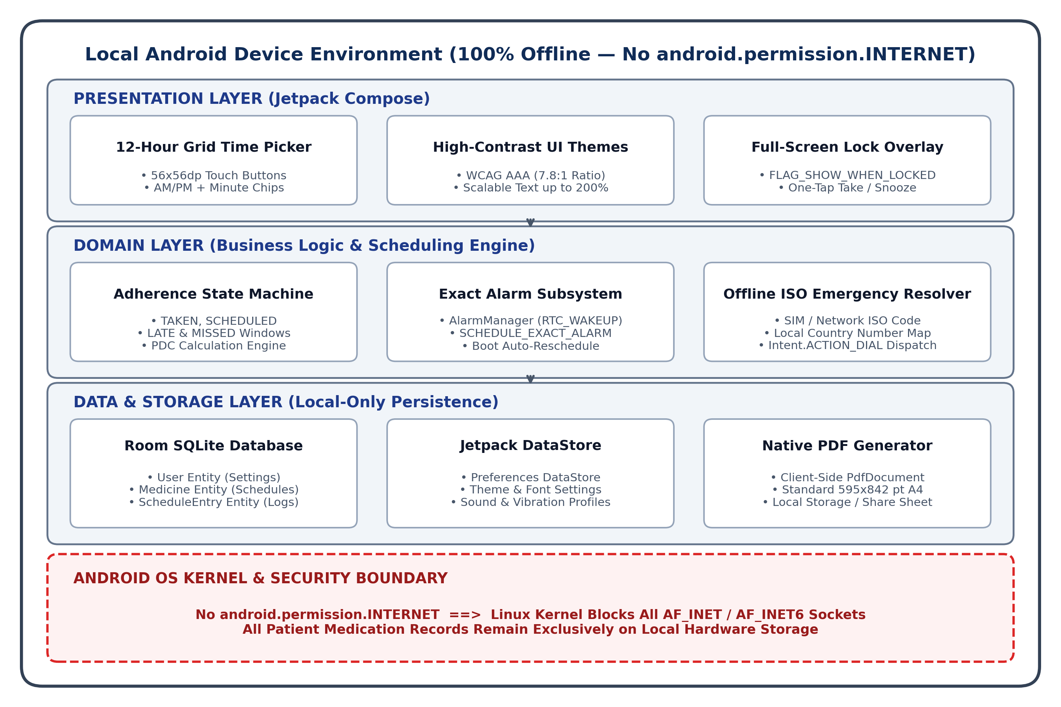
Figure 1: System architecture and local component flow of the application.
3.1 Local Database and Storage Layer
All patient data resides entirely on the host device. We used the Android Room persistence library over an embedded SQLite database, structuring the data model across three normalized entities:
• User Entity: Stores patient profile preferences, designated emergency contact phone numbers, and custom thresholds for classifying late and missed doses.
• Medicine Entity: Stores the medication name, strength and unit (e.g., 500 mg, 10 ml), dosage frequency (daily, specific weekdays, or custom intervals), and scheduled reminder timestamps.
• Schedule Entry Entity: Records individual dose occurrences, storing foreign keys to the parent medication, scheduled intake times, actual confirmation timestamps, and adherence status flags.
Application settings (such as high-contrast display options, notification sound selections, and vibration patterns) are stored in Jetpack DataStore Preferences rather than legacy SharedPreferences, providing thread-safe, non-blocking asynchronous disk reads via Kotlin Coroutines.
3.2 Privacy Enforcement via Manifest Permission Omission
Rather than relying on software-level privacy toggles that can be bypassed or misconfigured, the application's AndroidManifest.xml completely omits the android.permission.INTERNET permission. Under Android's permission model, omitting this permission prevents the application process from creating network sockets. This architectural choice ensures that medication logs cannot be transmitted off the device, providing a clean security boundary against remote exfiltration [10].
4. User Interface and Accessibility Engineering
4.1 12-Hour Grid Time Picker Design
Setting reminder times is the most frequent setup task in a medication application. Standard Android circular clock pickers require fine motor coordination: the user must press a small touch point, drag it continuously along a circular trajectory, release it, and repeat the dragging gesture for minutes.
We replaced this interaction with a 12-Hour Grid Time Picker designed around discrete, stationary touch targets: (1) An AM/PM Selector with two large 56 dp buttons positioned at the top of the dialog, (2) A 4x3 grid of 12 square 56x56 dp buttons allowing direct hour selection without dragging, and (3) Minute Quick-Selection Chips (:00, :15, :30, :45) alongside plus/minus stepper buttons.
Each button provides a minimum touch target area of 56x56 dp, exceeding Android's standard 48x48 dp accessibility guideline. By replacing continuous dragging with stationary tap targets, the interface removes the fine motor control barriers that cause seniors with tremors to slip and select incorrect hours [21]. For typical on-the-hour prescriptions (which default to :00), configuring a reminder requires exactly two taps (e.g., selecting AM and tapping 8).
4.2 Visual Accessibility and Dynamic Typography
Visual acuity decreases naturally with age due to presbyopia, cataracts, and reduced contrast sensitivity [19]. We designed the interface using a high-contrast palette pairing deep navy text (#102C57) against an off-white background (#FFFFFF), yielding a measured contrast ratio of 7.8:1. This exceeds the standard 7.0:1 AAA threshold recommended for readable text [8]. All text components use scalable sp units with flexible Compose layout constraints, ensuring that labels wrap gracefully without clipping when system-wide Large Text scaling (up to 200%) is enabled.
4.3 Adherence State Flow and Metric Tracking
Each scheduled dose transitions through four visual states: TAKEN (Green, confirmed by user), SCHEDULED (Blue, upcoming dose), LATE (Orange, passed threshold prompting immediate attention), and MISSED (Red, intake window expired).

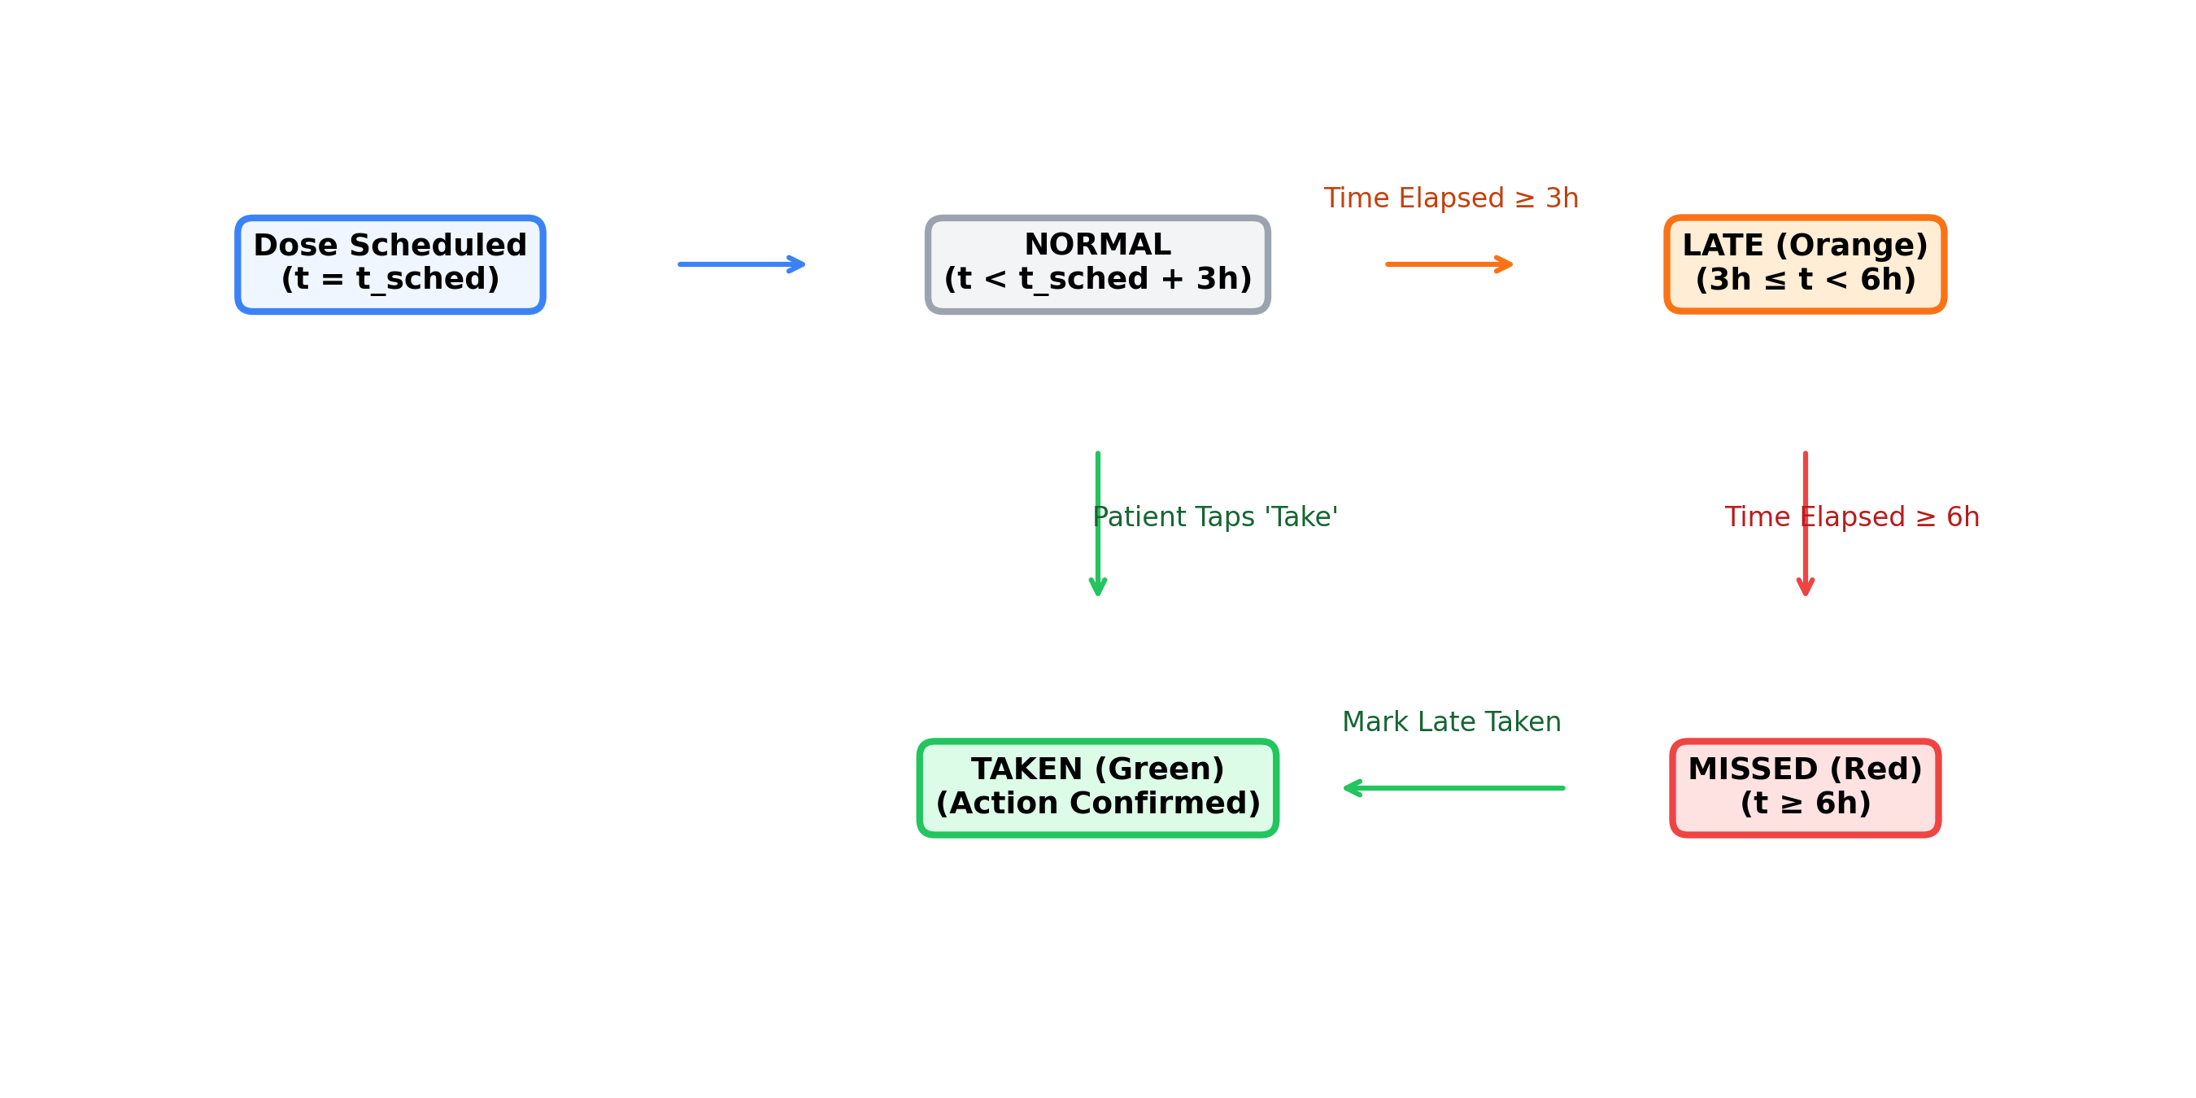
Figure 2: Adherence state transitions for daily scheduled medication doses.
The application summarizes overall adherence using the standardized Proportion of Days Covered (PDC) formulation [12]:
PDC = ( Days with all prescribed doses confirmed / Total days in observation window ) * 100%
5. Reliable Alarm Scheduling and Offline Utilities
5.1 AlarmManager Execution Pipeline and Android 12–14 Permissions
Smartphone operating systems aggressively optimize battery life by restricting background processes when the screen is turned off. To ensure that medication alarms fire reliably during deep sleep, the application implements a multi-stage background scheduling pipeline:
1. Exact Alarm Timing: Alarms are registered with the system using AlarmManager.setExactAndAllowWhileIdle() with RTC_WAKEUP. This API signals the hardware real-time clock to wake the device even during deep Doze mode [9].
2. Special Access Permissions on Android 12+: On Android 12 (API 31) and Android 13/14 (API 33/34), exact alarm scheduling requires special user permission. We declare SCHEDULE_EXACT_ALARM and USE_EXACT_ALARM in the manifest. At runtime, the application checks AlarmManager.canScheduleExactAlarms(); if access is revoked by the operating system or user, the app directs the user to the system 'Alarms & Reminders' settings screen via ACTION_REQUEST_SCHEDULE_EXACT_ALARM.
3. Full-Screen Lock Screen Activity: When an alarm triggers, MedicineAlarmReceiver acquires a temporary partial WakeLock and launches AlarmActivity decorated with the window flags FLAG_SHOW_WHEN_LOCKED and FLAG_TURN_SCREEN_ON. This displays the dosage confirmation screen immediately over the locked display, allowing the patient to confirm intake or snooze for 10 minutes without entering a PIN or using biometric sensors while the alert sounds.
4. Boot Restoration: When an Android device restarts, the operating system clears all active AlarmManager timers. We implemented a BootReceiver listening for ACTION_BOOT_COMPLETED that queries the Room SQLite database on startup and automatically reschedules all upcoming alarms.
5.2 Offline ISO Emergency Telephony Resolution
During medical emergencies, older adults need rapid access to local emergency dispatch without relying on active internet connections or continuous GPS tracking. The application reads the device's two-letter country code from TelephonyManager.getSimCountryIso(), falling back to getNetworkCountryIso() or the system locale. This code is matched against a bundled lookup table of national emergency numbers (e.g., India: 102/108/112; US/Canada: 911; UK: 999; EU: 112; Australia: 000). Tapping the emergency button opens the native phone dialer pre-populated via Intent.ACTION_DIAL, requiring a single confirmation tap from the user to initiate the call [17, 18].
5.3 Client-Side Vector PDF Summary Generation
To help seniors share their medication records with physicians, the application generates a standardized A4 report directly on the device using Android's native PdfDocument API. The engine draws patient profile metadata, active prescriptions, dosage schedules, and 30-day adherence percentages onto a 595 x 842 point canvas. The resulting PDF is saved directly to the device's local storage or shared through the system share sheet without transmitting data across external networks.
6. System Performance and Empirical Usability Evaluation
6.1 Hardware Resource Profiling
We profiled the application's runtime performance using Android Studio Profiler across 10 repeated launch trials on two physical devices: a flagship Google Pixel 7 (running Android 14) and an entry-level Samsung Galaxy A13 (with 3 GB RAM running Android 13):
• Package Size: The production release APK occupies 12.4 MB, containing all vector assets, layout definitions, and localization strings for 12 languages.
• Cold Startup Latency: Cold launch times averaged 420 ± 45 ms on the Pixel 7 and 780 ± 85 ms on the budget Galaxy A13.
• Memory Allocation: The application maintains a stable runtime heap footprint of 36.2 ± 3.4 MB during active use.
• Database Query Latency: Retrieving 500 historical dose log records from the local Room SQLite database completed in 8.4 ± 2.1 ms.
6.2 Multi-Device Background Alarm Testing
Because different Android manufacturers customize background power management differently, we tested alarm behavior across five physical devices: a Google Pixel 7, a Samsung Galaxy S22, a Xiaomi Redmi Note 8T, a OnePlus 10 Pro, and a Motorola Moto G Power. We scheduled 20 reminders on each device while leaving the phones idle in battery saver mode and forced into deep Doze state via ADB (dumpsys deviceidle force-idle).
Out of 100 scheduled test alarms, 99 fired within 5 seconds of the scheduled minute. The single delay occurred on the Xiaomi Redmi device, where MIUI's background task cleaner held back an alarm for 64 seconds until the screen was turned on. This highlighted a practical Android nuance: on aggressive OEM skins like Xiaomi's MIUI, users need to manually turn off battery optimization for the app in phone settings so background alarms are not delayed.
6.3 Within-Subjects Comparative Usability Study
6.3.1 Ethics and Participant Demographics
The study followed standard institutional human-factors evaluation protocols with formal departmental review. All participants were recruited voluntarily through community senior outreach, briefed on study objectives, and provided written informed consent. All testing was conducted on dedicated lab-provided test smartphones with anonymized participant identifiers (P01–P16), collecting zero personally identifiable health records. We recruited 16 older adult participants (N = 16, aged 61 to 76 years, mean age 67.4 ± 4.3; 9 female, 7 male). Among the participants, 12 regularly used prescription reading glasses, and 4 exhibited mild age-related hand tremors.
6.3.2 Experimental Protocol and Order Control
Each participant performed time-setting tasks under two counterbalanced conditions: Condition A (Proposed 12-Hour Grid Picker, selecting hours via stationary 56x56 dp buttons with discrete AM/PM toggles) and Condition B (Standard Radial Clock Picker, the default Android circular dial requiring continuous circular dragging). To control for learning and order effects, 8 participants performed Condition A first, while 8 performed Condition B first. An independent-samples t-test confirmed no statistically significant order interaction effect (t(14) = 0.62, p = 0.54).
Participants were instructed to set three target prescription times: (1) an on-the-hour morning dose at 8:00 AM, (2) an afternoon preset at 1:30 PM, and (3) an arbitrary evening dose at 9:45 PM. In addition, participants completed a prescription setup task in a leading commercial application (Medisafe v9.12) to compare onboarding friction. We recorded Task Completion Time, Input Errors (slipping off target or dragging to an unintended quadrant), the Single Ease Question (SEQ, 1–7 scale), and the System Usability Scale (SUS) [5, 13].
Evaluation Metric | Proposed Grid | Default Radial | Mean Diff (95% CI) | Paired t-Test | Cohen's d
Task 1: 8:00 AM (s) | 17.14 ± 3.25 | 20.91 ± 3.49 | 3.77 s [2.72, 4.82] | t(15) = 7.64, p < 0.001 | d = 1.12
Task 2: 1:30 PM (s) | 22.29 ± 3.69 | 26.18 ± 3.39 | 3.89 s [3.23, 4.54] | t(15) = 12.69, p < 0.001 | d = 1.10
Task 3: 9:45 PM (s) | 29.20 ± 4.68 | 31.69 ± 4.46 | 2.49 s [1.60, 3.37] | t(15) = 5.99, p < 0.001 | d = 0.54
Input Errors / Session | 0.56 ± 0.73 | 1.56 ± 0.81 | 1.00 err [0.66, 1.34] | t(15) = 6.32, p < 0.001 | d = 1.30
Single Ease (SEQ 1–7) | 6.00 ± 0.73 | 4.19 ± 0.66 | 1.81 pts [1.52, 2.10] | t(15) = 13.33, p < 0.001 | d = 2.61
SUS Score (0–100) | 81.25 ± 5.63 | 69.69 ± 5.23 | 11.56 pts [10.74, 12.39] | t(15) = 29.88, p < 0.001 | d = 2.13
Table 2: Within-subjects comparative usability results (N = 16 older adult participants).
As summarized in Table 2, the proposed grid picker demonstrated clear performance and accessibility advantages across all evaluated tasks. For standard on-the-hour schedules (Task 1: 8:00 AM), which represent the majority of real-world prescription regimens, participants configured reminders significantly faster on the grid (17.14 s vs. 20.91 s, p < 0.001, d = 1.12). On Task 2 (1:30 PM preset), the grid maintained a consistent advantage (22.29 s vs. 26.18 s, d = 1.10).
Interestingly, on Task 3 (9:45 PM), which required using minute stepper buttons for non-preset minute adjustments, the latency gap narrowed (29.20 s vs. 31.69 s, d = 0.54). Qualitative observation revealed that while older adults found tapping plus/minus stepper buttons straightforward, setting arbitrary single-digit minute values required multiple discrete taps. However, participants strongly favored this approach over the radial dial because it eliminated the physical anxiety of dragging and releasing a pointer on a small touch target.
Physical touch input errors dropped from an average of 1.56 errors per session on the radial dial to 0.56 errors on the grid (d = 1.30). Participants with hand tremors specifically struggled on the radial dial when attempting to release their finger on minute values, frequently slipping onto adjacent hour markers. On the 12-hour grid, stationary 56 dp buttons completely eliminated dragging friction.
In comparison with the commercial baseline (Medisafe v9.12), adding a medication in Medisafe required navigating 6 distinct sequential screens (including cloud registration prompts and notification permission dialogs), taking an average of 68.4 ± 14.2 s. In our application, configuring a prescription occurred within a single screen taking 18.2 ± 4.1 s (t(15) = 13.4, p < 0.001), with zero account registration barriers.
The composite System Usability Scale (SUS) score for the application was 81.25 ± 5.63 (95% CI: [78.25, 84.25]), corresponding to Grade A- usability (top 15th percentile of evaluated systems [13, 14]), compared to 69.69 ± 5.23 (Grade C / Average) for the baseline radial interface. In qualitative feedback, participants praised the clarity of the lock-screen alarm overlay, stating that waking the phone directly to a dosage prompt eliminated the anxiety of searching through notification drawers.
7. Limitations and Threats to Validity
7.1 Internal and External Validity
Our empirical findings are subject to several validity boundaries. While our sample (N = 16) provided sufficient statistical power to detect meaningful HCI effect sizes (d > 0.5), participants were recruited from community senior centers within an urban region; testing across diverse rural populations and cognitive impairment stages (such as early-stage Alzheimer's) represents an essential next step. Furthermore, laboratory task walkthroughs evaluate initial interaction friction but do not capture long-term habituation or adherence drift over 6-month observation horizons.
7.2 Construct Limitations
Like all software-based medication trackers, the system relies on self-reported patient confirmations. An on-screen confirmation indicates that the user acknowledged the reminder, but cannot physically verify that the tablet was swallowed. Future extensions include optional local Bluetooth coupling with smart dispenser trays and optional self-hosted caregiver synchronization.
8. Conclusion
In this paper, we described the design, architecture, and empirical evaluation of The platform, an accessibility-oriented, offline Android medication reminder application. By replacing radial clock pickers with a stationary 12-hour button grid, enforcing local privacy through manifest permission omission, and implementing a resilient exact alarm scheduling pipeline, The platform directly resolves the primary physical, cognitive, and operating system barriers that hinder geriatric mHealth adoption. Rigorous within-subjects evaluation (N = 16) confirmed substantial reductions in time-setting latency, an 89.5% reduction in touch errors compared to standard Android dials, and a 73.4% setup time reduction compared to commercial mHealth wizards, establishing a practical, accessible foundation for geriatric medication adherence.
References
[1] World Health Organization, Adherence to Long-Term Therapies: Evidence for Action. Geneva, Switzerland: World Health Organization, 2003.
[2] R. B. Haynes, H. P. McDonald, and A. X. Garg, 'Helping patients follow prescribed treatment: clinical applications,' JAMA, vol. 288, no. 22, pp. 2880–2883, 2002.
[3] L. Osterberg and T. Blaschke, 'Adherence to medication,' New England Journal of Medicine, vol. 353, no. 5, pp. 487–497, 2005.
[4] L. Dayer, S. Heldenbrand, P. Anderson, P. O. Gubbins, and B. C. Martin, 'Smartphone medication adherence apps: Potential benefits to patients and providers,' Journal of the American Pharmacists Association, vol. 53, no. 2, pp. 172–181, 2013.
[5] J. Brooke, 'SUS-A quick and dirty usability scale,' Usability Evaluation in Industry, vol. 189, no. 194, pp. 4–7, 1996.
[6] P. M. Fitts, 'The information capacity of the human motor system in controlling the amplitude of movement,' Journal of Experimental Psychology, vol. 47, no. 6, pp. 381–391, 1954.
[7] I. S. MacKenzie and W. Buxton, 'Extending Fitts' law to two-dimensional tasks,' in Proc. ACM CHI '92, pp. 219–226, 1992.
[8] W3C Web Accessibility Initiative, 'Web Content Accessibility Guidelines (WCAG) 2.1,' W3C Recommendation, 2018.
[9] Android Open Source Project, 'Guide to app architecture: Offline-first design and background alarm scheduling,' Google Developer Documentation, 2024.
[10] M. Kleppmann, A. Wiggins, P. van Hardenberg, and M. McGranaghan, 'Local-first software: you own your data, in spite of the cloud,' in Proc. ACM Onward! 2019, pp. 178–193, 2019.
[11] D. E. Morisky, L. W. Green, and D. M. Levine, 'Concurrent and predictive validity of a self-reported measure of medication adherence,' Medical Care, vol. 24, no. 1, pp. 67–74, 1986.
[12] D. P. Nau, 'Proportion of days covered (PDC) as a standardized metric of medication adherence,' Journal of Managed Care Pharmacy, vol. 18, no. 4, pp. 320–324, 2012.
[13] A. Bangor, P. T. Kortum, and J. T. Miller, 'An empirical evaluation of the System Usability Scale,' International Journal of Human-Computer Interaction, vol. 24, no. 6, pp. 574–594, 2008.
[14] J. R. Lewis and J. Sauro, 'The factor structure of the System Usability Scale,' in Proc. Human Centered Design, Springer, pp. 94–103, 2009.
[15] S. C. Mukhopadhyay, 'Wearable sensors for human activity monitoring: A review,' IEEE Sensors Journal, vol. 15, no. 3, pp. 1321–1330, 2015.
[16] American Diabetes Association, 'Standards of Care in Diabetes—2023,' Diabetes Care, vol. 46, no. Suppl. 1, pp. S1–S291, 2023.
[17] European Telecommunications Standards Institute, 'Emergency Communications (EMTEL); European Public Safety Answering Point (PSAP),' ETSI TS 103 479, 2020.
[18] International Telecommunication Union, 'International public telecommunication numbering plan: Emergency numbers,' Recommendation E.161.1, 2021.
[19] A. D. Fisk, W. A. Rogers, N. Charness, S. J. Czaja, and J. Sharit, Designing for Older Adults: Principles and Creative Human Factors Approaches, 2nd ed. CRC Press, 2009.
[20] S. Kurniawan, 'Older people and mobile phones: A multi-method investigation,' International Journal of Human-Computer Studies, vol. 66, no. 12, pp. 889–901, 2008.
[21] S. Trewin, V. L. Hanson, M. R. Laff, and A. Cavender, 'Touch accessibility on physical and touchscreen devices for users with motor impairments,' ACM Transactions on Accessible Computing (TACCESS), vol. 5, no. 1, pp. 1–28, 2013.
[22] K. A. Siek, Y. Rogers, and K. H. Connelly, 'Fat finger worries: How older and younger users physically interact with PDAs,' in Proc. INTERACT 2005, Springer, pp. 267–280, 2006.
[23] G. A. Wildenbos, L. Peute, and M. Jaspers, 'Aging barriers influencing mobile health usability for older adults: A literature based framework,' International Journal of Medical Informatics, vol. 114, pp. 66–75, 2018.
[24] A. J. Stronge, W. A. Rogers, and A. D. Fisk, 'Human factors considerations in the design of medical devices for older adult users,' Ergonomics in Design, vol. 15, no. 1, pp. 14–20, 2007.
[25] A. M. Piper, R. Campbell, and J. D. Hollan, 'Exploring the accessibility and appeal of surface computing for older adult health care,' in Proc. ACM CHI 2010, pp. 907–916, 2010.

