Project
CMPE 691
Dr Naghmeh Karimi

Submitted by
Aakash Shah & Saad Rahman

Abstract:
In this project, we were asked to implement a time redundant CED (Concurrent error detection) using Verilog or VHDL on an existing AES implementation. For the time redundant CED approach, we used the Re-computing with permutated operands (RIPO) method described in the paper “Re-computing with permuted operands: A concurrent error detection approach” [1] authored by X. Guo and R. Karri. The project is divided into two main parts 1. CED implementation and 2. Fault injector. Both will be discussed briefly later.

Introduction:
In 2001 the 128-bit Advanced Encryption Standard (AES) replaced the 64-bit Data Encryption Standard (DES) as the symmetric encryption algorithm standard. Since then AES has become the most popular encryption algorithm to be implemented on smart cards and other devices. To extract the sensitive information protected by the encryption, attackers developed various attacks to extract the key from the hardware implementations of AES. One of the attack is fault attack or Differential fault attack (DFA), in which the attacked inject a fault into the AES module by glitching the voltage or clock and then, by comparing the faulty cipher text with the correct one, extracts the key. Moreover, because of the rapidly shrinking dimensions in VLSI, transient faults occur and will occur soon in increasing numbers, which will drastically decrease the reliability. These transient faults affect the memory as well as the combinational parts of a circuit and can only be detected using concurrent checking.

Re-computing with permutated operands (RIPO) is a robust concurrent checking method to detect both transient and permanent faults with high accuracy and minimal hardware overhead. As, the approach is time redundant, the only drawback of this implementation is throughput. The AES implementation with this CED will have a decreased throughput with respect to the normal AES implementation. In this project, we implemented the RIPO CED method to detect both transient and permanent faults in a AES implementation.

Implementation details:
CED:

Fault Injector:
To test our CED implementation we need a fault injector to simulate the fault which may occur in a real scenario. In this project, we were asked to develop a fault injector which will be capable to inject permanent and transient fault in any desired round. The fault injector was developed in Verilog and was tested using a standalone test-bench.
The input and output pins of the fault injector is presented in figure 1.

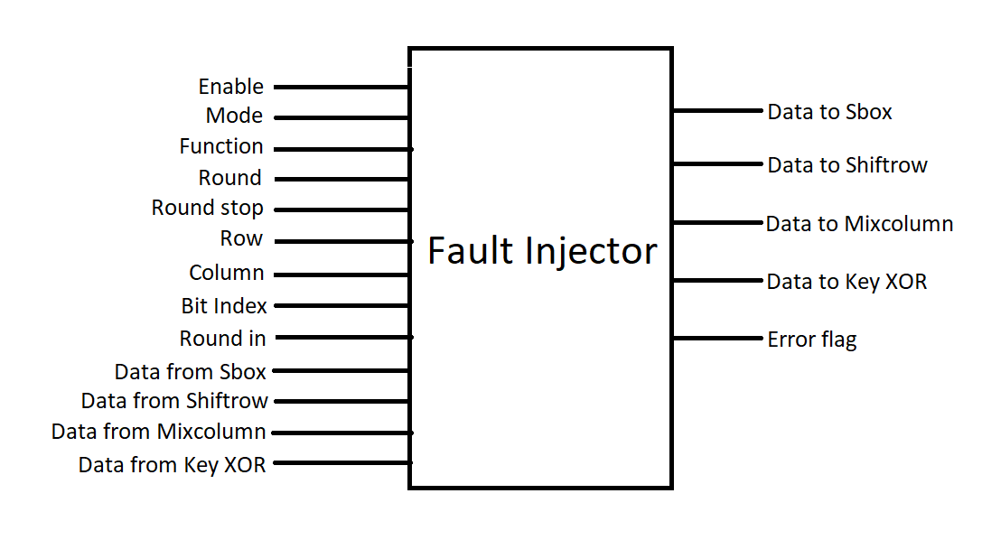
Figure 1: Fault injector

The main working procedure of the fault injector is: It takes all 128-bit data from 4 functional blocks of AES, which are Sbox, Shiftrow, Mixcolumn and Key XOR. Then it flips the specified bit at the specified position of the specified function and gives the output. Only the specified functional block’s input is changed, and the other inputs are unchanged. For example, if the specified round for fault injection is Shiftrow, it’ll only change the “Data from Shiftrow” and pass the other inputs unchanged. For fault input, we flipped the bit in case of 1-bit fault and flipped an entire byte in case of byte faults.

The details of the input output are as follows:
- Enable: 1-bit input. 1 to enable the module, 0 to disable it.
- Mode: 1-bit input. 0 for 1-bit fault, 1 for byte fault.
- Function: 4-bit input. Select the functional block for fault injection. 0 for Sbox,1 for Shiftrow,2 for Mixcolumn and 3 for Key XOR.
- Round: 4-bit input. Selects the round for fault injection. 0 for round 0 and 10 for round 10 respectively.
- Round stop: 4-bit input. Selects the round in which fault injection should stop. This allows us to inject fault in multiple rounds. 0 for round 0 and 9 for round 9 respectively.
- Row: 2-bit input. Specifies the row for fault injection. 0 for row 1, 1 for row 2, 2 for row 3 and 3 for row 4.
- Column: 2-bit input. Specifies the column for fault injection. 0 for column 1, 1 for column 2, 2 for column 3 and 3 for column 4.
- Bit index: 4-bit input. Specifies the bit which should be impacted by fault injection. 0 for the lowest significant bit and 7 for the highest significant bit respectively.
- Round in: 4-bit input. This input is fed by the AES core module. This input keeps track of the round in the fault injector module.
- Error flag: 1-bit output. Determines if any error occurred in fault injection. Stays 0 if no error occurred, becomes 1 if some error occurred.

Working procedure:
To inject fault by this fault injector, firstly we must give the input for enable, mode, function, round, round stop, row, column and bit index into the text file named input.txt. Then, the module will take all 128-bit outputs produced from all 4 blocks of AES and will take an input called “round in” from the AES core module. This “round in” input denotes the current round in AES core module. Then, the fault injector will match the “round in” with “round” and if it matches it’ll inject fault until the “round in” matches with “round stop”. The algorithm is described in figure 2. Moreover, if some error occurs due to improper input, the error flag will become 1 instead of 0 and no fault will be injected in that case. For example, there is no Mixcolumn block in round 10. If the input specifies to inject a fault in Mixcolumn block if round 10, error flag will become 1.
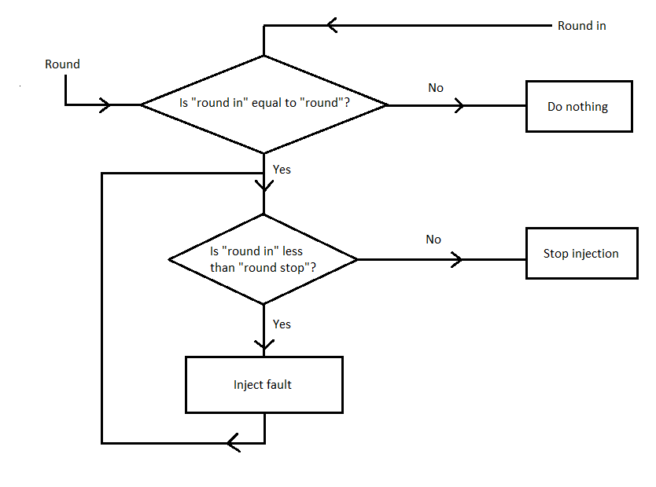

Figure 2: Algorithm of fault injector.

Reference:
- X. Guo and R. Karri, “Re-computing with permuted operands: A concurrent error detection approach,” IEEE Trans. on Computer-Aided Design of Integrated Circuits and Systems, 32(10), pp.1595-1608

