**Bootstrap**

**Bootstrap CDN:**

<link rel="stylesheet" href="https://stackpath.bootstrapcdn.com/bootstrap/4.3.1/css/bootstrap.min.css" integrity="sha384-ggOyR0iXCbMQv3Xipma34MD+dH/1fQ784/j6cY/iJTQUOhcWr7x9JvoRxT2MZw1T" crossorigin="anonymous">

<script src="https://stackpath.bootstrapcdn.com/bootstrap/4.3.1/js/bootstrap.min.js" integrity="sha384-JjSmVgyd0p3pXB1rRibZUAYoIIy6OrQ6VrjIEaFf/nJGzIxFDsf4x0xIM+B07jRM" crossorigin="anonymous"></script>

Jquery Plugin :

<script src="https://code.jquery.com/jquery-3.0.0.js"></script>

**Additional CDN :-**

<script src="https://code.jquery.com/jquery-3.2.1.slim.min.js" integrity="sha384-KJ3o2DKtIkvYIK3UENzmM7KCkRr/rE9/Qpg6aAZGJwFDMVNA/GpGFF93hXpG5KkN" crossorigin="anonymous"></script>

<script src="https://cdnjs.cloudflare.com/ajax/libs/popper.js/1.11.0/umd/popper.min.js" integrity="sha384-b/U6ypiBEHpOf/4+1nzFpr53nxSS+GLCkfwBdFNTxtclqqenISfwAzpKaMNFNmj4" crossorigin="anonymous"></script>

<script src="https://maxcdn.bootstrapcdn.com/bootstrap/4.0.0-beta/js/bootstrap.min.js" integrity="sha384-h0AbiXch4ZDo7tp9hKZ4TsHbi047NrKGLO3SEJAg45jXxnGIfYzk4Si90RDIqNm1" crossorigin="anonymous"></script>

Checking for loaded :

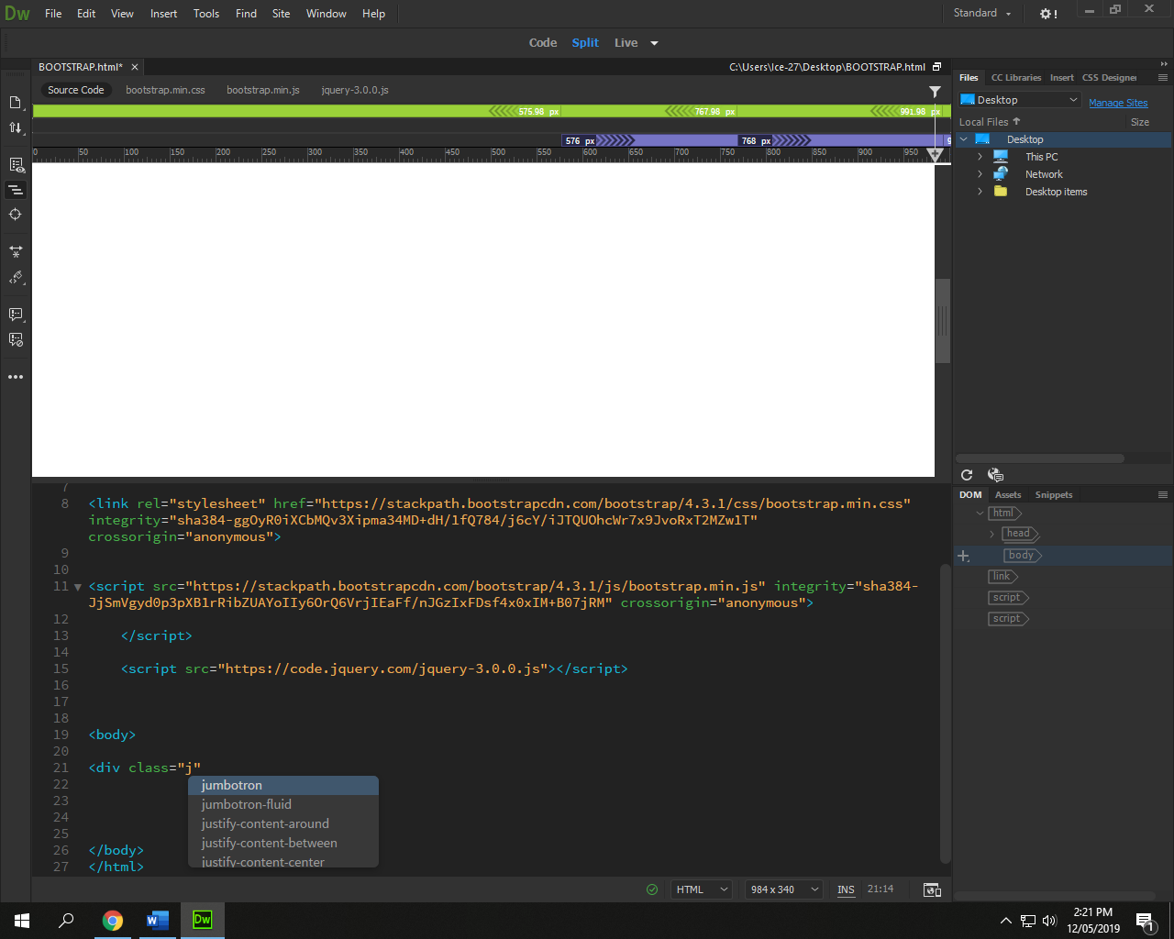

Downloaded :

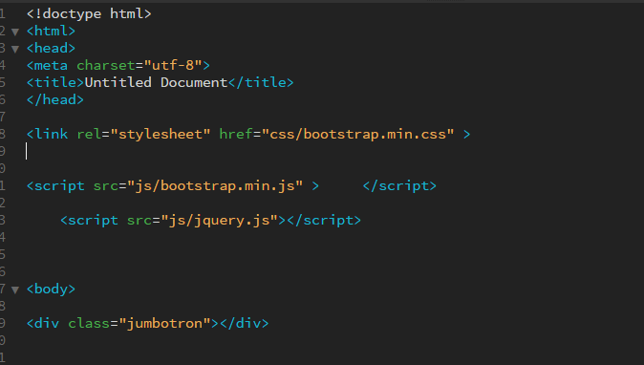

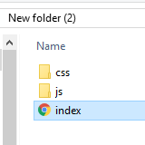

**Container :**

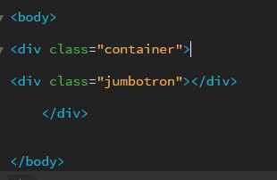

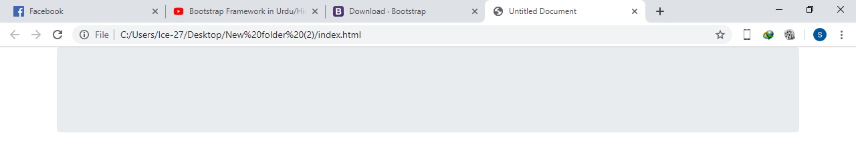

**Table :**

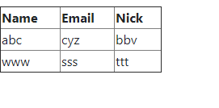

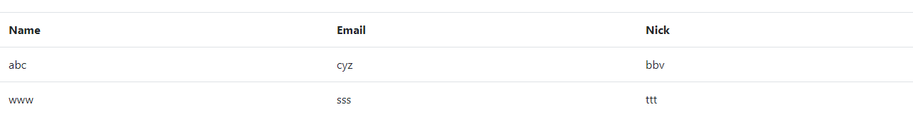

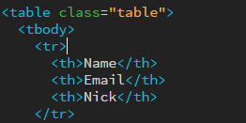

**Rows and Column classes :**

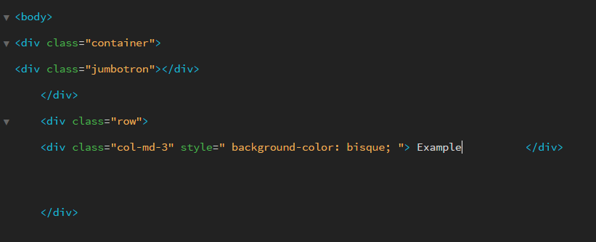

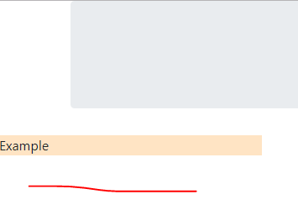

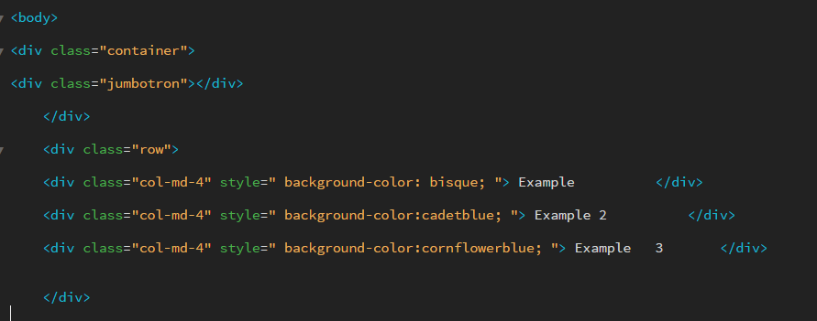

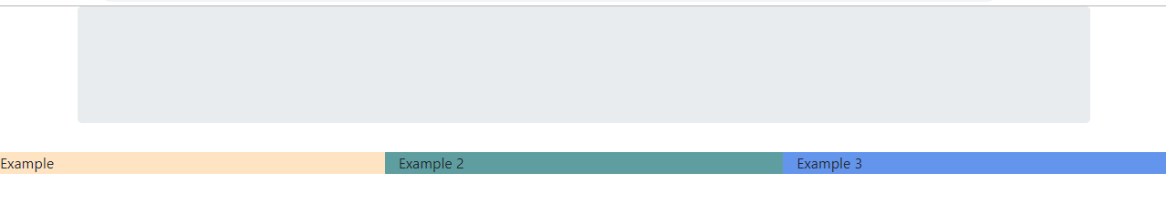

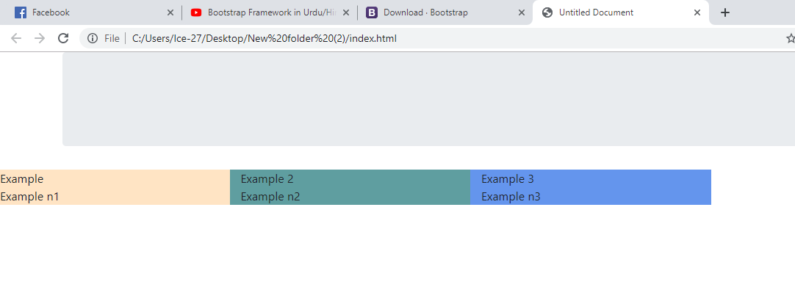

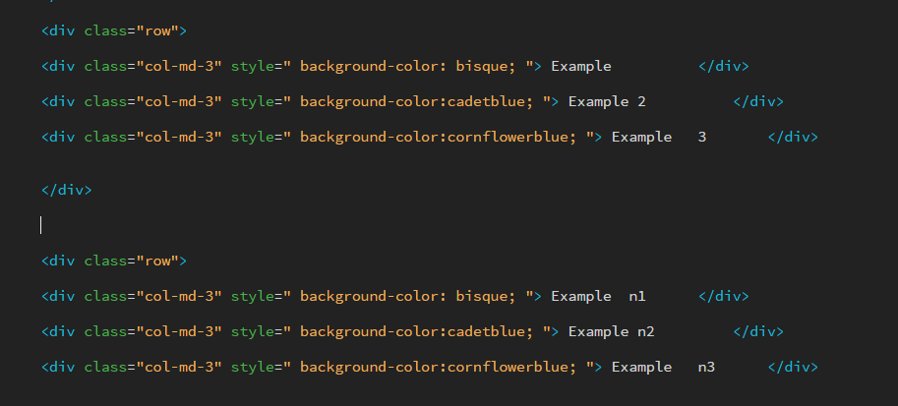

Container-fluid for no extra scrolling

**Formatting :**

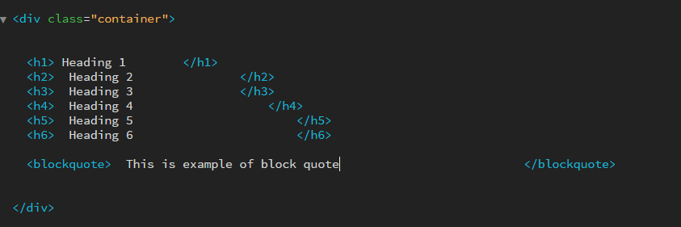

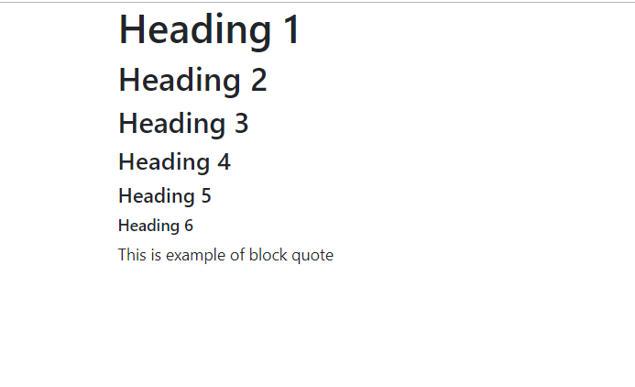

<abbr title=””> <abbr>

Description List :

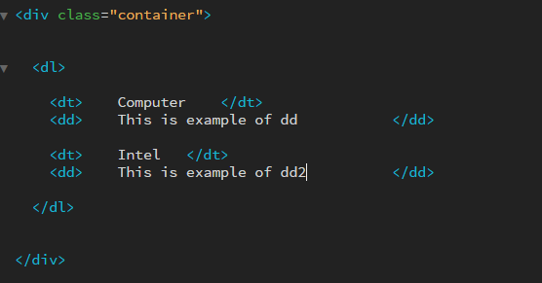

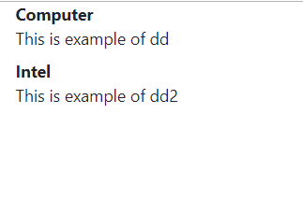

Text Styles :

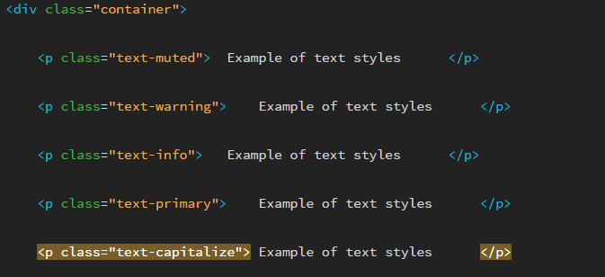

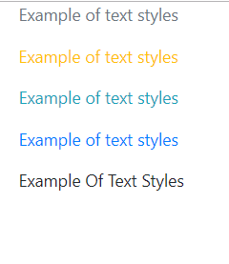

Bg-info , bg-danger , bg-primary for background

dl-horizontal for better dl .

text-uppercase   
text-lowercase

text-center  
text-right

**Tables :**

Class=”table”

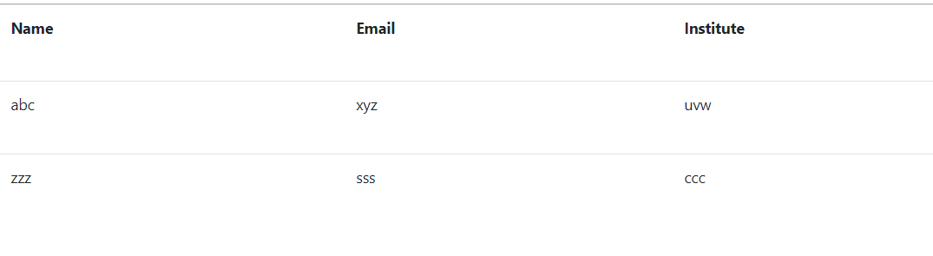

Class=”table table-striped”

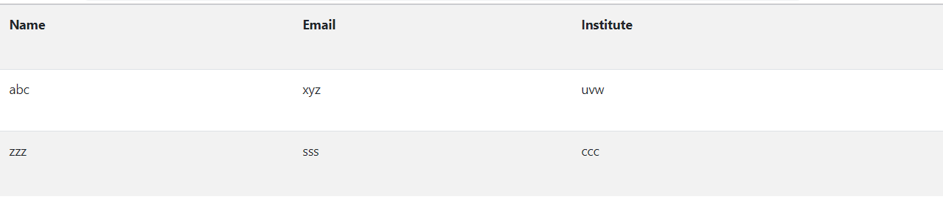

Class=”table table-bordered”

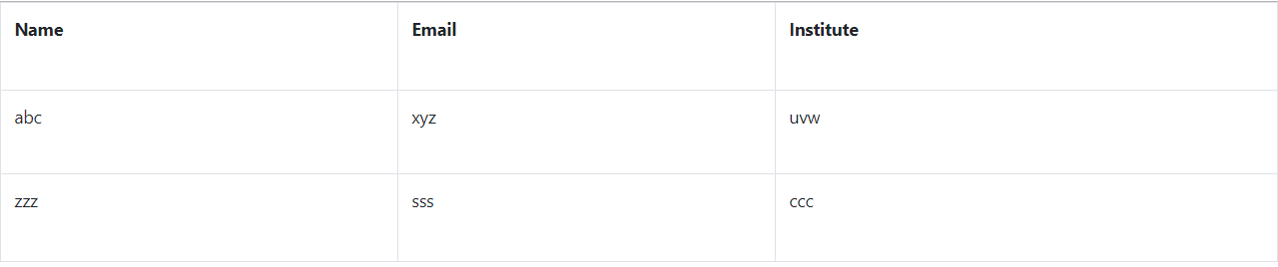

Class=” table table-hover” for hover effect

Class=”table table-condensed” for less spaces

Class=”table-responsive”

**Images :**

Class=”rounded-circle” for image in circle

Class=”img-thumbnail” for good border and responsiveness

Class=”img-fluid” for responsiveness

**Buttons :**

Class=”btn”

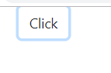

Btn Btn-warning

Btn Btn-danger

Btn For further styles

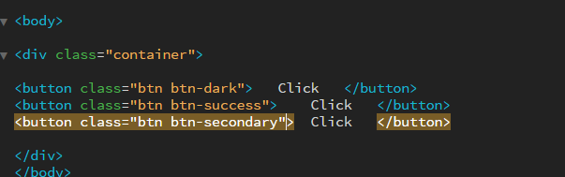

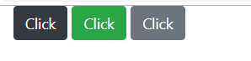

Btn Btn-warning btn-lg for large button

Btn Btn-warning btn-sm for small button

Class=”btn btn-secondary btn-block” makes button size of parent

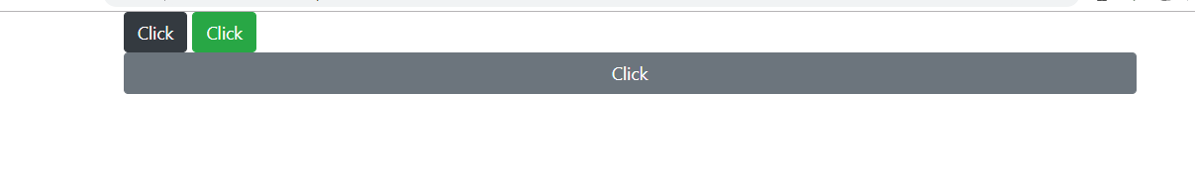

**Button Group :**

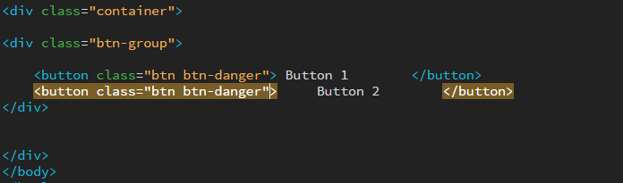

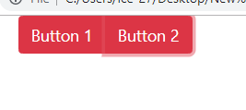

<div Class = “btn-group btn-group-lg” for size of all>

Class=”btn-group-vertical”

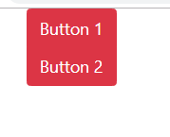

d-flex :

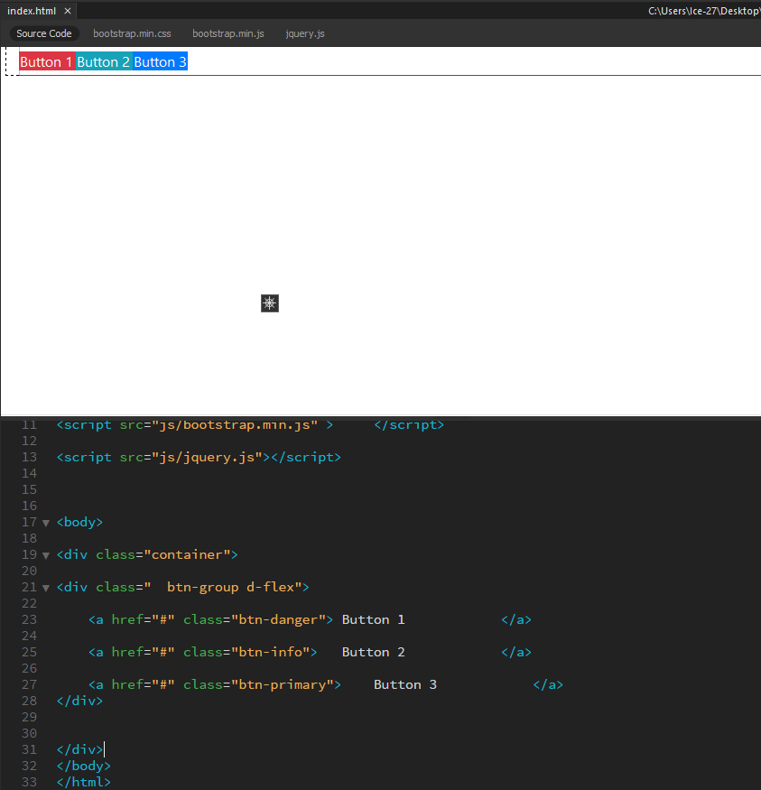

**Creating a drop down :**

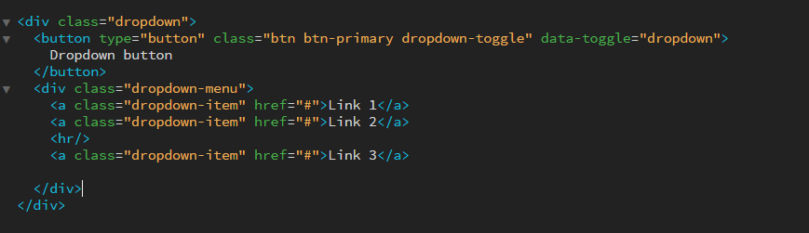

For divider :

<hr/>

Glyphicons :

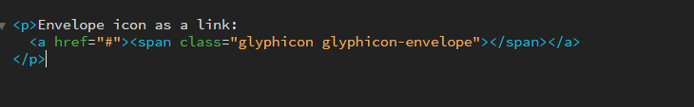

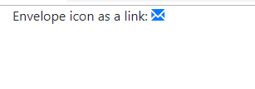

**Page Header :**

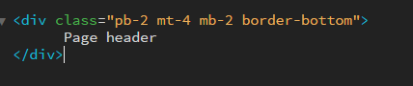

* pb-2 - padding bottom 2 spacer units
* mt-4 - margin top 4 spacer units
* mb-2 - margin bottom 2 spacer units
* border-bottom - border-bottom: 1px solid rgb(222, 226, 230)



**Well :**

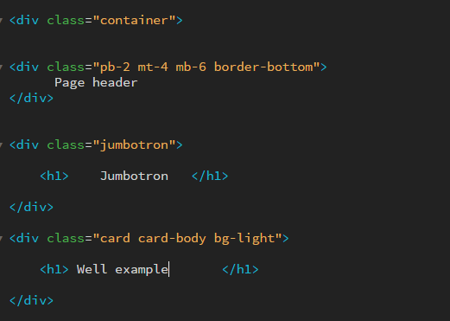

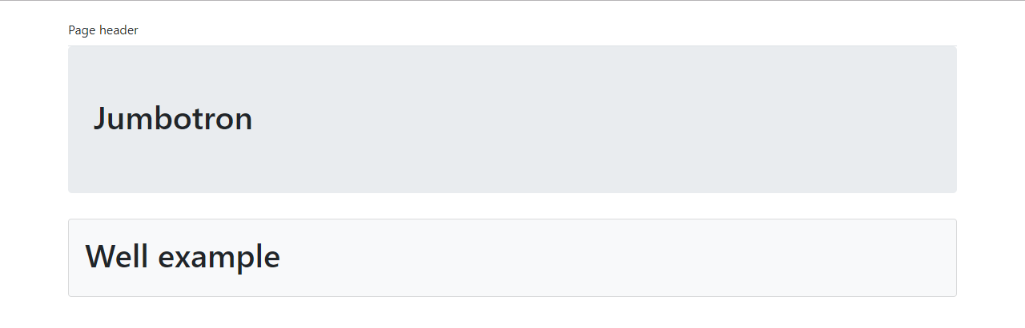

**Alert :**

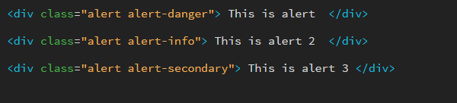

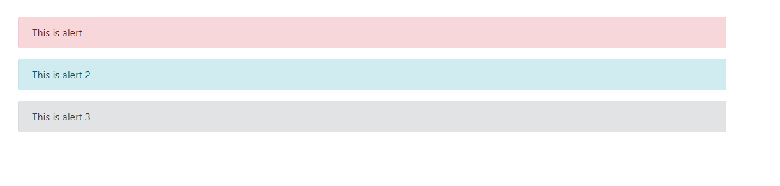

**Badge :**

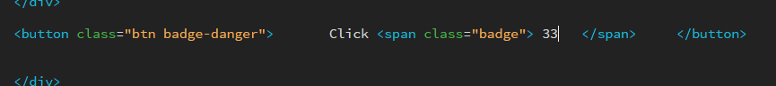

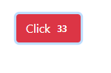





**Panel :**

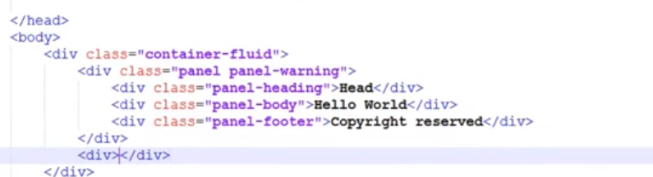

**Collapse :**

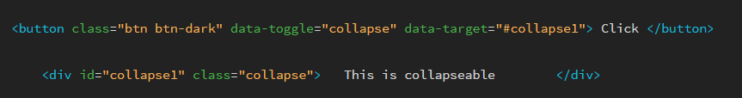

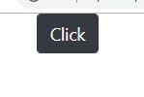

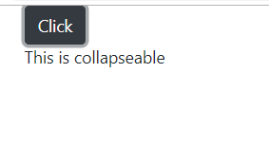

**List :**

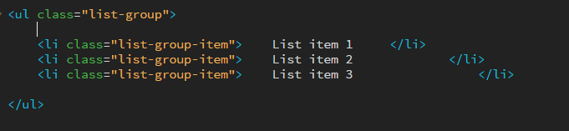

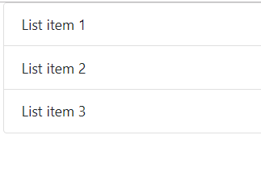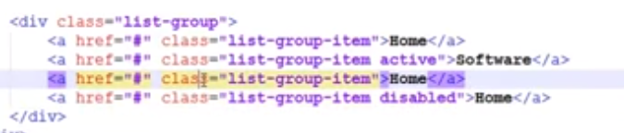

**Menu :**

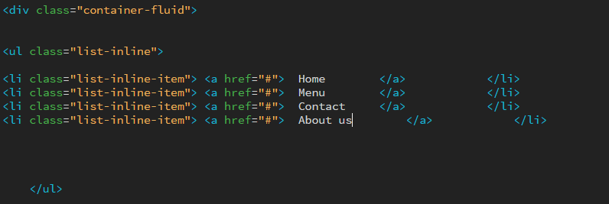

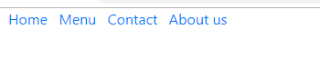

**Nav :**

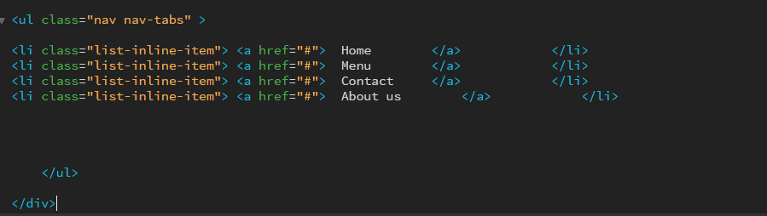



**Drop down in nav :**

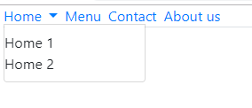

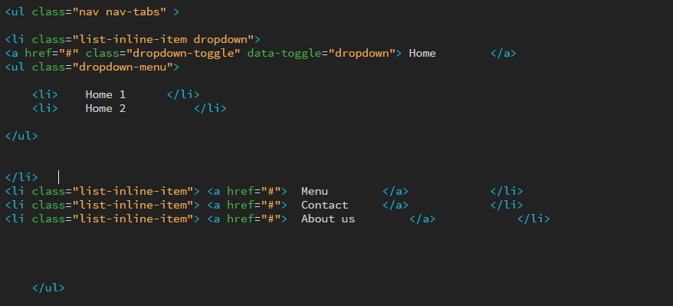

Class=”active” for selected item

**Nav – pills :**

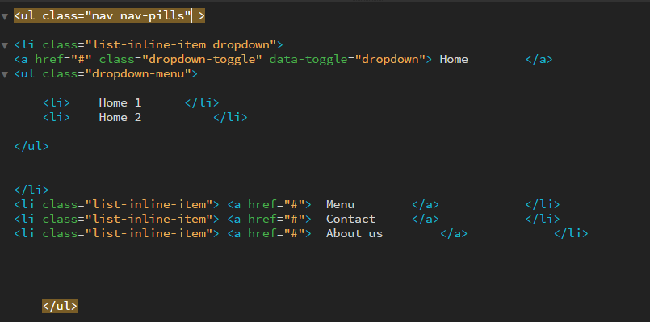

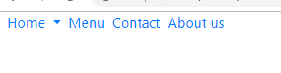

Class=”nav-justified” for wrapped content menus

**Form :**

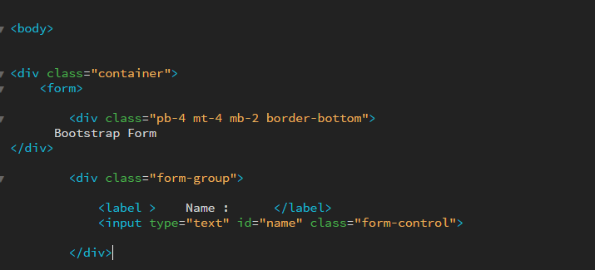

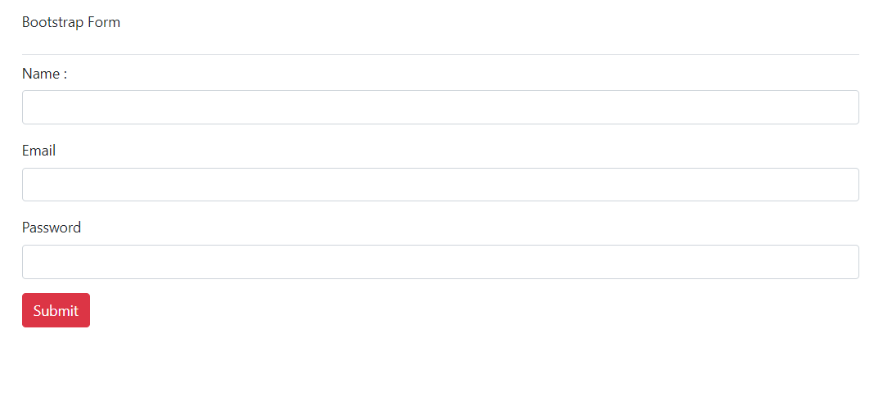

<form class=”form-inline” > for inline elements

**Carousel Image Slider :**

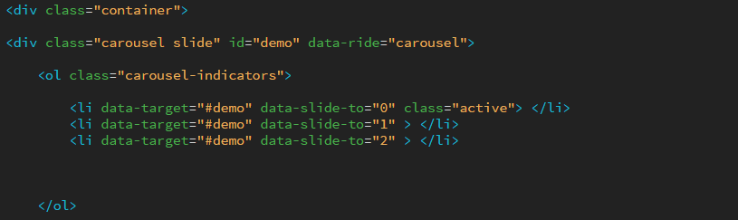

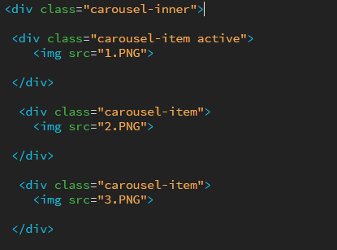

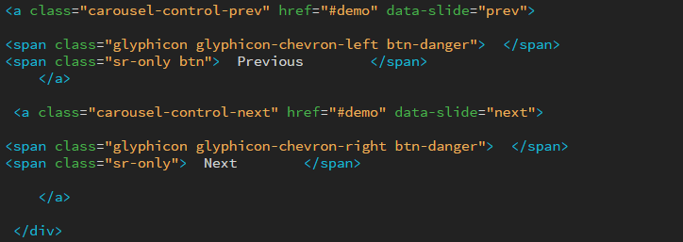

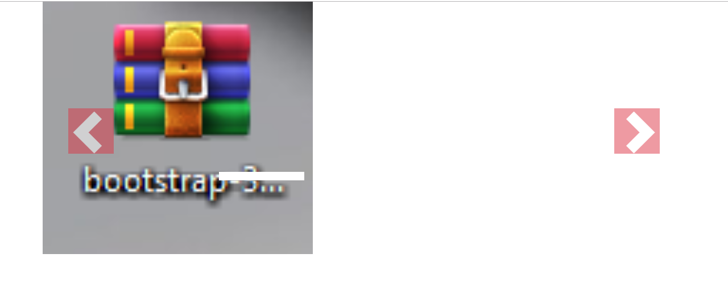

**Caption on images :**

