**CSS**

Cascading Styling Sheet

Adds style to your html.

Controls the layout of the website.

Syntax :

<style>

</style>

**Change Background Color :**

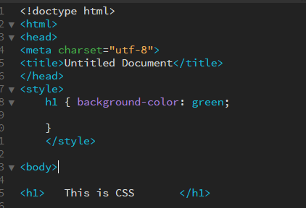

{ called the container

h1 is specified in style tag for css.

All style done on h1 will be written in the h1 container.

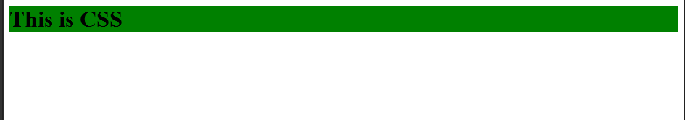

**Changing font type, color, and size :**

**Syntax :**

Add the following in container.

Name {

color: specify ;

font-size : specify ;

font-family : specify ; }

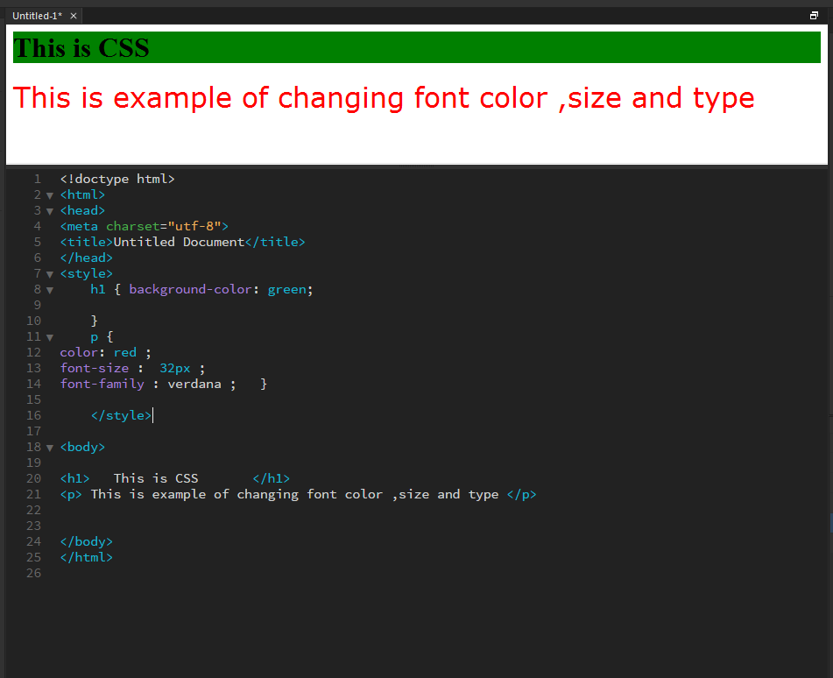

**Multiple Selectors :**

More than 1 selectors can be specified before a container.

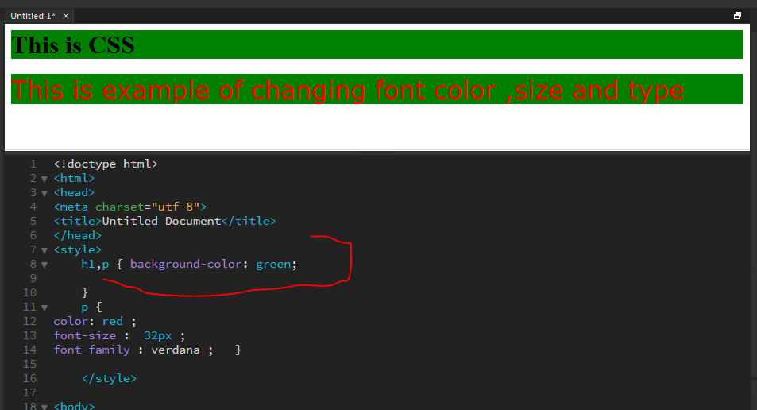

**Border to header :**

**Syntax :**

Name {

Border-bottom: size specify ;

}

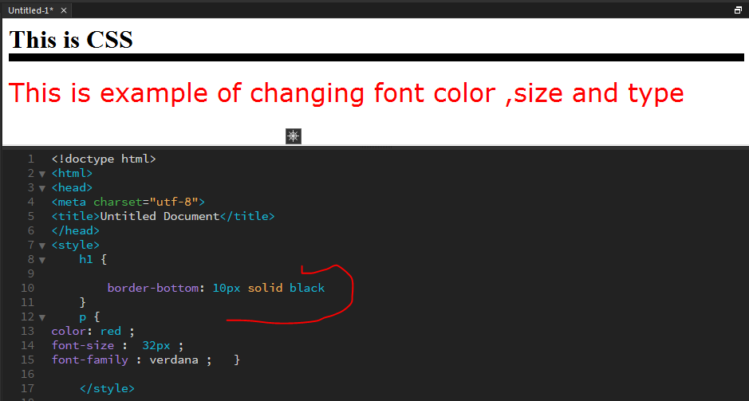

**Classes :**

So that different styles can be applied to the same tag used more than once.

**Syntax :**

For tag :

< tag class=”example”> </tag>

For Style :

tag.example {

}

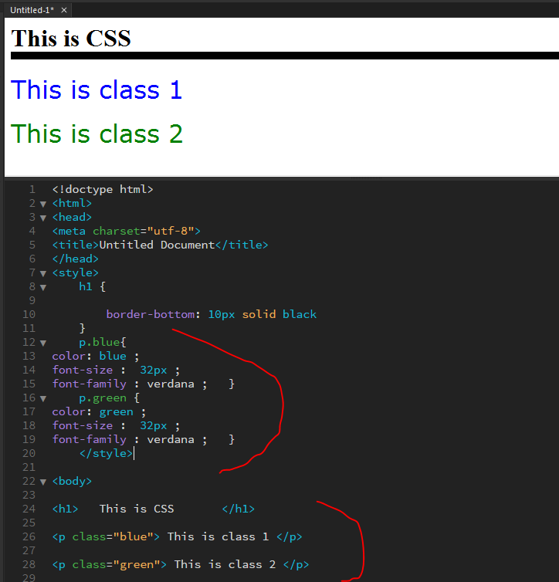

**Example 2 :**

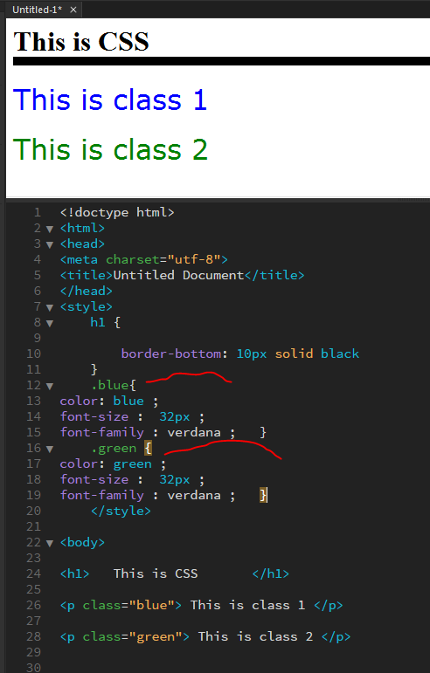

No need to write tag with class.

.class_name will also work for the corresponding tag.

**Using Multiple Classes :**

Syntax :

< tag class=”name1 name2”> </tag>

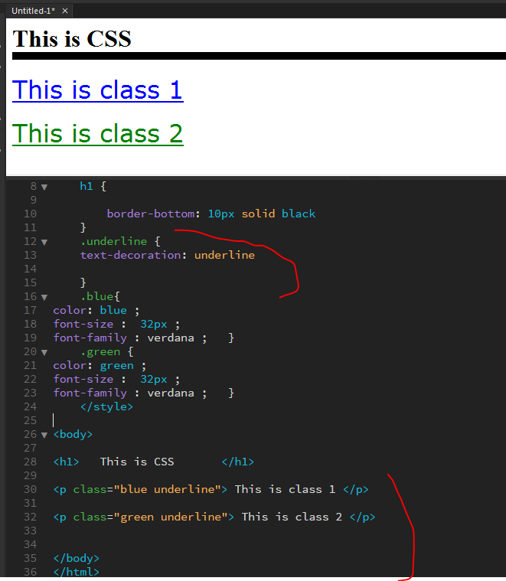

Two classes used for each p tag.

**Attaching an External Style Sheet :**

Create a new txt file.  
Copy Styles in the new txt file.  
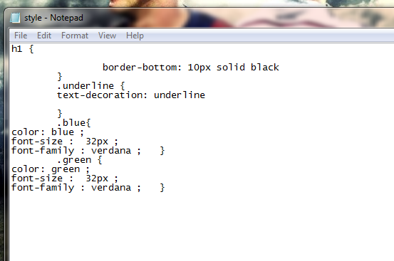

Save it as name.css

Go in html file and give link for the css style sheet before the body tag :

<link href="style.css" rel="stylesheet" type="text/css">

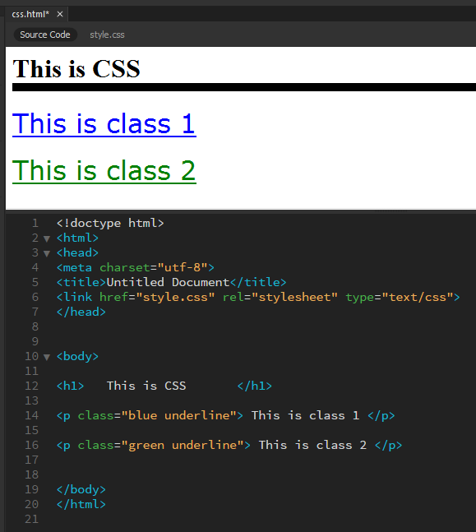

**Text Decoration :**

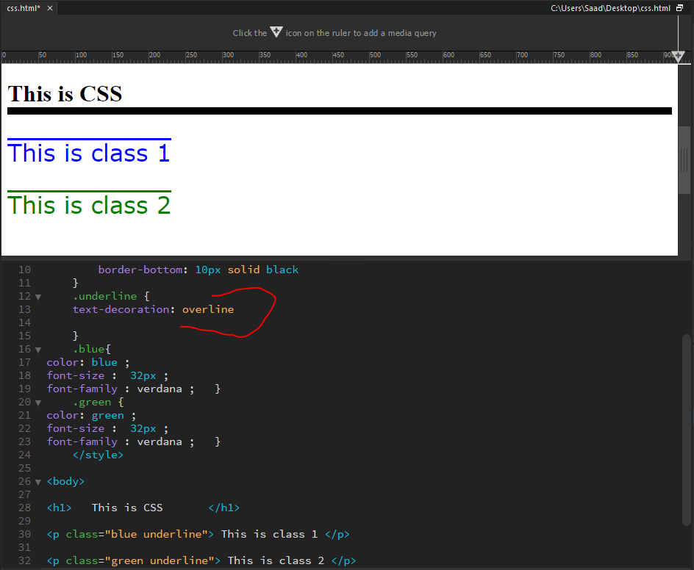

**Italic Fonts :**

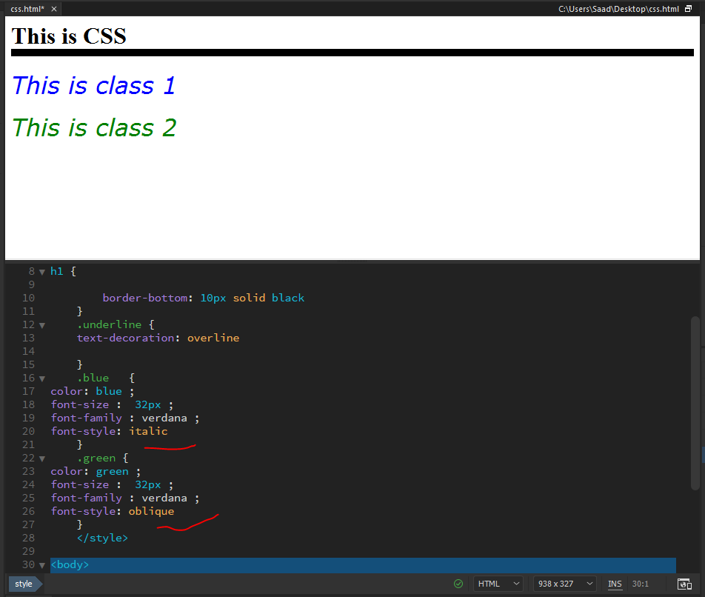

**Colors :**

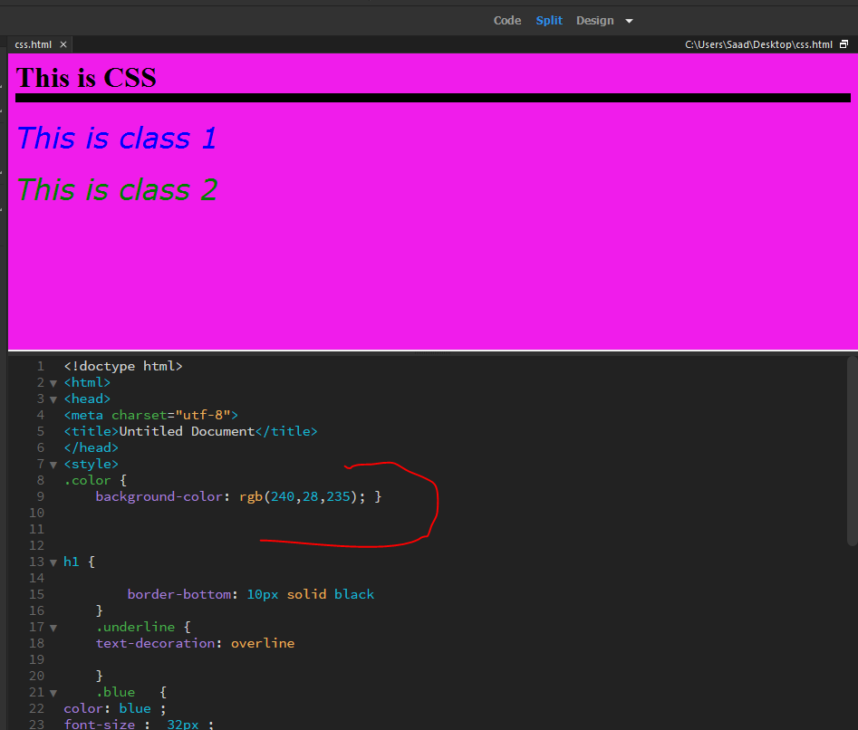

**Inline style :**

Css specified with in a tag is called in line style.

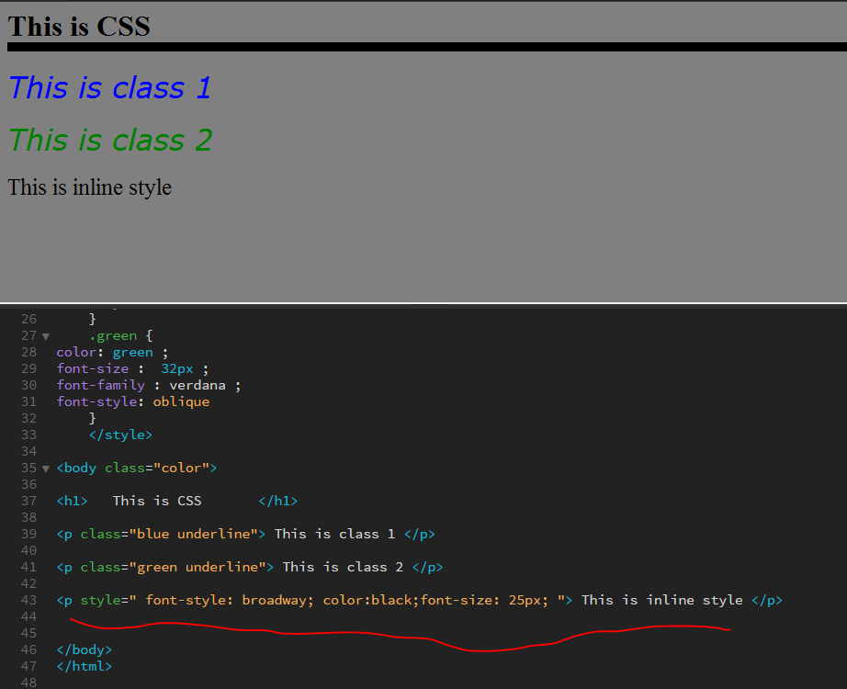

**Font size Inheritance :**

Body will be the default font size for every tag.

However the default font size can be adjusted in every tag by specifying the percentage.

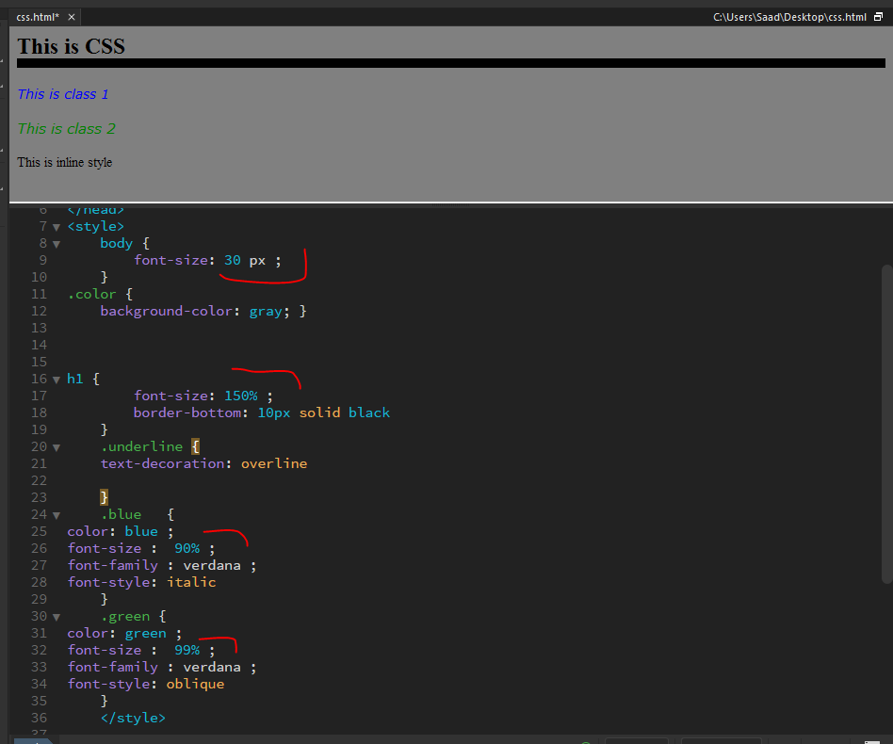

**Line Height :**

Adds space between lines.

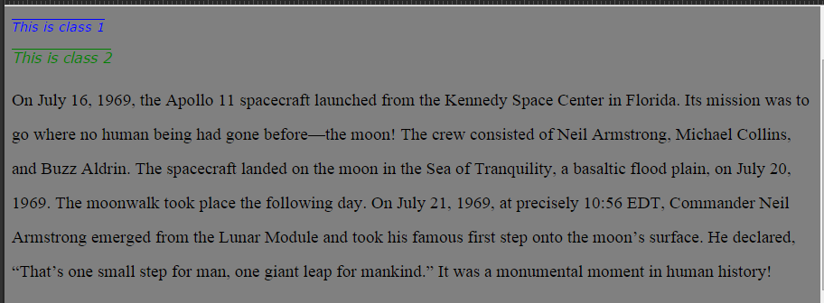

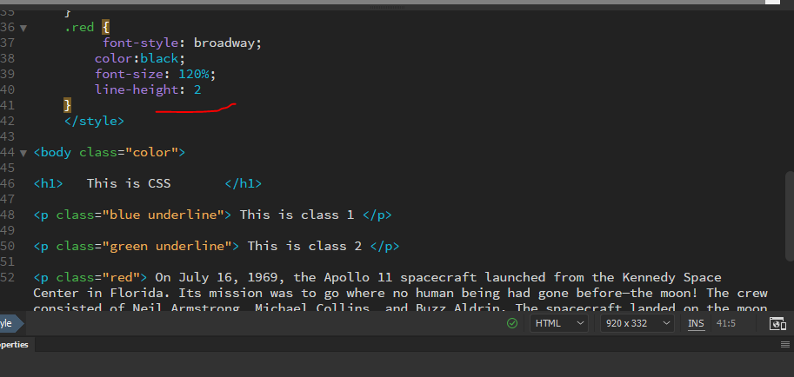

**Box Model :**

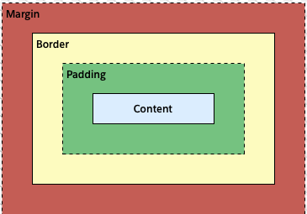

**Content :**

Content is where our main text or image is . But we can further stylize the content with the above given stuff.

Padding, border and Margin have to be specified.

**Padding :**

Space around the element.

**Border:**

Edges around the element :

**Margin**:

Distance between the content and the edge of the page.

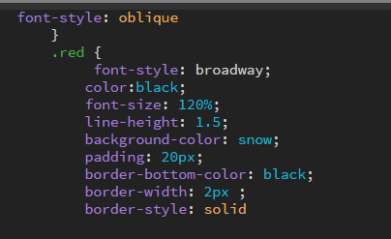

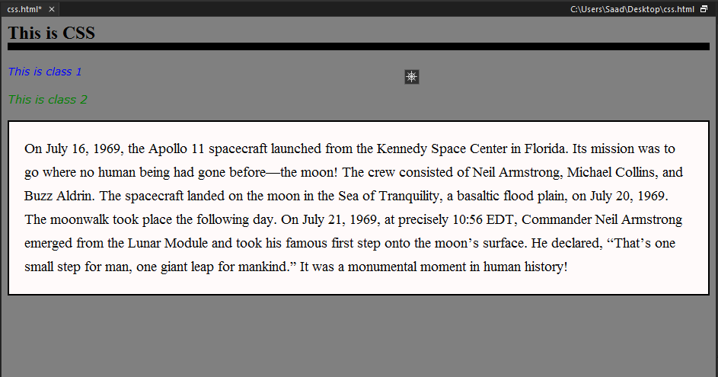

**Margin Examples :**

margin-left  
margin-right  
margin-bottom  
margin-top

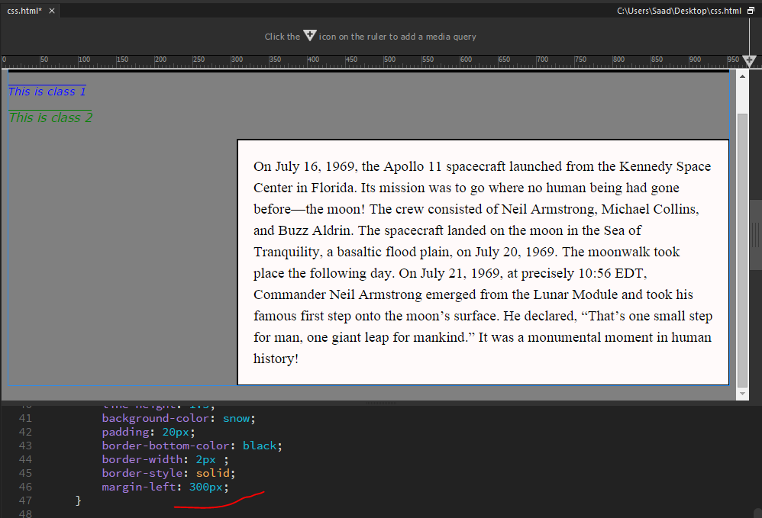

**Padding-examples :**

padding-left;  
padding-right;  
padding-top ;  
padding-bottom ;

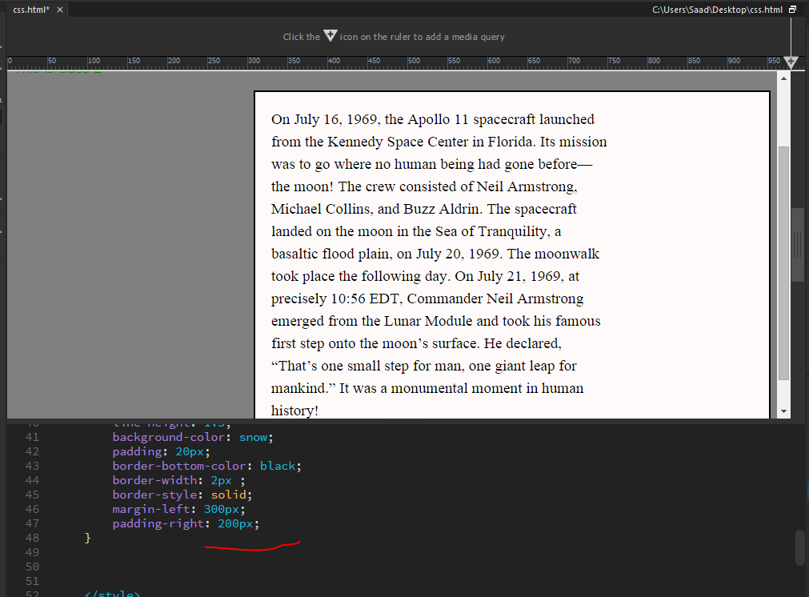

**Box model on image :**

To place image in center.

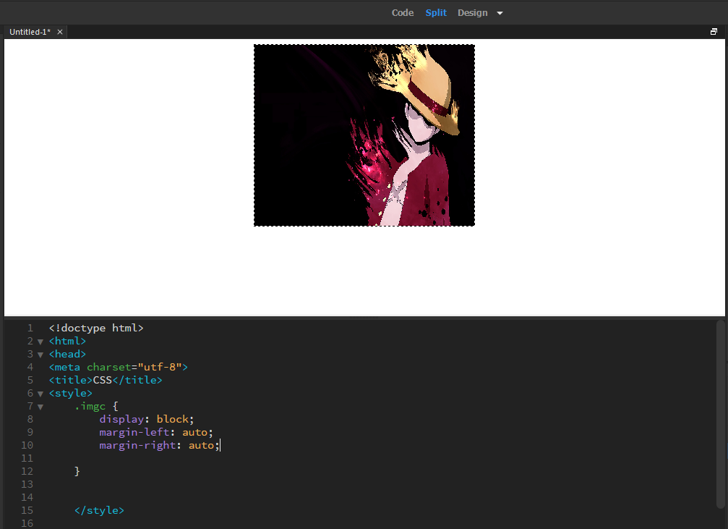

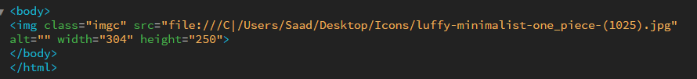

**Border and Padding for image :**

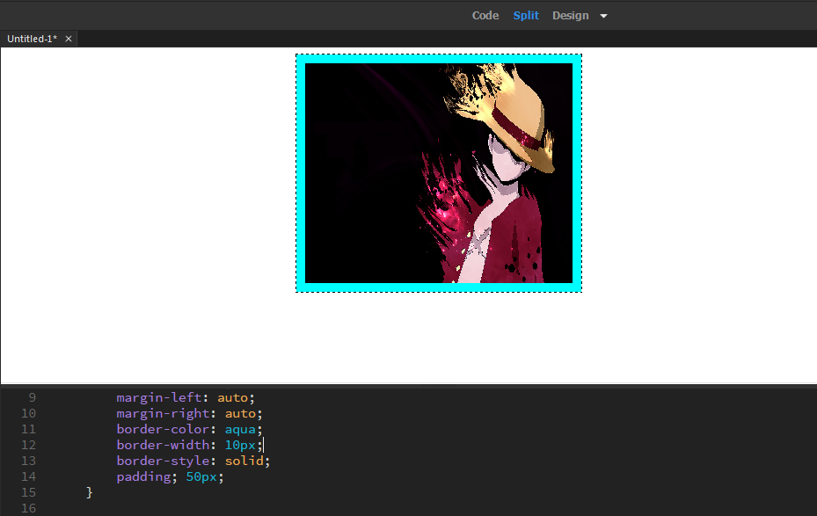

**Border Merging property :**

Syntax :

border : color width type ;

**Example :**

border : black 6px solid ;

**Padding Merging properties :**

**Background image :**

Places a background image only in the specified tag .

**Syntax :**

background-image: url(location) ;

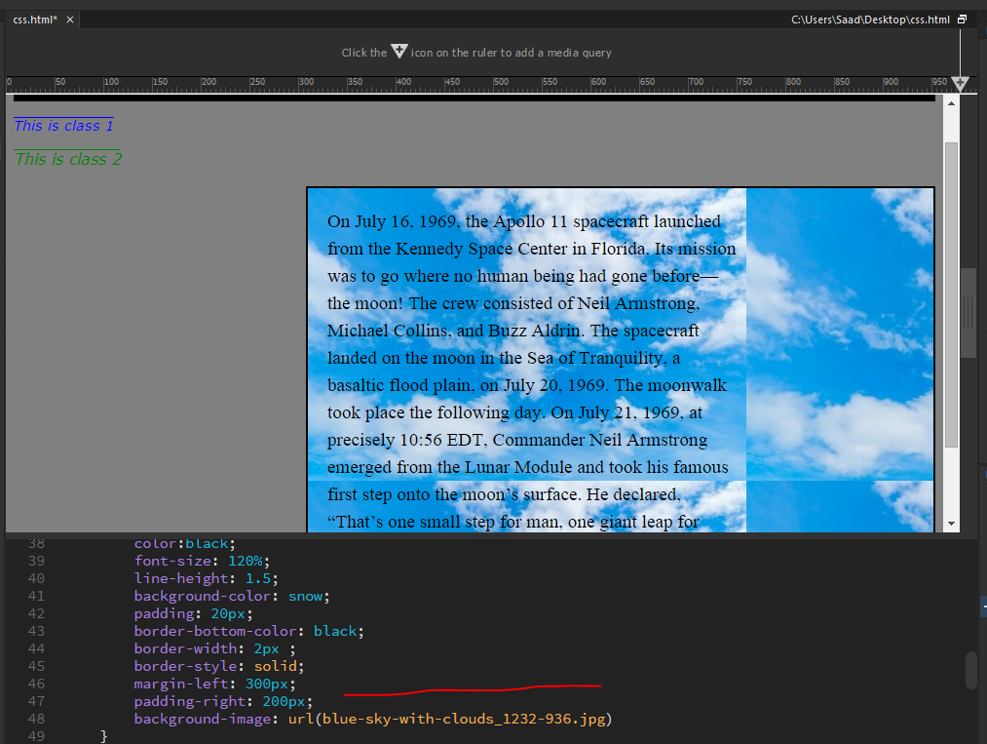

**ID Attribute :**

For specific set of css codes which u want to differentitate from the others.

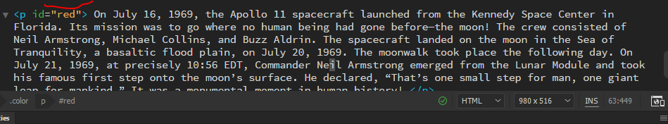

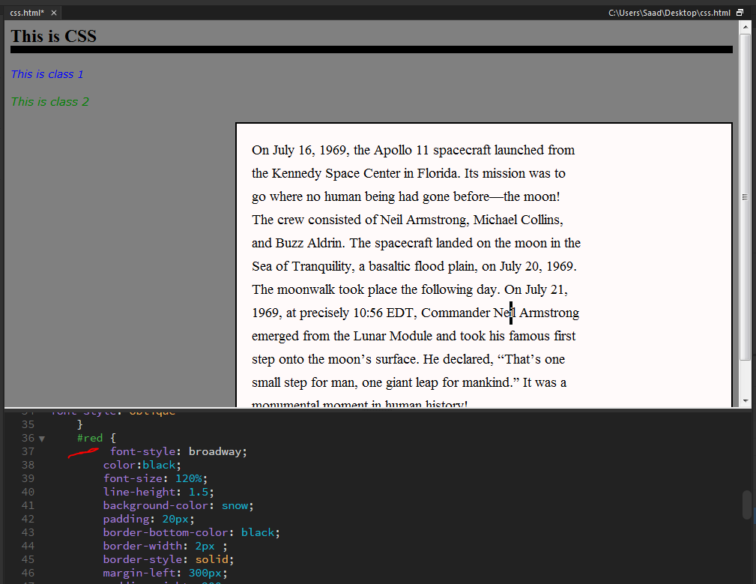

**Text- Align :**

Aligns the text specified .

**Syntax :**

text-align : position ;

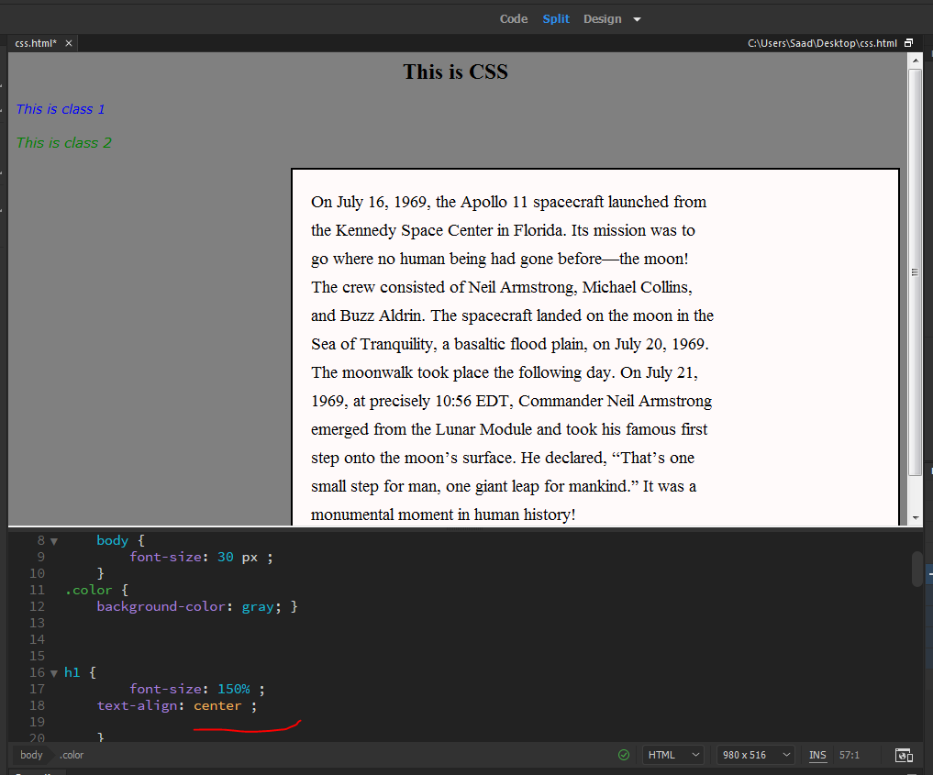

**Border-radius :**

Will curve the edge of your border .

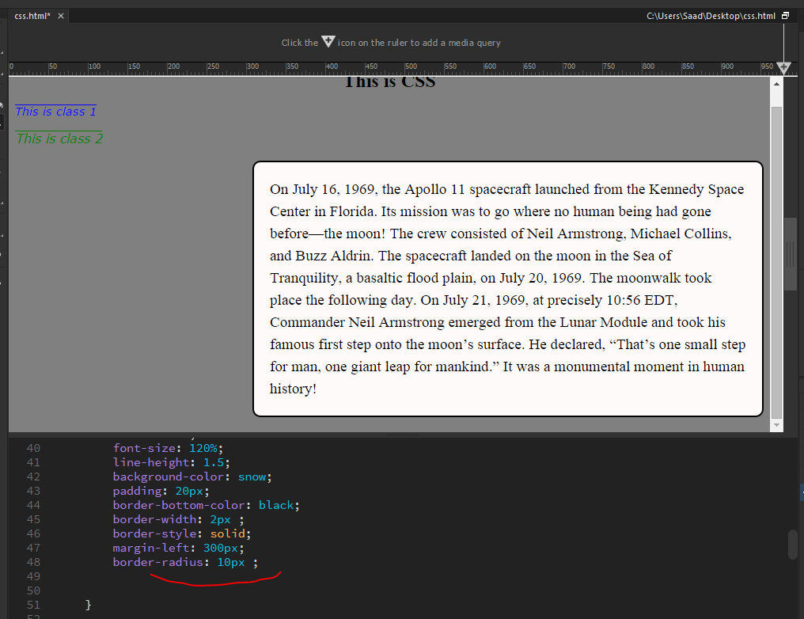

**For specific curves :**

border-bottom-left-radius: px ;

border-bottom-right-radius: px ;

border-top-left-radius: px ;

border-top-right-radius: px ;

**Border Style in Specific area :**

Border-bottom-style: specify ;

Border-top-style: specify ;

Border-left-style: specify ;

Border-right-style: specify ;

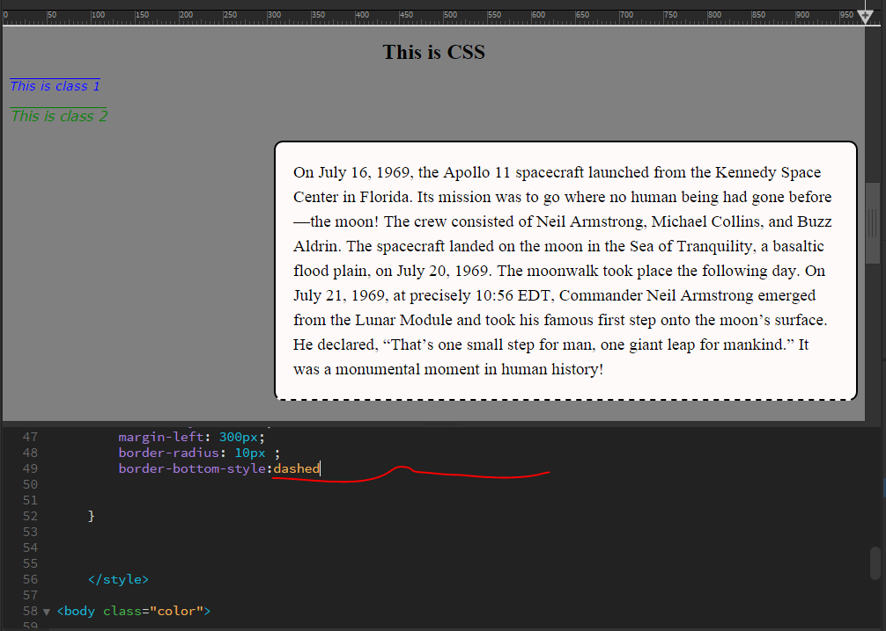

**Div tag :**

Used to divide your web page into sections.

<div>

#classes and ids can be specified in the div tags for

inheritance

</div>

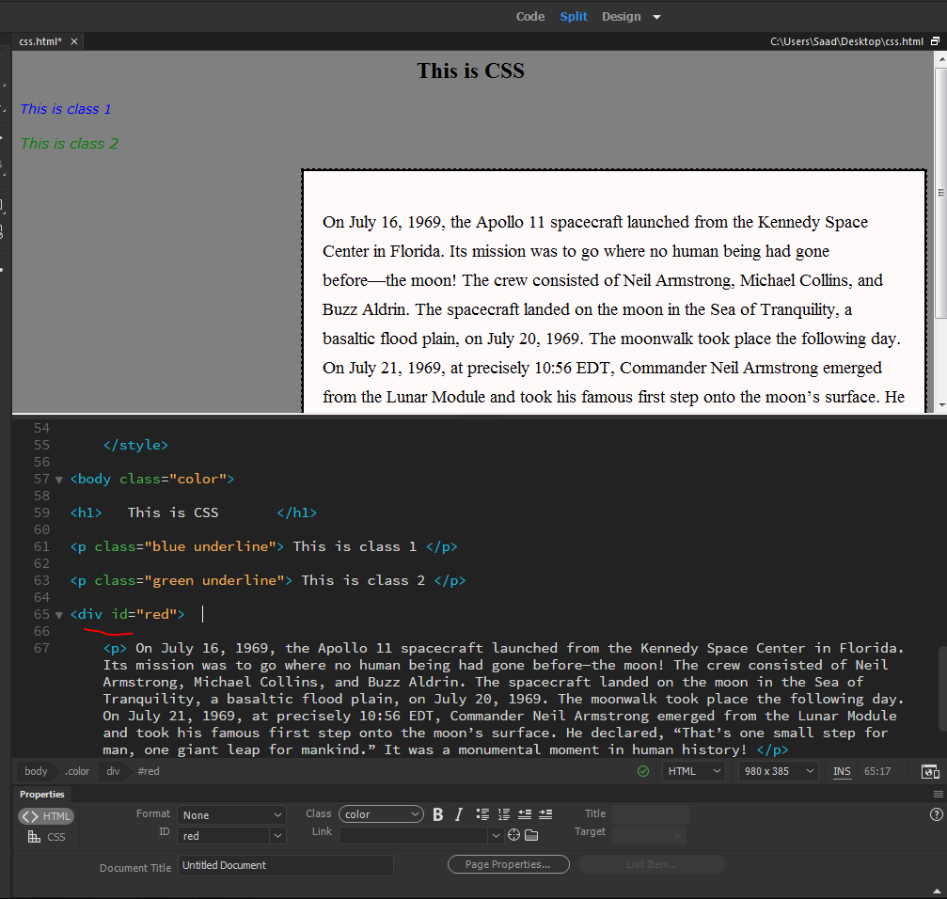

**Span tag :**

Similar to a div tag but can be used on small scale.

<span> </span>

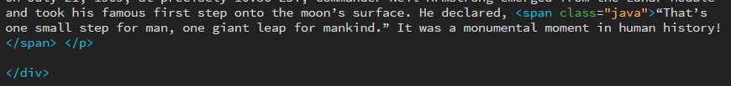

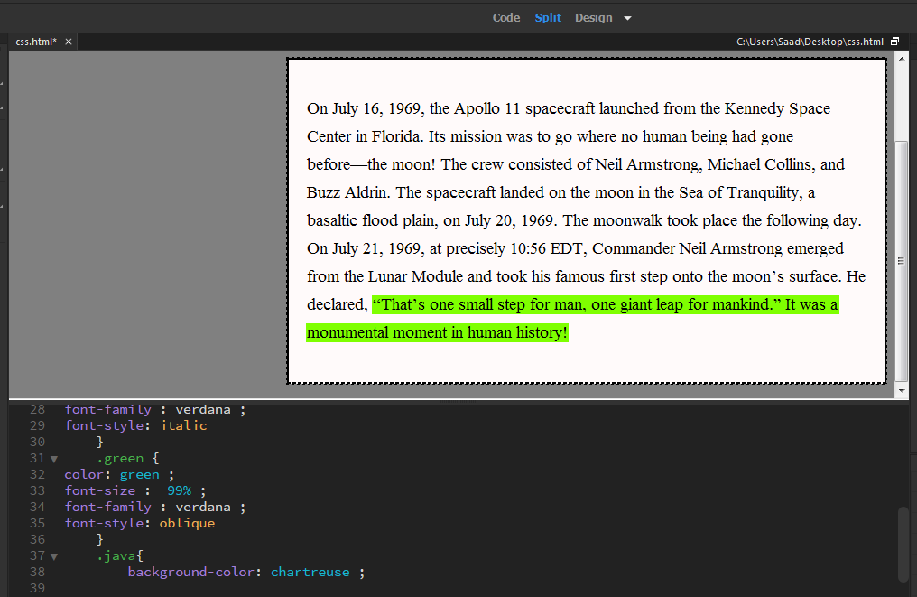

**Pseudo classes special effects :**

Syntax :

a:link {

color : define ; } #for href

a:hover {

color : define ; } #for placing cursor on a link

a: visited {

color ; } #when u clicked on a link

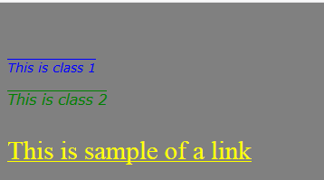

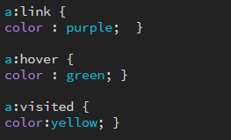

**Width:**

Use to adjust occupation of elements .

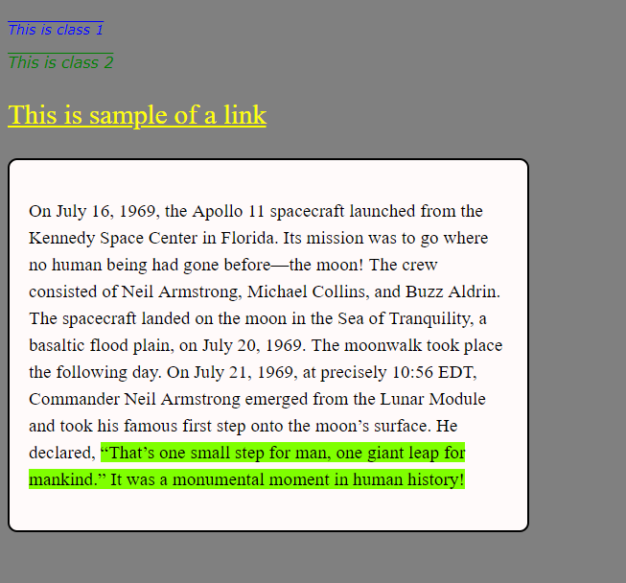

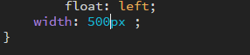

**Float :**

Used to pin elements to desired position .

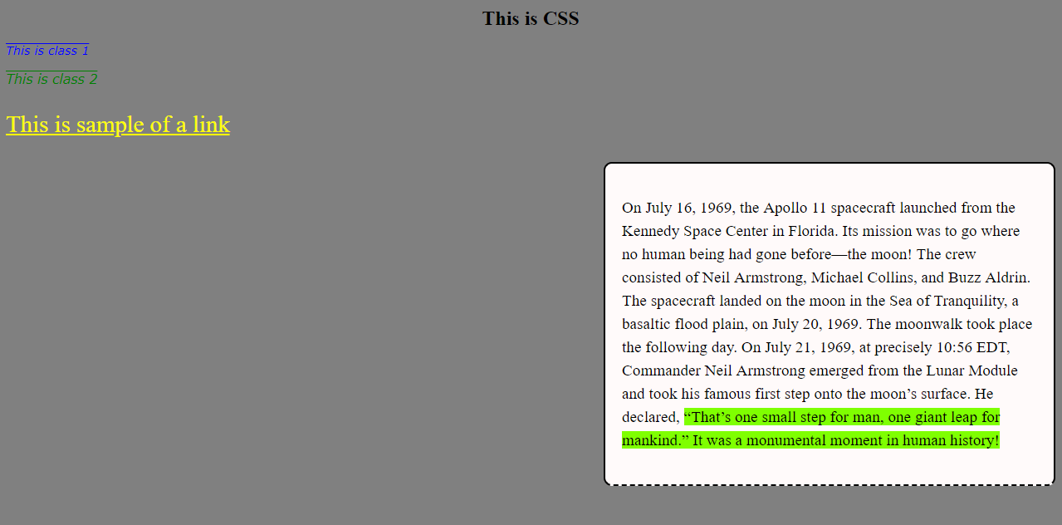

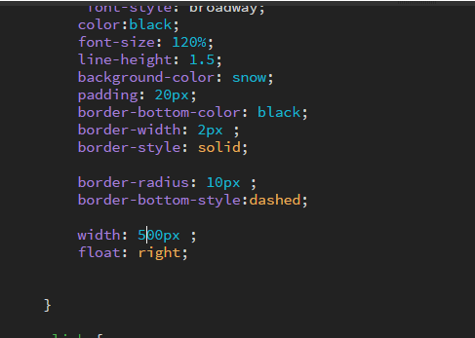

**Absolute Position :**

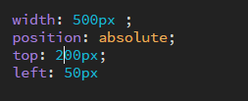

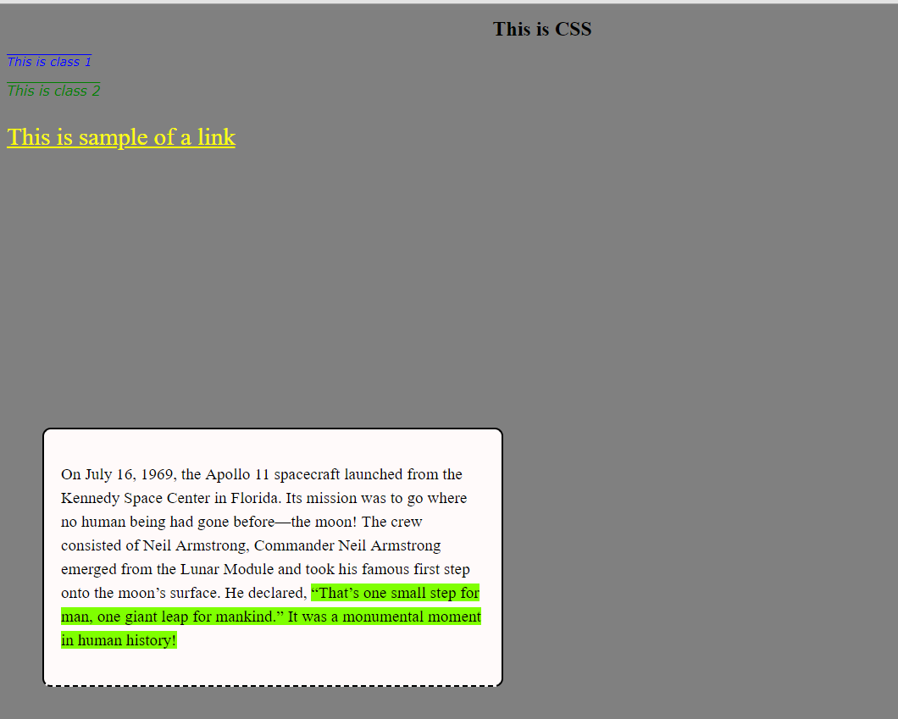

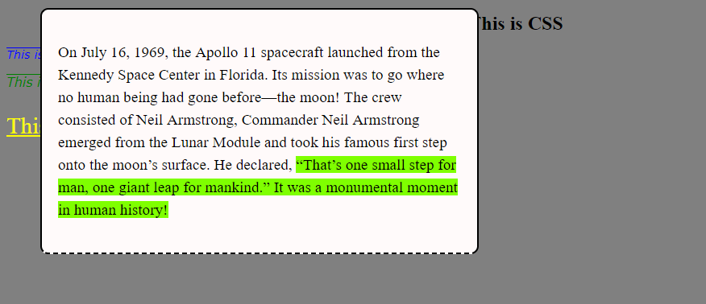

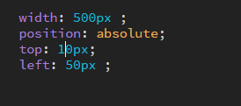

Also does not respect other elements .

**Fixed :**

Even if u scroll down the page it will still remain on the fixed position :

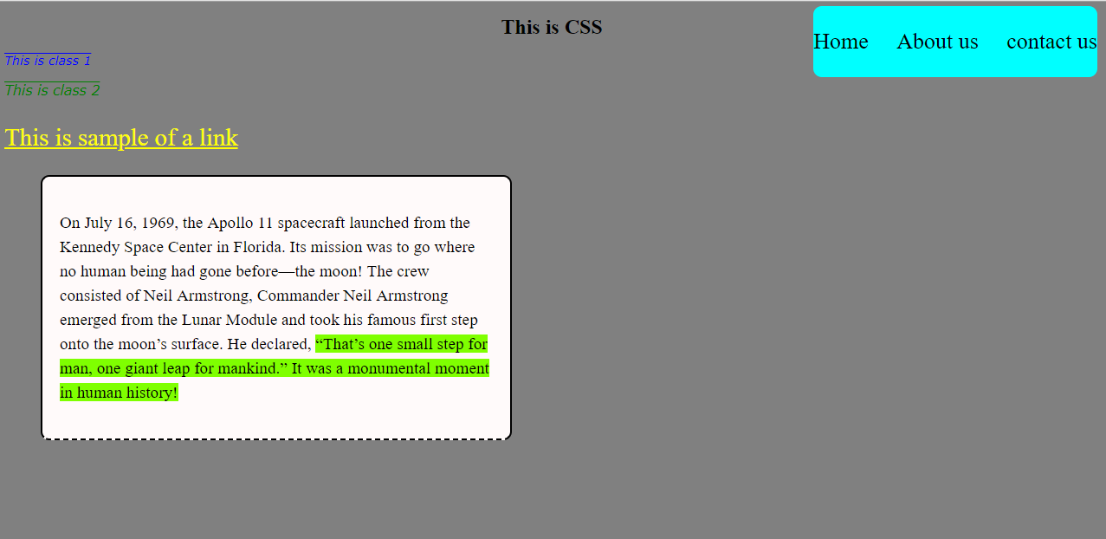

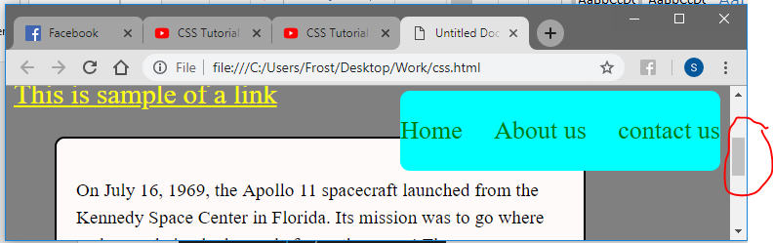

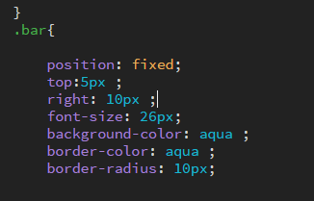

**Over flow :**

Used for large amount of text . adds a scroll feature to view texts .

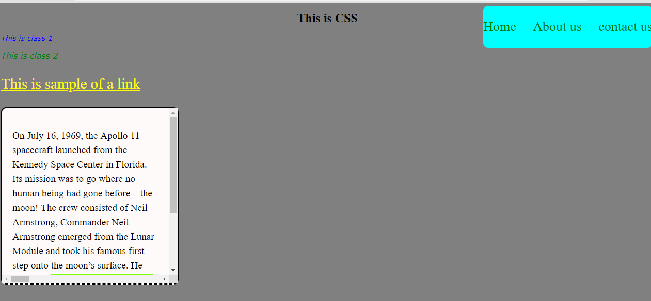

**Cursor Property :**

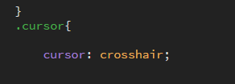

**Flex box :**

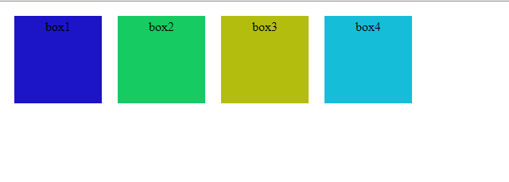

<style>

.flexbox {

display: flex;

}

.box1{

width: 100px;

height: 100px ;

margin: 10px ;

padding: 5px ;

background: #1C14C7;

text-align: center;

}

.box2 {

width: 100px;

height: 100px;

margin: 10px;

padding: 5px ;

background:#17CB63;

text-align: center;

}

.box3 {

width: 100px;

height: 100px ;

margin: 10px;

padding: 5px ;

background:#B3BD0E;

text-align: center;

}

.box4 {

width: 100px;

height: 100px;

margin: 10px;

padding: 5px ;

background:#16BDD8;

text-align: center;

}

</style>

<html>

<body>

<div class="flexbox">

<div class="box1"> box1 </div>

<div class="box2"> box2 </div>

<div class="box3"> box3 </div>

<div class="box4"> box4 </div>

</div>

</body>

</html>

**Flex Box Direction :**

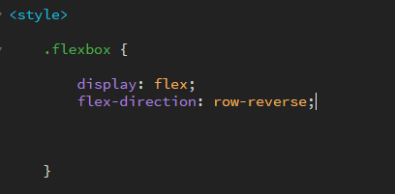

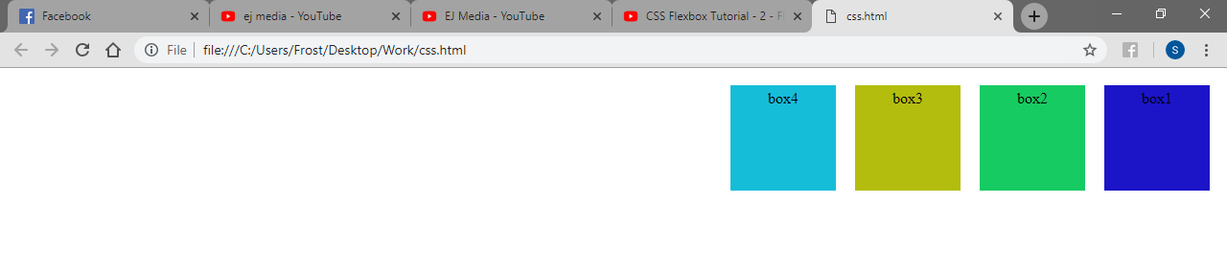

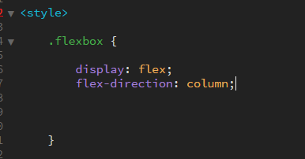

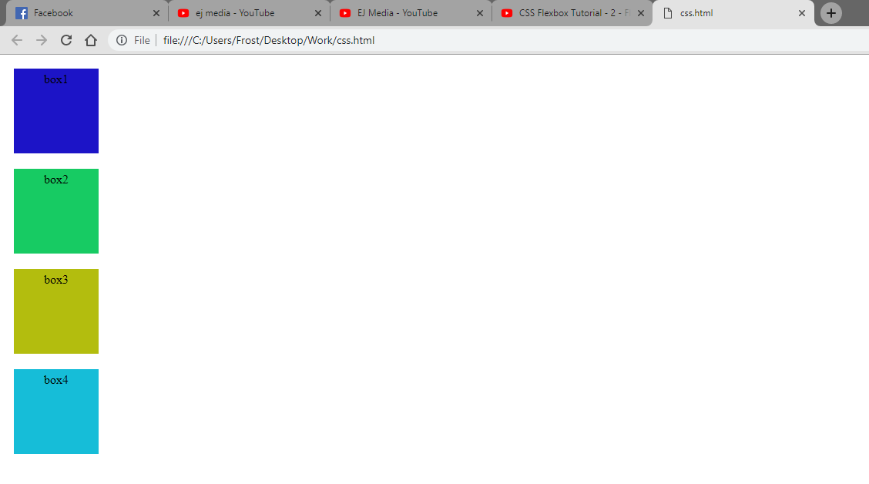

**Order :**

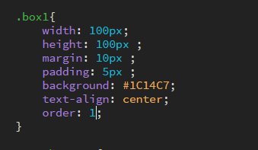

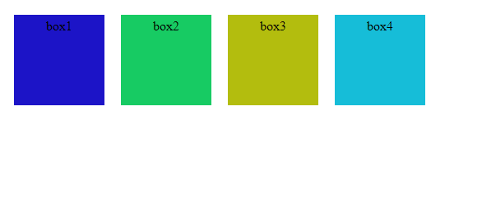

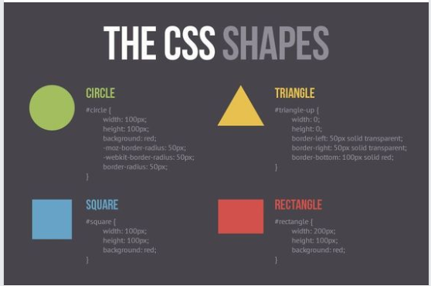

Transform : translate (x,y)

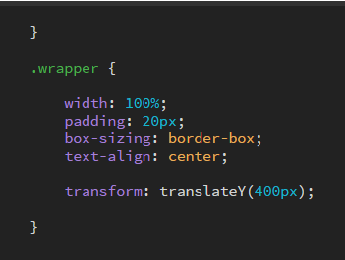

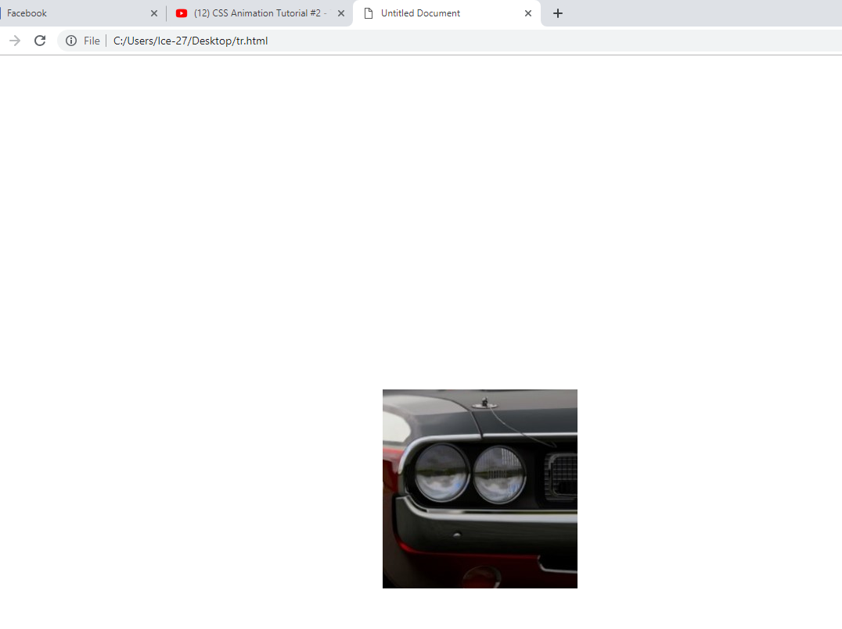

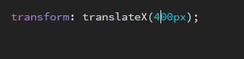

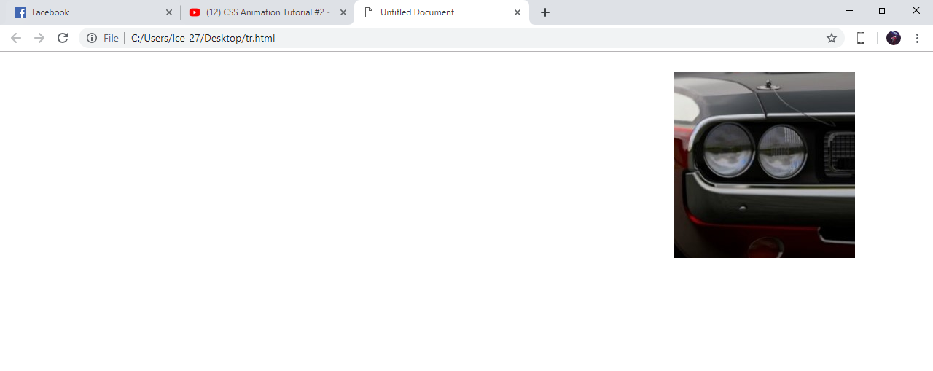

**Transform : scale (x,y) ;**

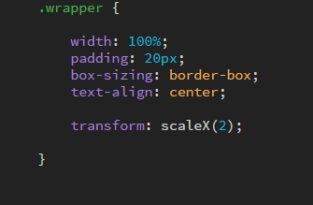

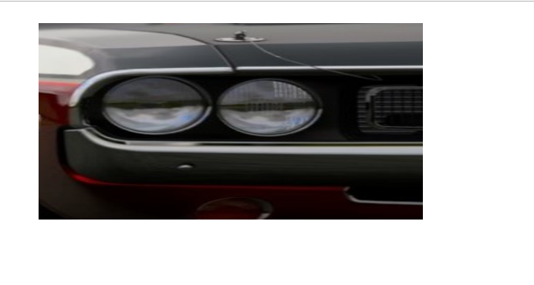

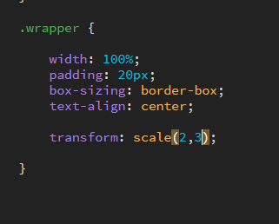

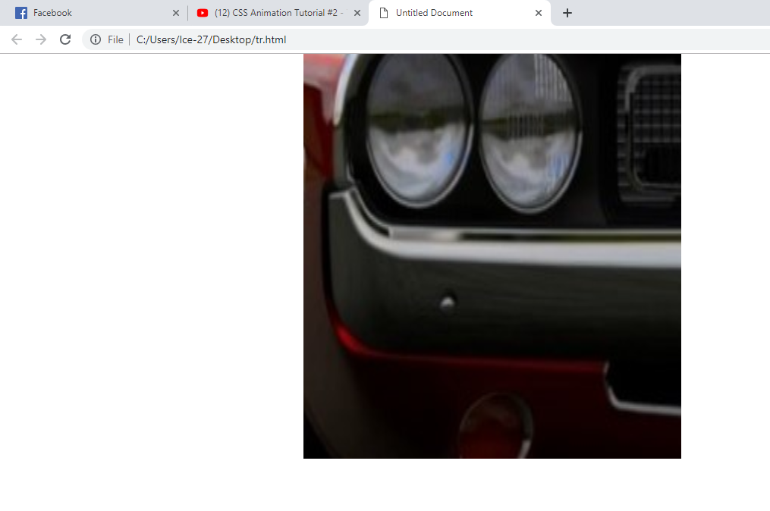

Transform : rotateX , rotateY

**Transition :**

**Change from one state to another :**

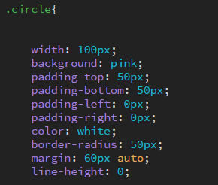

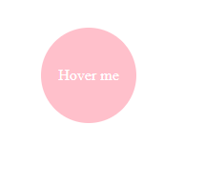

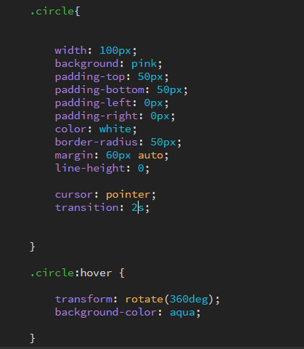

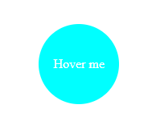

For background only :

Transition : background 1s;

Manipulate other :

Transition : background 1s , transform 0.3s;

**Key frames :**

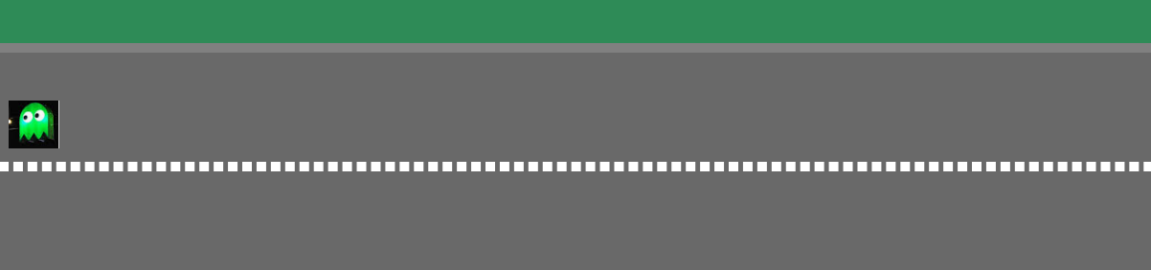

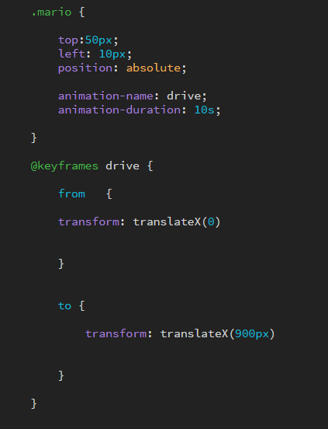

Animation-name and duration used to import

**Animation-fill-mode: forward ;**

Specifies an end point .

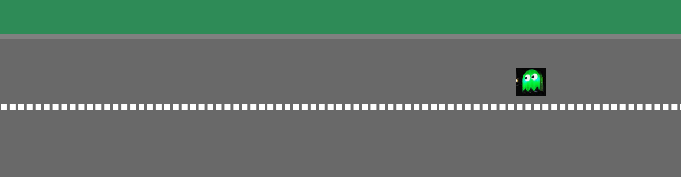

It will stay there

**Animation Delay :**

Gives a delay time for the animation to start :

**Making animation repeat infinite times :**

animation-iteration-count: infinite;

**Start animation in reverse :**



Animation-timing-function : ease-in

**Variables in SASS :**

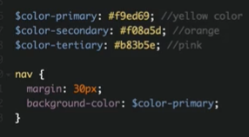

**Nesting is Sass :**

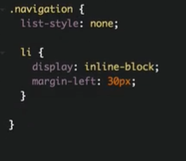

**Targetting childs :**

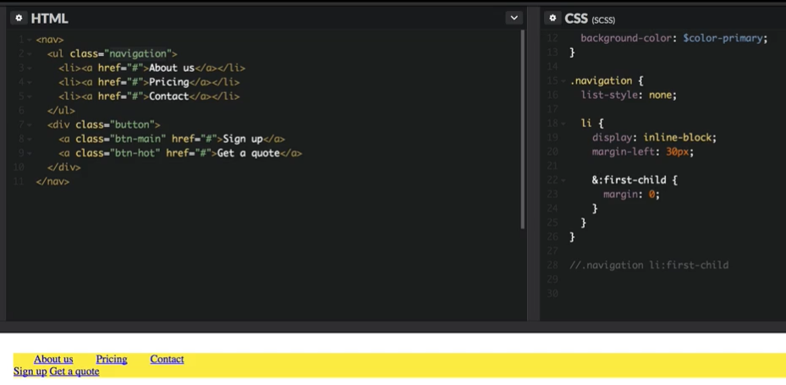

**Storing classes in variables :**

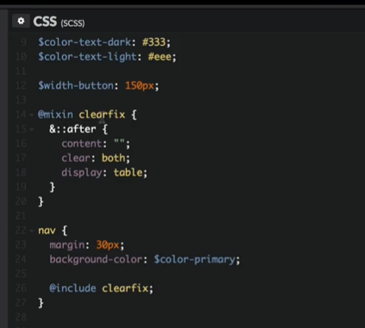

**Passing variables in mixin :**

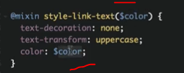

**Calling function :**



**Extending :**

