**HTML  
(Hyper Text Markup Language)**

Created by Berners lee in 1991

**Tutorials :**

<https://www.youtube.com/watch?v=dD2EISBDjWM&list=PLr6-GrHUlVf_ZNmuQSXdS197Oyr1L9sPB>

Softwares :

Adobe dreameaver cc 17 *(writing codes and displaying output)*

*Visual studio (writing codes and displaying output)*Notepad++ (writing codes)

Google chrome or firefox for better output (for output)

**Program Syntax :**

<!doctype html> #defines document type  
<html > #web document

<body> #contents of a web page

</body>

</html>

**Extension :**

file.html

**Tags :**

<tag> #opening  
</tag> #closing

**Examples :**

<Head> #document’s header  
<title> #document title for tab   
<br> #new line

**Comments :**

< ! any text

**Space :**

&nbsp

**HTML LISTS :**

Ordered Lists :

Used Listing elements.

**Tag :**

**<ol> #ordered list tag**

**<li> element 1 </li> #listing tag used for every elememt  
<li> element 2 </li>  
<li> element 3 </li>**

**</ol>**

**Output :**

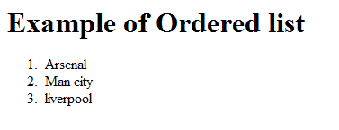

**Code :**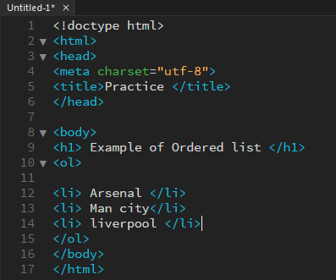

**Types :**

<ol type =’a’ > # char= ‘ ‘

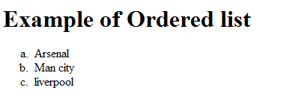

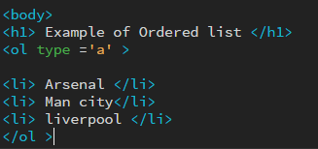

<ol type=”1” start=”6”>

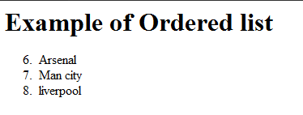

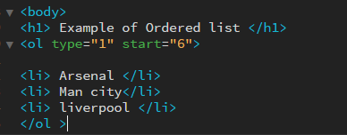

Un Ordered Lists :

For bullets listing.

**Tag :**

**<ul> #ordered list tag**

**<li> element 1 </li> #listing tag used for every elememt  
<li> element 2 </li>  
<li> element 3 </li>**

**</ul>**

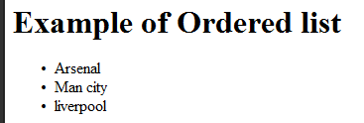

**Types :**

**<ul type=”circle” >  
<ul type=”square” >  
<ul type=”disc” >**

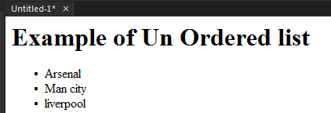

**Description List :**

**<dl> #defining description list**

**<dt> </dt> #element   
<dd> </dd> #description of element**

**</dl>**

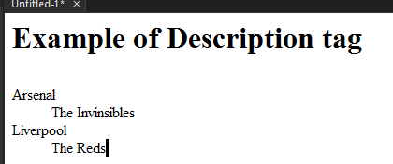

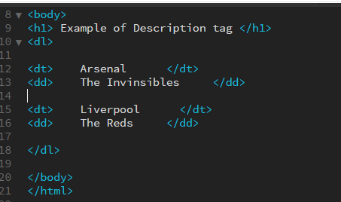

**Table :**

<table> # table is generated row wise

<tr>

<td> element </td> #data is entered row wise

</tr>

</table>

Output :

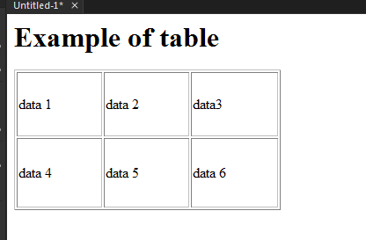

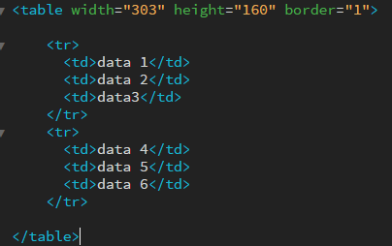

**Table headers :**

**Placed above the row tag for headings**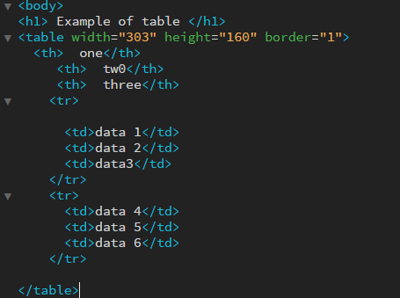

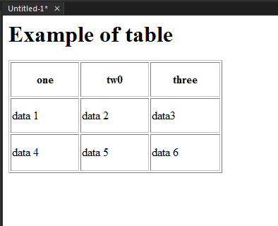

**Cell spacing :**

< table cellspacing=”number” >

Distance between cells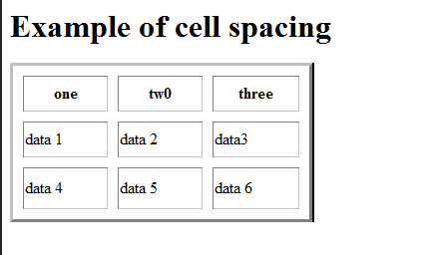



**Cellpadding :**

**<table cellpadding=”number” >**

**Size of each cell**

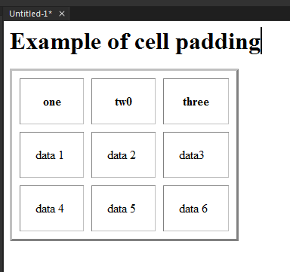



**Column span :**

Merges column

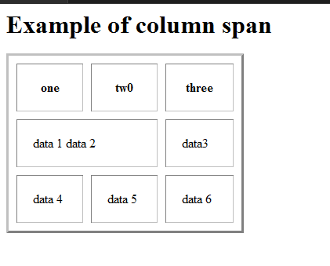

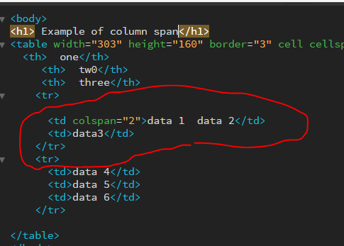

**Row span :**

Merges rows

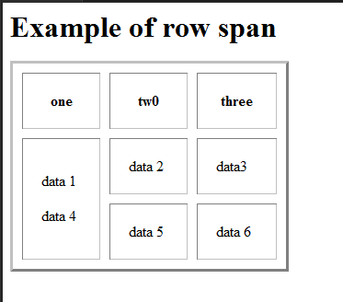

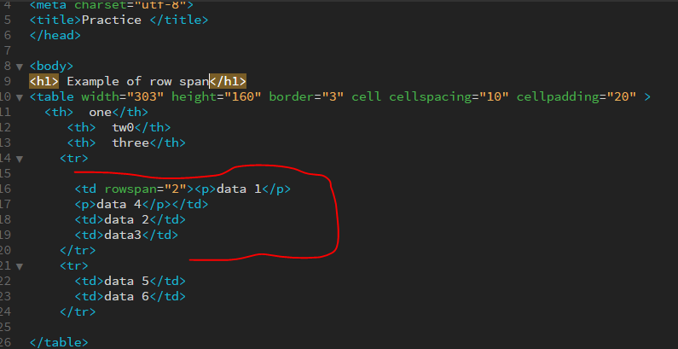

**Frames :**

Divides pages into multiple sections .  
Each frame can load a different html file.

**Tag**

< frameset rows =”10%,80%,10%”>

**or**  
<frameset colomns =”10%,80%,10%”>

<frame name=”f1” src=”file.html” >

<frame name=”f2” src=”file2.html” >

</frameset >

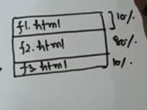

**Creating A web link :**

Direct or redirects to a specified page . Done through the anchor tag .

< a href=”www.google.com> text </a>

**Adding Images :**

By the img tag.

<img src=”imagename.jpg” >

Image Directory should be specified correctly

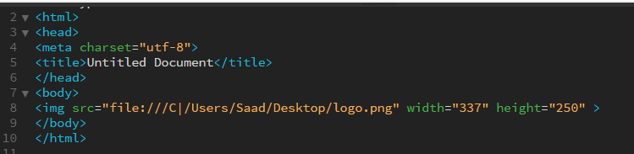

**Forms :**

Contains a set of buttons and fields commonly used for data entry.

<form action=”” method=””> </form>

**One line text box :**

<input type=”text” name=”” >

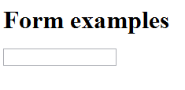

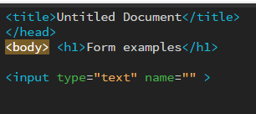

**Size :**

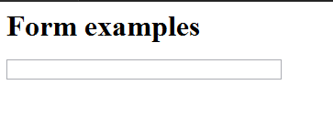

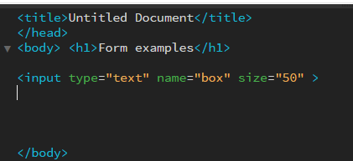

**Label :**

<label for=”name”> name </label> # id & for should be same

<input type=”text” id=”name” name=”” >

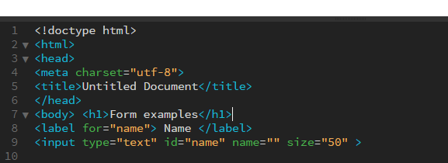

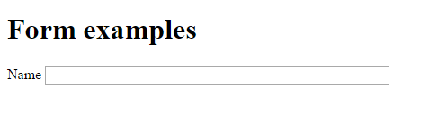

**Multi line Text box**

Scroll down text field for multiple line inputs.

<textarea rows=”20” columns=”15”> </textarea>

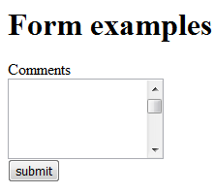

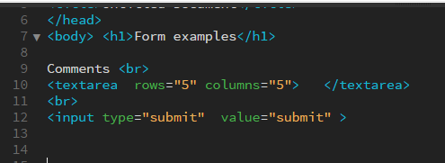

**Radio Button :**

For selecting one item or one category

Yes:<input type=”radio” name=”yesorno” value=””>

no<input type=”radio” name=”yesorno” value=””>

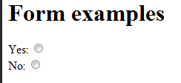

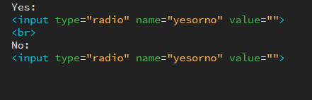

#name=”yesorno” should be same for both buttons otherwise radio buttons would not work.

**Chech box:**

Selects multiple categories for input.

<input type=”checkbox” name=””> category 1 <br>

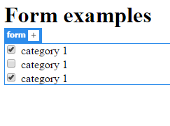

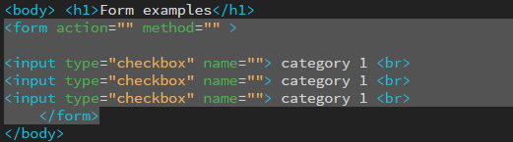

<input type=”checkbox” name=”” chechked=”checked”> category 1 <br>

#for automatically pre selected category

**Number input box :**

Inputs numbers only in a field can also specify a minimum or maximum range.

<input type=”number”>

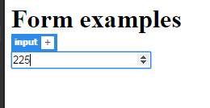

Range :

<input type=”number” min=”10” max=”20”>

**Drop down list :**

Produces a list to select one option from the category.

<select>

<option value=””> </option>

</select>

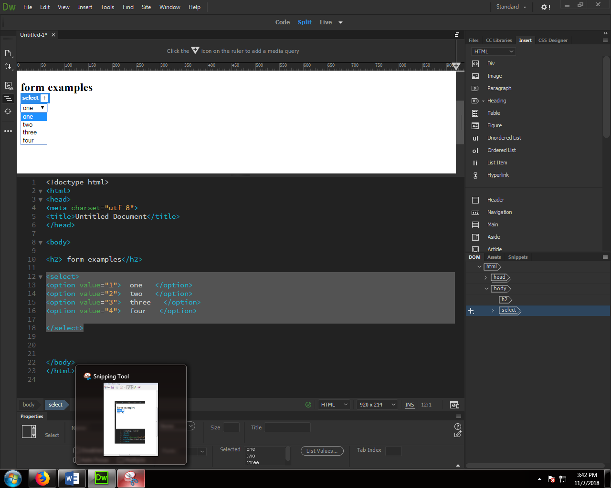

**Date box :**

<input type=”date” name=”any” >

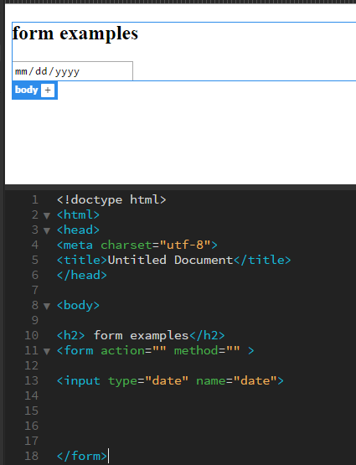

**Fieldset & Legend element for Form :**

<fieldset>

<legend> caption </legend>

</fieldset>

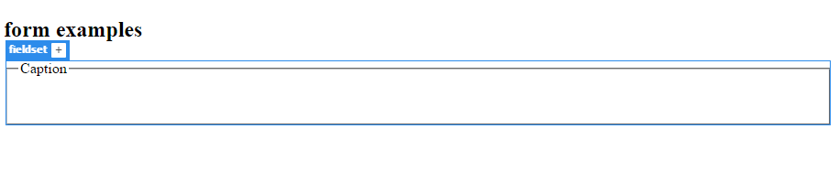

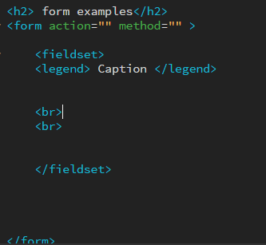

**Meta Elements :**

Non visible in the output.

Will make it easier for the search engines to look up your page when searched.

<meta name=”description” content=”this is a web page about ***”

<meta http-equiv=”content-language” content=”contact us”>

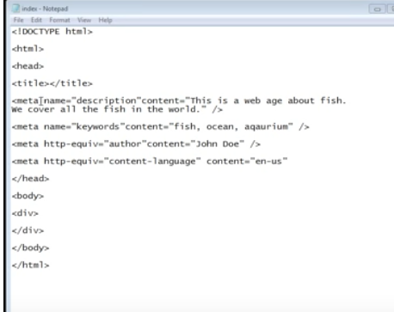

Meta element description example :

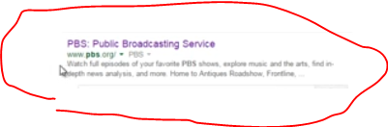

**Escape elements :**Since the browser cannot recognize multiple spaces or special characters therefore escape elements provide just that.

space ------- &nbsp;

™ ---------- &#8482;

& ---------- &amp;

© ---------- &copy;

< ----------- &lt;

> ----------- &gt;

? ----------- &#63;

Text elements :

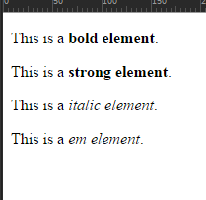

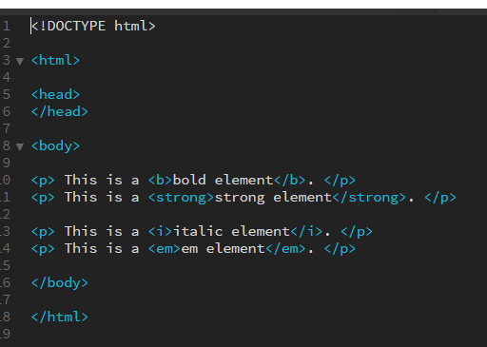

**iframe :**

Creates a section where u can load different web pages in it .

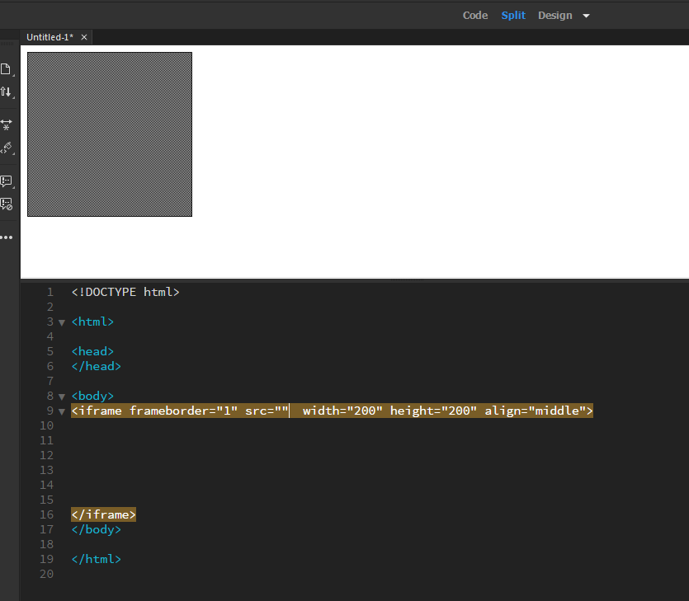

src=”webpage.html”

# sup and sub elements :

Sup element displays characters or numbers in exponential form and the sub displays in down notation.

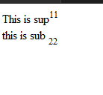

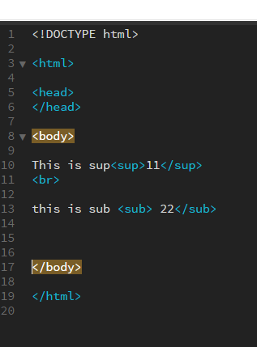

**Title :**

Used for displaying description.

< title=” “>

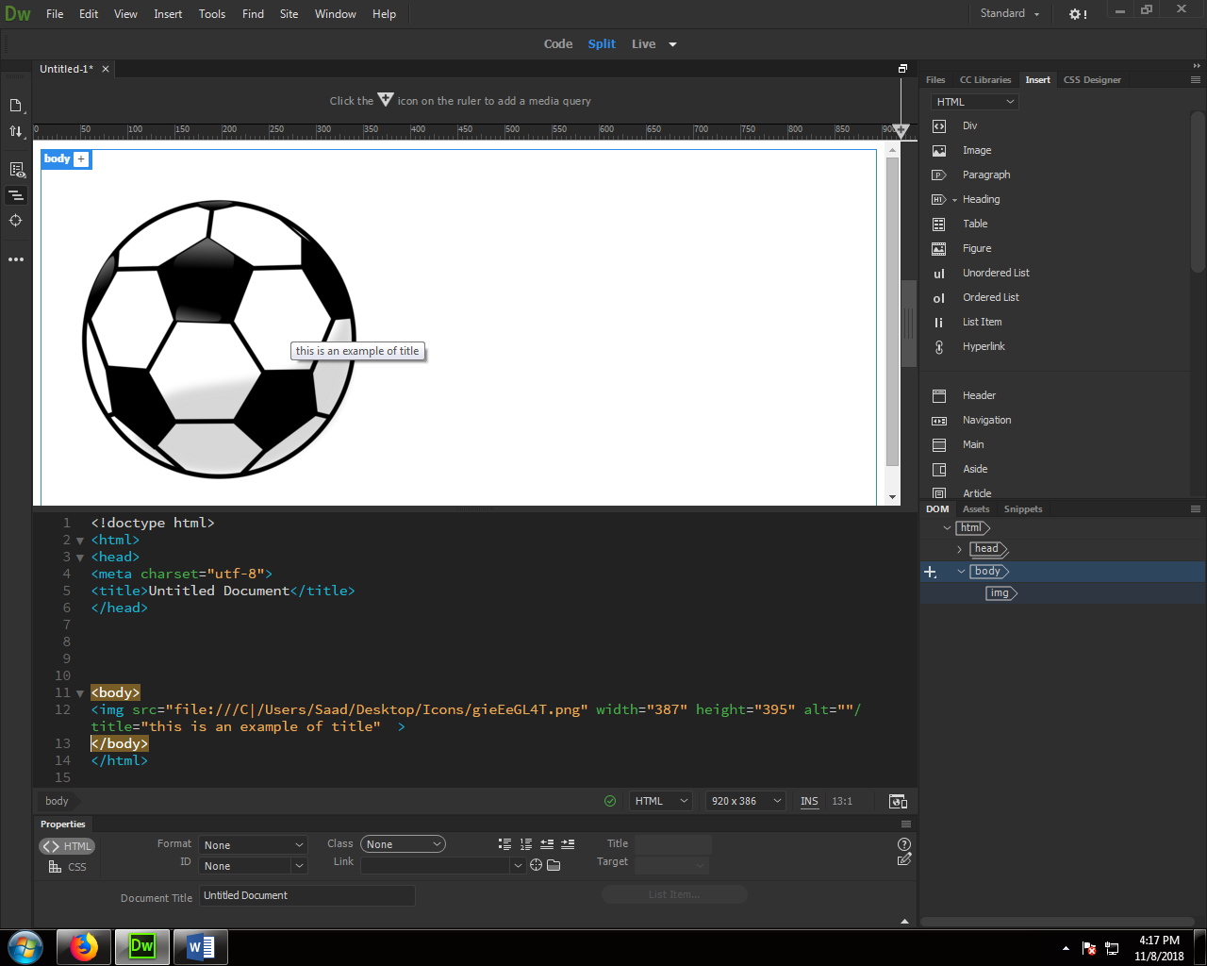

**Audio :**

Places an audio playing bar for the desired file.

< audio controls=”audiocontrol1” >

<source src=”filename.mp3”>

</audio>

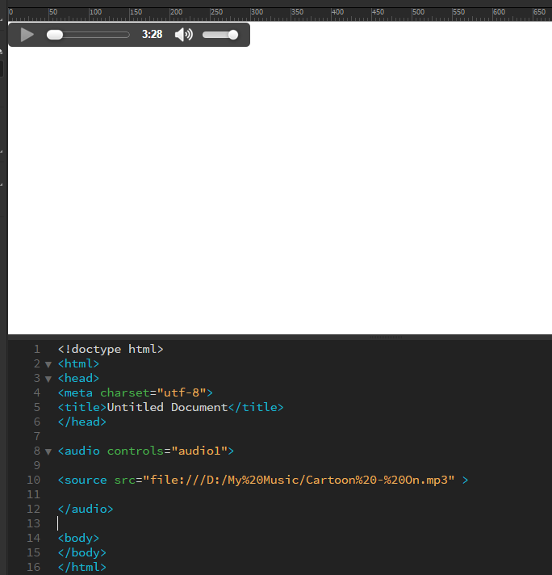

For autoplay :  
< audio controls autoplay >

<source src=“filename.mp3” >

</audio>

For frequently playing auto loop :

< audio controls autoplay loop >

<source src=“filename.mp3” >

</audio>

**Video :**

<video width=”” height=”” controls>

<source src=”filename.mp4” >

</video>

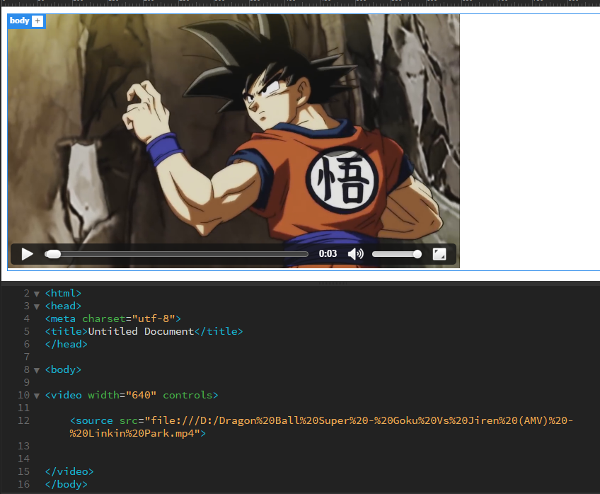

**Extras :**

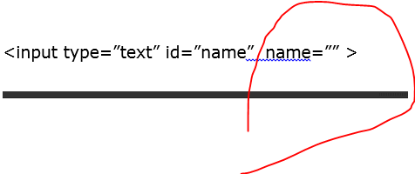

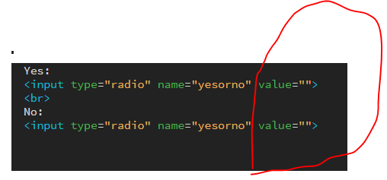

**These unused variable are for php data input that is why not covered.**

**Suggestions :**

Use adobe dream weaver cc 17 it will ease in writing codes.

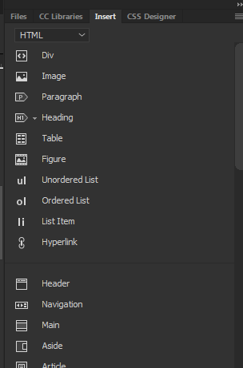

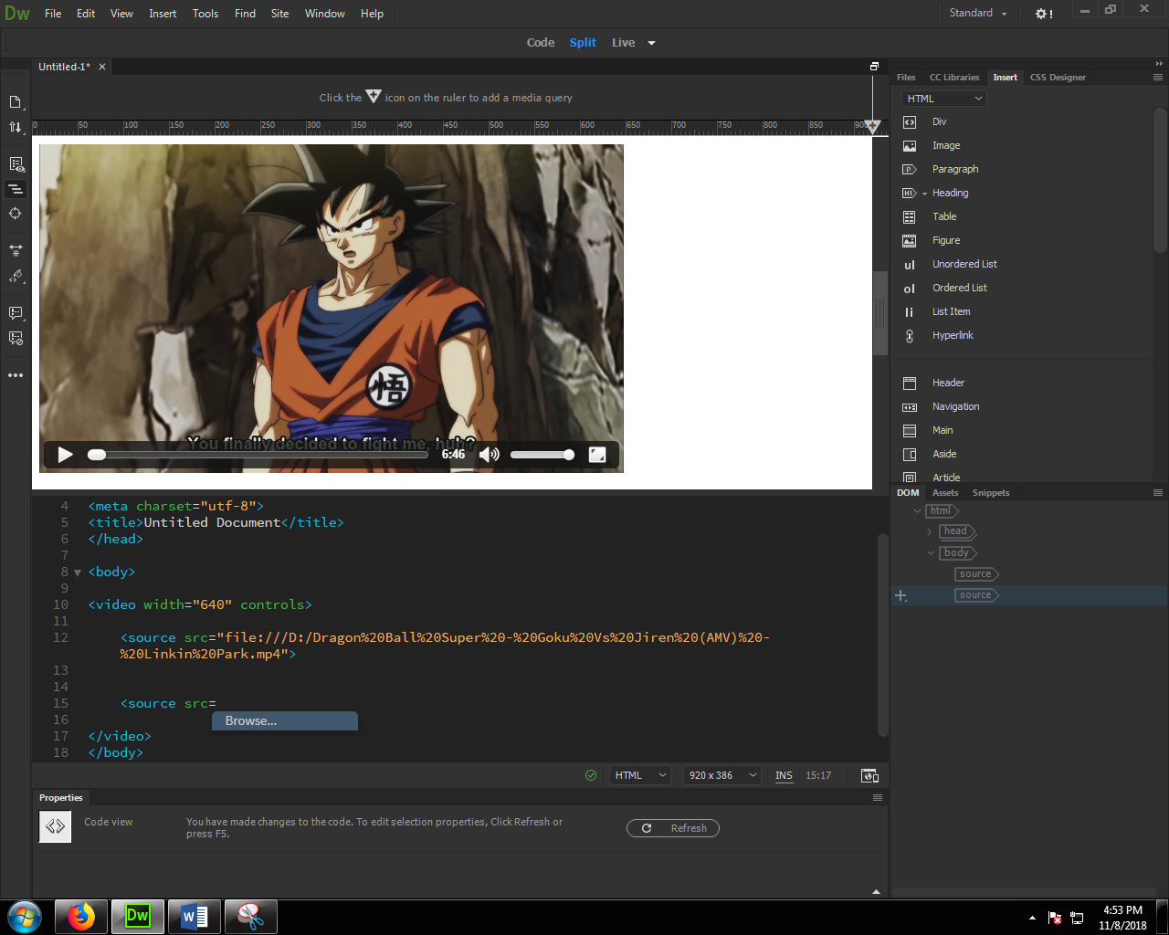

Also Gives quick location to any file by “browse” option.