**PHP**

(Hypertext Preprocessor )

Server side scripting language.

**Syntax :**

<?php

?>

**Softwares :**

XAMPP ( database connection )

NOTE PAD++

**Tutorials :**

https://www.youtube.com/playlist?list=PLr6-GrHUlVf86WpAyqV5dJUwYUUTzJWWV

**XAMPP :**

XAMPP should be running to run php codes.

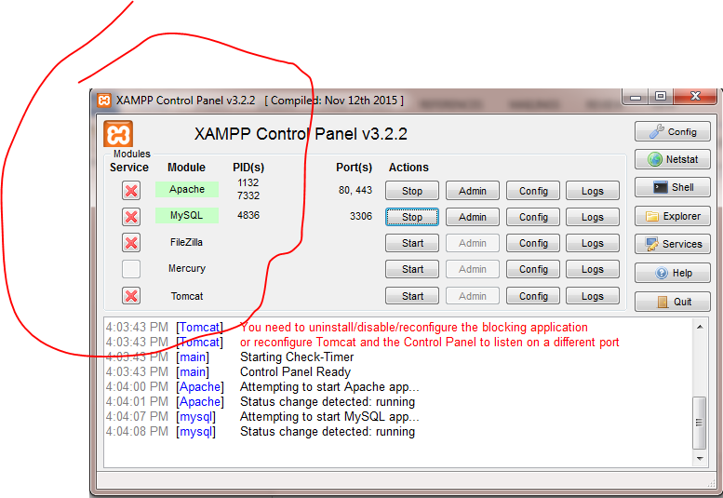

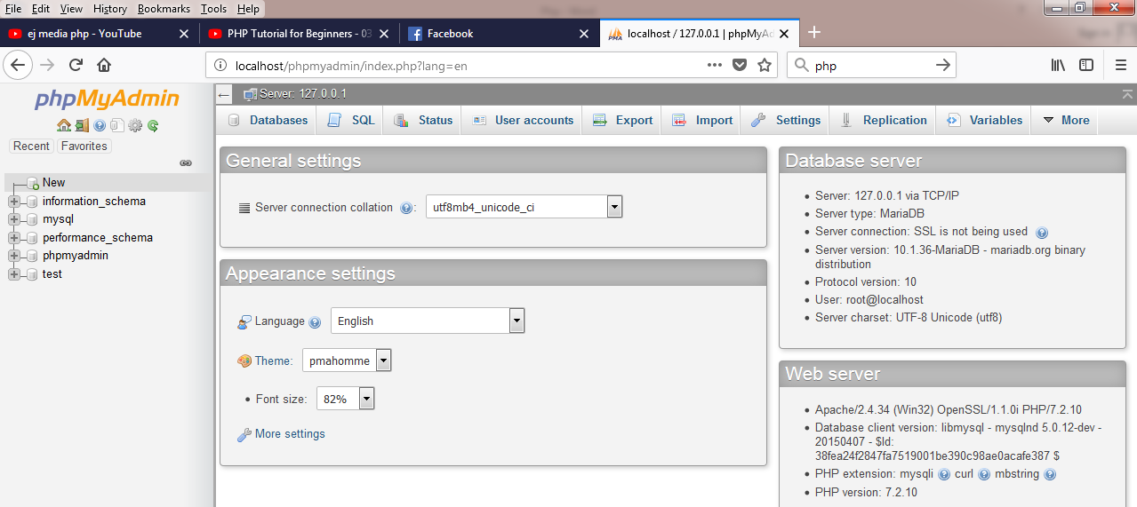

**localhost/phpmyadmin**

**Saving a php code :**

Save in your server directory.  
php files need a local host to execute.

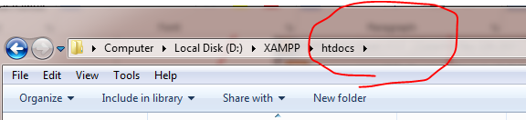

**Echo :**

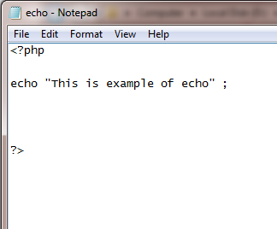

Will display the given string. 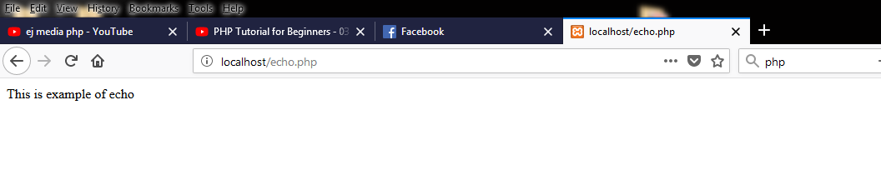

**Variables :**

**Syntax :**

$name=” “; #for string

$name=number; # for integers

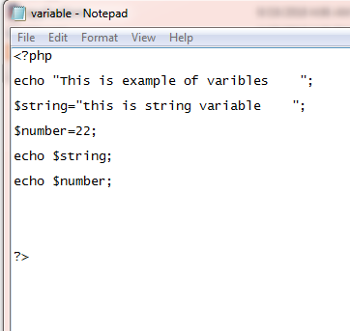

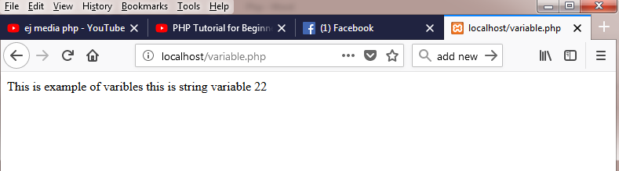

**String Concatenation :**

Combines two strings .

**Syntax :**

. placed in echo

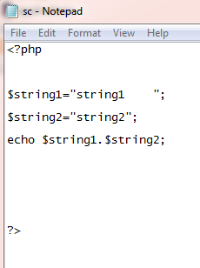

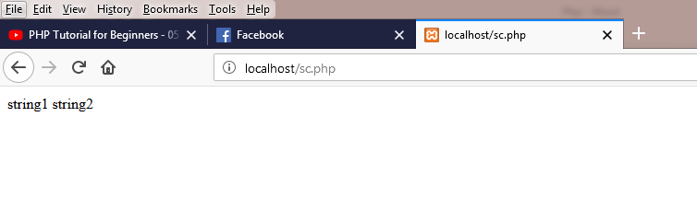

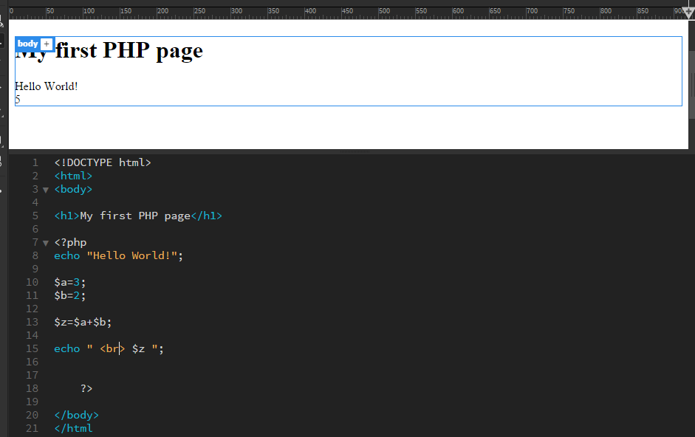

**Escape Characters :**

To add “ “ in your strings so that php can read.

**Syntax :**

\“Example\”

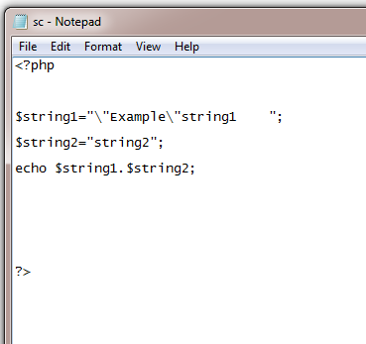

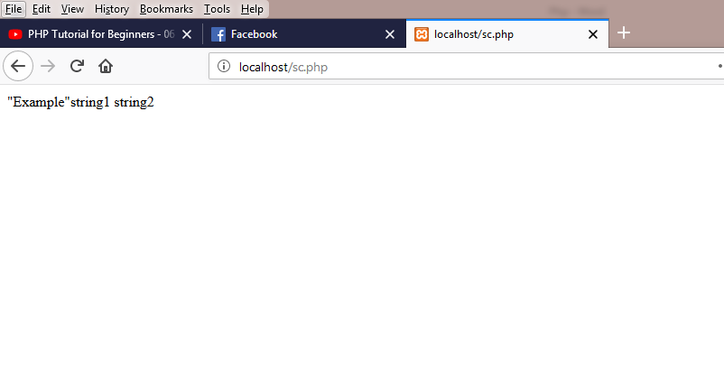

**Comments :**

// example //

/* example */

Operators :

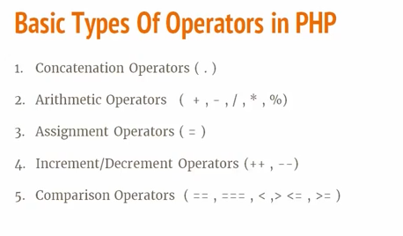

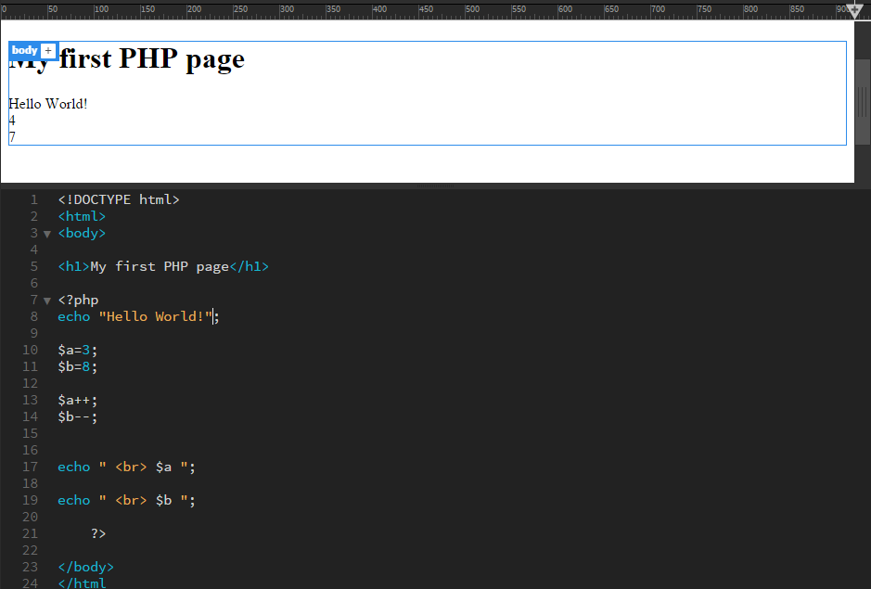

**Arrays :**

$variable_name=array();

Example :

$narr=array();

narr[0]=4;

narr[1]=”abc”;

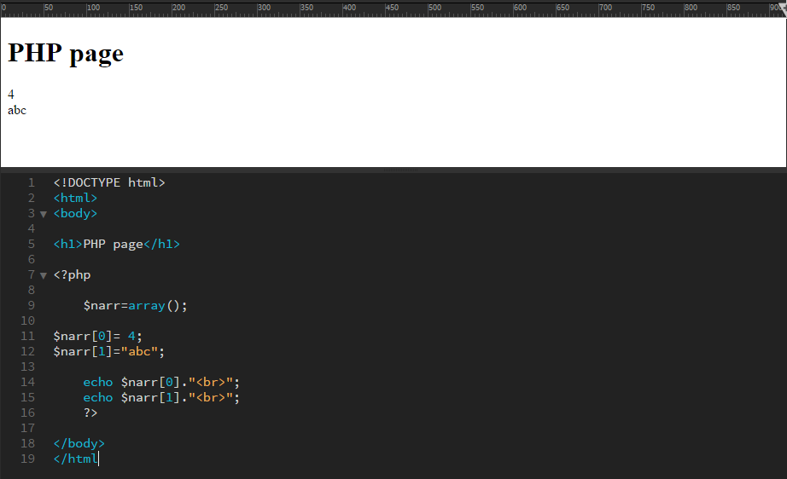

**Method 2:**

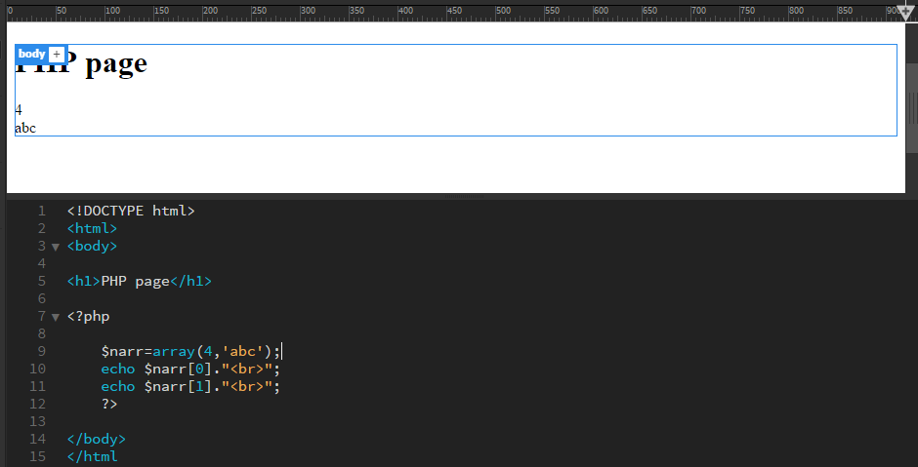

Method 3:

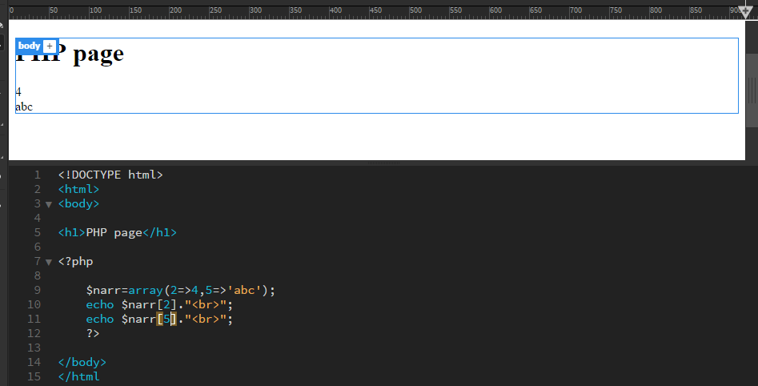

It means index 2 contains 4 (assigning)

It means index 5 contains abc (assigning)

Method 3 : (2d array )

The **print_r**() function is a built-in function in PHP and is used to print or display information stored in a variable

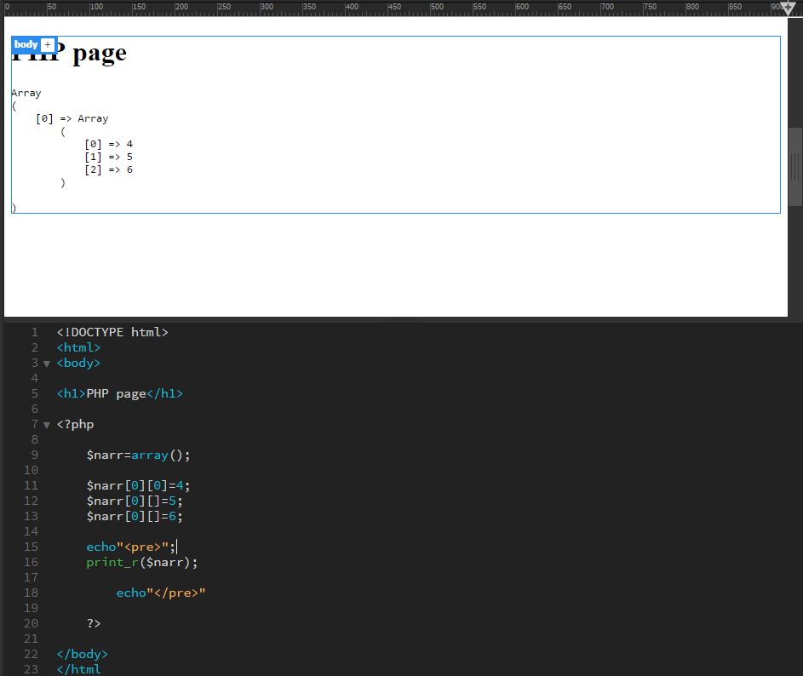

**For Loops :**

for($i=0; $i<=condition ; $i++ )

{

}

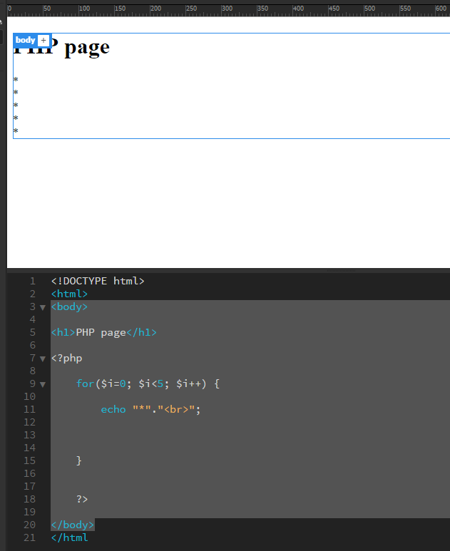

**Foreach : ( arrays only )**

The foreach loop works only on arrays, and is used to loop through each key/value pair in an array.

**Syntax**

foreach ($*array*as$*value*) {  
    *code to be executed;*  
}

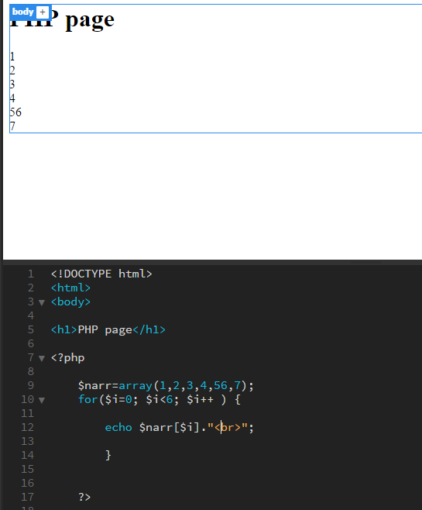

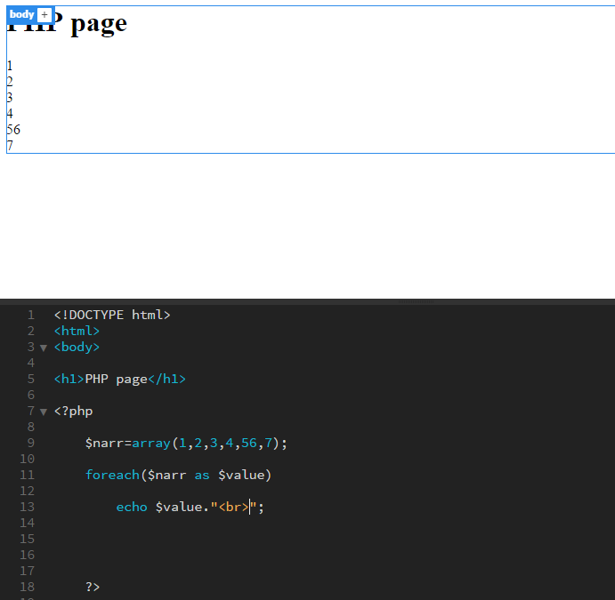

**IF ELSE :**

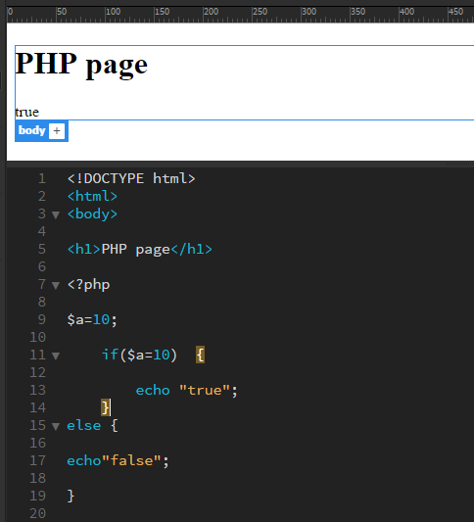

**Functions :**

Function_name (parameters)

{

}

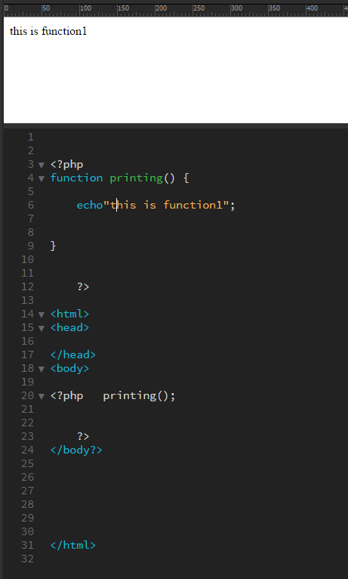

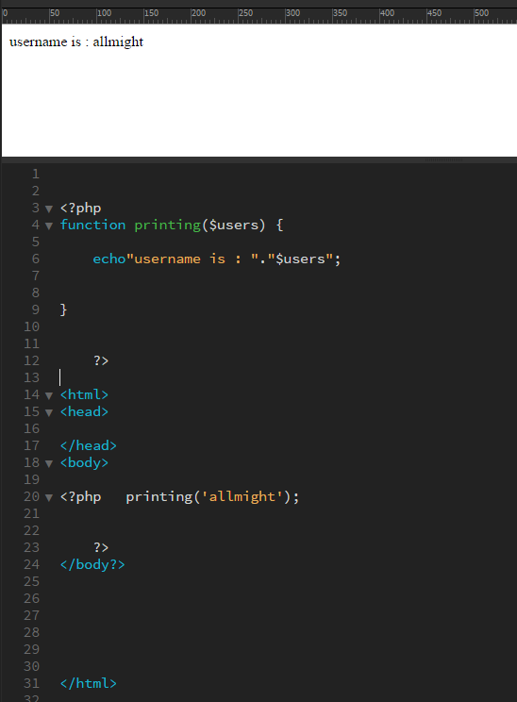

**Include :**

Works like attaching css sheet contains functions of phps in a separate files.

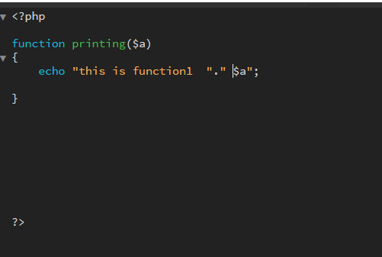

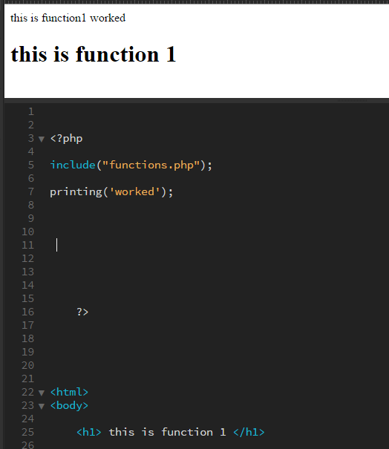

**Require :**

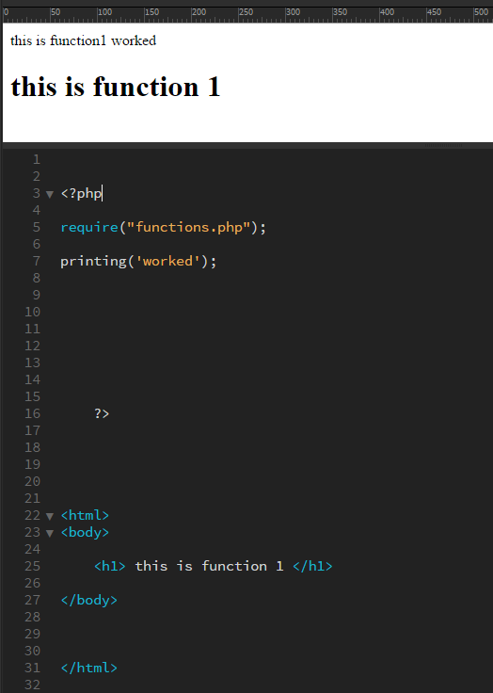

Same as include but if error in attached file whole program will not work.

**Include once :**

Include_once(“name.php”);

**Require once :**

Require_once(“name.php”);

U will not need to attach a file multiple times if used a once statement. And all duplications will be removed.

**Global Variables :**

Variables declared outside the function are not access able . to make them access able the global keyword is used.

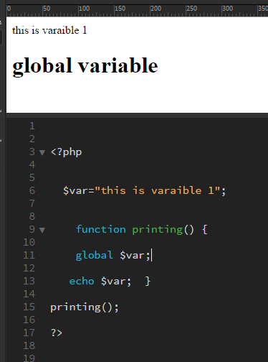

**Super global array :**

Easily access able from any function or class.  
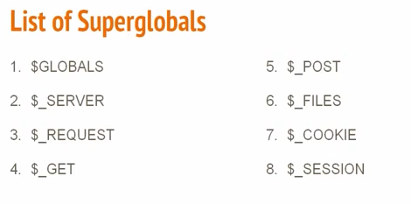

**$_SERVER :**

**$_SERVER** is one of the **PHP** global variables—termed Superglobals—which contain information about **server** and execution environments. These are pre-defined variables so they are always accessible from any class, function or file.

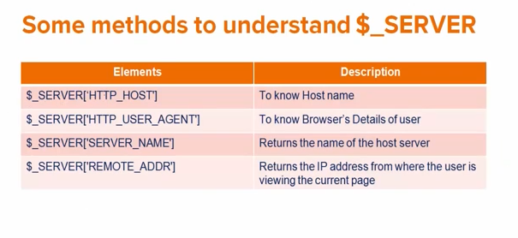

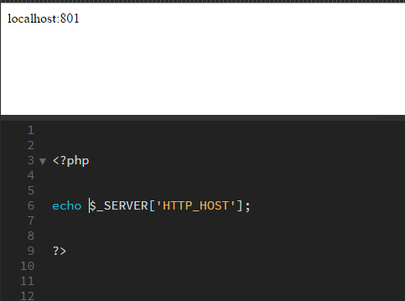

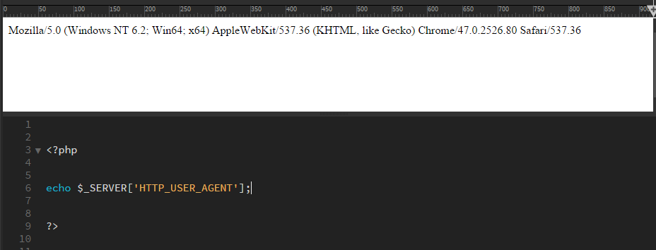

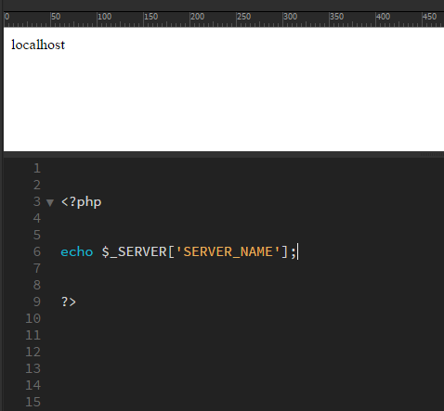

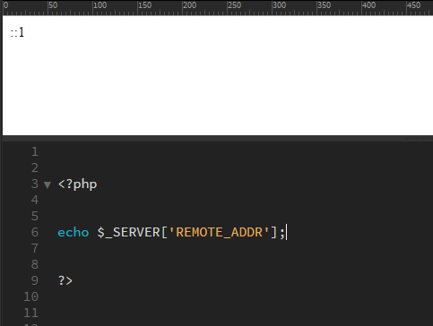

**$_GET :**

**PHP** POST method. This is the built in **PHP** super global array variable that is used to **get** values submitted via HTTP POST method.

Form :

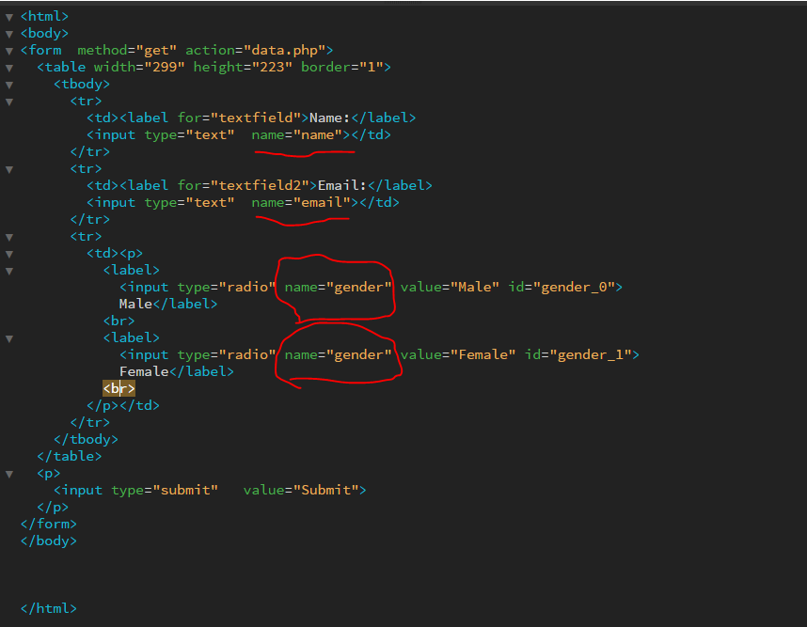

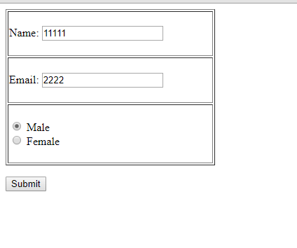

File which has $get method :

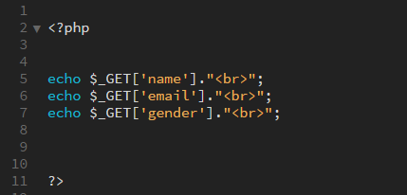

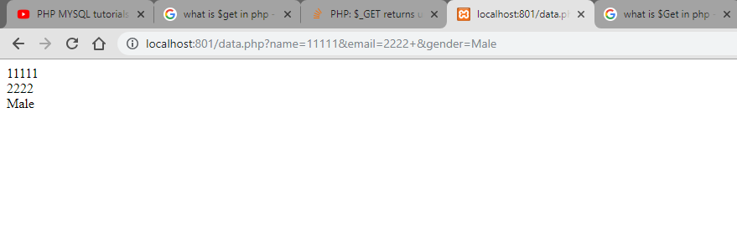

**$_POST :**

Used to pass information through http.

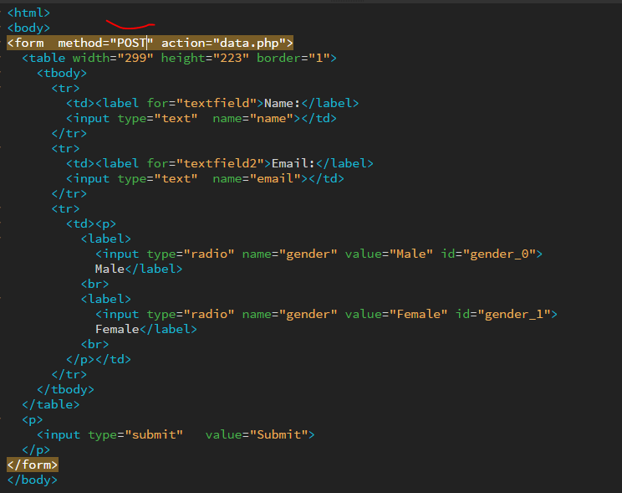

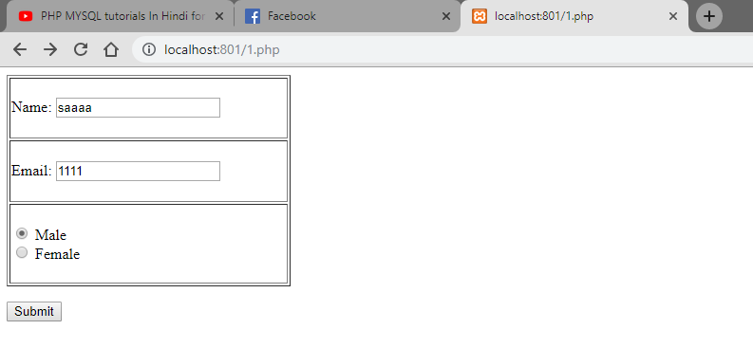

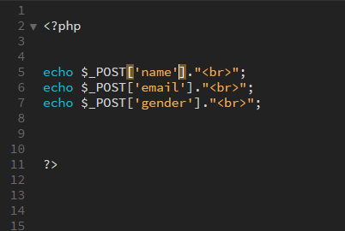

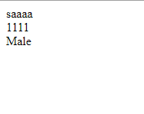

$_REQUEST :

$_REQUEST works with both get and post.

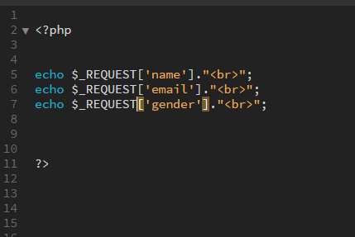

**$_Files :**

Used to upload file to a server.

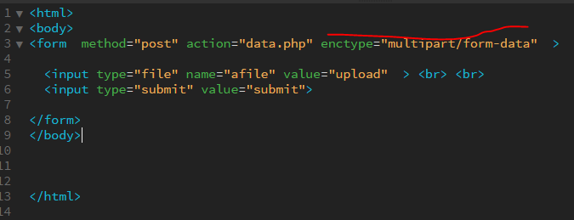

enctype=”multipart/form-data” #mandatory for upload

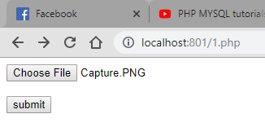

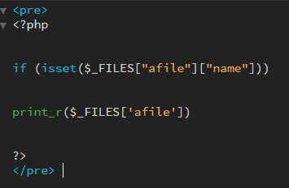

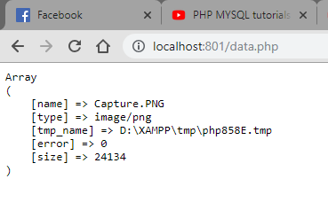

**Isset :**

**isset**() function. The **isset** () function is used to check whether a variable is set or not. If a variable is already unset with unset() function, it will no longer be set. The**isset**() function return false if testing variable contains a NULL value.

**$_SESSION :**

Suppose uve logged into your account and you move forward or back and do not want to login on every step. Session stores user actions & keeps your id logged in for the site.

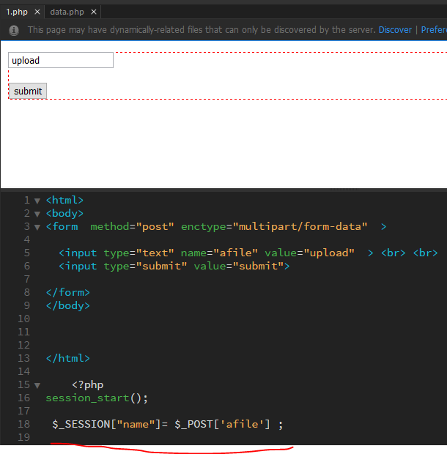

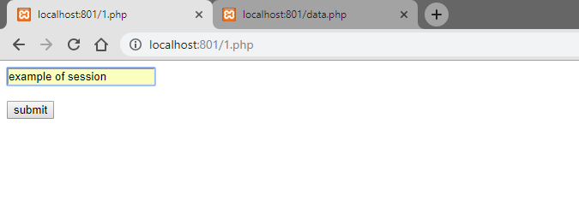

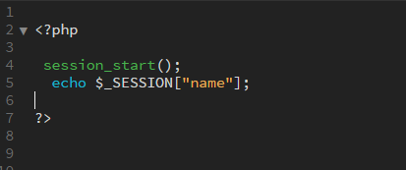

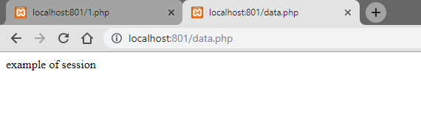

Already logged in session :

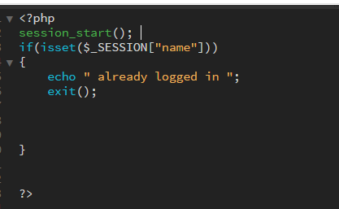

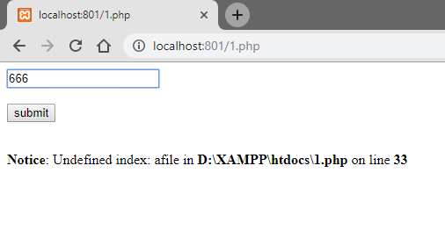

After submit :

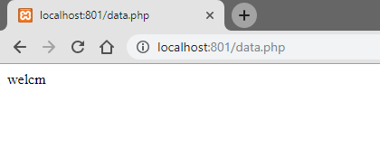

Going back to login page :

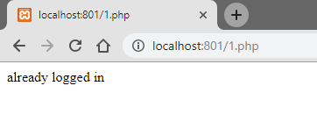

**Header :**

Redirects to a given page .

**Syntax:**

Header(location: _______ );

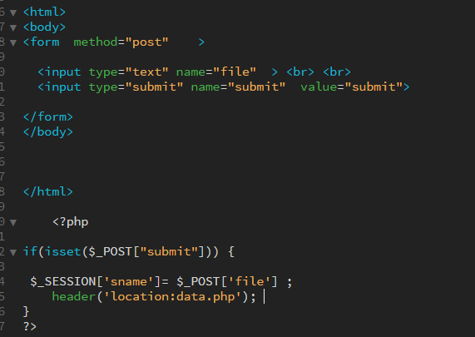

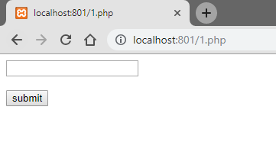

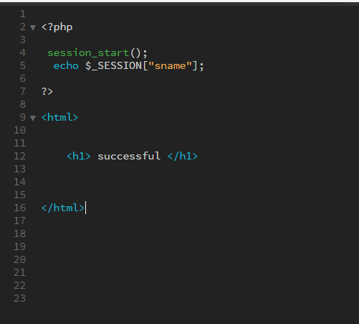

**After submitting values :**

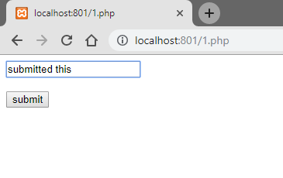

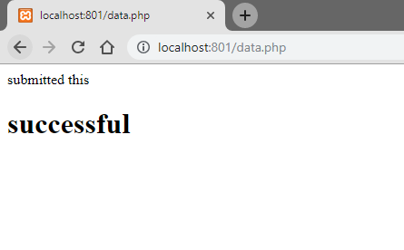

**Clicking back :**

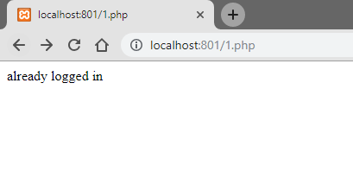

**Destroy a session :**

**2 ways :**

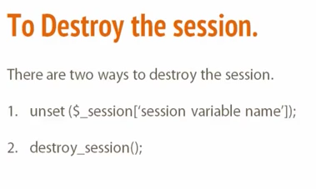

**By unset :**

**Create a file where it will contain unset Variable .**

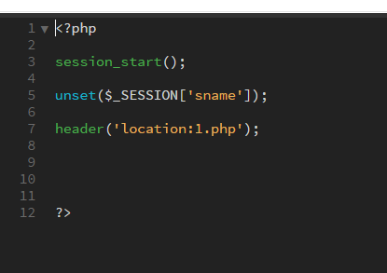

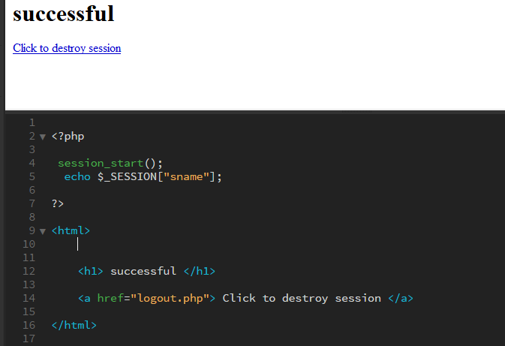

Logout page will destroy session.

**2nd method :**

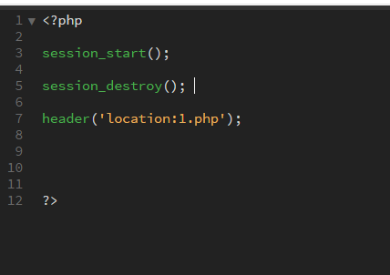

**$_Cookies :**

Saves user info for next visit. Such as saves login info so user does not have to enter info again .

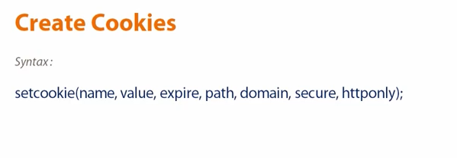

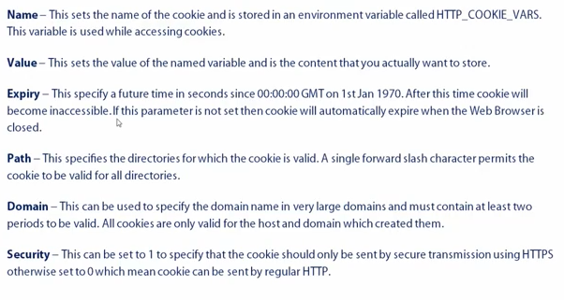

**Creating :**

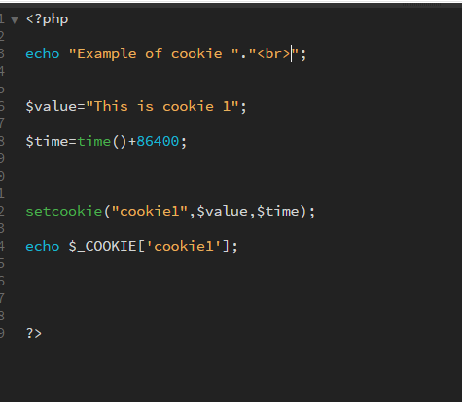

**Filters :**

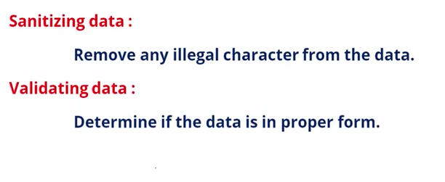

**For filters commands go to here :**

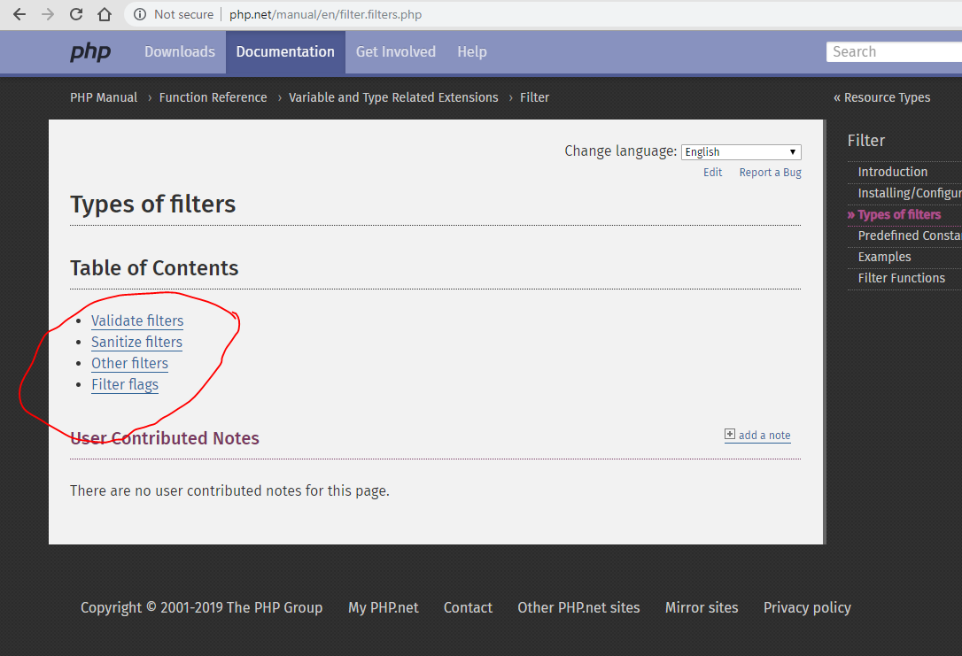

**Validation :**

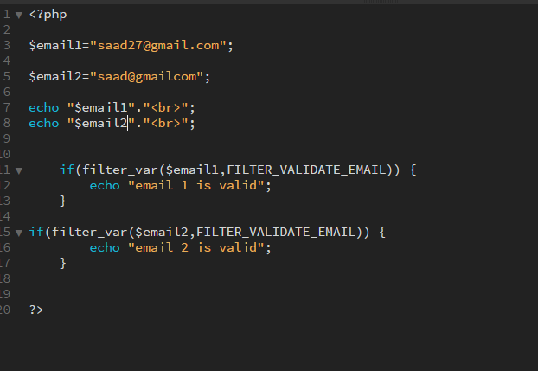

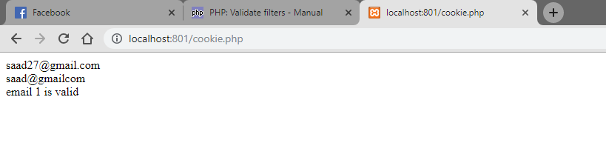

**Sanitize :**

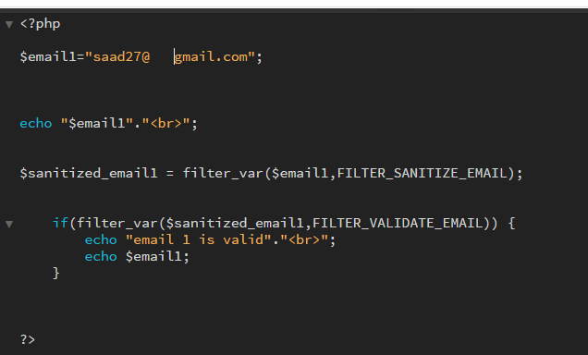

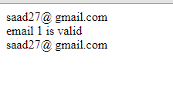

**Creating a database :**

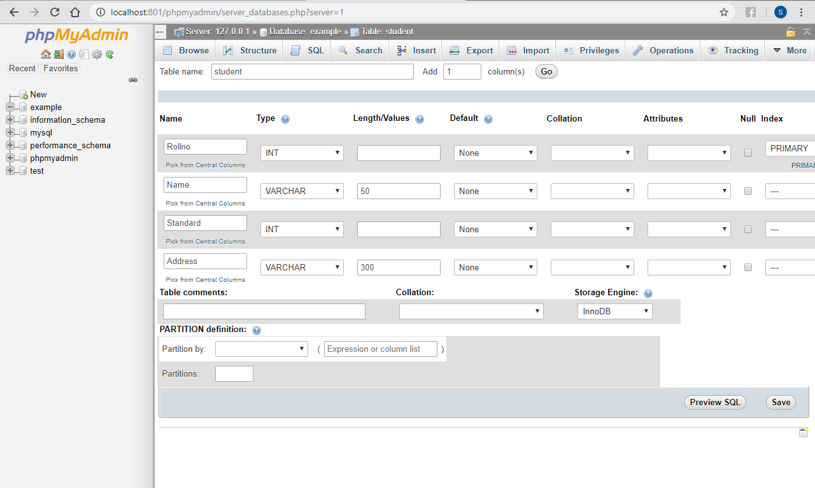

Database name ---🡪 example   
table name ---🡪 student

**Inserting values :**

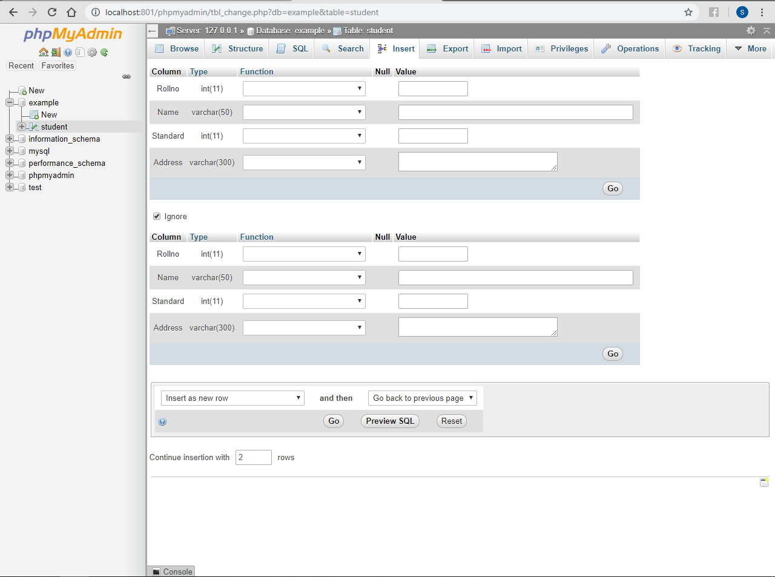

**Creating a connection :**

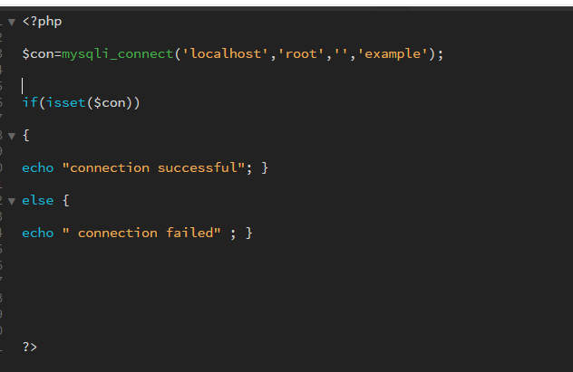

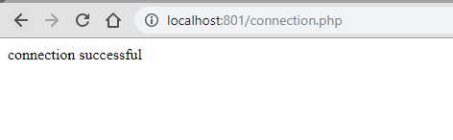

Syntax :

mysqli_connect(‘hostname’,’username’,’password’,’databasename’);

**Inserting values in a database :**

Create a form :

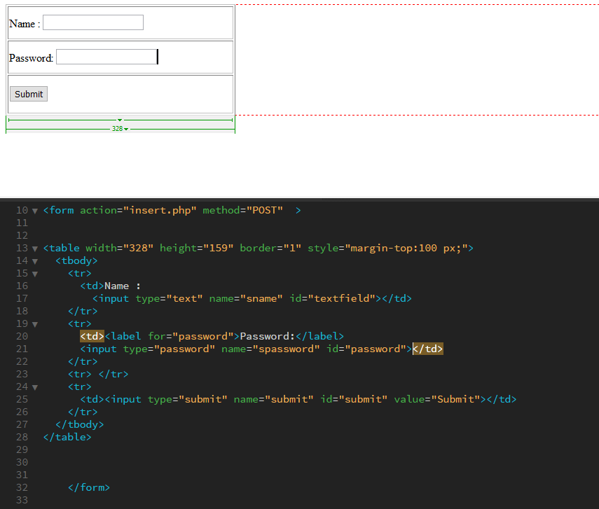

Create a connection :

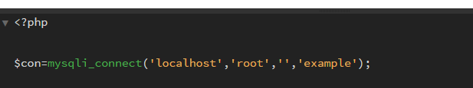

Get variables :

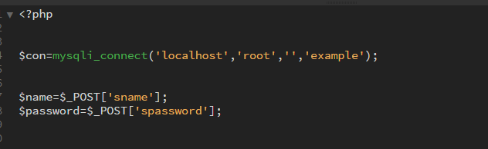

Make query to insert values :

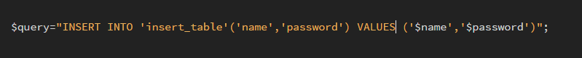

mysqli_query(connection,query,resultmode);

connection = connection variable  
query = query variable

Make variable to execute query :

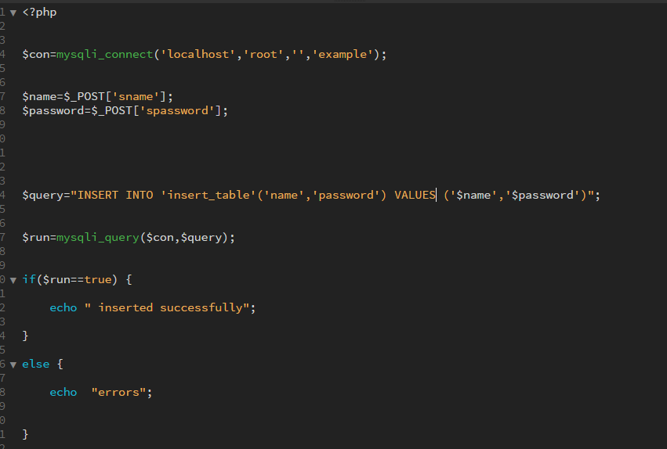

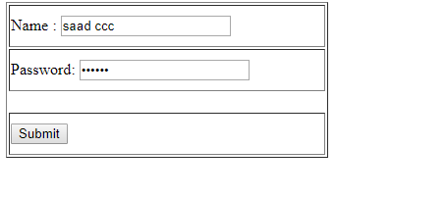

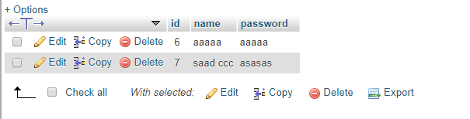

**Retrieve data from database :**

Create connection :

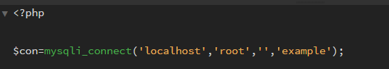

Make function to retrieve data :

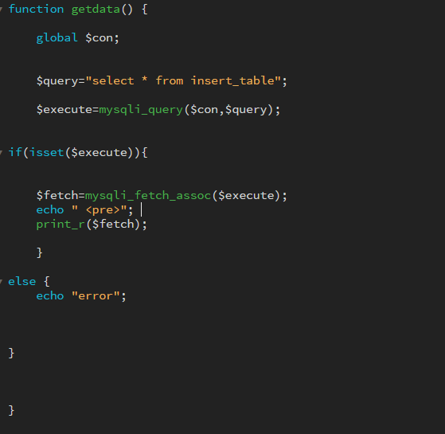

**For fetching data :**

mysqli_fetch_assoc(mysqlquery_*variable*)*;*

The mysqli_fetch_assoc() function fetches a result row as an associative array.

Call function :

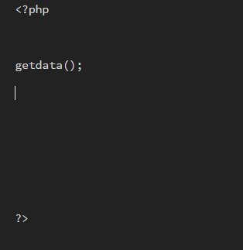

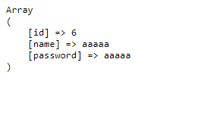

This will only fetch one value :

**For retrieving multiple values :**

Use a while or a for loop :

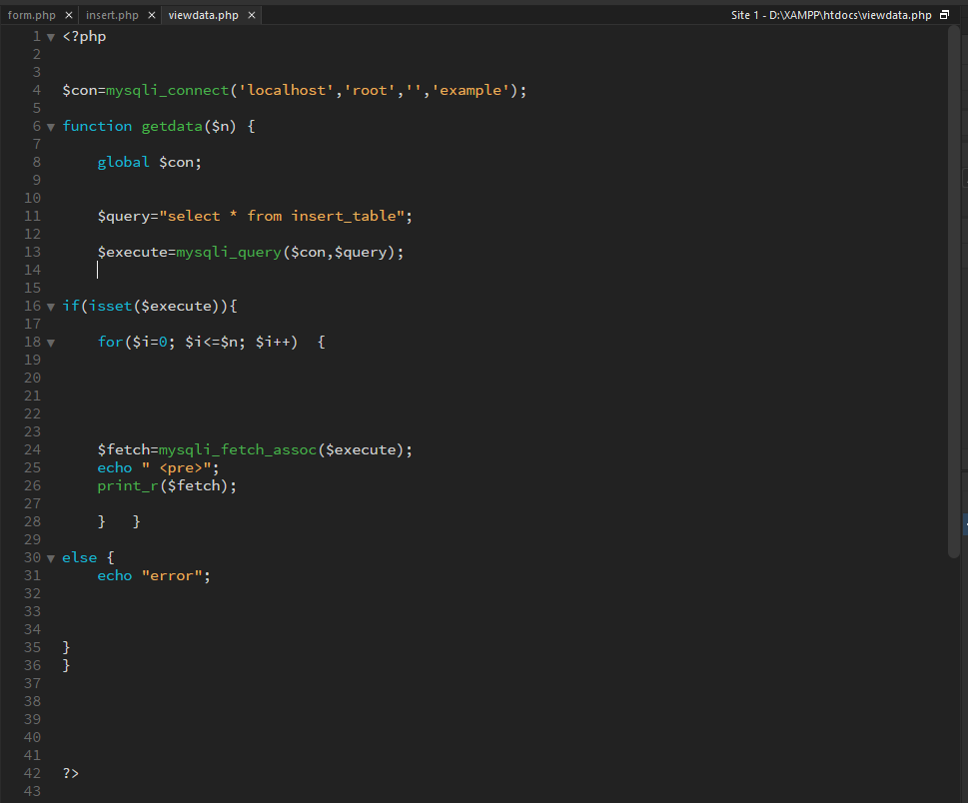

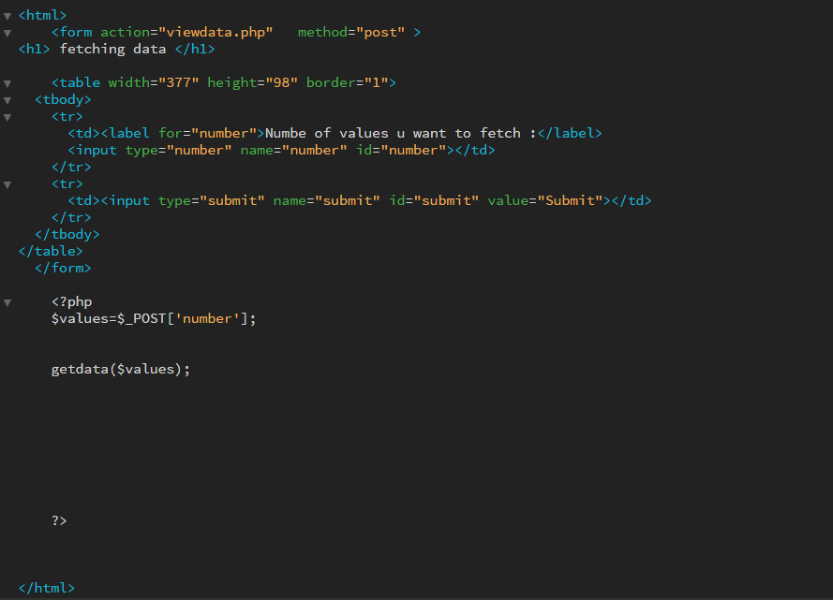

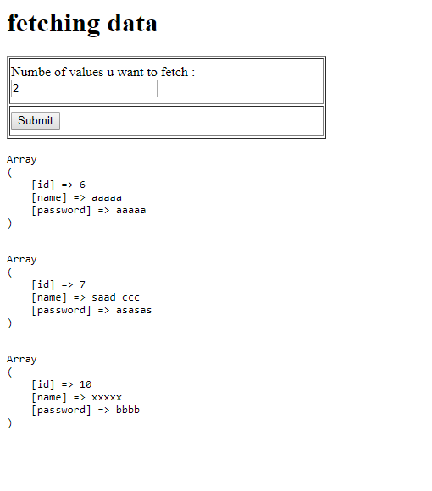

Index values 0,1,2 are retrieved

**For fetching fields only :**

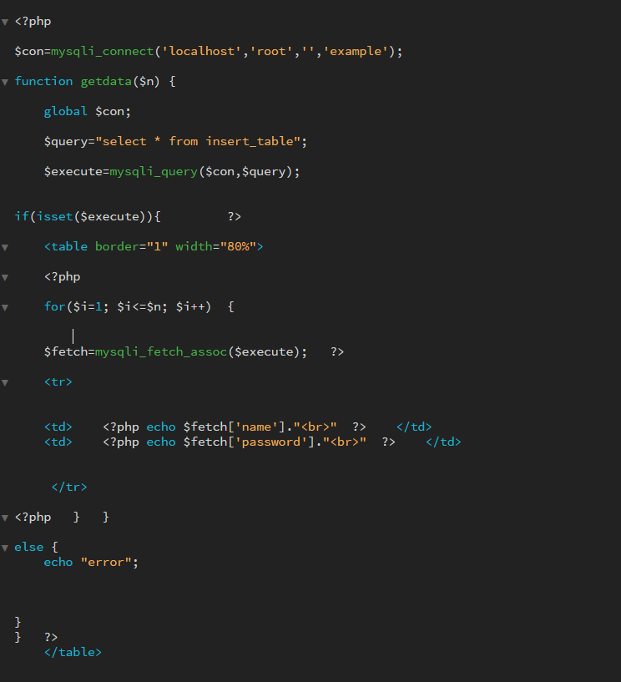

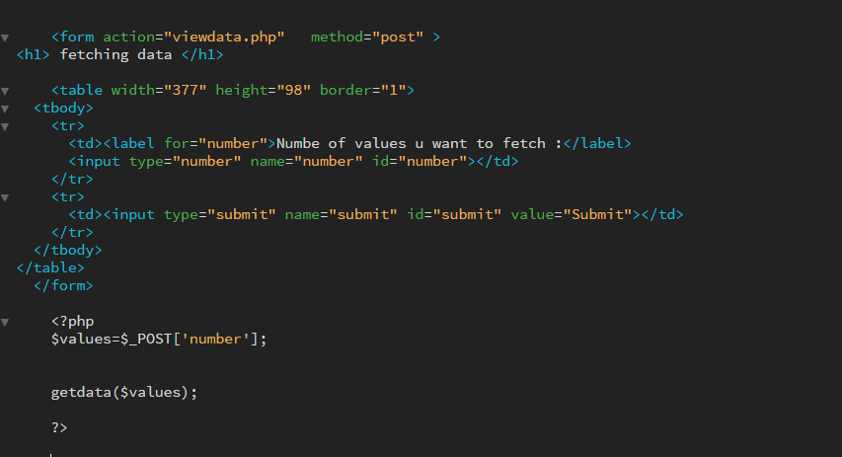

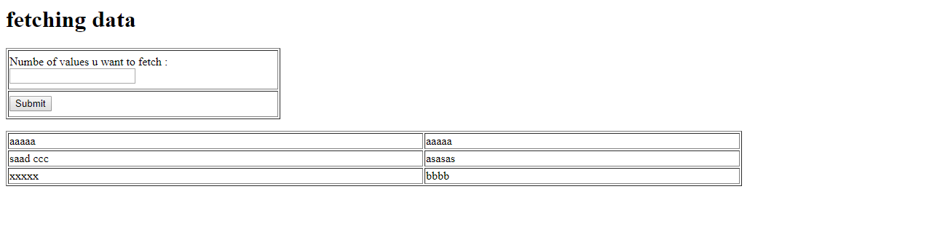

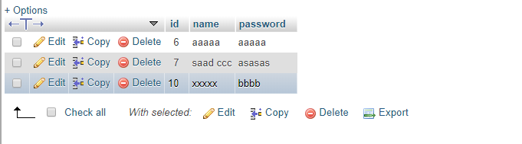

**Creating connection with MS SQL Server :**

Place dll files in :

Xampp -🡪 php -🡪 ext

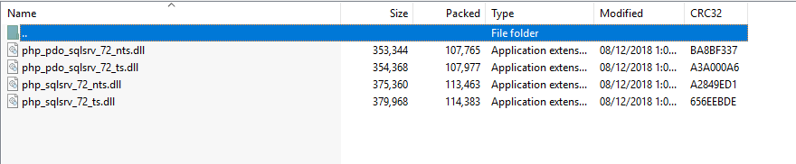

Import them in php.ini

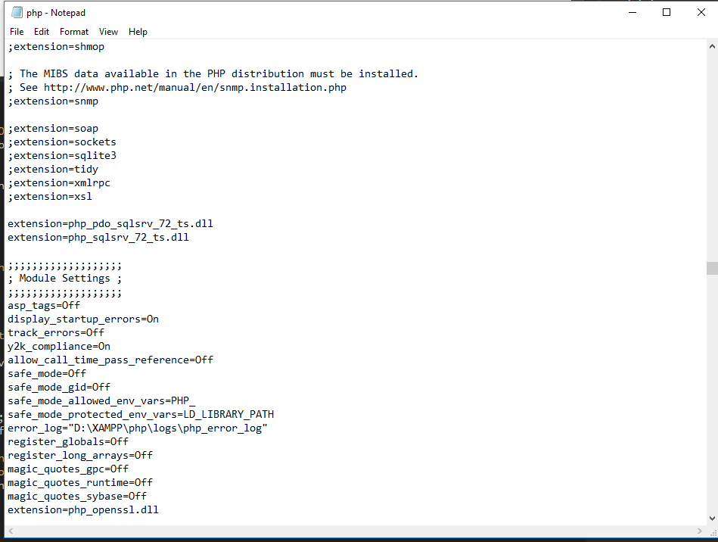

Dll file extension should match php version.

Write connection code :

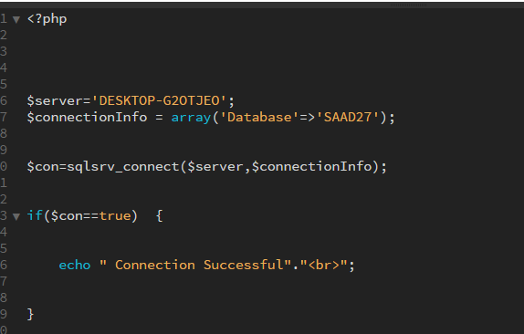

$con=sqlsrv_connect($servername,$connectioninfo) ;



Check queries :

