**Graded lab**

**Roll no:** L1F19BSCS0549

**Name:** Saad

***Question 1:***

**Query**

SELECT countryLanguage.CountryCode from countrylanguage where Language = 'ENGLISH' and percentage > 50;

**Screenshot:**

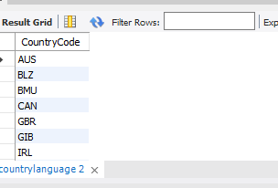

***Question 2:***

**Query**

SELECT countryLanguage.CountryCode, countryLanguage.language from countrylanguage WHERE percentage > 50;

**Screenshot**

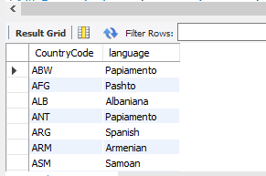

***Question 3:***

**Query**

select country.name from country where country.name like '%ist%';

**Screenshot:**

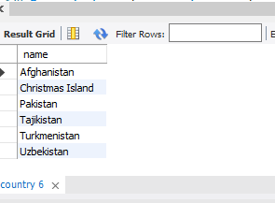

***Question 4:***

**Query**

select city.name,city.population from city where city.Countrycode ='NLD';

**Screenshot:**

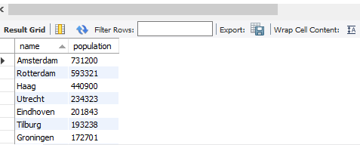

***Question 5:***

**Query**

select country.name from country where not country.code = 'NLD' and not country.code = 'AFG';

**Screenshot:**

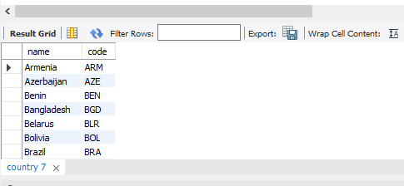

***Question 6:***

**Query**

select country.name , country.code from country where country.lifeexpectancy > 50 and country.lifeexpectancy < 70;

**Screenshot:**

