**LAB 6**

**Name: Saad**

**Roll no. L1F19BSCS0549**

**Q1**

**Table 1**

**Query:**

insert into Employees(Fname,Minit,Lname,Ssn,Bdate,Address,Sex,Salary,Super_ssn,Dno)

values('saad','C','akram',12345678,'1999-09-02','lahore','M',1500,5432198,1),

('sana','B','arbaab',12345679,'2000-06-24','karachi','F',3000,5432198,2),

('ali','C','ans',12345681,'2003-06-24','karachi','M',3000,5432199,3);

**Screenshot**

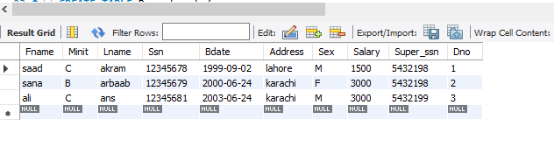

**TABLE 2**

**QUERY**

insert into Department(Dname,Dnumber,Mgr_ssn,Mgr_start_date)

values('Headquarters',1,12345678,'1981-06-19'),

('Administration',2,12345679 ,'1995-01-01'),

('Research',3,12345681,'1995-01-01');

**Screenshot**

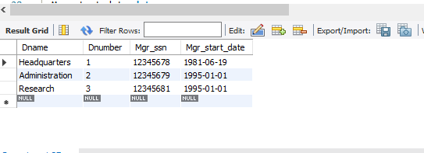

**TABLE 3**

**QUERY:**

insert into Dept_Locations(Dnumber,Dlocation)

values(1,'Houston'),(2,'Stafford'),(1,'Sugarland');

**Screenshot**

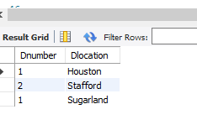

**TABLE4**

**Query**

insert into project (Pname,Pnumber,Plocation,Dnum)

values('ProductX',1,'Bellaire',1),

('ProductY',2,'Huston',2),

('ProductZ',3,'Sugarland',3);

**Screenshot**

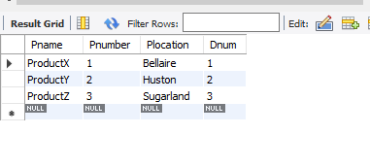

**TABLE5**

**Query**

insert into Works_on(Essn,Pno,Hours)

values(12345678,1,3),

(1234579,2,8),

(1234581,3,10);

**Screenshot**

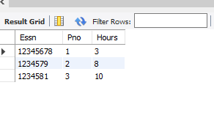

**TABLE6**

**Query**

insert into Dependant (Essn,Dependant_name,Sex,Bdate,Relationship)

values(12345678,'saad','M','1986-04-05','Son'),

(12345679,'sana','F','1986-06-25','Daughter'),

(12345681,'ali','M','1986-06-25','spouse');

**Screenshot**

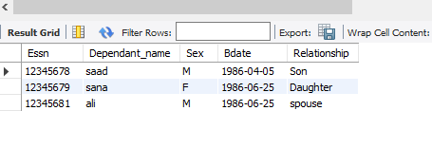

**Q2:**

**QUERY:**

select Fname,salary from Employees

where salary>=1000 and Employees.Sex='M';

**Screenshot**:

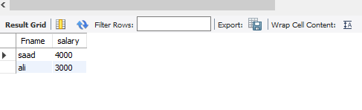

**Q2:**

**QUERY:**

select Address from Employees

where Employees.salary>=1000 and Employees.salary <=2000;

**Screenshot:**

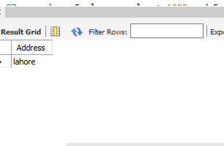

**Q4:**

**QUERY:**

select Lname from Employees

where Lname like 'A%B';

**Screenshot:**

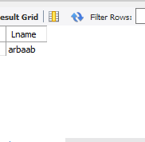

**Q5:**

**QUERY:**

select Fname from Employees

where Fname like 'A__';

**Screenshot:**

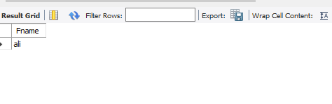

**Q6**

**QUERY:**

select Pname,Pnumber from Project

where Project.Dnum=1;

**Screenshot**

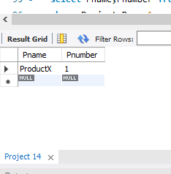

**Q7:**

**QUERY:**

select Dependant_name from Dependant

where Dependant.Bdate !='%2002%' and Dependant.Bdate !='%2003%'and Dependant.Bdate !='%2004%';

**Screenshot:**

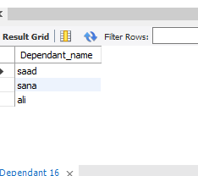

**Q8:**

**QUERY:**

select Pno from Work_on

where Work_on.Hours<3 and Work_on.Hours>10;

**Screenshot:**

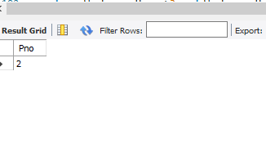

**Q9:**

**QUERY:**

update Works_on set Hours=5 where Hours=3;

select * from Works_on;

**Screenshot:**

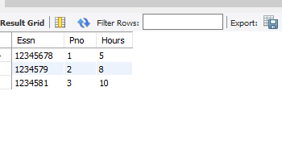

**Q10:**

**QUERY:**

delete from Dependant where Sex='M';

select * from Dependant;

**Screenshot:**

