# ***Lab 7***

**Name:**  saad

**Roll no:** L1F19bscs0549

**Question #1:**

**Query:**

select employees.firstName,employees.lastName, offices.city from offices inner join employees on offices.officeCode= employees.officeCode;

**Screenshot:**

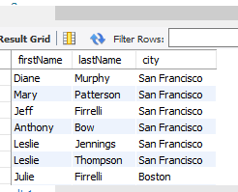

**Question #2:**

**Query:**

select c.customerName,c.customerNumber, p.amount from Customers as c inner join payments as p on c.customerNumber=p.customerNumber and p.amount> 25000;

**Screenshot:**

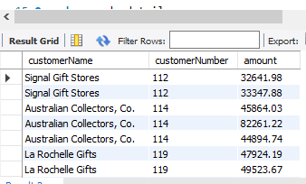

**Question #3:**

**Query:**

select Customers.customerNumber,products.productName,orderdetails.quantityOrdered from Customers inner join orders inner join orderdetails inner join products on Customers.customerNumber=orders.customerNumber and orders.orderNumber=orderdetails.orderNumber and orderdetails.productCode=products.productCode and orderdetails.quantityOrdered >30 ;

**Screenshot:**

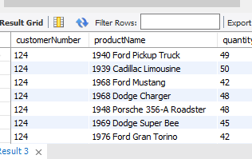

**Question #4:**

**Query:**

select Customers.customerName,orders.orderdate from Customers inner join orders on Customers.customerNumber=orders.customerNumber and orders.status='shipped';

**Screenshot:**

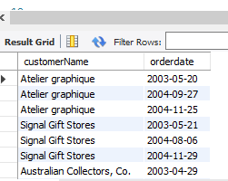

**Question #5:**

**Query:**

Select Customers.customerName from Customers inner join payments on Customers.customerNumber=payments.customerNumber and payments.amount>8000 ;

**Screenshot:**

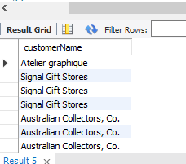

**Question #6:**

**Query:**

select employees.firstName,employees.lastName from offices inner join employees on offices.officeCode= employees.officeCode and employees.jobTitle='Sales Rep' and offices.country='USA';

**Screenshot:**

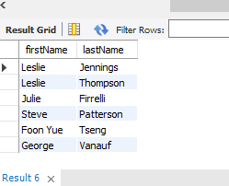

**Question #7:**

**Query:**

select * from offices inner join employees where offices.officeCode= employees.officeCode and offices.city='sydney';

**Screenshot:**

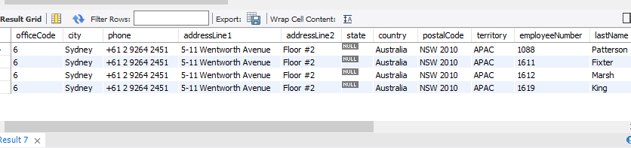

**Question #8:**

**Query:**

select Customers.customerName,orders.orderdate from Customers inner join orders on Customers.customerNumber=orders.customerNumber and orders.orderNumber between 10101 and 10110;

**Screenshot:**

