Roll no L1F19BSCS0549

Name: Saad

**LAB 8**

**Q1:**

**Query**

select employees.firstName, employees.lastName from employees where employees.officeCode in (select offices.officeCode from offices where offices.country = 'USA');

**Screenshot:**

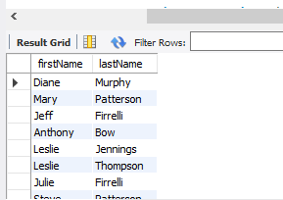

**Q2:**

**Query**

select * from customers where customers.customerNumber in (select payments.customerNumber from payments where amount > 1000 and amount < 5000);

**Screenshot:**

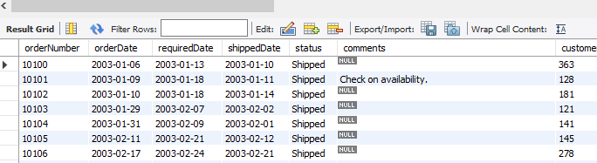

**Q3:**

**Query**

select customers.customerName,customers.phone from customers where customers.customerNumber in(select orders.customerNumber from orders where orders.orderDate like'%2003%');

**Screenshot:**

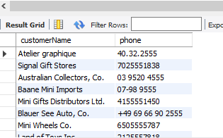

**Q4:**

**Query**

select customers.customerName,customers.phone from customers where not exists (select orders.customerNumber from orders );

**Screenshot:**

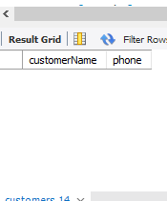

**Q5:**

**Query**

select products.productCode,products.productName,orderdetails.quantityOrdered from products,orderdetails where exists (select orderdetails.productCode from orderdetails where orderdetails.quantityOrdered between 30 and 50 );

**Screenshot:**

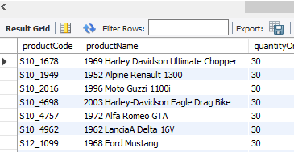

**Q6:**

**Query**

select customers.customerName from customers where customers.customerNumber in(select orders.customerNumber from orders,payments where orders.customerNumber=payments.customerNumber and orders.status='Cancelled' and payments.amount >50 );

**Screenshot:**

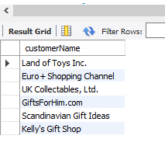

**Q7:**

**Query**

select orders.orderNumber from orders where orders.customerNumber in (select payments.customerNumber from orderdetails,payments where orders.orderNumber=orderdetails.orderNumber and payments.amount > 6000 );

**Screenshot:**

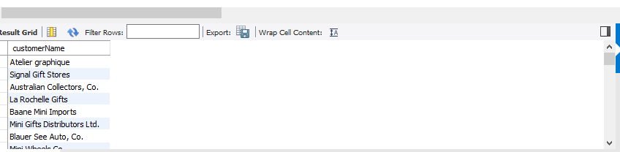

**Q8:**

**Query**

select orders.orderNumber from orders where orders.customerNumber in (select payments.customerNumber from orderdetails,payments where orders.orderNumber=orderdetails.orderNumber and payments.amount > 6000 );

**Screenshot:**

