***MOCK LAB***

***L1F19BSCS0549***

***Name: saad***

**Q1**

select distinct employees.firstName from employees inner join offices inner join Customers where offices.officeCode= employees.officeCode and employees.employeeNumber = customers.salesRepEmployeeNumber and offices.city = customers.city;

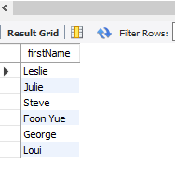

**Q2**

select count( distinct Customers.customerName) from Customers inner join orders on Customers.customerNumber=orders.customerNumber and orders.status='shipped';

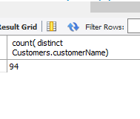

**Q3**

select Customers.customerName from Customers inner join payments on Customers.customerNumber=payments.customerNumber and payments.paymentDate between'2004-11-03' and '2004-11-14';

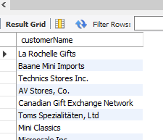

**-- q4**

select Customers.customerName from Customers inner join payments on Customers.customerNumber=payments.customerNumber and payments.amount>=(select avg(payments.amount) from payments);

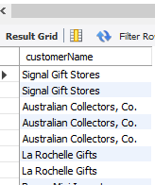

**-- q5**

select Customers.customerName from Customers where Customers.customerNumber not in(select orders.customerNumber from orders );

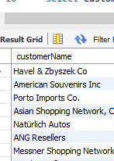

**-- q6**

select products.productName, orderdetails.quantityOrdered from products inner join orderdetails where products.productCode=orderdetails.productCode and products.productCode in (select orderdetails.productCode from orderdetails where products.productCode=orderdetails.productCode);

