BSCS FINAL PROJECT
FWEC MANAGER



Project Advisor

<Advisor Name>
Usama Pervaiz

Presented by:
Group ID: S23BS029

Student Reg#
L1F19BSCS0460
L1F17BSCS0570
L1F19BSCS0549
Student Name
Muhammad abdul mueed
Momin khan
Muhammad saad

Faculty of Information Technology

University of Central Punjab
Software Design Specification
SDP Phase II

FWEC Manager
Advisor
USAMA PARVAIZ
Member Name | Primary Responsibility
L1F19bscs0469 | Phase1 and phase 2
L1F17bscs0570 | Phase 1
L1F19bscs0549 | Screen

Table of Contents
Table of Contents i
Revision History ii
Abstract iii
1. Introduction 1
1.1 Product 1
1.2 Background 1
1.3 Objective(s)/Aim(s)/Target(s) 1
1.4 Scope 1
1.5 Business Goals 1
1.6 Document Conventions 1
1.7 Miscellaneous 1
2. Overall Description 2
2.1 Product Features 2
2.2 Functional Description 2
2.3 User Classes and Characteristics 2
2.4 Design and Implementation Constraints 2
2.5 Assumptions and Dependencies 2
3. Technical Architecture 3
3.1 Application and Data Architecture 3
3.2 Component Interactions and Collaborations 3
3.3 Design Reuse and Design Patterns 4
3.4 Technology Architecture 4
4. Screenshots/Prototype 5
4.1 Workflow 5
4.2 Screens 5
4.3 Additional Information 5
5. Other Design Details 5
6. Revised Project Plan 5
7. References 5
Appendix A: Glossary 6
Appendix B: IV & V Report 7

Revision History
Name | Date | Reason For Changes | Version

Abstract
In order to streamline operations and provide convenience to the forest department, a comprehensive online system has been developed to digitize paperwork and facilitate various aspects related to wildlife, forests, environment and climate. This system aims to raise awareness among the public about these crucial issues while also enabling them to contribute through donations. Additionally, client details are securely stored for efficient management. The system incorporates climate change awareness initiatives specific to our country and establishes an online store for the sale of goods and items related to wildlife, forests, environment, and climate. Furthermore, it offers an easy-to-use platform for wildlife management, where animal details are stored and relevant laws are publicly accessible through the website. This integrated system serves as an efficient tool to enhance public engagement, protect wildlife, preserve forests, conserve the environment, combat climate change, and ensure transparency in governance.

Introduction

Product
Our website shifts all paper work into online ear. we are creating this product for climate awareness, online store for forest items and collecting donation

Background
Introducing our comprehensive online system designed to streamline forest department operations and promote environmental conservation. Our platform digitizes paperwork, raises awareness about wildlife, forests, environment, and climate, facilitates donations, stores client details securely, provides climate change updates, offers an online store for related goods, and simplifies wildlife management. Join us in creating a sustainable future by engaging the public, protecting wildlife, preserving forests, combatting climate change, and ensuring transparency in governance.

Objective(s)/Aim(s)/Target(s)
- Digitize paperwork and eliminate manual processes, ensuring streamlined operations for the forest department.

- Raise public awareness about wildlife, forests, environment, and climate-related issues through accessible and informative resources.

- Enable the public to contribute to conservation efforts by providing a platform for donations.

- Securely store and manage client details to enhance communication and personalized engagement.

- Provide climate change awareness initiatives specific to our country, offering real-time updates and mitigation strategies.

- Establish an online store to sell goods and items related to wildlife, forests, environment, and climate, promoting sustainable consumption.

- Develop an easy-to-use platform for wildlife management, storing comprehensive details of animals for efficient monitoring and conservation.

- Make relevant wildlife-related laws and regulations publicly accessible through the website, ensuring transparency and compliance.

- Enhance public engagement and participation in wildlife conservation and environmental initiatives.

- Protect wildlife by implementing effective management practices and promoting habitat preservation.

- Preserve forests by implementing sustainable forestry practices and raising awareness about deforestation.

- Conserve the environment by promoting eco-friendly practices and sustainable resource management.

- Combat climate change by educating the public about its impacts and encouraging sustainable actions.

- Ensure transparency in governance by providing public access to information and promoting accountability in wildlife management.

Scope

The comprehensive online system covers a wide range of functionalities, including digitizing paperwork, raising public awareness about wildlife, forests, environment, and climate, facilitating donations, securely storing client details, providing climate change updates, establishing an online store for related goods, and offering a user-friendly platform for wildlife management. The system aims to enhance public engagement, protect wildlife, preserve forests, promote environmental conservation, combat climate change, and ensure transparency in governance.

Business Goals
Streamline operations, raise public awareness, facilitate fundraising, enhance wildlife management, generate revenue through the online store.

Document Conventions
The document is prepared using Microsoft Word 2021 using the font style ‘Times new romen’. The fixed font size used to type this document is 12 font size, with the heading being 14. It has used the bold property to set the heading of the document

Miscellaneous
N/A

Overall Description

Product Features
- . Paperwork Digitization: The system digitizes paperwork, eliminating manual documentation and streamlining operations for the forest department.

- Awareness and Education: The system raises public awareness about wildlife, forests, environment, and climate through educational resources and interactive content.

- Donation Management: Users can contribute to conservation efforts by making donations through the system, supporting wildlife, forests, environment, and climate initiatives.

- Secure Client Management: Client details are securely stored for efficient management and communication with individuals interested in wildlife and environmental matters.

- Climate Change Awareness: The system incorporates country-specific climate change initiatives, providing up-to-date information and promoting understanding of climate-related challenges.

- Online Store: An online store within the system allows users to purchase goods and items related to wildlife, forests, environment, and climate.

- Wildlife Management Platform: The system offers an easy-to-use platform for wildlife management, storing animal details and ensuring compliance with relevant laws.

- Public Accessibility of Laws: Relevant wildlife-related laws are made publicly accessible through the system's website, promoting transparency and awareness of legal regulations

Functional Description
The online system serves multiple functions related to wildlife, forests, environment, and climate. It enables users to register accounts, access awareness information, make donations, store client details, and purchase goods. It provides a platform for wildlife management and allows users to store animal details and access relevant laws. The system enhances public engagement, protects wildlife, preserves forests, conserves the environment, combats climate change, and ensures transparency in governance.

User Classes and Characteristics

• User
• Users use the web application and make donations and use other resources.
• Admin
• Developers of Web application or other trained person.
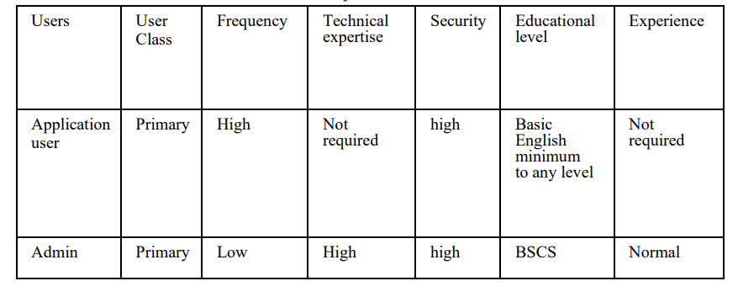

Design and Implementation Constraints
The system shall use a MySQL database. Databases should be protected.
The system should be a Web-based application.
The system is only accessible within the Pakistan premises only
Only Administrator and users authorized by the administrator can make changes in the system.

Assumptions and Dependencies

Assumptions:
- Users have basic computer skills and internet access.
- The forest department has reliable internet connectivity and necessary infrastructure.
- The forest department can maintain and support the system.
- Public is willing to engage and contribute to wildlife conservation.
- Laws and regulations are provided accurately for public dissemination.

Dependencies:
- Availability and reliability of internet services and infrastructure.
- Accuracy and availability of wildlife and environmental information.
- Integration with third-party payment gateways.
- Compliance with data protection and privacy regulations.
- Active participation and interest from the public and stakeholders.

Technical Architecture
The software is built with a scalable and secure technical architecture. It includes a user-friendly front-end interface developed using modern web technologies. The back-end consists of a robust server infrastructure handling data processing and storage. A reliable database system is used to manage client details, wildlife information, donations, and store inventory. The system prioritizes security with encryption, authentication mechanisms, and access controls. It may leverage cloud infrastructure for scalability and high availability. Integration with external services ensures seamless payment processing and shipment tracking. The technical architecture ensures optimal performance, data integrity, and user satisfaction.

Application and Data Architecture

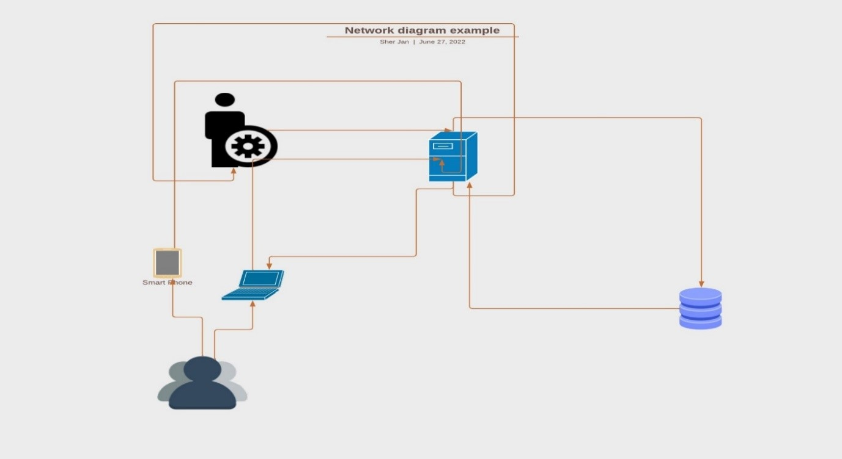

Use case diagram:
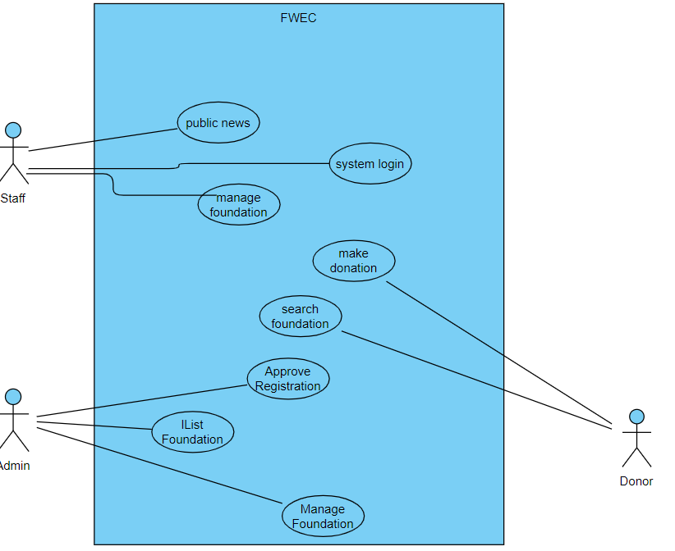

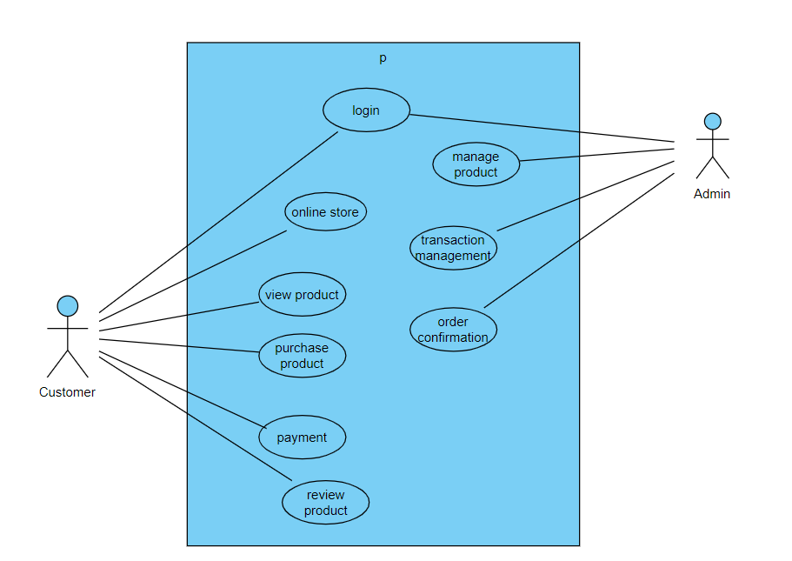

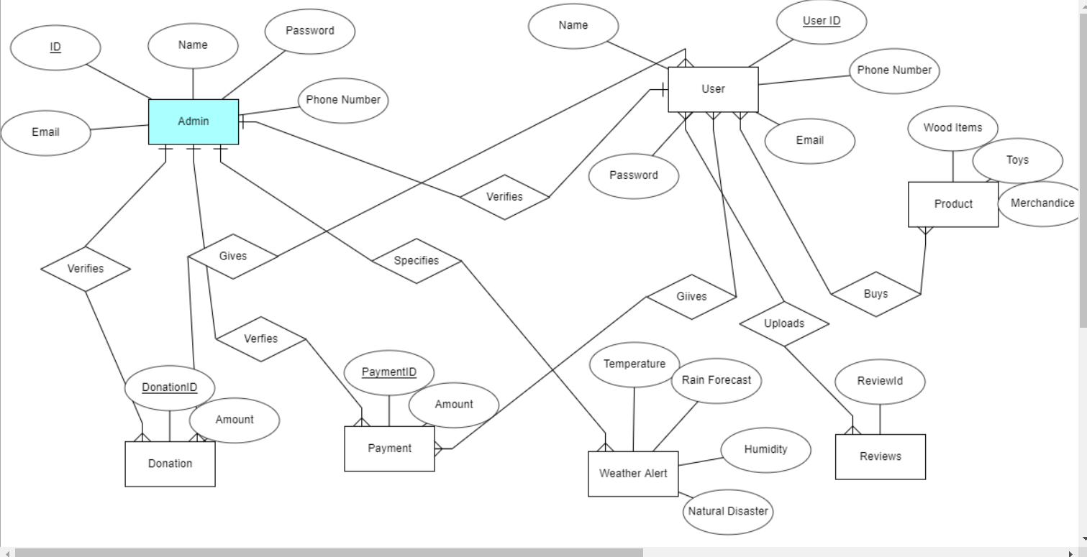

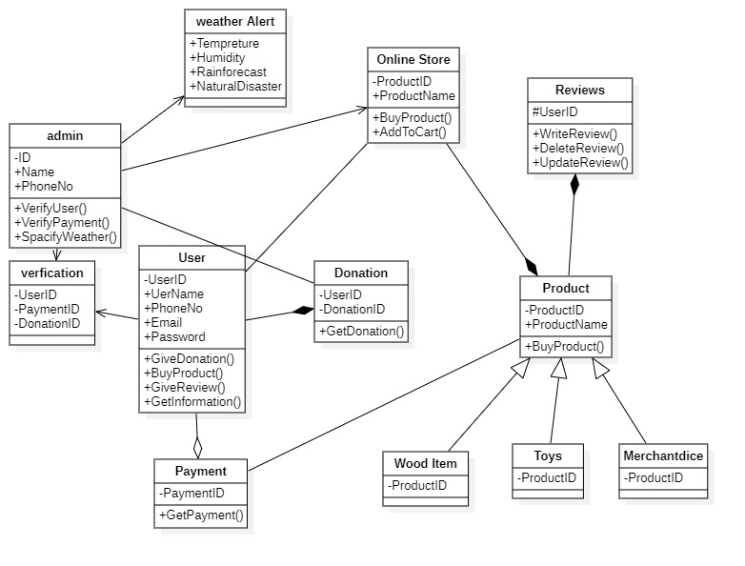

Component Interactions and Collaborations

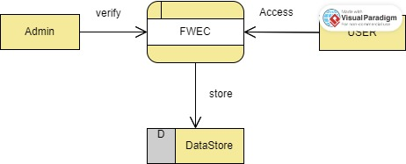

LVL 1

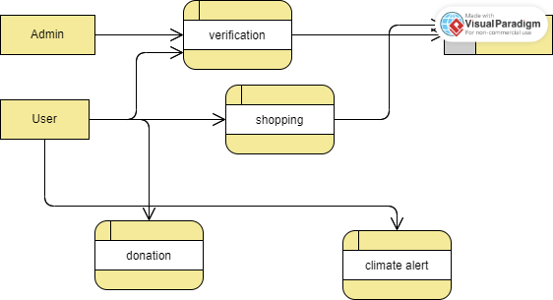

LEVEL 2

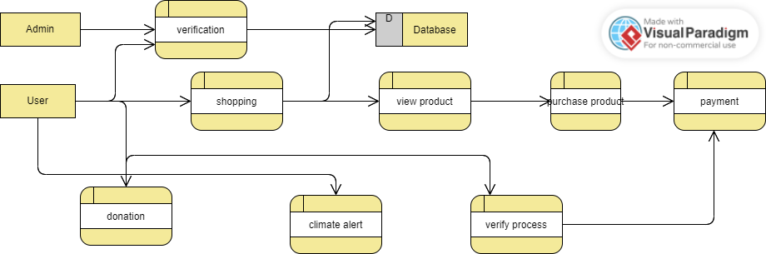

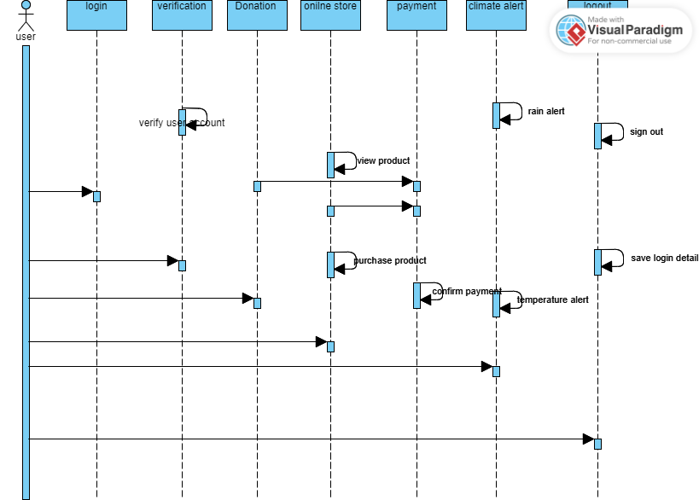

Design Reuse and Design Patterns
N/A

Technology Architecture

This project is web-based and can be accessed through any search engine or browser so, there is not any need of high technology. Anyone with smartphone or laptop and internet connection can have access to this website easily.

Screenshots/Prototype

Workflow

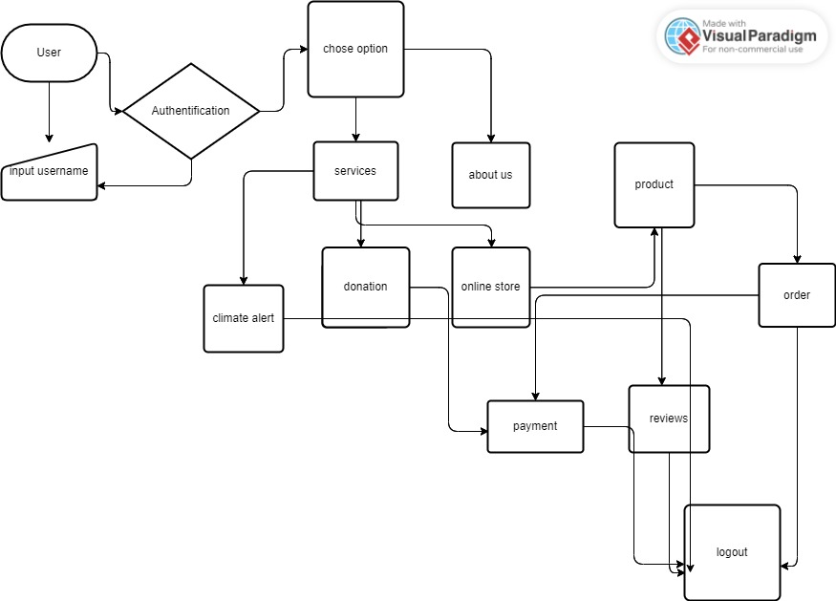

Screens

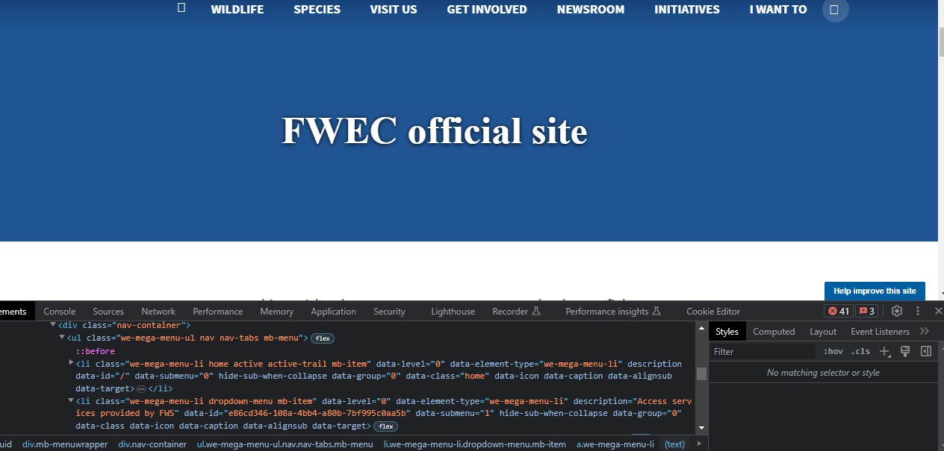
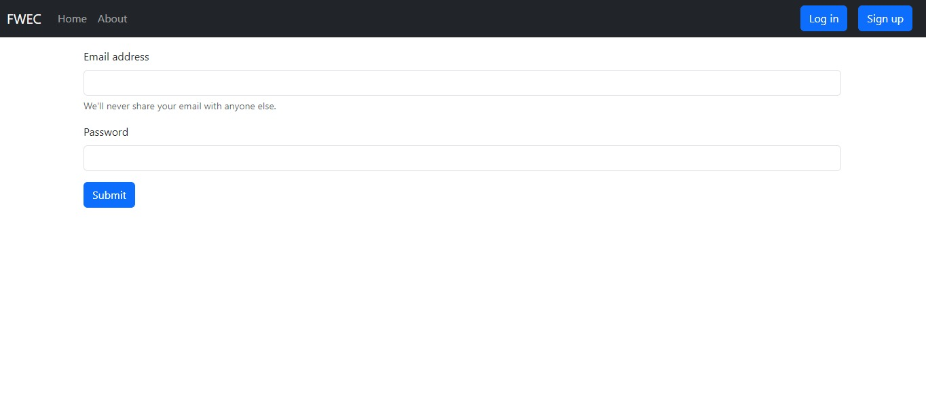

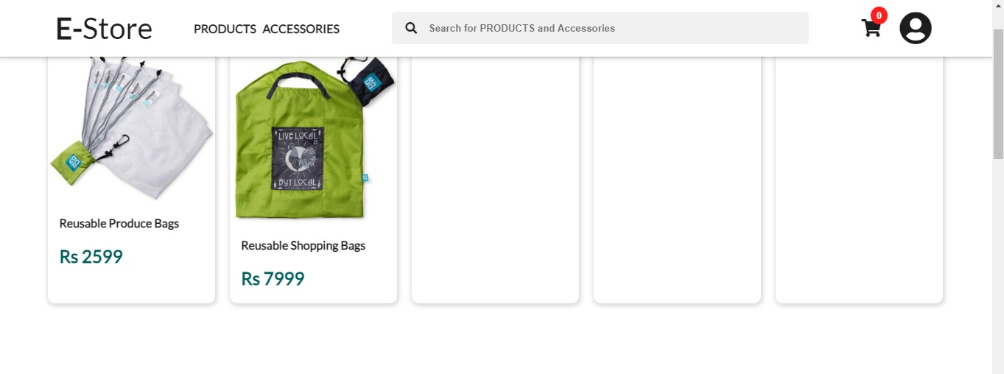

Additional Information
N/A

Other Design Details
N/A

Revised Project Plan
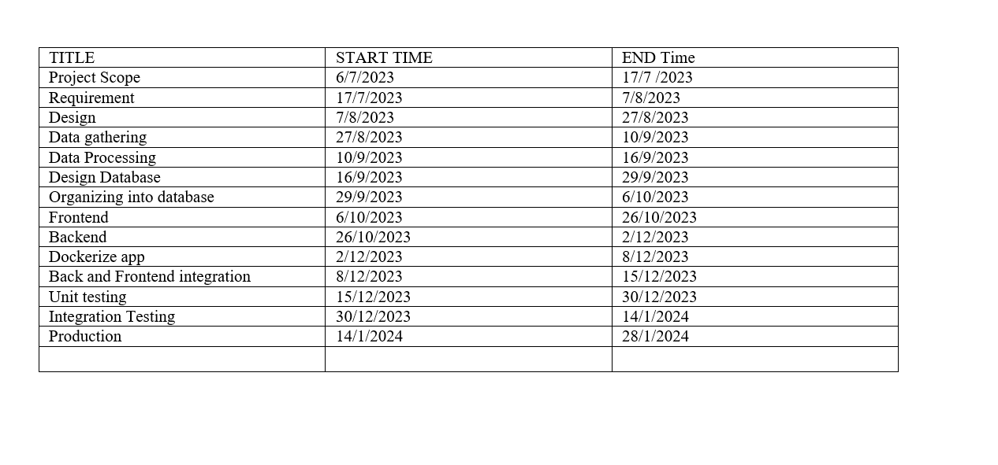

References
US WILD LIFE

Appendix A: Glossary
N/A
Appendix B: IV & V Report
(Independent verification & validation)
IV & V Resource

Name Signature

S# | Defect Description | Origin Stage | Status | Fix Time
 |  |  |  | Hours | Minutes
1
2
3
…
Table 1: List of non-trivial defects

This document has been adapted from the following:
- Previous project templates at UCP
- High-level Technical Design, Centers for Medicare & Medicaid Services. (www.cms.gov)

