**ROLL NO:L1F19BSCS049**

**Name: Saad**

**Subject: OS LAB**

**SCREEN SHORTS:**

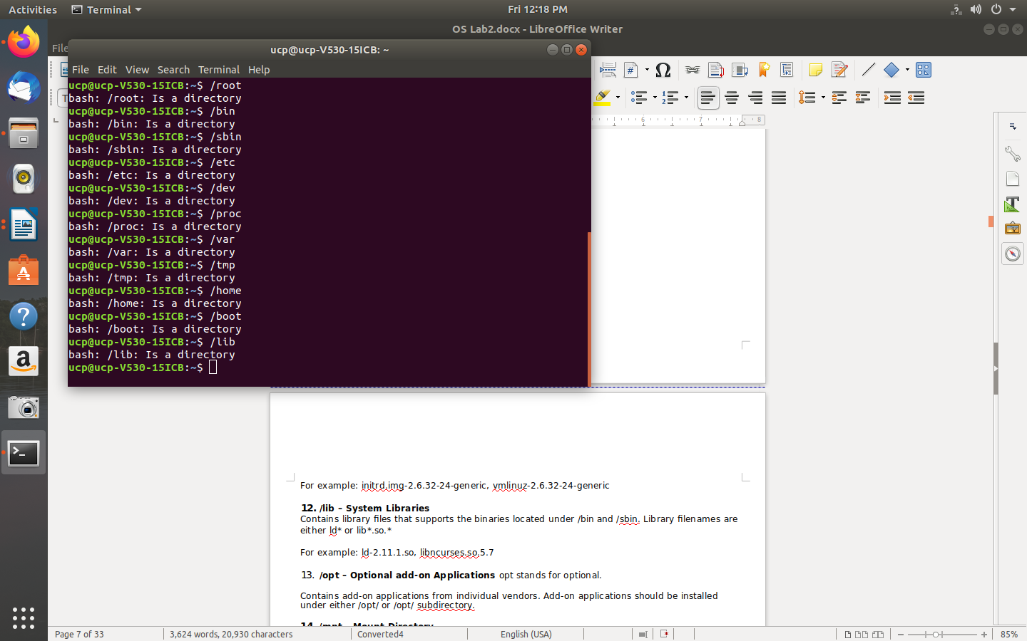

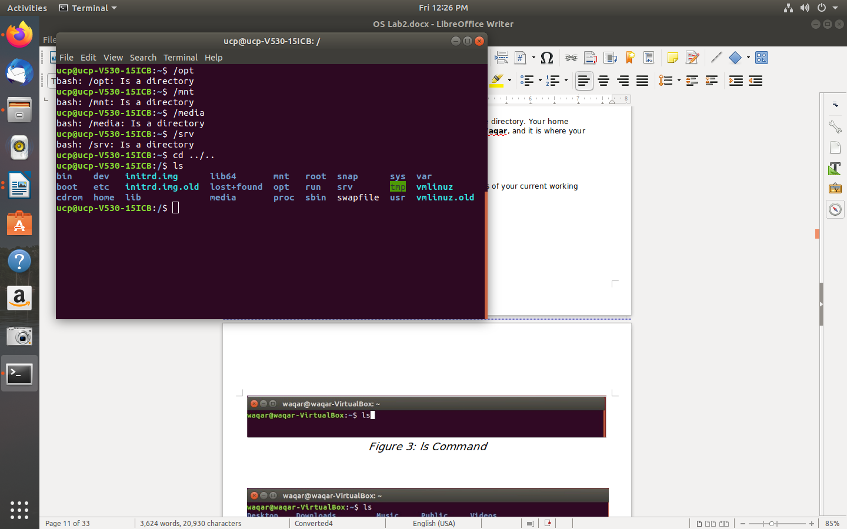

* **bash: /root: Is a directory**
* **ucp@ucp-V530-15ICB:~$ /bin**
* **bash: /bin: Is a directory**
* **ucp@ucp-V530-15ICB:~$ /sbin**
* **bash: /sbin: Is a directory**
* **ucp@ucp-V530-15ICB:~$ /etc**
* **bash: /etc: Is a directory**
* **ucp@ucp-V530-15ICB:~$ /dev**
* **bash: /dev: Is a directory**
* **ucp@ucp-V530-15ICB:~$ /proc**
* **bash: /proc: Is a directory**
* **ucp@ucp-V530-15ICB:~$ /var**
* **bash: /var: Is a directory**
* **ucp@ucp-V530-15ICB:~$ /tmp**
* **bash: /tmp: Is a directory**
* **ucp@ucp-V530-15ICB:~$ /home**
* **bash: /home: Is a directory**
* **ucp@ucp-V530-15ICB:~$ /boot**
* **bash: /boot: Is a directory**
* **ucp@ucp-V530-15ICB:~$ /lib**
* **bash: /lib: Is a directory**
* **ucp@ucp-V530-15ICB:~$ /opt**
* **bash: /opt: Is a directory**
* **ucp@ucp-V530-15ICB:~$ /mnt**
* **bash: /mnt: Is a directory**
* **ucp@ucp-V530-15ICB:~$ /media**
* **bash: /media: Is a directory**
* **ucp@ucp-V530-15ICB:~$ /srv**
* **bash: /srv: Is a directory**
* **ucp@ucp-V530-15ICB:~$ cd ../..**
* **ucp@ucp-V530-15ICB:/$ ls**

**man ls**

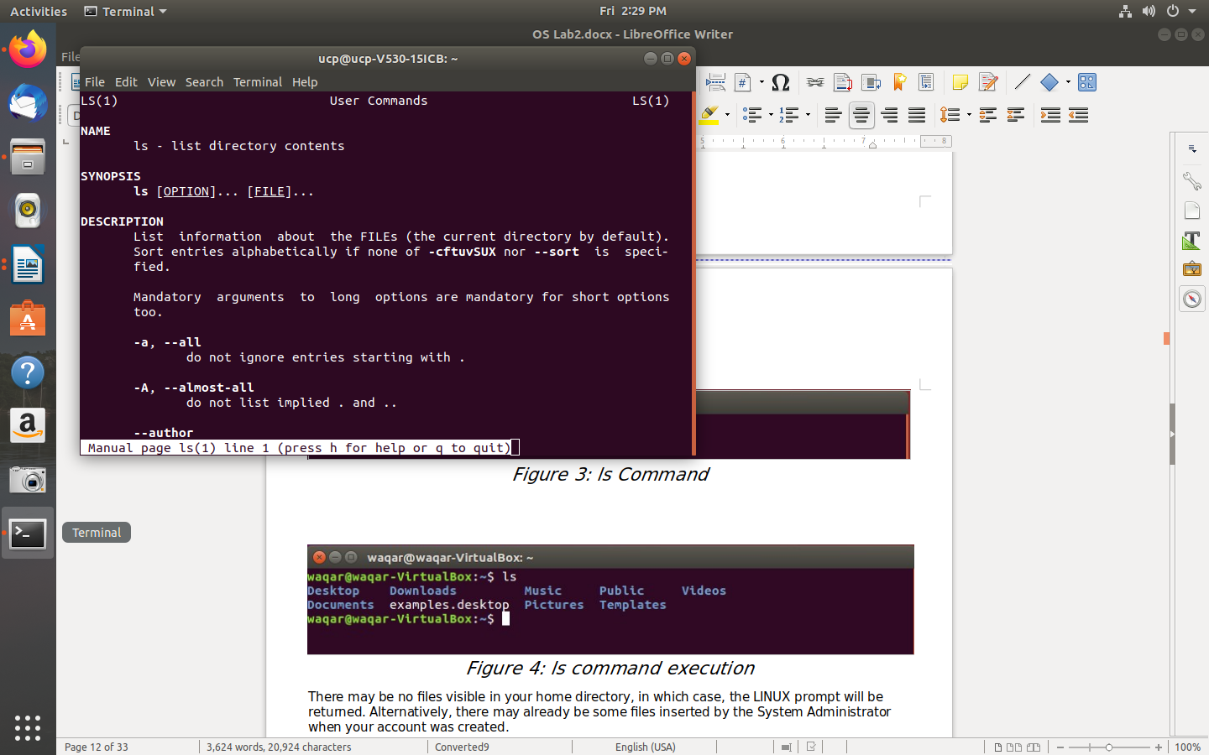

**ls -r &ls -a**

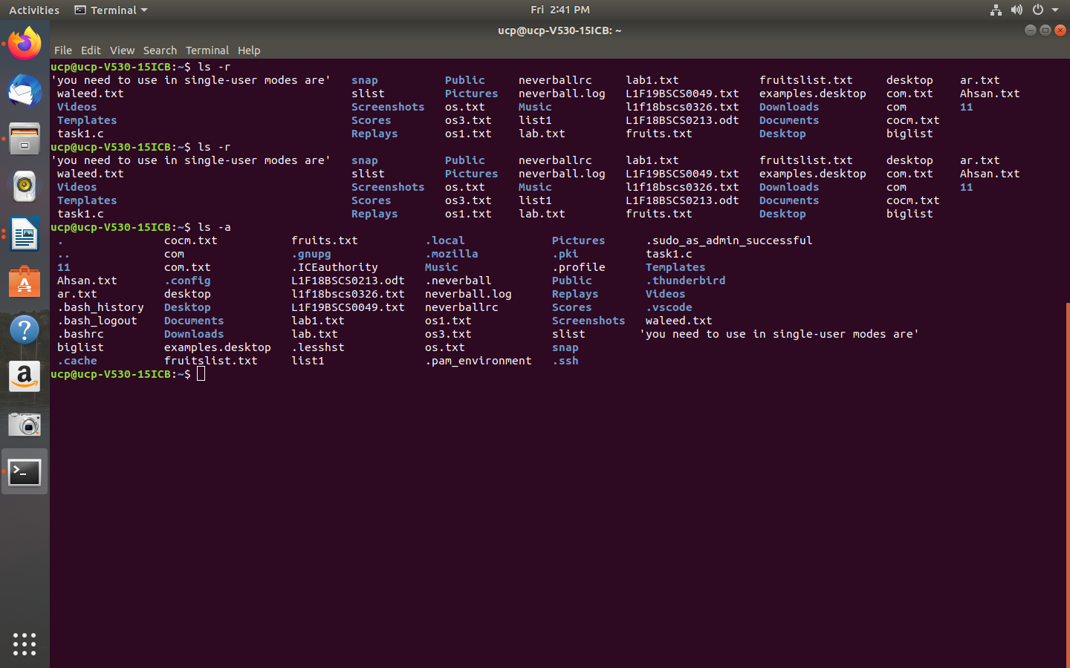

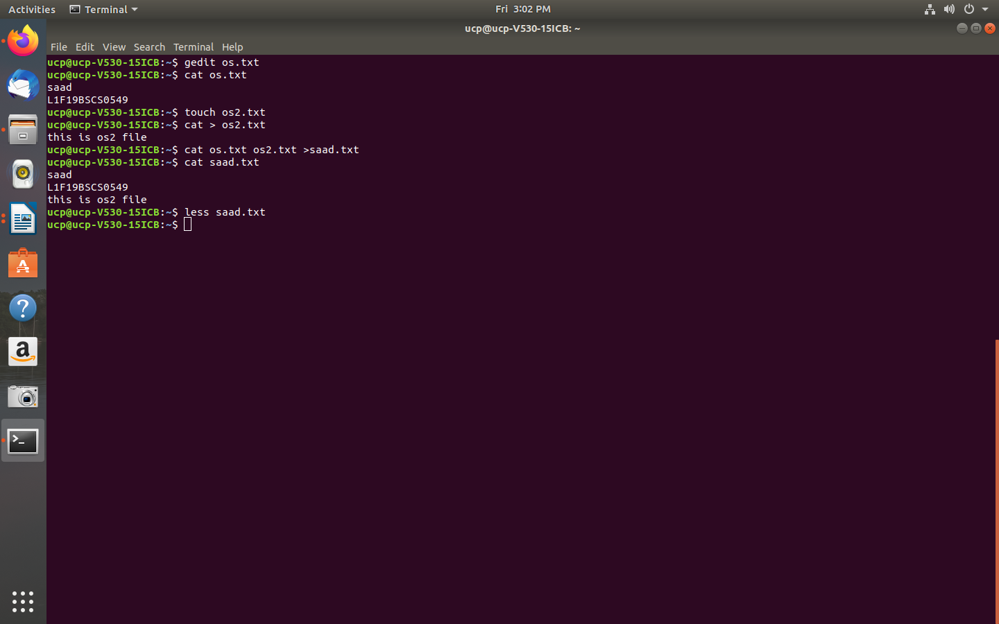

**less saad.txt**

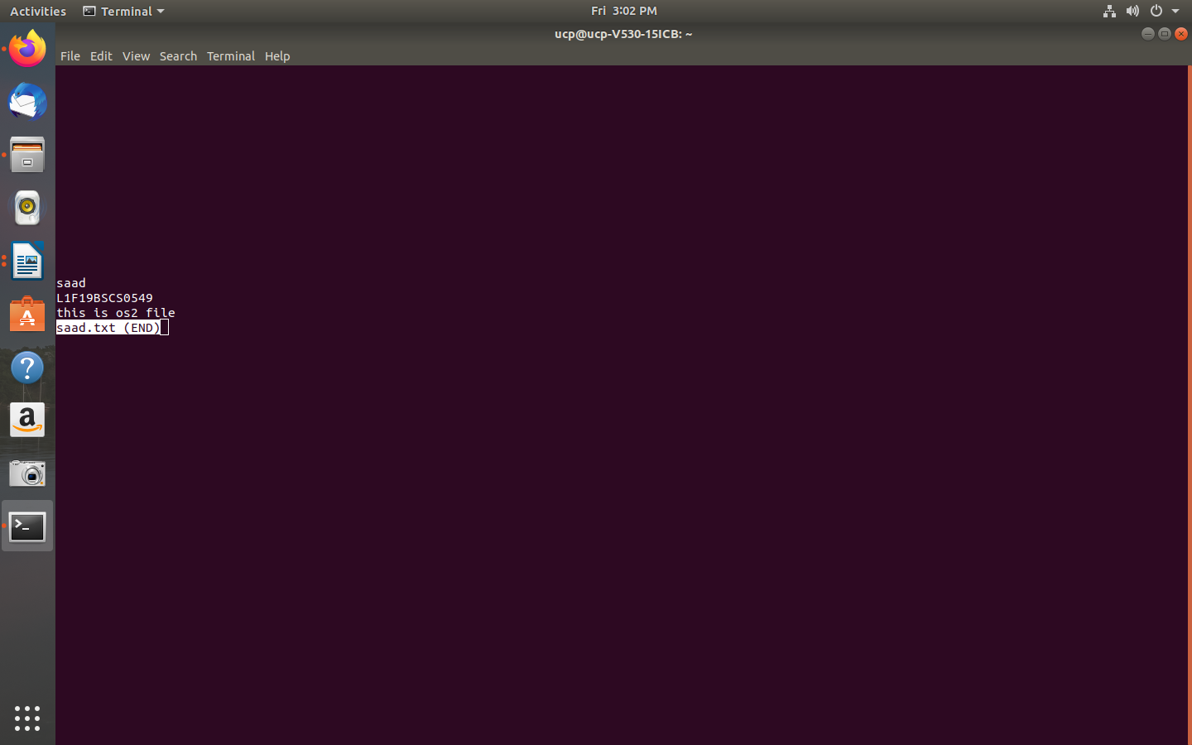**task 1:**

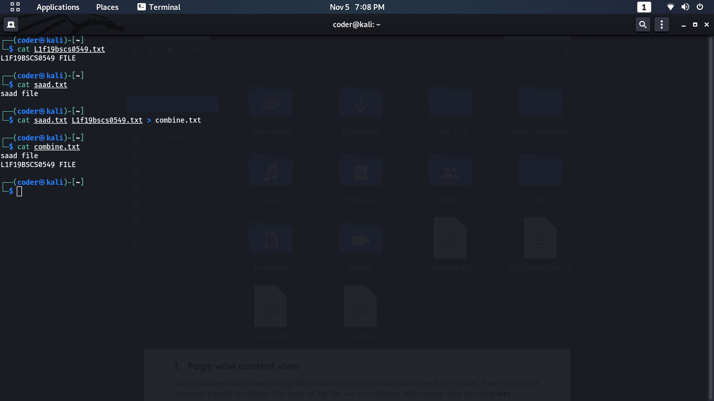**rm**

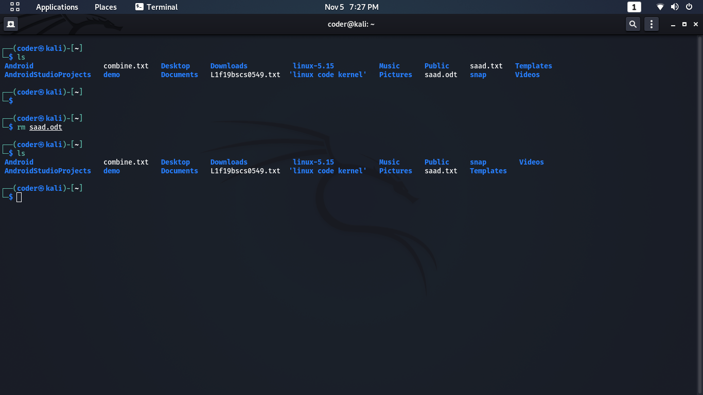**mv**

**mv**

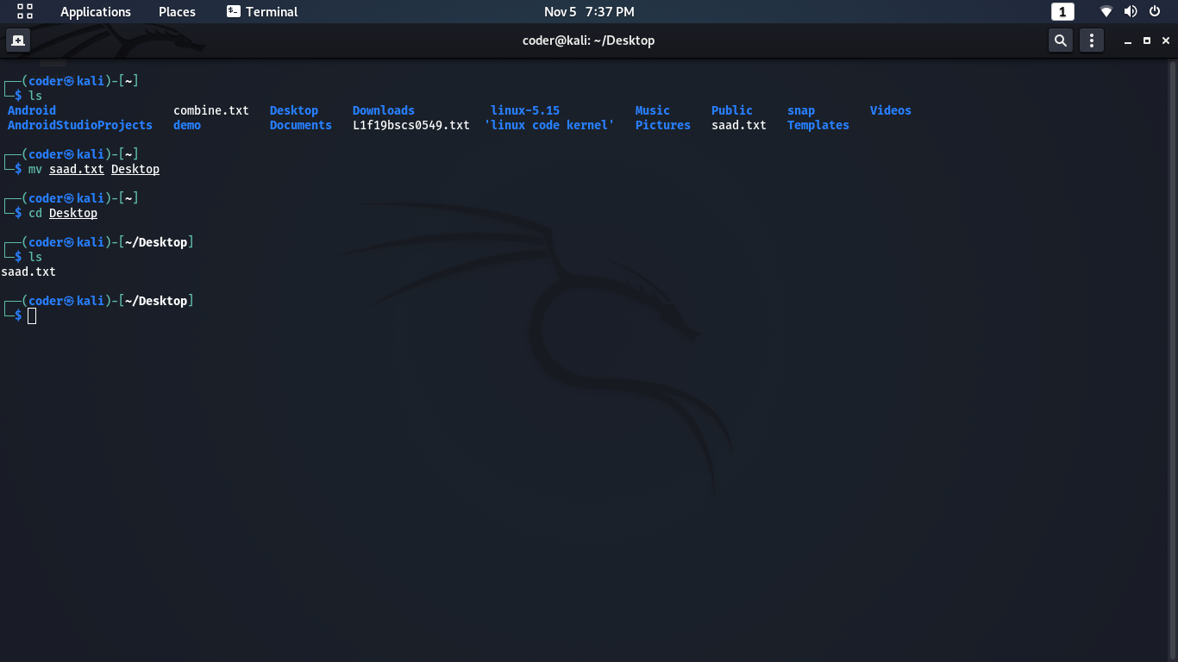**Searching using less**

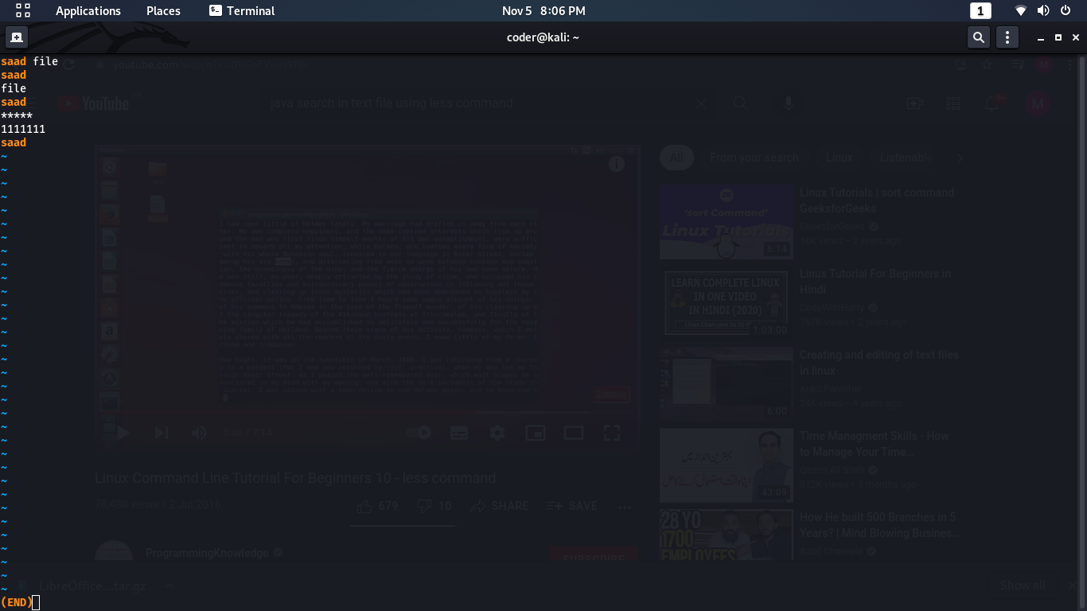**grep**

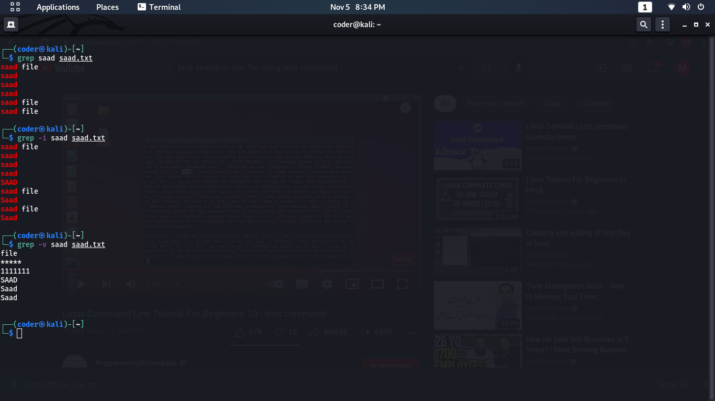

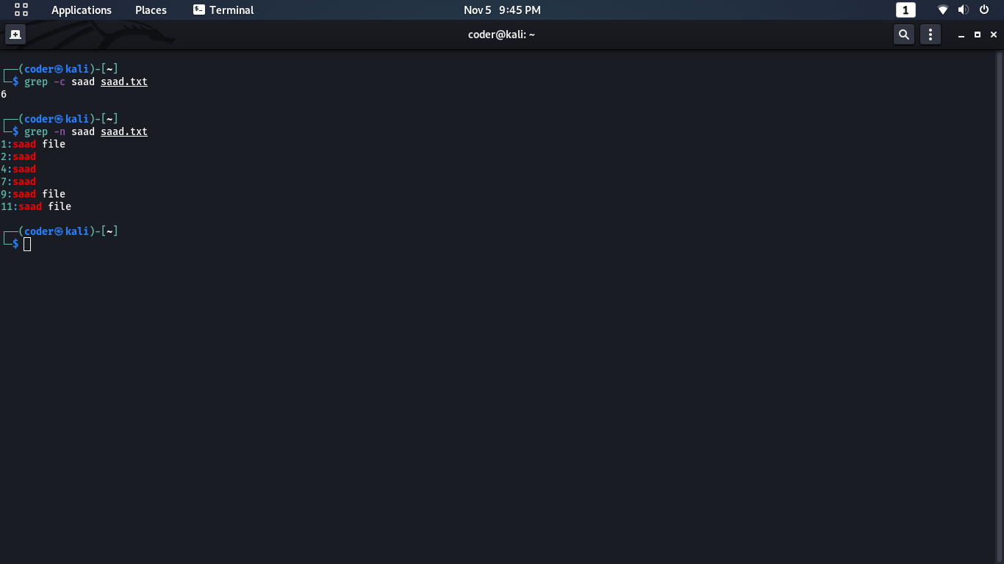**wc**

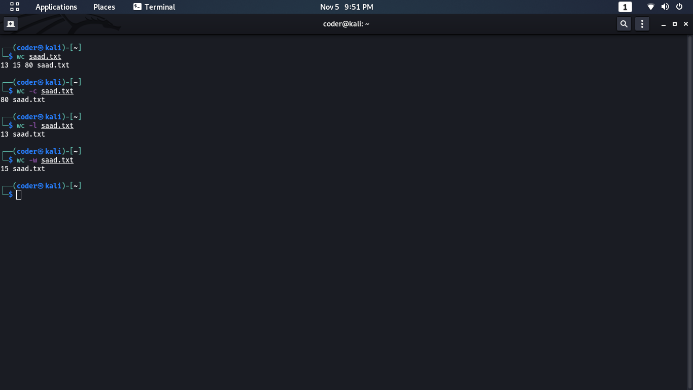**sort**

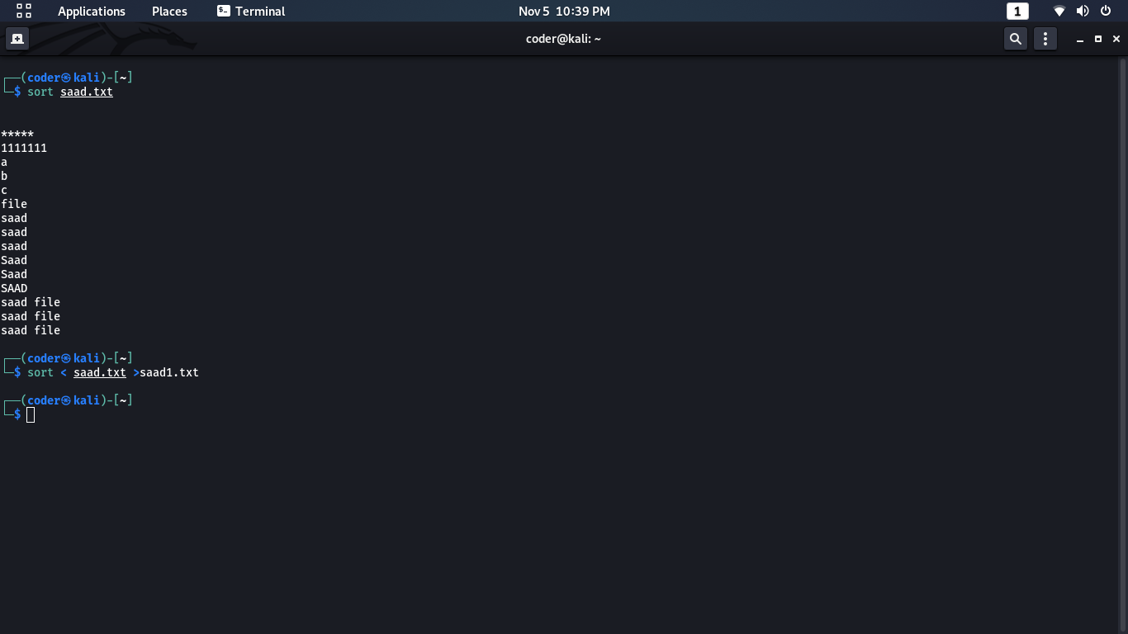

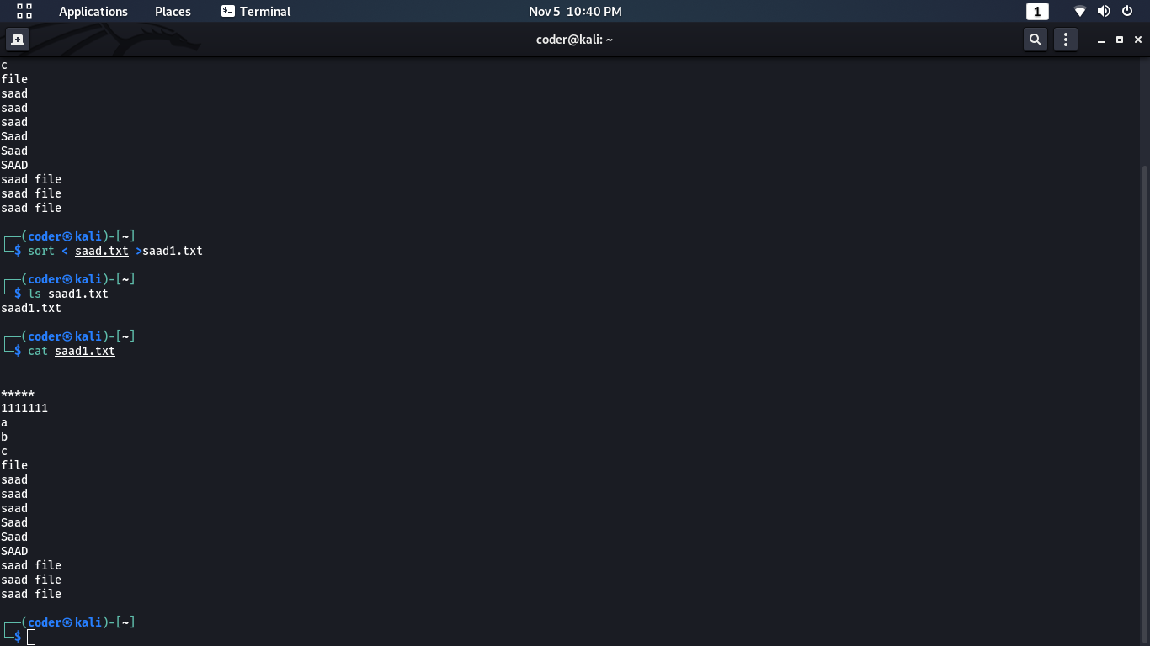**change access**

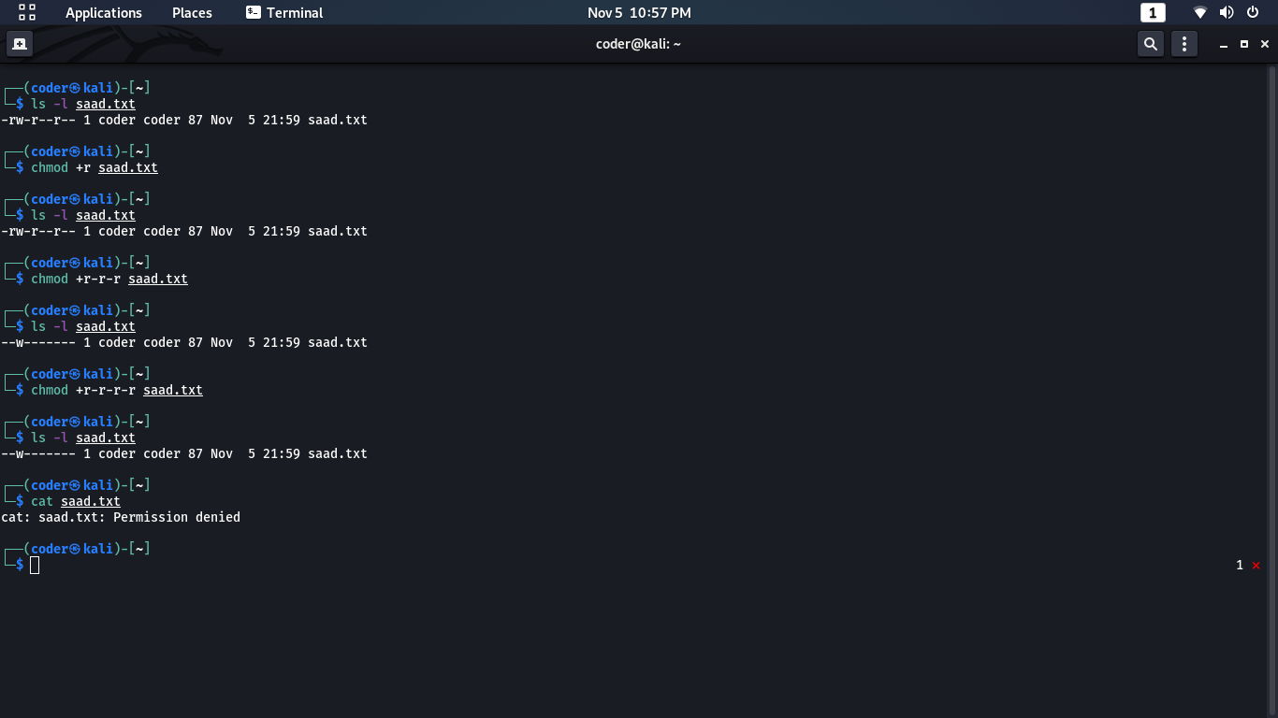

**• Directory Manipulation**

