**OPERATING SYSTEMS LAB** Due Date 4-4-2024

**Lab Assignment 2**

**ClO2 SO3**

**Name : Muhammad Saad Nadeem**

**Reg no : SP22-BCS-086**

**Subject : Operating System Lab**

**Submitted to : Sir Fahad Amin**

**Question #1:**

Write a shell program to find greatest number in your complete roll number.

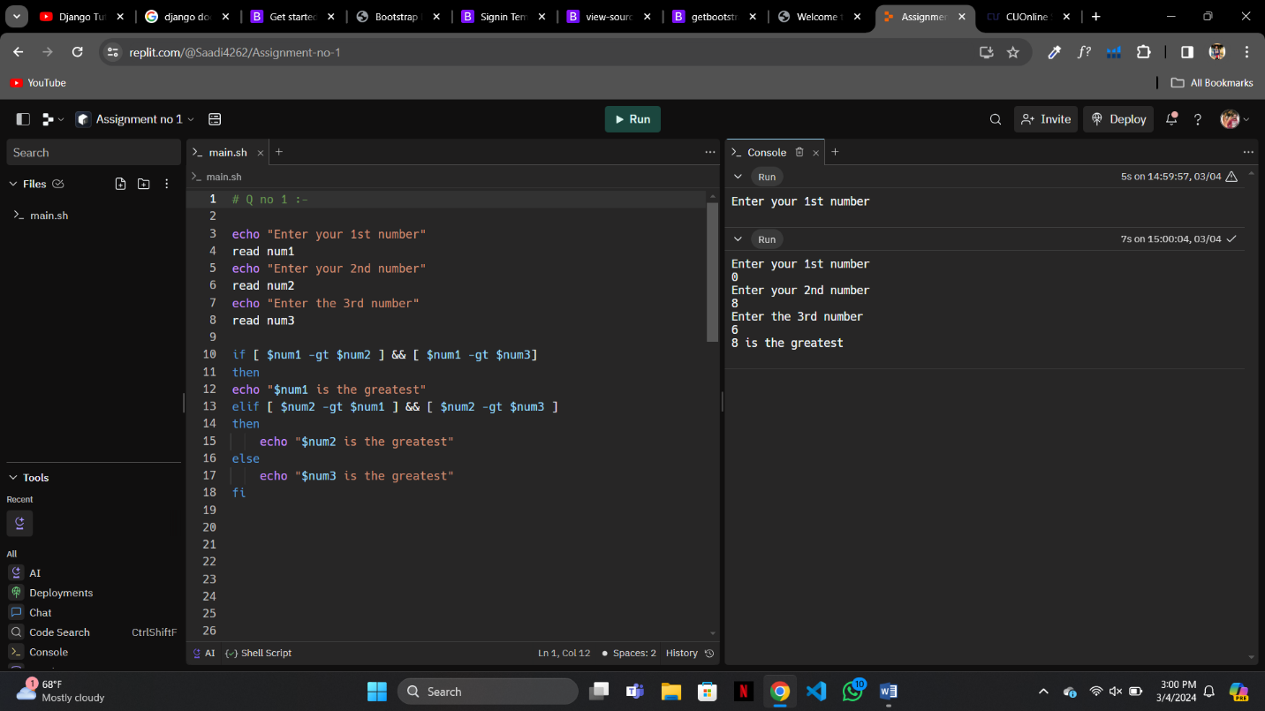

**Question#2:**

Take input from user and concatenate course code, course name, credit hours, department name and instructor name using shell programming.

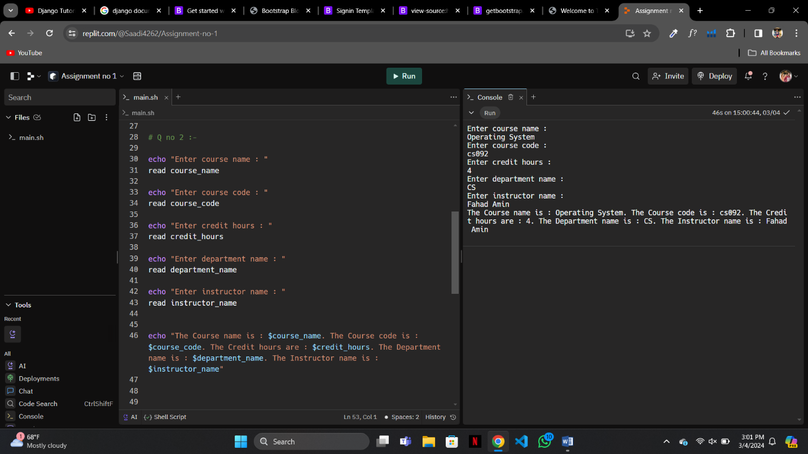

**Question#3:**

Write a shell program to generate Fibonacci series till 100

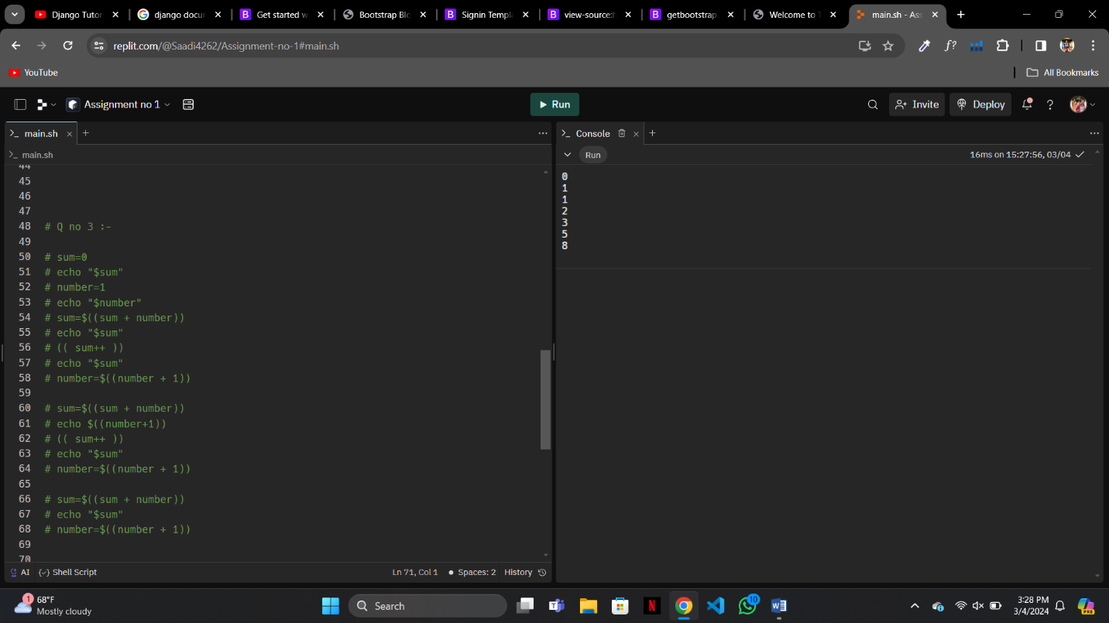

**Question#4:**

**Write a menu driven program which has following options**:

1. Factorial

2. Positive or Negative

3. Odd or even

4. Exit

Once a menu is selected, the appropriate action should be taken and once this action is finished, the menu should reappear.

Unless the user selects the ‘Exit’ option the program should continue to work.

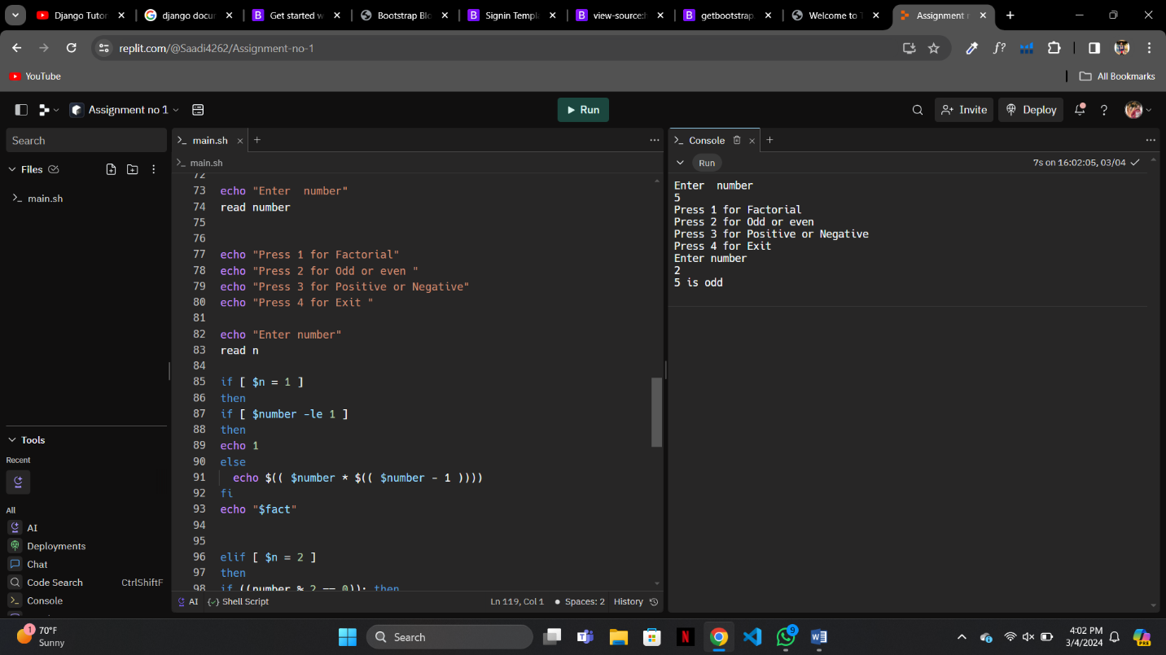

**Question#5:**

Write a program to calculate the electricity bill.

The rates of electricity per unit are as follows:

1. If the units consumed are equal or less than 100, then the cost is Rs 8/- per unit.
2. If the units consumed are more than 100 and less than and equal to 300, then the cost is Rs 10/- per unit and surcharge of 5% of bill is added.
3. If the units consumed are more than 300 and less than and equal to 500, then the cost is Rs 12/- per unit and surcharge of 15% of bill is added.
4. If the units consumed are more than 500, then the cost is Rs 15/- per unit and surcharge of 25% of bill is added.

