

COMSATS University Islamabad

Sahiwal Campus

**Department of Computer Science**

**QUIZ No.1**

**Submitted to:**

**Mam Amna Tariq**

**Submitted by:**

**Muhammad Nubaid Asif**

**Registration No.**

**SP22-BCS-084**

**Section:**

**5-B**

**Subject:**

**DATABASE LAB**

# Quiz#1

**Question 1**: Retrieve the count of all employees in the table.

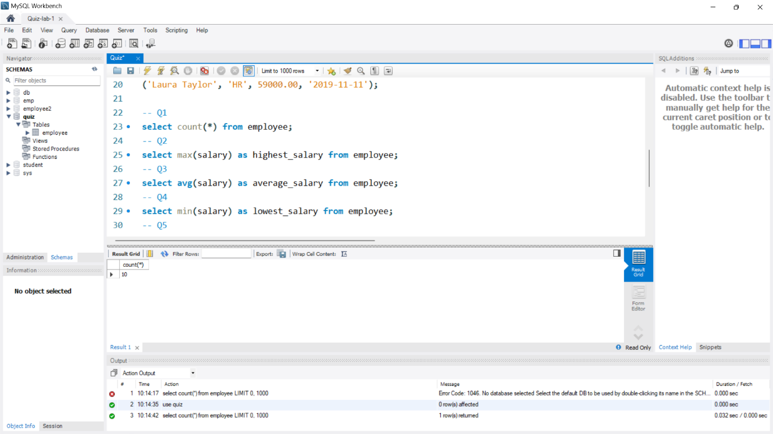

**Question 2**: Find the highest salary among all employees.

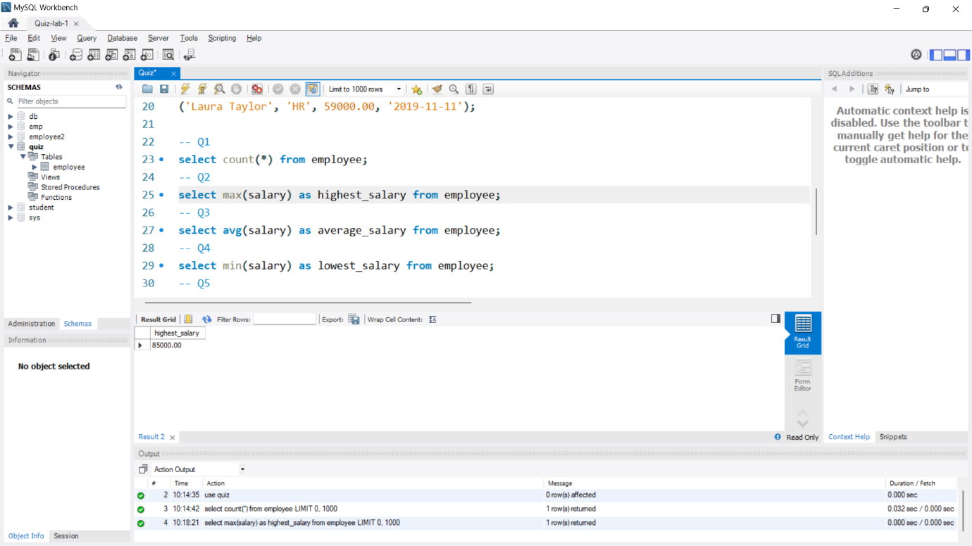

**Question 3**: Get the average salary of all employees.

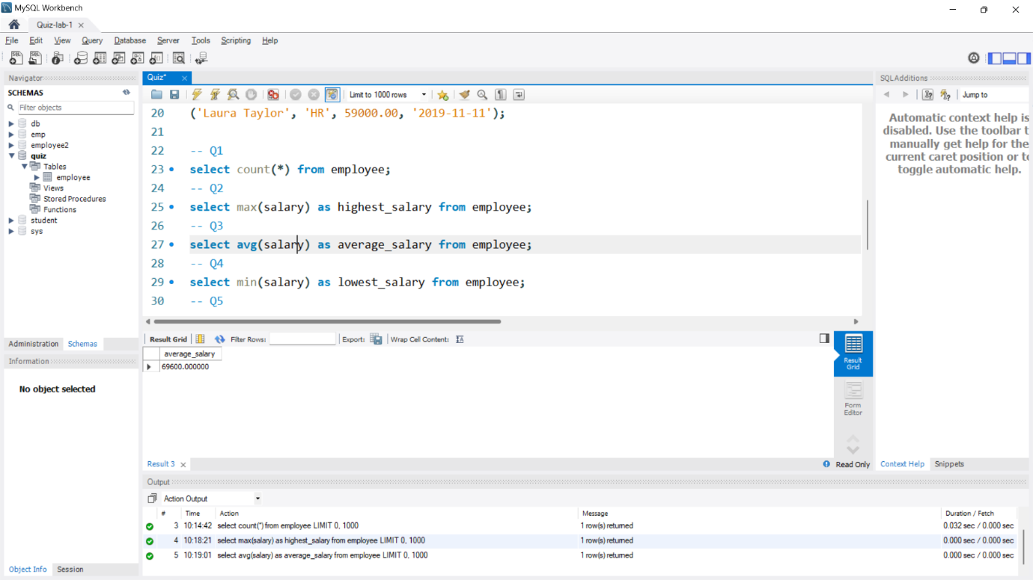

**Question 4**: Find the employee(s) with the lowest salary.

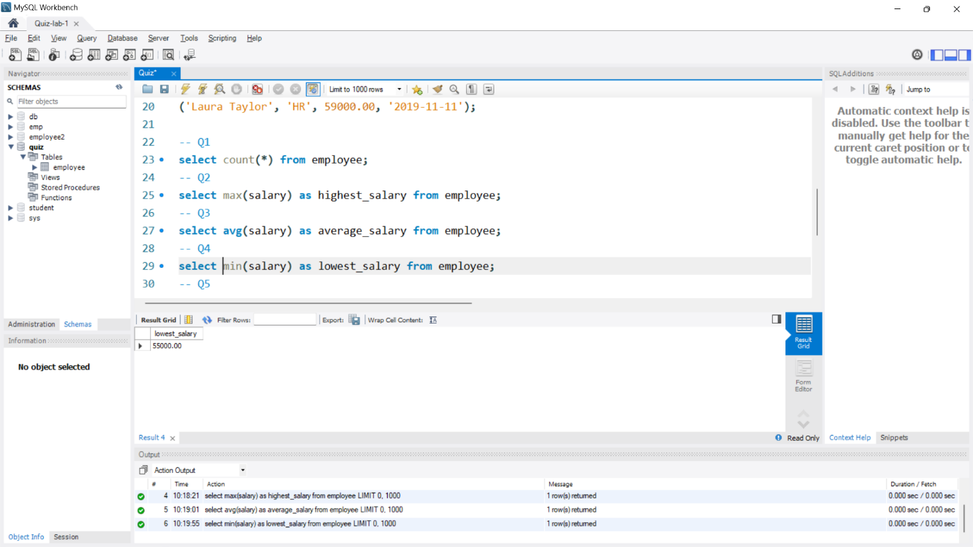

**Question 5**: Retrieve the name and hire date of the employee(s) who joined the company last.

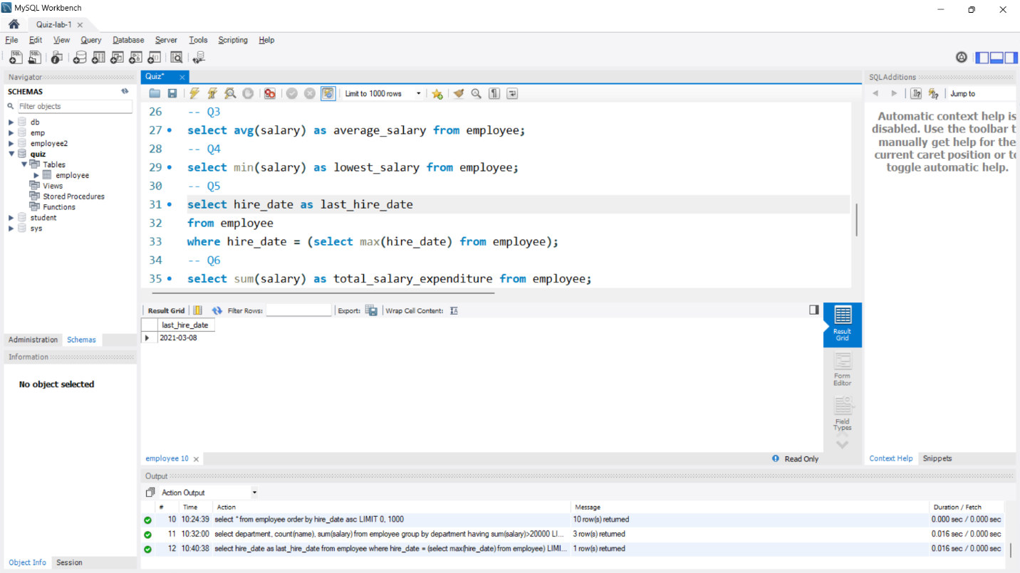

**Question 6**: Get the total salary expenditure for the company.

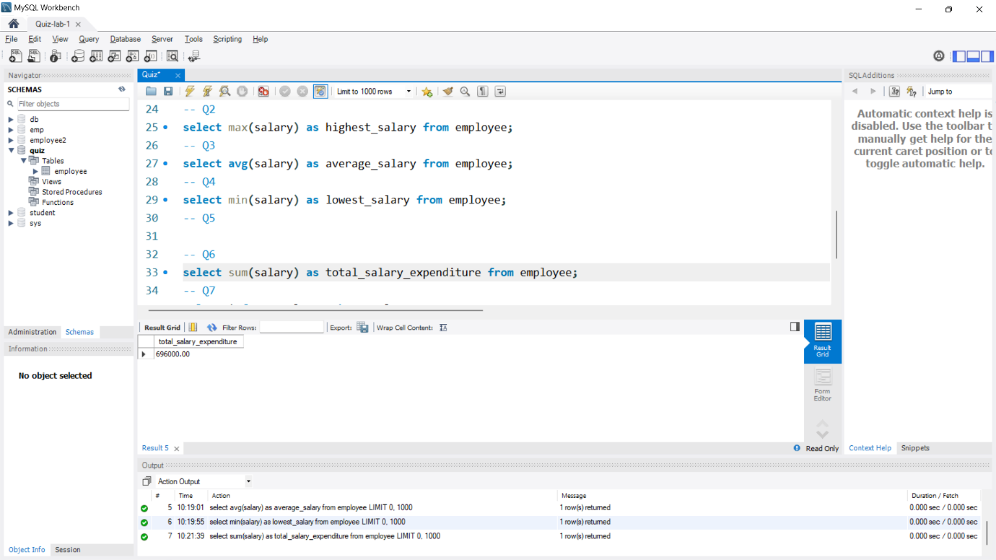

**Question 7**: Find the employee(s) with a salary greater than 70000.

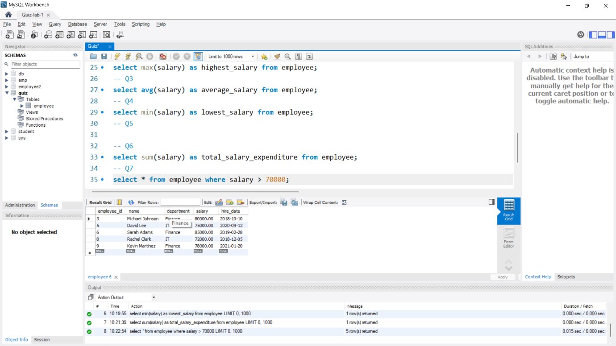

**Question 8**: Get the number of employees grouped by their department.

**Question 9**: Find the employee(s) who have the letter 'a' in their name.

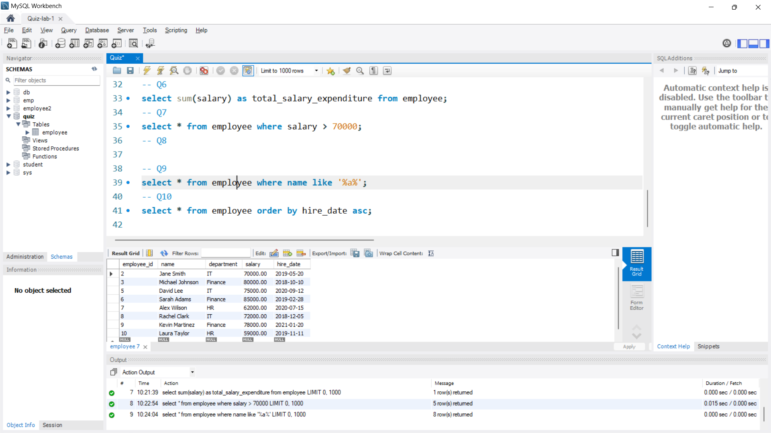

**Question 10**: Retrieve the employee(s) with the earliest hire date.

