Saadaa Creative Testing Dashboard
User Guidebook

Generated 2026-07-02 · v2 dashboard

A field-by-field reference for the v2 dashboard (index_v2.html). Covers every view, every filter, every column. Drop screenshots into docs/screenshots/ and reference them under each section — the placeholder image tags below already point there.

Table of contents
- Getting started
- Global concepts
- Sidebar navigation
- Section 1 — Creative Testing
- Section 2 — Creative Lifecycle
- Section 3 — Ads Analyse
- Section 4 — Ad Intelligence
- Section 5 — Inventory
- Modals and drawers
- Data pipeline — where the numbers come from
- FAQ and troubleshooting

Getting started
Opening the dashboard
The dashboard is a single HTML file that reads Supabase over the browser's REST API. Two query-string parameters are required:
index_v2.html?supabaseUrl=https://<project>.supabase.co&supabaseAnon=<anon-key>
Without those params the top-status strip shows Missing ?supabaseUrl & ?supabaseAnon and nothing loads.
First-load behaviour
On first open the dashboard fires four parallel HTTP calls and waits for all of them:
ae_table_view 15,268 ads lifetime aggregates + F1/F2/F3/F4 pass flags
ae_reach_recent varies incremental daily reach snapshot
ae_freq_lifecycle_mat 11,681 rows per-ad frequency crossing dates
results_table (cache) 30-day set fast-path aggregate for Creative Testing
The top-right status strip shows which source is loaded and the date window it covers. Loaded 3,289 ads (results_table cache · 2026-06-03 → 2026-07-02) is normal.
![Getting Started — top strip](docs/screenshots/getting-started-top-strip.png)

Global concepts
The four filters (F1–F4)
Every ad in the system is scored against four cost-and-signal filters. Every category (Winner, P0, etc.) is a rule on top of these:
F1 Impressions >= 50,000 (delivery — has this ad served enough to judge)
F2 ROAS >= 3.2 (return on ad spend — Meta-attributed)
F3 Cost per NCP <= ₹525 (new customer purchase — retention proxy)
F4 Cost per FTEWV <= ₹25 (first-time engaged video-viewer — creative quality)
Thresholds are editable in the toolbar of both Creative Testing and Ads Analyse (fields #ctF1..#ctF4 / #aeF1..#aeF4). Resetting reverts to the defaults above.
The six categories
Every ad falls into exactly one bucket. Priority order matters — the first matching rule wins:
Incremental Winner F1 AND (F2 OR F3) AND F4 scale aggressively; top-tier proven
Winner F1 AND (F2 OR F3) scale; F4 close-second, iterate on quality
P0 analysis F1 AND F4 impressions + cheap FTEWV; iteration target
P1 analysis F1 only hit impressions but no signal on ROAS/NCP/FTEWV
P2 analysis F2 only strong ROAS but still building impressions
Discarded else no signal — cut spend or rework creative
Colours across every KPI tile and badge follow this same scheme.
The unified date-range picker
Every view uses the same picker. Preset shortcuts (.drp-preset):
Today Last 7 Days This Month Last 90 Days
Yesterday Last 30 Days Last Month Lifetime Custom Range
Ad Intelligence adds a Last 15 Days between Last 7 Days and This Month.
The picker has dual month calendars, arrow navigation, and an Apply button that only commits after a valid from / to range is set. Cancel discards.
![Date-range picker](docs/screenshots/date-range-picker.png)
The multi-filter builder
Both Creative Testing (#ctMfRows) and Ads Analyse (#aeMfRows) have a chainable rule builder. Each row is field | operator | value and rules combine with AND.
Field Any of: ad_name, campaign, adset, account, category, status, spend, ROAS,
impressions, reach, cost_per_ftewv, cost_per_ncp
Operator contains, does_not_contain, equals, not_equals, > , >=, <, <=, is_empty
Value free text or numeric (auto-parses)
Buttons:
Add Rule appends a fresh field/operator/value row
Apply commits all rules; KPIs, funnel, charts, and table re-compute
Clear removes all rules and reapplies

Sidebar navigation
The left rail (#sidebar) groups five destinations:
CREATIVE TESTING
Creative testing → view-testing broad performance dashboard
Creative Lifecycle → view-lifecycle frequency saturation + 14-day buffer
ANALYSIS
Ads Analyse → view-ae row-level table (60+ columns)
Ad Intelligence → view-adintel Shopify orders / UTM attribution
CATALOG
Inventory → view-inventory Shopify product + stock
The active item highlights yellow. Switching views doesn't re-fetch — the data was loaded once at boot and each view reads whichever slice it needs. Below the nav is a live DB status line (#dbStat) showing which source is powering the current numbers.

Section 1 — Creative Testing
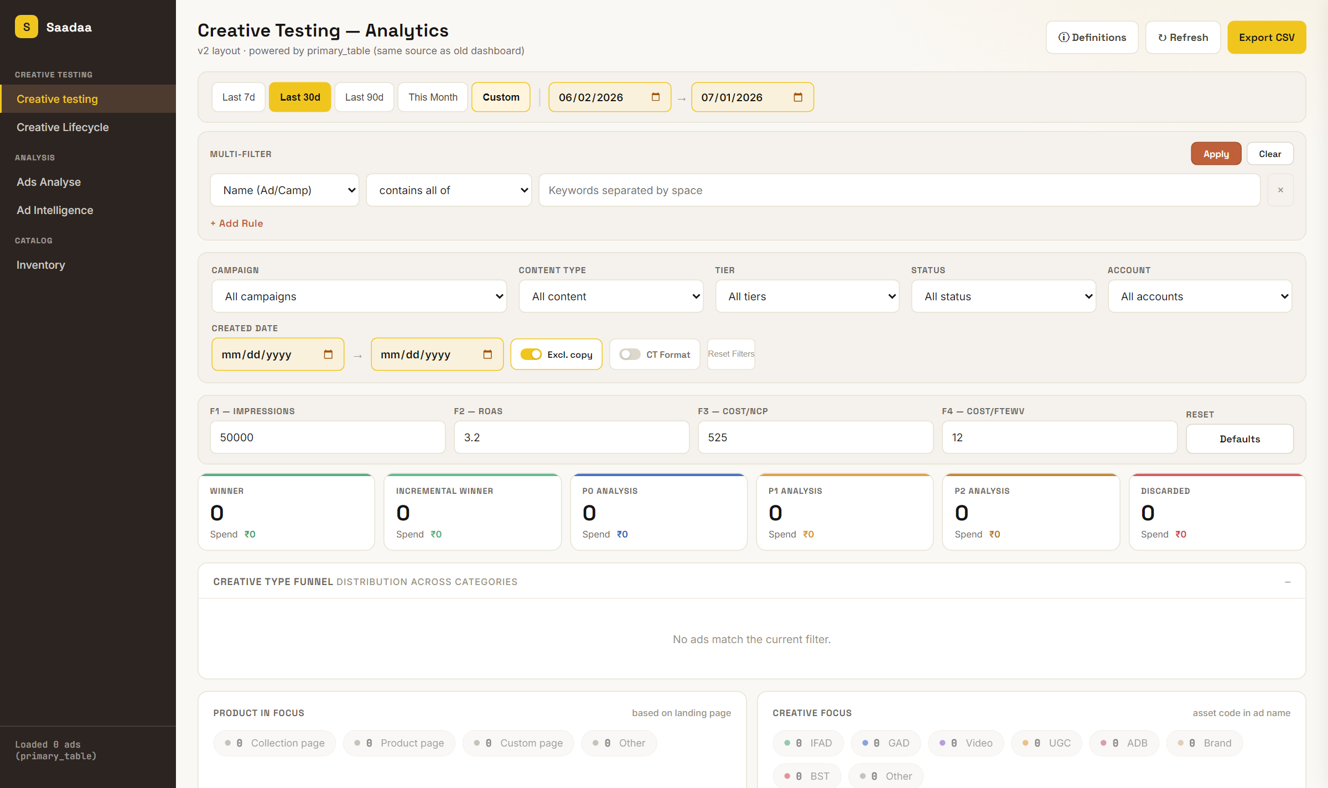
01 ct overview
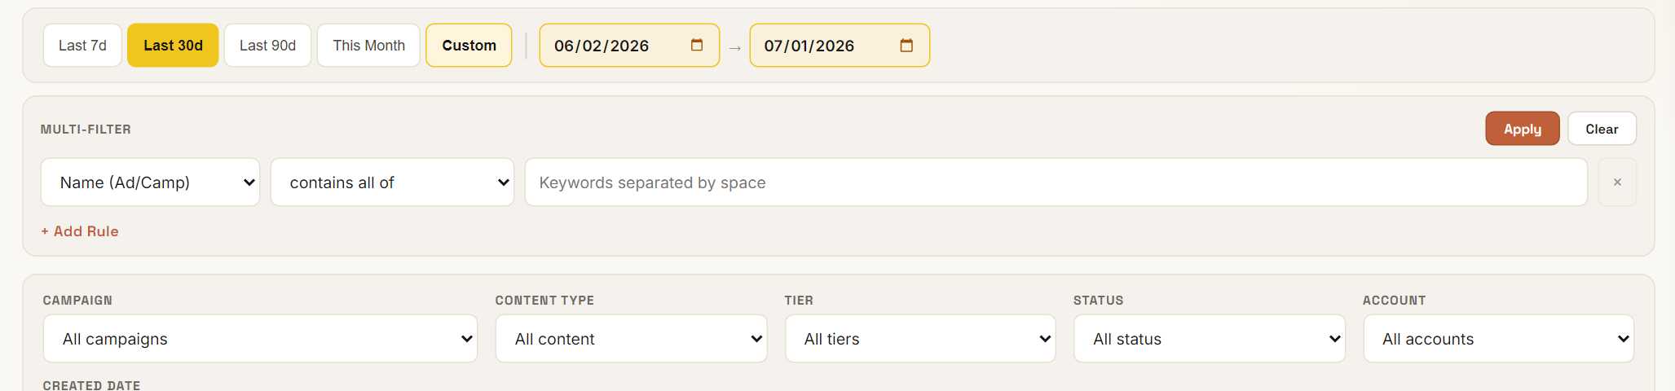
01a ct kpis
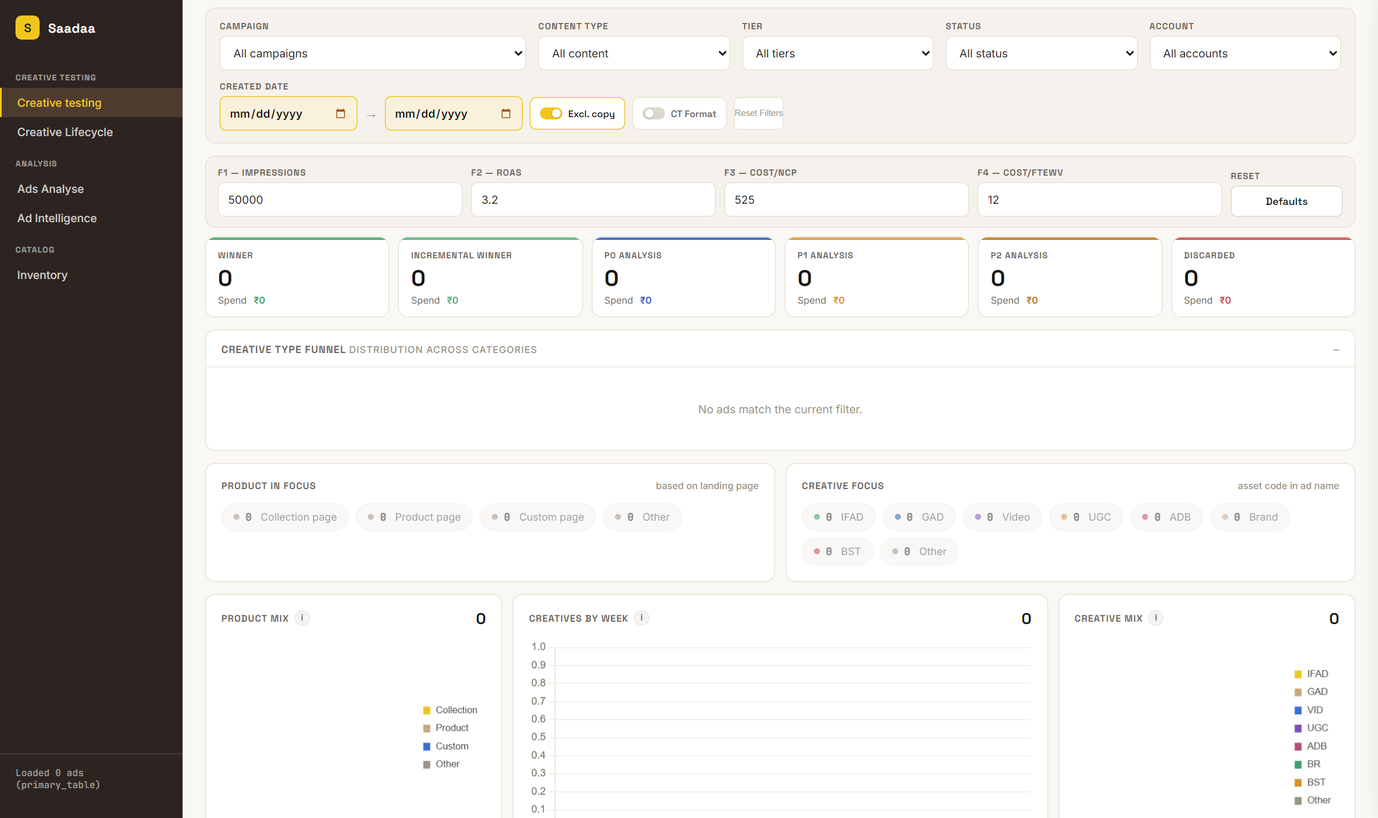
01b ct funnel
The default landing view. Mirrors the layout of the legacy v1 dashboard.
![Creative Testing — overview](docs/screenshots/ct-overview.png)
Toolbar
Definitions (#btnDef) opens the metric-definitions modal
Refresh (#btnRefresh) re-fetches ae_table_view + primary aggregation
Export CSV (#btnExport) exports the currently-filtered ad list
Date-preset row
Chip row above the toolbar. Default is Last 30d. Custom presets show #fDateFrom and #fDateTo date inputs.
Last 7d Last 30d Last 90d This Month Custom
Changing the preset re-runs fetchPrimaryAggregated() against primary_table with the new window.
Filter grid
Six controls arranged left-to-right, then a second row of thresholds:
Campaign (#fCampaign) dropdown — list is derived from primary_table
Content type (#fContent) IFAD / Graphic AD / Video / Static
Tier (#fTier) the 6 categories
Status (#fStatus) Active / Paused / Archived
Account (#fAccount) one of 3 Meta ad accounts
Created from-to (#fCreatedFrom) ad creation-date window (independent of delivery window)
Excl. copy (#fExclCopy) toggle — hides ads with "copy" in the name
CT Format (#fCtFormat) toggle — restrict to CLP-/CTP- creative-testing names
Reset Filters (#fCreatedClear) clears every filter and preset back to Last 30d
Thresholds (second row, editable numeric):
F1 — Impressions (#ctF1) default 50,000
F2 — ROAS (#ctF2) default 3.2
F3 — Cost / NCP (#ctF3) default 525
F4 — Cost / FTEWV (#ctF4) default 12
Reset (#ctResetThresh) defaults
Changing a threshold live-recategorises every ad in the browser (no HTTP refetch) and updates every KPI tile, the Funnel, and the table.
![Creative Testing — filter grid](docs/screenshots/ct-filter-grid.png)
KPI tiles
Six clickable tiles across the top (#kpiRow). Each shows count + total spend for its category. Clicking any tile opens the Category Performers modal (see the modals section).
Winner (#kp-winner) green
Incremental Winner (#kp-incr) dark green
P0 analysis (#kp-pri) amber
P1 analysis (#kp-a1) muted amber
P2 analysis (#kp-a2) terracotta
Discarded (#kp-dis) red
Clicking the same tile again closes the modal.
Creative Type Funnel
A 6×6 matrix (#funnelBody): rows are creative types (IFAD / GAD / VID / UGC / ADB / BR / BST / Other), columns are the 6 categories plus a "grand total" column. Each cell shows count + a percentage bar.
row header IFAD, Graphic AD, Video, UGC, ADB, Brand, BST, Other
column header Incremental Winner, Winner, P0, P1, P2, Discarded
Click any cell with a non-zero count to open the drill modal pre-filtered to that intersection. data-fnl-ct and data-fnl-cat on the cell carry the exact filter.
![Creative Type Funnel](docs/screenshots/ct-funnel.png)
Focus panels
Two pill strips below the funnel:
Product Focus (#prodStrip) — how ad spend distributes across landing-page types:
Collection page /collections/... URLs
Product page /products/... URLs
Custom page /pages/... URLs
Other everything else (blog, homepage, etc.)
Creative Focus (#creativeStrip) — same but for creative type buckets:
IFAD GAD VID UGC ADB BR BST Other
Every pill shows count + spend and opens the drill modal for that bucket on click.
Charts strip
Three canvases side-by-side (#chProd, #chTrend, #chCreative):
Product mix donut spend by product bucket
Creatives by week bar creatives added per week (creation date)
Creative mix donut spend by creative-type bucket
Each has a small i icon (data-ci) that shows a tooltip explaining what the metric measures.
Landing Page Focus
Grouped table (#landingPageFocus) sorted by ad count or spend. One row per unique landing URL.
Column Meaning
Product code friendly name derived from URL (collection slug, product slug)
Landing URL full ad_link
Count number of ads pointing at this URL
Spend sum of amount_spent for those ads
Click any row to open the drill modal filtered to that URL.

Section 2 — Creative Lifecycle
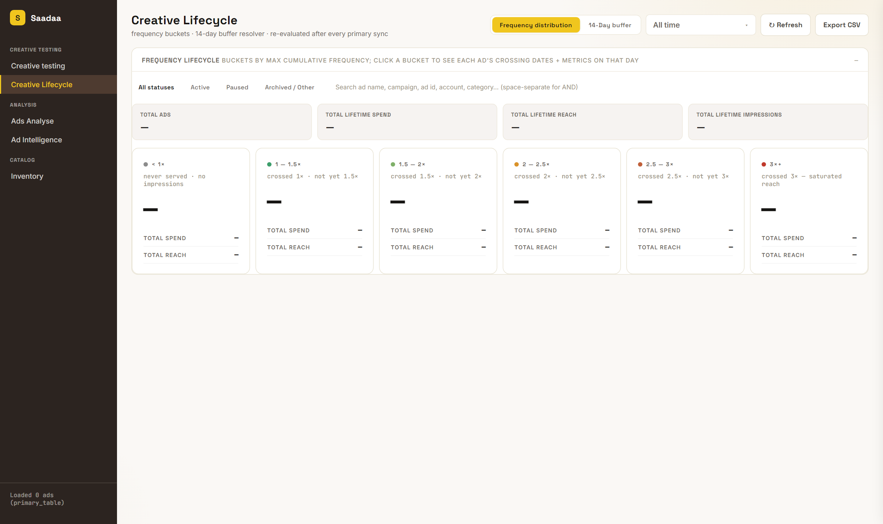
02 lifecycle overview
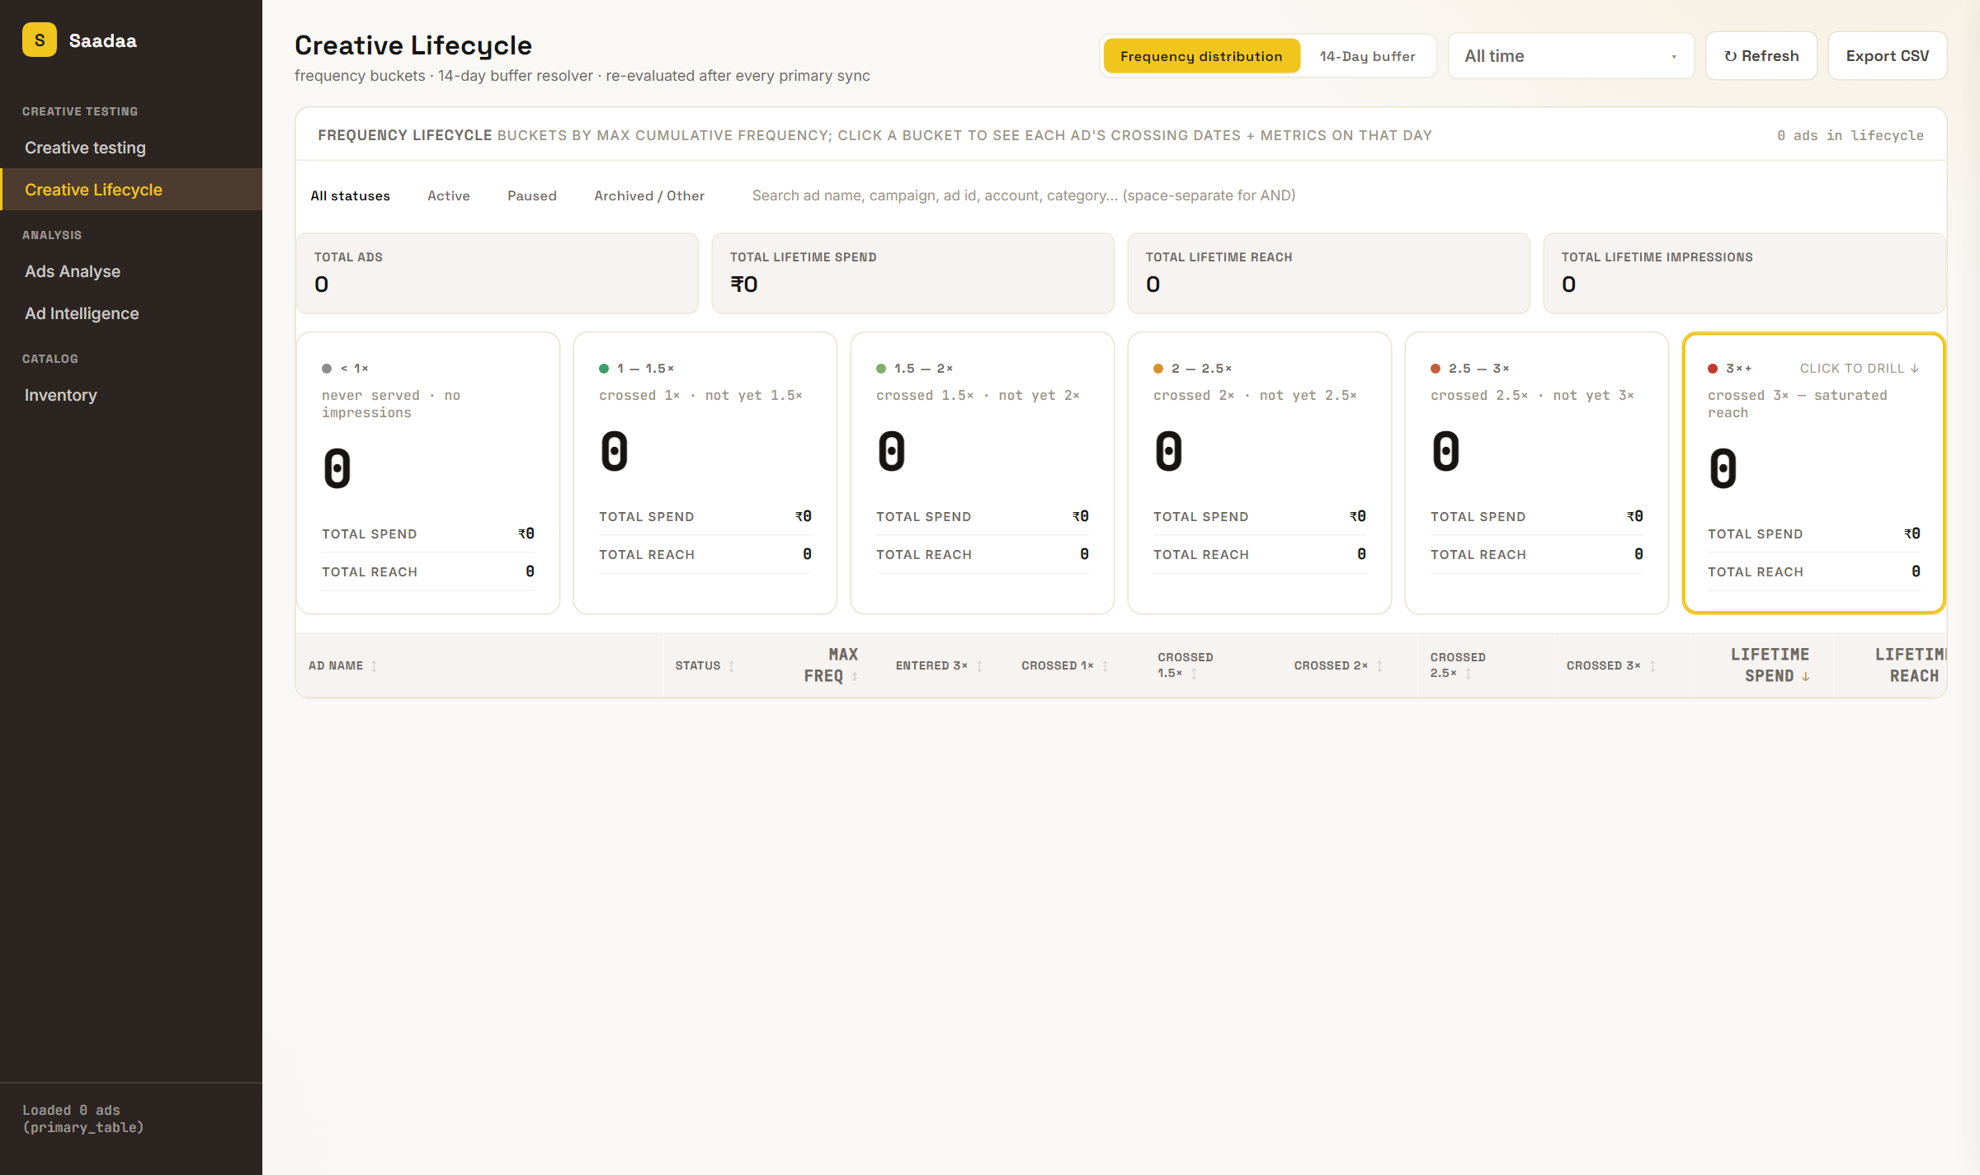
02a lifecycle freq drill
Two sub-sections toggle at the top of the view (#lifeSectionToggle):
Frequency distribution (default) frequency saturation across ad lifecycles
14-Day buffer ads at or past day-14 needing verdict
![Creative Lifecycle — overview](docs/screenshots/lifecycle-overview.png)
Date-range control
Lifetime by default. The picker filters the view to ads created within the chosen range (ad_created window, not delivery). All KPIs and bucket counts respect it.
Refresh (#lifeRefresh) re-fetches allAds + freqLifecycleByAdId
Export CSV (#lifeExport) exports the visible ad list
Frequency Distribution sub-view
Status filter + search bar
Chip row above the KPI tiles (#lifeFreqStatusRow). Applies to totals, bucket counts, and drill:
All statuses Active Paused Archived / Other
Adjacent search input (#lifeFreqSearch) supports AND-tokenised search across ad_name, campaign, ad_id, account, adset, category. Type shubh active winner to require all three tokens. The counter to the right shows N / M matched live.
Lifetime totals strip
Four tiles (#freqTotals) — always reflect the full filtered set:
Total ads (#freqTotAds)
Total lifetime spend (#freqTotSpend)
Total lifetime reach (#freqTotReach)
Total lifetime impressions (#freqTotImpr)
Frequency buckets
Six clickable cards (#lifeFreqBuckets) keyed by max_cum_freq (peak cumulative frequency the ad has ever reached):
< 1× never served — no impressions
1 – 1.5× crossed 1× but not 1.5×
1.5 – 2× crossed 1.5× but not 2×
2 – 2.5× crossed 2× but not 2.5×
2.5 – 3× crossed 2.5× but not 3×
3×+ saturated reach — crossed 3×
Each card shows ad count + total spend + total reach for that bucket. Colour progresses grey → green → amber → red as frequency grows. Click any bucket to open the drill table.
Drill table (`#freqDrillTable`)
Appears below the buckets when a card is active. Sortable headers with visible arrows (↕ neutral, ↑ asc, ↓ desc). Sensible defaults per column family:
Column Sort key First-click direction
Ad name ad_name desc (Z-A)
Status ad_status desc
Max freq max_cum_freq desc (highest first)
Entered N× depends on b asc (oldest crossing first)
Crossed 1× d_1 asc (chronological)
Crossed 1.5× d_1_5 asc
Crossed 2× d_2 asc
Crossed 2.5× d_2_5 asc
Crossed 3× d_3 asc
Lifetime spend amount_spent desc (top spend first)
Lifetime reach reach desc
Each Crossed N× cell shows impressions / reach / spend on that day. Cells for thresholds the ad never reached render as em-dashes and sort to the bottom.
The Entered column shows the date the ad entered its current bucket. Header re-labels dynamically (Entered 1×, Entered 1.5×, etc.) as you click through buckets.
![Frequency drill](docs/screenshots/lifecycle-freq-drill.png)
14-Day Buffer sub-view
Every ad at day-14 or later since creation. Meant for the daily "should we cut / keep / scale" review.
Verdict filter presets (`#lifeBufferStatusRow`)
All Winners Inc. Winners P0 analysis
P1 analysis P2 analysis Discarded
Adjacent search input (#lifeBufferSearch).
Table (`#lifeBufferTbl`)
Column Meaning
Ad name + campaign_name underneath
Status Meta ad_status pill
Created ad_created (mono, YYYY-MM-DD)
Days since integer days from ad_created to today
Verdict category badge
F1..F4 individual pass ticks (✓ / ✗)
Spend amount_spent (lifetime)
ROAS roas_ma
FTEWV ftewv_count
NCP ncp_count
Sorted by spend desc. Top 500 shown.

Section 3 — Ads Analyse
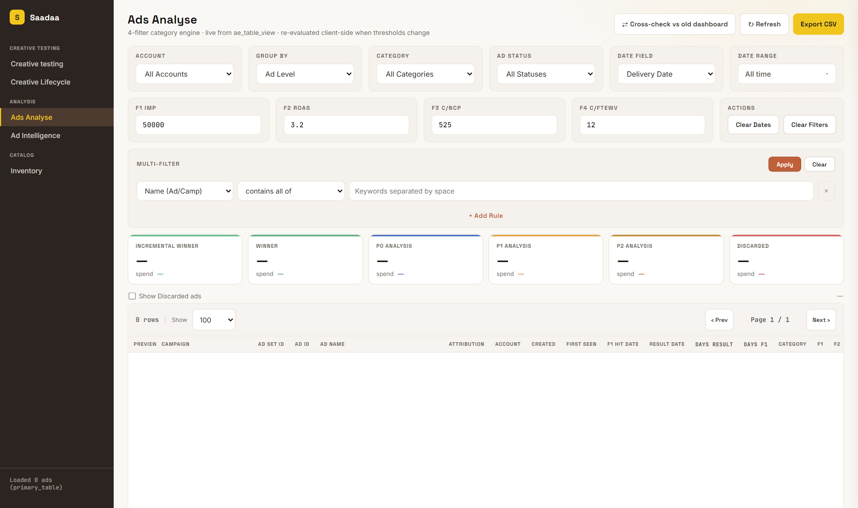
03 ae overview
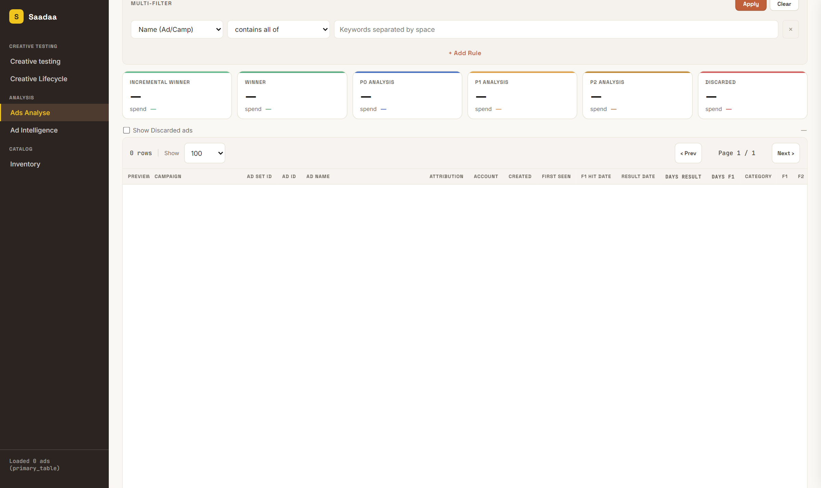
03a ae table
Row-level table with 60+ columns pulled from ae_table_view. Use this when you need a specific column, an ad-level export, or want to cross-check the KPI tiles.
![Ads Analyse — overview](docs/screenshots/ae-overview.png)
Toolbar
Cross-check (#aeBtnCrosscheck) diff DB category vs current-threshold category
Refresh (#aeBtnRefresh) re-fetches ae_table_view (all 15k ads)
Export CSV (#aeBtnExport) exports current filtered slice
Filter grid — row 1
Six controls:
Account (#aeAcct) ad-account dropdown (or All)
Group By (#aeGroupBy) Ad / Ad name / Campaign — aggregation level
Category (#aeCategory) the 6 tiers (or All)
Ad Status (#aeStatus) Active / Paused / Campaign paused / Archived / With issues
Date Field (#aeDateField) which date column the range filter applies to
Date Range (#ae-drp-btn) 9 preset picker
`Date Field` options — crucial to understand, this is the source of most "why do I see 79 ads" confusion:
Delivery (__delivery__) ads that had impressions in the window
(looked up via aeDeliverySet from primary_table)
Ad created ad_created when the ad object was created in Meta
First seen first_seen_date first day the ad reported ANY row
Result date date_of_result when Meta computed the tier verdict
Reporting end reporting_ends last day the ad had reporting data
Default is Delivery — this matches "ads that actually ran on those days" (622 for June 29, 2026, for example). Reporting end filters to ads whose last reporting day was that specific day (much narrower — only 79 for June 29).
Filter grid — row 2
Thresholds and clear buttons:
F1 Imp (#aeF1) default 50,000
F2 ROAS (#aeF2) default 3.2
F3 C/NCP (#aeF3) default 525
F4 C/FTEWV (#aeF4) default 12
Clear Dates (#aeClearDates) resets both date inputs
Clear Filters (#aeClearFilters) resets everything to defaults + Delivery date field
Multi-filter builder
Same pattern as Creative Testing (#aeMfRows). Chainable rules with AND semantics.
Category KPI cards (`#aeCats`)
Six horizontal tiles, each with count + total spend. Clicking a tile pins that category as an active filter (highlight state). Click again to unpin.
Incremental Winner Winner P0 analysis P1 analysis P2 analysis Discarded
An "Options" row underneath includes:
Show Discarded (#aeShowDiscarded) toggle — Discarded is hidden by default
Cross-check (#aeCrossPanel) panel — DB-category vs recomputed-category diff
Main table (`#aeMain`)
Every column is sortable via the header (arrows visible). Pagination strip above and below shows row info + page-size picker (25 / 50 / 100 / 250 / 500 / 1000) + prev/next.
Identity columns
Preview thumbnail from Meta ad-preview API (thumbsByAdId cache)
Campaign campaign_name
Adset ID adset_id
Ad ID ad_id (17-digit Meta ID)
Ad Name ad_name (bold)
Attribution attribution_setting
Account account_name
Lifecycle columns
Created ad_created
First Seen first_seen_date
F1 Hit Date date_target_imp_achieved (first day cumulative impressions ≥ F1)
Result Date date_of_result
Days to Result result_date - first_seen_date
Days to F1 F1_hit_date - first_seen_date
Category the 6-tier badge
F1 / F2 / F3 / F4 individual pass ticks
Ad Status Meta ad_status pill
Delivery columns
Impressions impressions
Reach reach
Incr. Reach latest daily reach - previous daily reach
Cost/Incr Reach latest daily spend / incremental_reach
Reach Weight % reach / global_reach * 100
Frequency impressions / reach
Spend amount_spent
Cost/1k cost_per_1000 (CPM)
CPC Link cpc_link
CTR % ctr_pct
Link Clicks link_clicks_raw
Funnel columns
ATC add_to_cart events
ATC/LC % add_to_cart / link_clicks
CI checkout_initiations
CI/ATC % checkout_initiations / add_to_cart
Checkout % checkout_completion_pct
CR/LC % checkout / link_clicks
Purchases purchases
Conv Value conv_value (Meta-attributed)
ROAS conv_value / spend
Shopify columns
Shopify Orders from ae_shopify_enriched + shopify_ad_agg joins on ad_id
Shopify Sales sum of matched order totals
Cost/quality columns
Cost/FTEWV cost_per_ftewv
FTEWV ftewv_count (first-time engaged video views)
% Reach FTEWV ftewv_count / reach
Cost/NCP cost_per_ncp
NCP ncp_count (new customer purchases)
Efficiency columns (all normalised to global averages)
Profit Eff conv_value - amount_spent
Contrib Margin % (1 - spend/conv_value) * 100
Blended Eff weighted composite: 10% CPR + 25% FTV Contrib + 15% FTEV Vol +
20% NCP Cost + 20% ROAS + 10% Profit Vol
Delivery Eff CPR + FTV Contrib + Cost/FTEWV (delivery quality slice)
Sales-Spend Eff NCP Cost + ROAS (return slice)
CPR Eff cost per reach vs global average (higher = cheaper reach)
FTV Contrib Eff FTEWV rate on reach vs global
FTEV Volume absolute FTEWV vs global median
NCP Cost Eff cost per NCP vs global average
ROAS Eff ROAS vs global average
Profit Vol Eff profit vs global median
Every efficiency column is 1.00 = "same as global average". Higher is better across every metric.
Meta metadata
LTV Reach ltv_reach
LTV Freq ltv_frequency
Engagement engagement_count
Preview link Meta ad preview URL
Ad link destination URL (landing page)

Section 4 — Ad Intelligence
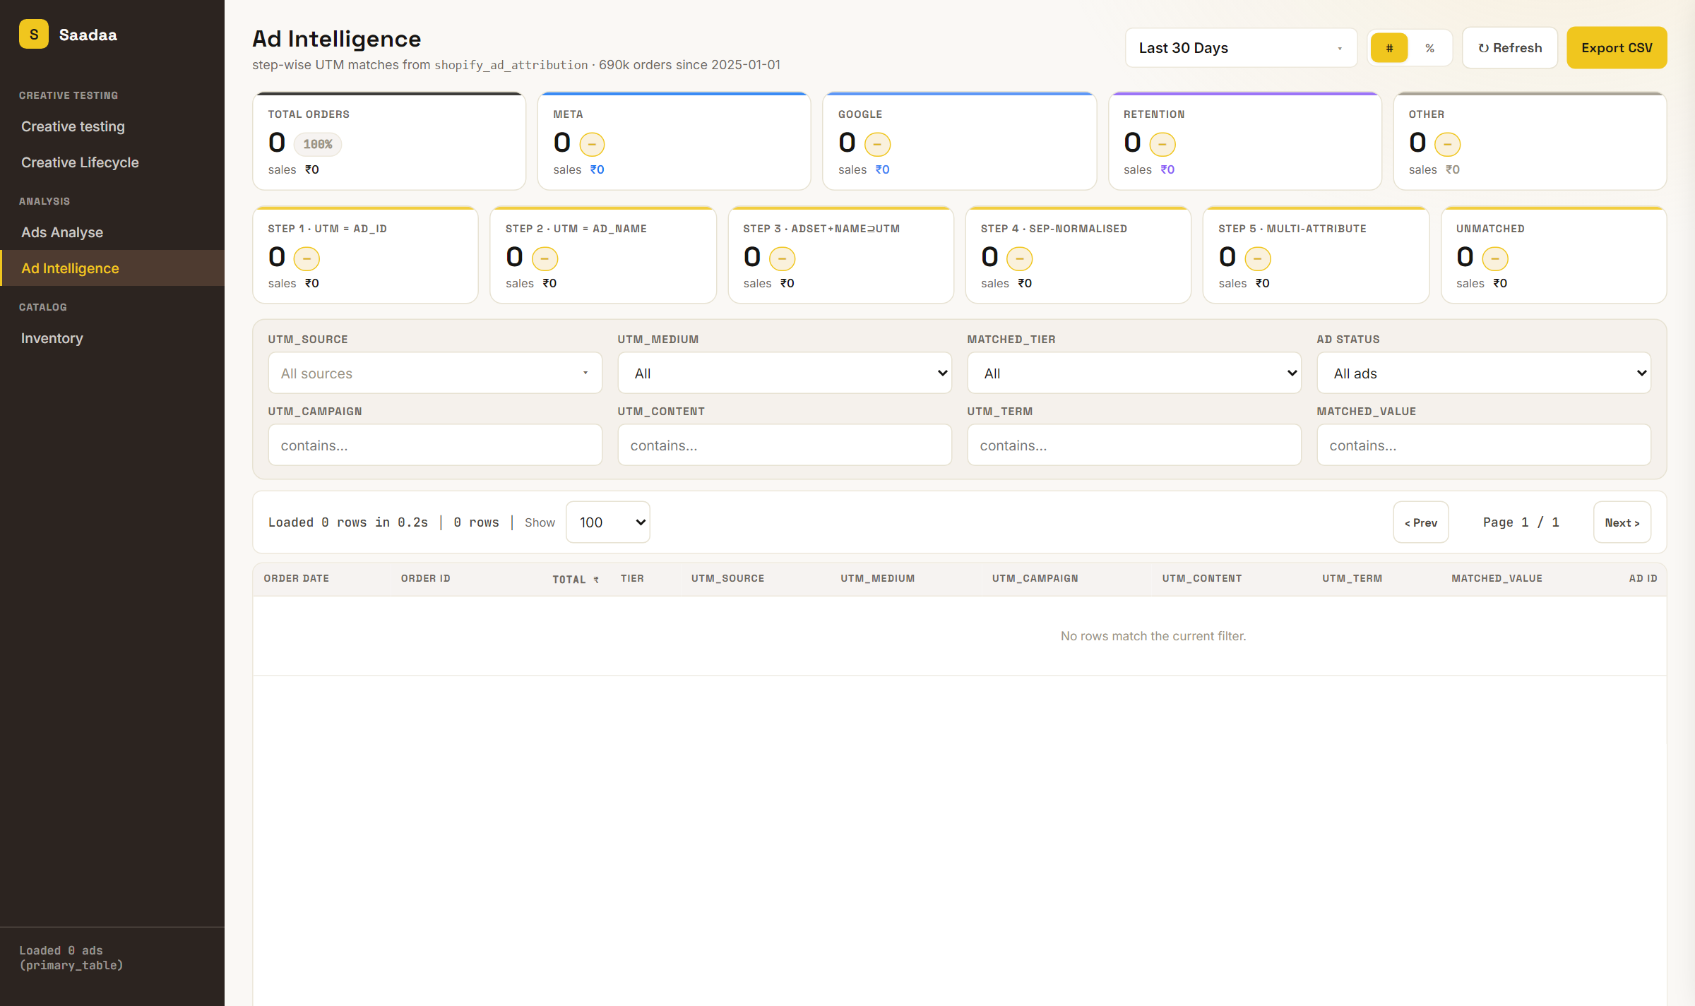
04 adintel overview
Shopify-order-level view. Every row is one Shopify order and shows how it was attributed back to a Meta ad via UTM matching.
![Ad Intelligence — overview](docs/screenshots/adintel-overview.png)
Toolbar
Date Range (#ai-drp-btn) 9 presets (default Last 30 Days)
Display toggle (#aiDisplayToggle) Count (#) or Percentage (%) — swaps KPI display
Refresh (#aiRefresh) re-fetches shopify_ad_attribution
Export CSV (#aiExport) exports current filtered slice
Channel KPI row (`#aiChannelRow`)
Five tiles:
Total Orders everything in the window
Meta utm_source in (meta / facebook / instagram / ig)
Google utm_source in (google / adwords)
Retention utm_source in (email / sms / whatsapp / klaviyo)
Other everything else + no utm_source
Each tile shows count + percentage + sales. Click a tile to open the channel drilldown panel below, which breaks it down by exact utm_source value.
Tier KPI row (`#aiTierCards`)
Six tiles showing which of the 5-step matching rules attributed the order:
Step 1 utm = ad_id strongest match
Step 2 utm = ad_name strong
Step 3 adset_name + ad_name superset medium
Step 4 separator-normalised weak
Step 5 multi-attribute fuzzy weakest
Unmatched no rule fired
Each shows count + percentage + sales.
Filter grid
Eight controls:
utm_source (#aiUtmSourceBtn) multi-select with search, All, None
utm_medium (#aiUtmMedium) dropdown (single)
matched_tier (#aiTierSel) Step 1-5, Any match, Unmatched
Ad status (#aiAdStatus) All / Active only / Inactive only
utm_campaign (#aiUtmCampaign) substring search
utm_content (#aiUtmContent) substring search
utm_term (#aiUtmTerm) substring search
matched_value (#aiMatchedValue) substring search
Main table (`#aiTbl`)
Every column sortable via data-aisort:
Order Date order_created_at (mono, DD-MMM)
Order ID Shopify order name (e.g. #10025)
Total ₹ order total
Tier matched_tier badge (Step 1..5 / Unmatched)
utm_source raw UTM
utm_medium raw UTM
utm_campaign raw UTM
utm_content raw UTM
utm_term raw UTM
matched_value the value the rule matched on (ad_id / ad_name / etc.)
Ad ID matched Meta ad_id (empty if Unmatched)
Ad Name matched ad_name
Campaign matched campaign_name
Ad Status matched Meta ad_status
Pagination strip (#aiPager): row info + page size (50 / 100 / 250 / 500 / 1000) + prev/next.

Section 5 — Inventory
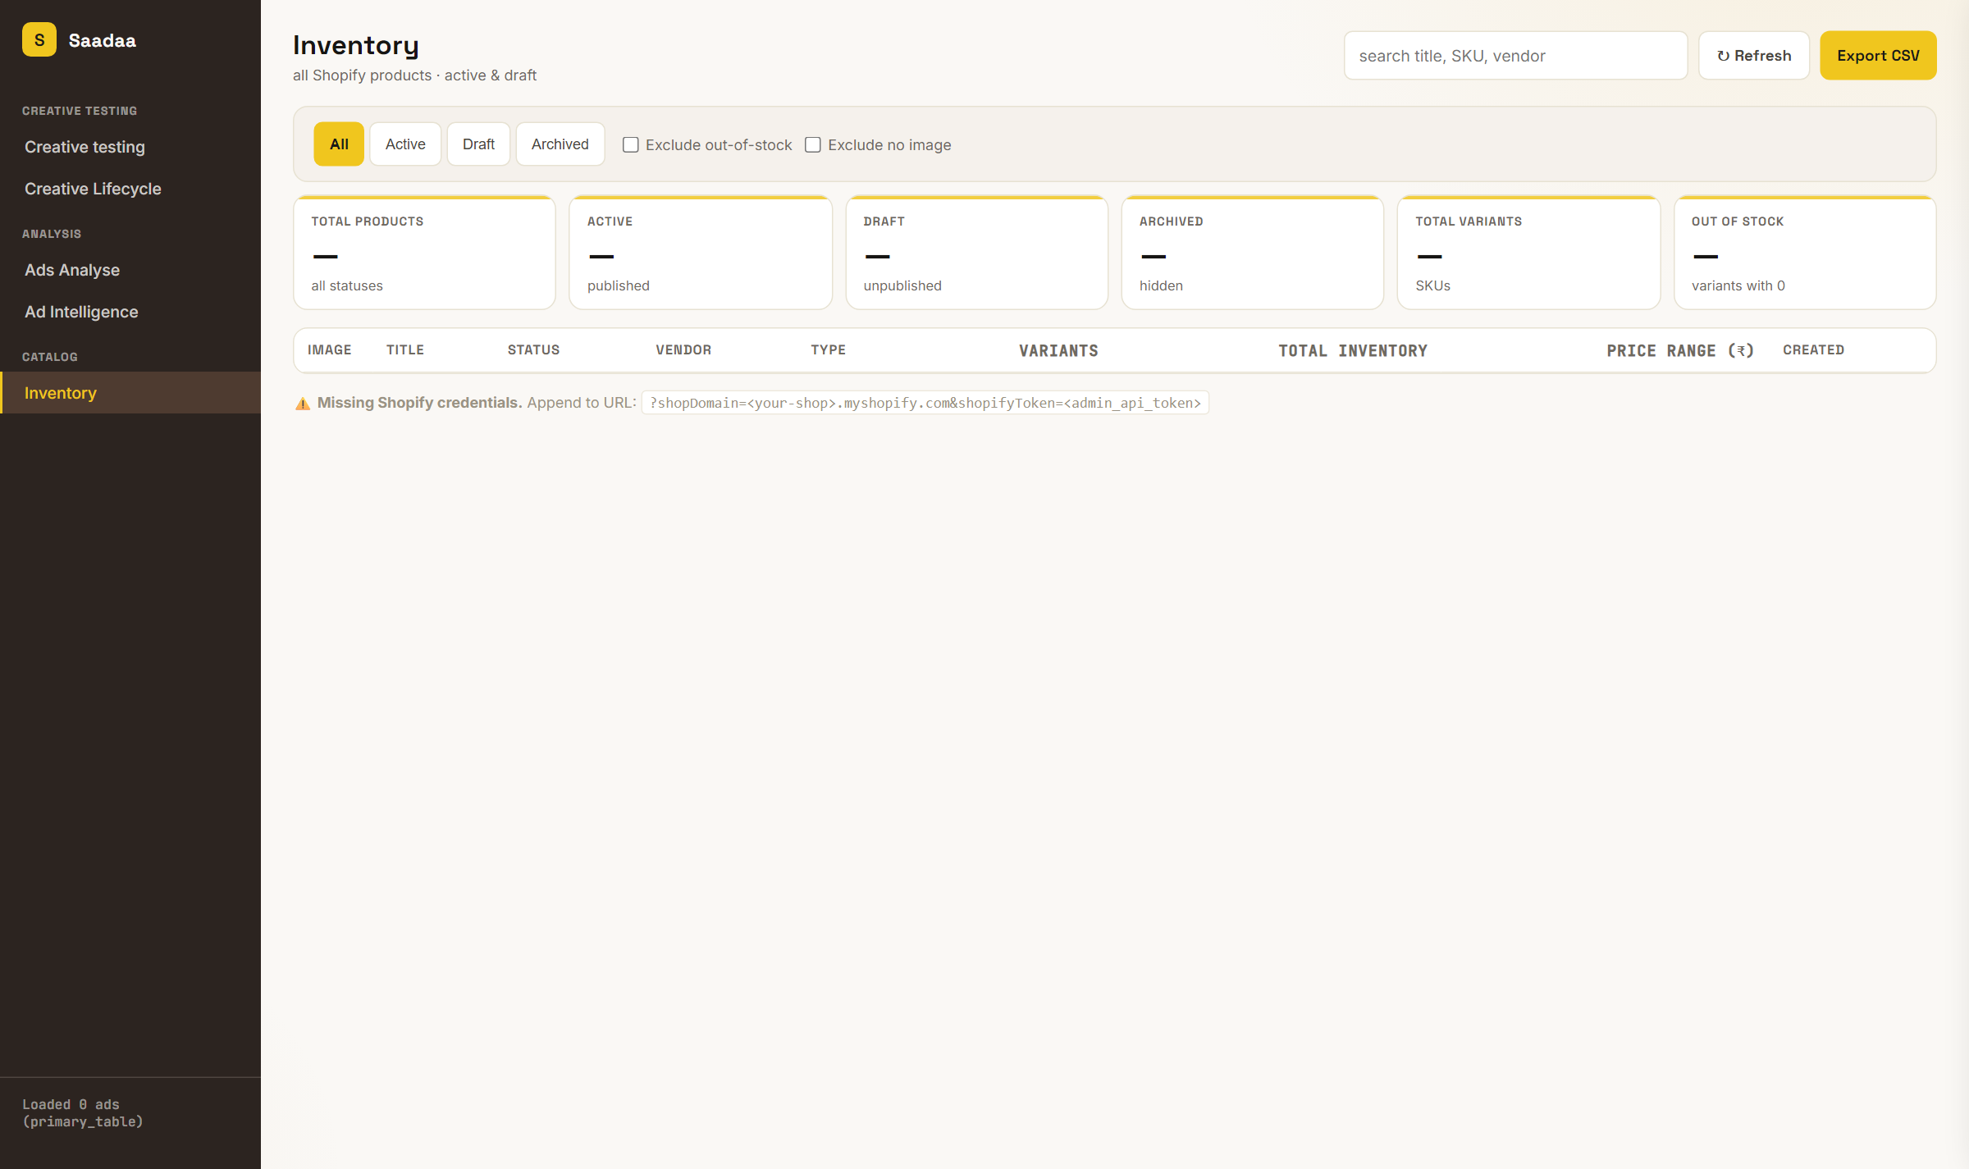
05 inventory overview
Shopify product catalogue with stock levels.
![Inventory — overview](docs/screenshots/inventory-overview.png)
Toolbar
Search (#invSearch) substring — title, SKU, vendor
Refresh (#invRefresh) re-fetches Shopify product catalogue
Export CSV (#invExport) exports current filtered list
Status filter chips (`#invStatusRow`)
All Active Draft Archived
Exclusion toggles
Exclude out-of-stock (#invExcludeOOS)
Exclude no image (#invExcludeNoImg)
KPI tiles (`#invKpis`)
Total products Active Draft Archived Total variants Out of stock
Product table (`#invTbl`)
Column Meaning
Image 48×48 product thumbnail from Shopify CDN
Title product title
Status ACTIVE / DRAFT / ARCHIVED pill
Vendor product.vendor
Type product.productType
Variants count of variants
Total inventory sum of variant inventory quantities
Price range min - max variant price in ₹
Created product.createdAt
Sticky header, hover highlight per row.

Modals and drawers
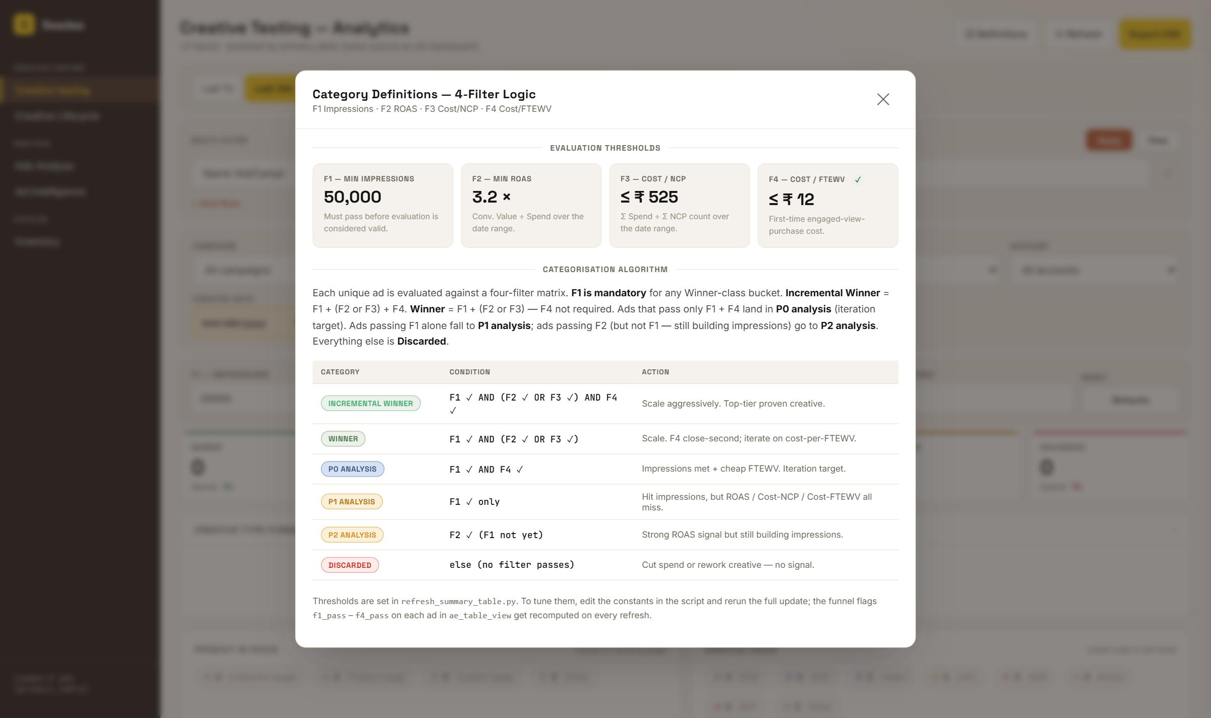
06 definitions modal
Definitions modal (`#defsModal`)
Opens from the Definitions toolbar button in Creative Testing. Explains F1–F4 thresholds and the category algorithm with a worked example table.
Header category name
Threshold grid F1/F2/F3/F4 with default target values
Algorithm prose how the ordering works
Decision table each category: condition, action
Bucket drill modal (`#bucketModal`)
Opens from:
- Any funnel cell (Creative Type × Category intersection)
- Any Product Focus pill
- Any Creative Focus pill
- Any Landing Page Focus row
Contents:
Title "Product in Focus — Collection page" or similar
Sort chips Spend / ROAS / FTEWV / Newest
Limit chips Top 15 / 50 / All
Trend chart Creatives added per week
Spend chart Top-15 spend + ROAS combo
Detail table one row per ad in the selection
Detail table columns
Preview thumbnail
Ad name + URL bold ad_name, muted destination URL beneath (host + path)
Created ad_created
Spend amount_spent
ROAS roas_ma
FTEWV ftewv_count
NCP ncp_count
Shop. orders shopify_orders (looked up from ae_table_view by ad_id)
Status category badge
Links ↗ Landing (destination) + ◈ Preview (Meta preview)
Row click opens the ad drawer. Link chips open the raw URL in a new tab (click doesn't propagate).
![Bucket drill modal](docs/screenshots/bucket-drill.png)
Category performers modal (`#modal`)
Opens by clicking any KPI tile in Creative Testing. Shows the top N ads for that category:
Top-N chips 10 / 20 / 50
Metric chips Spend / ROAS / FTEWV / NCP (any combination)
Bar chart top-N by selected metric
Detail table Preview, Ad, Spend, ROAS, FTEWV, NCP, Shopify orders, Status
Ad drawer (`#drawer`)
Right-slide panel. Opens from a row click in any drill table.
Header ad_name + campaign_name subtitle
Metrics grid 2-column dense grid: impressions, reach, freq, spend, ROAS,
cost per FTEWV, cost per NCP, category, etc.
Preview section Meta ad preview URL button + rendered thumbnail;
fallback to Ads Library link if no thumbnail is cached

Data pipeline — where the numbers come from
Every number in the dashboard resolves back to one of these views/tables:
Table / View Purpose
primary_table daily raw Meta insights, last 6-9 months
backfill_table daily raw Meta insights, from launch (full history)
ae_raw_view union of primary + backfill + computed pass flags
ae_table_view ae_raw_view + Shopify joins + efficiency columns + category
ae_reach_recent per-ad latest daily reach + incremental delta
ae_freq_lifecycle_mat per-ad crossing dates for 1×/1.5×/2×/2.5×/3×
ae_freq_lifecycle thin view pointing at the mat table (frontend URL)
summary_table per-ad lifetime aggregates, refreshed by refresh_summary_table.py
results_table per-window aggregate cache (results_sync.py)
shopify_ad_attribution one row per Shopify order + matched Meta ad (5-step rule)
shopify_ad_agg per-ad aggregate of matched Shopify orders
ae_shopify_enriched per-ad Shopify metrics + tier
Pipeline order (backend/full_run.py):
1. primary_sync.py daily fetch yesterday's Meta insights
2. propagate_primary_to_backfill mirror primary into backfill
3. apply_ctp_unique_ids deduplicate CTP variant ad IDs
4. refresh_ae_table rebuild ae_raw_view, ae_table_view, ae_reach_recent
5. refresh_summary_table rebuild summary_table
6. result_classifier re-tag verdicts on new ads
7. results_sync rebuild results_table cache
8. rebuild_attribution_orders rebuild shopify_ad_attribution (5-step matching)
Typical full run is ~45 min end-to-end.

FAQ and troubleshooting
Q: I see a completely blank/frozen dashboard, no sections open. Almost always a JavaScript parse error. Open browser DevTools console. Look for a SyntaxError — usually a duplicate const in the same scope. Fix, hard-refresh (Ctrl+F5).
Q: A section shows zero data even though the KPI tiles look right. That section's data source failed silently. Common cause: PostgREST statement timeout on a slow view. Check DevTools → Network tab for a 504 response. Solution: materialise the view (see ae_freq_lifecycle_mat for the pattern).
Q: Why do I see 79 ads instead of 622 for a specific date? Your Date Field in Ads Analyse is set to Reporting End. That filters ads whose last reporting day was that specific day — a much narrower set. Change to Delivery to see "every ad that ran that day".
Q: The `Total lifetime spend` tile says ₹36,88,11,570. Is this correct? Yes — this is SUM(amount_spent) from ae_table_view and matches the raw backfill_table lifetime sum to the paise. Every rupee ever billed on Meta across the three ad accounts since day one.
Q: The Shopify orders column shows `—` in a drill table. Fixed as of c02c1d9 — the drill now looks up shopify_orders from ae_table_view by ad_id. If it still shows —, hard-refresh to bypass the browser cache.
Q: Meta ad status changed, but the dashboard still shows the old one. Meta status is baked into ae_table_view at the last pipeline run. Hit the toolbar Refresh button; the whole ad list re-fetches. If it's still stale, the pipeline itself hasn't run — check backend/full_run.log for the last run timestamp.
Q: I want to change the category thresholds temporarily. Edit the F1/F2/F3/F4 fields in the toolbar. Ads recategorise live in the browser — no DB writes. To make it permanent, edit aeCategorise() in index_v2.html, and the CASE statement in ae_table_view (via a migration) so the DB-side categorisation matches.
Q: I want to see how an ad's category was computed. Open the ad drawer (row click). The F1..F4 pass flags are shown individually. In Ads Analyse, the F1 / F2 / F3 / F4 columns show individual ticks. The Category column is the ordered rule result.

_Last updated 2026-07-02 — matches commit 22e3d1e (URL preview under ad name)._

