PROJECT 20 OF 21 • 11.A — GROUP 5 • AI PROJECT (ARDUINO) – 20 MARKS
Hearing Range Tester
Sweeps from a low hum to a high whine and finds where your hearing stops

BUILT IN CLASS, WITH REAL PARTS. First build and test it in Tinkercad (checkpoint marks), then assemble the real Arduino, components and wiring in the ICT lesson. Bring this sheet to every lesson – printed, or saved as pictures/PDF on your iPad.
PURPOSE – WHY THIS PROJECT EXISTS
What it does | Turning the knob sweeps the buzzer from a low hum up towards a high whine. The 7-segment shows which frequency band you are on, from 0 to 9. When the listener can no longer hear the tone, they press the button and the display holds their band. The green LED marks the best band reached so far.
UAE link | Noise-induced hearing loss on worksites, and headphone habits in teenagers
Why it matters | Hearing loss is the most common permanent injury on construction and industrial sites, and it is completely invisible until it is permanent. It also runs the other way: young people lose the top of their range early from loud headphones, and they never notice, because you cannot miss a sound you have stopped hearing. This tester makes an invisible loss audible in one minute. Be honest at the booth about what it is not: a small piezo buzzer is weak at high frequencies and a classroom is not a sound booth, so this demonstrates the principle and screens for a difference — it does not diagnose anybody.
Who it helps | Students and parents — early awareness of hearing damage from loud headphones.
The science | tone(pin, frequency) generates a square wave. Human hearing runs roughly 20 Hz to 20 kHz when young, and the top end falls with age and exposure.
COMPONENTS YOU NEED
Component | Qty
Arduino UNO R3 + USB cable | 1
400-point breadboard | 1
Potentiometer 10k | 1
1-digit 7-segment (common cathode) | 1
Push button | 1
LED | 2
Passive buzzer | 1
220Ω resistors (red-red-brown) | 9
Jumper wires (male-male) | about 20
WIRING DIAGRAM – EVERY PIN, EVERY WIRE
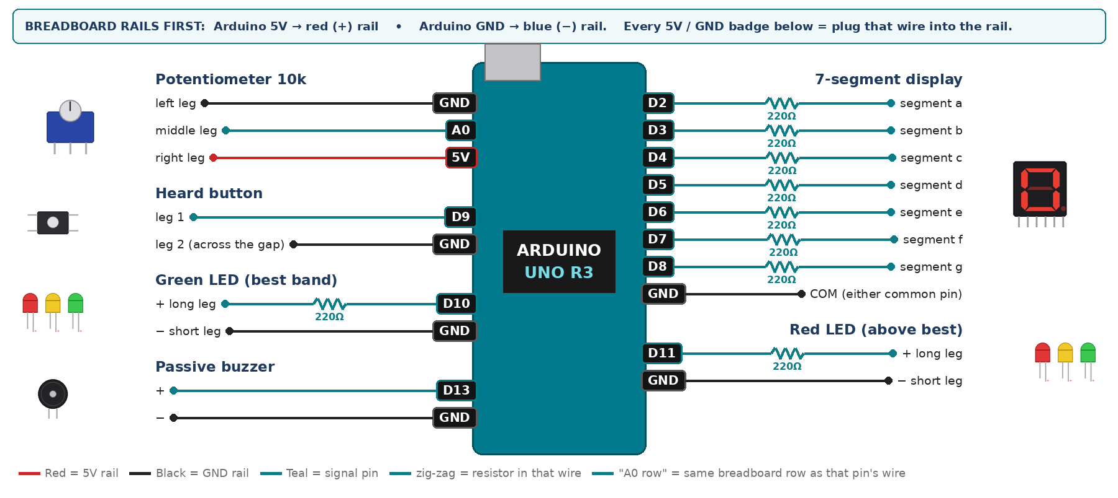
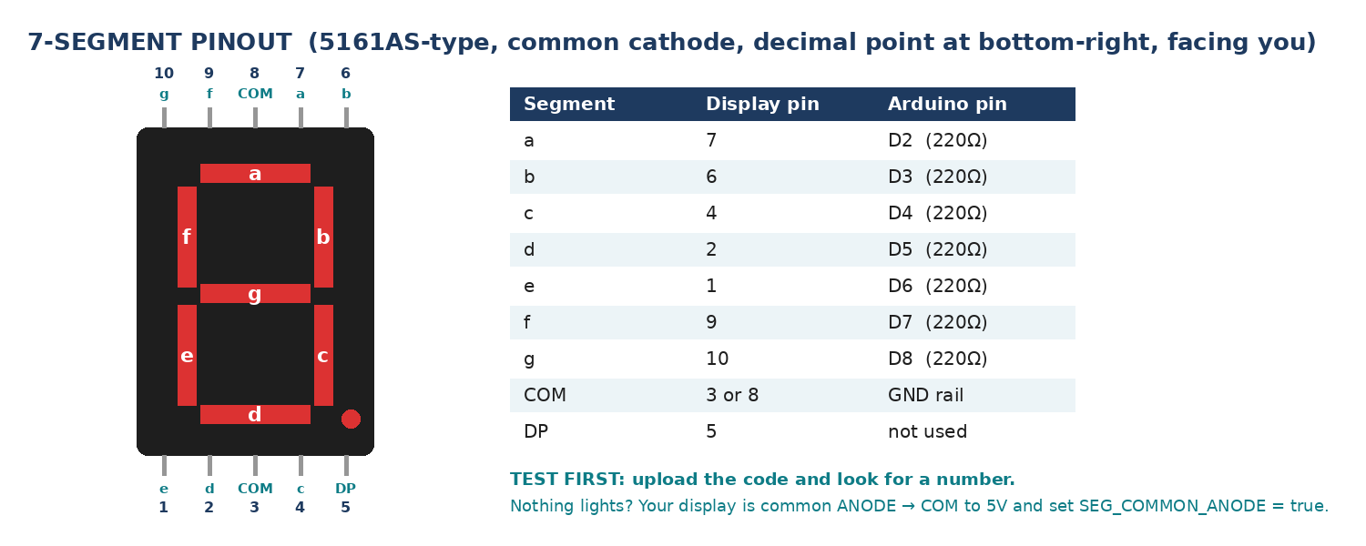
WIRING TABLE – TICK EACH WIRE AS YOU PLACE IT
Component | Component pin | Goes to | Resistor | Note | ✓
Potentiometer 10k | left leg | GND rail | — |  | ☐
Potentiometer 10k | middle leg | A0 | — | frequency knob | ☐
Potentiometer 10k | right leg | 5V rail | — |  | ☐
7-segment display | segment a | D2 | 220Ω |  | ☐
7-segment display | segment b | D3 | 220Ω |  | ☐
7-segment display | segment c | D4 | 220Ω |  | ☐
7-segment display | segment d | D5 | 220Ω |  | ☐
7-segment display | segment e | D6 | 220Ω |  | ☐
7-segment display | segment f | D7 | 220Ω |  | ☐
7-segment display | segment g | D8 | 220Ω |  | ☐
7-segment display | COM (either common pin) | GND rail | — | common cathode | ☐
Heard button | leg 1 | D9 | — | INPUT_PULLUP | ☐
Heard button | leg 2 (across the gap) | GND rail | — |  | ☐
Green LED (best band) | + long leg | D10 | 220Ω |  | ☐
Green LED (best band) | − short leg | GND rail | — |  | ☐
Red LED (above best) | + long leg | D11 | 220Ω |  | ☐
Red LED (above best) | − short leg | GND rail | — |  | ☐
Passive buzzer | + | D13 | — | tone() | ☐
Passive buzzer | − | GND rail | — |  | ☐
BUILD ORDER – USB UNPLUGGED UNTIL STEP 7
- Connect Arduino 5V to the red (+) rail and GND to the blue (−) rail of the breadboard.
- Wire the potentiometer and print analogRead(A0) — it must sweep 0 to 1023 smoothly.
- Add the passive buzzer and test a fixed tone(BUZZ, 440) before mapping anything.
- Wire and test the 7-segment, then map the knob to a frequency and to a band number.
- Add the button and the two LEDs, then run the test on five people and record every result.
- Check every wire against the table with a partner, THEN plug in the USB. The green ON light must come on – if not, unplug at once (short circuit).
- Arduino IDE: Tools › Board › Arduino Uno, then Tools › Port.
- Paste the code below, press Upload, open Tools › Serial Monitor at 9600 baud and watch your own readings.
STEP 1 – TINKERCAD FIRST (CHECKPOINT MARKS)
Go to www.tinkercad.com › Circuits › Create new Circuit. Build the same wiring, paste the same code, press Start Simulation. Parts that Tinkercad does not have:
- Passive buzzer → use a Piezo (same code, tone() works).
- 7-segment → '7 Segment Display', set it to Cathode in the inspector.
Save it with the name 11.A G5 – Hearing Range Tester and share the link with your teacher. The REAL build in class is your AI Project.
HOW THE CODE THINKS
- read the knob and map it to a frequency between 200 Hz and 12000 Hz
- map the same reading to a band number 0 to 9 and show it
- play that frequency continuously on the passive buzzer
- if the listener presses the button, record this band as the best heard so far
- green LED while the current band is at or below the best heard, red LED above it
THE COMPLETE CODE (TESTED)
Yellow lines = numbers YOU must change after measuring with your own sensor. Every member must be able to explain at least one line.
/* PROJECT 20 - HEARING RANGE TESTER (11.A Group 5)
Turn the knob slowly upward: the tone rises from 200 Hz to 12 000 Hz.
Press HEARD while you can still hear it. Display = band 0-9.
GREEN = inside your best heard band, RED = above it.
SAFETY: keep the buzzer at arm's length - never against the ear. */
const int POT = A0; // frequency knob (middle leg)
const int HEARD = 9; // button (other leg to GND)
const int GRN = 10, REDL = 11; // LEDs (each through 220 ohm)
const int BUZZ = 13; // PASSIVE buzzer (tone)

const long F_LOW = 200; // Hz at the bottom of the knob
const long F_HIGH = 12000; // Hz at the top of the knob

int bestBand = -1, lastBtn = HIGH;
long lastFreq = 0;
unsigned long lastPrint = 0;

// ---------- 7-SEGMENT DISPLAY (pins a,b,c,d,e,f,g) ----------
const int SEG[7] = {2, 3, 4, 5, 6, 7, 8};
const bool SEG_COMMON_ANODE = false; // true = common pin goes to 5V instead of GND
const byte DIGIT[10][7] = {
{1,1,1,1,1,1,0}, {0,1,1,0,0,0,0}, {1,1,0,1,1,0,1}, {1,1,1,1,0,0,1},
{0,1,1,0,0,1,1}, {1,0,1,1,0,1,1}, {1,0,1,1,1,1,1}, {1,1,1,0,0,0,0},
{1,1,1,1,1,1,1}, {1,1,1,1,0,1,1} };

void show(int n) { // show one number 0-9
n = constrain(n, 0, 9);
for (int i = 0; i < 7; i++) {
bool on = DIGIT[n][i];
digitalWrite(SEG[i], SEG_COMMON_ANODE ? !on : on);
}
}
// True ONCE at the moment a button goes from up (HIGH) to pressed (LOW).
// Holding the button down does NOT repeat it.
bool justPressed(int pin, int &lastState) {
int now = digitalRead(pin);
bool pressed = (lastState == HIGH && now == LOW);
lastState = now;
if (pressed) delay(25); // ignore contact bounce
return pressed;
}

void setup() {
Serial.begin(9600);
for (int i = 0; i < 7; i++) pinMode(SEG[i], OUTPUT);
pinMode(HEARD, INPUT_PULLUP);
pinMode(GRN, OUTPUT); pinMode(REDL, OUTPUT);
pinMode(BUZZ, OUTPUT);
}

void loop() {
long sum = 0;
for (int i = 0; i < 8; i++) sum += analogRead(POT); // smooth the knob
int knob = sum / 8;
long freq = map(knob, 0, 1023, F_LOW, F_HIGH);
int band = map(knob, 0, 1023, 0, 9);

if (abs(freq - lastFreq) > 20) { tone(BUZZ, freq); lastFreq = freq; } // only retune on change
show(band);

if (justPressed(HEARD, lastBtn)) {
if (band > bestBand) bestBand = band;
Serial.print("HEARD at band "); Serial.print(band);
Serial.print(" ("); Serial.print(freq); Serial.println(" Hz)");
}

digitalWrite(GRN, bestBand >= 0 && band <= bestBand);
digitalWrite(REDL, bestBand >= 0 && band > bestBand);

if (millis() - lastPrint >= 300) {
lastPrint = millis();
Serial.print("freq="); Serial.print(freq);
Serial.print(" band="); Serial.print(band);
Serial.print(" best="); Serial.println(bestBand);
}
}
TEST IT AND RECORD YOUR READINGS
- Test five people of different ages, recording the highest band each one confirms. Plot band against age.
- Test the same person twice, five minutes apart, and report how much the result moved — that is your repeatability.
- Test once in a quiet room and once with the class talking, and report the difference.
Test # | What we did | Reading / value | What happened
1
2
3
4
5
IF IT DOES NOT WORK
- No sound at all: that is the ACTIVE buzzer. tone() needs the PASSIVE one.
- The tone goes quiet near the top of the knob even for young ears — a small piezo is genuinely weak above about 8 kHz. Report this as a limitation of your instrument, not of the listener.
- The display flickers between two bands: the knob sits exactly on a boundary. Average several readings before mapping.
- 7-segment shows the wrong shapes: one segment wire is in the wrong pin — check a→D2 … g→D8 against the pinout picture.
- Button does nothing: it is not straddling the centre gap, or both wires are on legs that are already joined. Use legs on OPPOSITE sides of the gap.
AT THE STEM WEEK TABLE
Use headphones so the booth stays usable. Keep a chart of band number against frequency on the table so visitors can see the actual hertz value they stopped at.
CHALLENGE: Sweep automatically from band 0 upward on a timer and record the band at the moment the button is pressed, so the listener never sees the number in advance and cannot guess.
BUILD A COVER FOR YOUR PROJECT (NOTE)
Make a cover or case that suits your project design, using cardboard or materials from stationery (card, coloured paper, tape, glue, markers). Idea: a headphone- or ear-shaped cardboard panel with the knob and button on the side.
Keep the USB port, the sensor and any buttons or knobs easy to reach. Never cover the Arduino so tightly that wires are pulled.
PROJECT POSTER (SUPPORT – 4 MARKS)
Make one clear poster (A3 paper or Canva) for the STEM Week table. It must show:
- Project name and the school, your names, class and group.
- The problem in the UAE and who it helps.
- How it works in 3 steps: sensor → Arduino decides → output.
- A photo of your real wiring and of the finished project with its cover.
- Your test results (a small table or chart) and one improvement you made.
AI LOG – PROMPTS, EXAMPLES AND DATA (CORE – 4 MARKS)
Use an AI tool (ChatGPT, Claude, Gemini or Z.ai) to help you understand and improve your project, and record EVERY prompt you use. Example prompts:
- Explain line by line what the loop() does in this Arduino sketch for a "Hearing Range Tester": [paste the code]
- My sensor gives ___ in one condition and ___ in the other. Which numbers should I put in the CALIBRATE lines and why?
- Suggest one improvement for our "Hearing Range Tester" that we can test in one lesson.
AI tool | Prompt we typed | What the AI answered (short) | What we used / changed
PROJECT VIDEO – EXPLAIN THE AI PROCESS AND RESULTS (4 MARKS)
Every group – or each student – records a 1–2 minute video in class. Include:
- Who you are (names, class, group) and the problem your project solves in the UAE.
- How it works: show the real wiring and explain one sensor and one part of the code.
- The AI process: which AI tool you used, one prompt you typed and what you changed because of it.
- Your results: a live demo and your test readings – before and after your improvement.
- One thing you learned.
HOW YOUR PROJECT IS MARKED – 20 MARKS
Criterion | What you must do | For your Arduino project | Marks
Support | Choose an idea and create a clear project poster. | Your project is chosen for you – make a clear A3 / Canva poster: name, problem, how it works, wiring photo, team names. | 4
Core | Use an AI tool and document the required prompts, examples, or data. | Use an AI tool (ChatGPT, Claude, Gemini, Z.ai) to understand, test or improve your code and plan your calibration. Copy your prompts and your sensor data into the AI LOG. | 4
Advanced | Build, test, and improve the project using evidence. | Build the real circuit, test it, record readings, improve it – and show before / after evidence. | 4
Video | Explain the AI process and results in a short video. | 1–2 minute video: how it works, how AI helped you (your prompts) and what your test results show. | 4
On time | Submit the complete project on time. | Poster, AI log, readings table, video and the working project – all ready by Friday 30 October. | 4
TOTAL |  |  | 20
Deadline: submit the complete project – poster, AI log, readings, video and working build – by Friday 30 October (end of Week 9).

