PROJECT 21 OF 21 • 11.A — GROUP 6 • AI PROJECT (ARDUINO) – 20 MARKS
Well Water Salinity Tester
Tells a farmer whether the well water will feed the crop or kill it

BUILT IN CLASS, WITH REAL PARTS. First build and test it in Tinkercad (checkpoint marks), then assemble the real Arduino, components and wiring in the ICT lesson. Bring this sheet to every lesson – printed, or saved as pictures/PDF on your iPad.
PURPOSE – WHY THIS PROJECT EXISTS
What it does | The two-pin probe sits in a water sample and measures how well it conducts. The 7-segment shows a salinity band from 0 (clean) to 9 (heavily saline), a knob sets the limit the crop can tolerate, and past that limit the red LED and buzzer warn that the water is unsafe to irrigate with.
UAE link | Rising groundwater salinity — the biggest threat to farming in the Emirates
Why it matters | Groundwater under the Emirates has been getting saltier for decades, because more is pumped out than rain puts back and seawater moves in behind it. A farmer cannot see the difference between good well water and water that will slowly poison the soil — the damage shows up in the crop weeks later, by which time the field is already harmed. The knob matters because tolerance is not one number: date palms take far more salt than tomatoes do. This is the one project in the pack where your class produces a real calibration curve from known samples, which is exactly what a laboratory does.
Who it helps | Farmers in inland areas who irrigate with groundwater that can be salty.
The science | Dissolved salt turns water into an electrolyte, so conductivity rises with concentration. Mix known amounts of salt into measured water and you can plot reading against concentration — a genuine calibration curve.
COMPONENTS YOU NEED
Component | Qty
Arduino UNO R3 + USB cable | 1
400-point breadboard | 1
Soil moisture probe + module | 1
Potentiometer 10k | 1
1-digit 7-segment (common cathode) | 1
LED | 2
Active buzzer | 1
220Ω resistors (red-red-brown) | 9
Jumper wires (male-male) | about 20
Male-FEMALE jumper wires (for modules) | 3
WIRING DIAGRAM – EVERY PIN, EVERY WIRE
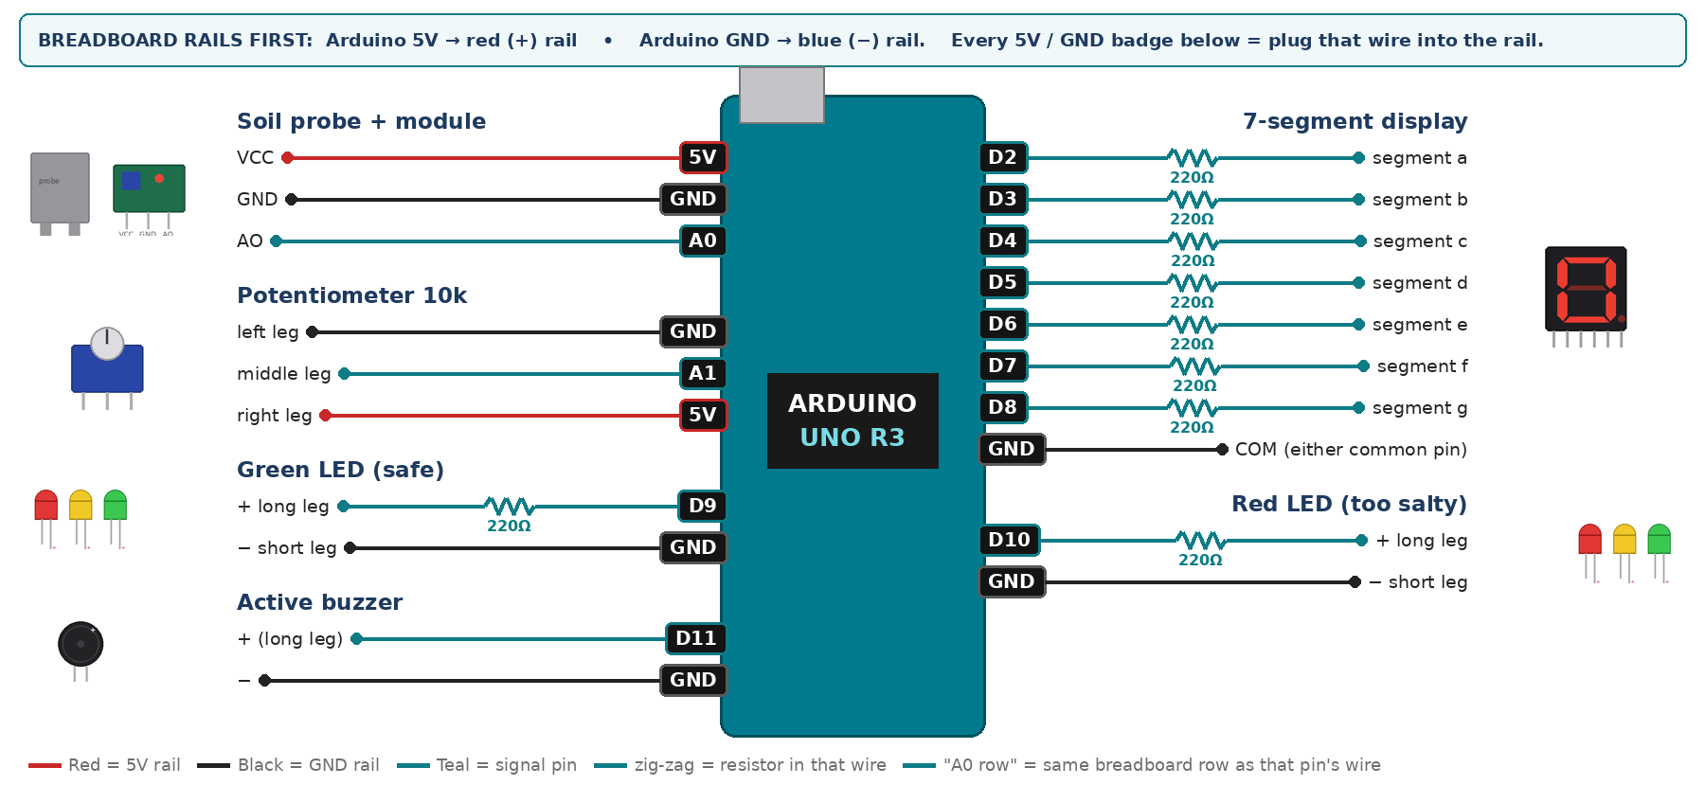
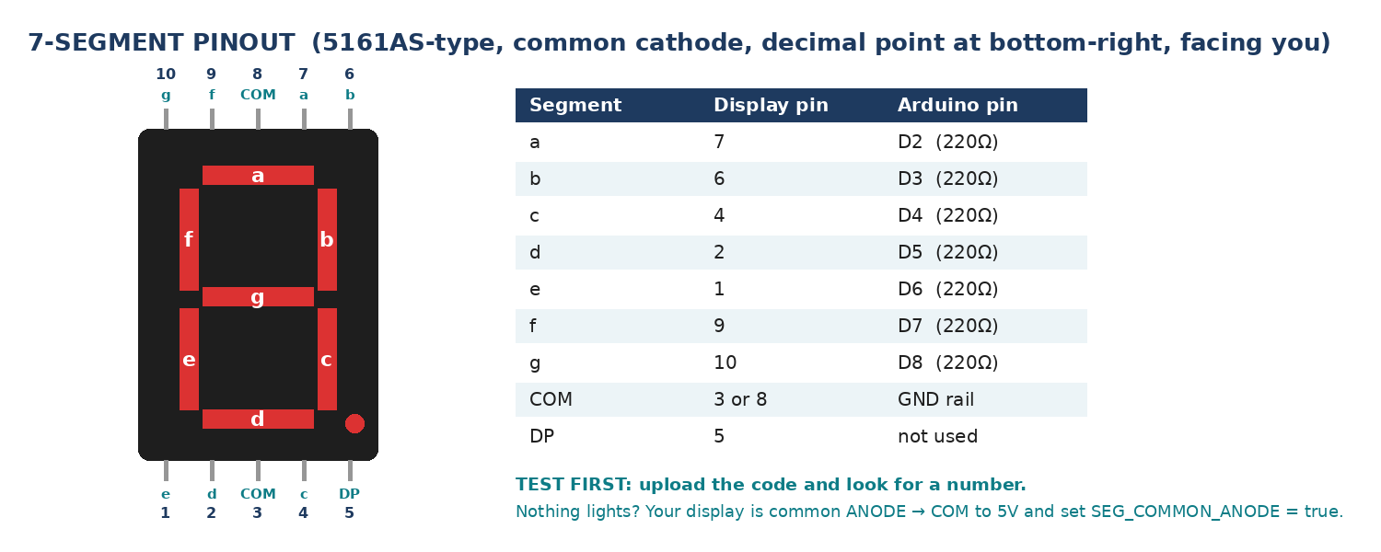
WIRING TABLE – TICK EACH WIRE AS YOU PLACE IT
Component | Component pin | Goes to | Resistor | Note | ✓
Soil probe + module | VCC | 5V rail | — |  | ☐
Soil probe + module | GND | GND rail | — |  | ☐
Soil probe + module | AO | A0 | — | analog | ☐
Potentiometer 10k | left leg | GND rail | — |  | ☐
Potentiometer 10k | middle leg | A1 | — | crop tolerance | ☐
Potentiometer 10k | right leg | 5V rail | — |  | ☐
7-segment display | segment a | D2 | 220Ω |  | ☐
7-segment display | segment b | D3 | 220Ω |  | ☐
7-segment display | segment c | D4 | 220Ω |  | ☐
7-segment display | segment d | D5 | 220Ω |  | ☐
7-segment display | segment e | D6 | 220Ω |  | ☐
7-segment display | segment f | D7 | 220Ω |  | ☐
7-segment display | segment g | D8 | 220Ω |  | ☐
7-segment display | COM (either common pin) | GND rail | — | common cathode | ☐
Green LED (safe) | + long leg | D9 | 220Ω |  | ☐
Green LED (safe) | − short leg | GND rail | — |  | ☐
Red LED (too salty) | + long leg | D10 | 220Ω |  | ☐
Red LED (too salty) | − short leg | GND rail | — |  | ☐
Active buzzer | + (long leg) | D11 | — |  | ☐
Active buzzer | − | GND rail | — |  | ☐
BUILD ORDER – USB UNPLUGGED UNTIL STEP 7
- Connect Arduino 5V to the red (+) rail and GND to the blue (−) rail of the breadboard.
- Wire the probe and print the raw reading with the probe in the air — that is your zero.
- Make five cups: pure water, then a quarter, a half, three quarters and a full spoon of salt in the same volume. Record the raw reading in each. Insert the probe to the SAME depth every time.
- Plot reading against salt added. That graph is your calibration and it goes on the poster.
- Add the knob, the display, the LEDs and the buzzer, and put your own two end readings into the map().
- Check every wire against the table with a partner, THEN plug in the USB. The green ON light must come on – if not, unplug at once (short circuit).
- Arduino IDE: Tools › Board › Arduino Uno, then Tools › Port.
- Paste the code below, press Upload, open Tools › Serial Monitor at 9600 baud and watch your own readings.
STEP 1 – TINKERCAD FIRST (CHECKPOINT MARKS)
Go to www.tinkercad.com › Circuits › Create new Circuit. Build the same wiring, paste the same code, press Start Simulation. Parts that Tinkercad does not have:
- Soil probe → use Tinkercad's Soil Moisture Sensor, or a Potentiometer on the same pin.
- Active buzzer → use an LED + 220Ω in its place so you can SEE every beep (no code change).
- 7-segment → '7 Segment Display', set it to Cathode in the inspector.
Save it with the name 11.A G6 – Well Water Salinity Tester and share the link with your teacher. The REAL build in class is your AI Project.
HOW THE CODE THINKS
- read the probe on A0
- map the reading onto a salinity band 0 to 9 using YOUR calibration end points
- read the knob on A1 and map it to a crop tolerance 0 to 9
- show the salinity band on the display
- band above the tolerance → red LED and a warning beep, otherwise green
THE COMPLETE CODE (TESTED)
Yellow lines = numbers YOU must change after measuring with your own sensor. Every member must be able to explain at least one line.
/* PROJECT 21 - WELL WATER SALINITY TESTER (11.A Group 6)
The soil probe is used as a conductivity cell: salty water conducts better.
Salinity 0 (fresh) to 9 (your saltiest cup) on the display. The knob sets
what the crop can tolerate: saltier than the knob = RED + beep. */
const int PROBE = A0, KNOB = A1;
const int GRN = 9, REDL = 10; // LEDs (each through 220 ohm)
const int BUZZ = 11; // ACTIVE buzzer

// ---- CALIBRATE from your own cups (Serial Monitor) ----
// With most kit modules the number goes DOWN as water gets saltier.
// Just type YOUR two numbers: map() works in either direction.
const int CLEAN_READING = 750; // probe in tap / bottled water
const int SALTY_READING = 200; // probe in your saltiest cup

unsigned long lastBeep = 0;

// ---------- 7-SEGMENT DISPLAY (pins a,b,c,d,e,f,g) ----------
const int SEG[7] = {2, 3, 4, 5, 6, 7, 8};
const bool SEG_COMMON_ANODE = false; // true = common pin goes to 5V instead of GND
const byte DIGIT[10][7] = {
{1,1,1,1,1,1,0}, {0,1,1,0,0,0,0}, {1,1,0,1,1,0,1}, {1,1,1,1,0,0,1},
{0,1,1,0,0,1,1}, {1,0,1,1,0,1,1}, {1,0,1,1,1,1,1}, {1,1,1,0,0,0,0},
{1,1,1,1,1,1,1}, {1,1,1,1,0,1,1} };

void show(int n) { // show one number 0-9
n = constrain(n, 0, 9);
for (int i = 0; i < 7; i++) {
bool on = DIGIT[n][i];
digitalWrite(SEG[i], SEG_COMMON_ANODE ? !on : on);
}
}

int readProbe() {
long s = 0;
for (int i = 0; i < 10; i++) { s += analogRead(PROBE); delay(2); }
return s / 10;
}

void setup() {
Serial.begin(9600);
for (int i = 0; i < 7; i++) pinMode(SEG[i], OUTPUT);
pinMode(GRN, OUTPUT); pinMode(REDL, OUTPUT); pinMode(BUZZ, OUTPUT);
}

void loop() {
int raw = readProbe();
int salinity = constrain(map(raw, CLEAN_READING, SALTY_READING, 0, 9), 0, 9);
int tolerance = map(analogRead(KNOB), 0, 1023, 0, 9);
show(salinity);

bool tooSalty = (salinity > tolerance);
digitalWrite(REDL, tooSalty);
digitalWrite(GRN, !tooSalty);
if (tooSalty && millis() - lastBeep >= 1000) lastBeep = millis();
digitalWrite(BUZZ, (tooSalty && millis() - lastBeep < 150) ? HIGH : LOW);

Serial.print("raw="); Serial.print(raw);
Serial.print(" salinity="); Serial.print(salinity);
Serial.print(" crop limit="); Serial.println(tolerance);
delay(100);
}
TEST IT AND RECORD YOUR READINGS
- Read each of your five known cups three times and record every value. How repeatable is it?
- Test tap water, bottled water and salt water. Rank them and see whether the ranking matches what you expected.
- Rinse and dry the probe between samples, then repeat one sample. Does carry-over change the reading?
Test # | What we did | Reading / value | What happened
1
2
3
4
5
IF IT DOES NOT WORK
- Every cup reads the same: the probe is not going in to the same depth, or not deep enough to cover both pins.
- The reading drifts upward while the probe sits in one cup: that is electrolysis on the pins. Take a reading, lift the probe out, and say so in your pitch — it is the reason laboratory meters use AC, not DC.
- The band runs backwards: CLEAN_READING and SALTY_READING are swapped.
- 7-segment shows the wrong shapes: one segment wire is in the wrong pin — check a→D2 … g→D8 against the pinout picture.
AT THE STEM WEEK TABLE
Line up your five labelled cups at the booth and let visitors dip the probe themselves and watch the number climb. Hang your calibration graph behind it — that graph is what separates a science project from a gadget.
CHALLENGE: Use your calibration curve to convert the band into an estimated grams-per-litre figure and print that to Serial instead of a 0-9 band.
BUILD A COVER FOR YOUR PROJECT (NOTE)
Make a cover or case that suits your project design, using cardboard or materials from stationery (card, coloured paper, tape, glue, markers). Idea: a cardboard well with a small bucket; the probe goes into the water cup.
Keep the USB port, the sensor and any buttons or knobs easy to reach. Never cover the Arduino so tightly that wires are pulled.
PROJECT POSTER (SUPPORT – 4 MARKS)
Make one clear poster (A3 paper or Canva) for the STEM Week table. It must show:
- Project name and the school, your names, class and group.
- The problem in the UAE and who it helps.
- How it works in 3 steps: sensor → Arduino decides → output.
- A photo of your real wiring and of the finished project with its cover.
- Your test results (a small table or chart) and one improvement you made.
AI LOG – PROMPTS, EXAMPLES AND DATA (CORE – 4 MARKS)
Use an AI tool (ChatGPT, Claude, Gemini or Z.ai) to help you understand and improve your project, and record EVERY prompt you use. Example prompts:
- Explain line by line what the loop() does in this Arduino sketch for a "Well Water Salinity Tester": [paste the code]
- My sensor gives ___ in one condition and ___ in the other. Which numbers should I put in the CALIBRATE lines and why?
- Suggest one improvement for our "Well Water Salinity Tester" that we can test in one lesson.
AI tool | Prompt we typed | What the AI answered (short) | What we used / changed
PROJECT VIDEO – EXPLAIN THE AI PROCESS AND RESULTS (4 MARKS)
Every group – or each student – records a 1–2 minute video in class. Include:
- Who you are (names, class, group) and the problem your project solves in the UAE.
- How it works: show the real wiring and explain one sensor and one part of the code.
- The AI process: which AI tool you used, one prompt you typed and what you changed because of it.
- Your results: a live demo and your test readings – before and after your improvement.
- One thing you learned.
HOW YOUR PROJECT IS MARKED – 20 MARKS
Criterion | What you must do | For your Arduino project | Marks
Support | Choose an idea and create a clear project poster. | Your project is chosen for you – make a clear A3 / Canva poster: name, problem, how it works, wiring photo, team names. | 4
Core | Use an AI tool and document the required prompts, examples, or data. | Use an AI tool (ChatGPT, Claude, Gemini, Z.ai) to understand, test or improve your code and plan your calibration. Copy your prompts and your sensor data into the AI LOG. | 4
Advanced | Build, test, and improve the project using evidence. | Build the real circuit, test it, record readings, improve it – and show before / after evidence. | 4
Video | Explain the AI process and results in a short video. | 1–2 minute video: how it works, how AI helped you (your prompts) and what your test results show. | 4
On time | Submit the complete project on time. | Poster, AI log, readings table, video and the working project – all ready by Friday 30 October. | 4
TOTAL |  |  | 20
Deadline: submit the complete project – poster, AI log, readings, video and working build – by Friday 30 October (end of Week 9).

