PROJECT 1 OF 21 • 11.C — GROUP 3 • AI PROJECT (ARDUINO) – 20 MARKS
Midday Break Guard
Tells a site supervisor the exact moment outdoor work must stop

BUILT IN CLASS, WITH REAL PARTS. First build and test it in Tinkercad (checkpoint marks), then assemble the real Arduino, components and wiring in the ICT lesson. Bring this sheet to every lesson – printed, or saved as pictures/PDF on your iPad.
PURPOSE – WHY THIS PROJECT EXISTS
What it does | Measures air temperature and humidity together and works out how hot the air actually FEELS on the skin. Green means safe, yellow means take care, red means stop work — and on red the buzzer sounds until a supervisor presses mute.
UAE link | UAE Midday Break Rule — outdoor work is paused through the summer afternoons
Why it matters | Every summer the UAE pauses outdoor work at midday, because humid heat is far more dangerous than dry heat at the same temperature. A thermometer cannot tell you this: 38°C in high humidity is a medical emergency, 38°C in dry desert air is not. The workers who built this country are the people standing in it. A 40-dirham badge on a site pole gives their supervisor the real number — no phone, no app, no internet.
Who it helps | Outdoor workers and the site supervisors responsible for them during the UAE summer.
The science | Thom Discomfort Index: DI = T − 0.55 × (1 − H/100) × (T − 14.5)
COMPONENTS YOU NEED
Component | Qty
Arduino UNO R3 + USB cable | 1
400-point breadboard | 1
DHT11 sensor | 1
RGB LED | 1
Active buzzer | 1
Push button | 1
220Ω resistors (red-red-brown) | 3
Jumper wires (male-male) | about 20
Male-FEMALE jumper wires (for modules) | 3
WIRING DIAGRAM – EVERY PIN, EVERY WIRE
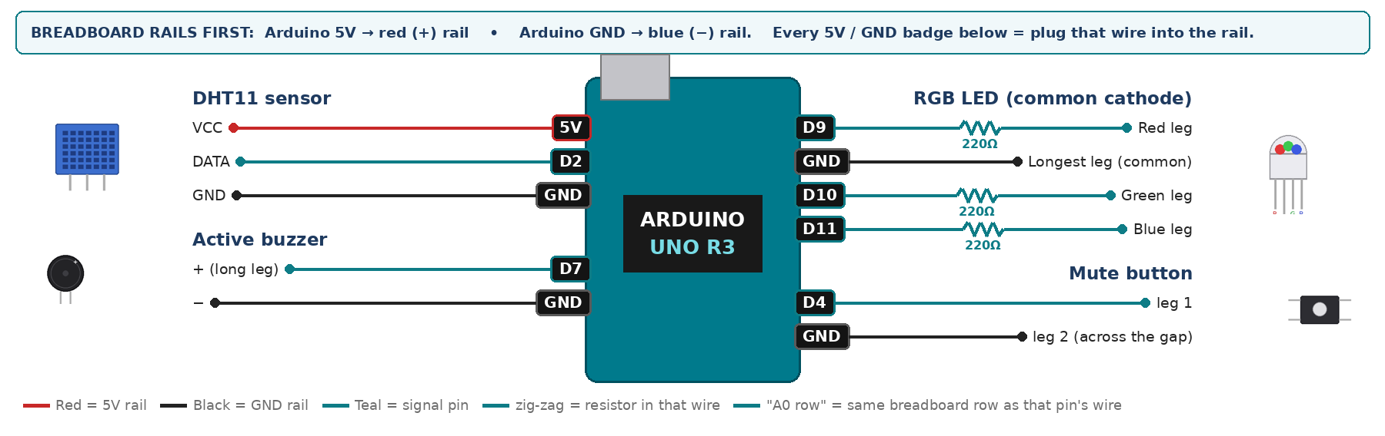
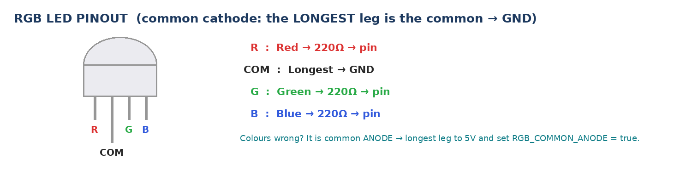
WIRING TABLE – TICK EACH WIRE AS YOU PLACE IT
Component | Component pin | Goes to | Resistor | Note | ✓
DHT11 sensor | VCC | 5V rail | — |  | ☐
DHT11 sensor | DATA | D2 | — | 10k to 5V if nan | ☐
DHT11 sensor | GND | GND rail | — |  | ☐
RGB LED (common cathode) | Red leg | D9 | 220Ω |  | ☐
RGB LED (common cathode) | Longest leg (common) | GND rail | — | no resistor | ☐
RGB LED (common cathode) | Green leg | D10 | 220Ω |  | ☐
RGB LED (common cathode) | Blue leg | D11 | 220Ω |  | ☐
Active buzzer | + (long leg) | D7 | — |  | ☐
Active buzzer | − | GND rail | — |  | ☐
Mute button | leg 1 | D4 | — | INPUT_PULLUP | ☐
Mute button | leg 2 (across the gap) | GND rail | — |  | ☐
BUILD ORDER – USB UNPLUGGED UNTIL STEP 7
- Connect Arduino 5V to the red (+) rail and GND to the blue (−) rail of the breadboard.
- Fit the RGB LED — longest leg straight to GND, 220Ω on the other three.
- Add the DHT11 and the buzzer, checking + and − carefully.
- Add the button, upload, open Serial Monitor at 9600.
- Check every wire against the table with a partner, THEN plug in the USB. The green ON light must come on – if not, unplug at once (short circuit).
- Arduino IDE: Tools › Board › Arduino Uno, then Tools › Port. Sketch › Include Library › Manage Libraries → install "DHT sensor library" (Adafruit) and "Adafruit Unified Sensor".
- Paste the code below, press Upload, open Tools › Serial Monitor at 9600 baud and watch your own readings.
STEP 1 – TINKERCAD FIRST (CHECKPOINT MARKS)
Go to www.tinkercad.com › Circuits › Create new Circuit. Build the same wiring, paste the same code, press Start Simulation. Parts that Tinkercad does not have:
- DHT11 → not in Tinkercad: use a TMP36 temperature sensor on A2 + a potentiometer on A3 as 'humidity' (snippet T1).
- Active buzzer → use an LED + 220Ω in its place so you can SEE every beep (no code change).
- RGB LED → 'LED RGB', set it to Cathode in the inspector.
Save it with the name 11.C G3 – Midday Break Guard and share the link with your teacher. The REAL build in class is your AI Project.
HOW THE CODE THINKS
- read temperature T and humidity H from the DHT11
- if the reading is nan, print an error and skip this round
- calculate DI with the formula above
- DI under 24 → green; 24 to 28 → yellow; over 28 → red and beep
- skip the beep while mute is on, then wait 2 seconds
THE COMPLETE CODE (TESTED)
Yellow lines = numbers YOU must change after measuring with your own sensor. Every member must be able to explain at least one line.
/* PROJECT 1 - MIDDAY BREAK GUARD (11.C Group 3)
Measures temperature + humidity, works out how hot the air FEELS
(Thom Discomfort Index) and shows GREEN / YELLOW / RED.
On RED the buzzer beeps every second until MUTE is pressed.
Libraries: "DHT sensor library" (Adafruit) + "Adafruit Unified Sensor" */
#include <DHT.h>
#define DHTPIN 2
#define DHTTYPE DHT11
DHT dht(DHTPIN, DHTTYPE);

const int R = 9, G = 10, B = 11; // RGB LED legs (each through 220 ohm)
const int BUZZ = 7; // ACTIVE buzzer
const int BTN = 4; // MUTE button (other leg to GND)

const float DI_CARE = 24.0; // from here: YELLOW (take care)
const float DI_STOP = 28.0; // from here: RED (stop outdoor work)

bool muted = false;
int lastBtn = HIGH;
int level = -1; // -1 none yet, 0 green, 1 yellow, 2 red
unsigned long lastRead = 0, lastBeep = 0;
unsigned long redSeconds = 0; // CHALLENGE: time spent in red

// ---------- RGB LED ----------
const bool RGB_COMMON_ANODE = false; // true = longest leg goes to 5V instead of GND
void colour(bool r, bool g, bool b) {
digitalWrite(R, RGB_COMMON_ANODE ? !r : r);
digitalWrite(G, RGB_COMMON_ANODE ? !g : g);
digitalWrite(B, RGB_COMMON_ANODE ? !b : b);
}
// True ONCE at the moment a button goes from up (HIGH) to pressed (LOW).
// Holding the button down does NOT repeat it.
bool justPressed(int pin, int &lastState) {
int now = digitalRead(pin);
bool pressed = (lastState == HIGH && now == LOW);
lastState = now;
if (pressed) delay(25); // ignore contact bounce
return pressed;
}

void setup() {
Serial.begin(9600);
dht.begin();
pinMode(R, OUTPUT); pinMode(G, OUTPUT); pinMode(B, OUTPUT);
pinMode(BUZZ, OUTPUT);
pinMode(BTN, INPUT_PULLUP);
colour(0, 0, 0);
delay(1000); // DHT11 needs 1 s after power-up
}

void loop() {
// 1) the mute button is checked EVERY loop, so a press is never missed
if (justPressed(BTN, lastBtn)) {
muted = !muted;
Serial.println(muted ? "MUTE ON" : "MUTE OFF");
}

// 2) read the DHT11 only every 2 seconds (it cannot go faster)
if (millis() - lastRead >= 2000) {
lastRead = millis();
float t = dht.readTemperature();
float h = dht.readHumidity();
if (isnan(t) || isnan(h)) {
Serial.println("DHT11 not responding - check DATA wire / 10k pull-up");
} else {
float di = t - 0.55 * (1 - h / 100.0) * (t - 14.5);
if (di < DI_CARE) level = 0;
else if (di < DI_STOP) level = 1;
else level = 2;
if (level < 2) muted = false; // safe again: next red will alarm
if (level == 2) redSeconds += 2;

if (level == 0) colour(0, 1, 0); // green
if (level == 1) colour(1, 1, 0); // yellow = red + green
if (level == 2) colour(1, 0, 0); // red

Serial.print("T="); Serial.print(t, 1);
Serial.print(" C H="); Serial.print(h, 0);
Serial.print(" % DI="); Serial.print(di, 1);
Serial.print(" red minutes="); Serial.println(redSeconds / 60.0, 1);
}
}

// 3) buzzer: 200 ms beep every second while RED and not muted (no delay!)
if (level == 2 && !muted && millis() - lastBeep >= 1000) lastBeep = millis();
digitalWrite(BUZZ, (level == 2 && !muted && millis() - lastBeep < 200) ? HIGH : LOW);
}
TEST IT AND RECORD YOUR READINGS
- Breathe on the sensor for 20 s — humidity climbs and the colour must move up a level.
- Press mute on red: light stays red, buzzer stops.
- Record T, H and DI every 10 s for one minute.
Test # | What we did | Reading / value | What happened
1
2
3
4
5
IF IT DOES NOT WORK
- Colours wrong or dead: the RGB LED is common ANODE — common leg to 5V and set RGB_COMMON_ANODE = true at the top of the code.
- Permanent nan: add a 10k from DATA to 5V and allow 1 s after power-up.
- Install 'DHT sensor library' by Adafruit plus 'Adafruit Unified Sensor'.
- Button does nothing: it is not straddling the centre gap, or both wires are on legs that are already joined. Use legs on OPPOSITE sides of the gap.
AT THE STEM WEEK TABLE
Keep a sealed box with a damp tissue at the booth. Drop the badge in for 30 seconds and it turns red in front of the visitor.
CHALLENGE: Add a 'stop work NOW' level: if the badge stays red for 15 minutes in a row, flash the LED and sound the buzzer continuously until a supervisor presses mute.
BUILD A COVER FOR YOUR PROJECT (NOTE)
Make a cover or case that suits your project design, using cardboard or materials from stationery (card, coloured paper, tape, glue, markers). Idea: a mini construction-site pole or warning sign from cardboard with yellow-and-black tape and a small paper worker figure.
Keep the USB port, the sensor and any buttons or knobs easy to reach. Never cover the Arduino so tightly that wires are pulled.
PROJECT POSTER (SUPPORT – 4 MARKS)
Make one clear poster (A3 paper or Canva) for the STEM Week table. It must show:
- Project name and the school, your names, class and group.
- The problem in the UAE and who it helps.
- How it works in 3 steps: sensor → Arduino decides → output.
- A photo of your real wiring and of the finished project with its cover.
- Your test results (a small table or chart) and one improvement you made.
AI LOG – PROMPTS, EXAMPLES AND DATA (CORE – 4 MARKS)
Use an AI tool (ChatGPT, Claude, Gemini or Z.ai) to help you understand and improve your project, and record EVERY prompt you use. Example prompts:
- Explain line by line what the loop() does in this Arduino sketch for a "Midday Break Guard": [paste the code]
- My sensor gives ___ in one condition and ___ in the other. Which numbers should I put in the CALIBRATE lines and why?
- Suggest one improvement for our "Midday Break Guard" that we can test in one lesson.
AI tool | Prompt we typed | What the AI answered (short) | What we used / changed
PROJECT VIDEO – EXPLAIN THE AI PROCESS AND RESULTS (4 MARKS)
Every group – or each student – records a 1–2 minute video in class. Include:
- Who you are (names, class, group) and the problem your project solves in the UAE.
- How it works: show the real wiring and explain one sensor and one part of the code.
- The AI process: which AI tool you used, one prompt you typed and what you changed because of it.
- Your results: a live demo and your test readings – before and after your improvement.
- One thing you learned.
HOW YOUR PROJECT IS MARKED – 20 MARKS
Criterion | What you must do | For your Arduino project | Marks
Support | Choose an idea and create a clear project poster. | Your project is chosen for you – make a clear A3 / Canva poster: name, problem, how it works, wiring photo, team names. | 4
Core | Use an AI tool and document the required prompts, examples, or data. | Use an AI tool (ChatGPT, Claude, Gemini, Z.ai) to understand, test or improve your code and plan your calibration. Copy your prompts and your sensor data into the AI LOG. | 4
Advanced | Build, test, and improve the project using evidence. | Build the real circuit, test it, record readings, improve it – and show before / after evidence. | 4
Video | Explain the AI process and results in a short video. | 1–2 minute video: how it works, how AI helped you (your prompts) and what your test results show. | 4
On time | Submit the complete project on time. | Poster, AI log, readings table, video and the working project – all ready by Friday 30 October. | 4
TOTAL |  |  | 20
Deadline: submit the complete project – poster, AI log, readings, video and working build – by Friday 30 October (end of Week 9).

