PROJECT 2 OF 21 • 11.C — GROUP 4 • AI PROJECT (ARDUINO) – 20 MARKS
Masjid Quiet Zone Monitor
Lets a crowded prayer hall correct its own noise, without anyone shouting

BUILT IN CLASS, WITH REAL PARTS. First build and test it in Tinkercad (checkpoint marks), then assemble the real Arduino, components and wiring in the ICT lesson. Bring this sheet to every lesson – printed, or saved as pictures/PDF on your iPad.
PURPOSE – WHY THIS PROJECT EXISTS
What it does | A microphone measures how far the sound wave swings. The 7-segment shows a live noise score from 0 to 9, three LEDs give traffic-light feedback, and if the room stays above 6 for five full seconds the buzzer gives one short reminder.
UAE link | Adab of the prayer hall — and of the majlis, the library and the clinic
Why it matters | Our mosques fill far past normal capacity for taraweeh in Ramadan, and the same happens in a family majlis at Eid. Asking a crowded hall to be quiet only adds more noise, and it embarrasses people in front of their neighbours. A silent score on the wall lets a group correct itself with dignity. The five-second rule is the design decision: one cough must never trigger it, only sustained noise should.
Who it helps | Worshippers, imams and mosque staff — and any quiet space: majlis, library, clinic waiting room.
The science | Loudness = peak-to-peak amplitude. Sample as fast as possible for 50 ms, keep the highest and lowest values, subtract.
COMPONENTS YOU NEED
Component | Qty
Arduino UNO R3 + USB cable | 1
400-point breadboard | 1
Sound sensor module | 1
1-digit 7-segment (common cathode) | 1
LED | 3
Passive buzzer | 1
220Ω resistors (red-red-brown) | 10
Jumper wires (male-male) | about 20
Male-FEMALE jumper wires (for modules) | 3
WIRING DIAGRAM – EVERY PIN, EVERY WIRE
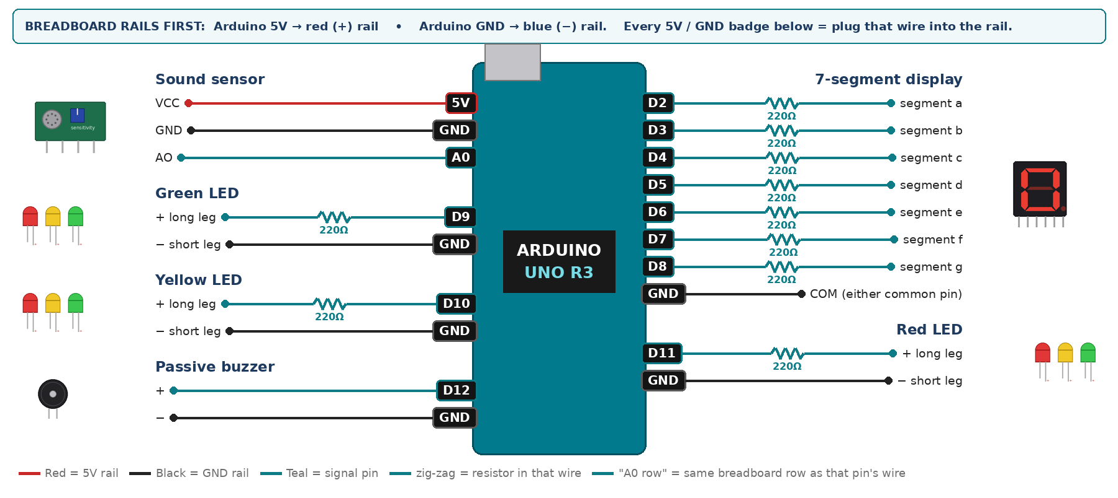
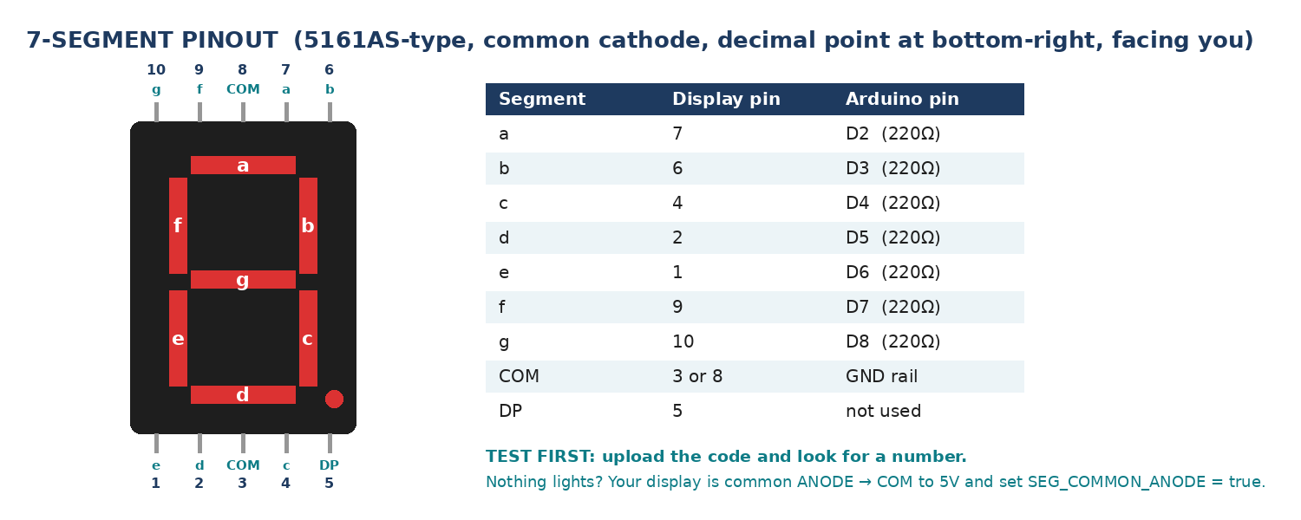
WIRING TABLE – TICK EACH WIRE AS YOU PLACE IT
Component | Component pin | Goes to | Resistor | Note | ✓
Sound sensor | VCC | 5V rail | — |  | ☐
Sound sensor | GND | GND rail | — |  | ☐
Sound sensor | AO | A0 | — | analog, not DO | ☐
7-segment display | segment a | D2 | 220Ω |  | ☐
7-segment display | segment b | D3 | 220Ω |  | ☐
7-segment display | segment c | D4 | 220Ω |  | ☐
7-segment display | segment d | D5 | 220Ω |  | ☐
7-segment display | segment e | D6 | 220Ω |  | ☐
7-segment display | segment f | D7 | 220Ω |  | ☐
7-segment display | segment g | D8 | 220Ω |  | ☐
7-segment display | COM (either common pin) | GND rail | — | common cathode | ☐
Green LED | + long leg | D9 | 220Ω |  | ☐
Green LED | − short leg | GND rail | — |  | ☐
Yellow LED | + long leg | D10 | 220Ω |  | ☐
Yellow LED | − short leg | GND rail | — |  | ☐
Red LED | + long leg | D11 | 220Ω |  | ☐
Red LED | − short leg | GND rail | — |  | ☐
Passive buzzer | + | D12 | — | tone() | ☐
Passive buzzer | − | GND rail | — |  | ☐
BUILD ORDER – USB UNPLUGGED UNTIL STEP 7
- Connect Arduino 5V to the red (+) rail and GND to the blue (−) rail of the breadboard.
- Wire the 7-segment first and test it alone with a 0-9 counter — it is the fussiest part.
- Add the three LEDs, each with its own resistor.
- Add the sound module; turn its blue screw until the on-board LED just goes off in a quiet room.
- Add the buzzer, upload, and watch the Serial numbers while you clap.
- Check every wire against the table with a partner, THEN plug in the USB. The green ON light must come on – if not, unplug at once (short circuit).
- Arduino IDE: Tools › Board › Arduino Uno, then Tools › Port.
- Paste the code below, press Upload, open Tools › Serial Monitor at 9600 baud and watch your own readings.
STEP 1 – TINKERCAD FIRST (CHECKPOINT MARKS)
Go to www.tinkercad.com › Circuits › Create new Circuit. Build the same wiring, paste the same code, press Start Simulation. Parts that Tinkercad does not have:
- Sound sensor → use a Potentiometer on the same analog pin as 'loudness' (snippet T2).
- Passive buzzer → use a Piezo (same code, tone() works).
- 7-segment → '7 Segment Display', set it to Cathode in the inspector.
Save it with the name 11.C G4 – Masjid Quiet Zone Monitor and share the link with your teacher. The REAL build in class is your AI Project.
HOW THE CODE THINKS
- sample the microphone as fast as possible for 50 ms
- subtract the smallest reading from the largest = peak-to-peak
- map that onto a score 0 to 9 and show it on the display
- green 0-3, yellow 4-6, red 7-9
- if red has lasted over 5 seconds, beep once
THE COMPLETE CODE (TESTED)
Yellow lines = numbers YOU must change after measuring with your own sensor. Every member must be able to explain at least one line.
/* PROJECT 2 - MASJID QUIET ZONE MONITOR (11.C Group 4)
Microphone loudness -> score 0-9 on the 7-segment + traffic-light LEDs.
Only noise that stays RED for 5 seconds gives one gentle reminder tone. */
const int MIC = A0; // sound module AO (analog) pin
const int GRN = 9, YEL = 10, RED = 11; // LEDs (each through 220 ohm)
const int BUZZ = 12; // PASSIVE buzzer

// ---- CALIBRATE: read the Serial Monitor in a silent room and while shouting ----
const int QUIET_PP = 5; // peak-to-peak in a silent room
const int LOUD_PP = 400; // peak-to-peak when very loud

unsigned long loudSince = 0;

// ---------- 7-SEGMENT DISPLAY (pins a,b,c,d,e,f,g) ----------
const int SEG[7] = {2, 3, 4, 5, 6, 7, 8};
const bool SEG_COMMON_ANODE = false; // true = common pin goes to 5V instead of GND
const byte DIGIT[10][7] = {
{1,1,1,1,1,1,0}, {0,1,1,0,0,0,0}, {1,1,0,1,1,0,1}, {1,1,1,1,0,0,1},
{0,1,1,0,0,1,1}, {1,0,1,1,0,1,1}, {1,0,1,1,1,1,1}, {1,1,1,0,0,0,0},
{1,1,1,1,1,1,1}, {1,1,1,1,0,1,1} };

void show(int n) { // show one number 0-9
n = constrain(n, 0, 9);
for (int i = 0; i < 7; i++) {
bool on = DIGIT[n][i];
digitalWrite(SEG[i], SEG_COMMON_ANODE ? !on : on);
}
}

int loudness() { // peak-to-peak over 50 ms
unsigned long start = millis();
int hi = 0, lo = 1023;
while (millis() - start < 50) {
int v = analogRead(MIC);
if (v > hi) hi = v;
if (v < lo) lo = v;
}
return hi - lo;
}

void setup() {
Serial.begin(9600);
for (int i = 0; i < 7; i++) pinMode(SEG[i], OUTPUT);
pinMode(GRN, OUTPUT); pinMode(YEL, OUTPUT); pinMode(RED, OUTPUT);
pinMode(BUZZ, OUTPUT);
}

void loop() {
int pp = loudness();
int score = constrain(map(pp, QUIET_PP, LOUD_PP, 0, 9), 0, 9);
show(score);

digitalWrite(GRN, score <= 3);
digitalWrite(YEL, score >= 4 && score <= 6);
digitalWrite(RED, score >= 7);

if (score >= 7) {
if (loudSince == 0) loudSince = millis(); // start the 5 s clock
if (millis() - loudSince > 5000) { // loud for 5 s
tone(BUZZ, 1200, 300);
loudSince = millis(); // wait another 5 s
}
} else {
loudSince = 0; // one cough resets it
}

Serial.print("pp="); Serial.print(pp);
Serial.print(" score="); Serial.println(score);
delay(80);
}
TEST IT AND RECORD YOUR READINGS
- Silent room: write down the peak-to-peak value — that is your zero point.
- One loud clap must NOT trigger the buzzer.
- The whole group talking for 6 seconds MUST trigger it.
Test # | What we did | Reading / value | What happened
1
2
3
4
5
IF IT DOES NOT WORK
- Display dead: it is common ANODE — common to 5V, and set SEG_COMMON_ANODE = true at the top of the code.
- Score stuck at 9: lower the module screw or raise 400 in the map().
- Score stuck at 0: raise the screw or lower 400.
- 7-segment shows the wrong shapes: one segment wire is in the wrong pin — check a→D2 … g→D8 against the pinout picture.
AT THE STEM WEEK TABLE
Ask two visitors to talk normally, then to raise their voices. The number climbing from 2 to 8 explains the project without you saying a word.
CHALLENGE: Log the score every second for a lesson, paste into Excel and draw a noise graph of your classroom.
BUILD A COVER FOR YOUR PROJECT (NOTE)
Make a cover or case that suits your project design, using cardboard or materials from stationery (card, coloured paper, tape, glue, markers). Idea: a cardboard wall plaque shaped like a masjid arch, with a window for the display and the words “Quiet please” in nice calligraphy.
Keep the USB port, the sensor and any buttons or knobs easy to reach. Never cover the Arduino so tightly that wires are pulled.
PROJECT POSTER (SUPPORT – 4 MARKS)
Make one clear poster (A3 paper or Canva) for the STEM Week table. It must show:
- Project name and the school, your names, class and group.
- The problem in the UAE and who it helps.
- How it works in 3 steps: sensor → Arduino decides → output.
- A photo of your real wiring and of the finished project with its cover.
- Your test results (a small table or chart) and one improvement you made.
AI LOG – PROMPTS, EXAMPLES AND DATA (CORE – 4 MARKS)
Use an AI tool (ChatGPT, Claude, Gemini or Z.ai) to help you understand and improve your project, and record EVERY prompt you use. Example prompts:
- Explain line by line what the loop() does in this Arduino sketch for a "Masjid Quiet Zone Monitor": [paste the code]
- My sensor gives ___ in one condition and ___ in the other. Which numbers should I put in the CALIBRATE lines and why?
- Suggest one improvement for our "Masjid Quiet Zone Monitor" that we can test in one lesson.
AI tool | Prompt we typed | What the AI answered (short) | What we used / changed
PROJECT VIDEO – EXPLAIN THE AI PROCESS AND RESULTS (4 MARKS)
Every group – or each student – records a 1–2 minute video in class. Include:
- Who you are (names, class, group) and the problem your project solves in the UAE.
- How it works: show the real wiring and explain one sensor and one part of the code.
- The AI process: which AI tool you used, one prompt you typed and what you changed because of it.
- Your results: a live demo and your test readings – before and after your improvement.
- One thing you learned.
HOW YOUR PROJECT IS MARKED – 20 MARKS
Criterion | What you must do | For your Arduino project | Marks
Support | Choose an idea and create a clear project poster. | Your project is chosen for you – make a clear A3 / Canva poster: name, problem, how it works, wiring photo, team names. | 4
Core | Use an AI tool and document the required prompts, examples, or data. | Use an AI tool (ChatGPT, Claude, Gemini, Z.ai) to understand, test or improve your code and plan your calibration. Copy your prompts and your sensor data into the AI LOG. | 4
Advanced | Build, test, and improve the project using evidence. | Build the real circuit, test it, record readings, improve it – and show before / after evidence. | 4
Video | Explain the AI process and results in a short video. | 1–2 minute video: how it works, how AI helped you (your prompts) and what your test results show. | 4
On time | Submit the complete project on time. | Poster, AI log, readings table, video and the working project – all ready by Friday 30 October. | 4
TOTAL |  |  | 20
Deadline: submit the complete project – poster, AI log, readings, video and working build – by Friday 30 October (end of Week 9).

