PROJECT 3 OF 21 • 11.B — GROUP 3 • AI PROJECT (ARDUINO) – 20 MARKS
Date Palm Water Saver
Waters the palm when the soil is dry, not when the clock says so

BUILT IN CLASS, WITH REAL PARTS. First build and test it in Tinkercad (checkpoint marks), then assemble the real Arduino, components and wiring in the ICT lesson. Bring this sheet to every lesson – printed, or saved as pictures/PDF on your iPad.
PURPOSE – WHY THIS PROJECT EXISTS
What it does | A probe in the soil measures dryness. The 7-segment shows a dryness number from 0 (soaking) to 9 (bone dry). A knob sets the level at which watering should begin. Past that line the red LED and buzzer call for water; below it the green LED says do not waste.
UAE link | The date palm — national symbol and the root of Emirati farming
Why it matters | The date palm has fed and sheltered people on this coast for thousands of years, and the UAE now holds tens of millions of them. But we are also among the heaviest water users per person on earth, and nearly all our fresh water is desalinated at real cost in energy. Most farm timers water on a fixed schedule even after rain. Watering by measurement saves water and prevents root rot. The knob matters because a date palm, a ghaf tree and a vegetable bed each want different moisture — one device serves the whole farm.
Who it helps | Date palm farmers, school gardens and home gardeners — every litre saved is desalinated water saved.
The science | Wet soil conducts better, so the analog reading goes DOWN as soil gets wetter. Your numbers will not match any other group — you must calibrate.
COMPONENTS YOU NEED
Component | Qty
Arduino UNO R3 + USB cable | 1
400-point breadboard | 1
Soil moisture probe + module | 1
Potentiometer 10k | 1
1-digit 7-segment (common cathode) | 1
LED | 2
Active buzzer | 1
220Ω resistors (red-red-brown) | 9
Jumper wires (male-male) | about 20
Male-FEMALE jumper wires (for modules) | 3
WIRING DIAGRAM – EVERY PIN, EVERY WIRE
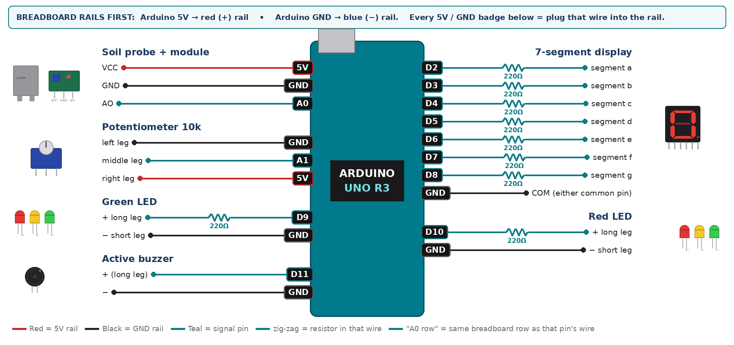
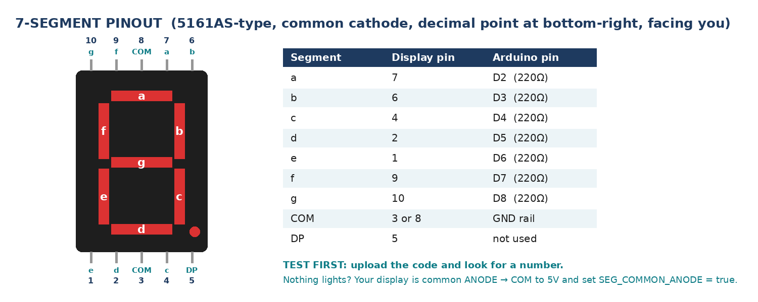
WIRING TABLE – TICK EACH WIRE AS YOU PLACE IT
Component | Component pin | Goes to | Resistor | Note | ✓
Soil probe + module | VCC | 5V rail | — |  | ☐
Soil probe + module | GND | GND rail | — |  | ☐
Soil probe + module | AO | A0 | — | analog | ☐
Potentiometer 10k | left leg | GND rail | — |  | ☐
Potentiometer 10k | middle leg | A1 | — | threshold knob | ☐
Potentiometer 10k | right leg | 5V rail | — |  | ☐
7-segment display | segment a | D2 | 220Ω |  | ☐
7-segment display | segment b | D3 | 220Ω |  | ☐
7-segment display | segment c | D4 | 220Ω |  | ☐
7-segment display | segment d | D5 | 220Ω |  | ☐
7-segment display | segment e | D6 | 220Ω |  | ☐
7-segment display | segment f | D7 | 220Ω |  | ☐
7-segment display | segment g | D8 | 220Ω |  | ☐
7-segment display | COM (either common pin) | GND rail | — | common cathode | ☐
Green LED | + long leg | D9 | 220Ω |  | ☐
Green LED | − short leg | GND rail | — |  | ☐
Red LED | + long leg | D10 | 220Ω |  | ☐
Red LED | − short leg | GND rail | — |  | ☐
Active buzzer | + (long leg) | D11 | — |  | ☐
Active buzzer | − | GND rail | — |  | ☐
BUILD ORDER – USB UNPLUGGED UNTIL STEP 7
- Connect Arduino 5V to the red (+) rail and GND to the blue (−) rail of the breadboard.
- Wire and test the 7-segment on its own first.
- Add the knob and print analogRead(A1) — it must sweep 0 to 1023.
- Add the soil sensor. Record the reading in dry soil and in water — those two numbers go into your map().
- Add the LEDs and buzzer, then calibrate.
- Check every wire against the table with a partner, THEN plug in the USB. The green ON light must come on – if not, unplug at once (short circuit).
- Arduino IDE: Tools › Board › Arduino Uno, then Tools › Port.
- Paste the code below, press Upload, open Tools › Serial Monitor at 9600 baud and watch your own readings.
STEP 1 – TINKERCAD FIRST (CHECKPOINT MARKS)
Go to www.tinkercad.com › Circuits › Create new Circuit. Build the same wiring, paste the same code, press Start Simulation. Parts that Tinkercad does not have:
- Soil probe → use Tinkercad's Soil Moisture Sensor, or a Potentiometer on the same pin.
- Active buzzer → use an LED + 220Ω in its place so you can SEE every beep (no code change).
- 7-segment → '7 Segment Display', set it to Cathode in the inspector.
Save it with the name 11.B G3 – Date Palm Water Saver and share the link with your teacher. The REAL build in class is your AI Project.
HOW THE CODE THINKS
- read the soil sensor on A0
- map it to a dryness score 0-9 using YOUR two calibration numbers
- read the knob and map it to a threshold 0-9
- show dryness on the display
- dryness at or above the threshold → red LED and a short beep, else green
THE COMPLETE CODE (TESTED)
Yellow lines = numbers YOU must change after measuring with your own sensor. Every member must be able to explain at least one line.
/* PROJECT 3 - DATE PALM WATER SAVER (11.B Group 3)
Soil probe -> dryness 0 (soaking) to 9 (bone dry). The knob sets when
to water. Dry past the knob = RED + beep each second, else GREEN. */
const int SOIL = A0, KNOB = A1;
const int GRN = 9, REDL = 10; // LEDs (each through 220 ohm)
const int BUZZ = 11; // ACTIVE buzzer

// ---- CALIBRATE: put YOUR two readings from the Serial Monitor here ----
const int WET_READING = 280; // probe in a glass of water
const int DRY_READING = 680; // probe in dry soil / in the air

unsigned long lastBeep = 0;

// ---------- 7-SEGMENT DISPLAY (pins a,b,c,d,e,f,g) ----------
const int SEG[7] = {2, 3, 4, 5, 6, 7, 8};
const bool SEG_COMMON_ANODE = false; // true = common pin goes to 5V instead of GND
const byte DIGIT[10][7] = {
{1,1,1,1,1,1,0}, {0,1,1,0,0,0,0}, {1,1,0,1,1,0,1}, {1,1,1,1,0,0,1},
{0,1,1,0,0,1,1}, {1,0,1,1,0,1,1}, {1,0,1,1,1,1,1}, {1,1,1,0,0,0,0},
{1,1,1,1,1,1,1}, {1,1,1,1,0,1,1} };

void show(int n) { // show one number 0-9
n = constrain(n, 0, 9);
for (int i = 0; i < 7; i++) {
bool on = DIGIT[n][i];
digitalWrite(SEG[i], SEG_COMMON_ANODE ? !on : on);
}
}

int readSoil() { // average 10 readings = steadier number
long sum = 0;
for (int i = 0; i < 10; i++) { sum += analogRead(SOIL); delay(2); }
return sum / 10;
}

void setup() {
Serial.begin(9600);
for (int i = 0; i < 7; i++) pinMode(SEG[i], OUTPUT);
pinMode(GRN, OUTPUT); pinMode(REDL, OUTPUT); pinMode(BUZZ, OUTPUT);
}

void loop() {
int raw = readSoil();
int dryness = constrain(map(raw, WET_READING, DRY_READING, 0, 9), 0, 9);
int threshold = map(analogRead(KNOB), 0, 1023, 0, 9);
show(dryness);

bool needWater = (dryness >= threshold);
digitalWrite(REDL, needWater);
digitalWrite(GRN, !needWater);

if (needWater && millis() - lastBeep >= 1000) lastBeep = millis();
digitalWrite(BUZZ, (needWater && millis() - lastBeep < 150) ? HIGH : LOW);

Serial.print("raw="); Serial.print(raw);
Serial.print(" dryness="); Serial.print(dryness);
Serial.print(" knob="); Serial.println(threshold);
delay(50);
}
TEST IT AND RECORD YOUR READINGS
- Record the raw value in dry soil and again in a glass of water.
- Set the knob to 5 and pour water slowly until the alarm stops. Note the switching point.
- Leave it in a plant pot for a lesson, reading every 10 minutes.
Test # | What we did | Reading / value | What happened
1
2
3
4
5
IF IT DOES NOT WORK
- Dryness reads backwards: WET_READING and DRY_READING are swapped.
- The probe corrodes over a week — real electrolysis, and exactly why commercial probes are capacitive. Say so in the pitch.
- Jumpy readings: probe wires loose in the screw terminals.
- 7-segment shows the wrong shapes: one segment wire is in the wrong pin — check a→D2 … g→D8 against the pinout picture.
AT THE STEM WEEK TABLE
Bring two identical pots — one watered this morning, one dry for a week. Move the probe between them and let the visitor watch the number jump.
CHALLENGE: Only allow the alarm once the soil has been dry for two continuous minutes.
BUILD A COVER FOR YOUR PROJECT (NOTE)
Make a cover or case that suits your project design, using cardboard or materials from stationery (card, coloured paper, tape, glue, markers). Idea: a cardboard palm-tree trunk with paper fronds standing next to a real plant pot for the probe.
Keep the USB port, the sensor and any buttons or knobs easy to reach. Never cover the Arduino so tightly that wires are pulled.
PROJECT POSTER (SUPPORT – 4 MARKS)
Make one clear poster (A3 paper or Canva) for the STEM Week table. It must show:
- Project name and the school, your names, class and group.
- The problem in the UAE and who it helps.
- How it works in 3 steps: sensor → Arduino decides → output.
- A photo of your real wiring and of the finished project with its cover.
- Your test results (a small table or chart) and one improvement you made.
AI LOG – PROMPTS, EXAMPLES AND DATA (CORE – 4 MARKS)
Use an AI tool (ChatGPT, Claude, Gemini or Z.ai) to help you understand and improve your project, and record EVERY prompt you use. Example prompts:
- Explain line by line what the loop() does in this Arduino sketch for a "Date Palm Water Saver": [paste the code]
- My sensor gives ___ in one condition and ___ in the other. Which numbers should I put in the CALIBRATE lines and why?
- Suggest one improvement for our "Date Palm Water Saver" that we can test in one lesson.
AI tool | Prompt we typed | What the AI answered (short) | What we used / changed
PROJECT VIDEO – EXPLAIN THE AI PROCESS AND RESULTS (4 MARKS)
Every group – or each student – records a 1–2 minute video in class. Include:
- Who you are (names, class, group) and the problem your project solves in the UAE.
- How it works: show the real wiring and explain one sensor and one part of the code.
- The AI process: which AI tool you used, one prompt you typed and what you changed because of it.
- Your results: a live demo and your test readings – before and after your improvement.
- One thing you learned.
HOW YOUR PROJECT IS MARKED – 20 MARKS
Criterion | What you must do | For your Arduino project | Marks
Support | Choose an idea and create a clear project poster. | Your project is chosen for you – make a clear A3 / Canva poster: name, problem, how it works, wiring photo, team names. | 4
Core | Use an AI tool and document the required prompts, examples, or data. | Use an AI tool (ChatGPT, Claude, Gemini, Z.ai) to understand, test or improve your code and plan your calibration. Copy your prompts and your sensor data into the AI LOG. | 4
Advanced | Build, test, and improve the project using evidence. | Build the real circuit, test it, record readings, improve it – and show before / after evidence. | 4
Video | Explain the AI process and results in a short video. | 1–2 minute video: how it works, how AI helped you (your prompts) and what your test results show. | 4
On time | Submit the complete project on time. | Poster, AI log, readings table, video and the working project – all ready by Friday 30 October. | 4
TOTAL |  |  | 20
Deadline: submit the complete project – poster, AI log, readings, video and working build – by Friday 30 October (end of Week 9).

