PROJECT 4 OF 21 • 11.B — GROUP 4 • AI PROJECT (ARDUINO) – 20 MARKS
Wudu Water Guardian
Shows how many litres each ablution actually uses, right at the tap

BUILT IN CLASS, WITH REAL PARTS. First build and test it in Tinkercad (checkpoint marks), then assemble the real Arduino, components and wiring in the ICT lesson. Bring this sheet to every lesson – printed, or saved as pictures/PDF on your iPad.
PURPOSE – WHY THIS PROJECT EXISTS
What it does | An infrared sensor at the tap detects hands underneath and times how long the water runs. It converts that time into litres, shows it on the 7-segment, and turns the LED red with a warning beep once the ablution passes the set limit. A button resets it for the next person.
UAE link | Not wasting water in wudu — a teaching of the faith and a national water problem
Why it matters | The Prophet, peace be upon him, performed wudu with a small vessel and taught against waste even at a flowing river. A standard mosque tap runs around six litres a minute, and a large mosque serves thousands of ablutions a day — nearly all of it desalinated water. This device scolds nobody. It simply makes an invisible number visible, which is the only thing that reliably changes a habit. It joins faith, engineering and national water policy in one small box.
Who it helps | Mosque users and mosque maintenance teams who pay for the water and the energy to make it.
The science | Litres = flow rate × time. Time must come from millis(), never delay(), or the sensor would freeze while counting.
COMPONENTS YOU NEED
Component | Qty
Arduino UNO R3 + USB cable | 1
400-point breadboard | 1
1-digit 7-segment (common cathode) | 1
LED | 2
Active buzzer | 1
IR obstacle module | 1
Push button | 1
220Ω resistors (red-red-brown) | 9
Jumper wires (male-male) | about 20
Male-FEMALE jumper wires (for modules) | 3
WIRING DIAGRAM – EVERY PIN, EVERY WIRE
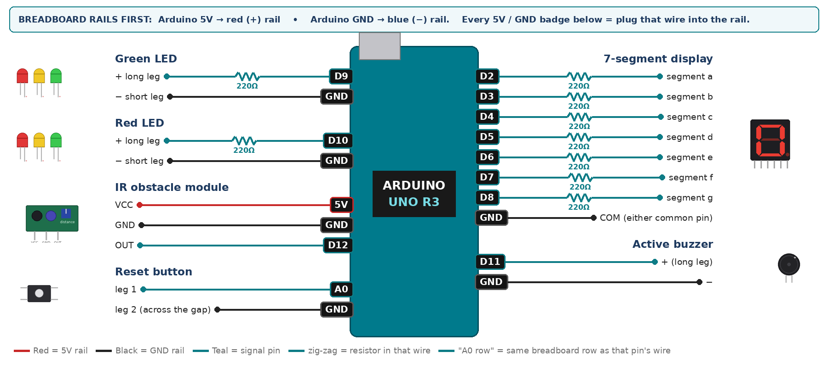
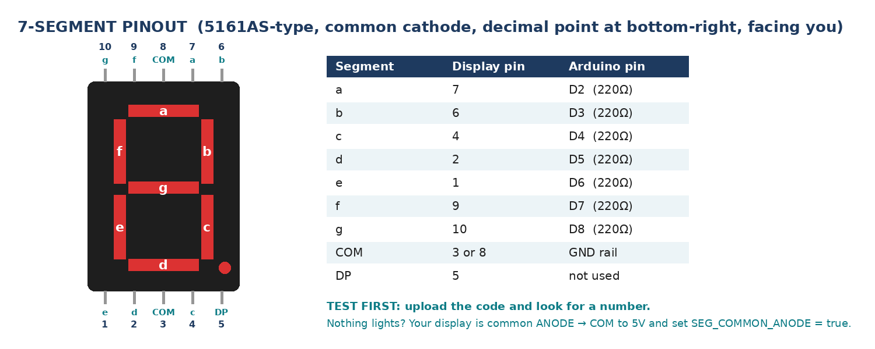
WIRING TABLE – TICK EACH WIRE AS YOU PLACE IT
Component | Component pin | Goes to | Resistor | Note | ✓
7-segment display | segment a | D2 | 220Ω |  | ☐
7-segment display | segment b | D3 | 220Ω |  | ☐
7-segment display | segment c | D4 | 220Ω |  | ☐
7-segment display | segment d | D5 | 220Ω |  | ☐
7-segment display | segment e | D6 | 220Ω |  | ☐
7-segment display | segment f | D7 | 220Ω |  | ☐
7-segment display | segment g | D8 | 220Ω |  | ☐
7-segment display | COM (either common pin) | GND rail | — | common cathode | ☐
Green LED | + long leg | D9 | 220Ω |  | ☐
Green LED | − short leg | GND rail | — |  | ☐
Red LED | + long leg | D10 | 220Ω |  | ☐
Red LED | − short leg | GND rail | — |  | ☐
Active buzzer | + (long leg) | D11 | — |  | ☐
Active buzzer | − | GND rail | — |  | ☐
IR obstacle module | VCC | 5V rail | — |  | ☐
IR obstacle module | GND | GND rail | — |  | ☐
IR obstacle module | OUT | D12 | — | LOW = something close | ☐
Reset button | leg 1 | A0 | — | INPUT_PULLUP | ☐
Reset button | leg 2 (across the gap) | GND rail | — |  | ☐
BUILD ORDER – USB UNPLUGGED UNTIL STEP 7
- Connect Arduino 5V to the red (+) rail and GND to the blue (−) rail of the breadboard.
- Wire and test the 7-segment alone.
- Add the IR module; set its screw to trigger at about 15 cm — hand distance under a tap.
- Write the timing with millis(). Holding a hand still must make the litres climb steadily.
- Add the LEDs, buzzer and reset button.
- Check every wire against the table with a partner, THEN plug in the USB. The green ON light must come on – if not, unplug at once (short circuit).
- Arduino IDE: Tools › Board › Arduino Uno, then Tools › Port.
- Paste the code below, press Upload, open Tools › Serial Monitor at 9600 baud and watch your own readings.
STEP 1 – TINKERCAD FIRST (CHECKPOINT MARKS)
Go to www.tinkercad.com › Circuits › Create new Circuit. Build the same wiring, paste the same code, press Start Simulation. Parts that Tinkercad does not have:
- IR obstacle module → use a Pushbutton (pressed = LOW = 'something close'), same pin.
- Active buzzer → use an LED + 220Ω in its place so you can SEE every beep (no code change).
- 7-segment → '7 Segment Display', set it to Cathode in the inspector.
Save it with the name 11.B G4 – Wudu Water Guardian and share the link with your teacher. The REAL build in class is your AI Project.
HOW THE CODE THINKS
- read the IR module — LOW means hands are under the tap
- while hands are present, add flow rate × elapsed time to the litre total
- show the whole number of litres on the display
- green while under the limit; past it → red LED and a warning beep
- reset button sets the total back to zero
THE COMPLETE CODE (TESTED)
Yellow lines = numbers YOU must change after measuring with your own sensor. Every member must be able to explain at least one line.
/* PROJECT 4 - WUDU WATER GUARDIAN (11.B Group 4)
IR sensor sees hands under the tap and times the water with millis().
Litres = flow rate x time, shown on the 7-segment. Past the limit the
LED turns RED and beeps while water runs. Button = reset for next person. */
const int GRN = 9, REDL = 10; // LEDs (each through 220 ohm)
const int BUZZ = 11; // ACTIVE buzzer
const int IR = 12; // IR module OUT (LOW = hands present)
const int RESETBTN = A0; // A0 used as a normal digital input

// ---- MEASURE YOUR OWN TAP: seconds to fill a 1-litre bottle -> 1 / seconds ----
const float FLOW_LPS = 0.10; // litres per second (0.10 = 6 L per minute)
const float LIMIT_L = 3.0; // litres allowed for one wudu

float litres = 0;
bool flowing = false;
int lastBtn = HIGH;
unsigned long lastTick = 0, lastBeep = 0, lastPrint = 0;

// ---------- 7-SEGMENT DISPLAY (pins a,b,c,d,e,f,g) ----------
const int SEG[7] = {2, 3, 4, 5, 6, 7, 8};
const bool SEG_COMMON_ANODE = false; // true = common pin goes to 5V instead of GND
const byte DIGIT[10][7] = {
{1,1,1,1,1,1,0}, {0,1,1,0,0,0,0}, {1,1,0,1,1,0,1}, {1,1,1,1,0,0,1},
{0,1,1,0,0,1,1}, {1,0,1,1,0,1,1}, {1,0,1,1,1,1,1}, {1,1,1,0,0,0,0},
{1,1,1,1,1,1,1}, {1,1,1,1,0,1,1} };

void show(int n) { // show one number 0-9
n = constrain(n, 0, 9);
for (int i = 0; i < 7; i++) {
bool on = DIGIT[n][i];
digitalWrite(SEG[i], SEG_COMMON_ANODE ? !on : on);
}
}
// True ONCE at the moment a button goes from up (HIGH) to pressed (LOW).
// Holding the button down does NOT repeat it.
bool justPressed(int pin, int &lastState) {
int now = digitalRead(pin);
bool pressed = (lastState == HIGH && now == LOW);
lastState = now;
if (pressed) delay(25); // ignore contact bounce
return pressed;
}

void setup() {
Serial.begin(9600);
for (int i = 0; i < 7; i++) pinMode(SEG[i], OUTPUT);
pinMode(GRN, OUTPUT); pinMode(REDL, OUTPUT); pinMode(BUZZ, OUTPUT);
pinMode(IR, INPUT);
pinMode(RESETBTN, INPUT_PULLUP);
}

void loop() {
bool hands = (digitalRead(IR) == LOW);

if (hands) {
if (!flowing) { flowing = true; lastTick = millis(); }
unsigned long now = millis();
litres += FLOW_LPS * (now - lastTick) / 1000.0; // add this slice of time
lastTick = now;
} else {
flowing = false;
}

if (justPressed(RESETBTN, lastBtn)) { litres = 0; Serial.println("RESET - next person"); }

show((int)litres); // whole litres 0-9
bool over = (litres > LIMIT_L);
digitalWrite(REDL, over);
digitalWrite(GRN, !over);

// beep 100 ms every second, only while over the limit AND water is running
if (over && hands && millis() - lastBeep >= 1000) lastBeep = millis();
digitalWrite(BUZZ, (over && hands && millis() - lastBeep < 100) ? HIGH : LOW);

if (millis() - lastPrint >= 500) {
lastPrint = millis();
Serial.print("litres = "); Serial.println(litres, 2);
}
}
TEST IT AND RECORD YOUR READINGS
- Hold a hand under it for exactly 10 s — litres shown must equal flow rate × 10.
- Measure your real tap: fill a 1-litre bottle and time it. Put YOUR flow rate in the code.
- Compare a careful ablution with a careless one and record both.
Test # | What we did | Reading / value | What happened
1
2
3
4
5
IF IT DOES NOT WORK
- Litres climb with nobody there: the IR screw is too far open, or sunlight is saturating it.
- Litres jump instead of climbing smoothly: you timed with delay() instead of millis().
- The display cannot show past 9 — that is the point of the alarm. Print the exact value to Serial.
- 7-segment shows the wrong shapes: one segment wire is in the wrong pin — check a→D2 … g→D8 against the pinout picture.
- Button does nothing: it is not straddling the centre gap, or both wires are on legs that are already joined. Use legs on OPPOSITE sides of the gap.
AT THE STEM WEEK TABLE
Mount it over a real bowl and tap. Let a visitor perform a wudu motion and watch their own litre count climb. Put the hadith about not wasting water on the poster above it.
CHALLENGE: Keep a running daily total and estimate the water a mosque of 500 worshippers would save.
BUILD A COVER FOR YOUR PROJECT (NOTE)
Make a cover or case that suits your project design, using cardboard or materials from stationery (card, coloured paper, tape, glue, markers). Idea: a model tap and basin from cardboard and a plastic cup, with the IR sensor hidden under the spout.
Keep the USB port, the sensor and any buttons or knobs easy to reach. Never cover the Arduino so tightly that wires are pulled.
PROJECT POSTER (SUPPORT – 4 MARKS)
Make one clear poster (A3 paper or Canva) for the STEM Week table. It must show:
- Project name and the school, your names, class and group.
- The problem in the UAE and who it helps.
- How it works in 3 steps: sensor → Arduino decides → output.
- A photo of your real wiring and of the finished project with its cover.
- Your test results (a small table or chart) and one improvement you made.
AI LOG – PROMPTS, EXAMPLES AND DATA (CORE – 4 MARKS)
Use an AI tool (ChatGPT, Claude, Gemini or Z.ai) to help you understand and improve your project, and record EVERY prompt you use. Example prompts:
- Explain line by line what the loop() does in this Arduino sketch for a "Wudu Water Guardian": [paste the code]
- My sensor gives ___ in one condition and ___ in the other. Which numbers should I put in the CALIBRATE lines and why?
- Suggest one improvement for our "Wudu Water Guardian" that we can test in one lesson.
AI tool | Prompt we typed | What the AI answered (short) | What we used / changed
PROJECT VIDEO – EXPLAIN THE AI PROCESS AND RESULTS (4 MARKS)
Every group – or each student – records a 1–2 minute video in class. Include:
- Who you are (names, class, group) and the problem your project solves in the UAE.
- How it works: show the real wiring and explain one sensor and one part of the code.
- The AI process: which AI tool you used, one prompt you typed and what you changed because of it.
- Your results: a live demo and your test readings – before and after your improvement.
- One thing you learned.
HOW YOUR PROJECT IS MARKED – 20 MARKS
Criterion | What you must do | For your Arduino project | Marks
Support | Choose an idea and create a clear project poster. | Your project is chosen for you – make a clear A3 / Canva poster: name, problem, how it works, wiring photo, team names. | 4
Core | Use an AI tool and document the required prompts, examples, or data. | Use an AI tool (ChatGPT, Claude, Gemini, Z.ai) to understand, test or improve your code and plan your calibration. Copy your prompts and your sensor data into the AI LOG. | 4
Advanced | Build, test, and improve the project using evidence. | Build the real circuit, test it, record readings, improve it – and show before / after evidence. | 4
Video | Explain the AI process and results in a short video. | 1–2 minute video: how it works, how AI helped you (your prompts) and what your test results show. | 4
On time | Submit the complete project on time. | Poster, AI log, readings table, video and the working project – all ready by Friday 30 October. | 4
TOTAL |  |  | 20
Deadline: submit the complete project – poster, AI log, readings, video and working build – by Friday 30 October (end of Week 9).

