PROJECT 6 OF 21 • 11.B — GROUP 6 • AI PROJECT (ARDUINO) – 20 MARKS
Masjid Corridor Light Saver
Light only when it is dark AND somebody is actually there

BUILT IN CLASS, WITH REAL PARTS. First build and test it in Tinkercad (checkpoint marks), then assemble the real Arduino, components and wiring in the ICT lesson. Bring this sheet to every lesson – printed, or saved as pictures/PDF on your iPad.
PURPOSE – WHY THIS PROJECT EXISTS
What it does | A light sensor decides whether it is dark. An infrared sensor decides whether someone is passing. The lamp — four LEDs — turns on only when BOTH are true, and stays on ten seconds after the person leaves. A knob sets how dark is dark, so one unit suits a bright lobby or a dim stairwell.
UAE link | Energy waste in mosques, majlis entrances and villa stairwells
Why it matters | Mosque corridors, wudu areas, majlis entrances and villa stairwells across the country stay lit all night for nobody. A timer switch is worse than useless — it runs in daylight too. The design idea is two conditions joined by AND, which is exactly how commercial occupancy sensors work. The ten-second hold is not decoration: without it the light drops out while you are still walking, and people tear the sensor off the wall.
Who it helps | Mosque and community-building managers who want to cut wasted electricity (UAE Net Zero 2050).
The science | An LDR is not a sensor on its own. Paired with a fixed 10k resistor it becomes a voltage divider — the thing the Arduino can actually read.
COMPONENTS YOU NEED
Component | Qty
Arduino UNO R3 + USB cable | 1
400-point breadboard | 1
Photoresistor (LDR) | 1
Potentiometer 10k | 1
IR obstacle module | 1
LED | 4
220Ω resistors (red-red-brown) | 4
10kΩ resistors (brown-black-orange) | 1
Jumper wires (male-male) | about 20
Male-FEMALE jumper wires (for modules) | 3
WIRING DIAGRAM – EVERY PIN, EVERY WIRE
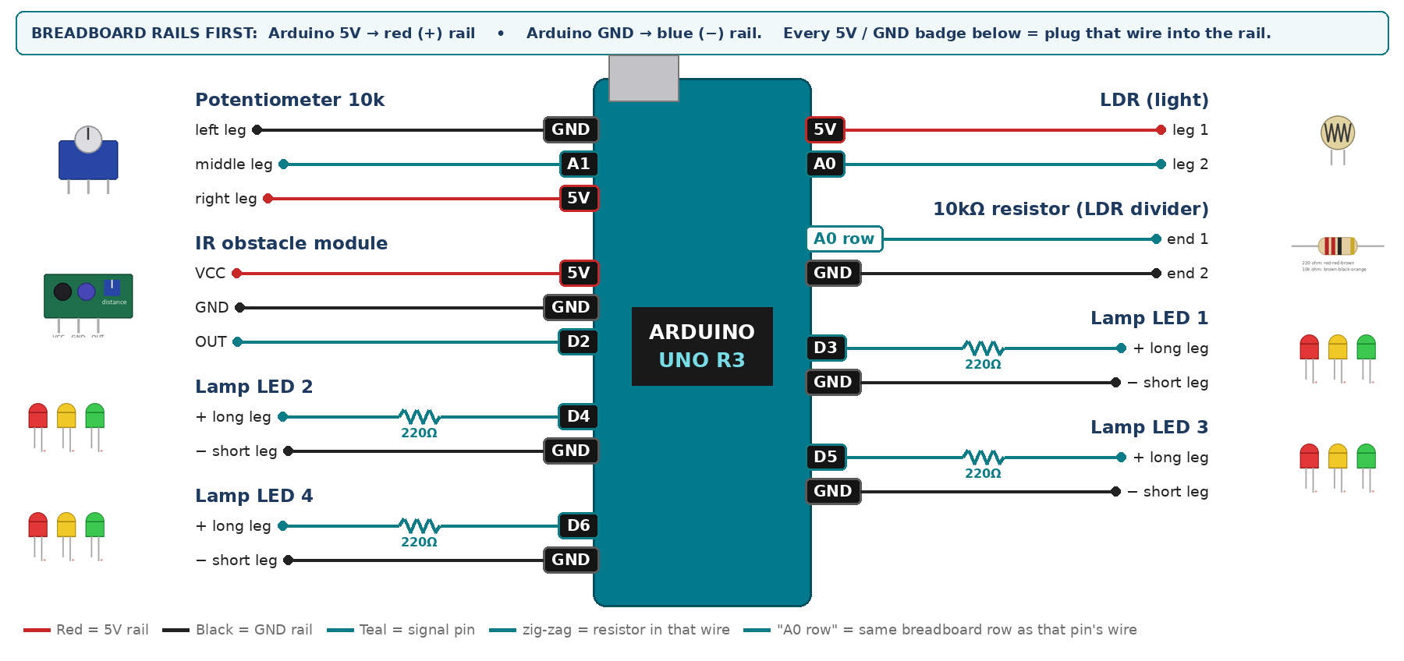
WIRING TABLE – TICK EACH WIRE AS YOU PLACE IT
Component | Component pin | Goes to | Resistor | Note | ✓
LDR (light) | leg 1 | 5V rail | — |  | ☐
LDR (light) | leg 2 | A0 | — | joins the 10k | ☐
10kΩ resistor (LDR divider) | end 1 | same breadboard row as A0 | — | same row as leg 2 | ☐
10kΩ resistor (LDR divider) | end 2 | GND rail | — |  | ☐
Potentiometer 10k | left leg | GND rail | — |  | ☐
Potentiometer 10k | middle leg | A1 | — | darkness setting | ☐
Potentiometer 10k | right leg | 5V rail | — |  | ☐
IR obstacle module | VCC | 5V rail | — |  | ☐
IR obstacle module | GND | GND rail | — |  | ☐
IR obstacle module | OUT | D2 | — | LOW = something close | ☐
Lamp LED 1 | + long leg | D3 | 220Ω |  | ☐
Lamp LED 1 | − short leg | GND rail | — |  | ☐
Lamp LED 2 | + long leg | D4 | 220Ω |  | ☐
Lamp LED 2 | − short leg | GND rail | — |  | ☐
Lamp LED 3 | + long leg | D5 | 220Ω |  | ☐
Lamp LED 3 | − short leg | GND rail | — |  | ☐
Lamp LED 4 | + long leg | D6 | 220Ω |  | ☐
Lamp LED 4 | − short leg | GND rail | — |  | ☐
BUILD ORDER – USB UNPLUGGED UNTIL STEP 7
- Connect Arduino 5V to the red (+) rail and GND to the blue (−) rail of the breadboard.
- Build the LDR divider and print analogRead(A0). Record the value covered and in torchlight.
- Add the knob and confirm it sweeps 0 to 1023.
- Add the IR module and check it sees a hand at 15 cm.
- Add the four LEDs and write the AND logic with the 10-second hold.
- Check every wire against the table with a partner, THEN plug in the USB. The green ON light must come on – if not, unplug at once (short circuit).
- Arduino IDE: Tools › Board › Arduino Uno, then Tools › Port.
- Paste the code below, press Upload, open Tools › Serial Monitor at 9600 baud and watch your own readings.
STEP 1 – TINKERCAD FIRST (CHECKPOINT MARKS)
Go to www.tinkercad.com › Circuits › Create new Circuit. Build the same wiring, paste the same code, press Start Simulation. Parts that Tinkercad does not have:
- IR obstacle module → use a Pushbutton (pressed = LOW = 'something close'), same pin.
Save it with the name 11.B G6 – Masjid Corridor Light Saver and share the link with your teacher. The REAL build in class is your AI Project.
HOW THE CODE THINKS
- read the light level and the knob setting
- isDark = light level is below the knob threshold
- person = IR module reads LOW
- if a person is seen, save the current time
- lamp ON only if isDark AND under 10 s since that time
THE COMPLETE CODE (TESTED)
Yellow lines = numbers YOU must change after measuring with your own sensor. Every member must be able to explain at least one line.
/* PROJECT 6 - MASJID CORRIDOR LIGHT SAVER (11.B Group 6)
Lamps (4 LEDs) switch on ONLY when it is dark AND a person passed in
the last 10 seconds. The knob sets how dark counts as "dark". */
const int LDR = A0, KNOB = A1;
const int IR = 2; // IR OUT (LOW = person)
const int LAMP[4] = {3, 4, 5, 6}; // 4 LEDs, each with its OWN 220 ohm
const unsigned long HOLD_MS = 10000; // lamps stay on 10 s after last person

unsigned long lastSeen = 0;
bool everSeen = false;

void setup() {
Serial.begin(9600);
pinMode(IR, INPUT);
for (int i = 0; i < 4; i++) pinMode(LAMP[i], OUTPUT);
}

void loop() {
int light = analogRead(LDR); // brighter = bigger
int darkLevel = map(analogRead(KNOB), 0, 1023, 100, 900);

bool isDark = (light < darkLevel);
bool person = (digitalRead(IR) == LOW);
if (person) { lastSeen = millis(); everSeen = true; }

bool on = isDark && everSeen && (millis() - lastSeen < HOLD_MS);
for (int i = 0; i < 4; i++) digitalWrite(LAMP[i], on);

// three numbers -> open Tools > Serial Plotter to see the graph
Serial.print(light); Serial.print(",");
Serial.print(darkLevel); Serial.print(",");
Serial.println(on ? 900 : 0);
delay(100);
}
TEST IT AND RECORD YOUR READINGS
- Room light plus a waving hand: lamp must stay OFF.
- Cover the LDR then wave: lamp must come ON.
- Cover it and stand still 15 s: lamp must switch itself OFF.
Test # | What we did | Reading / value | What happened
1
2
3
4
5
IF IT DOES NOT WORK
- Light reading barely moves: the 10k is not truly at GND, or shares a row with the wrong leg.
- Lamp never switches off: the IR module is permanently triggered — back its screw off.
- Only some LEDs light: you shared one resistor. Each LED needs its own.
AT THE STEM WEEK TABLE
Build a cardboard corridor with a slot for the sensor. Visitors walk two fingers through it in the dark and the lamp follows them.
CHALLENGE: Fade the lamp with analogWrite, and calculate the lighting hours saved over one night.
BUILD A COVER FOR YOUR PROJECT (NOTE)
Make a cover or case that suits your project design, using cardboard or materials from stationery (card, coloured paper, tape, glue, markers). Idea: a cardboard corridor box with arches; the four LEDs become ceiling lamps.
Keep the USB port, the sensor and any buttons or knobs easy to reach. Never cover the Arduino so tightly that wires are pulled.
PROJECT POSTER (SUPPORT – 4 MARKS)
Make one clear poster (A3 paper or Canva) for the STEM Week table. It must show:
- Project name and the school, your names, class and group.
- The problem in the UAE and who it helps.
- How it works in 3 steps: sensor → Arduino decides → output.
- A photo of your real wiring and of the finished project with its cover.
- Your test results (a small table or chart) and one improvement you made.
AI LOG – PROMPTS, EXAMPLES AND DATA (CORE – 4 MARKS)
Use an AI tool (ChatGPT, Claude, Gemini or Z.ai) to help you understand and improve your project, and record EVERY prompt you use. Example prompts:
- Explain line by line what the loop() does in this Arduino sketch for a "Masjid Corridor Light Saver": [paste the code]
- My sensor gives ___ in one condition and ___ in the other. Which numbers should I put in the CALIBRATE lines and why?
- Suggest one improvement for our "Masjid Corridor Light Saver" that we can test in one lesson.
AI tool | Prompt we typed | What the AI answered (short) | What we used / changed
PROJECT VIDEO – EXPLAIN THE AI PROCESS AND RESULTS (4 MARKS)
Every group – or each student – records a 1–2 minute video in class. Include:
- Who you are (names, class, group) and the problem your project solves in the UAE.
- How it works: show the real wiring and explain one sensor and one part of the code.
- The AI process: which AI tool you used, one prompt you typed and what you changed because of it.
- Your results: a live demo and your test readings – before and after your improvement.
- One thing you learned.
HOW YOUR PROJECT IS MARKED – 20 MARKS
Criterion | What you must do | For your Arduino project | Marks
Support | Choose an idea and create a clear project poster. | Your project is chosen for you – make a clear A3 / Canva poster: name, problem, how it works, wiring photo, team names. | 4
Core | Use an AI tool and document the required prompts, examples, or data. | Use an AI tool (ChatGPT, Claude, Gemini, Z.ai) to understand, test or improve your code and plan your calibration. Copy your prompts and your sensor data into the AI LOG. | 4
Advanced | Build, test, and improve the project using evidence. | Build the real circuit, test it, record readings, improve it – and show before / after evidence. | 4
Video | Explain the AI process and results in a short video. | 1–2 minute video: how it works, how AI helped you (your prompts) and what your test results show. | 4
On time | Submit the complete project on time. | Poster, AI log, readings table, video and the working project – all ready by Friday 30 October. | 4
TOTAL |  |  | 20
Deadline: submit the complete project – poster, AI log, readings, video and working build – by Friday 30 October (end of Week 9).

