PROJECT 7 OF 21 • 11.B — GROUP 7 • AI PROJECT (ARDUINO) – 20 MARKS
Sharing Fridge Guard
Keeps donated food safe in a community fridge

BUILT IN CLASS, WITH REAL PARTS. First build and test it in Tinkercad (checkpoint marks), then assemble the real Arduino, components and wiring in the ICT lesson. Bring this sheet to every lesson – printed, or saved as pictures/PDF on your iPad.
PURPOSE – WHY THIS PROJECT EXISTS
What it does | A thermistor inside the fridge measures temperature. The RGB LED shows blue for too cold, green for the safe band, red for too warm. If it stays out of range for 30 seconds the buzzer alarms until somebody presses acknowledge — so a quick door opening is ignored, but a door left open is not.
UAE link | The neighbourhood sharing fridge — food left out for workers and anyone in need
Why it matters | Sharing fridges stand outside mosques and compounds across the Emirates so neighbours can leave food for labourers and anyone in need. It is one of the quietly beautiful things about this country. But a fridge on a pavement in a Gulf summer is opened all day, and spoiled donated food turns a gift into harm. The same logic protects vaccines and insulin, which are destroyed silently between 2 and 8 degrees while still looking perfectly normal. The 30-second delay is the engineering judgement: too short and staff ignore the alarm, too long and the food is already gone.
Who it helps | Volunteers who run neighbourhood sharing fridges, and the workers and families who take food from them.
The science | Beta equation: 1/T = 1/T₀ + (1/B) × ln(R / R₀), T in kelvin, B = 3950, R₀ = 10k at 25°C. Real maths, not a map().
COMPONENTS YOU NEED
Component | Qty
Arduino UNO R3 + USB cable | 1
400-point breadboard | 1
Thermistor NTC 10k | 1
RGB LED | 1
Active buzzer | 1
Push button | 1
220Ω resistors (red-red-brown) | 3
10kΩ resistors (brown-black-orange) | 1
Jumper wires (male-male) | about 20
WIRING DIAGRAM – EVERY PIN, EVERY WIRE
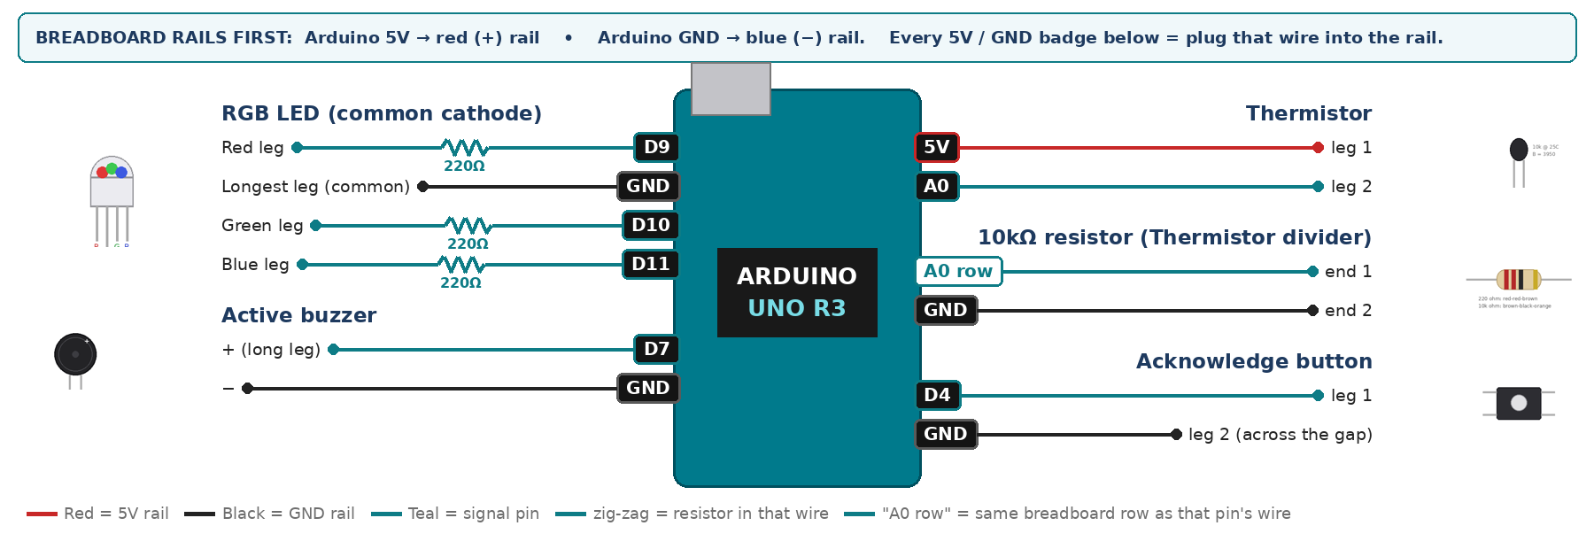
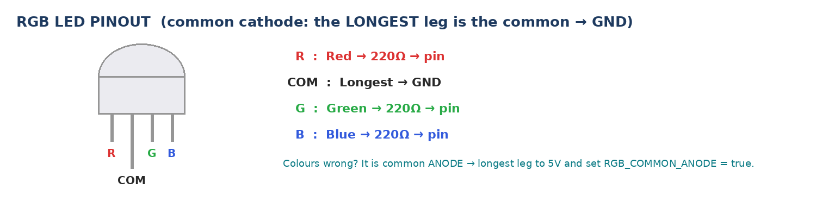
WIRING TABLE – TICK EACH WIRE AS YOU PLACE IT
Component | Component pin | Goes to | Resistor | Note | ✓
Thermistor | leg 1 | 5V rail | — |  | ☐
Thermistor | leg 2 | A0 | — | joins the 10k | ☐
10kΩ resistor (Thermistor divider) | end 1 | same breadboard row as A0 | — | same row as leg 2 | ☐
10kΩ resistor (Thermistor divider) | end 2 | GND rail | — |  | ☐
RGB LED (common cathode) | Red leg | D9 | 220Ω |  | ☐
RGB LED (common cathode) | Longest leg (common) | GND rail | — | no resistor | ☐
RGB LED (common cathode) | Green leg | D10 | 220Ω |  | ☐
RGB LED (common cathode) | Blue leg | D11 | 220Ω |  | ☐
Active buzzer | + (long leg) | D7 | — |  | ☐
Active buzzer | − | GND rail | — |  | ☐
Acknowledge button | leg 1 | D4 | — | INPUT_PULLUP | ☐
Acknowledge button | leg 2 (across the gap) | GND rail | — |  | ☐
BUILD ORDER – USB UNPLUGGED UNTIL STEP 7
- Connect Arduino 5V to the red (+) rail and GND to the blue (−) rail of the breadboard.
- Build the divider and print the raw value. It must change when you pinch the bead.
- Add the Beta equation; check it against a real thermometer — within about 2 degrees.
- Add the RGB LED, buzzer and button.
- Use 20 and 26 for classroom testing; explain that a real fridge uses 2 and 8.
- Check every wire against the table with a partner, THEN plug in the USB. The green ON light must come on – if not, unplug at once (short circuit).
- Arduino IDE: Tools › Board › Arduino Uno, then Tools › Port.
- Paste the code below, press Upload, open Tools › Serial Monitor at 9600 baud and watch your own readings.
STEP 1 – TINKERCAD FIRST (CHECKPOINT MARKS)
Go to www.tinkercad.com › Circuits › Create new Circuit. Build the same wiring, paste the same code, press Start Simulation. Parts that Tinkercad does not have:
- Thermistor → use a TMP36 temperature sensor on the same analog pin (snippet T3).
- Active buzzer → use an LED + 220Ω in its place so you can SEE every beep (no code change).
- RGB LED → 'LED RGB', set it to Cathode in the inspector.
Save it with the name 11.B G7 – Sharing Fridge Guard and share the link with your teacher. The REAL build in class is your AI Project.
HOW THE CODE THINKS
- read A0 and convert it to thermistor resistance
- use the Beta equation to get temperature in Celsius
- blue below the band, red above it, green inside
- if outside, remember the time it first went out
- 30 s outside and not acknowledged → buzzer on
THE COMPLETE CODE (TESTED)
Yellow lines = numbers YOU must change after measuring with your own sensor. Every member must be able to explain at least one line.
/* PROJECT 7 - SHARING FRIDGE GUARD (11.B Group 7)
Thermistor measures temperature. RGB: BLUE too cold, GREEN safe, RED too warm.
Out of range for 30 s -> buzzer until ACKNOWLEDGE is pressed.
Also remembers the lowest and highest temperature since power-on. */
const int TH = A0; // thermistor divider middle point
const int R = 9, G = 10, B = 11; // RGB LED legs (each through 220 ohm)
const int BUZZ = 7; // ACTIVE buzzer
const int ACK = 4; // acknowledge button (other leg to GND)

// classroom demo band - a REAL food fridge uses 2.0 to 8.0
const float SAFE_LOW = 20.0, SAFE_HIGH = 26.0;
const unsigned long ALARM_AFTER = 30000; // 30 seconds

unsigned long outSince = 0, lastPrint = 0;
bool acknowledged = false;
int lastBtn = HIGH;
float tMin = 999, tMax = -999;

// ---------- THERMISTOR -> degrees C (Beta equation) ----------
const float BETA = 3950.0, R0 = 10000.0, T0 = 298.15, RFIX = 10000.0;
float tempC() {
long sum = 0;
for (int i = 0; i < 10; i++) sum += analogRead(TH); // average 10 readings
float raw = sum / 10.0;
if (raw < 1 || raw > 1022) return -99; // wire loose / short
float rTh = RFIX * ((1023.0 / raw) - 1.0); // thermistor to 5V, 10k to GND
float tK = 1.0 / (1.0 / T0 + (1.0 / BETA) * log(rTh / R0));
return tK - 273.15;
}
// ---------- RGB LED ----------
const bool RGB_COMMON_ANODE = false; // true = longest leg goes to 5V instead of GND
void colour(bool r, bool g, bool b) {
digitalWrite(R, RGB_COMMON_ANODE ? !r : r);
digitalWrite(G, RGB_COMMON_ANODE ? !g : g);
digitalWrite(B, RGB_COMMON_ANODE ? !b : b);
}
// True ONCE at the moment a button goes from up (HIGH) to pressed (LOW).
// Holding the button down does NOT repeat it.
bool justPressed(int pin, int &lastState) {
int now = digitalRead(pin);
bool pressed = (lastState == HIGH && now == LOW);
lastState = now;
if (pressed) delay(25); // ignore contact bounce
return pressed;
}

void setup() {
Serial.begin(9600);
pinMode(R, OUTPUT); pinMode(G, OUTPUT); pinMode(B, OUTPUT);
pinMode(BUZZ, OUTPUT);
pinMode(ACK, INPUT_PULLUP);
}

void loop() {
float t = tempC();
if (t == -99) { colour(1, 0, 1); Serial.println("Check thermistor wiring"); delay(500); return; }
if (t < tMin) tMin = t;
if (t > tMax) tMax = t;

bool cold = (t < SAFE_LOW), hot = (t > SAFE_HIGH);
if (cold) colour(0, 0, 1);
else if (hot) colour(1, 0, 0);
else colour(0, 1, 0);

if (justPressed(ACK, lastBtn)) acknowledged = true;

bool alarm = false;
if (cold || hot) {
if (outSince == 0) outSince = millis(); // first moment outside
alarm = (millis() - outSince > ALARM_AFTER) && !acknowledged;
} else {
outSince = 0; acknowledged = false; // back to safe: re-arm
}
digitalWrite(BUZZ, alarm ? HIGH : LOW);

if (millis() - lastPrint >= 1000) {
lastPrint = millis();
Serial.print("T="); Serial.print(t, 1);
Serial.print(" C min="); Serial.print(tMin, 1);
Serial.print(" max="); Serial.println(tMax, 1);
}
}
TEST IT AND RECORD YOUR READINGS
- Hold the bead in your fist for a minute, recording every 10 s.
- Dip in iced water and compare with a real thermometer — write down the error.
- Time the alarm: it must be 30 s, not 5.
Test # | What we did | Reading / value | What happened
1
2
3
4
5
IF IT DOES NOT WORK
- Reads about −273 or a huge number: the divider is reversed. Thermistor to 5V, fixed 10k to GND.
- Reads 5-10 degrees high: the board is warming the bead. Move it onto long wires — and say so in the pitch.
- Temperature falls when you warm it: the two divider legs are swapped.
- Button does nothing: it is not straddling the centre gap, or both wires are on legs that are already joined. Use legs on OPPOSITE sides of the gap.
AT THE STEM WEEK TABLE
Bring a flask of ice water and a cup of warm water. Move the thermistor between them and the colour changes in seconds — visitors see the physics happening.
CHALLENGE: Count how many times the fridge went out of the safe band today (door openings) and print the total every minute.
BUILD A COVER FOR YOUR PROJECT (NOTE)
Make a cover or case that suits your project design, using cardboard or materials from stationery (card, coloured paper, tape, glue, markers). Idea: a shoebox painted white as a mini sharing fridge, with a door that opens and a “Sharing Fridge” sign.
Keep the USB port, the sensor and any buttons or knobs easy to reach. Never cover the Arduino so tightly that wires are pulled.
PROJECT POSTER (SUPPORT – 4 MARKS)
Make one clear poster (A3 paper or Canva) for the STEM Week table. It must show:
- Project name and the school, your names, class and group.
- The problem in the UAE and who it helps.
- How it works in 3 steps: sensor → Arduino decides → output.
- A photo of your real wiring and of the finished project with its cover.
- Your test results (a small table or chart) and one improvement you made.
AI LOG – PROMPTS, EXAMPLES AND DATA (CORE – 4 MARKS)
Use an AI tool (ChatGPT, Claude, Gemini or Z.ai) to help you understand and improve your project, and record EVERY prompt you use. Example prompts:
- Explain line by line what the loop() does in this Arduino sketch for a "Sharing Fridge Guard": [paste the code]
- My sensor gives ___ in one condition and ___ in the other. Which numbers should I put in the CALIBRATE lines and why?
- Suggest one improvement for our "Sharing Fridge Guard" that we can test in one lesson.
AI tool | Prompt we typed | What the AI answered (short) | What we used / changed
PROJECT VIDEO – EXPLAIN THE AI PROCESS AND RESULTS (4 MARKS)
Every group – or each student – records a 1–2 minute video in class. Include:
- Who you are (names, class, group) and the problem your project solves in the UAE.
- How it works: show the real wiring and explain one sensor and one part of the code.
- The AI process: which AI tool you used, one prompt you typed and what you changed because of it.
- Your results: a live demo and your test readings – before and after your improvement.
- One thing you learned.
HOW YOUR PROJECT IS MARKED – 20 MARKS
Criterion | What you must do | For your Arduino project | Marks
Support | Choose an idea and create a clear project poster. | Your project is chosen for you – make a clear A3 / Canva poster: name, problem, how it works, wiring photo, team names. | 4
Core | Use an AI tool and document the required prompts, examples, or data. | Use an AI tool (ChatGPT, Claude, Gemini, Z.ai) to understand, test or improve your code and plan your calibration. Copy your prompts and your sensor data into the AI LOG. | 4
Advanced | Build, test, and improve the project using evidence. | Build the real circuit, test it, record readings, improve it – and show before / after evidence. | 4
Video | Explain the AI process and results in a short video. | 1–2 minute video: how it works, how AI helped you (your prompts) and what your test results show. | 4
On time | Submit the complete project on time. | Poster, AI log, readings table, video and the working project – all ready by Friday 30 October. | 4
TOTAL |  |  | 20
Deadline: submit the complete project – poster, AI log, readings, video and working build – by Friday 30 October (end of Week 9).

