PROJECT 8 OF 21 • 11.B — GROUP 1 • AI PROJECT (ARDUINO) – 20 MARKS
Heritage Light Harp
Play Arabic scales by moving your hands through the air — no touch needed

BUILT IN CLASS, WITH REAL PARTS. First build and test it in Tinkercad (checkpoint marks), then assemble the real Arduino, components and wiring in the ICT lesson. Bring this sheet to every lesson – printed, or saved as pictures/PDF on your iPad.
PURPOSE – WHY THIS PROJECT EXISTS
What it does | Two light sensors act as invisible strings. A hand over the first changes the note through an eight-note scale; a hand over the second changes the colour of the RGB LED. One button switches between a Western major scale and maqam Hijaz, the other jumps an octave. Cover the first sensor fully and the sound stops.
UAE link | Maqam scales and Al Ayala rhythm — Emirati musical heritage
Why it matters | Al Ayala, the Emirati line dance with drums and cane, sits on the UNESCO intangible heritage list — and the maqam scales behind Gulf music use intervals a piano cannot play. Putting those scales into code is one way of preserving them. The second purpose is practical: a person with limited hand strength cannot press keys or hold a cane, but can move a hand through a beam. Touch-free instruments are used in music therapy for exactly this reason, which ties straight back to People of Determination.
Who it helps | Children and visitors at heritage events — Emirati music and culture explained through science.
The science | tone() makes a square wave at a chosen frequency. Notes are frequencies — A4 is 440 Hz and one octave up is double, 880 Hz.
COMPONENTS YOU NEED
Component | Qty
Arduino UNO R3 + USB cable | 1
400-point breadboard | 1
Photoresistor (LDR) | 2
Passive buzzer | 1
RGB LED | 1
Push button | 2
220Ω resistors (red-red-brown) | 3
10kΩ resistors (brown-black-orange) | 2
Jumper wires (male-male) | about 20
WIRING DIAGRAM – EVERY PIN, EVERY WIRE
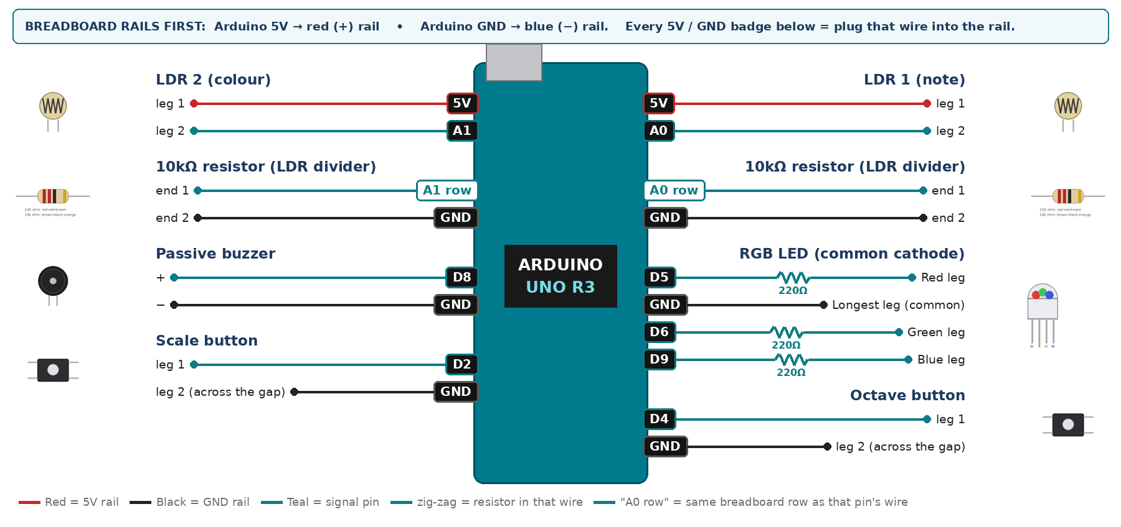
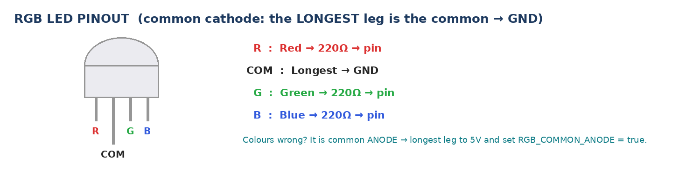
WIRING TABLE – TICK EACH WIRE AS YOU PLACE IT
Component | Component pin | Goes to | Resistor | Note | ✓
LDR 1 (note) | leg 1 | 5V rail | — |  | ☐
LDR 1 (note) | leg 2 | A0 | — | joins the 10k | ☐
10kΩ resistor (LDR divider) | end 1 | same breadboard row as A0 | — | same row as leg 2 | ☐
10kΩ resistor (LDR divider) | end 2 | GND rail | — |  | ☐
LDR 2 (colour) | leg 1 | 5V rail | — |  | ☐
LDR 2 (colour) | leg 2 | A1 | — | joins the 10k | ☐
10kΩ resistor (LDR divider) | end 1 | same breadboard row as A1 | — | same row as leg 2 | ☐
10kΩ resistor (LDR divider) | end 2 | GND rail | — |  | ☐
Passive buzzer | + | D8 | — | tone() | ☐
Passive buzzer | − | GND rail | — |  | ☐
RGB LED (common cathode) | Red leg | D5 | 220Ω |  | ☐
RGB LED (common cathode) | Longest leg (common) | GND rail | — | no resistor | ☐
RGB LED (common cathode) | Green leg | D6 | 220Ω |  | ☐
RGB LED (common cathode) | Blue leg | D9 | 220Ω |  | ☐
Scale button | leg 1 | D2 | — | INPUT_PULLUP | ☐
Scale button | leg 2 (across the gap) | GND rail | — |  | ☐
Octave button | leg 1 | D4 | — | INPUT_PULLUP | ☐
Octave button | leg 2 (across the gap) | GND rail | — |  | ☐
BUILD ORDER – USB UNPLUGGED UNTIL STEP 7
- Connect Arduino 5V to the red (+) rail and GND to the blue (−) rail of the breadboard.
- Build both LDR dividers and print A0 and A1. Record the lamp-on and fully-covered values.
- Add the passive buzzer and test a single tone(BUZZ, 440) first.
- Add the RGB LED on pins 5, 6 and 9 ONLY — never 3 or 11, because tone() takes that timer.
- Add the two buttons and calibrate.
- Check every wire against the table with a partner, THEN plug in the USB. The green ON light must come on – if not, unplug at once (short circuit).
- Arduino IDE: Tools › Board › Arduino Uno, then Tools › Port.
- Paste the code below, press Upload, open Tools › Serial Monitor at 9600 baud and watch your own readings.
STEP 1 – TINKERCAD FIRST (CHECKPOINT MARKS)
Go to www.tinkercad.com › Circuits › Create new Circuit. Build the same wiring, paste the same code, press Start Simulation. Parts that Tinkercad does not have:
- Passive buzzer → use a Piezo (same code, tone() works).
- RGB LED → 'LED RGB', set it to Cathode in the inspector.
Save it with the name 11.B G1 – Heritage Light Harp and share the link with your teacher. The REAL build in class is your AI Project.
HOW THE CODE THINKS
- scale button swaps between major and hijaz
- octave button swaps the multiplier between 1 and 2
- map LDR 1 to a note index 0 to 7
- LDR 1 almost fully covered → silence
- map LDR 2 to a colour and analogWrite it to the RGB
THE COMPLETE CODE (TESTED)
Yellow lines = numbers YOU must change after measuring with your own sensor. Every member must be able to explain at least one line.
/* PROJECT 8 - HERITAGE LIGHT HARP (11.B Group 1)
Hand over LDR 1 = choose the note. Hand over LDR 2 = change the colour.
SCALE button: Western major <-> maqam Hijaz feel. OCTAVE button: x1 / x2. */
const int L1 = A0, L2 = A1; // LDR dividers
const int BUZZ = 8; // PASSIVE buzzer (tone)
const int R = 5, G = 6, B = 9; // RGB on PWM pins (NOT 3 or 11: tone() uses that timer)
const int SW_SCALE = 2, SW_OCT = 4; // buttons (other leg to GND)

int major[8] = {262, 294, 330, 349, 392, 440, 494, 523}; // C major
int hijaz[8] = {262, 277, 330, 349, 392, 415, 494, 523}; // maqam Hijaz feel

// ---- CALIBRATE with your own readings (Serial Monitor) ----
const int BRIGHT = 800; // LDR in full light
const int COVERED = 120; // hand close over the LDR
const int SILENCE_LEVEL = 80; // completely covered = silence
const bool RGB_COMMON_ANODE = false; // true = longest leg to 5V

bool useHijaz = false;
int octave = 1, lastNote = 0;
int lastScale = HIGH, lastOct = HIGH;

// True ONCE at the moment a button goes from up (HIGH) to pressed (LOW).
// Holding the button down does NOT repeat it.
bool justPressed(int pin, int &lastState) {
int now = digitalRead(pin);
bool pressed = (lastState == HIGH && now == LOW);
lastState = now;
if (pressed) delay(25); // ignore contact bounce
return pressed;
}

int readAvg(int pin) { // average 5 readings (lights flicker at 50 Hz)
long s = 0;
for (int i = 0; i < 5; i++) s += analogRead(pin);
return s / 5;
}

void pwm(int pin, int v) {
v = constrain(v, 0, 255);
analogWrite(pin, RGB_COMMON_ANODE ? 255 - v : v);
}

void setup() {
Serial.begin(9600);
pinMode(SW_SCALE, INPUT_PULLUP);
pinMode(SW_OCT, INPUT_PULLUP);
pinMode(R, OUTPUT); pinMode(G, OUTPUT); pinMode(B, OUTPUT);
}

void loop() {
if (justPressed(SW_SCALE, lastScale)) { useHijaz = !useHijaz; Serial.println(useHijaz ? "HIJAZ" : "MAJOR"); }
if (justPressed(SW_OCT, lastOct)) { octave = (octave == 1) ? 2 : 1; }

int a = readAvg(L1);
int b = readAvg(L2);

int note = 0;
if (a >= SILENCE_LEVEL) {
int idx = constrain(map(a, COVERED, BRIGHT, 0, 7), 0, 7);
note = (useHijaz ? hijaz[idx] : major[idx]) * octave;
}
if (note != lastNote) { // only change the sound when the note changes
if (note == 0) noTone(BUZZ); else tone(BUZZ, note);
lastNote = note;
}

int hue = constrain(map(b, COVERED, BRIGHT, 0, 255), 0, 255);
pwm(R, hue);
pwm(G, 255 - hue);
pwm(B, abs(128 - hue) * 2);

Serial.print(a); Serial.print(","); Serial.println(b);
delay(30);
}
TEST IT AND RECORD YOUR READINGS
- Record the A0 value at each of the eight note positions so you can play on purpose, not by luck.
- Test under classroom lights, then by the window. Write down what changes.
- Play a recognisable eight-note phrase and record it on a phone.
Test # | What we did | Reading / value | What happened
1
2
3
4
5
IF IT DOES NOT WORK
- No sound at all: that is the ACTIVE buzzer. tone() needs the PASSIVE one.
- RGB flickers or a colour sticks: you used pin 3 or 11. tone() owns that timer — use 5, 6, 9.
- Notes jump randomly: classroom lights flicker at 50 Hz. Use a desk lamp and average five readings.
- Button does nothing: it is not straddling the centre gap, or both wires are on legs that are already joined. Use legs on OPPOSITE sides of the gap.
AT THE STEM WEEK TABLE
Fix a desk lamp above the sensors so calibration holds in a busy hall. Tape a paper strip with note names beside LDR 1 and let visitors play it themselves — do not play it for them.
CHALLENGE: Store the last 16 notes with their timings in an array and replay them when a button is held.
BUILD A COVER FOR YOUR PROJECT (NOTE)
Make a cover or case that suits your project design, using cardboard or materials from stationery (card, coloured paper, tape, glue, markers). Idea: a cardboard harp or oud shape decorated with Al Sadu-pattern paper; the LDRs sit where the strings are.
Keep the USB port, the sensor and any buttons or knobs easy to reach. Never cover the Arduino so tightly that wires are pulled.
PROJECT POSTER (SUPPORT – 4 MARKS)
Make one clear poster (A3 paper or Canva) for the STEM Week table. It must show:
- Project name and the school, your names, class and group.
- The problem in the UAE and who it helps.
- How it works in 3 steps: sensor → Arduino decides → output.
- A photo of your real wiring and of the finished project with its cover.
- Your test results (a small table or chart) and one improvement you made.
AI LOG – PROMPTS, EXAMPLES AND DATA (CORE – 4 MARKS)
Use an AI tool (ChatGPT, Claude, Gemini or Z.ai) to help you understand and improve your project, and record EVERY prompt you use. Example prompts:
- Explain line by line what the loop() does in this Arduino sketch for a "Heritage Light Harp": [paste the code]
- My sensor gives ___ in one condition and ___ in the other. Which numbers should I put in the CALIBRATE lines and why?
- Suggest one improvement for our "Heritage Light Harp" that we can test in one lesson.
AI tool | Prompt we typed | What the AI answered (short) | What we used / changed
PROJECT VIDEO – EXPLAIN THE AI PROCESS AND RESULTS (4 MARKS)
Every group – or each student – records a 1–2 minute video in class. Include:
- Who you are (names, class, group) and the problem your project solves in the UAE.
- How it works: show the real wiring and explain one sensor and one part of the code.
- The AI process: which AI tool you used, one prompt you typed and what you changed because of it.
- Your results: a live demo and your test readings – before and after your improvement.
- One thing you learned.
HOW YOUR PROJECT IS MARKED – 20 MARKS
Criterion | What you must do | For your Arduino project | Marks
Support | Choose an idea and create a clear project poster. | Your project is chosen for you – make a clear A3 / Canva poster: name, problem, how it works, wiring photo, team names. | 4
Core | Use an AI tool and document the required prompts, examples, or data. | Use an AI tool (ChatGPT, Claude, Gemini, Z.ai) to understand, test or improve your code and plan your calibration. Copy your prompts and your sensor data into the AI LOG. | 4
Advanced | Build, test, and improve the project using evidence. | Build the real circuit, test it, record readings, improve it – and show before / after evidence. | 4
Video | Explain the AI process and results in a short video. | 1–2 minute video: how it works, how AI helped you (your prompts) and what your test results show. | 4
On time | Submit the complete project on time. | Poster, AI log, readings table, video and the working project – all ready by Friday 30 October. | 4
TOTAL |  |  | 20
Deadline: submit the complete project – poster, AI log, readings, video and working build – by Friday 30 October (end of Week 9).

