PROJECT 9 OF 21 • 11.B — GROUP 2 • AI PROJECT (ARDUINO) – 20 MARKS
Dust Storm School Alert
Decides whether it is safe to hold PE and assembly outdoors today

BUILT IN CLASS, WITH REAL PARTS. First build and test it in Tinkercad (checkpoint marks), then assemble the real Arduino, components and wiring in the ICT lesson. Bring this sheet to every lesson – printed, or saved as pictures/PDF on your iPad.
PURPOSE – WHY THIS PROJECT EXISTS
What it does | Measures daylight, temperature and humidity together and streams all three as live graphs to the Arduino Serial Plotter. When daylight drops sharply in the middle of the day while temperature stays high, that pattern means airborne dust. Three LEDs give the verdict: green for outdoor activity, yellow for caution, red for keep indoors.
UAE link | Shamal dust storms — a recurring UAE health and school-safety decision
Why it matters | Shamal winds blow dust across the Emirates several times a year, and every school has to decide each morning whether to send children outside. Children with asthma pay for a wrong decision. Official monitoring stations are few, so a school on the coast often reads data from a city away. A device on your own roof reports YOUR playground. You must also be honest at the booth: this is a visibility proxy, not a PM2.5 sensor, and knowing that difference is the mark of a real scientist.
Who it helps | School leaders and PE teachers deciding on outdoor activities, and students with asthma.
The science | Serial Plotter draws every comma-separated number as its own line. Scale the values so all three fit one axis.
COMPONENTS YOU NEED
Component | Qty
Arduino UNO R3 + USB cable | 1
400-point breadboard | 1
DHT11 sensor | 1
Photoresistor (LDR) | 1
LED | 3
220Ω resistors (red-red-brown) | 3
10kΩ resistors (brown-black-orange) | 1
Jumper wires (male-male) | about 20
Male-FEMALE jumper wires (for modules) | 3
WIRING DIAGRAM – EVERY PIN, EVERY WIRE
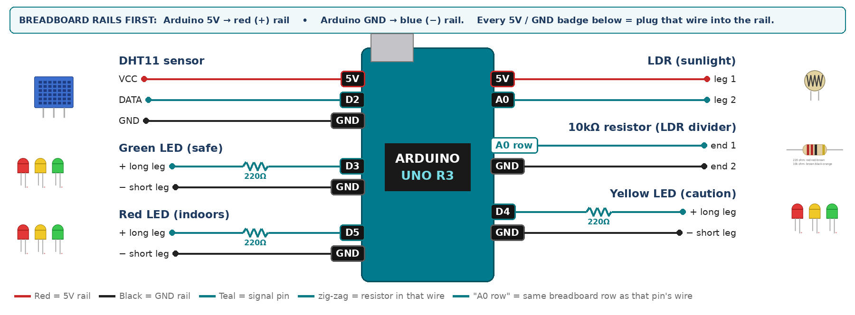
WIRING TABLE – TICK EACH WIRE AS YOU PLACE IT
Component | Component pin | Goes to | Resistor | Note | ✓
DHT11 sensor | VCC | 5V rail | — |  | ☐
DHT11 sensor | DATA | D2 | — | 10k to 5V if nan | ☐
DHT11 sensor | GND | GND rail | — |  | ☐
LDR (sunlight) | leg 1 | 5V rail | — |  | ☐
LDR (sunlight) | leg 2 | A0 | — | joins the 10k | ☐
10kΩ resistor (LDR divider) | end 1 | same breadboard row as A0 | — | same row as leg 2 | ☐
10kΩ resistor (LDR divider) | end 2 | GND rail | — |  | ☐
Green LED (safe) | + long leg | D3 | 220Ω |  | ☐
Green LED (safe) | − short leg | GND rail | — |  | ☐
Yellow LED (caution) | + long leg | D4 | 220Ω |  | ☐
Yellow LED (caution) | − short leg | GND rail | — |  | ☐
Red LED (indoors) | + long leg | D5 | 220Ω |  | ☐
Red LED (indoors) | − short leg | GND rail | — |  | ☐
BUILD ORDER – USB UNPLUGGED UNTIL STEP 7
- Connect Arduino 5V to the red (+) rail and GND to the blue (−) rail of the breadboard.
- Get the DHT11 printing temperature and humidity to Serial first.
- Add the LDR divider and check the value drops when you cover it.
- Print all three as one comma-separated line, then open Tools › Serial Plotter.
- Add the LEDs and collect a full lesson of data.
- Check every wire against the table with a partner, THEN plug in the USB. The green ON light must come on – if not, unplug at once (short circuit).
- Arduino IDE: Tools › Board › Arduino Uno, then Tools › Port. Sketch › Include Library › Manage Libraries → install "DHT sensor library" (Adafruit) and "Adafruit Unified Sensor".
- Paste the code below, press Upload, open Tools › Serial Monitor at 9600 baud and watch your own readings.
STEP 1 – TINKERCAD FIRST (CHECKPOINT MARKS)
Go to www.tinkercad.com › Circuits › Create new Circuit. Build the same wiring, paste the same code, press Start Simulation. Parts that Tinkercad does not have:
- DHT11 → not in Tinkercad: use a TMP36 temperature sensor on A2 + a potentiometer on A3 as 'humidity' (snippet T1).
Save it with the name 11.B G2 – Dust Storm School Alert and share the link with your teacher. The REAL build in class is your AI Project.
HOW THE CODE THINKS
- read temperature, humidity and daylight
- skip the round if the DHT11 returns nan
- print temperature, comma, humidity, comma, light ÷ 10
- bright daylight → green; clearly reduced → yellow; heavily reduced → red
THE COMPLETE CODE (TESTED)
Yellow lines = numbers YOU must change after measuring with your own sensor. Every member must be able to explain at least one line.
/* PROJECT 9 - DUST STORM SCHOOL ALERT (11.B Group 2)
Dust in the air blocks sunlight. The LDR compares today's light with a
clear day: GREEN safe, YELLOW caution, RED = keep students indoors.
The DHT11 adds temperature and humidity to the Serial Plotter. */
#include <DHT.h>
#define DHTPIN 2
#define DHTTYPE DHT11
DHT dht(DHTPIN, DHTTYPE);

const int LDR = A0;
const int SAFE = 3, CAUTION = 4, INDOORS = 5; // LEDs (each through 220 ohm)

// ---- CALIBRATE: LDR reading on a CLEAR day at the same hour ----
const int CLEAR_DAY = 700;

void setup() {
Serial.begin(9600);
dht.begin();
pinMode(SAFE, OUTPUT); pinMode(CAUTION, OUTPUT); pinMode(INDOORS, OUTPUT);
delay(1000);
}

void loop() {
long sum = 0;
for (int i = 0; i < 10; i++) { sum += analogRead(LDR); delay(5); }
int light = sum / 10;
float percent = 100.0 * light / CLEAR_DAY; // % of a clear day's light

digitalWrite(SAFE, percent > 75);
digitalWrite(CAUTION, percent <= 75 && percent > 45);
digitalWrite(INDOORS, percent <= 45);

float t = dht.readTemperature();
float h = dht.readHumidity();
if (isnan(t) || isnan(h)) { t = 0; h = 0; } // keep the plotter running

// numbers only -> Tools > Serial Plotter draws three lines
Serial.print(t); Serial.print(",");
Serial.print(h); Serial.print(",");
Serial.println(percent);
delay(2000); // DHT11: never faster than 2 s
}
TEST IT AND RECORD YOUR READINGS
- Record 20 readings by the window and 20 in the middle of the room.
- Hold a dusty cloth over the LDR to simulate haze and record the drop.
- Copy an hour of Serial output into Excel and draw a line chart.
Test # | What we did | Reading / value | What happened
1
2
3
4
5
IF IT DOES NOT WORK
- Plotter shows one flat line: you printed words as well as numbers. Print numbers only.
- nan appears often: the DHT11 updates every 2 s — never go below delay(2000).
- Verdict flips at sunset — a genuine limit. Say that a real unit would check the clock.
AT THE STEM WEEK TABLE
Project the Serial Plotter behind your table — a live moving graph pulls people in from across the hall. Pin your Excel chart of a real day beside it.
CHALLENGE: Log a whole school day, then compare your readings with the published air-quality index for Ajman and report how closely they agree.
BUILD A COVER FOR YOUR PROJECT (NOTE)
Make a cover or case that suits your project design, using cardboard or materials from stationery (card, coloured paper, tape, glue, markers). Idea: a cardboard school building with the LDR on the roof and the three LEDs on the front gate.
Keep the USB port, the sensor and any buttons or knobs easy to reach. Never cover the Arduino so tightly that wires are pulled.
PROJECT POSTER (SUPPORT – 4 MARKS)
Make one clear poster (A3 paper or Canva) for the STEM Week table. It must show:
- Project name and the school, your names, class and group.
- The problem in the UAE and who it helps.
- How it works in 3 steps: sensor → Arduino decides → output.
- A photo of your real wiring and of the finished project with its cover.
- Your test results (a small table or chart) and one improvement you made.
AI LOG – PROMPTS, EXAMPLES AND DATA (CORE – 4 MARKS)
Use an AI tool (ChatGPT, Claude, Gemini or Z.ai) to help you understand and improve your project, and record EVERY prompt you use. Example prompts:
- Explain line by line what the loop() does in this Arduino sketch for a "Dust Storm School Alert": [paste the code]
- My sensor gives ___ in one condition and ___ in the other. Which numbers should I put in the CALIBRATE lines and why?
- Suggest one improvement for our "Dust Storm School Alert" that we can test in one lesson.
AI tool | Prompt we typed | What the AI answered (short) | What we used / changed
PROJECT VIDEO – EXPLAIN THE AI PROCESS AND RESULTS (4 MARKS)
Every group – or each student – records a 1–2 minute video in class. Include:
- Who you are (names, class, group) and the problem your project solves in the UAE.
- How it works: show the real wiring and explain one sensor and one part of the code.
- The AI process: which AI tool you used, one prompt you typed and what you changed because of it.
- Your results: a live demo and your test readings – before and after your improvement.
- One thing you learned.
HOW YOUR PROJECT IS MARKED – 20 MARKS
Criterion | What you must do | For your Arduino project | Marks
Support | Choose an idea and create a clear project poster. | Your project is chosen for you – make a clear A3 / Canva poster: name, problem, how it works, wiring photo, team names. | 4
Core | Use an AI tool and document the required prompts, examples, or data. | Use an AI tool (ChatGPT, Claude, Gemini, Z.ai) to understand, test or improve your code and plan your calibration. Copy your prompts and your sensor data into the AI LOG. | 4
Advanced | Build, test, and improve the project using evidence. | Build the real circuit, test it, record readings, improve it – and show before / after evidence. | 4
Video | Explain the AI process and results in a short video. | 1–2 minute video: how it works, how AI helped you (your prompts) and what your test results show. | 4
On time | Submit the complete project on time. | Poster, AI log, readings table, video and the working project – all ready by Friday 30 October. | 4
TOTAL |  |  | 20
Deadline: submit the complete project – poster, AI log, readings, video and working build – by Friday 30 October (end of Week 9).

