PROJECT 10 OF 21 • 11.C — GROUP 5 • AI PROJECT (ARDUINO) – 20 MARKS
Hot Car Child Alarm
Detects an occupied seat in a parked car and alarms before the cabin turns dangerous

BUILT IN CLASS, WITH REAL PARTS. First build and test it in Tinkercad (checkpoint marks), then assemble the real Arduino, components and wiring in the ICT lesson. Bring this sheet to every lesson – printed, or saved as pictures/PDF on your iPad.
PURPOSE – WHY THIS PROJECT EXISTS
What it does | A switch under the seat cushion shows the seat is occupied. The DHT11 watches cabin temperature. If the seat is occupied AND the cabin passes the danger temperature, the RGB flashes red and the buzzer sounds continuously. A button arms and disarms it when the driver returns.
UAE link | Children left in parked cars — a recurring UAE summer tragedy
Why it matters | A car parked in Gulf sunshine can pass 60 degrees inside in under twenty minutes, and children die this way in the UAE almost every summer. The parent is never careless on purpose — the failure is memory, and memory is exactly what a machine is good at. The AND condition is the entire design: alarm only when the seat is occupied and it is hot. An empty parked car that screams all afternoon gets disconnected within a week, and then it saves nobody.
Who it helps | Parents of young children — and every driver who has ever left a car in the summer sun.
The science | A tilt switch is not a weight sensor. Say honestly at the booth that a real product uses a pressure pad — this is a working model of the logic, not the finished product.
COMPONENTS YOU NEED
Component | Qty
Arduino UNO R3 + USB cable | 1
400-point breadboard | 1
Tilt / vibration switch | 1
DHT11 sensor | 1
Active buzzer | 1
Push button | 1
RGB LED | 1
220Ω resistors (red-red-brown) | 3
Jumper wires (male-male) | about 20
Male-FEMALE jumper wires (for modules) | 3
WIRING DIAGRAM – EVERY PIN, EVERY WIRE
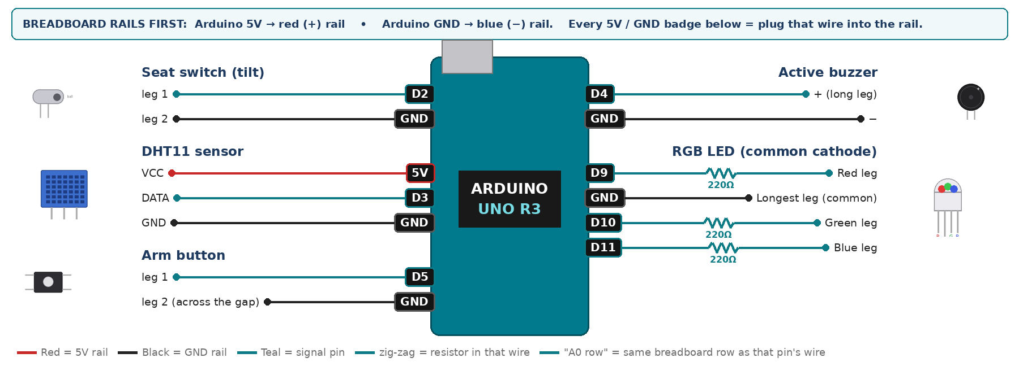
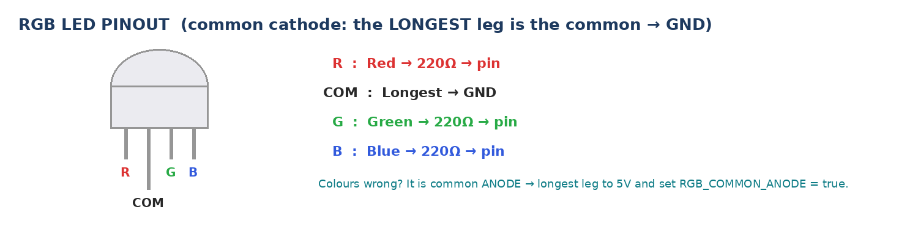
WIRING TABLE – TICK EACH WIRE AS YOU PLACE IT
Component | Component pin | Goes to | Resistor | Note | ✓
Seat switch (tilt) | leg 1 | D2 | — | INPUT_PULLUP | ☐
Seat switch (tilt) | leg 2 | GND rail | — |  | ☐
DHT11 sensor | VCC | 5V rail | — |  | ☐
DHT11 sensor | DATA | D3 | — | 10k to 5V if nan | ☐
DHT11 sensor | GND | GND rail | — |  | ☐
Active buzzer | + (long leg) | D4 | — |  | ☐
Active buzzer | − | GND rail | — |  | ☐
Arm button | leg 1 | D5 | — | INPUT_PULLUP | ☐
Arm button | leg 2 (across the gap) | GND rail | — |  | ☐
RGB LED (common cathode) | Red leg | D9 | 220Ω |  | ☐
RGB LED (common cathode) | Longest leg (common) | GND rail | — | no resistor | ☐
RGB LED (common cathode) | Green leg | D10 | 220Ω |  | ☐
RGB LED (common cathode) | Blue leg | D11 | 220Ω |  | ☐
BUILD ORDER – USB UNPLUGGED UNTIL STEP 7
- Connect Arduino 5V to the red (+) rail and GND to the blue (−) rail of the breadboard.
- Wire the tilt switch and print its state. Tape it under a folded cloth so pressing tips it.
- Add the DHT11 and confirm the temperature reading.
- Add the RGB LED and buzzer.
- Set the limit to 32 for the classroom; explain that a real unit uses 30.
- Check every wire against the table with a partner, THEN plug in the USB. The green ON light must come on – if not, unplug at once (short circuit).
- Arduino IDE: Tools › Board › Arduino Uno, then Tools › Port. Sketch › Include Library › Manage Libraries → install "DHT sensor library" (Adafruit) and "Adafruit Unified Sensor".
- Paste the code below, press Upload, open Tools › Serial Monitor at 9600 baud and watch your own readings.
STEP 1 – TINKERCAD FIRST (CHECKPOINT MARKS)
Go to www.tinkercad.com › Circuits › Create new Circuit. Build the same wiring, paste the same code, press Start Simulation. Parts that Tinkercad does not have:
- DHT11 → not in Tinkercad: use a TMP36 temperature sensor on A2 + a potentiometer on A3 as 'humidity' (snippet T1).
- Active buzzer → use an LED + 220Ω in its place so you can SEE every beep (no code change).
- Tilt switch → use Tinkercad's Tilt Sensor, or a Pushbutton/Slideswitch to fake a tilt.
- RGB LED → 'LED RGB', set it to Cathode in the inspector.
Save it with the name 11.C G5 – Hot Car Child Alarm and share the link with your teacher. The REAL build in class is your AI Project.
HOW THE CODE THINKS
- arm button flips the armed flag; not armed → blue LED, silent
- read the seat (LOW = occupied) and the cabin temperature
- occupied AND above the limit → flash red and sound the buzzer
- occupied only → yellow, silent; empty → green, silent
THE COMPLETE CODE (TESTED)
Yellow lines = numbers YOU must change after measuring with your own sensor. Every member must be able to explain at least one line.
/* PROJECT 10 - HOT CAR CHILD ALARM (11.C Group 5)
Alarm ONLY when the seat is occupied AND the car is too hot.
RGB: GREEN empty, YELLOW occupied & OK, flashing RED + buzzer = danger,
BLUE = system disarmed (ARM button toggles). */
#include <DHT.h>
#define DHTPIN 3
#define DHTTYPE DHT11
DHT dht(DHTPIN, DHTTYPE);

const int SEAT = 2; // tilt switch as seat sensor (LOW = occupied)
const int BUZZ = 4; // ACTIVE buzzer
const int ARM = 5; // ARM / DISARM button
const int R = 9, G = 10, B = 11; // RGB LED (each through 220 ohm)
const float TEMP_LIMIT = 32.0; // 32 for the class demo, about 30 in a real car

bool armed = true;
int lastBtn = HIGH;
float t = NAN;
unsigned long lastRead = 0;

// ---------- RGB LED ----------
const bool RGB_COMMON_ANODE = false; // true = longest leg goes to 5V instead of GND
void colour(bool r, bool g, bool b) {
digitalWrite(R, RGB_COMMON_ANODE ? !r : r);
digitalWrite(G, RGB_COMMON_ANODE ? !g : g);
digitalWrite(B, RGB_COMMON_ANODE ? !b : b);
}
// True ONCE at the moment a button goes from up (HIGH) to pressed (LOW).
// Holding the button down does NOT repeat it.
bool justPressed(int pin, int &lastState) {
int now = digitalRead(pin);
bool pressed = (lastState == HIGH && now == LOW);
lastState = now;
if (pressed) delay(25); // ignore contact bounce
return pressed;
}

void setup() {
Serial.begin(9600);
dht.begin();
pinMode(SEAT, INPUT_PULLUP);
pinMode(ARM, INPUT_PULLUP);
pinMode(BUZZ, OUTPUT);
pinMode(R, OUTPUT); pinMode(G, OUTPUT); pinMode(B, OUTPUT);
}

void loop() {
if (justPressed(ARM, lastBtn)) { armed = !armed; Serial.println(armed ? "ARMED" : "DISARMED"); }

if (millis() - lastRead >= 2000) { // DHT11 every 2 s
lastRead = millis();
float v = dht.readTemperature();
if (!isnan(v)) t = v;
Serial.print("occupied="); Serial.print(digitalRead(SEAT) == LOW);
Serial.print(" T="); Serial.println(t);
}

if (!armed) { colour(0, 0, 1); digitalWrite(BUZZ, LOW); return; }

bool occupied = (digitalRead(SEAT) == LOW);
bool danger = occupied && !isnan(t) && t > TEMP_LIMIT; // the AND is the whole idea

if (danger) {
bool flashOn = (millis() / 300) % 2; // flash every 300 ms
colour(flashOn, 0, 0);
digitalWrite(BUZZ, flashOn);
} else {
digitalWrite(BUZZ, LOW);
if (occupied) colour(1, 1, 0); // yellow
else colour(0, 1, 0); // green
}
}
TEST IT AND RECORD YOUR READINGS
- Occupied plus a cool room MUST stay quiet — this proves you did not just build a thermometer alarm.
- Occupied plus warm hands on the sensor: alarm within seconds.
- Empty seat plus a hot sensor MUST stay quiet.
Test # | What we did | Reading / value | What happened
1
2
3
4
5
IF IT DOES NOT WORK
- Seat always reads occupied: the ball rests closed. Mount it so the resting state is OPEN.
- Alarm fires on an empty seat: you used OR instead of AND.
- Temperature climbs too slowly for the booth: hold the DHT11 in your fist or drop the limit to 30.
- Button does nothing: it is not straddling the centre gap, or both wires are on legs that are already joined. Use legs on OPPOSITE sides of the gap.
AT THE STEM WEEK TABLE
Use a shoebox as the car with a doll on the seat and a hairdryer on low. Print on the poster how hot a parked car in Ajman gets in twenty minutes in July.
CHALLENGE: Add a 60-second grace period, then argue whether that delay makes the device safer or more dangerous.
BUILD A COVER FOR YOUR PROJECT (NOTE)
Make a cover or case that suits your project design, using cardboard or materials from stationery (card, coloured paper, tape, glue, markers). Idea: a shoebox car with a paper seat; the tilt switch hides under the seat and the DHT11 on the dashboard.
Keep the USB port, the sensor and any buttons or knobs easy to reach. Never cover the Arduino so tightly that wires are pulled.
PROJECT POSTER (SUPPORT – 4 MARKS)
Make one clear poster (A3 paper or Canva) for the STEM Week table. It must show:
- Project name and the school, your names, class and group.
- The problem in the UAE and who it helps.
- How it works in 3 steps: sensor → Arduino decides → output.
- A photo of your real wiring and of the finished project with its cover.
- Your test results (a small table or chart) and one improvement you made.
AI LOG – PROMPTS, EXAMPLES AND DATA (CORE – 4 MARKS)
Use an AI tool (ChatGPT, Claude, Gemini or Z.ai) to help you understand and improve your project, and record EVERY prompt you use. Example prompts:
- Explain line by line what the loop() does in this Arduino sketch for a "Hot Car Child Alarm": [paste the code]
- My sensor gives ___ in one condition and ___ in the other. Which numbers should I put in the CALIBRATE lines and why?
- Suggest one improvement for our "Hot Car Child Alarm" that we can test in one lesson.
AI tool | Prompt we typed | What the AI answered (short) | What we used / changed
PROJECT VIDEO – EXPLAIN THE AI PROCESS AND RESULTS (4 MARKS)
Every group – or each student – records a 1–2 minute video in class. Include:
- Who you are (names, class, group) and the problem your project solves in the UAE.
- How it works: show the real wiring and explain one sensor and one part of the code.
- The AI process: which AI tool you used, one prompt you typed and what you changed because of it.
- Your results: a live demo and your test readings – before and after your improvement.
- One thing you learned.
HOW YOUR PROJECT IS MARKED – 20 MARKS
Criterion | What you must do | For your Arduino project | Marks
Support | Choose an idea and create a clear project poster. | Your project is chosen for you – make a clear A3 / Canva poster: name, problem, how it works, wiring photo, team names. | 4
Core | Use an AI tool and document the required prompts, examples, or data. | Use an AI tool (ChatGPT, Claude, Gemini, Z.ai) to understand, test or improve your code and plan your calibration. Copy your prompts and your sensor data into the AI LOG. | 4
Advanced | Build, test, and improve the project using evidence. | Build the real circuit, test it, record readings, improve it – and show before / after evidence. | 4
Video | Explain the AI process and results in a short video. | 1–2 minute video: how it works, how AI helped you (your prompts) and what your test results show. | 4
On time | Submit the complete project on time. | Poster, AI log, readings table, video and the working project – all ready by Friday 30 October. | 4
TOTAL |  |  | 20
Deadline: submit the complete project – poster, AI log, readings, video and working build – by Friday 30 October (end of Week 9).

