PROJECT 11 OF 21 • 11.C — GROUP 6 • AI PROJECT (ARDUINO) – 20 MARKS
Masjid Parking Counter
Shows free spaces at the gate so nobody circles during Jumu'ah

BUILT IN CLASS, WITH REAL PARTS. First build and test it in Tinkercad (checkpoint marks), then assemble the real Arduino, components and wiring in the ICT lesson. Bring this sheet to every lesson – printed, or saved as pictures/PDF on your iPad.
PURPOSE – WHY THIS PROJECT EXISTS
What it does | An infrared beam at the entrance detects each car passing. The 7-segment counts free spaces down from 9. Green means spaces remain; at zero the red LED lights and the buzzer signals FULL. A button resets the count.
UAE link | Friday prayer parking overflow — every neighbourhood mosque in the country
Why it matters | Anyone who has arrived late to Jumu'ah knows the problem: the car park is full, cars circle the block, and worshippers end up parked across residents' driveways. A sign at the gate showing free spaces solves it, and this is genuinely how mall systems work. The hard part is not the sensor — it is the counting. You must detect the MOMENT the beam breaks, not the fact that it is broken, or one slow car counts as fifty.
Who it helps | Worshippers looking for a space before Jumu'ah prayer and the volunteers who marshal traffic.
The science | Edge detection: compare the current reading with the previous one and count only on a HIGH to LOW change. This idea appears everywhere in computing.
COMPONENTS YOU NEED
Component | Qty
Arduino UNO R3 + USB cable | 1
400-point breadboard | 1
1-digit 7-segment (common cathode) | 1
LED | 2
Active buzzer | 1
IR obstacle module | 1
Push button | 1
220Ω resistors (red-red-brown) | 9
Jumper wires (male-male) | about 20
Male-FEMALE jumper wires (for modules) | 3
WIRING DIAGRAM – EVERY PIN, EVERY WIRE
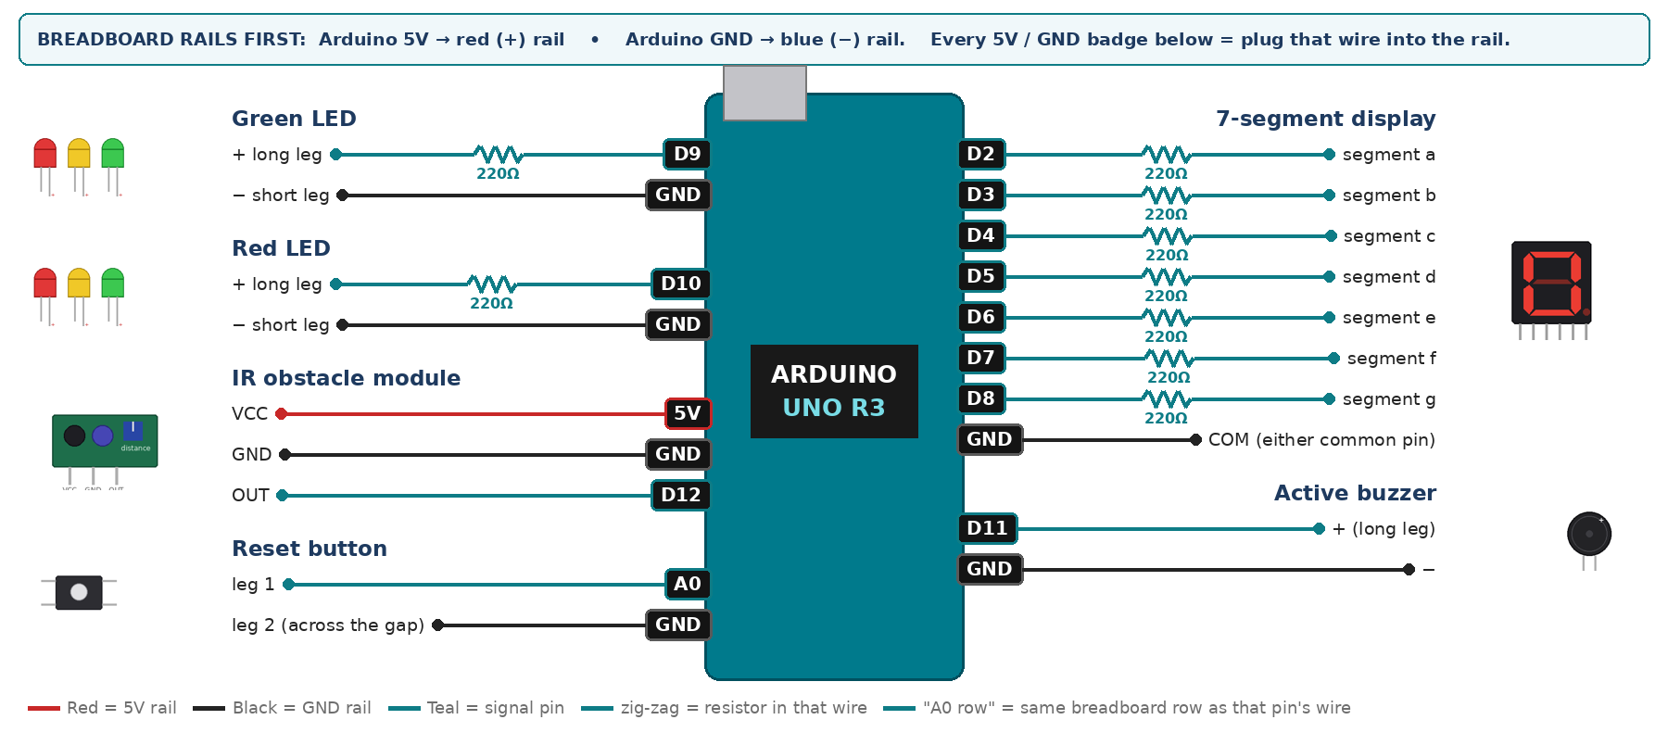
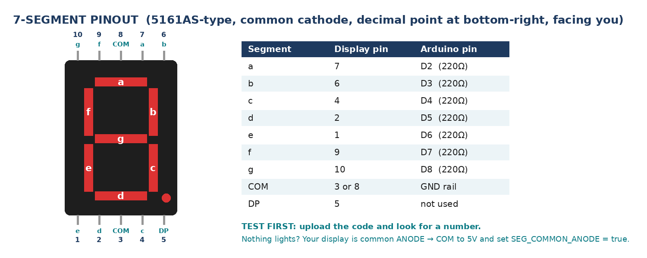
WIRING TABLE – TICK EACH WIRE AS YOU PLACE IT
Component | Component pin | Goes to | Resistor | Note | ✓
7-segment display | segment a | D2 | 220Ω |  | ☐
7-segment display | segment b | D3 | 220Ω |  | ☐
7-segment display | segment c | D4 | 220Ω |  | ☐
7-segment display | segment d | D5 | 220Ω |  | ☐
7-segment display | segment e | D6 | 220Ω |  | ☐
7-segment display | segment f | D7 | 220Ω |  | ☐
7-segment display | segment g | D8 | 220Ω |  | ☐
7-segment display | COM (either common pin) | GND rail | — | common cathode | ☐
Green LED | + long leg | D9 | 220Ω |  | ☐
Green LED | − short leg | GND rail | — |  | ☐
Red LED | + long leg | D10 | 220Ω |  | ☐
Red LED | − short leg | GND rail | — |  | ☐
Active buzzer | + (long leg) | D11 | — |  | ☐
Active buzzer | − | GND rail | — |  | ☐
IR obstacle module | VCC | 5V rail | — |  | ☐
IR obstacle module | GND | GND rail | — |  | ☐
IR obstacle module | OUT | D12 | — | LOW = something close | ☐
Reset button | leg 1 | A0 | — | INPUT_PULLUP | ☐
Reset button | leg 2 (across the gap) | GND rail | — |  | ☐
BUILD ORDER – USB UNPLUGGED UNTIL STEP 7
- Connect Arduino 5V to the red (+) rail and GND to the blue (−) rail of the breadboard.
- Wire and test the 7-segment alone with a countdown.
- Add the IR module and print digitalRead(D12) while passing your hand.
- Write the edge detection — this is the part to get right. Move your hand SLOWLY; the count must drop by exactly one.
- Add the LEDs, buzzer and reset button.
- Check every wire against the table with a partner, THEN plug in the USB. The green ON light must come on – if not, unplug at once (short circuit).
- Arduino IDE: Tools › Board › Arduino Uno, then Tools › Port.
- Paste the code below, press Upload, open Tools › Serial Monitor at 9600 baud and watch your own readings.
STEP 1 – TINKERCAD FIRST (CHECKPOINT MARKS)
Go to www.tinkercad.com › Circuits › Create new Circuit. Build the same wiring, paste the same code, press Start Simulation. Parts that Tinkercad does not have:
- IR obstacle module → use a Pushbutton (pressed = LOW = 'something close'), same pin.
- Active buzzer → use an LED + 220Ω in its place so you can SEE every beep (no code change).
- 7-segment → '7 Segment Display', set it to Cathode in the inspector.
Save it with the name 11.C G6 – Masjid Parking Counter and share the link with your teacher. The REAL build in class is your AI Project.
HOW THE CODE THINKS
- read the IR module into a variable called now
- previous was HIGH and now is LOW → a car just entered
- subtract one space, then wait 300 ms to debounce
- save now as previous for the next loop
- green while spaces remain, red and buzzer at zero
THE COMPLETE CODE (TESTED)
Yellow lines = numbers YOU must change after measuring with your own sensor. Every member must be able to explain at least one line.
/* PROJECT 11 - MASJID PARKING COUNTER (11.C Group 6)
Every car that breaks the IR beam = one space less. The 7-segment shows
free spaces (9 to 0). FULL = RED LED + beep. RESET = car park empty. */
const int GRN = 9, REDL = 10; // LEDs (each through 220 ohm)
const int BUZZ = 11; // ACTIVE buzzer
const int IR = 12; // IR OUT (LOW = car in the beam)
const int RESETBTN = A0; // A0 used as a digital input
const int CAPACITY = 9;

int freeSlots = CAPACITY;
int lastIR = HIGH, lastBtn = HIGH;
unsigned long lastCar = 0, lastBeep = 0;

// ---------- 7-SEGMENT DISPLAY (pins a,b,c,d,e,f,g) ----------
const int SEG[7] = {2, 3, 4, 5, 6, 7, 8};
const bool SEG_COMMON_ANODE = false; // true = common pin goes to 5V instead of GND
const byte DIGIT[10][7] = {
{1,1,1,1,1,1,0}, {0,1,1,0,0,0,0}, {1,1,0,1,1,0,1}, {1,1,1,1,0,0,1},
{0,1,1,0,0,1,1}, {1,0,1,1,0,1,1}, {1,0,1,1,1,1,1}, {1,1,1,0,0,0,0},
{1,1,1,1,1,1,1}, {1,1,1,1,0,1,1} };

void show(int n) { // show one number 0-9
n = constrain(n, 0, 9);
for (int i = 0; i < 7; i++) {
bool on = DIGIT[n][i];
digitalWrite(SEG[i], SEG_COMMON_ANODE ? !on : on);
}
}
// True ONCE at the moment a button goes from up (HIGH) to pressed (LOW).
// Holding the button down does NOT repeat it.
bool justPressed(int pin, int &lastState) {
int now = digitalRead(pin);
bool pressed = (lastState == HIGH && now == LOW);
lastState = now;
if (pressed) delay(25); // ignore contact bounce
return pressed;
}

void setup() {
Serial.begin(9600);
for (int i = 0; i < 7; i++) pinMode(SEG[i], OUTPUT);
pinMode(GRN, OUTPUT); pinMode(REDL, OUTPUT); pinMode(BUZZ, OUTPUT);
pinMode(IR, INPUT);
pinMode(RESETBTN, INPUT_PULLUP);
}

void loop() {
int now = digitalRead(IR);
// count the EDGE (the moment a car arrives), not the state; 300 ms debounce
if (lastIR == HIGH && now == LOW && millis() - lastCar > 300) {
lastCar = millis();
if (freeSlots > 0) freeSlots--;
Serial.print("Car in. Free spaces = "); Serial.println(freeSlots);
}
lastIR = now;

if (justPressed(RESETBTN, lastBtn)) { freeSlots = CAPACITY; Serial.println("RESET"); }

show(freeSlots);
bool full = (freeSlots == 0);
digitalWrite(GRN, !full);
digitalWrite(REDL, full);

if (full && millis() - lastBeep >= 2000) lastBeep = millis();
digitalWrite(BUZZ, (full && millis() - lastBeep < 100) ? HIGH : LOW);
}
TEST IT AND RECORD YOUR READINGS
- Pass your hand 9 times — the display must reach exactly 0.
- Hold your hand still in the beam 10 s — the count must drop by ONE only.
- Pass five hands quickly and report how many were missed.
Test # | What we did | Reading / value | What happened
1
2
3
4
5
IF IT DOES NOT WORK
- Count races to zero: you counted the STATE not the EDGE. lastState must update every loop.
- One hand counts twice: raise the 300 ms debounce.
- Fast cars are missed: lower the delay at the end of loop().
- 7-segment shows the wrong shapes: one segment wire is in the wrong pin — check a→D2 … g→D8 against the pinout picture.
- Button does nothing: it is not straddling the centre gap, or both wires are on legs that are already joined. Use legs on OPPOSITE sides of the gap.
AT THE STEM WEEK TABLE
Build a cardboard gate at car height and let visitors push a toy car through, with a printed SPACES sign above the display.
CHALLENGE: Add a second sensor for the exit so departing cars add a space back — then decide what happens if both trigger at once.
BUILD A COVER FOR YOUR PROJECT (NOTE)
Make a cover or case that suits your project design, using cardboard or materials from stationery (card, coloured paper, tape, glue, markers). Idea: a car-park entrance from cardboard with a barrier arm; the display sits on the “Free spaces” sign.
Keep the USB port, the sensor and any buttons or knobs easy to reach. Never cover the Arduino so tightly that wires are pulled.
PROJECT POSTER (SUPPORT – 4 MARKS)
Make one clear poster (A3 paper or Canva) for the STEM Week table. It must show:
- Project name and the school, your names, class and group.
- The problem in the UAE and who it helps.
- How it works in 3 steps: sensor → Arduino decides → output.
- A photo of your real wiring and of the finished project with its cover.
- Your test results (a small table or chart) and one improvement you made.
AI LOG – PROMPTS, EXAMPLES AND DATA (CORE – 4 MARKS)
Use an AI tool (ChatGPT, Claude, Gemini or Z.ai) to help you understand and improve your project, and record EVERY prompt you use. Example prompts:
- Explain line by line what the loop() does in this Arduino sketch for a "Masjid Parking Counter": [paste the code]
- My sensor gives ___ in one condition and ___ in the other. Which numbers should I put in the CALIBRATE lines and why?
- Suggest one improvement for our "Masjid Parking Counter" that we can test in one lesson.
AI tool | Prompt we typed | What the AI answered (short) | What we used / changed
PROJECT VIDEO – EXPLAIN THE AI PROCESS AND RESULTS (4 MARKS)
Every group – or each student – records a 1–2 minute video in class. Include:
- Who you are (names, class, group) and the problem your project solves in the UAE.
- How it works: show the real wiring and explain one sensor and one part of the code.
- The AI process: which AI tool you used, one prompt you typed and what you changed because of it.
- Your results: a live demo and your test readings – before and after your improvement.
- One thing you learned.
HOW YOUR PROJECT IS MARKED – 20 MARKS
Criterion | What you must do | For your Arduino project | Marks
Support | Choose an idea and create a clear project poster. | Your project is chosen for you – make a clear A3 / Canva poster: name, problem, how it works, wiring photo, team names. | 4
Core | Use an AI tool and document the required prompts, examples, or data. | Use an AI tool (ChatGPT, Claude, Gemini, Z.ai) to understand, test or improve your code and plan your calibration. Copy your prompts and your sensor data into the AI LOG. | 4
Advanced | Build, test, and improve the project using evidence. | Build the real circuit, test it, record readings, improve it – and show before / after evidence. | 4
Video | Explain the AI process and results in a short video. | 1–2 minute video: how it works, how AI helped you (your prompts) and what your test results show. | 4
On time | Submit the complete project on time. | Poster, AI log, readings table, video and the working project – all ready by Friday 30 October. | 4
TOTAL |  |  | 20
Deadline: submit the complete project – poster, AI log, readings, video and working build – by Friday 30 October (end of Week 9).

