PROJECT 12 OF 21 • 11.C — GROUP 7 • AI PROJECT (ARDUINO) – 20 MARKS
Al Zorah Mangrove Tide Monitor
Watches the tide over a mangrove nursery and warns when seedlings dry out

BUILT IN CLASS, WITH REAL PARTS. First build and test it in Tinkercad (checkpoint marks), then assemble the real Arduino, components and wiring in the ICT lesson. Bring this sheet to every lesson – printed, or saved as pictures/PDF on your iPad.
PURPOSE – WHY THIS PROJECT EXISTS
What it does | A level sensor in the water shows the tide as three stages: low, mid and high. A tilt switch detects that the marker stake has been knocked over. The buzzer warns if the water stays too low for too long, or if the stake has fallen. The sensor is powered from an Arduino pin and switched on only for the 20 ms of the reading.
UAE link | Al Zorah, Ajman — mangrove and flamingo habitat on our own doorstep
Why it matters | Al Zorah in Ajman holds one of the most important mangrove and flamingo habitats in the country, and mangroves are among the strongest natural carbon stores on this coast. Young seedlings need regular tidal flooding — too little and they dry out, too much and they drown. Volunteer replanting groups cannot stand in the creek all day watching the water. The engineering decision here is the one judges will ask about: a permanently powered water sensor corrodes its own traces within days, so you power it only for the instant you read it.
Who it helps | Mangrove nurseries, environmental rangers and researchers along the Ajman / Al Zorah coast.
The science | More conducting traces covered by water means lower resistance and a higher analog reading.
COMPONENTS YOU NEED
Component | Qty
Arduino UNO R3 + USB cable | 1
400-point breadboard | 1
Water level sensor | 1
LED | 3
Tilt / vibration switch | 1
Active buzzer | 1
220Ω resistors (red-red-brown) | 3
Jumper wires (male-male) | about 20
Male-FEMALE jumper wires (for modules) | 3
WIRING DIAGRAM – EVERY PIN, EVERY WIRE
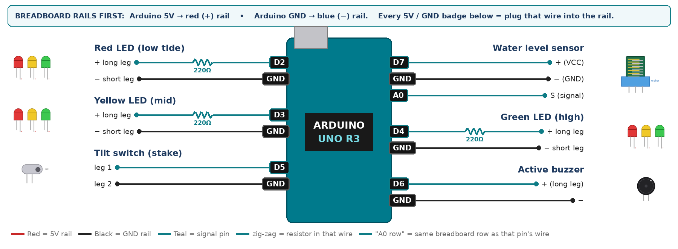
WIRING TABLE – TICK EACH WIRE AS YOU PLACE IT
Component | Component pin | Goes to | Resistor | Note | ✓
Water level sensor | + (VCC) | D7 | — | powered from a PIN | ☐
Water level sensor | − (GND) | GND rail | — |  | ☐
Water level sensor | S (signal) | A0 | — |  | ☐
Red LED (low tide) | + long leg | D2 | 220Ω |  | ☐
Red LED (low tide) | − short leg | GND rail | — |  | ☐
Yellow LED (mid) | + long leg | D3 | 220Ω |  | ☐
Yellow LED (mid) | − short leg | GND rail | — |  | ☐
Green LED (high) | + long leg | D4 | 220Ω |  | ☐
Green LED (high) | − short leg | GND rail | — |  | ☐
Tilt switch (stake) | leg 1 | D5 | — | INPUT_PULLUP | ☐
Tilt switch (stake) | leg 2 | GND rail | — |  | ☐
Active buzzer | + (long leg) | D6 | — |  | ☐
Active buzzer | − | GND rail | — |  | ☐
BUILD ORDER – USB UNPLUGGED UNTIL STEP 7
- Connect Arduino 5V to the red (+) rail and GND to the blue (−) rail of the breadboard.
- Build the three LEDs first and flash them in sequence to prove all three pins work.
- Wire the sensor + to D7, not to 5V. Explain to your teacher why before continuing.
- Add the tilt switch and print its state while you rock the board.
- Add the buzzer and calibrate the tide thresholds with a real cup of water.
- Check every wire against the table with a partner, THEN plug in the USB. The green ON light must come on – if not, unplug at once (short circuit).
- Arduino IDE: Tools › Board › Arduino Uno, then Tools › Port.
- Paste the code below, press Upload, open Tools › Serial Monitor at 9600 baud and watch your own readings.
STEP 1 – TINKERCAD FIRST (CHECKPOINT MARKS)
Go to www.tinkercad.com › Circuits › Create new Circuit. Build the same wiring, paste the same code, press Start Simulation. Parts that Tinkercad does not have:
- Water level sensor → use a Potentiometer: outer legs to D7 and GND, middle leg to A0.
- Active buzzer → use an LED + 220Ω in its place so you can SEE every beep (no code change).
- Tilt switch → use Tinkercad's Tilt Sensor, or a Pushbutton/Slideswitch to fake a tilt.
Save it with the name 11.C G7 – Al Zorah Mangrove Tide Monitor and share the link with your teacher. The REAL build in class is your AI Project.
HOW THE CODE THINKS
- set D7 HIGH, wait 20 ms, read A0, set D7 LOW again
- below the low mark → red; between → yellow; above the high mark → green
- tilt switch LOW means the stake has fallen
- buzz if the tide is low OR the stake has fallen
THE COMPLETE CODE (TESTED)
Yellow lines = numbers YOU must change after measuring with your own sensor. Every member must be able to explain at least one line.
/* PROJECT 12 - AL ZORAH MANGROVE TIDE MONITOR (11.C Group 7)
Water level sensor -> RED low tide, YELLOW mid, GREEN high tide.
Low tide OR the stake falling over (tilt switch) -> beep.
The sensor is powered from D7 ONLY while reading = much less corrosion. */
const int SENSE = A0, POWER = 7;
const int RED = 2, YEL = 3, GRN = 4; // LEDs (each through 220 ohm)
const int TILT = 5; // tilt switch on the stake
const int BUZZ = 6; // ACTIVE buzzer

// ---- CALIBRATE with your own cup of water ----
const int LOW_MARK = 150, HIGH_MARK = 400;

unsigned long tiltSince = 0, lastBeep = 0, lastRead = 0, lastPrint = 0;
int lvl = 0;

int readLevel() {
digitalWrite(POWER, HIGH); // switch the strip ON
delay(20);
int v = analogRead(SENSE);
digitalWrite(POWER, LOW); // and OFF again
return v;
}

void setup() {
Serial.begin(9600);
pinMode(POWER, OUTPUT); digitalWrite(POWER, LOW);
pinMode(RED, OUTPUT); pinMode(YEL, OUTPUT); pinMode(GRN, OUTPUT);
pinMode(BUZZ, OUTPUT);
pinMode(TILT, INPUT_PULLUP);
}

void loop() {
if (millis() - lastRead >= 400) { lastRead = millis(); lvl = readLevel(); }

// stake counts as fallen only if the tilt switch stays closed for 300 ms
if (digitalRead(TILT) == LOW) { if (tiltSince == 0) tiltSince = millis(); }
else tiltSince = 0;
bool fallen = (tiltSince != 0 && millis() - tiltSince > 300);

digitalWrite(RED, lvl < LOW_MARK);
digitalWrite(YEL, lvl >= LOW_MARK && lvl < HIGH_MARK);
digitalWrite(GRN, lvl >= HIGH_MARK);

bool alarm = (lvl < LOW_MARK) || fallen;
if (alarm && millis() - lastBeep >= 1000) lastBeep = millis();
digitalWrite(BUZZ, (alarm && millis() - lastBeep < 120) ? HIGH : LOW);

if (millis() - lastPrint >= 1000) {
lastPrint = millis();
Serial.print("tide="); Serial.print(lvl);
Serial.print(" stake fallen="); Serial.println(fallen);
}
}
TEST IT AND RECORD YOUR READINGS
- Record the dry reading, then at 1 cm, 2 cm and 3 cm. These set your thresholds.
- Tip the board with the water high — the buzzer must sound even though the level is fine.
- Run it 10 minutes and check the traces are not bubbling — proof the pin-power trick works.
Test # | What we did | Reading / value | What happened
1
2
3
4
5
IF IT DOES NOT WORK
- Reading always 0: you forgot pinMode(POWER, OUTPUT).
- Only one LED works: you shared a resistor. Each LED needs its own 220Ω.
- Tilt switch chatters: it is a rolling ball. Require LOW for 100 ms before alarming.
AT THE STEM WEEK TABLE
Pour water in slowly from a jug and let the LEDs climb red to yellow to green, then tip the cup for the stake alarm. Put a photo of the Al Zorah mangroves on the poster.
CHALLENGE: Detect a leak: if the level drops more than two steps in 30 seconds, sound a different alarm pattern.
BUILD A COVER FOR YOUR PROJECT (NOTE)
Make a cover or case that suits your project design, using cardboard or materials from stationery (card, coloured paper, tape, glue, markers). Idea: a clear cup or box as the sea, cardboard mangrove trees around it and a straw stake for the tilt switch.
Keep the USB port, the sensor and any buttons or knobs easy to reach. Never cover the Arduino so tightly that wires are pulled.
PROJECT POSTER (SUPPORT – 4 MARKS)
Make one clear poster (A3 paper or Canva) for the STEM Week table. It must show:
- Project name and the school, your names, class and group.
- The problem in the UAE and who it helps.
- How it works in 3 steps: sensor → Arduino decides → output.
- A photo of your real wiring and of the finished project with its cover.
- Your test results (a small table or chart) and one improvement you made.
AI LOG – PROMPTS, EXAMPLES AND DATA (CORE – 4 MARKS)
Use an AI tool (ChatGPT, Claude, Gemini or Z.ai) to help you understand and improve your project, and record EVERY prompt you use. Example prompts:
- Explain line by line what the loop() does in this Arduino sketch for a "Al Zorah Mangrove Tide Monitor": [paste the code]
- My sensor gives ___ in one condition and ___ in the other. Which numbers should I put in the CALIBRATE lines and why?
- Suggest one improvement for our "Al Zorah Mangrove Tide Monitor" that we can test in one lesson.
AI tool | Prompt we typed | What the AI answered (short) | What we used / changed
PROJECT VIDEO – EXPLAIN THE AI PROCESS AND RESULTS (4 MARKS)
Every group – or each student – records a 1–2 minute video in class. Include:
- Who you are (names, class, group) and the problem your project solves in the UAE.
- How it works: show the real wiring and explain one sensor and one part of the code.
- The AI process: which AI tool you used, one prompt you typed and what you changed because of it.
- Your results: a live demo and your test readings – before and after your improvement.
- One thing you learned.
HOW YOUR PROJECT IS MARKED – 20 MARKS
Criterion | What you must do | For your Arduino project | Marks
Support | Choose an idea and create a clear project poster. | Your project is chosen for you – make a clear A3 / Canva poster: name, problem, how it works, wiring photo, team names. | 4
Core | Use an AI tool and document the required prompts, examples, or data. | Use an AI tool (ChatGPT, Claude, Gemini, Z.ai) to understand, test or improve your code and plan your calibration. Copy your prompts and your sensor data into the AI LOG. | 4
Advanced | Build, test, and improve the project using evidence. | Build the real circuit, test it, record readings, improve it – and show before / after evidence. | 4
Video | Explain the AI process and results in a short video. | 1–2 minute video: how it works, how AI helped you (your prompts) and what your test results show. | 4
On time | Submit the complete project on time. | Poster, AI log, readings table, video and the working project – all ready by Friday 30 October. | 4
TOTAL |  |  | 20
Deadline: submit the complete project – poster, AI log, readings, video and working build – by Friday 30 October (end of Week 9).

