PROJECT 13 OF 21 • 11.A — GROUP 7 • AI PROJECT (ARDUINO) – 20 MARKS
Healthy Study Desk Guardian
Watches how you study: screen distance, room light and room heat

BUILT IN CLASS, WITH REAL PARTS. First build and test it in Tinkercad (checkpoint marks), then assemble the real Arduino, components and wiring in the ICT lesson. Bring this sheet to every lesson – printed, or saved as pictures/PDF on your iPad.
PURPOSE – WHY THIS PROJECT EXISTS
What it does | Three checks run at once. An infrared eye watches how close your face is to the screen, a light sensor checks whether the room is bright enough to read in, and the DHT11 checks whether the room has become too warm to concentrate. Each problem lights its own LED, and if you stay too close to the screen for more than ten seconds the buzzer reminds you to sit back. A snooze button silences it while you finish a sentence.
UAE link | Exam-season study habits — long screen hours, dim rooms and rising short-sightedness
Why it matters | Short-sightedness in children has been climbing across the Gulf, and the two strongest causes are close-up screen work and too little bright light. Our students revise for hours in a bedroom with one dim lamp, face almost touching the screen, in a room the AC has stopped reaching. Nobody notices any of the three, because all three creep up slowly. This device does not lecture anyone — it just turns three invisible problems into three visible lights on the desk, and the ten-second delay means it reacts to a habit rather than to one lean forward.
Who it helps | Students studying at home — eye health, comfort and better concentration.
The science | Three independent conditions, three independent outputs. The buzzer uses millis() so a brief lean does not trigger it — only a sustained one.
COMPONENTS YOU NEED
Component | Qty
Arduino UNO R3 + USB cable | 1
400-point breadboard | 1
IR obstacle module | 1
DHT11 sensor | 1
Photoresistor (LDR) | 1
Push button | 1
LED | 3
Active buzzer | 1
220Ω resistors (red-red-brown) | 3
10kΩ resistors (brown-black-orange) | 1
Jumper wires (male-male) | about 20
Male-FEMALE jumper wires (for modules) | 6
WIRING DIAGRAM – EVERY PIN, EVERY WIRE
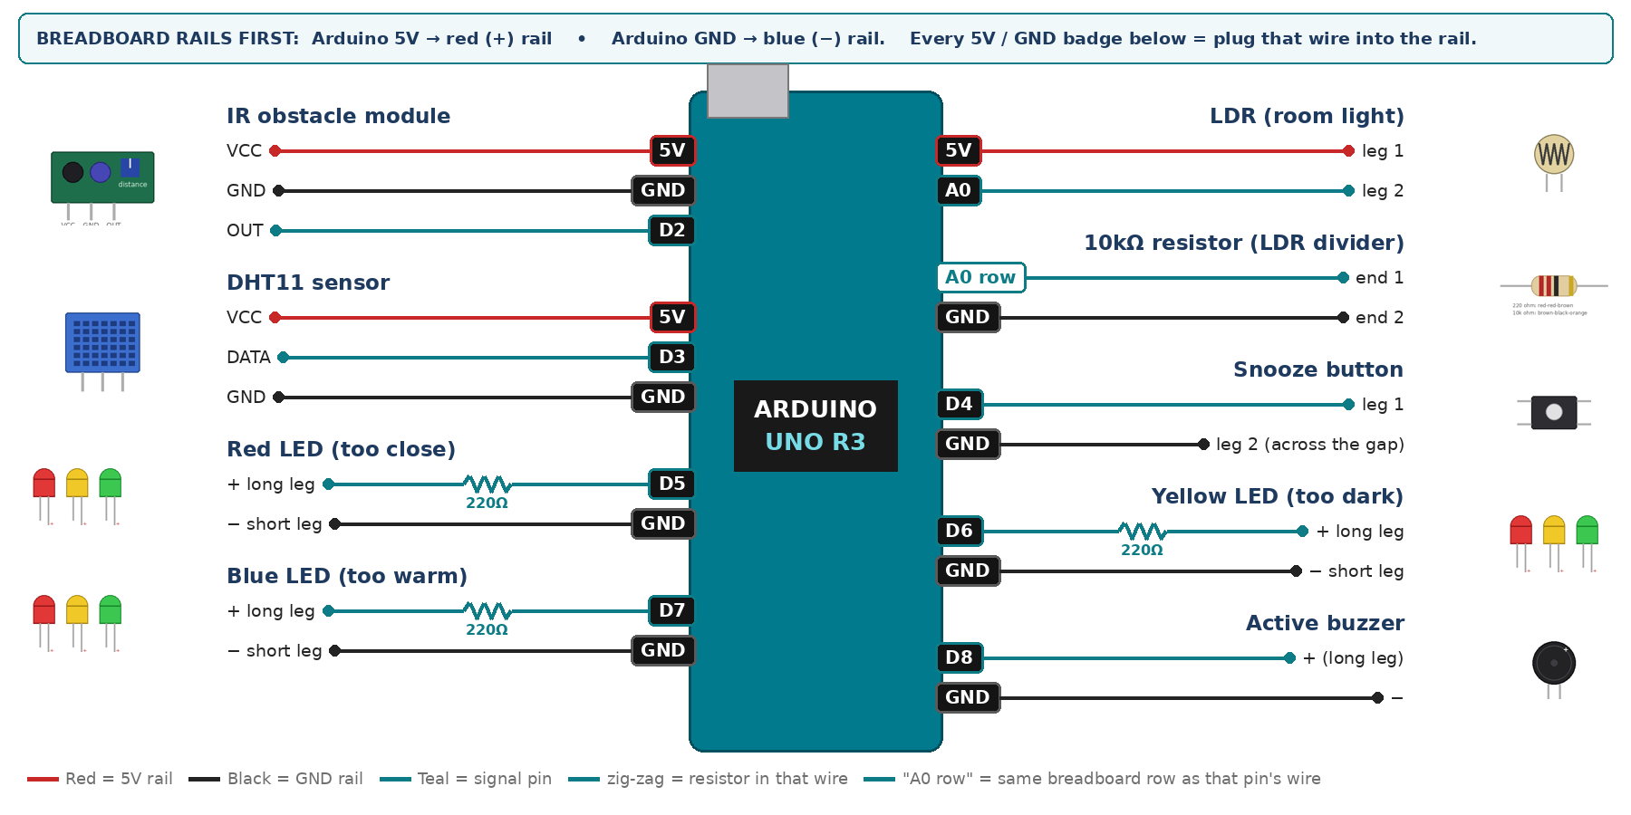
WIRING TABLE – TICK EACH WIRE AS YOU PLACE IT
Component | Component pin | Goes to | Resistor | Note | ✓
IR obstacle module | VCC | 5V rail | — |  | ☐
IR obstacle module | GND | GND rail | — |  | ☐
IR obstacle module | OUT | D2 | — | LOW = something close | ☐
DHT11 sensor | VCC | 5V rail | — |  | ☐
DHT11 sensor | DATA | D3 | — | 10k to 5V if nan | ☐
DHT11 sensor | GND | GND rail | — |  | ☐
LDR (room light) | leg 1 | 5V rail | — |  | ☐
LDR (room light) | leg 2 | A0 | — | joins the 10k | ☐
10kΩ resistor (LDR divider) | end 1 | same breadboard row as A0 | — | same row as leg 2 | ☐
10kΩ resistor (LDR divider) | end 2 | GND rail | — |  | ☐
Snooze button | leg 1 | D4 | — | INPUT_PULLUP | ☐
Snooze button | leg 2 (across the gap) | GND rail | — |  | ☐
Red LED (too close) | + long leg | D5 | 220Ω |  | ☐
Red LED (too close) | − short leg | GND rail | — |  | ☐
Yellow LED (too dark) | + long leg | D6 | 220Ω |  | ☐
Yellow LED (too dark) | − short leg | GND rail | — |  | ☐
Blue LED (too warm) | + long leg | D7 | 220Ω |  | ☐
Blue LED (too warm) | − short leg | GND rail | — |  | ☐
Active buzzer | + (long leg) | D8 | — |  | ☐
Active buzzer | − | GND rail | — |  | ☐
BUILD ORDER – USB UNPLUGGED UNTIL STEP 7
- Connect Arduino 5V to the red (+) rail and GND to the blue (−) rail of the breadboard.
- Build the LDR divider first and print analogRead(A0). Record the value under a desk lamp and with the room lamp off — that sets DARK_LEVEL.
- Add the IR module and set its screw so it triggers at about 40 cm — a healthy screen distance.
- Add the DHT11 and confirm the temperature reading.
- Add the three LEDs, the buzzer and the snooze button, then test all three warnings separately.
- Check every wire against the table with a partner, THEN plug in the USB. The green ON light must come on – if not, unplug at once (short circuit).
- Arduino IDE: Tools › Board › Arduino Uno, then Tools › Port. Sketch › Include Library › Manage Libraries → install "DHT sensor library" (Adafruit) and "Adafruit Unified Sensor".
- Paste the code below, press Upload, open Tools › Serial Monitor at 9600 baud and watch your own readings.
STEP 1 – TINKERCAD FIRST (CHECKPOINT MARKS)
Go to www.tinkercad.com › Circuits › Create new Circuit. Build the same wiring, paste the same code, press Start Simulation. Parts that Tinkercad does not have:
- DHT11 → not in Tinkercad: use a TMP36 temperature sensor on A2 + a potentiometer on A3 as 'humidity' (snippet T1).
- IR obstacle module → use a Pushbutton (pressed = LOW = 'something close'), same pin.
- Active buzzer → use an LED + 220Ω in its place so you can SEE every beep (no code change).
Save it with the name 11.A G7 – Healthy Study Desk Guardian and share the link with your teacher. The REAL build in class is your AI Project.
HOW THE CODE THINKS
- snooze button flips the snoozed flag
- read the IR module — LOW means the face is too close
- read the light level — below your DARK_LEVEL means the room is too dim
- read the temperature — above your limit means the room is too warm
- light each LED for its own condition
- if too-close has lasted over 10 seconds and snooze is off, beep
THE COMPLETE CODE (TESTED)
Yellow lines = numbers YOU must change after measuring with your own sensor. Every member must be able to explain at least one line.
/* PROJECT 13 - HEALTHY STUDY DESK GUARDIAN (11.A Group 7)
RED LED = face too close to the book/screen, YELLOW = room too dark,
BLUE = room too warm. Too close for 10 s -> beep (SNOOZE button mutes). */
#include <DHT.h>
#define DHTPIN 3
#define DHTTYPE DHT11
DHT dht(DHTPIN, DHTTYPE);

const int IR = 2, SNOOZE = 4;
const int L_CLOSE = 5, L_DARK = 6, L_WARM = 7; // LEDs (each through 220 ohm)
const int BUZZ = 8; // ACTIVE buzzer
const int LDR = A0;

// ---- CALIBRATE in your own room ----
const int DARK_ON = 300; // darker than this -> yellow ON
const int DARK_OFF = 340; // brighter than this -> yellow OFF (dead band)
const float WARM_LIMIT = 27.0;

unsigned long tooCloseSince = 0, lastRead = 0, lastBeep = 0, lastPrint = 0;
bool snoozed = false, tooDark = false, tooWarm = false;
int lastBtn = HIGH;
float t = NAN;

// True ONCE at the moment a button goes from up (HIGH) to pressed (LOW).
// Holding the button down does NOT repeat it.
bool justPressed(int pin, int &lastState) {
int now = digitalRead(pin);
bool pressed = (lastState == HIGH && now == LOW);
lastState = now;
if (pressed) delay(25); // ignore contact bounce
return pressed;
}

void setup() {
Serial.begin(9600);
dht.begin();
pinMode(IR, INPUT);
pinMode(SNOOZE, INPUT_PULLUP);
pinMode(L_CLOSE, OUTPUT); pinMode(L_DARK, OUTPUT); pinMode(L_WARM, OUTPUT);
pinMode(BUZZ, OUTPUT);
}

void loop() {
if (justPressed(SNOOZE, lastBtn)) { snoozed = !snoozed; Serial.println(snoozed ? "SNOOZE ON" : "SNOOZE OFF"); }

bool tooClose = (digitalRead(IR) == LOW);
int light = analogRead(LDR);
if (light < DARK_ON) tooDark = true; // dead band stops flicker
if (light > DARK_OFF) tooDark = false;

if (millis() - lastRead >= 2000) {
lastRead = millis();
float v = dht.readTemperature();
if (!isnan(v)) t = v;
tooWarm = (!isnan(t) && t > WARM_LIMIT);
}

digitalWrite(L_CLOSE, tooClose);
digitalWrite(L_DARK, tooDark);
digitalWrite(L_WARM, tooWarm);

if (tooClose) { if (tooCloseSince == 0) tooCloseSince = millis(); }
else tooCloseSince = 0;

bool nag = !snoozed && tooCloseSince != 0 && millis() - tooCloseSince > 10000;
if (nag && millis() - lastBeep >= 1000) lastBeep = millis();
digitalWrite(BUZZ, (nag && millis() - lastBeep < 150) ? HIGH : LOW);

if (millis() - lastPrint >= 500) {
lastPrint = millis();
Serial.print("close="); Serial.print(tooClose);
Serial.print(" light="); Serial.print(light);
Serial.print(" T="); Serial.println(t);
}
}
TEST IT AND RECORD YOUR READINGS
- Sit at a normal distance, then lean in slowly — measure the exact distance where the red LED comes on.
- Switch off the room light: the yellow LED must come on within a second.
- Lean in and stay for 12 seconds: the buzzer must fire. Lean in for 3 seconds: it must not.
Test # | What we did | Reading / value | What happened
1
2
3
4
5
IF IT DOES NOT WORK
- Red LED never goes off: the IR trimmer is turned too far open. Back it off until it releases at about 40 cm.
- Yellow LED flickers at the edge: add a small dead band — turn on below 300 but only off above 340.
- The DHT11 sits next to the board and reads warm. Move it onto long wires away from the UNO.
- Button does nothing: it is not straddling the centre gap, or both wires are on legs that are already joined. Use legs on OPPOSITE sides of the gap.
AT THE STEM WEEK TABLE
Set up a real chair and a laptop at the booth. Ask a visitor to sit and revise for thirty seconds — most people lean in without realising, and the red LED catches them live.
CHALLENGE: Count how many minutes in a lesson the user spent too close, and print a posture score out of 100 at the end.
BUILD A COVER FOR YOUR PROJECT (NOTE)
Make a cover or case that suits your project design, using cardboard or materials from stationery (card, coloured paper, tape, glue, markers). Idea: a small desk organiser or mini desk lamp made from cardboard, sensors facing the student.
Keep the USB port, the sensor and any buttons or knobs easy to reach. Never cover the Arduino so tightly that wires are pulled.
PROJECT POSTER (SUPPORT – 4 MARKS)
Make one clear poster (A3 paper or Canva) for the STEM Week table. It must show:
- Project name and the school, your names, class and group.
- The problem in the UAE and who it helps.
- How it works in 3 steps: sensor → Arduino decides → output.
- A photo of your real wiring and of the finished project with its cover.
- Your test results (a small table or chart) and one improvement you made.
AI LOG – PROMPTS, EXAMPLES AND DATA (CORE – 4 MARKS)
Use an AI tool (ChatGPT, Claude, Gemini or Z.ai) to help you understand and improve your project, and record EVERY prompt you use. Example prompts:
- Explain line by line what the loop() does in this Arduino sketch for a "Healthy Study Desk Guardian": [paste the code]
- My sensor gives ___ in one condition and ___ in the other. Which numbers should I put in the CALIBRATE lines and why?
- Suggest one improvement for our "Healthy Study Desk Guardian" that we can test in one lesson.
AI tool | Prompt we typed | What the AI answered (short) | What we used / changed
PROJECT VIDEO – EXPLAIN THE AI PROCESS AND RESULTS (4 MARKS)
Every group – or each student – records a 1–2 minute video in class. Include:
- Who you are (names, class, group) and the problem your project solves in the UAE.
- How it works: show the real wiring and explain one sensor and one part of the code.
- The AI process: which AI tool you used, one prompt you typed and what you changed because of it.
- Your results: a live demo and your test readings – before and after your improvement.
- One thing you learned.
HOW YOUR PROJECT IS MARKED – 20 MARKS
Criterion | What you must do | For your Arduino project | Marks
Support | Choose an idea and create a clear project poster. | Your project is chosen for you – make a clear A3 / Canva poster: name, problem, how it works, wiring photo, team names. | 4
Core | Use an AI tool and document the required prompts, examples, or data. | Use an AI tool (ChatGPT, Claude, Gemini, Z.ai) to understand, test or improve your code and plan your calibration. Copy your prompts and your sensor data into the AI LOG. | 4
Advanced | Build, test, and improve the project using evidence. | Build the real circuit, test it, record readings, improve it – and show before / after evidence. | 4
Video | Explain the AI process and results in a short video. | 1–2 minute video: how it works, how AI helped you (your prompts) and what your test results show. | 4
On time | Submit the complete project on time. | Poster, AI log, readings table, video and the working project – all ready by Friday 30 October. | 4
TOTAL |  |  | 20
Deadline: submit the complete project – poster, AI log, readings, video and working build – by Friday 30 October (end of Week 9).

