PROJECT 14 OF 21 • 11.C — GROUP 1 • AI PROJECT (ARDUINO) – 20 MARKS
Anti-Sleep Driver Simulator
A driver-awareness trainer that catches slow reactions and a nodding head

BUILT IN CLASS, WITH REAL PARTS. First build and test it in Tinkercad (checkpoint marks), then assemble the real Arduino, components and wiring in the ICT lesson. Bring this sheet to every lesson – printed, or saved as pictures/PDF on your iPad.
PURPOSE – WHY THIS PROJECT EXISTS
What it does | At random intervals the green light asks the driver to press the alert button. Press quickly and the alertness score on the 7-segment stays high; press slowly, or miss it entirely, and the score falls. A tilt sensor mounted on a cap detects a nodding head and drops the score straight to zero. Below a score of three the red light and buzzer sound a wake-up alarm. A reset button starts a fresh session.
UAE link | Drowsy driving on the long inter-emirate highways
Why it matters | The drive from Ajman down to Abu Dhabi is long, flat, straight and hypnotic, and drowsy driving causes serious crashes on our highways every year. The dangerous part is that a tired driver does not feel tired — reaction time degrades long before anyone admits to being sleepy. This build is deliberately a SIMULATOR for driver-awareness lessons, not something to fit inside a real car: a device that alarms at the wheel would itself be a distraction. Say that clearly at the booth, because knowing where your invention should NOT be used is real engineering judgement.
Who it helps | New and young drivers, and road-safety campaigns that fight tiredness behind the wheel.
The science | Reaction time is measured with millis(), and the interval between checks comes from random() so the driver cannot learn the rhythm and cheat.
COMPONENTS YOU NEED
Component | Qty
Arduino UNO R3 + USB cable | 1
400-point breadboard | 1
1-digit 7-segment (common cathode) | 1
Push button | 2
Tilt / vibration switch | 1
LED | 2
Passive buzzer | 1
220Ω resistors (red-red-brown) | 9
Jumper wires (male-male) | about 20
WIRING DIAGRAM – EVERY PIN, EVERY WIRE
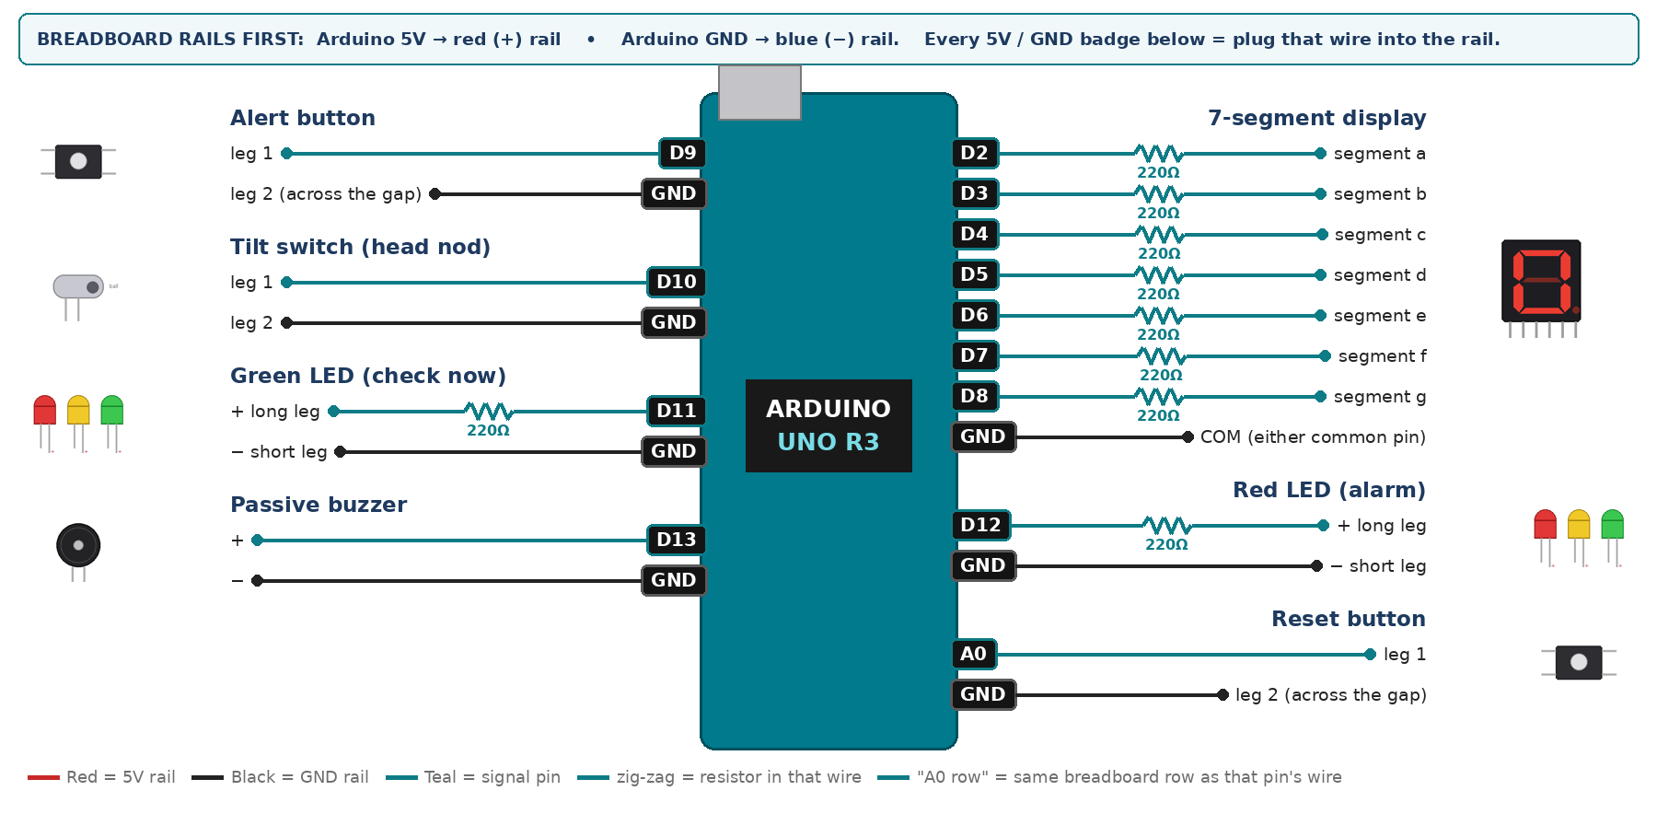
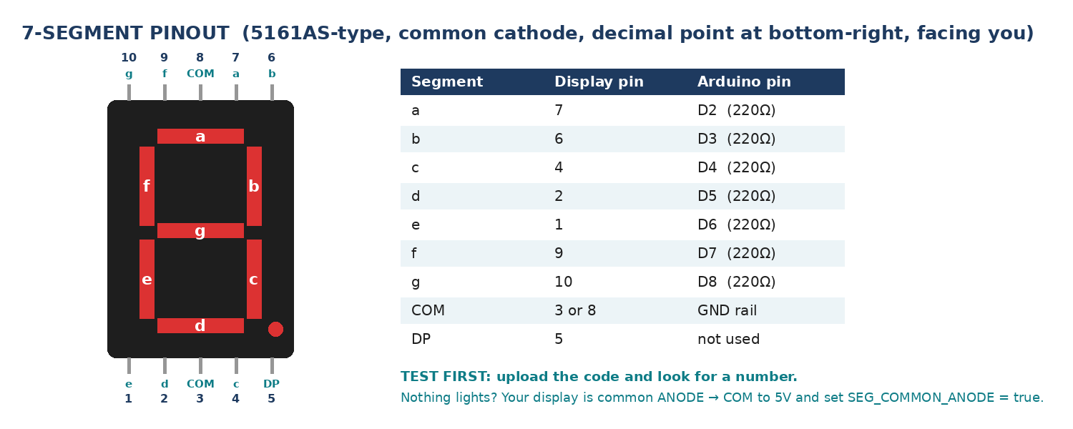
WIRING TABLE – TICK EACH WIRE AS YOU PLACE IT
Component | Component pin | Goes to | Resistor | Note | ✓
7-segment display | segment a | D2 | 220Ω |  | ☐
7-segment display | segment b | D3 | 220Ω |  | ☐
7-segment display | segment c | D4 | 220Ω |  | ☐
7-segment display | segment d | D5 | 220Ω |  | ☐
7-segment display | segment e | D6 | 220Ω |  | ☐
7-segment display | segment f | D7 | 220Ω |  | ☐
7-segment display | segment g | D8 | 220Ω |  | ☐
7-segment display | COM (either common pin) | GND rail | — | common cathode | ☐
Alert button | leg 1 | D9 | — | INPUT_PULLUP | ☐
Alert button | leg 2 (across the gap) | GND rail | — |  | ☐
Tilt switch (head nod) | leg 1 | D10 | — | INPUT_PULLUP | ☐
Tilt switch (head nod) | leg 2 | GND rail | — |  | ☐
Green LED (check now) | + long leg | D11 | 220Ω |  | ☐
Green LED (check now) | − short leg | GND rail | — |  | ☐
Red LED (alarm) | + long leg | D12 | 220Ω |  | ☐
Red LED (alarm) | − short leg | GND rail | — |  | ☐
Passive buzzer | + | D13 | — | tone() | ☐
Passive buzzer | − | GND rail | — |  | ☐
Reset button | leg 1 | A0 | — | INPUT_PULLUP | ☐
Reset button | leg 2 (across the gap) | GND rail | — |  | ☐
BUILD ORDER – USB UNPLUGGED UNTIL STEP 7
- Connect Arduino 5V to the red (+) rail and GND to the blue (−) rail of the breadboard.
- Wire and test the 7-segment alone with a 9-to-0 countdown.
- Add the alert button and print its state. Then add the tilt switch and check it reads LOW when tipped forward.
- Write the random check cycle with millis() and random() — never with delay().
- Add the LEDs and buzzer, then run a full three-minute session and record every reaction time.
- Check every wire against the table with a partner, THEN plug in the USB. The green ON light must come on – if not, unplug at once (short circuit).
- Arduino IDE: Tools › Board › Arduino Uno, then Tools › Port.
- Paste the code below, press Upload, open Tools › Serial Monitor at 9600 baud and watch your own readings.
STEP 1 – TINKERCAD FIRST (CHECKPOINT MARKS)
Go to www.tinkercad.com › Circuits › Create new Circuit. Build the same wiring, paste the same code, press Start Simulation. Parts that Tinkercad does not have:
- Passive buzzer → use a Piezo (same code, tone() works).
- Tilt switch → use Tinkercad's Tilt Sensor, or a Pushbutton/Slideswitch to fake a tilt.
- 7-segment → '7 Segment Display', set it to Cathode in the inspector.
Save it with the name 11.C G1 – Anti-Sleep Driver Simulator and share the link with your teacher. The REAL build in class is your AI Project.
HOW THE CODE THINKS
- reset button sets the score back to 9
- tilt switch LOW means the head has nodded → score drops to 0 immediately
- when the wait has expired, light the green LED and record the time
- press within the time limit → keep the score, but a slow press costs one point
- no press within 3 seconds → lose a point
- score of 3 or less → red LED and a repeating wake-up tone
- show the score on the 7-segment
THE COMPLETE CODE (TESTED)
Yellow lines = numbers YOU must change after measuring with your own sensor. Every member must be able to explain at least one line.
/* PROJECT 14 - ANTI-SLEEP DRIVER SIMULATOR (11.C Group 1)
At random times the GREEN LED asks "are you awake?" - press ALERT fast.
Slow (>1.5 s) or missed checks lower the alertness score (9 -> 0).
Head nod (tilt switch) = score 0 at once. Score 3 or less = RED + alarm. */
const int ALERT = 9, TILT = 10; // buttons / tilt switch (other leg to GND)
const int GRN = 11, REDL = 12; // LEDs (each through 220 ohm)
const int BUZZ = 13; // PASSIVE buzzer (tone)
const int RESETBTN = A0; // A0 used as a digital input

int score = 9;
bool waiting = false;
int lastAlert = HIGH, lastReset = HIGH;
unsigned long askedAt = 0, nextCheck = 0, lastBeep = 0, tiltSince = 0;

// ---------- 7-SEGMENT DISPLAY (pins a,b,c,d,e,f,g) ----------
const int SEG[7] = {2, 3, 4, 5, 6, 7, 8};
const bool SEG_COMMON_ANODE = false; // true = common pin goes to 5V instead of GND
const byte DIGIT[10][7] = {
{1,1,1,1,1,1,0}, {0,1,1,0,0,0,0}, {1,1,0,1,1,0,1}, {1,1,1,1,0,0,1},
{0,1,1,0,0,1,1}, {1,0,1,1,0,1,1}, {1,0,1,1,1,1,1}, {1,1,1,0,0,0,0},
{1,1,1,1,1,1,1}, {1,1,1,1,0,1,1} };

void show(int n) { // show one number 0-9
n = constrain(n, 0, 9);
for (int i = 0; i < 7; i++) {
bool on = DIGIT[n][i];
digitalWrite(SEG[i], SEG_COMMON_ANODE ? !on : on);
}
}
// True ONCE at the moment a button goes from up (HIGH) to pressed (LOW).
// Holding the button down does NOT repeat it.
bool justPressed(int pin, int &lastState) {
int now = digitalRead(pin);
bool pressed = (lastState == HIGH && now == LOW);
lastState = now;
if (pressed) delay(25); // ignore contact bounce
return pressed;
}

void scheduleNext() {
waiting = false;
digitalWrite(GRN, LOW);
nextCheck = millis() + random(6000, 15000); // next check in 6-15 s
}

void setup() {
Serial.begin(9600);
for (int i = 0; i < 7; i++) pinMode(SEG[i], OUTPUT);
pinMode(ALERT, INPUT_PULLUP);
pinMode(TILT, INPUT_PULLUP);
pinMode(RESETBTN, INPUT_PULLUP);
pinMode(GRN, OUTPUT); pinMode(REDL, OUTPUT); pinMode(BUZZ, OUTPUT);
randomSeed(analogRead(A1)); // A1 left EMPTY on purpose = random noise
scheduleNext();
Serial.println("Anti-Sleep Driver Simulator - session start");
}

void loop() {
if (justPressed(RESETBTN, lastReset)) { score = 9; scheduleNext(); Serial.println("RESET"); }

// head nod = tilt switch closed for at least 300 ms
if (digitalRead(TILT) == LOW) { if (tiltSince == 0) tiltSince = millis(); }
else tiltSince = 0;
if (tiltSince != 0 && millis() - tiltSince > 300 && score > 0) {
score = 0;
Serial.println("HEAD NOD DETECTED");
}

if (!waiting && (long)(millis() - nextCheck) >= 0) { // time for a check
waiting = true; askedAt = millis();
digitalWrite(GRN, HIGH);
}

bool pressed = justPressed(ALERT, lastAlert); // a new press, not a held button
if (waiting) {
if (pressed) {
unsigned long rt = millis() - askedAt;
Serial.print("reaction = "); Serial.print(rt); Serial.println(" ms");
if (rt > 1500 && score > 0) score--; // slow = getting tired
scheduleNext();
} else if (millis() - askedAt > 3000) { // missed completely
Serial.println("MISSED CHECK");
if (score > 0) score--;
scheduleNext();
}
}

show(score);
digitalWrite(REDL, score <= 3);
if (score <= 3 && millis() - lastBeep > 700) { // wake-up alarm, no delay()
tone(BUZZ, 850, 250);
lastBeep = millis();
}
}
TEST IT AND RECORD YOUR READINGS
- Run a session while fully alert and record every reaction time. Take the average.
- Run a second session while distracted by a conversation and compare the averages.
- Nod the cap forward once — the score must hit 0 and the alarm must start immediately.
Test # | What we did | Reading / value | What happened
1
2
3
4
5
IF IT DOES NOT WORK
- Score falls with nobody touching it: the tilt switch is resting closed. Mount it so the resting position is OPEN and it only closes when tipped forward.
- The same wait every round: randomSeed() is missing, or something is plugged into A1.
- Buzzer only clicks: that is the ACTIVE buzzer. tone() needs the PASSIVE one.
- 7-segment shows the wrong shapes: one segment wire is in the wrong pin — check a→D2 … g→D8 against the pinout picture.
- Button does nothing: it is not straddling the centre gap, or both wires are on legs that are already joined. Use legs on OPPOSITE sides of the gap.
AT THE STEM WEEK TABLE
Let a visitor wear the cap and sit through a two-minute session at the table. Print the average human reaction time on the poster so they can compare their own score with it.
CHALLENGE: Store the last five reaction times in an array and drop the score when the AVERAGE gets slower, rather than on any single slow press — that is how real fatigue monitors work.
BUILD A COVER FOR YOUR PROJECT (NOTE)
Make a cover or case that suits your project design, using cardboard or materials from stationery (card, coloured paper, tape, glue, markers). Idea: a cardboard dashboard and steering wheel with the buttons on the wheel; the tilt switch on a cap or headband.
Keep the USB port, the sensor and any buttons or knobs easy to reach. Never cover the Arduino so tightly that wires are pulled.
PROJECT POSTER (SUPPORT – 4 MARKS)
Make one clear poster (A3 paper or Canva) for the STEM Week table. It must show:
- Project name and the school, your names, class and group.
- The problem in the UAE and who it helps.
- How it works in 3 steps: sensor → Arduino decides → output.
- A photo of your real wiring and of the finished project with its cover.
- Your test results (a small table or chart) and one improvement you made.
AI LOG – PROMPTS, EXAMPLES AND DATA (CORE – 4 MARKS)
Use an AI tool (ChatGPT, Claude, Gemini or Z.ai) to help you understand and improve your project, and record EVERY prompt you use. Example prompts:
- Explain line by line what the loop() does in this Arduino sketch for a "Anti-Sleep Driver Simulator": [paste the code]
- My sensor gives ___ in one condition and ___ in the other. Which numbers should I put in the CALIBRATE lines and why?
- Suggest one improvement for our "Anti-Sleep Driver Simulator" that we can test in one lesson.
AI tool | Prompt we typed | What the AI answered (short) | What we used / changed
PROJECT VIDEO – EXPLAIN THE AI PROCESS AND RESULTS (4 MARKS)
Every group – or each student – records a 1–2 minute video in class. Include:
- Who you are (names, class, group) and the problem your project solves in the UAE.
- How it works: show the real wiring and explain one sensor and one part of the code.
- The AI process: which AI tool you used, one prompt you typed and what you changed because of it.
- Your results: a live demo and your test readings – before and after your improvement.
- One thing you learned.
HOW YOUR PROJECT IS MARKED – 20 MARKS
Criterion | What you must do | For your Arduino project | Marks
Support | Choose an idea and create a clear project poster. | Your project is chosen for you – make a clear A3 / Canva poster: name, problem, how it works, wiring photo, team names. | 4
Core | Use an AI tool and document the required prompts, examples, or data. | Use an AI tool (ChatGPT, Claude, Gemini, Z.ai) to understand, test or improve your code and plan your calibration. Copy your prompts and your sensor data into the AI LOG. | 4
Advanced | Build, test, and improve the project using evidence. | Build the real circuit, test it, record readings, improve it – and show before / after evidence. | 4
Video | Explain the AI process and results in a short video. | 1–2 minute video: how it works, how AI helped you (your prompts) and what your test results show. | 4
On time | Submit the complete project on time. | Poster, AI log, readings table, video and the working project – all ready by Friday 30 October. | 4
TOTAL |  |  | 20
Deadline: submit the complete project – poster, AI log, readings, video and working build – by Friday 30 October (end of Week 9).

