PROJECT 15 OF 21 • 11.C — GROUP 2 • AI PROJECT (ARDUINO) – 20 MARKS
Reaction Time Champion
Two-player reaction duel — and the booth magnet that pulls a crowd

BUILT IN CLASS, WITH REAL PARTS. First build and test it in Tinkercad (checkpoint marks), then assemble the real Arduino, components and wiring in the ICT lesson. Bring this sheet to every lesson – printed, or saved as pictures/PDF on your iPad.
PURPOSE – WHY THIS PROJECT EXISTS
What it does | Two players hold a button each. The red light waits, then after a random pause of two to six seconds the green light flashes — first to press wins. The 7-segment shows the winner's number, the buzzer plays a short victory tune, and pressing before the light is caught as a false start.
UAE link | Reaction testing in driver licensing and sports academies
Why it matters | Reaction time is genuine science: it is measured in driver assessment, in sports academies across the Emirates, and in concussion screening, and the average human visual reaction is around 250 milliseconds. For STEM Week this project has a second job, and it is an honest one. Visitors queue up to beat the record, and while they queue they stand in front of your other tables and read the posters. Every good exhibition needs one stand that stops people walking.
Who it helps | Students and athletes training reaction speed — and road-safety lessons on why reaction time matters.
The science | delay() cannot be used for timing, because it freezes everything. millis() returns the milliseconds since power-on, so elapsed time is simply end minus start.
COMPONENTS YOU NEED
Component | Qty
Arduino UNO R3 + USB cable | 1
400-point breadboard | 1
1-digit 7-segment (common cathode) | 1
Push button | 2
LED | 2
Passive buzzer | 1
220Ω resistors (red-red-brown) | 9
Jumper wires (male-male) | about 20
WIRING DIAGRAM – EVERY PIN, EVERY WIRE
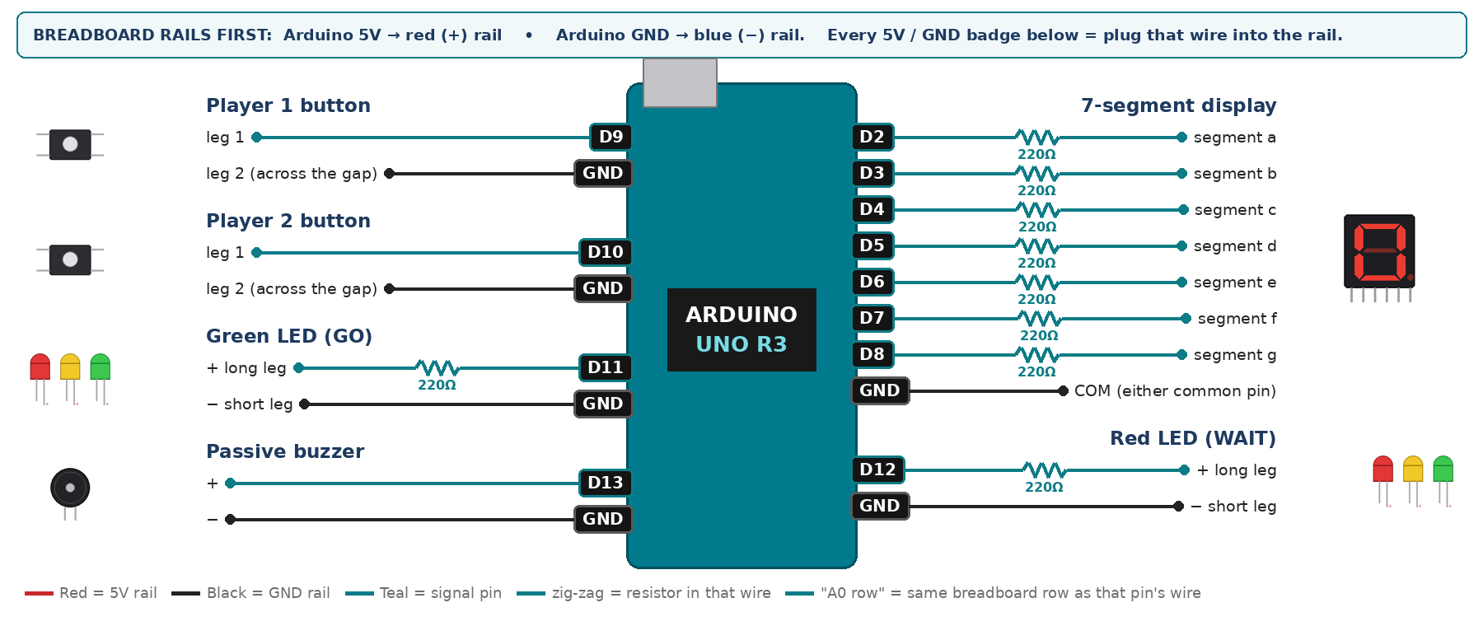
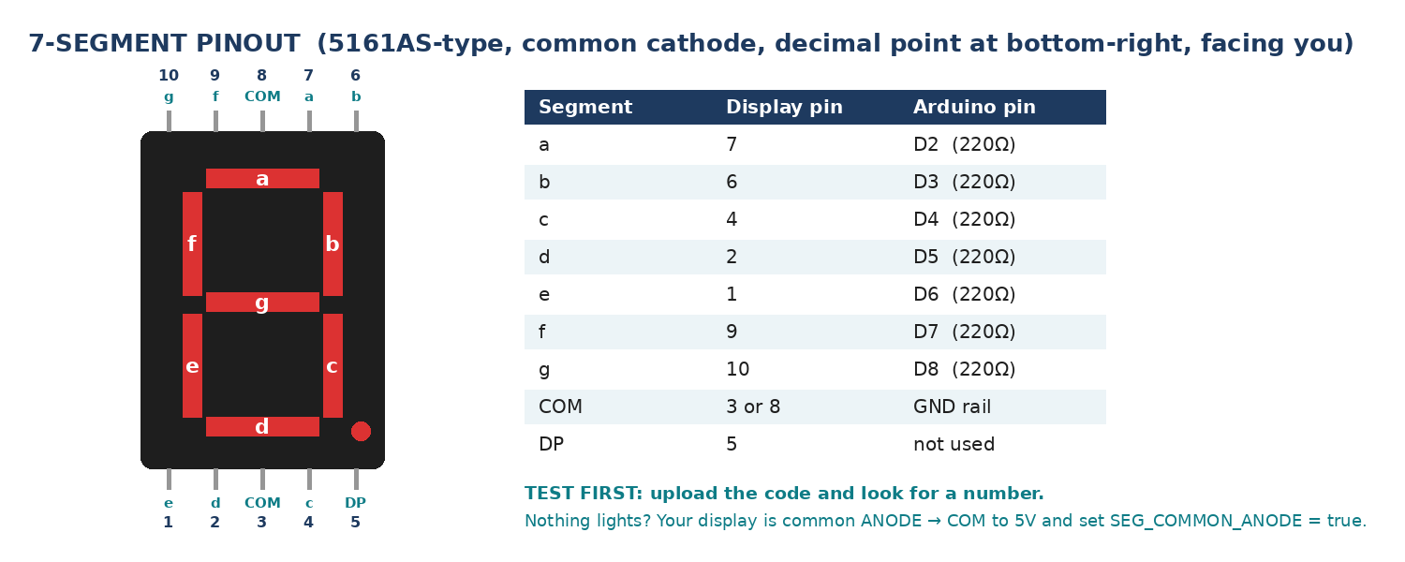
WIRING TABLE – TICK EACH WIRE AS YOU PLACE IT
Component | Component pin | Goes to | Resistor | Note | ✓
7-segment display | segment a | D2 | 220Ω |  | ☐
7-segment display | segment b | D3 | 220Ω |  | ☐
7-segment display | segment c | D4 | 220Ω |  | ☐
7-segment display | segment d | D5 | 220Ω |  | ☐
7-segment display | segment e | D6 | 220Ω |  | ☐
7-segment display | segment f | D7 | 220Ω |  | ☐
7-segment display | segment g | D8 | 220Ω |  | ☐
7-segment display | COM (either common pin) | GND rail | — | common cathode | ☐
Player 1 button | leg 1 | D9 | — | INPUT_PULLUP | ☐
Player 1 button | leg 2 (across the gap) | GND rail | — |  | ☐
Player 2 button | leg 1 | D10 | — | INPUT_PULLUP | ☐
Player 2 button | leg 2 (across the gap) | GND rail | — |  | ☐
Green LED (GO) | + long leg | D11 | 220Ω |  | ☐
Green LED (GO) | − short leg | GND rail | — |  | ☐
Red LED (WAIT) | + long leg | D12 | 220Ω |  | ☐
Red LED (WAIT) | − short leg | GND rail | — |  | ☐
Passive buzzer | + | D13 | — | tone() | ☐
Passive buzzer | − | GND rail | — |  | ☐
BUILD ORDER – USB UNPLUGGED UNTIL STEP 7
- Connect Arduino 5V to the red (+) rail and GND to the blue (−) rail of the breadboard.
- Wire and test the 7-segment on its own first.
- Add both buttons and print their state — each must read LOW when pressed.
- Add the two LEDs, then the buzzer.
- Upload, play ten rounds, and record every reaction time in your results table.
- Check every wire against the table with a partner, THEN plug in the USB. The green ON light must come on – if not, unplug at once (short circuit).
- Arduino IDE: Tools › Board › Arduino Uno, then Tools › Port.
- Paste the code below, press Upload, open Tools › Serial Monitor at 9600 baud and watch your own readings.
STEP 1 – TINKERCAD FIRST (CHECKPOINT MARKS)
Go to www.tinkercad.com › Circuits › Create new Circuit. Build the same wiring, paste the same code, press Start Simulation. Parts that Tinkercad does not have:
- Passive buzzer → use a Piezo (same code, tone() works).
- 7-segment → '7 Segment Display', set it to Cathode in the inspector.
Save it with the name 11.C G2 – Reaction Time Champion and share the link with your teacher. The REAL build in class is your AI Project.
HOW THE CODE THINKS
- show 0, red LED on, green off, and wait for both buttons to be released
- pick a random wait between 2000 and 6000 ms
- if anyone presses during the wait, call it a false start and restart
- when the wait ends, turn the green LED on and save the start time
- wait until player 1 or player 2 presses
- reaction time = now minus the start time; show the winner and play the tune
THE COMPLETE CODE (TESTED)
Yellow lines = numbers YOU must change after measuring with your own sensor. Every member must be able to explain at least one line.
/* PROJECT 15 - REACTION TIME CHAMPION (11.C Group 2)
RED = wait... after a random 2-6 s the GREEN LED says GO.
First player to press wins (display shows 1 or 2). Pressing early = FALSE START. */
const int BTN_A = 9, BTN_B = 10; // player buttons (other leg to GND)
const int GRN = 11, REDL = 12; // LEDs (each through 220 ohm)
const int BUZZ = 13; // PASSIVE buzzer (tone)

int bestMs = 9999; // CHALLENGE: best time of the day

// ---------- 7-SEGMENT DISPLAY (pins a,b,c,d,e,f,g) ----------
const int SEG[7] = {2, 3, 4, 5, 6, 7, 8};
const bool SEG_COMMON_ANODE = false; // true = common pin goes to 5V instead of GND
const byte DIGIT[10][7] = {
{1,1,1,1,1,1,0}, {0,1,1,0,0,0,0}, {1,1,0,1,1,0,1}, {1,1,1,1,0,0,1},
{0,1,1,0,0,1,1}, {1,0,1,1,0,1,1}, {1,0,1,1,1,1,1}, {1,1,1,0,0,0,0},
{1,1,1,1,1,1,1}, {1,1,1,1,0,1,1} };

void show(int n) { // show one number 0-9
n = constrain(n, 0, 9);
for (int i = 0; i < 7; i++) {
bool on = DIGIT[n][i];
digitalWrite(SEG[i], SEG_COMMON_ANODE ? !on : on);
}
}

bool anyPressed() { return digitalRead(BTN_A) == LOW || digitalRead(BTN_B) == LOW; }

void falseStart() {
show(0);
digitalWrite(GRN, LOW); digitalWrite(REDL, HIGH);
tone(BUZZ, 200, 600);
Serial.println("FALSE START");
delay(1500);
}

void setup() {
Serial.begin(9600);
for (int i = 0; i < 7; i++) pinMode(SEG[i], OUTPUT);
pinMode(BTN_A, INPUT_PULLUP); pinMode(BTN_B, INPUT_PULLUP);
pinMode(GRN, OUTPUT); pinMode(REDL, OUTPUT); pinMode(BUZZ, OUTPUT);
randomSeed(analogRead(A0)); // A0 left EMPTY on purpose
Serial.println("Reaction Time Champion - ready");
}

void loop() {
show(0);
digitalWrite(REDL, HIGH); digitalWrite(GRN, LOW);

while (anyPressed()) { } // wait until both buttons are released
delay(500);

unsigned long wait = random(2000, 6000);
unsigned long t0 = millis();
while (millis() - t0 < wait) {
if (anyPressed()) { falseStart(); return; }
}

digitalWrite(REDL, LOW); digitalWrite(GRN, HIGH); // GO!
unsigned long start = millis();

int winner = 0;
while (winner == 0) {
byte a = digitalRead(BTN_A), b = digitalRead(BTN_B); // read both together
if (a == LOW && b == LOW) winner = (random(2) == 0) ? 1 : 2; // exact tie: fair coin
else if (a == LOW) winner = 1;
else if (b == LOW) winner = 2;
if (millis() - start > 5000) { Serial.println("Nobody pressed"); return; }
}
unsigned long rt = millis() - start;
if ((int)rt < bestMs) bestMs = rt;

show(winner);
tone(BUZZ, 1500, 150); delay(180); tone(BUZZ, 2200, 250);

Serial.print("Winner: Player "); Serial.print(winner);
Serial.print(" reaction = "); Serial.print(rt);
Serial.print(" ms best today = "); Serial.print(bestMs); Serial.println(" ms");
delay(3000);
}
TEST IT AND RECORD YOUR READINGS
- Play 10 rounds, record every time, and calculate the mean and the fastest.
- Press early on purpose — the false start must be caught every single time.
- Compare 5 rounds in bright light with 5 rounds in a dim room and report the difference.
Test # | What we did | Reading / value | What happened
1
2
3
4
5
IF IT DOES NOT WORK
- The same random wait every game: randomSeed() is missing, or something is plugged into A0.
- Player 1 always wins a tie: BTN_A is read first. That is a real bias — mention it rather than hiding it.
- Buzzer only clicks: that is the ACTIVE buzzer. tone() needs the PASSIVE one.
- 7-segment shows the wrong shapes: one segment wire is in the wrong pin — check a→D2 … g→D8 against the pinout picture.
- Button does nothing: it is not straddling the centre gap, or both wires are on legs that are already joined. Use legs on OPPOSITE sides of the gap.
AT THE STEM WEEK TABLE
Write the fastest time of the day on a whiteboard beside the table and update it live. That turns a demonstration into a competition, and a queue forms on its own.
CHALLENGE: Best of 5: keep a score for each player and show the match winner on the display after five rounds.
BUILD A COVER FOR YOUR PROJECT (NOTE)
Make a cover or case that suits your project design, using cardboard or materials from stationery (card, coloured paper, tape, glue, markers). Idea: an arcade-style game box with two big buttons, one at each end.
Keep the USB port, the sensor and any buttons or knobs easy to reach. Never cover the Arduino so tightly that wires are pulled.
PROJECT POSTER (SUPPORT – 4 MARKS)
Make one clear poster (A3 paper or Canva) for the STEM Week table. It must show:
- Project name and the school, your names, class and group.
- The problem in the UAE and who it helps.
- How it works in 3 steps: sensor → Arduino decides → output.
- A photo of your real wiring and of the finished project with its cover.
- Your test results (a small table or chart) and one improvement you made.
AI LOG – PROMPTS, EXAMPLES AND DATA (CORE – 4 MARKS)
Use an AI tool (ChatGPT, Claude, Gemini or Z.ai) to help you understand and improve your project, and record EVERY prompt you use. Example prompts:
- Explain line by line what the loop() does in this Arduino sketch for a "Reaction Time Champion": [paste the code]
- My sensor gives ___ in one condition and ___ in the other. Which numbers should I put in the CALIBRATE lines and why?
- Suggest one improvement for our "Reaction Time Champion" that we can test in one lesson.
AI tool | Prompt we typed | What the AI answered (short) | What we used / changed
PROJECT VIDEO – EXPLAIN THE AI PROCESS AND RESULTS (4 MARKS)
Every group – or each student – records a 1–2 minute video in class. Include:
- Who you are (names, class, group) and the problem your project solves in the UAE.
- How it works: show the real wiring and explain one sensor and one part of the code.
- The AI process: which AI tool you used, one prompt you typed and what you changed because of it.
- Your results: a live demo and your test readings – before and after your improvement.
- One thing you learned.
HOW YOUR PROJECT IS MARKED – 20 MARKS
Criterion | What you must do | For your Arduino project | Marks
Support | Choose an idea and create a clear project poster. | Your project is chosen for you – make a clear A3 / Canva poster: name, problem, how it works, wiring photo, team names. | 4
Core | Use an AI tool and document the required prompts, examples, or data. | Use an AI tool (ChatGPT, Claude, Gemini, Z.ai) to understand, test or improve your code and plan your calibration. Copy your prompts and your sensor data into the AI LOG. | 4
Advanced | Build, test, and improve the project using evidence. | Build the real circuit, test it, record readings, improve it – and show before / after evidence. | 4
Video | Explain the AI process and results in a short video. | 1–2 minute video: how it works, how AI helped you (your prompts) and what your test results show. | 4
On time | Submit the complete project on time. | Poster, AI log, readings table, video and the working project – all ready by Friday 30 October. | 4
TOTAL |  |  | 20
Deadline: submit the complete project – poster, AI log, readings, video and working build – by Friday 30 October (end of Week 9).

