PROJECT 16 OF 21 • 11.A — GROUP 1 • AI PROJECT (ARDUINO) – 20 MARKS
Solar Panel Angle Finder
Finds the tilt angle that gets the most energy out of a panel — and proves what dust costs you

BUILT IN CLASS, WITH REAL PARTS. First build and test it in Tinkercad (checkpoint marks), then assemble the real Arduino, components and wiring in the ICT lesson. Bring this sheet to every lesson – printed, or saved as pictures/PDF on your iPad.
PURPOSE – WHY THIS PROJECT EXISTS
What it does | A light sensor sits on a model panel. The 7-segment shows the power score from 0 to 9 as you tilt the panel, the buzzer chirps every time you find a new best angle, and the green LED stays on while you are holding the best position found so far. A button clears the record so you can search again on a different day or with a dirty panel.
UAE link | UAE Energy Strategy 2050 and the solar parks — panel tilt and dust losses
Why it matters | The Emirates are building solar at enormous scale, and two things decide how much energy a panel actually delivers: the angle it faces and how much dust is sitting on it. Dust is the bigger problem here than almost anywhere — a panel in this climate can lose a serious share of its output within weeks of being cleaned. This build lets you measure both effects yourself instead of reading them in a book: find the best angle, record the score, then sprinkle fine sand on the sensor and watch the score fall.
Who it helps | Homes, schools and farms installing solar panels (clean energy, UAE Net Zero 2050).
The science | An LDR plus a fixed 10k makes a voltage divider. The reading is proportional to light energy hitting the surface, which is what a real panel converts.
COMPONENTS YOU NEED
Component | Qty
Arduino UNO R3 + USB cable | 1
400-point breadboard | 1
Photoresistor (LDR) | 1
1-digit 7-segment (common cathode) | 1
LED | 2
Active buzzer | 1
Push button | 1
220Ω resistors (red-red-brown) | 9
10kΩ resistors (brown-black-orange) | 1
Jumper wires (male-male) | about 20
WIRING DIAGRAM – EVERY PIN, EVERY WIRE
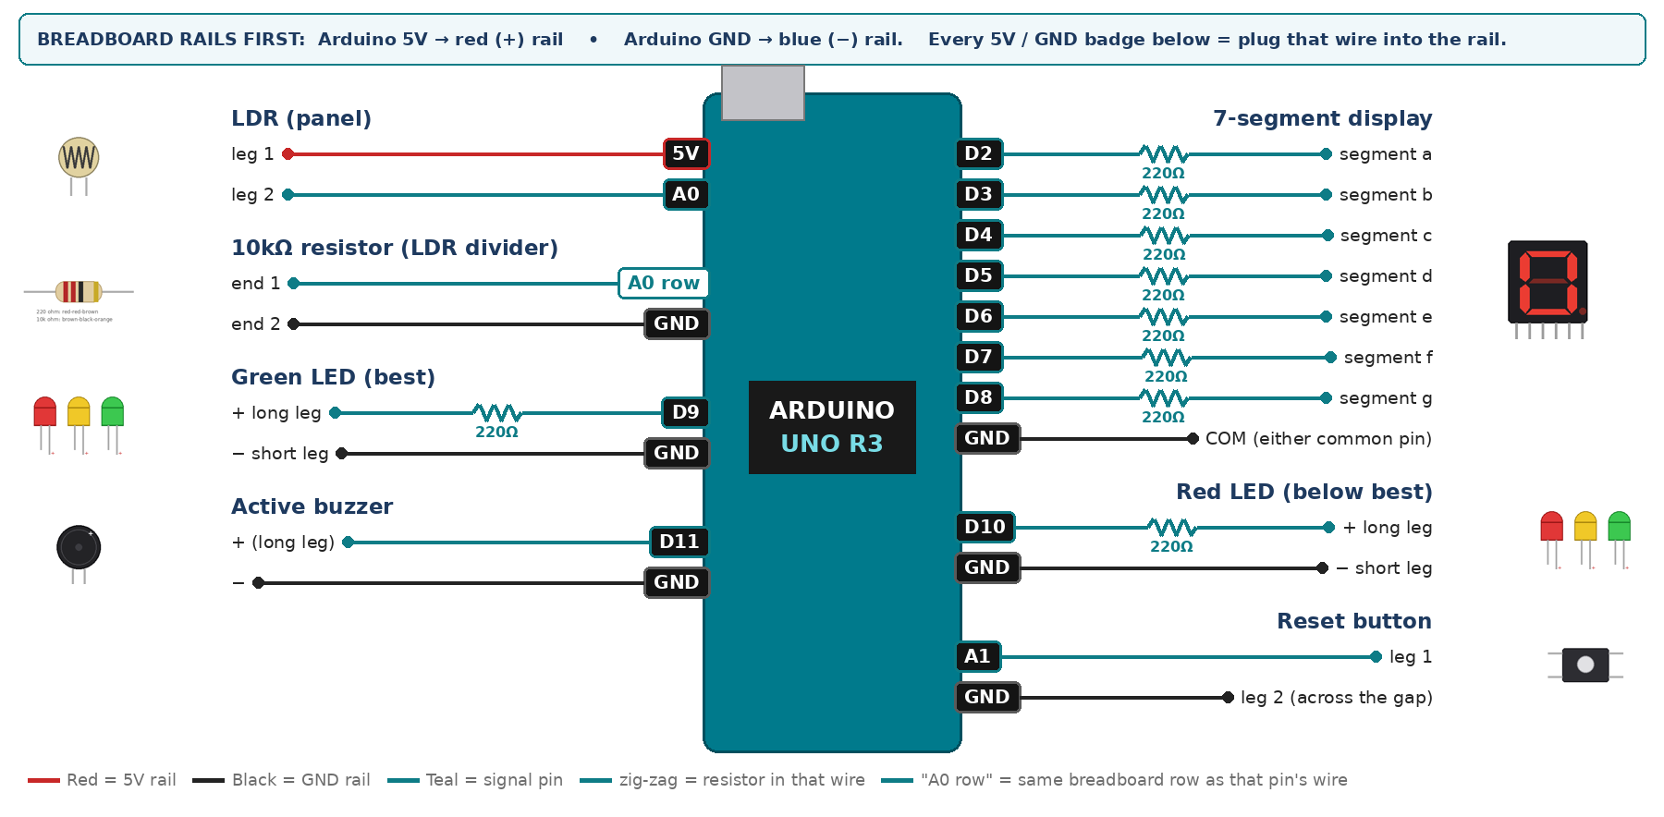
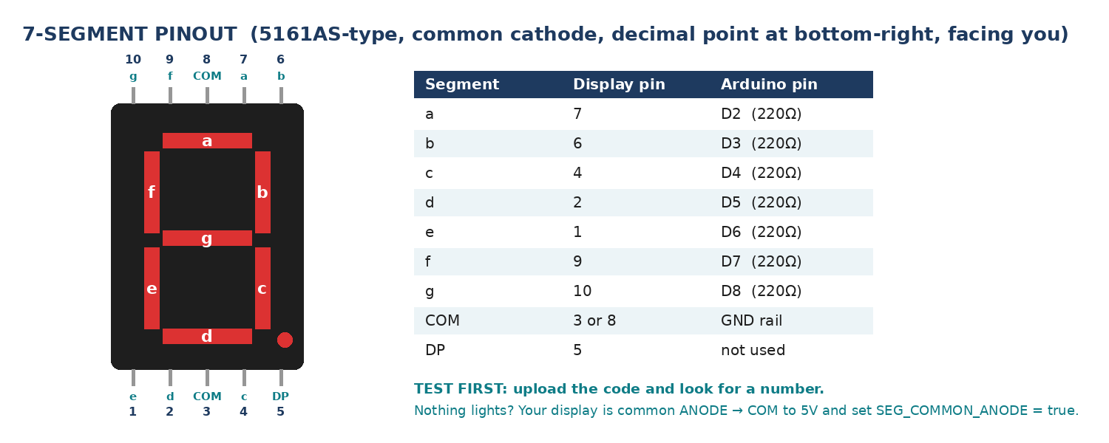
WIRING TABLE – TICK EACH WIRE AS YOU PLACE IT
Component | Component pin | Goes to | Resistor | Note | ✓
LDR (panel) | leg 1 | 5V rail | — |  | ☐
LDR (panel) | leg 2 | A0 | — | joins the 10k | ☐
10kΩ resistor (LDR divider) | end 1 | same breadboard row as A0 | — | same row as leg 2 | ☐
10kΩ resistor (LDR divider) | end 2 | GND rail | — |  | ☐
7-segment display | segment a | D2 | 220Ω |  | ☐
7-segment display | segment b | D3 | 220Ω |  | ☐
7-segment display | segment c | D4 | 220Ω |  | ☐
7-segment display | segment d | D5 | 220Ω |  | ☐
7-segment display | segment e | D6 | 220Ω |  | ☐
7-segment display | segment f | D7 | 220Ω |  | ☐
7-segment display | segment g | D8 | 220Ω |  | ☐
7-segment display | COM (either common pin) | GND rail | — | common cathode | ☐
Green LED (best) | + long leg | D9 | 220Ω |  | ☐
Green LED (best) | − short leg | GND rail | — |  | ☐
Red LED (below best) | + long leg | D10 | 220Ω |  | ☐
Red LED (below best) | − short leg | GND rail | — |  | ☐
Active buzzer | + (long leg) | D11 | — |  | ☐
Active buzzer | − | GND rail | — |  | ☐
Reset button | leg 1 | A1 | — | INPUT_PULLUP | ☐
Reset button | leg 2 (across the gap) | GND rail | — |  | ☐
BUILD ORDER – USB UNPLUGGED UNTIL STEP 7
- Connect Arduino 5V to the red (+) rail and GND to the blue (−) rail of the breadboard.
- Build the LDR divider and print analogRead(A0). Record the value in shade and pointing straight at a lamp — those two numbers become DARK and BRIGHT.
- Wire and test the 7-segment on its own with a 0-9 counter.
- Add the LEDs, buzzer and reset button.
- Tape the LDR to a card panel with a protractor behind it so you can read the angle.
- Check every wire against the table with a partner, THEN plug in the USB. The green ON light must come on – if not, unplug at once (short circuit).
- Arduino IDE: Tools › Board › Arduino Uno, then Tools › Port.
- Paste the code below, press Upload, open Tools › Serial Monitor at 9600 baud and watch your own readings.
STEP 1 – TINKERCAD FIRST (CHECKPOINT MARKS)
Go to www.tinkercad.com › Circuits › Create new Circuit. Build the same wiring, paste the same code, press Start Simulation. Parts that Tinkercad does not have:
- Active buzzer → use an LED + 220Ω in its place so you can SEE every beep (no code change).
- 7-segment → '7 Segment Display', set it to Cathode in the inspector.
Save it with the name 11.A G1 – Solar Panel Angle Finder and share the link with your teacher. The REAL build in class is your AI Project.
HOW THE CODE THINKS
- read the LDR and map it to a power score 0 to 9 using YOUR two calibration numbers
- show the score on the display
- if the reset button is pressed, set the best score back to 0
- if the score beats the best so far, save it and chirp once
- green LED while the score equals the best, red LED while it is below
THE COMPLETE CODE (TESTED)
Yellow lines = numbers YOU must change after measuring with your own sensor. Every member must be able to explain at least one line.
/* PROJECT 16 - SOLAR PANEL ANGLE FINDER (11.A Group 1)
Tilt the "panel" (LDR on card) slowly. Score 0-9 = how much light it gets.
A beep marks every new best; GREEN = at the best angle, RED = below it. */
const int LDR = A0, RESETBTN = A1; // RESET: A1 used as a digital input
const int GRN = 9, REDL = 10; // LEDs (each through 220 ohm)
const int BUZZ = 11; // ACTIVE buzzer

// ---- CALIBRATE with your own lamp ----
const int DARK = 80; // LDR in shade
const int BRIGHT = 900; // LDR facing the lamp

int best = 0, lastBtn = HIGH;
unsigned long beepAt = 0, lastPrint = 0;

// ---------- 7-SEGMENT DISPLAY (pins a,b,c,d,e,f,g) ----------
const int SEG[7] = {2, 3, 4, 5, 6, 7, 8};
const bool SEG_COMMON_ANODE = false; // true = common pin goes to 5V instead of GND
const byte DIGIT[10][7] = {
{1,1,1,1,1,1,0}, {0,1,1,0,0,0,0}, {1,1,0,1,1,0,1}, {1,1,1,1,0,0,1},
{0,1,1,0,0,1,1}, {1,0,1,1,0,1,1}, {1,0,1,1,1,1,1}, {1,1,1,0,0,0,0},
{1,1,1,1,1,1,1}, {1,1,1,1,0,1,1} };

void show(int n) { // show one number 0-9
n = constrain(n, 0, 9);
for (int i = 0; i < 7; i++) {
bool on = DIGIT[n][i];
digitalWrite(SEG[i], SEG_COMMON_ANODE ? !on : on);
}
}
// True ONCE at the moment a button goes from up (HIGH) to pressed (LOW).
// Holding the button down does NOT repeat it.
bool justPressed(int pin, int &lastState) {
int now = digitalRead(pin);
bool pressed = (lastState == HIGH && now == LOW);
lastState = now;
if (pressed) delay(25); // ignore contact bounce
return pressed;
}

int readAvg() { // average 20 readings (lights flicker)
long s = 0;
for (int i = 0; i < 20; i++) s += analogRead(LDR);
return s / 20;
}

void setup() {
Serial.begin(9600);
for (int i = 0; i < 7; i++) pinMode(SEG[i], OUTPUT);
pinMode(GRN, OUTPUT); pinMode(REDL, OUTPUT); pinMode(BUZZ, OUTPUT);
pinMode(RESETBTN, INPUT_PULLUP);
}

void loop() {
int raw = readAvg();
int score = constrain(map(raw, DARK, BRIGHT, 0, 9), 0, 9);

if (justPressed(RESETBTN, lastBtn)) { best = 0; Serial.println("RESET - search again"); }
if (score > best) { best = score; beepAt = millis(); } // new record
digitalWrite(BUZZ, (millis() - beepAt < 80 && beepAt != 0) ? HIGH : LOW);

show(score);
digitalWrite(GRN, best > 0 && score >= best);
digitalWrite(REDL, best > 0 && score < best);

if (millis() - lastPrint >= 200) {
lastPrint = millis();
Serial.print("raw="); Serial.print(raw);
Serial.print(" score="); Serial.print(score);
Serial.print(" best="); Serial.println(best);
}
}
TEST IT AND RECORD YOUR READINGS
- Fix the lamp, then tilt the panel in 10° steps from 0° to 90° and record the score at every step. Plot score against angle.
- Repeat with the lamp moved to a low 'winter sun' position and compare the best angles.
- Sprinkle fine sand on the LDR and record how much of the score you lose.
Test # | What we did | Reading / value | What happened
1
2
3
4
5
IF IT DOES NOT WORK
- Score is stuck at 9 indoors: your BRIGHT value is too low. Re-measure pointing straight at the lamp.
- Green LED never goes off: the score only ever ties the best. That is correct behaviour — press reset and search again.
- Score jumps about: classroom lights flicker at 50 Hz. Average several readings (that is the challenge task).
- 7-segment shows the wrong shapes: one segment wire is in the wrong pin — check a→D2 … g→D8 against the pinout picture.
- Button does nothing: it is not straddling the centre gap, or both wires are on legs that are already joined. Use legs on OPPOSITE sides of the gap.
AT THE STEM WEEK TABLE
Put a desk lamp on a stand and let visitors tilt the panel themselves to hunt for the green LED. Pin your angle-versus-score graph behind it, and keep a dish of fine sand to show the dust effect.
CHALLENGE: Add a second LDR at 90° to the first and light a LEFT or RIGHT LED to tell the user which way to turn the panel.
BUILD A COVER FOR YOUR PROJECT (NOTE)
Make a cover or case that suits your project design, using cardboard or materials from stationery (card, coloured paper, tape, glue, markers). Idea: a cardboard “solar panel” on a hinge with a paper protractor scale to read the angle.
Keep the USB port, the sensor and any buttons or knobs easy to reach. Never cover the Arduino so tightly that wires are pulled.
PROJECT POSTER (SUPPORT – 4 MARKS)
Make one clear poster (A3 paper or Canva) for the STEM Week table. It must show:
- Project name and the school, your names, class and group.
- The problem in the UAE and who it helps.
- How it works in 3 steps: sensor → Arduino decides → output.
- A photo of your real wiring and of the finished project with its cover.
- Your test results (a small table or chart) and one improvement you made.
AI LOG – PROMPTS, EXAMPLES AND DATA (CORE – 4 MARKS)
Use an AI tool (ChatGPT, Claude, Gemini or Z.ai) to help you understand and improve your project, and record EVERY prompt you use. Example prompts:
- Explain line by line what the loop() does in this Arduino sketch for a "Solar Panel Angle Finder": [paste the code]
- My sensor gives ___ in one condition and ___ in the other. Which numbers should I put in the CALIBRATE lines and why?
- Suggest one improvement for our "Solar Panel Angle Finder" that we can test in one lesson.
AI tool | Prompt we typed | What the AI answered (short) | What we used / changed
PROJECT VIDEO – EXPLAIN THE AI PROCESS AND RESULTS (4 MARKS)
Every group – or each student – records a 1–2 minute video in class. Include:
- Who you are (names, class, group) and the problem your project solves in the UAE.
- How it works: show the real wiring and explain one sensor and one part of the code.
- The AI process: which AI tool you used, one prompt you typed and what you changed because of it.
- Your results: a live demo and your test readings – before and after your improvement.
- One thing you learned.
HOW YOUR PROJECT IS MARKED – 20 MARKS
Criterion | What you must do | For your Arduino project | Marks
Support | Choose an idea and create a clear project poster. | Your project is chosen for you – make a clear A3 / Canva poster: name, problem, how it works, wiring photo, team names. | 4
Core | Use an AI tool and document the required prompts, examples, or data. | Use an AI tool (ChatGPT, Claude, Gemini, Z.ai) to understand, test or improve your code and plan your calibration. Copy your prompts and your sensor data into the AI LOG. | 4
Advanced | Build, test, and improve the project using evidence. | Build the real circuit, test it, record readings, improve it – and show before / after evidence. | 4
Video | Explain the AI process and results in a short video. | 1–2 minute video: how it works, how AI helped you (your prompts) and what your test results show. | 4
On time | Submit the complete project on time. | Poster, AI log, readings table, video and the working project – all ready by Friday 30 October. | 4
TOTAL |  |  | 20
Deadline: submit the complete project – poster, AI log, readings, video and working build – by Friday 30 October (end of Week 9).

