PROJECT 17 OF 21 • 11.A — GROUP 2 • AI PROJECT (ARDUINO) – 20 MARKS
Gahwa Serving Temperature Guide
Tells the host when Arabic coffee is at the right heat to pour

BUILT IN CLASS, WITH REAL PARTS. First build and test it in Tinkercad (checkpoint marks), then assemble the real Arduino, components and wiring in the ICT lesson. Bring this sheet to every lesson – printed, or saved as pictures/PDF on your iPad.
PURPOSE – WHY THIS PROJECT EXISTS
What it does | A thermistor in the dallah or the cup reads the temperature and the 7-segment shows a readiness score from 0 to 9. Blue means still too cold to serve, green means ready, red means hot enough to scald a guest. The buzzer chirps once at the moment it first enters the serving band.
UAE link | Majlis hospitality — serving gahwa, a UNESCO-listed Emirati tradition
Why it matters | Serving gahwa in the majlis is a formal act of hospitality with its own rules, and temperature is part of getting it right. Too hot and you burn the guest's mouth and flatten the cardamom and saffron aroma; too cold and the coffee tastes flat and the serving looks careless. Elderly guests and young children are the ones most often scalded by drinks served straight from the pot. A cheap probe on the tray turns a judgement made by guesswork into a number, without changing the tradition at all.
Who it helps | Families and majlis hosts serving gahwa — Arabic coffee is UNESCO-listed heritage of the UAE.
The science | Beta equation: 1/T = 1/T₀ + (1/B) × ln(R / R₀), T in kelvin, B = 3950, R₀ = 10k at 25°C.
COMPONENTS YOU NEED
Component | Qty
Arduino UNO R3 + USB cable | 1
400-point breadboard | 1
Thermistor NTC 10k | 1
1-digit 7-segment (common cathode) | 1
LED | 3
Active buzzer | 1
220Ω resistors (red-red-brown) | 10
10kΩ resistors (brown-black-orange) | 1
Jumper wires (male-male) | about 20
WIRING DIAGRAM – EVERY PIN, EVERY WIRE
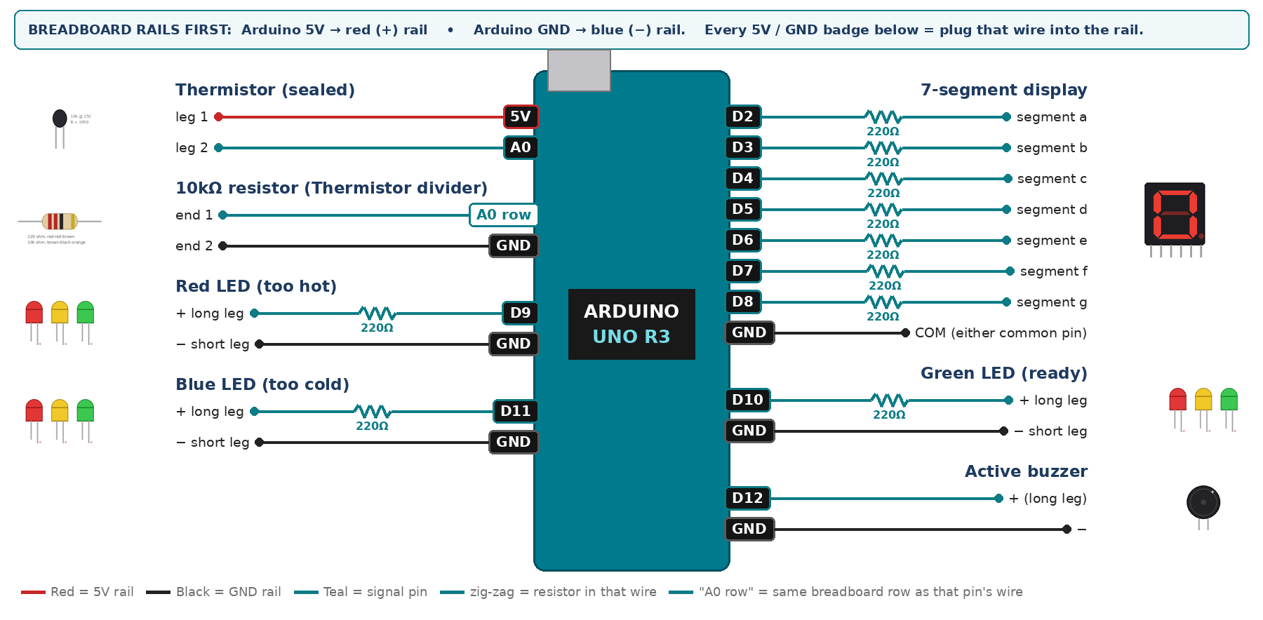
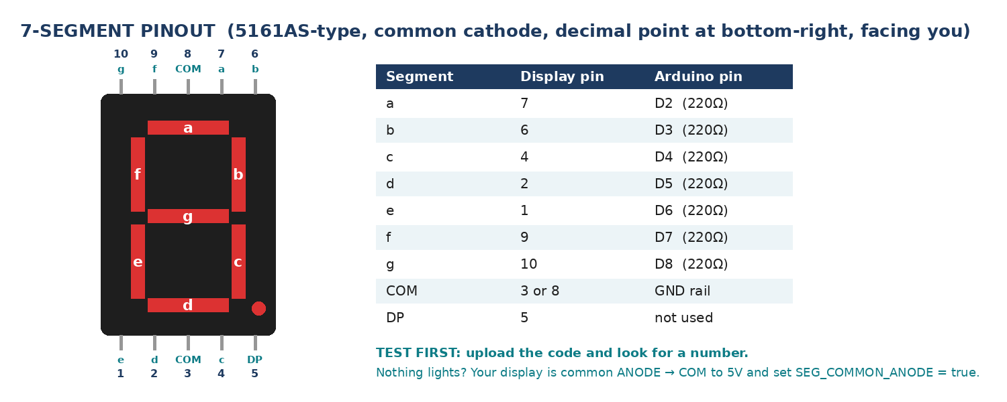
WIRING TABLE – TICK EACH WIRE AS YOU PLACE IT
Component | Component pin | Goes to | Resistor | Note | ✓
Thermistor (sealed) | leg 1 | 5V rail | — |  | ☐
Thermistor (sealed) | leg 2 | A0 | — | joins the 10k | ☐
10kΩ resistor (Thermistor divider) | end 1 | same breadboard row as A0 | — | same row as leg 2 | ☐
10kΩ resistor (Thermistor divider) | end 2 | GND rail | — |  | ☐
7-segment display | segment a | D2 | 220Ω |  | ☐
7-segment display | segment b | D3 | 220Ω |  | ☐
7-segment display | segment c | D4 | 220Ω |  | ☐
7-segment display | segment d | D5 | 220Ω |  | ☐
7-segment display | segment e | D6 | 220Ω |  | ☐
7-segment display | segment f | D7 | 220Ω |  | ☐
7-segment display | segment g | D8 | 220Ω |  | ☐
7-segment display | COM (either common pin) | GND rail | — | common cathode | ☐
Red LED (too hot) | + long leg | D9 | 220Ω |  | ☐
Red LED (too hot) | − short leg | GND rail | — |  | ☐
Green LED (ready) | + long leg | D10 | 220Ω |  | ☐
Green LED (ready) | − short leg | GND rail | — |  | ☐
Blue LED (too cold) | + long leg | D11 | 220Ω |  | ☐
Blue LED (too cold) | − short leg | GND rail | — |  | ☐
Active buzzer | + (long leg) | D12 | — |  | ☐
Active buzzer | − | GND rail | — |  | ☐
BUILD ORDER – USB UNPLUGGED UNTIL STEP 7
- Connect Arduino 5V to the red (+) rail and GND to the blue (−) rail of the breadboard.
- Build the divider and print the raw value. It must change when you pinch the bead.
- Add the Beta equation and check it against a real thermometer in a cup of warm water — agree within about 2°C before going further.
- Wire and test the 7-segment, then add the three LEDs and the buzzer.
- Set your own serving band after testing with real hot water and a thermometer.
- Check every wire against the table with a partner, THEN plug in the USB. The green ON light must come on – if not, unplug at once (short circuit).
- Arduino IDE: Tools › Board › Arduino Uno, then Tools › Port.
- Paste the code below, press Upload, open Tools › Serial Monitor at 9600 baud and watch your own readings.
STEP 1 – TINKERCAD FIRST (CHECKPOINT MARKS)
Go to www.tinkercad.com › Circuits › Create new Circuit. Build the same wiring, paste the same code, press Start Simulation. Parts that Tinkercad does not have:
- Thermistor → use a TMP36 temperature sensor on the same analog pin (snippet T3).
- Active buzzer → use an LED + 220Ω in its place so you can SEE every beep (no code change).
- 7-segment → '7 Segment Display', set it to Cathode in the inspector.
Save it with the name 11.A G2 – Gahwa Serving Temperature Guide and share the link with your teacher. The REAL build in class is your AI Project.
HOW THE CODE THINKS
- read A0 and convert it to thermistor resistance
- use the Beta equation to get temperature in Celsius
- map the temperature onto a readiness score 0 to 9 and show it
- below the band → blue; inside → green; above → red
- chirp once on the change from not-ready to ready, then remember that you have chirped
THE COMPLETE CODE (TESTED)
Yellow lines = numbers YOU must change after measuring with your own sensor. Every member must be able to explain at least one line.
/* PROJECT 17 - GAHWA SERVING TEMPERATURE GUIDE (11.A Group 2)
Thermistor (sealed in a thin plastic sleeve) in the cup.
BLUE too cold, GREEN ready to serve, RED too hot. One chirp when ready.
Display: 0 = 30 C ... 9 = 90 C. SAFETY: warm water only, never boiling. */
const int TH = A0;
const int REDL = 9, GRN = 10, BLU = 11; // LEDs (each through 220 ohm)
const int BUZZ = 12; // ACTIVE buzzer

// ---- YOUR serving band - set it after testing with a real thermometer ----
const float READY_LOW = 60.0;
const float READY_HIGH = 75.0;

bool chirped = false;
unsigned long chirpAt = 0;

// ---------- THERMISTOR -> degrees C (Beta equation) ----------
const float BETA = 3950.0, R0 = 10000.0, T0 = 298.15, RFIX = 10000.0;
float tempC() {
long sum = 0;
for (int i = 0; i < 10; i++) sum += analogRead(TH); // average 10 readings
float raw = sum / 10.0;
if (raw < 1 || raw > 1022) return -99; // wire loose / short
float rTh = RFIX * ((1023.0 / raw) - 1.0); // thermistor to 5V, 10k to GND
float tK = 1.0 / (1.0 / T0 + (1.0 / BETA) * log(rTh / R0));
return tK - 273.15;
}
// ---------- 7-SEGMENT DISPLAY (pins a,b,c,d,e,f,g) ----------
const int SEG[7] = {2, 3, 4, 5, 6, 7, 8};
const bool SEG_COMMON_ANODE = false; // true = common pin goes to 5V instead of GND
const byte DIGIT[10][7] = {
{1,1,1,1,1,1,0}, {0,1,1,0,0,0,0}, {1,1,0,1,1,0,1}, {1,1,1,1,0,0,1},
{0,1,1,0,0,1,1}, {1,0,1,1,0,1,1}, {1,0,1,1,1,1,1}, {1,1,1,0,0,0,0},
{1,1,1,1,1,1,1}, {1,1,1,1,0,1,1} };

void show(int n) { // show one number 0-9
n = constrain(n, 0, 9);
for (int i = 0; i < 7; i++) {
bool on = DIGIT[n][i];
digitalWrite(SEG[i], SEG_COMMON_ANODE ? !on : on);
}
}

void setup() {
Serial.begin(9600);
for (int i = 0; i < 7; i++) pinMode(SEG[i], OUTPUT);
pinMode(REDL, OUTPUT); pinMode(GRN, OUTPUT); pinMode(BLU, OUTPUT);
pinMode(BUZZ, OUTPUT);
}

void loop() {
float t = tempC();
if (t == -99) { Serial.println("Check thermistor wiring"); delay(500); return; }

int score = constrain((int)((t - 30.0) / 60.0 * 9.0 + 0.5), 0, 9);
show(score);

bool ready = (t >= READY_LOW && t <= READY_HIGH);
digitalWrite(BLU, t < READY_LOW);
digitalWrite(GRN, ready);
digitalWrite(REDL, t > READY_HIGH);

if (ready && !chirped) { chirped = true; chirpAt = millis(); } // once per entry
if (!ready) chirped = false;
digitalWrite(BUZZ, (chirped && millis() - chirpAt < 120) ? HIGH : LOW);

Serial.print("T = "); Serial.print(t, 1);
Serial.print(" C score = "); Serial.println(score);
delay(250);
}
TEST IT AND RECORD YOUR READINGS
- Pour boiling water into a flask cup and record the temperature every 30 seconds as it falls. Plot the cooling curve.
- Compare your reading with a real thermometer at five different temperatures and write down the error at each.
- From your cooling curve, work out how many minutes after pouring the gahwa is ready.
Test # | What we did | Reading / value | What happened
1
2
3
4
5
IF IT DOES NOT WORK
- Reads about −273 or a huge number: the divider is reversed. Thermistor to 5V, fixed 10k to GND.
- The bead cools far faster than the liquid: it must be IN the drink, not resting on the cup. Say this in the pitch.
- Buzzer chirps over and over: you forgot to set chirped = true, or you reset it in the wrong place.
- 7-segment shows the wrong shapes: one segment wire is in the wrong pin — check a→D2 … g→D8 against the pinout picture.
AT THE STEM WEEK TABLE
Bring a flask, a small dallah and paper cups. Pour at the booth and let visitors watch the display walk down from red to green while the cooling curve you measured hangs behind you.
CHALLENGE: Predict, from the cooling curve, how many seconds remain until the coffee is ready, and count that down on the display.
BUILD A COVER FOR YOUR PROJECT (NOTE)
Make a cover or case that suits your project design, using cardboard or materials from stationery (card, coloured paper, tape, glue, markers). Idea: a dallah-shaped cardboard stand with the display on the front and a cup holder for the sealed sensor.
Keep the USB port, the sensor and any buttons or knobs easy to reach. Never cover the Arduino so tightly that wires are pulled.
PROJECT POSTER (SUPPORT – 4 MARKS)
Make one clear poster (A3 paper or Canva) for the STEM Week table. It must show:
- Project name and the school, your names, class and group.
- The problem in the UAE and who it helps.
- How it works in 3 steps: sensor → Arduino decides → output.
- A photo of your real wiring and of the finished project with its cover.
- Your test results (a small table or chart) and one improvement you made.
AI LOG – PROMPTS, EXAMPLES AND DATA (CORE – 4 MARKS)
Use an AI tool (ChatGPT, Claude, Gemini or Z.ai) to help you understand and improve your project, and record EVERY prompt you use. Example prompts:
- Explain line by line what the loop() does in this Arduino sketch for a "Gahwa Serving Temperature Guide": [paste the code]
- My sensor gives ___ in one condition and ___ in the other. Which numbers should I put in the CALIBRATE lines and why?
- Suggest one improvement for our "Gahwa Serving Temperature Guide" that we can test in one lesson.
AI tool | Prompt we typed | What the AI answered (short) | What we used / changed
PROJECT VIDEO – EXPLAIN THE AI PROCESS AND RESULTS (4 MARKS)
Every group – or each student – records a 1–2 minute video in class. Include:
- Who you are (names, class, group) and the problem your project solves in the UAE.
- How it works: show the real wiring and explain one sensor and one part of the code.
- The AI process: which AI tool you used, one prompt you typed and what you changed because of it.
- Your results: a live demo and your test readings – before and after your improvement.
- One thing you learned.
HOW YOUR PROJECT IS MARKED – 20 MARKS
Criterion | What you must do | For your Arduino project | Marks
Support | Choose an idea and create a clear project poster. | Your project is chosen for you – make a clear A3 / Canva poster: name, problem, how it works, wiring photo, team names. | 4
Core | Use an AI tool and document the required prompts, examples, or data. | Use an AI tool (ChatGPT, Claude, Gemini, Z.ai) to understand, test or improve your code and plan your calibration. Copy your prompts and your sensor data into the AI LOG. | 4
Advanced | Build, test, and improve the project using evidence. | Build the real circuit, test it, record readings, improve it – and show before / after evidence. | 4
Video | Explain the AI process and results in a short video. | 1–2 minute video: how it works, how AI helped you (your prompts) and what your test results show. | 4
On time | Submit the complete project on time. | Poster, AI log, readings table, video and the working project – all ready by Friday 30 October. | 4
TOTAL |  |  | 20
Deadline: submit the complete project – poster, AI log, readings, video and working build – by Friday 30 October (end of Week 9).

