PROJECT 18 OF 21 • 11.A — GROUP 3 • AI PROJECT (ARDUINO) – 20 MARKS
Digital Tasbih Counter
Counts dhikr to 33 without losing your place

BUILT IN CLASS, WITH REAL PARTS. First build and test it in Tinkercad (checkpoint marks), then assemble the real Arduino, components and wiring in the ICT lesson. Bring this sheet to every lesson – printed, or saved as pictures/PDF on your iPad.
PURPOSE – WHY THIS PROJECT EXISTS
What it does | Each press of the button counts one. The 7-segment shows the last digit of the count, and three LEDs light at 10, 20 and 30 so you can read the whole number at a glance. At 33 the buzzer plays a short two-note chime and the counter resets itself. A shake of the tilt switch clears it early.
UAE link | The misbaha — counting dhikr after every prayer
Why it matters | Counting to 33 sounds trivial until you are doing it three times over, tired after Isha, while someone speaks to you. People lose their place constantly, and for an elderly worshipper with stiff fingers a string of beads is genuinely awkward to handle. A single large button solves both problems. The engineering lesson underneath is one of the most important in the course: a mechanical button does not close once, it bounces, and a counter that ignores that will jump from 4 to 11 in a single press.
Who it helps | Anyone doing dhikr after prayer, especially elderly people who lose count.
The science | Edge detection plus debouncing. Count only on the change from HIGH to LOW, then ignore the input briefly. The modulo operator gives you the last digit: count % 10.
COMPONENTS YOU NEED
Component | Qty
Arduino UNO R3 + USB cable | 1
400-point breadboard | 1
1-digit 7-segment (common cathode) | 1
Push button | 1
LED | 3
Passive buzzer | 1
Tilt / vibration switch | 1
220Ω resistors (red-red-brown) | 10
Jumper wires (male-male) | about 20
WIRING DIAGRAM – EVERY PIN, EVERY WIRE
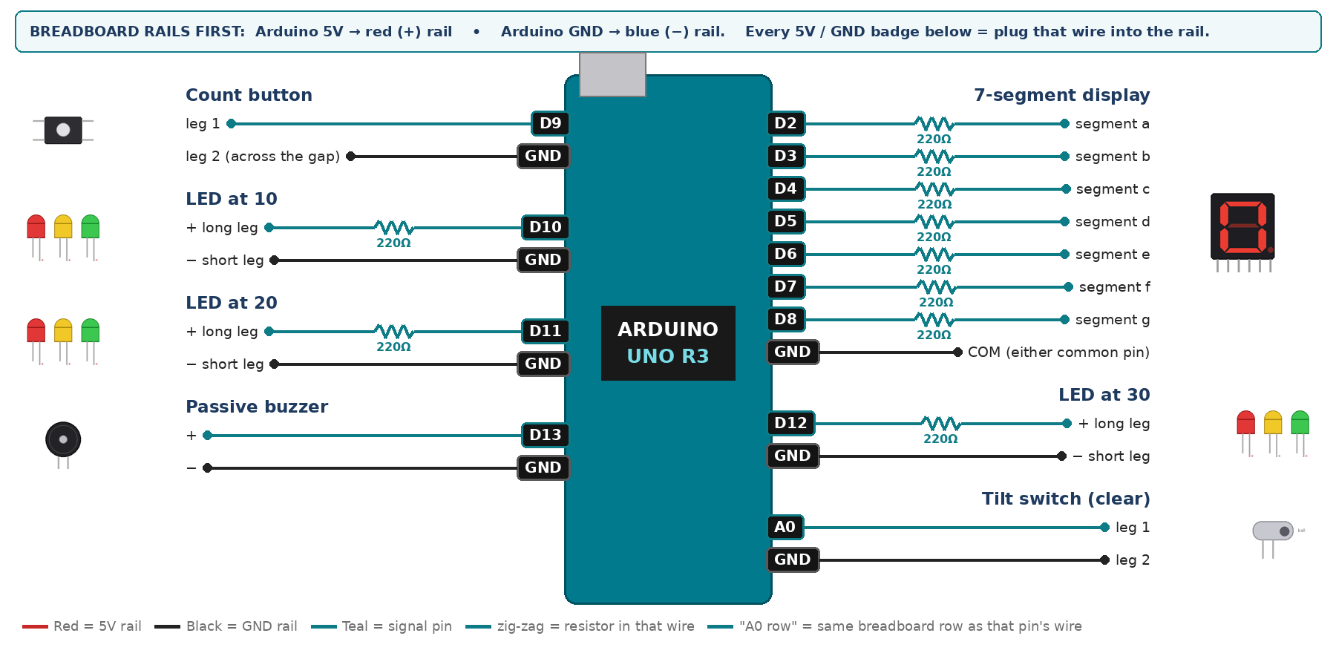
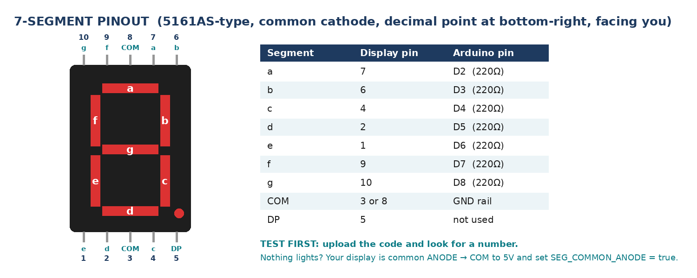
WIRING TABLE – TICK EACH WIRE AS YOU PLACE IT
Component | Component pin | Goes to | Resistor | Note | ✓
7-segment display | segment a | D2 | 220Ω |  | ☐
7-segment display | segment b | D3 | 220Ω |  | ☐
7-segment display | segment c | D4 | 220Ω |  | ☐
7-segment display | segment d | D5 | 220Ω |  | ☐
7-segment display | segment e | D6 | 220Ω |  | ☐
7-segment display | segment f | D7 | 220Ω |  | ☐
7-segment display | segment g | D8 | 220Ω |  | ☐
7-segment display | COM (either common pin) | GND rail | — | common cathode | ☐
Count button | leg 1 | D9 | — | INPUT_PULLUP | ☐
Count button | leg 2 (across the gap) | GND rail | — |  | ☐
LED at 10 | + long leg | D10 | 220Ω |  | ☐
LED at 10 | − short leg | GND rail | — |  | ☐
LED at 20 | + long leg | D11 | 220Ω |  | ☐
LED at 20 | − short leg | GND rail | — |  | ☐
LED at 30 | + long leg | D12 | 220Ω |  | ☐
LED at 30 | − short leg | GND rail | — |  | ☐
Passive buzzer | + | D13 | — | tone() | ☐
Passive buzzer | − | GND rail | — |  | ☐
Tilt switch (clear) | leg 1 | A0 | — | INPUT_PULLUP | ☐
Tilt switch (clear) | leg 2 | GND rail | — |  | ☐
BUILD ORDER – USB UNPLUGGED UNTIL STEP 7
- Connect Arduino 5V to the red (+) rail and GND to the blue (−) rail of the breadboard.
- Wire and test the 7-segment alone with a 0-9 counter.
- Add the button and print the count to Serial with NO debounce. Press it ten times and record what number you reach — this is the lesson.
- Now add edge detection and the debounce delay, and repeat the ten presses.
- Add the three LEDs, the buzzer and the tilt switch.
- Check every wire against the table with a partner, THEN plug in the USB. The green ON light must come on – if not, unplug at once (short circuit).
- Arduino IDE: Tools › Board › Arduino Uno, then Tools › Port.
- Paste the code below, press Upload, open Tools › Serial Monitor at 9600 baud and watch your own readings.
STEP 1 – TINKERCAD FIRST (CHECKPOINT MARKS)
Go to www.tinkercad.com › Circuits › Create new Circuit. Build the same wiring, paste the same code, press Start Simulation. Parts that Tinkercad does not have:
- Passive buzzer → use a Piezo (same code, tone() works).
- Tilt switch → use Tinkercad's Tilt Sensor, or a Pushbutton/Slideswitch to fake a tilt.
- 7-segment → '7 Segment Display', set it to Cathode in the inspector.
Save it with the name 11.A G3 – Digital Tasbih Counter and share the link with your teacher. The REAL build in class is your AI Project.
HOW THE CODE THINKS
- read the button into a variable called now
- previous was HIGH and now is LOW → add one to the count, then wait briefly to debounce
- save now as previous for the next loop
- show count % 10 on the display
- light the LEDs at 10, 20 and 30
- at 33, play the chime and set the count back to zero
- tilt switch LOW → clear the count
THE COMPLETE CODE (TESTED)
Yellow lines = numbers YOU must change after measuring with your own sensor. Every member must be able to explain at least one line.
/* PROJECT 18 - DIGITAL TASBIH COUNTER (11.A Group 3)
Each press = +1. Display shows the units; LEDs light at 10, 20 and 30.
At 33 a two-note tone plays and it starts again.
Hold the device tipped (tilt switch) for 1 second to clear. */
const int BTN = 9; // count button (other leg to GND)
const int L10 = 10, L20 = 11, L30 = 12; // LEDs (each through 220 ohm)
const int BUZZ = 13; // PASSIVE buzzer (tone)
const int TILT = A0; // tilt switch, A0 used as digital input
const int TARGET = 33;

int count = 0, rounds = 0, lastBtn = HIGH;
unsigned long tiltSince = 0;

// ---------- 7-SEGMENT DISPLAY (pins a,b,c,d,e,f,g) ----------
const int SEG[7] = {2, 3, 4, 5, 6, 7, 8};
const bool SEG_COMMON_ANODE = false; // true = common pin goes to 5V instead of GND
const byte DIGIT[10][7] = {
{1,1,1,1,1,1,0}, {0,1,1,0,0,0,0}, {1,1,0,1,1,0,1}, {1,1,1,1,0,0,1},
{0,1,1,0,0,1,1}, {1,0,1,1,0,1,1}, {1,0,1,1,1,1,1}, {1,1,1,0,0,0,0},
{1,1,1,1,1,1,1}, {1,1,1,1,0,1,1} };

void show(int n) { // show one number 0-9
n = constrain(n, 0, 9);
for (int i = 0; i < 7; i++) {
bool on = DIGIT[n][i];
digitalWrite(SEG[i], SEG_COMMON_ANODE ? !on : on);
}
}
// True ONCE at the moment a button goes from up (HIGH) to pressed (LOW).
// Holding the button down does NOT repeat it.
bool justPressed(int pin, int &lastState) {
int now = digitalRead(pin);
bool pressed = (lastState == HIGH && now == LOW);
lastState = now;
if (pressed) delay(25); // ignore contact bounce
return pressed;
}

void setup() {
Serial.begin(9600);
for (int i = 0; i < 7; i++) pinMode(SEG[i], OUTPUT);
pinMode(BTN, INPUT_PULLUP);
pinMode(TILT, INPUT_PULLUP);
pinMode(L10, OUTPUT); pinMode(L20, OUTPUT); pinMode(L30, OUTPUT);
pinMode(BUZZ, OUTPUT);
}

void loop() {
if (justPressed(BTN, lastBtn)) { // count the EDGE of the press
count++;
tone(BUZZ, 2500, 15); // tiny click so the user feels it counted
Serial.print("count = "); Serial.println(count);
}

if (digitalRead(TILT) == LOW) { if (tiltSince == 0) tiltSince = millis(); }
else tiltSince = 0;
if (tiltSince != 0 && millis() - tiltSince > 1000 && count > 0) {
count = 0; Serial.println("cleared");
}

show(count % 10);
digitalWrite(L10, count >= 10);
digitalWrite(L20, count >= 20);
digitalWrite(L30, count >= 30);

if (count >= TARGET) {
tone(BUZZ, 1200, 180); delay(220);
tone(BUZZ, 1600, 360); delay(400);
rounds++; count = 0;
Serial.print("33 reached - rounds completed = "); Serial.println(rounds);
}
}
TEST IT AND RECORD YOUR READINGS
- Press exactly ten times without debounce and record the number reached. Then repeat with debounce. Put both numbers on your poster.
- Press as fast as you can for five seconds — does it miss any? Adjust the debounce time and record the trade-off.
- Complete a full 33 and confirm it resets itself.
Test # | What we did | Reading / value | What happened
1
2
3
4
5
IF IT DOES NOT WORK
- The count jumps several at a time: you are reading the STATE not the EDGE, or the debounce delay is too short.
- Fast presses are missed: the 180 ms debounce is too long. Lower it until presses are missed the other way, and report the best value.
- Buzzer only clicks: that is the ACTIVE buzzer. tone() needs the PASSIVE one.
- 7-segment shows the wrong shapes: one segment wire is in the wrong pin — check a→D2 … g→D8 against the pinout picture.
- Button does nothing: it is not straddling the centre gap, or both wires are on legs that are already joined. Use legs on OPPOSITE sides of the gap.
AT THE STEM WEEK TABLE
Hand the button to a visitor and ask them to reach 33. Show them the two numbers from your debounce test — people are genuinely surprised that a button press is not one clean event.
CHALLENGE: Add a long press on the same button to cycle the target between 33, 34 and 100, showing the chosen target briefly on the display.
BUILD A COVER FOR YOUR PROJECT (NOTE)
Make a cover or case that suits your project design, using cardboard or materials from stationery (card, coloured paper, tape, glue, markers). Idea: a hand-held counter box decorated like prayer beads, the button on top.
Keep the USB port, the sensor and any buttons or knobs easy to reach. Never cover the Arduino so tightly that wires are pulled.
PROJECT POSTER (SUPPORT – 4 MARKS)
Make one clear poster (A3 paper or Canva) for the STEM Week table. It must show:
- Project name and the school, your names, class and group.
- The problem in the UAE and who it helps.
- How it works in 3 steps: sensor → Arduino decides → output.
- A photo of your real wiring and of the finished project with its cover.
- Your test results (a small table or chart) and one improvement you made.
AI LOG – PROMPTS, EXAMPLES AND DATA (CORE – 4 MARKS)
Use an AI tool (ChatGPT, Claude, Gemini or Z.ai) to help you understand and improve your project, and record EVERY prompt you use. Example prompts:
- Explain line by line what the loop() does in this Arduino sketch for a "Digital Tasbih Counter": [paste the code]
- My sensor gives ___ in one condition and ___ in the other. Which numbers should I put in the CALIBRATE lines and why?
- Suggest one improvement for our "Digital Tasbih Counter" that we can test in one lesson.
AI tool | Prompt we typed | What the AI answered (short) | What we used / changed
PROJECT VIDEO – EXPLAIN THE AI PROCESS AND RESULTS (4 MARKS)
Every group – or each student – records a 1–2 minute video in class. Include:
- Who you are (names, class, group) and the problem your project solves in the UAE.
- How it works: show the real wiring and explain one sensor and one part of the code.
- The AI process: which AI tool you used, one prompt you typed and what you changed because of it.
- Your results: a live demo and your test readings – before and after your improvement.
- One thing you learned.
HOW YOUR PROJECT IS MARKED – 20 MARKS
Criterion | What you must do | For your Arduino project | Marks
Support | Choose an idea and create a clear project poster. | Your project is chosen for you – make a clear A3 / Canva poster: name, problem, how it works, wiring photo, team names. | 4
Core | Use an AI tool and document the required prompts, examples, or data. | Use an AI tool (ChatGPT, Claude, Gemini, Z.ai) to understand, test or improve your code and plan your calibration. Copy your prompts and your sensor data into the AI LOG. | 4
Advanced | Build, test, and improve the project using evidence. | Build the real circuit, test it, record readings, improve it – and show before / after evidence. | 4
Video | Explain the AI process and results in a short video. | 1–2 minute video: how it works, how AI helped you (your prompts) and what your test results show. | 4
On time | Submit the complete project on time. | Poster, AI log, readings table, video and the working project – all ready by Friday 30 October. | 4
TOTAL |  |  | 20
Deadline: submit the complete project – poster, AI log, readings, video and working build – by Friday 30 October (end of Week 9).

