PROJECT 19 OF 21 • 11.A — GROUP 4 • AI PROJECT (ARDUINO) – 20 MARKS
Tremor Watch
Tells a shake apart from a knock — counts vibration events in a moving time window

BUILT IN CLASS, WITH REAL PARTS. First build and test it in Tinkercad (checkpoint marks), then assemble the real Arduino, components and wiring in the ICT lesson. Bring this sheet to every lesson – printed, or saved as pictures/PDF on your iPad.
PURPOSE – WHY THIS PROJECT EXISTS
What it does | A vibration switch counts every shake, and the 7-segment shows how many shakes have happened in the last five seconds. One knock on the table changes nothing. Five or more shakes inside the window turns on the red LED and sounds the alarm, and the microphone must also hear a rumble before the alarm is allowed to fire, so slamming a door alone will not set it off.
UAE link | Tremors felt in Gulf high-rise towers from earthquakes across the region
Why it matters | People in towers along this coast feel swaying when a large earthquake happens across the Gulf, and the first question is always the same: was that the building, or was that just the neighbours? Answering it needs a device that can tell a genuine tremor from ordinary noise — and that is the entire engineering problem. A single sensor cannot do it. This build uses a time window, a threshold and a second confirming sensor, which is exactly the structure of real seismic and alarm systems. Explaining WHY one sensor is not enough is worth more marks than the build itself.
Who it helps | Families and building managers in areas where small tremors are felt, such as the east coast.
The science | A sliding time window: record the time of each event, then count only the events whose timestamp is inside the last five seconds. Older events fall out of the window on their own.
COMPONENTS YOU NEED
Component | Qty
Arduino UNO R3 + USB cable | 1
400-point breadboard | 1
1-digit 7-segment (common cathode) | 1
Tilt / vibration switch | 1
LED | 2
Active buzzer | 1
Sound sensor module | 1
Push button | 1
220Ω resistors (red-red-brown) | 9
Jumper wires (male-male) | about 20
Male-FEMALE jumper wires (for modules) | 3
WIRING DIAGRAM – EVERY PIN, EVERY WIRE
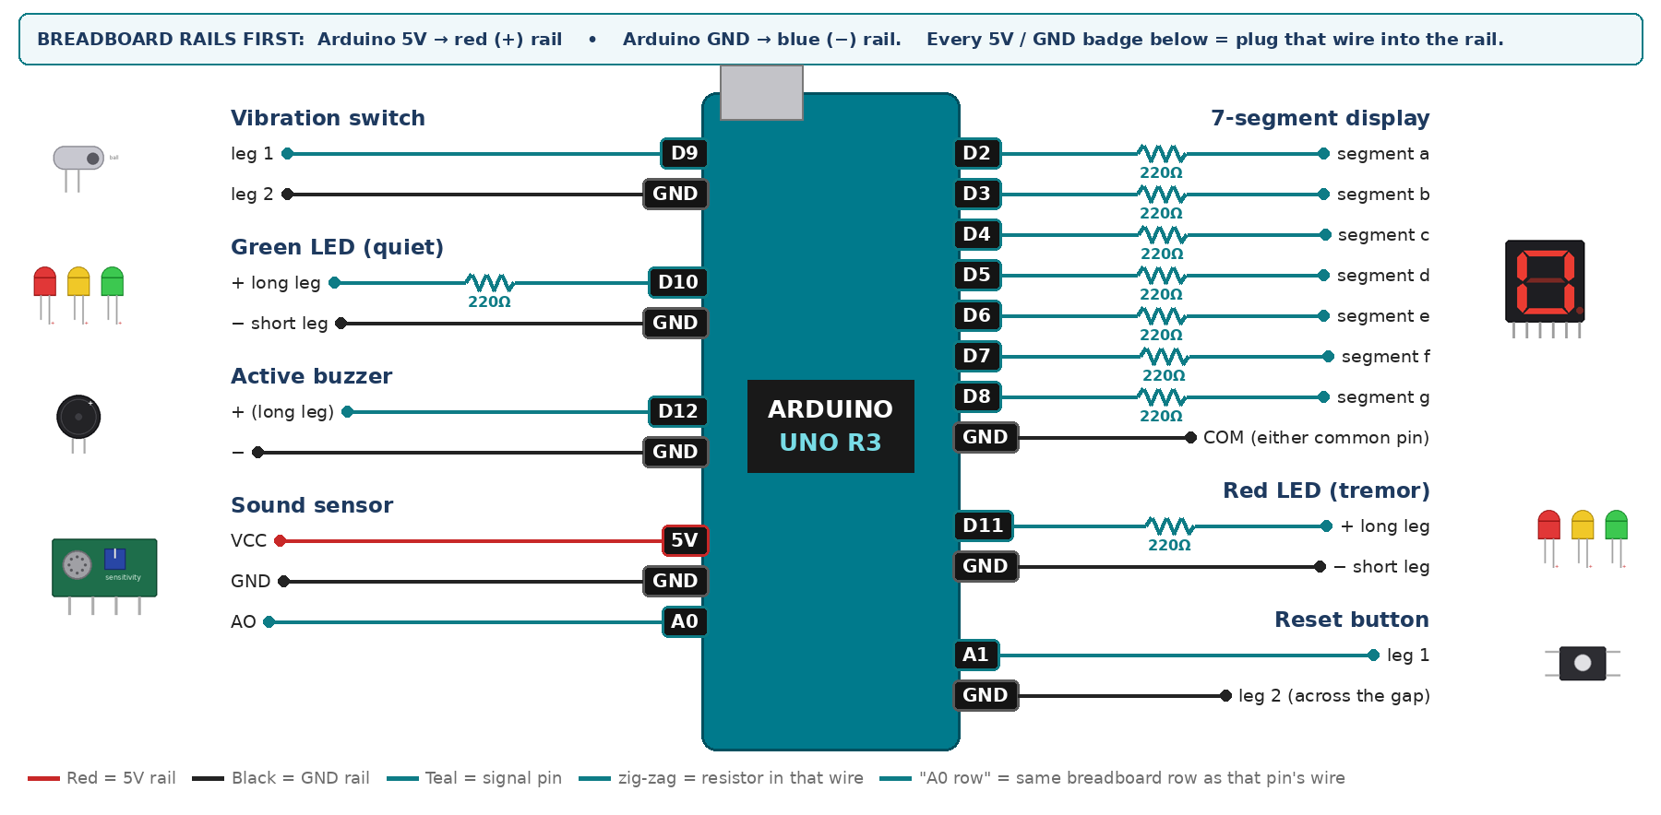
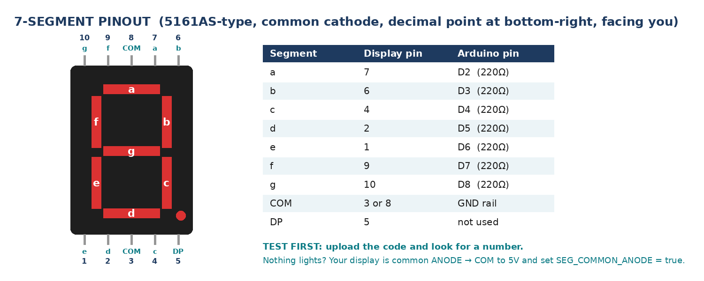
WIRING TABLE – TICK EACH WIRE AS YOU PLACE IT
Component | Component pin | Goes to | Resistor | Note | ✓
7-segment display | segment a | D2 | 220Ω |  | ☐
7-segment display | segment b | D3 | 220Ω |  | ☐
7-segment display | segment c | D4 | 220Ω |  | ☐
7-segment display | segment d | D5 | 220Ω |  | ☐
7-segment display | segment e | D6 | 220Ω |  | ☐
7-segment display | segment f | D7 | 220Ω |  | ☐
7-segment display | segment g | D8 | 220Ω |  | ☐
7-segment display | COM (either common pin) | GND rail | — | common cathode | ☐
Vibration switch | leg 1 | D9 | — | INPUT_PULLUP | ☐
Vibration switch | leg 2 | GND rail | — |  | ☐
Green LED (quiet) | + long leg | D10 | 220Ω |  | ☐
Green LED (quiet) | − short leg | GND rail | — |  | ☐
Red LED (tremor) | + long leg | D11 | 220Ω |  | ☐
Red LED (tremor) | − short leg | GND rail | — |  | ☐
Active buzzer | + (long leg) | D12 | — |  | ☐
Active buzzer | − | GND rail | — |  | ☐
Sound sensor | VCC | 5V rail | — |  | ☐
Sound sensor | GND | GND rail | — |  | ☐
Sound sensor | AO | A0 | — | analog, not DO | ☐
Reset button | leg 1 | A1 | — | INPUT_PULLUP | ☐
Reset button | leg 2 (across the gap) | GND rail | — |  | ☐
BUILD ORDER – USB UNPLUGGED UNTIL STEP 7
- Connect Arduino 5V to the red (+) rail and GND to the blue (−) rail of the breadboard.
- Wire and test the 7-segment alone.
- Add the vibration switch and print every trigger to Serial. Tap the desk and count how many triggers ONE tap produces — this number decides your debounce.
- Write the sliding window with an array of timestamps. Test it by tapping steadily and watching the count rise and fall.
- Add the sound module, the LEDs, the buzzer and the reset.
- Check every wire against the table with a partner, THEN plug in the USB. The green ON light must come on – if not, unplug at once (short circuit).
- Arduino IDE: Tools › Board › Arduino Uno, then Tools › Port.
- Paste the code below, press Upload, open Tools › Serial Monitor at 9600 baud and watch your own readings.
STEP 1 – TINKERCAD FIRST (CHECKPOINT MARKS)
Go to www.tinkercad.com › Circuits › Create new Circuit. Build the same wiring, paste the same code, press Start Simulation. Parts that Tinkercad does not have:
- Sound sensor → use a Potentiometer on the same analog pin as 'loudness' (snippet T2).
- Active buzzer → use an LED + 220Ω in its place so you can SEE every beep (no code change).
- Tilt switch → use Tinkercad's Tilt Sensor, or a Pushbutton/Slideswitch to fake a tilt.
- 7-segment → '7 Segment Display', set it to Cathode in the inspector.
Save it with the name 11.A G4 – Tremor Watch and share the link with your teacher. The REAL build in class is your AI Project.
HOW THE CODE THINKS
- read the vibration switch on the edge, with a short debounce, and store the time of each event
- count how many stored events are newer than five seconds ago
- show that count on the display
- read the microphone peak-to-peak as a second opinion
- alarm only if the count reaches five AND the microphone is above its threshold
- green LED while quiet, red LED and buzzer while alarming, reset button clears everything
THE COMPLETE CODE (TESTED)
Yellow lines = numbers YOU must change after measuring with your own sensor. Every member must be able to explain at least one line.
/* PROJECT 19 - TREMOR WATCH (11.A Group 4)
Counts shakes of the tilt switch in the last 5 seconds (sliding window).
Alarm only when BOTH agree: 5+ shakes AND a rumble on the microphone. */
const int TILT = 9; // tilt / vibration switch (other leg to GND)
const int GRN = 10, REDL = 11; // LEDs (each through 220 ohm)
const int BUZZ = 12; // ACTIVE buzzer
const int MIC = A0, RESETBTN = A1; // sound AO; RESET on A1 as digital input

const unsigned long WINDOW_MS = 5000; // the sliding window
const int SHAKE_LIMIT = 5; // shakes needed inside the window
const int RUMBLE_LIMIT = 60; // CALIBRATE: microphone peak-to-peak

const int MAX_EVENTS = 24;
unsigned long events[MAX_EVENTS];
int nEvents = 0, lastTilt = HIGH, lastBtn = HIGH;
unsigned long lastShake = 0, lastBeep = 0, lastPrint = 0;

// ---------- 7-SEGMENT DISPLAY (pins a,b,c,d,e,f,g) ----------
const int SEG[7] = {2, 3, 4, 5, 6, 7, 8};
const bool SEG_COMMON_ANODE = false; // true = common pin goes to 5V instead of GND
const byte DIGIT[10][7] = {
{1,1,1,1,1,1,0}, {0,1,1,0,0,0,0}, {1,1,0,1,1,0,1}, {1,1,1,1,0,0,1},
{0,1,1,0,0,1,1}, {1,0,1,1,0,1,1}, {1,0,1,1,1,1,1}, {1,1,1,0,0,0,0},
{1,1,1,1,1,1,1}, {1,1,1,1,0,1,1} };

void show(int n) { // show one number 0-9
n = constrain(n, 0, 9);
for (int i = 0; i < 7; i++) {
bool on = DIGIT[n][i];
digitalWrite(SEG[i], SEG_COMMON_ANODE ? !on : on);
}
}
// True ONCE at the moment a button goes from up (HIGH) to pressed (LOW).
// Holding the button down does NOT repeat it.
bool justPressed(int pin, int &lastState) {
int now = digitalRead(pin);
bool pressed = (lastState == HIGH && now == LOW);
lastState = now;
if (pressed) delay(25); // ignore contact bounce
return pressed;
}

int loudness() { // peak-to-peak over 30 ms
unsigned long start = millis();
int hi = 0, lo = 1023;
while (millis() - start < 30) {
int v = analogRead(MIC);
if (v > hi) hi = v;
if (v < lo) lo = v;
}
return hi - lo;
}

void addEvent() { if (nEvents < MAX_EVENTS) events[nEvents++] = millis(); }

int countInWindow() { // forget shakes older than 5 s
int keep = 0;
for (int i = 0; i < nEvents; i++)
if (millis() - events[i] <= WINDOW_MS) events[keep++] = events[i];
nEvents = keep;
return nEvents;
}

void setup() {
Serial.begin(9600);
for (int i = 0; i < 7; i++) pinMode(SEG[i], OUTPUT);
pinMode(TILT, INPUT_PULLUP);
pinMode(RESETBTN, INPUT_PULLUP);
pinMode(GRN, OUTPUT); pinMode(REDL, OUTPUT); pinMode(BUZZ, OUTPUT);
}

void loop() {
int now = digitalRead(TILT);
if (lastTilt == HIGH && now == LOW && millis() - lastShake > 60) { // one shake = one edge
addEvent();
lastShake = millis();
}
lastTilt = now;

if (justPressed(RESETBTN, lastBtn)) { nEvents = 0; Serial.println("RESET"); }

int shakes = countInWindow();
int rumble = loudness();
show(shakes);

bool alarm = (shakes >= SHAKE_LIMIT && rumble > RUMBLE_LIMIT); // BOTH must agree
digitalWrite(GRN, !alarm);
digitalWrite(REDL, alarm);
if (alarm && millis() - lastBeep >= 400) lastBeep = millis();
digitalWrite(BUZZ, (alarm && millis() - lastBeep < 120) ? HIGH : LOW);

if (millis() - lastPrint >= 250) {
lastPrint = millis();
Serial.print("shakes="); Serial.print(shakes);
Serial.print(" rumble="); Serial.println(rumble);
}
}
TEST IT AND RECORD YOUR READINGS
- Knock the table once, hard. The count must rise by ONE and the alarm must not fire.
- Shake the table steadily for six seconds. The alarm must fire.
- Slam a book on the desk without shaking the board — the sound passes but the vibration count does not, so it must stay silent. This is the test that proves the AND works.
Test # | What we did | Reading / value | What happened
1
2
3
4
5
IF IT DOES NOT WORK
- The count races upward on one tap: the ball switch bounces. Raise the 60 ms (lastShake test) until one tap gives one event.
- The alarm never fires however hard you shake: the microphone threshold is too high, or the module screw is turned down. Print rumble and read the real value.
- The count never falls: countInWindow is not being called every loop, or you compared the times the wrong way round.
- 7-segment shows the wrong shapes: one segment wire is in the wrong pin — check a→D2 … g→D8 against the pinout picture.
- Button does nothing: it is not straddling the centre gap, or both wires are on legs that are already joined. Use legs on OPPOSITE sides of the gap.
AT THE STEM WEEK TABLE
Put the board on a loose tray at the booth. Let a visitor knock it once (nothing happens), then shake it (the alarm fires). The contrast makes the whole idea obvious in four seconds.
CHALLENGE: Record the largest count reached in the session and show it when the reset button is held, so a resident can check overnight.
BUILD A COVER FOR YOUR PROJECT (NOTE)
Make a cover or case that suits your project design, using cardboard or materials from stationery (card, coloured paper, tape, glue, markers). Idea: a cardboard house model on a tray; the sensors sit inside the house.
Keep the USB port, the sensor and any buttons or knobs easy to reach. Never cover the Arduino so tightly that wires are pulled.
PROJECT POSTER (SUPPORT – 4 MARKS)
Make one clear poster (A3 paper or Canva) for the STEM Week table. It must show:
- Project name and the school, your names, class and group.
- The problem in the UAE and who it helps.
- How it works in 3 steps: sensor → Arduino decides → output.
- A photo of your real wiring and of the finished project with its cover.
- Your test results (a small table or chart) and one improvement you made.
AI LOG – PROMPTS, EXAMPLES AND DATA (CORE – 4 MARKS)
Use an AI tool (ChatGPT, Claude, Gemini or Z.ai) to help you understand and improve your project, and record EVERY prompt you use. Example prompts:
- Explain line by line what the loop() does in this Arduino sketch for a "Tremor Watch": [paste the code]
- My sensor gives ___ in one condition and ___ in the other. Which numbers should I put in the CALIBRATE lines and why?
- Suggest one improvement for our "Tremor Watch" that we can test in one lesson.
AI tool | Prompt we typed | What the AI answered (short) | What we used / changed
PROJECT VIDEO – EXPLAIN THE AI PROCESS AND RESULTS (4 MARKS)
Every group – or each student – records a 1–2 minute video in class. Include:
- Who you are (names, class, group) and the problem your project solves in the UAE.
- How it works: show the real wiring and explain one sensor and one part of the code.
- The AI process: which AI tool you used, one prompt you typed and what you changed because of it.
- Your results: a live demo and your test readings – before and after your improvement.
- One thing you learned.
HOW YOUR PROJECT IS MARKED – 20 MARKS
Criterion | What you must do | For your Arduino project | Marks
Support | Choose an idea and create a clear project poster. | Your project is chosen for you – make a clear A3 / Canva poster: name, problem, how it works, wiring photo, team names. | 4
Core | Use an AI tool and document the required prompts, examples, or data. | Use an AI tool (ChatGPT, Claude, Gemini, Z.ai) to understand, test or improve your code and plan your calibration. Copy your prompts and your sensor data into the AI LOG. | 4
Advanced | Build, test, and improve the project using evidence. | Build the real circuit, test it, record readings, improve it – and show before / after evidence. | 4
Video | Explain the AI process and results in a short video. | 1–2 minute video: how it works, how AI helped you (your prompts) and what your test results show. | 4
On time | Submit the complete project on time. | Poster, AI log, readings table, video and the working project – all ready by Friday 30 October. | 4
TOTAL |  |  | 20
Deadline: submit the complete project – poster, AI log, readings, video and working build – by Friday 30 October (end of Week 9).

