Shorten the letter while keeping warmth
HI SELEN!!!
First of all, your latest letter contains an impressive number of developments. You are becoming an academic, the bees are still occupying your campus, a squirrel has made its historical debut in your life, your fanfiction is gathering dust, and the flu has apparently challenged you to a duel. Meanwhile, your socks have committed crimes against your toes.
Your life is becoming a very strange television series, and I am beginning to suspect you are both the protagonist and the screenwriter. HHHHH.
But let me start with something important.
Yes, Selen. I do feel nostalgic when I talk to you.
A month sounds like almost nothing on a calendar, and yet so much can change in thirty days. I remember you talking about the uncertainties and excitement surrounding university, and now you're telling me about your classmates, your new friendships, your favorite subjects, and the strange wildlife occupying your campus. I got to know a little of the person who was anticipating all these changes, and now I get to hear from the person actually living through them. There is something lovely about that.
And yes, I understand what you mean about missing your best friend even after making new friends. Those things don't contradict each other. You can enjoy the people around you and still miss someone whose presence has become familiar in a different way. New friendships bring new experiences, but an older, closer friendship has its own little world of memories, jokes, and things that don't need much explanation.
I'm glad you told me. I like knowing that our letters have become part of how you remember this period of your life. We don't share the same classrooms or ordinary afternoons, but we still get little windows into each other's worlds. One day we're discussing your future, and the next we're investigating a squirrel like two exhausted zoologists.
Speaking of which, YOU ARE LYING ON THE COUCH, YOUR THROAT HURTS, AND YOU ARE APOLOGIZING FOR WRITING A SHORT LETTER.
Selen. 😭
You could send me three words and a picture of a squirrel, and I would consider it a perfectly valid communication. You don't have to entertain me every time you write. I like hearing from you, not receiving a literary performance on a schedule. So please rest, drink enough fluids, and look after yourself and your mother. I hope you both feel better soon.
As for your declaration of war against the flu, I respect the confidence.
"WHO IS BETTER, FLU? WE WILL SEE!"
Meanwhile, the virus is microscopic and has absolutely no idea that it has been challenged by a Turkish sociology student with questionable patience and a promising academic future. Please defeat it through rest rather than sheer stubbornness, though. I would prefer your next letter to be about something more exciting than Selen Versus the Common Cold: The Final Reckoning.
Now, sociology! I can absolutely imagine you becoming an academic. I suspect you'll eventually start asking questions about one thing, discover seventeen related questions, and end up reading about them at two in the morning.
Someone will ask you a simple question, and you'll begin with, "Well, historically speaking..."
Congratulations. The transformation will be complete.
Your friend was right about the profession Pokémon. You're evolving into a professor who collects sociological theories, historical figures, and increasingly obscure footnotes. The only problem is your memory for names. Imagine delivering a brilliant presentation and then forgetting the name of the professor congratulating you afterward. A promising academic career, interrupted by a minor administrative problem. HHHH.
Seriously, though, wanting to make your mother proud is a beautiful motivation. Just remember that you don't have to wait until you've earned a title or achieved something extraordinary to make your efforts meaningful. You're already learning, growing, and discovering something that genuinely excites you.
And the part about wanting to improve Turkey stayed with me. I understand why the state of your country can exhaust you when you care so deeply about it. Loving a place doesn't mean being blind to its problems, and wanting to change those problems doesn't mean you must carry the entire country on your shoulders. Sociology may give you tools to understand the structures and inequalities that frustrate you, and perhaps help you find ways to contribute.
You don't have to fix everything alone, Selen. Learn, question, find people who care about similar things, and keep your ability to think independently. And yes, if you can't throw a punch, you can learn how to spit. Olivia Rodrigo has apparently become the official spokesperson for politically frustrated sociology students.
I recommend that your future academic career involve fewer physical altercations and more carefully documented arguments. The publication process is painful enough.
Now, your elimination question: the Jane Doe incident.
I'm assuming you mean the Cornell University case involving a woman publicly identified as Jane Doe who alleges that she was drugged and sexually assaulted by fraternity members. The allegations, the university's handling of the matter, and efforts to expose her identity have all drawn attention. I want to distinguish allegations from facts established through a legal process, so I wouldn't want to make a definitive judgment about disputed details without examining reliable reporting and the available evidence.
My own view is that we have to hold several principles together. Someone reporting sexual assault deserves to be treated with dignity, and their privacy should be protected. An allegation should be investigated seriously, not turned into entertainment for strangers who feel entitled to dissect someone's life. At the same time, taking an allegation seriously doesn't mean pretending every factual question has already been answered. Evidence matters, fair procedures matter, and accountability matters.
What troubles me about online discussions of cases like this is how quickly people turn a human being into a public spectacle. They confuse investigating evidence with humiliating someone, and they sometimes treat uncertainty as permission to be cruel. We can demand a fair investigation without assuming guilt or dismissing a person who comes forward.
I also think institutions deserve scrutiny when they're responsible for student safety. They shouldn't prioritize protecting their reputation over handling serious complaints responsibly. And public support is not automatically meaningless just because some people might be performing for attention. What matters is whether our actions actually help people, respect their privacy, and encourage accountability.
So, no, I don't think justice should be a popularity contest. I want the evidence examined fairly, the people involved treated with dignity, and any established wrongdoing addressed appropriately. That's my honest position, rather than a slogan designed to make me look good.
I'm genuinely interested in your thoughts, too. Which part of the case made you curious about my opinion? And what do you think people tend to misunderstand about situations like this?
Right. Serious discussion concluded. Back to campus wildlife.
YOU SAW A SQUIRREL!
A REAL, LIVING SQUIRREL!
I imagine you freezing in place and pointing at it like you've discovered an unknown civilization. The squirrel, meanwhile, is probably thinking, "Humans are so strange. They stare at me for free."
Did it come close to you, or did it simply appear, inspect the situation, and disappear like a tiny furry landlord? Also, are squirrels uncommon where you live, or was this a rare wildlife event? The bees have dominated the headlines for weeks, so I'm delighted that a new character has entered the story.
Now, the French bob and ash blonde idea. Interesting. Very interesting.
I see you're entering your European cinema protagonist era. One minute you're collecting professions, and the next you're planning a haircut that sounds like it comes with a Parisian apartment, a complicated relationship with an intellectual, and a habit of staring out of rainy windows.
HHHHH.
But genuinely, I can imagine why you're considering it. A French bob has a distinctive style, and ash blonde would be quite a change. If you decide to do it, choose it because you like the idea, not simply because other people think it would suit you. Take reference pictures to your hairdresser, discuss the maintenance, and remember that experimenting with your appearance doesn't have to be an irreversible international treaty.
And your outfits are receiving compliments now! Excellent. The boots have finally escaped their six-month imprisonment, and your wardrobe is thriving.
Unfortunately, the socks have betrayed the organization.
Imagine putting together the perfect outfit, receiving compliments, feeling wonderful, and then discovering that your sock has decided to injure almost every toe. This isn't beauty being pain. This is a hostile takeover by the textile industry.
I hope your toes have recovered, by the way. Please inspect the remaining socks before the next fashion expedition. I refuse to lose another toe to poor textile engineering.
Also, the fact that you feel naked without eyeshadow made me laugh. Apparently, eyeshadow has become an essential organ.
ERROR 404: EYELID PERSONALITY NOT FOUND.
I understand having a particular look that makes you feel more like yourself, though. Just remember that you are allowed to go to university without operating a complete cosmetics department every morning.
As for my campus life, it's been the usual mixture of lectures, assignments, technical problems, and trying to keep my brain from becoming a browser with forty-seven tabs open. Software engineering has a funny way of making you feel that you're learning everything and know absolutely nothing at the same time.
But I'm making progress, and I'm learning to appreciate the small victories: understanding something that confused me last week, finishing a task, or finally getting a program to work after staring at it for an unreasonable amount of time.
And no, your long sentences aren't silencing me. I have enough material to establish an entire university: the sociology department, the campus bee investigation unit, the squirrel observation laboratory, and a special committee dedicated to your socks.
I have range.
More importantly, I like hearing about your life. You don't need to divide our conversations into equal speaking time as though we're in a parliamentary debate. Sometimes you'll have more to tell me; sometimes I will. Sometimes we'll both be tired and produce two sentences and a picture of a squirrel. That's fine.
You don't have to make your life sound interesting for me to be interested in hearing about it.
Now, your abandoned fanfiction. I feel sorry for your fictional characters. Somewhere in the depths of your imagination, they're standing in a dark room wondering whether their author is ever coming back. One of them has probably started writing fanfiction about the others to survive.
HHHHH.
Seriously, I understand missing your hobbies when life gets hectic. It can be frustrating when something you love becomes difficult to make time for, and then returning to it feels harder because you've forgotten the plot. But your stories can wait for you. Maybe one day you'll reread a paragraph and feel the urge to continue; maybe you'll start something new. You don't have to turn every hobby into another responsibility.
And MOBILE LEGENDS! Yes, I know of it: teams, heroes, strategies, and strangers on the internet testing everyone's patience. A peaceful hobby, obviously.
Nothing says inner tranquility like watching a teammate make a decision so catastrophically bad that you briefly consider becoming a monk.
I haven't played enough to pretend I'm an expert, so tell me: what kind of player are you? Strategic and supportive, aggressively competitive, or someone who chooses a character because they look cool and figures out the consequences afterward?
Please choose carefully. Your academic reputation is at stake.
Now, the era I'd live in.
I'd love to visit the Abbasid era in Baghdad, particularly the period associated with the House of Wisdom, when scholars, translators, mathematicians, physicians, and philosophers contributed to a remarkable intellectual culture. I'd want to be a scholar-engineer, studying mathematics and natural philosophy while building things, experimenting, and documenting discoveries.
Imagine walking into a place where people are discussing mathematics, translating philosophical texts, and questioning what they know about the natural world. I'd probably spend the entire day asking questions and irritating everyone by refusing to leave when the conversation became interesting.
"One final question."
"Saad, it is midnight."
"Yes, but what exactly did you mean by that?"
I'd be removed from the institution within a week.
Of course, I'm romanticizing it a little. Historical periods weren't museums filled exclusively with brilliant scholars. There were hardships, illnesses, conflicts, and plenty of things that would make me desperately miss modern conveniences. But I'd love to witness knowledge traveling between cultures, being translated, challenged, and developed.
As for the person I'd want to be, I'd hope to be curious, useful, and independent-minded. Someone willing to learn from people who disagree with him and change his mind when the evidence demands it.
What about you? Would you choose an era when sociology was emerging, a period of major social transformation, or somewhere much further back? Would you want to be an academic, a writer, a reformer, or someone quietly observing society and recording everything? I can imagine you starting as an observer and eventually arguing with an institution about why it needs to change.
Finally, a new series recommendation, since Dark has apparently been classified as an intellectual hazard in your household: The Good Place.
It's funny, accessible, and full of questions about ethics, morality, human behavior, and what it means to be a good person. It explores philosophical ideas without making every conversation feel like a lecture, and you don't need a conspiracy board with red string to understand what's happening.
I think you'd enjoy it, especially with your new sociological interests. If you watch it, I would love to hear what you think. Consider it a research opportunity for the future academic, not homework. 😂
And now, the photographs.
Selen, I loved all four of them. Every single one.
The first one has me investigating the stars around your eye. Were they a carefully planned artistic choice, or did you collide with a glitter-bombed unicorn and decide to make the accident fashionable?
Your hand is resting against your face, your finger is on your chin, and you look as though you're calculating the distance to another habitable planet. Perhaps you're solving a monumental scientific problem. Perhaps you forgot something in the oven.
I genuinely love the picture, though. The stars, headphones, striped outfit, and thoughtful expression give it a distinctive style. It feels creative and unmistakably yours. I like seeing the little choices you make with your appearance, especially when you're willing to experiment rather than follow a formula.
So, what inspired the stars? I'm asking for the official investigation report.
The second photograph, meanwhile, has a serious scientific problem.
THE CAPTION SAYS "TOUCHING GRASS," BUT YOU'RE STANDING ON PAVING STONES.
Where is the grass, Selen? Where is the contact? Where is the peer-reviewed documentation?
I am afraid the International Committee for Grass-Related Research has questions.
The camera angle is also suspicious, but somehow you've made it work. You're wearing a button-up shirt and holding your coat like someone with important business, and then you're sticking your tongue out at the camera. You look like you were on your way to a respectable appointment and suddenly remembered that being respectable is optional.
I love that contrast. You look lovely, but what makes the photograph memorable is the combination of your style and your silliness. You don't need to be perfectly composed in every picture to be beautiful. Sometimes the goofy ones are the best.
Now, the coastal photograph deserves its own travel documentary. There's a beautiful white chapel, the sea, cloudy skies, and a picturesque landscape. Everything is ready for a solemn cinematic moment.
And then there's you, winking, laughing, and sticking your tongue out.
The chapel is maintaining its historical dignity, the sea is providing the atmosphere, and you've decided solemnity is a social construct.
I love the contrast. Your reddish-brown hair is having its own negotiation with the wind, your olive-colored parka completes the look, and your expression gives the whole scene a playful energy. It isn't just a photograph of a beautiful place; it's a little glimpse of someone enjoying a moment in it.
What was happening when you took it? Were you enjoying the scenery, or did someone have to endure a full theatrical performance before getting the picture?
And finally, the magenta cosmic phenomenon.
Selen.
WHAT HAPPENED HERE? 😭
The glitter density has exceeded safe operating limits for the human visual system. Astronomers have spent centuries studying nebulae, only for you to arrive with a phone filter and make their entire profession look unnecessarily complicated.
The hand over your mouth adds mystery. Are you hiding a secret? Suppressing laughter? Containing an entire galaxy?
I suspect you opened the filter menu, selected every magenta effect available, and thought, "No. Not enough. The universe must feel this."
And honestly, I respect the commitment.
It's like the cover of an album by a futuristic pop star whose concerts take place exclusively in outer space. But I really do love the photograph. It's playful, unusual, and memorable. You seem perfectly willing to experiment and have fun without worrying about looking composed every second.
And that's what connects all four pictures for me. One shows your creative style, one your goofy humor, one your playful energy in a beautiful landscape, and one your apparent determination to overwhelm the known universe with glitter.
I loved every one of them.
You have the sort of beauty that belongs in a fairy tale, somewhere between the princess who walks into a grand hall and makes everyone turn around and the queen who abolishes royal etiquette because she has more important things to do.
Except your royal portrait collection would include a thoughtful star-covered photograph, a scientifically inaccurate grass report, a coastal picture sabotaged by laughter, and an image that causes three astronomers to resign.
The royal painters would never survive working for you.
But that's part of what I love about seeing these different sides of you. You can be elegant, creative, silly, and completely unserious without losing the qualities that make you beautiful. I don't need every photograph to show the same version of you. I enjoy that they don't.
Thank you for sharing them with me. I appreciate these little glimpses of your world, and I hope you never feel that you need to send only perfectly curated pictures. A silly photo is welcome, a dressed-up one is welcome, and even one where you look exhausted and have decided the camera must suffer alongside you is welcome. Of course, only whenever you feel like sharing.
I suppose that brings me back to nostalgia. It's strange how a friendship can grow through little details: university stories, music, jokes, ambitions, photographs, and complaints about socks. We have our separate lives, routines, and places to be, yet over time we've become familiar with little pieces of each other's worlds.
I find that meaningful, Selen. I'm glad our paths crossed, and I'm glad you feel comfortable sharing your thoughts and your everyday chaos with me. I enjoy the serious conversations just as much as the ridiculous ones.
You don't have to be fascinating every day, or arrive with a new achievement or profession to add to your collection. You can simply be the tired girl on the couch with a sore throat, missing her best friend, and that's enough reason to write.
So take care of yourself and your mother. I hope the flu loses its confidence, the bees eventually retire, the squirrel continues living its best squirrel life, and your fictional characters receive a reassuring sign that their author hasn't abandoned them forever.
And one last question: if you had to choose just one of the four photographs as the official portrait of your current university era, which would win? The thoughtful academic, the grass enthusiast, the coastal chaos princess, or the cosmic nebula?
Choose carefully. This decision will be archived for future sociological research.
See you later, Selen. 🌿
And please inspect your socks before the next fashion expedition. I refuse to lose another toe to the textile industry.
— Saad

in that same electronic letter, she sen me this painting , new functionality in slowly letting users to draw, what do you suggest i draw for her in return
Saad, she has handed you a tiny canvas in a letter. That’s honestly a lovely opportunity—not to outdo her drawing, but to make something that feels like a little piece of you, made specifically for her.
Her cat has green eyes, pink ears and a cute, slightly wonky expression. I’d return the same playful energy rather than suddenly producing the Mona Lisa and making this a competitive art exhibition. 😭
Here are my favourite ideas for you two:

Three drawings I’d consider
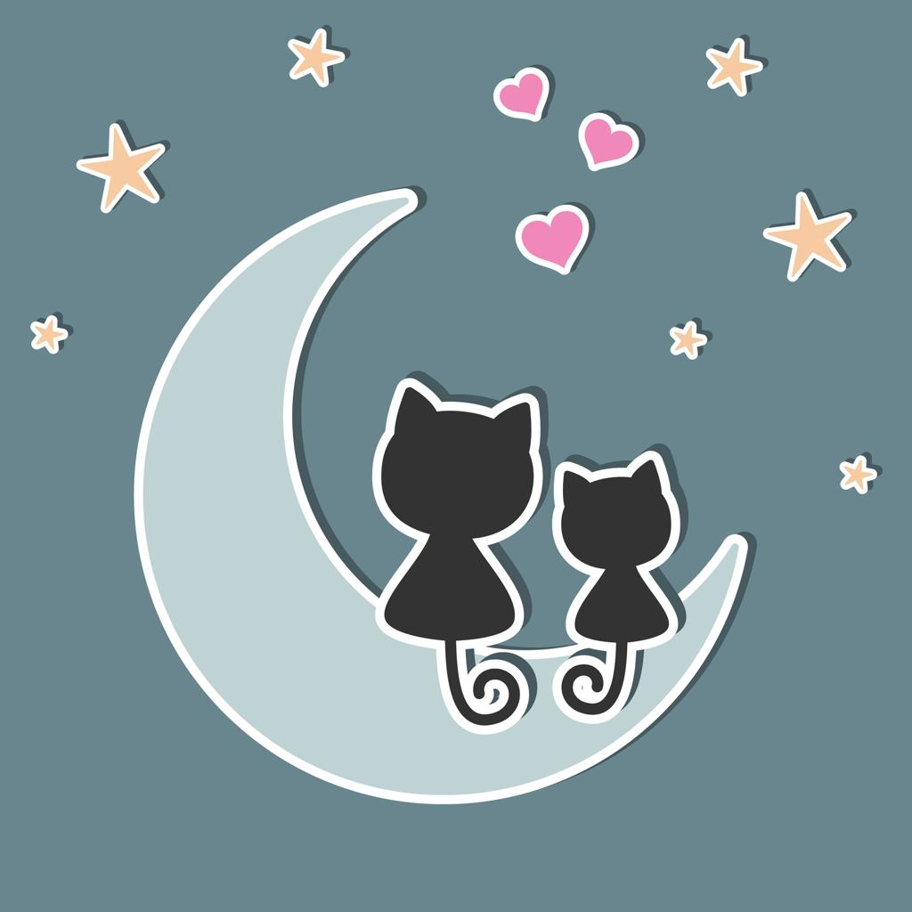
1. Two cats under the moon — my favourite for your situation.
Draw a little cat with green eyes (you) sitting beside another cat with pink details (her), looking at the same moon. Add two tiny stars and a little speech bubble: “Same sky, different corners of the world.”
It quietly captures your friendship across Morocco and Turkey without making a grand romantic declaration.
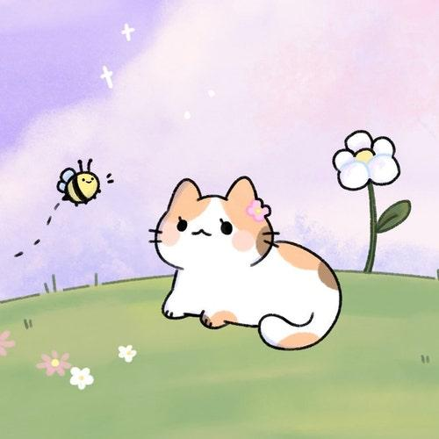
2. A bee delivering a flower to her cat.
Since the campus bees have become recurring characters in her life, draw one carrying a flower toward a cat that looks suspiciously like hers. Maybe the bee has a tiny envelope.
Caption: “Your campus security department has sent you a gift.”
It’s personal, funny, and connected to something she actually told you.
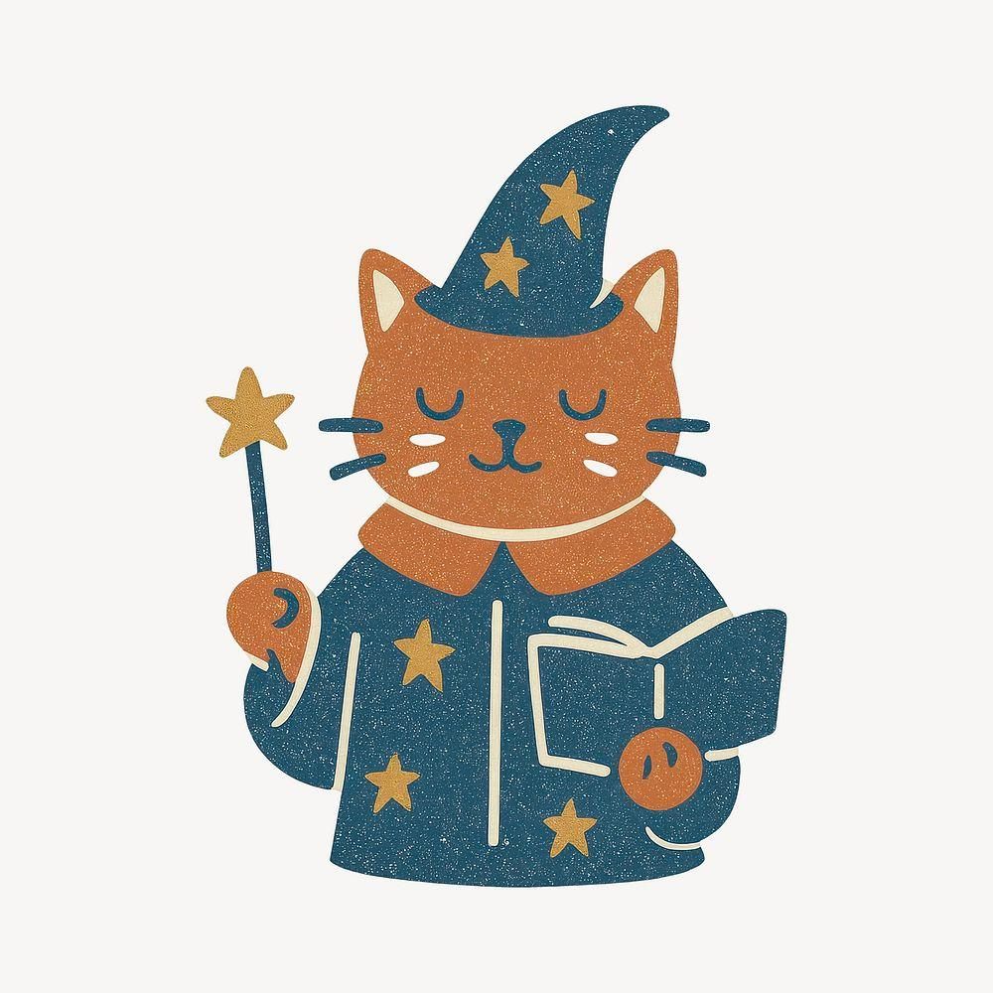
3. A tiny sociologist wizard.
Draw a little cat wearing a crooked wizard hat, holding a book in one paw and a star in the other. Add a tiny label: “Dr. Selen, future professor of understanding humans.”
This celebrates her ambition to become an academic, with enough silliness to avoid turning your drawing into a graduation speech.

What I would actually draw for her
I'd combine the first two ideas: a little cat with green eyes sitting beside a cat with pink ears, while a tiny bee delivers them a letter. It echoes her original drawing, includes your inside joke, and represents your letters bringing you together.
Keep it deliberately simple—slightly crooked lines, tiny stars, and a little envelope between the cats. The imperfections make it feel handmade instead of like you commissioned an artist.
And underneath, I'd write something like:
My artistic career begins today. Please be patient with me; I have approximately zero formal qualifications in cat engineering.
But I thought your little drawing deserved a reply of its own. So here's a tiny creature from my side of the world, accompanied by your campus's most dedicated postal bee. 🐝
One small suggestion: don't make the drawing too polished or overly romantic. The sweetest part is that she drew something for you, and you took the time to draw something back. Let it be your little shared joke.
a squirel?
YES. 😭 A squirrel would be an adorable choice because she recently told you she saw a real squirrel for the first time! It shows you remembered a tiny detail from her letter, and those details often mean more than an elaborate drawing.
I'd draw her a tiny, slightly chaotic squirrel holding an enormous acorn, with big eyes and little paws.

The concept: “Selen's First Squirrel”
- Big fluffy tail, tiny paws.
- A comically oversized acorn.
- Little pink cheeks and a mischievous expression.
- Maybe a tiny leaf on its head.
And underneath, you could write:
Since you recently met your first real squirrel, I thought it was only fair that I introduce you to your first professionally unqualified, hand-drawn squirrel.
He has no academic credentials, no career prospects, and absolutely no idea what he's doing. So naturally, I trust him with my artistic reputation.
Please take good care of him. He has one brain cell, and it's currently occupied by that acorn.
Or, for a subtler and sweeter version, draw the squirrel holding a tiny envelope addressed to Selen.
My vote? The squirrel carrying a letter. It connects her new little memory to the letters you exchange, without needing to explain the sentiment too much.
a simpler one
Keep it very simple: a little squirrel holding an acorn 🐿️
Just draw:
- Two round ears.
- A circle for the head and two dot eyes.
- A tiny nose and smile.
- A big curved tail.
- A little oval acorn between its paws.
Add a tiny caption: “Your first squirrel friend!”
corect and complete this paragprah by telling her that she is beautifull with or wthout makeup, she's almost a queen and she is perfect as she is: Also, the fact that you feel naked without eyeshadow made me laugh. Apparently, eyeshadow has become an essential organ
Also, the fact that you feel naked without eyeshadow made me laugh. Apparently, eyeshadow has become an essential organ, and leaving home without it is now a medical emergency. 😂 But seriously, Selen, I hope you know that you're beautiful with or without makeup. Makeup can be a fun way to express yourself, experiment with your appearance, and feel a little extra fabulous, but it doesn't create your beauty; it's already there. You're practically a queen already, and queens are allowed to have days when they don't feel like putting on a crown. You don't have to be perfectly dressed, have flawless makeup, or look a certain way to be beautiful. I hope you can see yourself with the same kindness you deserve from others, because you don't need to change or add anything to be enough. And if one day you want to wear eyeshadow and feel like the main character in a dramatic historical painting, go for it. If another day you want to leave the house looking like you just negotiated a peace treaty with your pillow, that's perfectly fine too. Both versions are still you, and both deserve to feel beautiful.
what;s that poem that tells to a women, if i coudl give you my eyes to see yourself through them
I think you're remembering the idea “I wish you could see yourself through my eyes” rather than one uniquely identifiable poem. There are several poems and quotes built around it.
A few possibilities:
- “Dear Friend, I Wish You Could See Yourself Through My Eyes” by Kirsten J. Robinson — about wanting someone to recognize their own beauty, strength, and worth.
Thought.is
- “If You Could See Yourself Through My Eyes” — a poem by an author using the name ThatGirlWithTheNotebook, about seeing someone's inner beauty beyond their appearance.

Hello Poetry
- “I Wish You Could See Yourself Through My Eyes” by Karen Clark — an article expressing the same sentiment.

Think aloud
But the wording you remember—“If I could give you my eyes, so you could see yourself the way I see you”—might be a paraphrase rather than the exact opening of a published poem.
If you're thinking of sending the sentiment to Selen, you could write something original and personal:
Sometimes I wish I could lend you my eyes for just a moment—not because I think you're incapable of seeing your own beauty, but because I wish you could see the little things you might overlook: the warmth in your expressions, the life in your eyes, and the way your personality makes even the smallest moments memorable. Maybe then you'd understand why I keep telling you that you're beautiful, with or without a trace of makeup.

